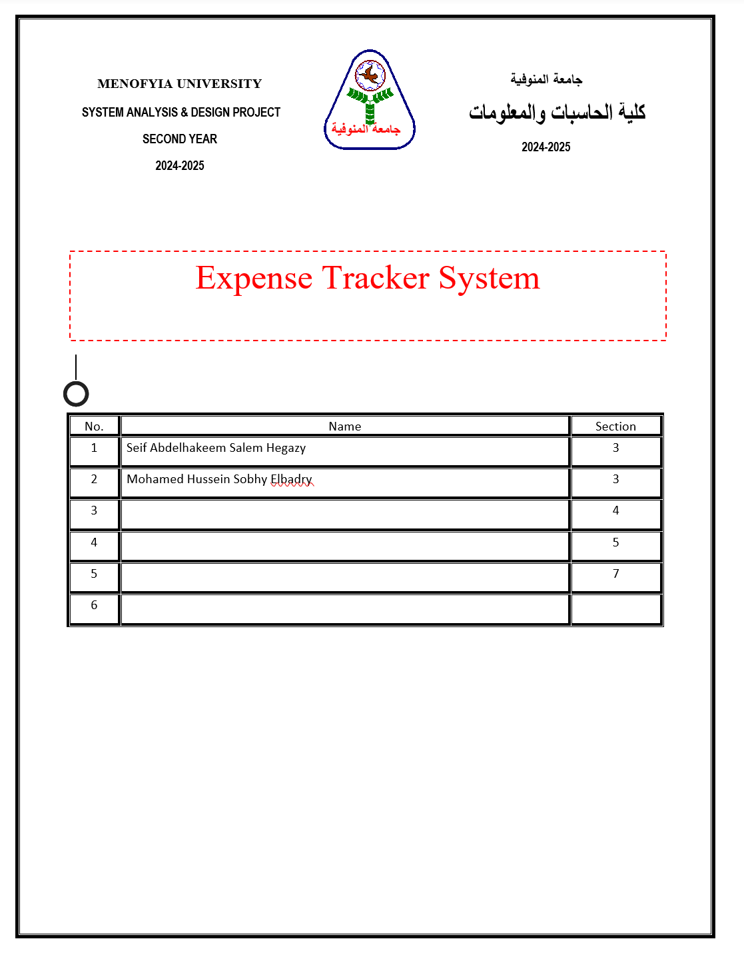Project Identification

Project Name:
Expense Tracker System

Current Problem:
1- Difficulty in tracking daily and monthly expenses manually or using paper records.
2- Lack of clear and organized expense categories (e.g., bills, food, entertainment, transportation).

3- Difficulty in knowing where the salary or available money goes by the end of the month due to the absence of reports and statistics.
4- Possibility of losing paper budget records or making manual calculation errors.

Description about project:
* The system is a web-based application that allows users to easily track their expenses and income by entering transactions and classifying them into specific budget categories.
* The system helps users set a specific budget for each category and alerts them when it is exceeded.
* It enables users to generate accurate reports and statistics, as well as visual charts showing cash flow, which reduces effort and time, prevents calculation errors, and helps in making better financial decisions.

System Request

Project Sponsor:
Project Management / Target Users

Business Need:
The urgent need to control personal expenses and provide accurate and quick financial reports to avoid financial crises.

Business Value:
1- Providing accurate and immediate financial information.
2- Saving time and effort in manual calculations.
3- Lowering costs and managing savings more effectively.
4- Making conscious financial decisions based on reliable reports.

Special Issues or Constraints:
1- Strict deadline for project delivery.
2- Ensuring the security and privacy of users' financial data with continuous system updates.

Feasibility Analysis

Technical Feasibility:
1- We need to design the user interface using HTML, CSS, and JavaScript.
2- We need development environments and tools such as Visual Studio Code.
3- We need the system to work online when connected to the internet (Web-based application).
4- We need this website to be compatible with standard operating systems and browsers across Windows and mobile devices.

Economic Feasibility:
1- The financial benefits of this project will be high and acceptable.
2- The potential losses or risks are minimal and mostly limited to initial development time.
3- The only requirement for full access is secure user authentication.
4- The development cost will be low since most tools and frameworks are open-source or free.

Organizational Feasibility:

Feasibility Analysis includes the assessment of:
1- Management prowess: What is the ability and readiness of the initial management team?
2- Resource sufficiency: What nonfinancial resources such as human resources (management, employees), facilities/location, equipment, intellectual property protection, etc., are required?

Time Estimation

| Phase | Standard Percentages | Estimated Time based on Planning time |
| :--- | :--- | :--- |
| Planning | 15% | Actual: 11 days |
| Analysis | 20% | 16 days |
| Design | 35% | 25 days |
| Implementation | 30% | 22 days |

Cost-Benefit Analysis – Expense Tracker System

| Category | Description | Estimated Cost | Estimated Value / Benefits |
| :--- | :--- | :--- | :--- |
| Software | In-house system development and tool licenses | $500 - $1,000 | Centralized automated system drastically reduces manual errors |
| Hardware | Cloud server hosting and backup storage | $300 - $600 | High security, fast access, and reliable system uptime |
| Training | User onboarding and quick guide sessions | $100 - $300 | Smooth user transition and correct feature utilization |
| Maintenance | Annual software updates, bug fixes, and security patches | $200 - $400 annually | Ensures continuous stability and data security |
| User Experience | Elimination of manual paper ledgers and notebooks | $200 annually | Elimination of wasted manual tracking time and higher satisfaction |

Summary

Total Estimated Costs (first year): $1,300 - $2,500
Total Estimated Annual Benefits/Savings: $3,000 - $5,000+
Payback Period: Within 1 year
Conclusion: The Expense Tracker System is economically feasible, with clear cost savings and long-term value.

