1/5/2023

Kids Area Application
Software Project Management

Supervisor
- Dr. Shaima Talaat
- Engineer\Abdullah Muhammad



Team Members:

- Mohamed AlaaELdein Said Bayume
- Mohamed Elsayed Abdallah
- Mohamed Mahmoud Masoud
- Mohamed Mahmoud Elsayed Elwakeel
- Hazem Reda Abdelhallem
- Mohamed Ali Mohamed Elbadry
- Mohamed ezzet

Contents

- Abstract
- Project Overview
  - Project Description
  - Project Scope
  - Assumptions
  - Constraints
- Project Start-Up
  - Project Life Cycle(planning phase-anaylsis phase-design phase-implementation testing phase)
  - Methods, Tools, and Techniques
  - Estimation Methods and Estimates
  - Schedule Allocation
  - Resource Allocation
  - Budget Allocation
- Risk Management
- fesabilty study l 5 years
- Unit Test
- Mapping
- Diagram
  - use case
  - activity
  - sequence
  - state
  - DFD
  - Class
  - Network

- GUI

Abstract

Abstract. The background of this research is the increasing of criminalization in children, one of which is kidnapping of children, Meanwhile many parents have to work so they don't have enough time to be always close to their children. The purpose of this research is to develop applications that can help a parents to monitor the movements of their children's outdoor activities. The application uses a smart watch to get the child's GPS position and at the same time the device sends the last position of the child to the firebase database server. Parents can monitor the child's movements through the android smart phone device in realtime. The application design uses several UML (unified modeling Language) diagrams namely use case diagrams, activity diagrams and squence diagrams. This application requires data objects including parent, child, family and child’s position (latitude and longitude). The main use cases in this application are sending position, case view, child location on map and view path of moving each child. The application can run only if there is an internet connection and the child uses smart time.
Project Overview
1.Project Description:
The main objective of kids area application is to build a seamless system for parent to discover top places for kids in the selected country.
Purpose: Parents and children use it for Parents use it to find places for children to play and enjoy their time.
Aim: To develop a software for discover top places for kids in the selected country. &Savings while creating exclusive deals, offers and discounts.& earn cashback use it to book your next activity& read parents reviews shar your own experience& save time with filters to find exactly what you need

The goals and objectives for this project will focus on implementing a kids area application that:
1. Flexibility and Accessibility:
It is easy for the clients to access information about their journey.
2. Cross-platform:
Bank systems can be accessed by Web browser or mobile apps software on Windows, Mac, UNIX, OS/2, Amiga, Android, iPhone, etc.

3. Save effort and travel time :
It saves the client time in going to the kids area to book a ticket

2.Project Scope

Internal deliverables :

Strengths | Weakness
- Fast and easy to use service  - It works 24 hours a day  - read parents reviews  - creating exclusive deals, offers | • The site needs to be constantly updated  • Needs technical support

External deliverables:

- User Screen | a screen for client to sign in and know about his bank account

3.Assumptions

Describe any project assumptions related to business, technology, resources, scope, expectations, or schedules.

• Information is always available
• All project participants will abide by the guidelines identified within this plan.

4.Constraints

Describe the limiting factors, or constraints, that restrict the project team’s options regarding scope, staffing, scheduling, and management of the project.
• Time
• Cost

Project Start Up

1.Project Life Cycle.

- Planning.
- Analysis.
- Design.
- Implementation.
- testing.

We will list the activities and tasks required to complete project

Phase | Activities | Sequence
Planning | 1-Define project problem and scope.  2-Produced detailed project schedule.  3-Confirm project feasibility  4-Determine staff of project. | Phase # 1
Analysis | 1-Gather information to learn problem domain.  2-Define system requirements.  3- Prioritize requirements  4- Generate and evaluate alternatives  5- Review recommendations with management | Phase#2
Design | 1-Design and integrate database.  2- Design and integrate the network  3- Design the application architecture  4- Design the user interfaces.  5- Prototype for design details.  6- Design and integrate system controls | Phase#3
Implementation | 1- Construct software components.  2-Vertify and test. | Phase#4
testing | 3-Train the users and document the system.  4-Install the system | Phase#5

2.Methods, Tools, and Techniques
At this stage, we will mention the tools, methods, and techniques with the sources at the end of the plan.
PROGRAMING LANGUEGE :
- My SQL
- JAVA
- Python

Tools we need to use :
- Netbeans
- Workbench

3 Estimation Methods and Estimates

Estimation Methods and Estimates
Description | facilitate the management of the pharmacy and inventory, and on the other hand, it is easy for the customer to purchase .
Effort in person-months or personhours | Weekly
Schedule in calendar months | 2 Months
Budget in dollars | 10000 $
Level of Uncertainty | 15%

4. Schedule Allocation

Activities |  | Predecessor |  | Time  (Days)
 | - Define project problem and scope.  - Produced a detailed project schedule.  - _{Define system requirements.}  - Gather information to learn the problem domain.  - Build prototypes for the discovery of requirements.  - _{Prioritize requirements}  - Review recommendations with management  - _{Design the user interfaces.}  - Design and integrated database.  - Design and integrate system controls  - _{Verify and test.}  - Train the users and document the system.  - _{Install the system} |  | 1  2  3  4  3,4  5,6  6,7  8  8  8,9  10,11  9,12  12,13 |  | 2  3  3  2  2  3  3  1  6  7  3  2  7  2

5.Resource Allocation

Task© |  | Resource
1- Define project problem and scope. |  | Analyst, computer tool to draw WBS
Produced detailed  project schedule |  | Project manager, computer tool
Determine staff of project |  | Project manager
Gather information to learn problem domain |  | Analyst, questioner method.
Define system requirements. |  | Analyst, computer tool.
Build prototypes for discovery of requirements |  | Computer tool to build it
Prioritize requirements |  | Analyst
Design and integrate database |  | Database designer, SQL server, shared computer room
Design the user interfaces |  | Interface designer, Graphic tools, shared computer room.
Design and integrate system controls |  | Designer and developers, shared computer room.
Vertify and test |  | Inspector, shared computer room and acceptance tester and independent tester
Train the users and document the system |  | Training rooms, trainers and users.
Install the system |  | Installation team

6 Budget Allocation:
Key Budget Category | Budget Amount | Time Period
1-Define project problem and scope. | 1000$ | 3days
2-Produced detailed project schedule. | 200$ | 3 days
4-Determine staff of project. | 1000$ | 5 days
5-Gather information to learn problem domain | 300$ | 3 days
6-Define system requirements. | 1000$ | 3 days
7- Prioritize requirements | 400$ | 3 days
8- Generate and evaluate alternatives | 300$ | 2 days
9- Review recommendations with management | 250$ | 5 days
10- Design and integrate database. | 1200$ | 3 days
13-Design the user interfaces. | 200$ | 3 days
14-Design and integrate system controls | 150$ | 2 days
16-Vertify and test | 100$ | 5 days
17- Train the users and document the system. | 400$ | 2 days
18-Install the system | 1200$ | 2 days

7. Feasibility Study :

 | Year of Project
 | Year0 | Year1 | Year2 | Year3 | Year4 |  | Totals
Net economic benefit | 0 | 90,000 | 90,000 | 90,000 | 90,000 |  | Y
Discount Rate (12%) | 10,000 | 0,8695 | 0,75614 | 0,6575 | 0,5717
PV of benefits | 0 | 78255 | 68053 | 59175 | 51453
NPV of all Benefits | 0 | 78255 | 146308 | 205483 | 256936 |  | 256936
One-time Costs | (80,000)
Net economic cost | 0 | 40,000 | 40,000 | 40,000 | 40,000 |  | Y
Discount Rate (12%) | 1,0000 | 0,8695 | 0,75614 | 0,6575 | 0,5717
PV of cost | 0 | 34780 | 30246 | 36300 | 22868
NPV of all cost | 80,000 | 114780 | 145026 | 171326 | 194194 |  | 194194
Overall NPV |  |  |  |  |  |  | 62742
Overall ROI |  |  |  |  |  |  | 0,32
Yearly PV cash flow | 80,000 | 43475 | 37807 | 32874 | 28585
Yearly overall NPV cash flow | 8,000 | 36525 | 1282 | 34157 | 62742
break-even point 0,96
Actual break-even occurred 1,96 year

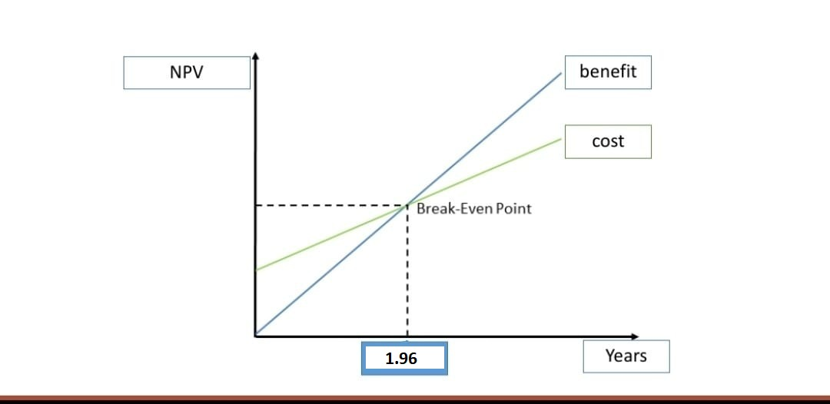

Risk Management

Risk Description | Probability | Impact | Strategy
Cost Estimates Unrealistic | Low | High | Included in project plan, subject to amendment as new details regarding project scope are revealed
Time Estimates Unrealistic | Low | Low | System will be ended in the correct time
software bugs | Low | High | 1- Define a quality system to reduce the probability of occurrence 2- Provide a support and maintenance plan
the gateway interfaces | Low | High | 1- Define a change management system with the gateway provider for any issues related to the software

Unit test
Now we will do a simple test because the )Login) for the site is working and loyalty using the programming language Python :

import unittest
from cids_area import login

class LoginTestCase(unittest.TestCase):
def test_successful_login(self):
username = "example_user"
password = "example_password"
result = login(username, password)
self.assertEqual(result, True)

def test_failed_login(self):
username = "invalid_user"
password = "invalid_password"
result = login(username, password)
self.assertEqual(result, False)

if __name__ == '__main__':
unittest.main()

In this example, we have created a test class LoginTestCase that inherits from unittest.TestCase. We define two tests: test_successful_login and test_failed_login. They both use the login function to check the expected login result with self.assertEqual.

You can successfully run this file now to perform logging unit tests. Ensure that the main program file cids_area.py contains the login function used in unit tests.

Please note that this is a simple example, and you may need to add additional tests depending on your needs and testing requirements.
We verify that the children location follows the correct parent sites using unit tests in Python :

import unittest
from cids_area import ChildLocation, ParentLocation

class ChildLocationTestCase(unittest.TestCase):
def test_child_location_follows_parent_location(self):
parent_location = ParentLocation(10, 20)
child_location = ChildLocation(10, 20, parent_location)
self.assertTrue(child_location.follows_parent_location())

if __name__ == '__main__':
unittest.main()

In this example, we have created a Child Location Test Case test class that inherits from unittest.TestCase. We have defined one unit test called test_child_location_follows_parent_location , which is used to verify that the ChildLocation follows the correct ParentLocation using self.assertTrue.
Of course, you must provide the class definitions ChildLocation and ParentLocation in your cids_area.py file. Modify the example according to your project's organization and structure.
To Find Kids Area With UnitTest in python :
import unittest
from cids_area import find_kids_area

class FindKidsAreaTestCase(unittest.TestCase):
def test_find_kids_area(self):
parent_area = 100
kids_count = 5
result = find_kids_area(parent_area, kids_count)
self.assertEqual(result, 20)

if __name__ == '__main__':
unittest.main()
In this example, an output type of the lookup test class. Employment equality

Ensure that the main program file cids_area.py contains the find_kids_area function that was used in the unit tests.
Using the unit test to get offers and discounts in python :
import unittest
from cids_area import get_offers_and_discounts

class OffersAndDiscountsTestCase(unittest.TestCase):
def test_get_offers_and_discounts(self):
area = "kids"
result = get_offers_and_discounts(area)
expected_result = ["Offer 1", "Offer 2", "Discount 1", "Discount 2"]
self.assertEqual(result, expected_result)

if __name__ == '__main__':
unittest.main()

In this example, we have created an OffersAndDiscountsTestCase test class that inherits from unittest.TestCase. We have defined one unit test called test_get_offers_and_discounts, and it uses the get_offers_and_discounts function to get the expected result using self.assertEqual.

Ensure that the main program file cids_area.py contains the get_offers_and_discounts function that was used in the unit tests.

Mapping
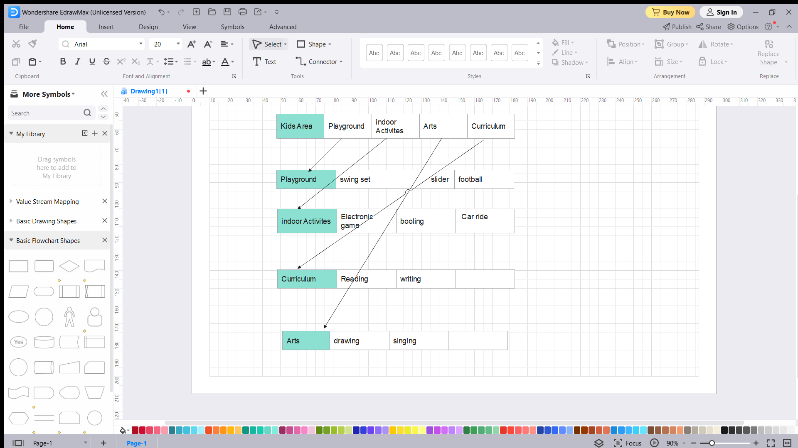
Diagrams
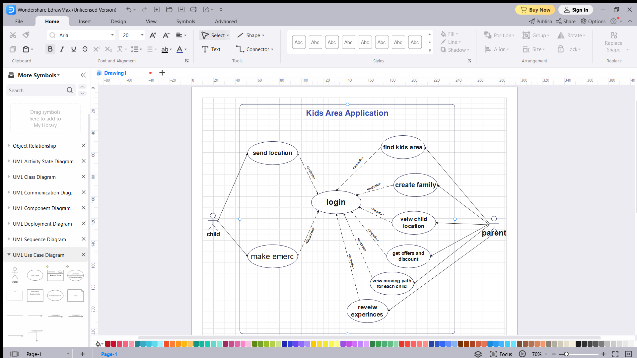
Use case diagram

is the use case diagram of a Child Monitoring System. In the use case there are case login ,
sending positions, SOS requests, create family groups, view child locations in the map, view child
names in groups, register members of family groups, view paths of moving each child . Case login is the main requirement for other case cases. The login case requires the username and password data of the child or parent as users. The username and password of the parent are inputted by the parent while the child password and username are stored internally in the smartwatch storage that is called at login via smartwatch. Case sending location is used to transmit position data from the child. Child's position is obtained by activating the GPS device on the smartwatch which will get latitude and longitude data. The smart watch used by the child will send this data to the server to be stored in the firebase database. Data will be saved from time to time with a timestamp as a differentiator. Case make emergency are used by children to do a contact with a parent phone number in an emergency. Case make family can be used by parents to create a family name as the parent of children. One family name is only made for one child. Case view child location in map allows parents to see all positions of the child on google map in real time. The position of each child on the map will be marked with an icon tag. This icon tag will move position in real time according to the position transfer from the child from time to time. Case view child name in group is used to view all members of the family member by parent. The case register member family group is used by parents to register children data. All child data will be stored in database, so that later the child will only read the data that has been stored by the parent. Case view path moves each child, used by the parent to review the path the child has passed on a certain date. Case delete all child data path, used by parent to delete child’s track data. This data can be deleted if it is no longer needed by the parent.
Activity Diagram
1.Activity Login

2.find kids Area
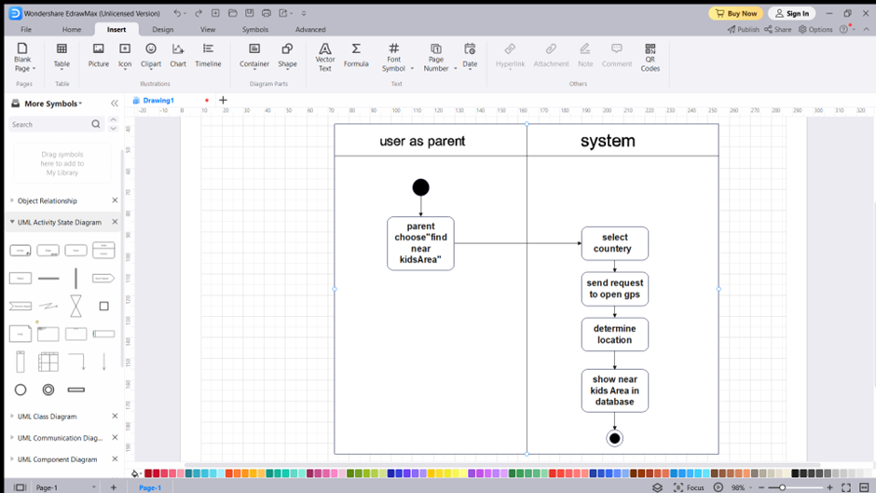

3.Activity sending position

4.Activity Create Group Family
5.Activity View Child Location On Map
6.get offer
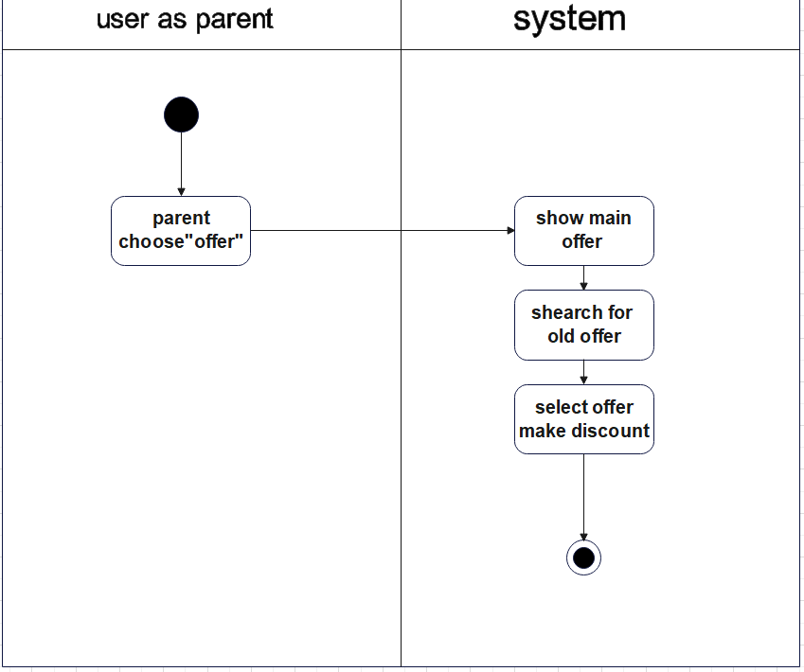

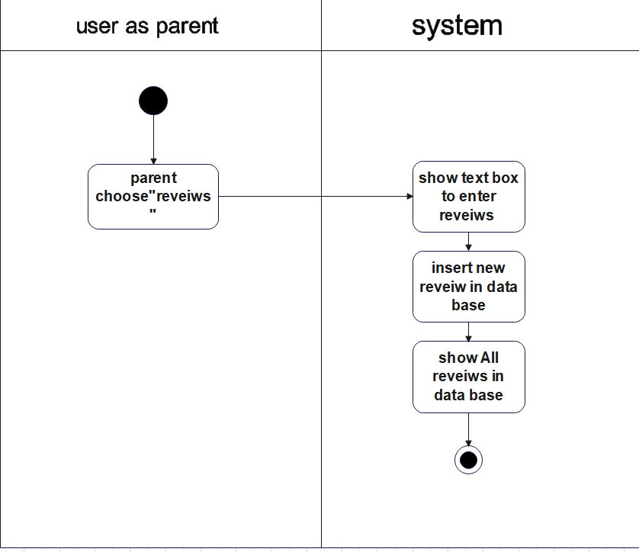
7.reveiw

Sequence Diagram

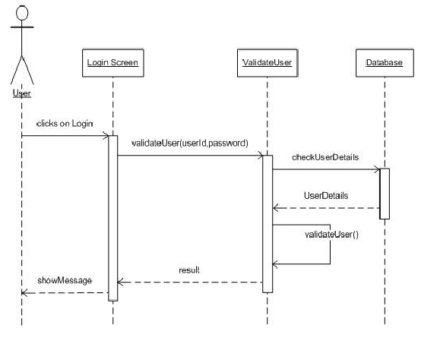
Login

Show All Child position

Class diagram
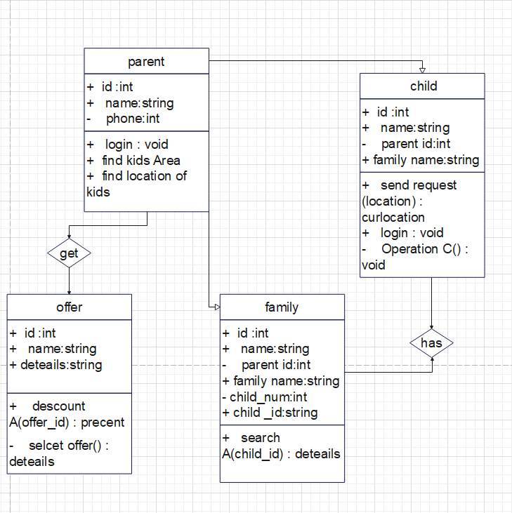
Network diagram

Te=2,TL=2 Te=5 ,TL=5 Te=8,TL=8 Te=10,TL=10 Te=14.TL=14
ET=2 ET=3 ET=3 ET=2 ET=4
4
5
3
1
2

ET=3,Te=13,TL=14
6
ET=3,TE=17,TL=17
7
ET=1,Te=18,TL=18
8

ET=6,Te=24,TL=24
9
ET=7,Te=25,TL=27
10
ET=3,Te=27,TL=27 ET= 7,Te=36,TL=36
11
13
ET= 2,Te=29,TL=29
12
ET=2,Te=38,TL=38
14

Activity | TL | TE | Slack(TL-TE) | ON Critical
1 | 2 | 2 | 0 | √
2 | 5 | 5 | 0 | √
3 | 8 | 8 | 0 | √
4 | 10 | 10 | 0 | √
5 | 14 | 14 | 0 | √
6 | 14 | 13 | 1
7 | 17 | 17 | 0 | √
8 | 18 | 18 | 0 | √
9 | 24 | 24 | 0 | √
10 | 27 | 25 | 2
11 | 27 | 27 | 0 | √
12 | 29 | 29 | 0 | √
13 | 36 | 36 | 0 | √
14 | 38 | 38 | 0 | √

Critical path:
11
9
8
7
5
4
3
2
1

14
13
12

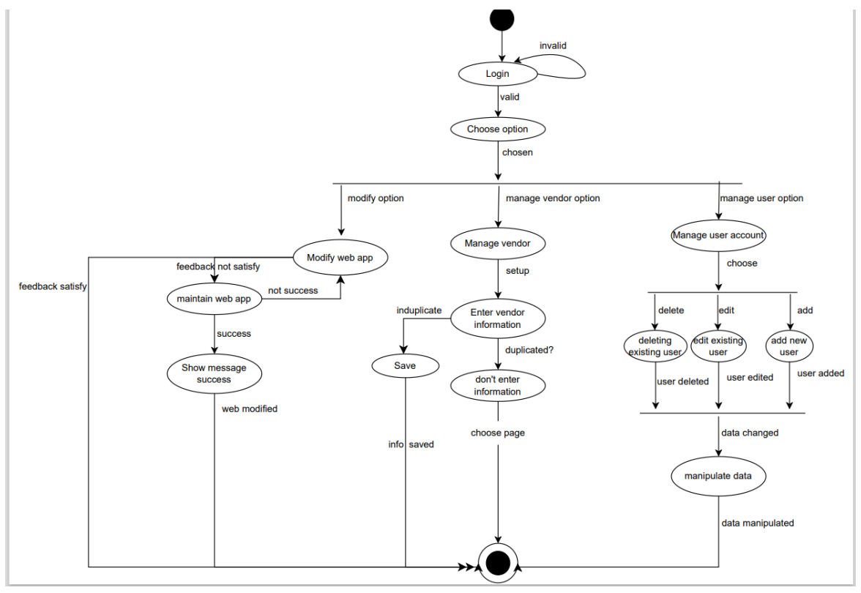
State diagram

DFD diagram
