WINDOWS 11
HELP DESK TROUBLESHOOTING LAB
Hands-on IT Support Portfolio Project
VirtualBox Lab | Windows 11 | Tier 1 Help Desk / Service Desk

Project Summary
This portfolio documents hands-on Windows 11 troubleshooting performed in a controlled virtual lab. The focus is the troubleshooting process: identify the user's symptom, form a theory, gather evidence, apply a safe fix, verify the result, and document the outcome.

Technical Skills Demonstrated
- TCP/IP, DHCP, DNS, gateway and ping diagnostics
- Windows network adapter troubleshooting
- NTFS permissions and standard-user access
- Windows Services and startup state
- Task Manager and application recovery
- Storage, startup applications and Windows Update review
- Event Viewer analysis and event correlation
- Device Manager and audio-device troubleshooting
- Clear technical documentation and verification

Troubleshooting Method
Stage | What I Did
1. Identify | Clarified the symptom, impact, and what the user could or could not do.
2. Theory | Considered likely causes before changing settings.
3. Test | Used low-risk Windows tools and commands to gather evidence.
4. Fix | Applied the least disruptive corrective action appropriate to the lab.
5. Verify | Repeated the original test or had the user confirm functionality.
6. Document | Recorded findings, evidence, actions, and next steps.

Case 1: Network Connectivity - DNS Failure
Reported symptom: User reports that internet access is not working.
My troubleshooting reasoning: I would first confirm the physical connection and then use Command Prompt to test connectivity. I would compare the local IP configuration, default gateway, an external IP address, and a hostname so I can separate a general network failure from a DNS-specific failure.
Tools used: Command Prompt, ipconfig, ping
Findings: The diagnostic sequence showed that network connectivity could be tested independently from name resolution. This allowed the problem to be narrowed to DNS rather than treating every internet complaint as the same issue.
Corrective action: Corrected the DNS/network configuration used in the lab and repeated the connectivity tests.
Verification / next step: Successful responses after the correction confirmed restored name resolution and connectivity.
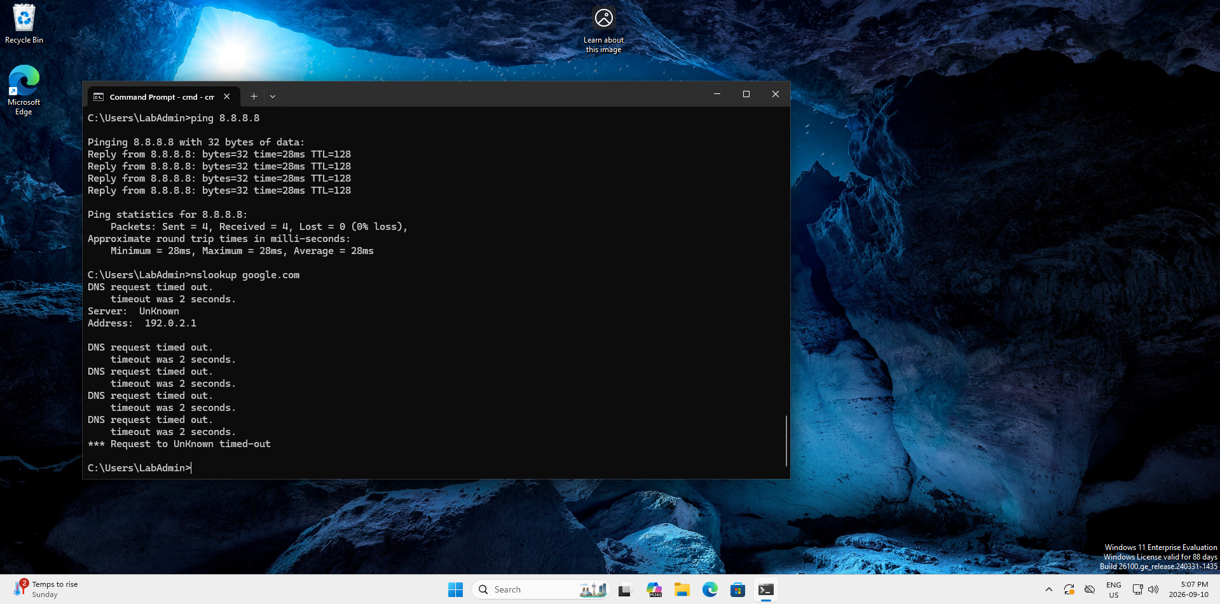
Evidence 1.1 - Network Connectivity - DNS Failure
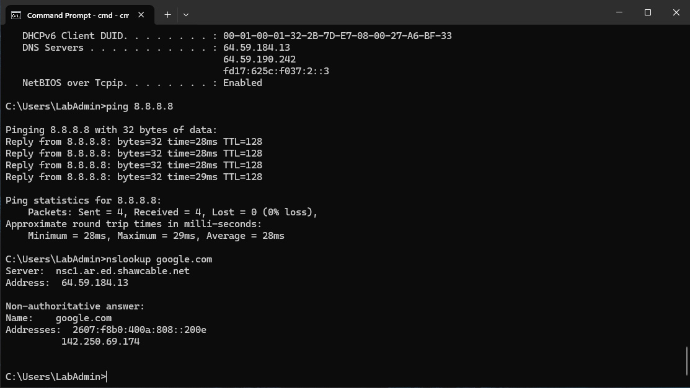
Evidence 1.2 - Network Connectivity - DNS Failure

Case 2: Network Connectivity - Disabled/Disconnected Adapter
Reported symptom: User reports no internet connection.
My troubleshooting reasoning: Before changing software settings, I would check the physical connection: cable, router connection, and link lights. If those look normal, I would check Windows network status and test from Command Prompt. When no usable Ethernet configuration appears and pings fail, I would investigate the network adapter state.
Tools used: Settings, Device Manager / Network Connections, Command Prompt, ipconfig, ping
Findings: The adapter was disconnected/disabled. The failed ping tests and missing usable interface configuration were consistent with the adapter not being active.
Corrective action: Enabled/restored the Ethernet adapter.
Verification / next step: A valid Ethernet configuration returned and pings to the gateway/external destination succeeded.
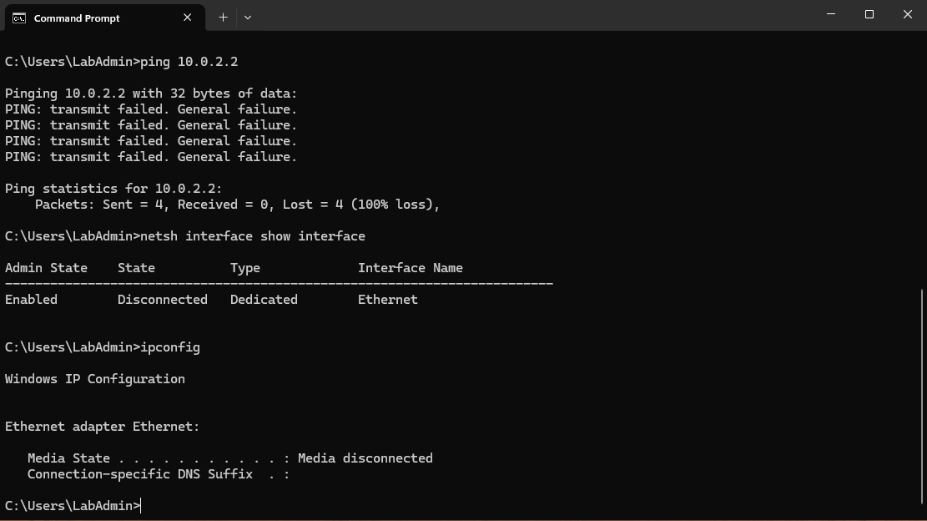
Evidence 2.1 - Network Connectivity - Disabled/Disconnected Adapter
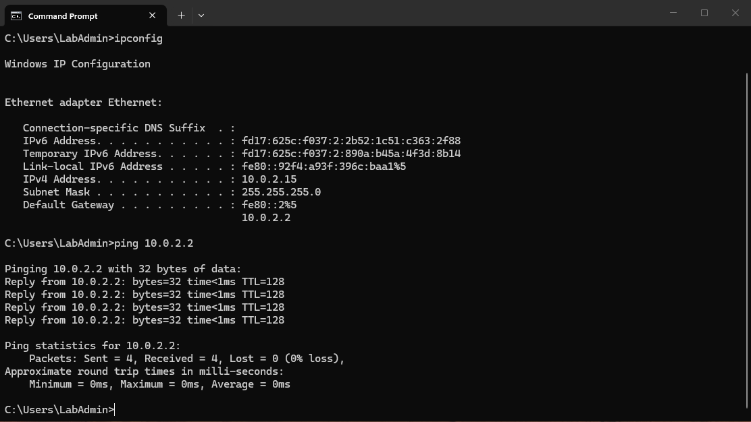
Evidence 2.2 - Network Connectivity - Disabled/Disconnected Adapter

Case 3: Network Configuration - Incorrect Static IP
Reported symptom: The workstation has network problems even though the adapter itself is present.
My troubleshooting reasoning: Once the adapter is active, I would inspect the assigned IP address, subnet mask, gateway, and DHCP state. A wrong static configuration can leave the adapter enabled while still preventing normal communication.
Tools used: Command Prompt, ipconfig, Windows network adapter settings
Findings: The lab workstation had an incorrect static IP configuration.
Corrective action: Returned the adapter to DHCP so it could obtain the correct network configuration automatically.
Verification / next step: A valid DHCP configuration was obtained and connectivity tests passed.
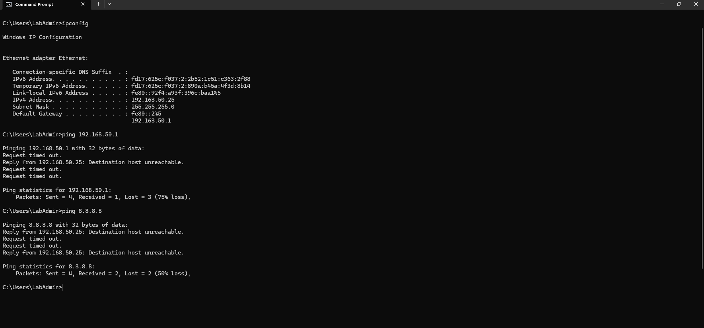
Evidence 3.1 - Network Configuration - Incorrect Static IP
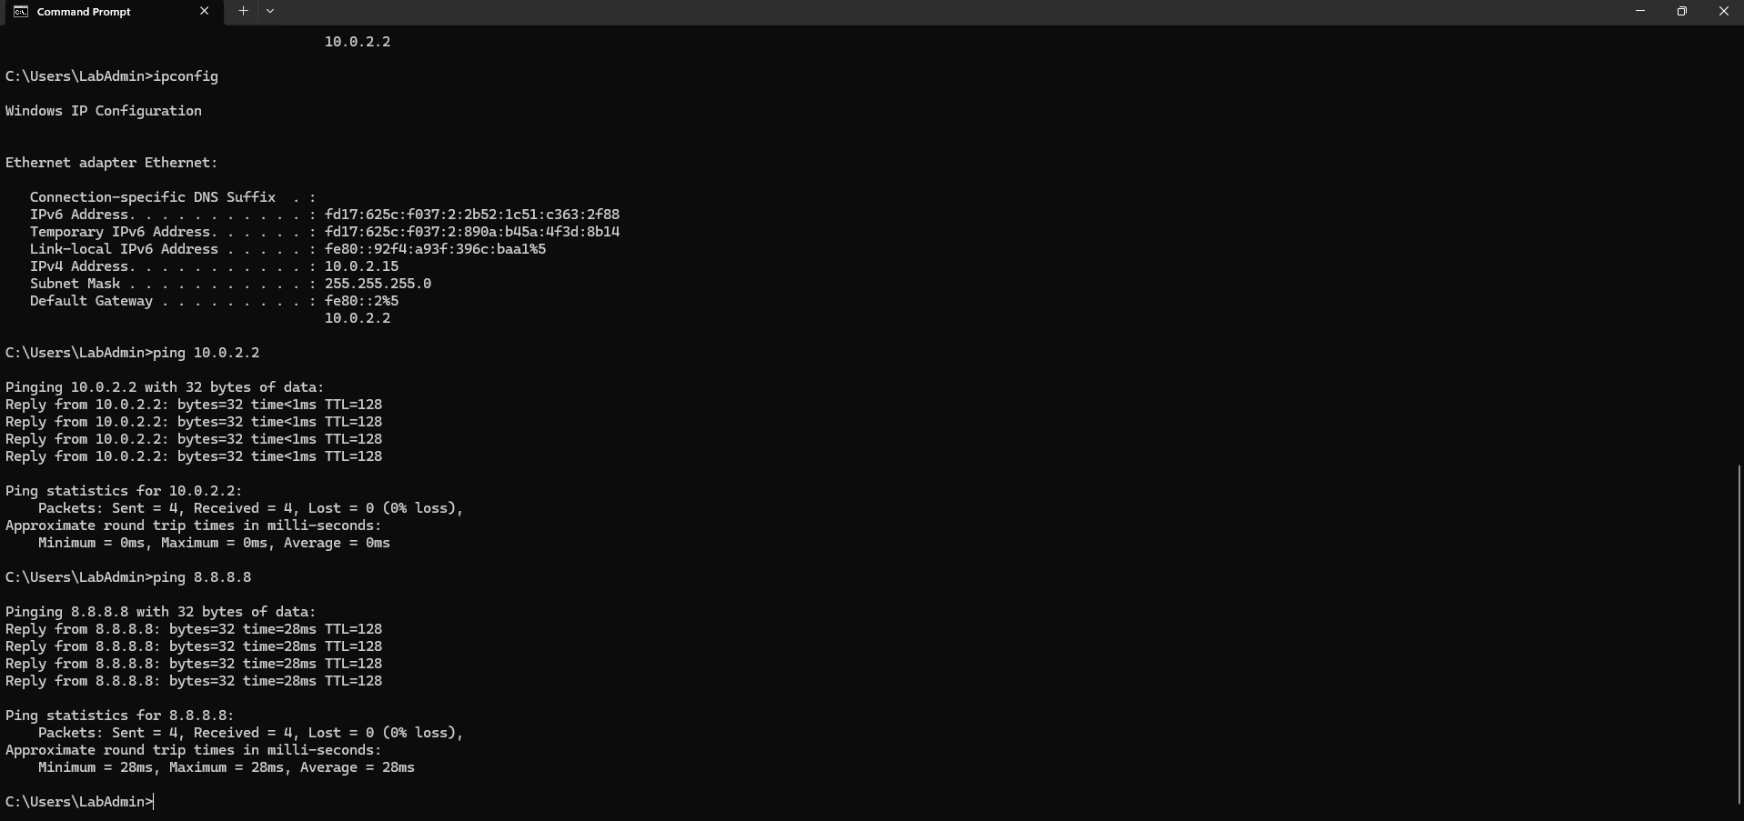
Evidence 3.2 - Network Configuration - Incorrect Static IP

Case 4: NTFS File Permissions - Employee Access
Reported symptom: A standard employee account cannot open a training document in C:\CompanyData\EmployeeFiles.
My troubleshooting reasoning: The access-denied message points toward permissions rather than a missing file. I would inspect the file/folder Security settings, inheritance, and the employee's effective permissions before changing ownership or granting broader access.
Tools used: File Explorer, Properties, Security, Advanced Security Settings
Findings: The standard user did not have the required access to the training document.
Corrective action: Adjusted the lab permissions to provide the required read access while avoiding unnecessary administrative/full-control rights.
Verification / next step: The TestEmployee account could open and read the training document after the permissions change.
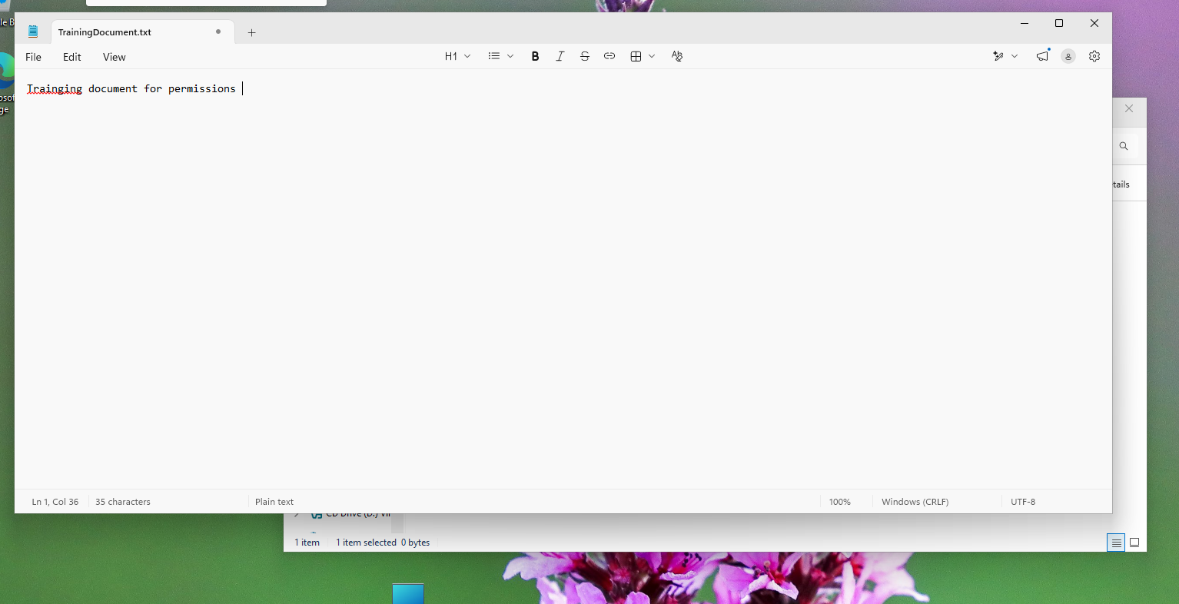
Evidence 4.1 - NTFS File Permissions - Employee Access

Case 5: Windows Search Service - Search Not Working
Reported symptom: User reports that Windows Search is not functioning.
My troubleshooting reasoning: I would inspect the Windows Search service in services.msc. Service Status tells me whether it is currently running, while Startup Type determines how Windows starts it. If the service is stopped or disabled, that can explain the search problem.
Tools used: Services (services.msc)
Findings: Windows Search had been stopped/disabled in the lab scenario.
Corrective action: Restored the Windows Search service to an appropriate startup state and started the service.
Verification / next step: The service showed Running and Windows Search functionality was restored.
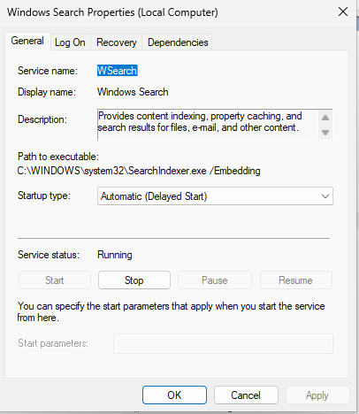
Evidence 5.1 - Windows Search Service - Search Not Working

Case 6: Application Troubleshooting - Frozen Notepad
Reported symptom: A user application becomes unresponsive.
My troubleshooting reasoning: If only one application is frozen, I would avoid restarting the entire computer. I would open Task Manager, identify the affected process, and end only that application if it is safe to do so.
Tools used: Task Manager, Notepad
Findings: The issue was isolated to the application rather than the whole Windows session.
Corrective action: Force-closed the nonresponsive Notepad process and reopened the application.
Verification / next step: Notepad reopened and accepted input normally.
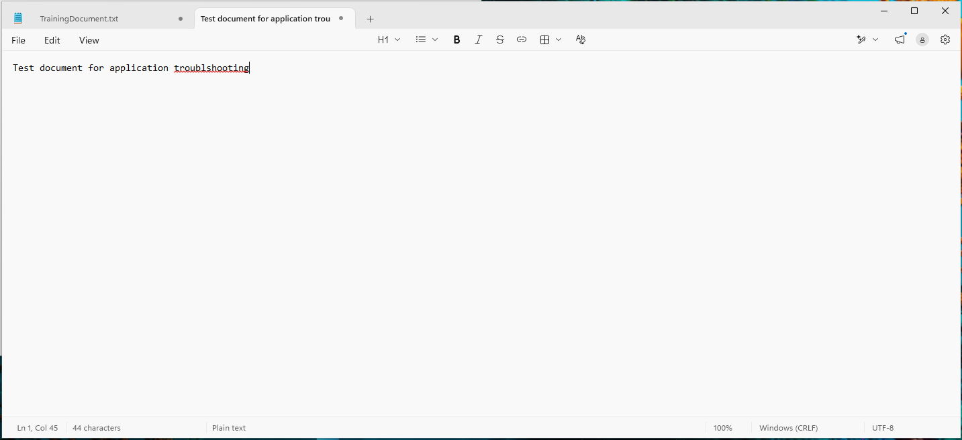
Evidence 6.1 - Application Troubleshooting - Frozen Notepad

Case 7: Performance and Stability Investigation
Reported symptom: User reports that the computer has recently been running slowly or has experienced an unexpected restart.
My troubleshooting reasoning: I would avoid assuming storage is the cause. With roughly 50 GB of free space, I would continue checking Task Manager resource usage, startup applications, Windows Update, and Event Viewer. A pending update may be relevant, but I would verify whether it is required before installing it. Event logs help establish whether a shutdown or crash occurred.
Tools used: Settings > Storage, Task Manager, Startup Apps, Windows Update, Event Viewer
Findings: No abnormal resource-heavy process was evident in the test VM. Event Viewer recorded Kernel-Power Event ID 41 and EventLog Event ID 6008, both consistent with an unexpected/unclean shutdown. These events document the shutdown but do not by themselves prove the underlying cause.
Corrective action: Documented the event IDs and correlated the timestamps. In a real ticket, I would continue with update history, hardware/power checks, reliability history, and recurrence data before assigning root cause.
Verification / next step: The VM was operational after restart; the investigation produced documented evidence and an escalation path rather than an unsupported conclusion.
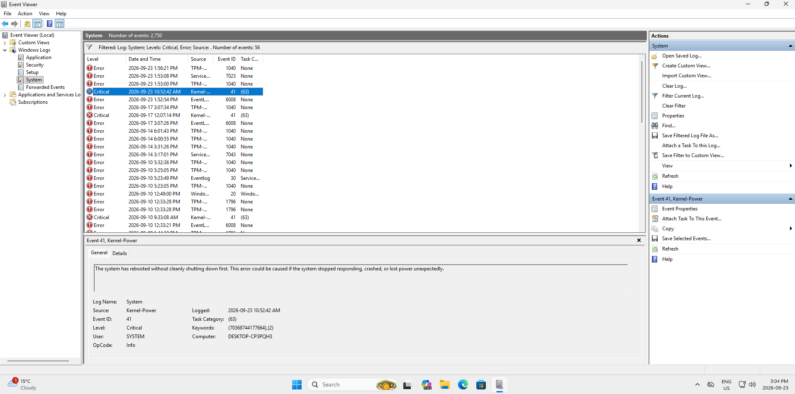
Evidence 7.1 - Performance and Stability Investigation
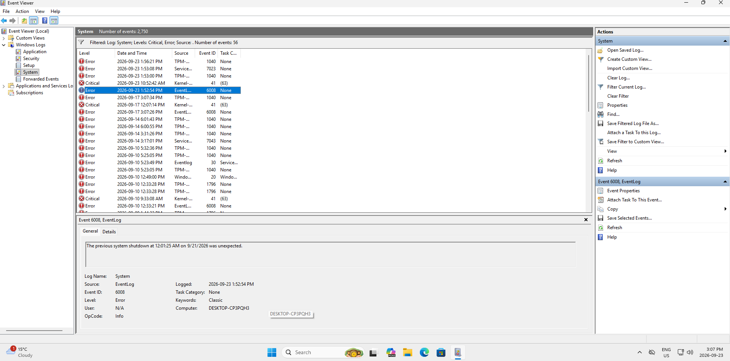
Evidence 7.2 - Performance and Stability Investigation

Case 8: Audio Troubleshooting - Disabled Output Device
Reported symptom: User reports no sound and Windows shows no output device.
My troubleshooting reasoning: I would first confirm the physical setup: where the speakers are connected, whether cables are secure, and whether the expected output is the monitor or another device. If the physical setup is correct, I would check Sound settings and then Device Manager.
Tools used: Settings > System > Sound, Device Manager
Findings: The High Definition Audio Device was present but disabled. The context menu displayed 'Enable device,' confirming the device was not currently enabled.
Corrective action: Enabled the High Definition Audio Device.
Verification / next step: The next step is to have the user play audio and confirm sound output. The lab diagnosis and corrective action were completed.
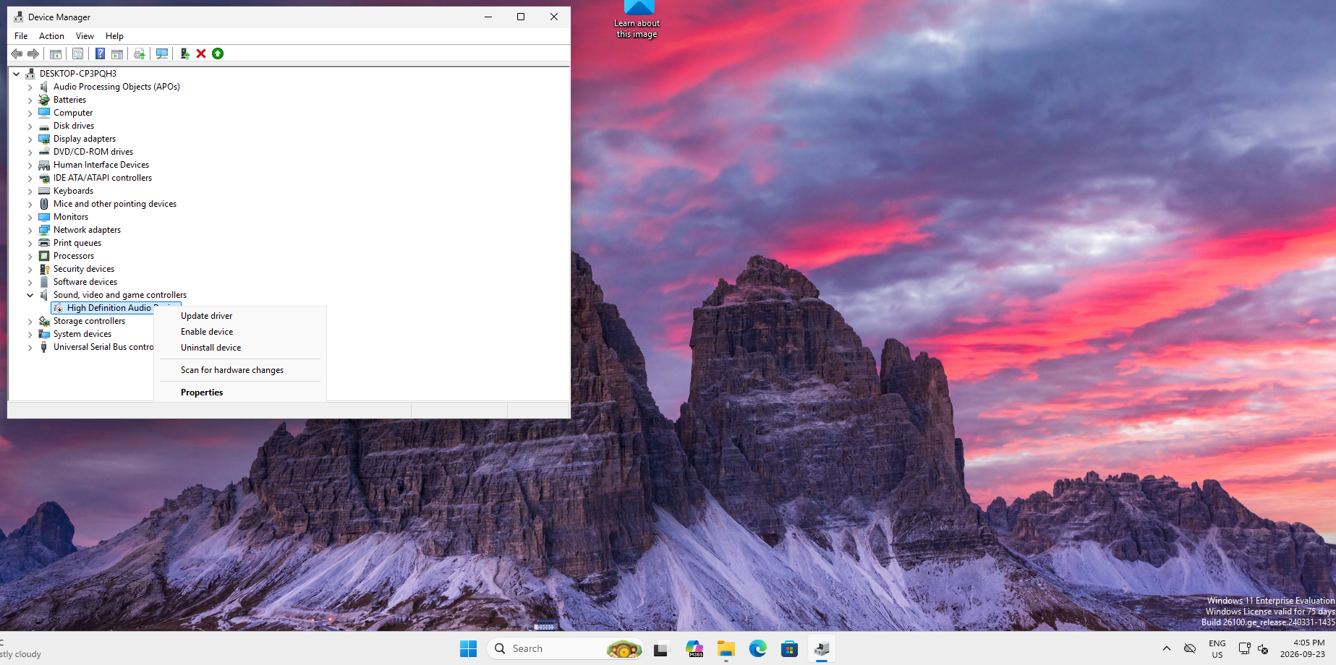
Evidence 8.1 - Audio Troubleshooting - Disabled Output Device

What This Lab Demonstrates to an Employer
The strongest outcome of this lab is the troubleshooting discipline behind the fixes. I practiced separating symptoms from root causes, using evidence before making changes, avoiding unnecessary disruption, and verifying the user's original problem after the corrective action.
- I can explain why I chose a diagnostic step instead of only listing commands.
- I can distinguish network-layer problems such as adapter state, IP configuration, gateway reachability and DNS.
- I understand the difference between service status and startup configuration.
- I use least-privilege thinking when correcting file permissions.
- I can isolate a frozen application instead of immediately rebooting an entire workstation.
- I treat Event Viewer entries as evidence to correlate, not automatic proof of root cause.
- I verify the result from the user's perspective before closing a ticket.

Interview-Ready Summary
In my Windows 11 support lab, I worked through realistic Tier 1 incidents involving DNS, DHCP, network adapters, NTFS permissions, Windows services, frozen applications, unexpected shutdown events, and audio devices. For each scenario, I started with the user's symptom, gathered evidence using built-in Windows tools, made a targeted change, and verified the result. The lab helped me practice not just the technical fix, but the reasoning and documentation expected in a Help Desk environment.

