**Portal: Origins [Part 2]**  
Naming Conventions and File Structure  
Colin Kennedy, 2015  
[colinvfx@gmail.com](mailto:colinvfx@gmail.com)

**Foreword:**  
This document outlines the file structure and naming conventions that will be used for all aspects of the project. It is important that everyone adhere to these guidelines for all assets that will be used in this project to avoid confusion and facilitate the location of files. Ideally, if everyone uses the same conventions, even if you are looking at a part of the project that you are not familiar with you will be able to quickly locate the most recent version of the assets and locate dependencies  
  
**Project Space:**   
We have space reserved in the Collaborative Space for the project that’s exclusively set up for Visual Effects work. Currently we have 200Gb on our drive but that number is going to increase substantially because of all of the 4K footage that will be used in compositing. Our goal, as a production, is to minimize waste on our Collaborative Space. Please, please clean up old files regularly and do not ever copy/paste film footage to different shot directories. Normally it’d be okay to do but we just don’t have the space to make more than a few copies of 12 minutes of 4K footage.  
  
**Working Remotely:**  
In general, it’s way safer for your work to just copy/paste whatever shots you’re working on to a local drive (on Windows, we’re talking about the D:\Temp folder. On Linux, it’s /var/tmp) and then re-upload it to the Collaborative Space when you’re done. If you do though, please use the tools designated for network-to-local and local-to-network transferring. Do not copy/paste manually. If you’d like to work off of the network for whatever reason, you must use the FileIO tool for your respective software (Maya, Nuke, Houdini, etc). The network DOES NOT handle having two people working or saving to the same file at once and these custom open/save commands are designed to make sure files do not get accidentally corrupted.  
  
For more information on network-to-local and local-to-network transfers, please refer to:  
**Network2Local_How_To.pdf # doesn’t exist yet  
Local2Network_How_To.pdf # doesn’t exist yet**  
**FileIO_How_To.pdf # doesn’t exist yet**  
  
Otherwise that though, the rule is: “Download everything, upload what you change”. Keep communication open with your teammates if you’re both supposed to be working on the same directory. We’ve got the Slack group, portaloriginspart2.slack.com just for that. Everyone there has the right to make channels and groups and private message whoever they want so make a group chat if that’ll help stay in touch.  
  
If you work at home, you can also use sav-myfile.scad.edu to access the Collaborative Space and sync with our projects on FileZilla. If you don’t know how to set up FileZilla on your home machine, most people and teachers know how so ask around. (There used to be a tutorial online but I couldn’t find it to link to it)  
  
EDIT: If sav-myfile.scad.edu does not work. Use, atl-myfile.scad.edu as your FTP address.  
  
**Project Folder Overview:**  
We have a mix of software that we’re using to create shots for POP2, so instead of having per-application folders, the folder structure is divided by production phases.  
  
- **Previs**  
 - Mostly used as a directing tool, this folder contains placeholders and basic animation, as well as look development.  
 - NO FILES are allowed in the Previs folder. Only folders. Folders must be named after the shots that they are meant for.   
  
 - **s0###** - the lowercase letter s, followed by a 0, then the number/letter for the shot  
 - **concept**  
 - References, animatics, storyboards, concept art, style keys, etc  
 - **maya**  
 - maya files and scene descriptions for the 3D work related to the scene  
 - **previs**  
  
- **Build**  
 - When assets are being created, their work-in-progress files will be placed here  
 - For the most part, because assets are shared across multiple shots and (in some cases) entire scenes, the folders in “Build” don’t have a shot-by-shot structure. Instead, the structure is by- type.  
 - If you’re working on a new model, go into the model folder and make a new folder. Name the new folder what you are going to call the asset once it’s final. (Let’s do this so that we can look at any final asset and see how it was made, in case we need to troubleshoot a problem)  
 - Beyond that initial structure, please think of the Build folder as a sandbox. There’s no naming convention required here or project structure. Work however makes sense to you  
  
- **Edit**  
 - When previs is ready to be taken out of pre-production into production, the entire shot folder from previs would be copied to here  
 - All conventions, standards, rules from Previs applies to the Edit folder  
  
- **Final**  
 - In a nutshell, never touch this folder directly. We have tools for interfacing finalized assets from this folder that prevents misuse. Please use those instead of copy/pasting to this folder directly. The following information is for system administrative reference:  
  
 - **models**  
 - **interior** – walls, ceiling information, general environment  
 - **hero** – objects close to camera  
 - **destructible** – any object that’s designed to break, and it’s non-broken counterparts  
 - **practical** – any geometry meant to represent lighting  
  
  
**Naming Conventions**Because we’re using references, everything must be really well organized. Because of this, the latest version of a file, as well as its path, must always be the same. When assets update, all of the changes will propagate as expected  
  
**Shots:** The farm doesn’t recognized scene files that exist anywhere else other than the scenes folder, so everything in the scenes folder must be .ma/.mb files related to the shot that we want to render. Please do not add anything into the scenes folder that are not maya .ma/.mb files that the farm can understand  
  
**Display Layers:** Display layers are a HUGE benefit when working with complex scenes. To prevent file-clutter, we are going to be keeping display layers in the reference files and rig files as much as possible. Display layers for all of the different parts of the assets will be loaded into the set reference files. If additional layers are needed that need to propagate across the entire project, they should be added to one of the referenced assets. If you have any questions about this, ask Colin  
  
**Adding References:** In the event that there is a scene that is not set up with all of the assets that you need, you can make a reference by using the Reference Editor in the File menu. When making a reference, it is important to use these options in the reference command box: **Deferred**: off, **Lock**: off, **Group**: on, **Locator**: off, **Load Settings**: Load All References, **Use Namespaces** checked in, **resolve all nodes with the filename**. Or, ask Colin and he can set this up for you.

**NOTE:**  
  
For a full list of the latest naming conventions and a more comprehensive list of filename examples, please run the following command in the terminal (if on Linux):  
  
/home/$USER/mount/collaborative/portal-origins-part-2/Pipeline/the_LATEST/latest_CONFIG/conf_SCRIPTS/pop2_conventions.py  
  
Otherwise, if on windows:  
  
I:\Savannah\CollaborativeSpace\portal-origins-part-2\Pipeline\the_LATEST\latest_CONFIG\conf_SCRIPTS\pop2_conventions.py   
  
  
  
  
  
  
  
  
  
  
  
  
When it doubt, use this general naming convention structure:  
  
GENERAL:  
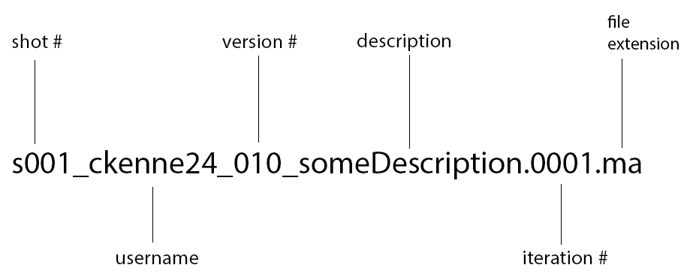  
***Important!***

Filenames should never contain:

● spaces or special characters (e.g. >, /, ?, ", ', \, |, }, $, %, ^)  
● dashes, ever. “-“. Dashes are for filthy casuals. If you need a dash, use “_” instead. Little dashes are the devil

● underscores, numbers or periods in any location not specified by this document.

This naming guide has been created so that filenames will contain useful information about the file, and so that scripts used throughout this production will be able to parse filenames in a uniform way. Even slight deviations from this format will break this functionality  
  
**How To Use It  
Shot #** - We aren’t going above 100 shots, so leave the first 0 of s0## alone and place your shot number in the ## slot. ** Adding a letter to the shot number sequence is OK.  
**Username** – I plan on rolling out tools and updates that involve automated messaging (don’t worry, I promise not to be too spammy) so having a single name attached to a file is required.  
**Version #** - When you’re working, the version number is basically a counter of where you are in a shot. So if you’re currently modeling, you’d write s001_ckenne24_001_modelingRoom.0001.ma. When you want another iteration of the modeling section for shot 1, add a number to the iteration number. Now the file reads like so:  
s001_ckenne24_001_modelingRoom.0002.ma. Once you start UVing the room, you add a number to the version 1, since the job you’re doing has changed from modeling to UVing  
s001_ckenne24_001_UVingChair.0001.ma.   
 - Notice, the iteration # has reset back to 0001  
**Description** – For the first underscore, you must include the asset type in all caps (look at ITYP asset name examples below for the possible options). Otherwise that, you can write literally whatever you want here, as long as it doesn’t include characters that were listed above. If file names are too long, they are automatically rejected so just keep within that 255-256 filepath + filename character limit and you’re good. Be as descriptive as you’d like  
**Iteration #** - This number system will vary per application (Maya expects *.####.ma, Nuke expects _v####.nk, Houdini doesn’t care). Otherwise that though, only numbers go here  
**Extension** – Come on Joe – I don’t need to explain this  
SCENE FILE NAMING CONVENTION:  
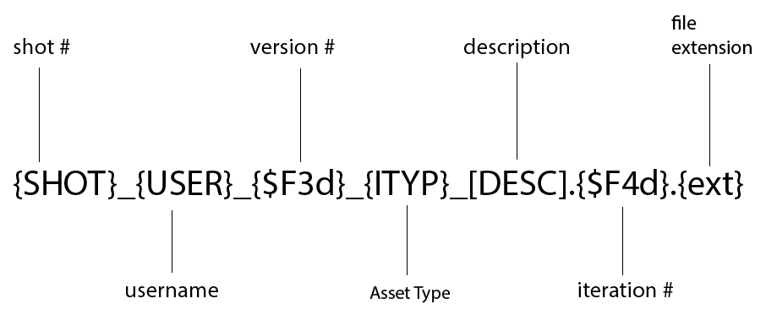  
**\*\*\*Note: {} means required. [] means optional  
  
ITYP** item type:  
 Comp related

○ **OUTPT** Editing Output

○ **COMP** Compositing Output

○ **PLTFG** Foreground Plate

○ **PLTBG** Background Plate

○ **PASS** Render output of characters, background plates, etc.

○ **FX** Render output from effects  
 ○ **FXA** Effects dept. asset

○ **MODEL** 3D Model

○ **TEX** Texture Image

○ **BOARD** Story Board

○ **DOC** Production Document

○ **REF** General Reference Material

○ **MOCAP** Motion Capture Data

○ **SFX** Audio, sound effects, music  
  
Some other additional “valid” names, in case you want some more ideas of how best to name your assets  
  
Names with shots that have letters: s007B_jbond_007_FXA_explosion.0420.mb  
Names with many “_”s: s099_jsmith_003_OUTPTInfo_andDetails_rig_white_chocolat.0001.ma  
Names with prefixed underscores: ____s017_tanals_088_BOARD_File_v0001.nk  
  
  
  
  
  
FINAL ASSET NAMING CONVENTION  
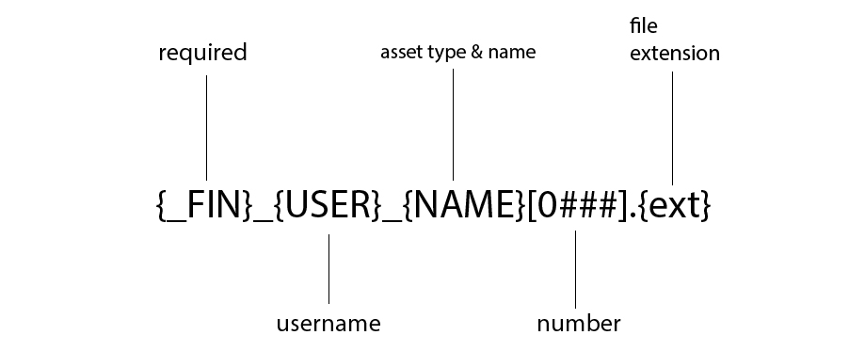  
Finalized assets have the most rules, as far as naming goes, because a single bad reference can easily break a farm render and cause many problems. In general, the rules are as follows:  
  
1. If an asset is final, it means that after you save the asset into the final, you will never work on it again. A final asset has no errors, no manifold geometry, has UVs, textures, etc. When you commit to final, it means you’re agreeing that you’ll never need to touch edit it directly again. Please don’t save the same asset over and over as version final 1, version final 2, etc. Just keep good practices and only save to final if it’s actually “final”  
2. All finalized assets are start with an underscore, “_FIN_”, to make them easy to find.  
3. camelCase everything in your description. Scene files are pretty lenient about infinite underscores, “_”, but final assets shouldn’t have more than **three**  
4. Final asset names may not start with a number   
5. Iterations and version numbers are omitted. Add numbers to the end of a filename padded with 4 numbers starting with 0, if you absolutely need to  
  
**_FIN** – required  
**USER** – your username for your SCAD e-mail, just like in the case of assets, we’d like people to be easily reachable if an asset is broken or a problem comes up  
**NAME** – the name of the asset. Names must be prefixed by asset type. For a full list of the asset prefixes, please refer to the ITYP listing in the previous section  
**0###** - users are allowed to add numbers to the end, in case an asset has more than one version – like a barrel with multiple designs  
**ext** – file extension  
  
examples:  
_FIN_MODEL_barrelLong0012.ma  
_FIN_TEX_gunRust0001.tiff