
Cairo University
Faculty of Computers and Artificial Intelligence

Report

Supervised Learning

ID | Name
20230232 | Abdlmonem Osama Gad
20230410 | Moaaz Mohamed Soliman
20230161 | Zeyad Mohamed Arafat
20230637 | Mohamed Sayed Bakry
20230352 | Mohamed magdy younes

1. Introduction
1.1 Project Overview
In the rapidly evolving field of Autonomous Systems, the ability of a vehicle to accurately perceive and categorize its surroundings is paramount. Object detection and road scene classification form the backbone of safe navigation for self-driving cars. This project aims to develop a robust computer vision pipeline, starting from classical machine learning baselines and progressing toward advanced deep learning architectures. The ultimate goal is to distinguish between various objects—such as vehicles, animals, and transport equipment—that a local autonomous agent might encounter in a real-world environment.
1.2 Dataset Description
For the initial phase (Phase 1), the CIFAR-10 dataset is utilized as a foundational benchmark. It consists of 60,000 $32 \times 32$ color images across 10 distinct classes:
Transport: Airplanes, Automobiles, Ships, and Trucks.
Living Beings: Birds, Cats, Deer, Dogs, Frogs, and Horses.
This dataset serves as a critical starting point to evaluate how traditional algorithms handle low-resolution, noisy, and high-dimensional image data before transitioning to more complex datasets like the German Traffic Sign Dataset or BDD100K in later phases.
1.3 Objectives of Phase 1
The primary focus of this phase is to establish a Performance Baseline using classical techniques. The key objectives include:
Exploratory Data Analysis (EDA): Analyzing class balance, pixel distributions, and channel-wise statistics to understand data characteristics.
Feature Engineering & Dimensionality Reduction: Implementing Principal Component
Analysis (PCA) to compress the high-dimensional pixel space and visualize class separability.
Classical Modeling: Implementing and evaluating K-Nearest Neighbors (KNN) and Gaussian
Naive Bayes (GNB) classifiers.
Performance Metrics: Assessing models based on Accuracy, F1-Score, and Confusion Matrices to identify common misclassifications (e.g., confusing "trucks" with "automobiles").

2. Exploratory Data Analysis (EDA)
2.1 Data Visualization and Class Balance
The CIFAR-10 dataset was loaded and inspected. A sample of 25 images was visualized to understand the image quality and resolution ($32 \times 32$ pixels).
Class Distribution: As shown in the count plot, the dataset is perfectly balanced, with 5,000 training images per class. This ensures that the classifiers will not have a bias toward a specific category during training.
2.2 Pixel and Channel Statistics
To understand the input features, pixel value distributions were analyzed:
Global Distribution: The pixel values range from 0 to 255. The histogram reveals a wide distribution across the intensity spectrum.
Channel Analysis: The distributions for Red, Green, and Blue channels were plotted separately. The high overlap between these distributions indicates that color alone is likely insufficient for accurate classification, necessitating more complex feature extraction.
Mean Images: By calculating the average image per class, we identified dominant color patterns (e.g., "Airplanes" and "Ships" tend to have a blue-dominant background representing the sky or sea).

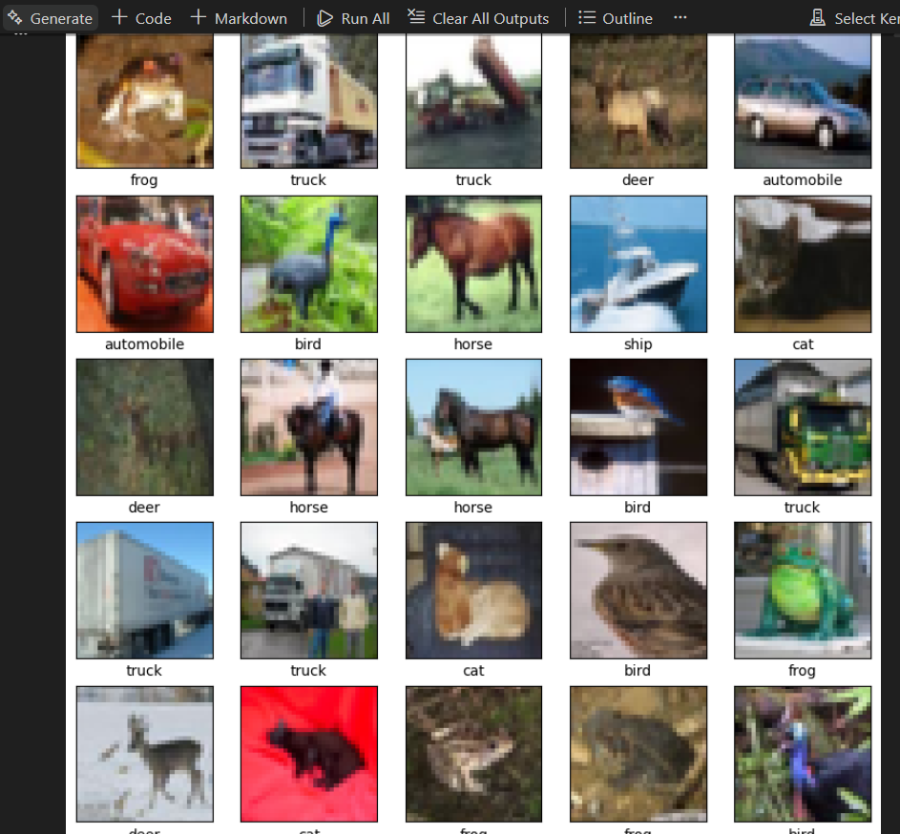
1. Sample Images Grid
• Description: This figure displays a random sample of 25 images from the CIFAR-10 training set with their corresponding labels.
• Analysis (Insight): The images are low-resolution ($32 \times 32$ pixels), which makes manual feature extraction difficult. Noticeable variations in lighting, background, and object orientation are present, which presents a challenge for classical ML models like KNN and Naive Bayes.
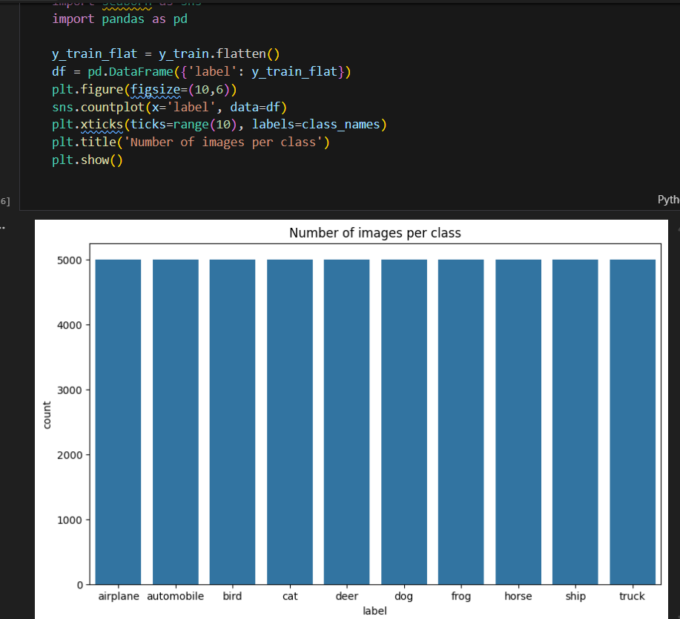
2. Class Distribution
• Description: A bar chart showing the frequency of each of the 10 classes in the training set.
• Analysis (Insight): The dataset is perfectly balanced, with exactly 5,000 images per class. This is ideal for training, as the model won't suffer from "Class Imbalance" issues, and accuracy will be a reliable metric for evaluation.
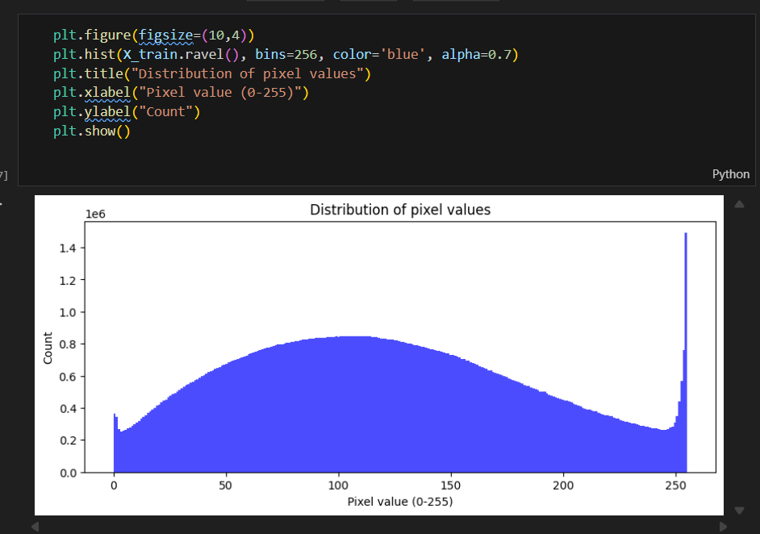
3. Global Pixel Distribution
• Description: A histogram showing the distribution of all pixel values (0-255) across the entire training set.
• Analysis (Insight): The distribution is roughly "bimodal" or spread out. The peaks at the extreme ends (0 and 255) suggest many images have dark backgrounds or bright highlights. The wide spread confirms the need for Normalization (scaling values to 0-1) to ensure the models converge faster.
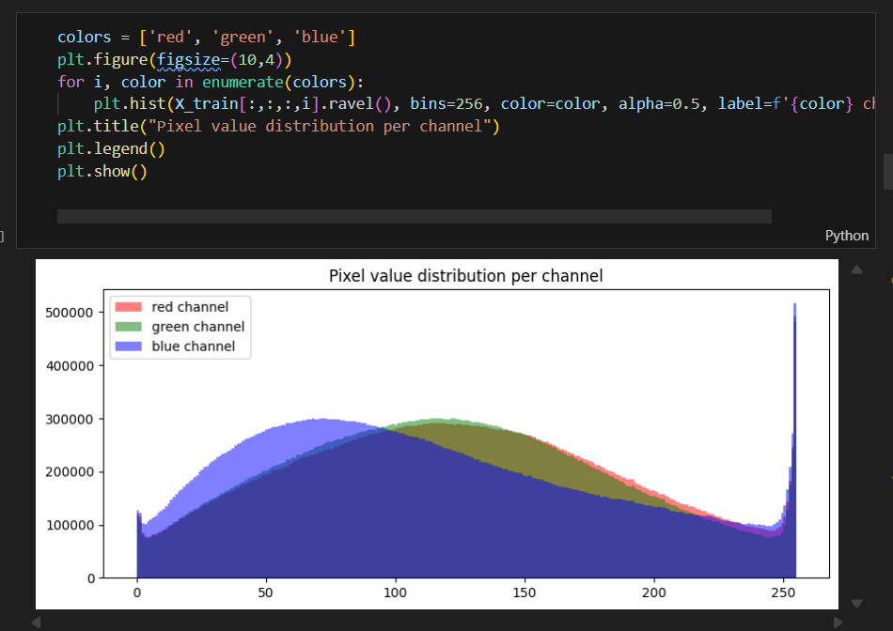
4. Channel-wise Distribution
• Description: This plot breaks down the pixel intensity distribution into the three primary color channels: Red, Green, and Blue.
• Analysis (Insight): All three channels follow a similar distribution pattern, but we can observe slight shifts. For instance, the Blue channel often has a slightly different peak, likely due to common background elements like the sky or water in "Airplane" and "Ship" classes. The high overlap between these channels suggests that color alone is not a strong enough feature to distinguish classes, and spatial patterns are more important.
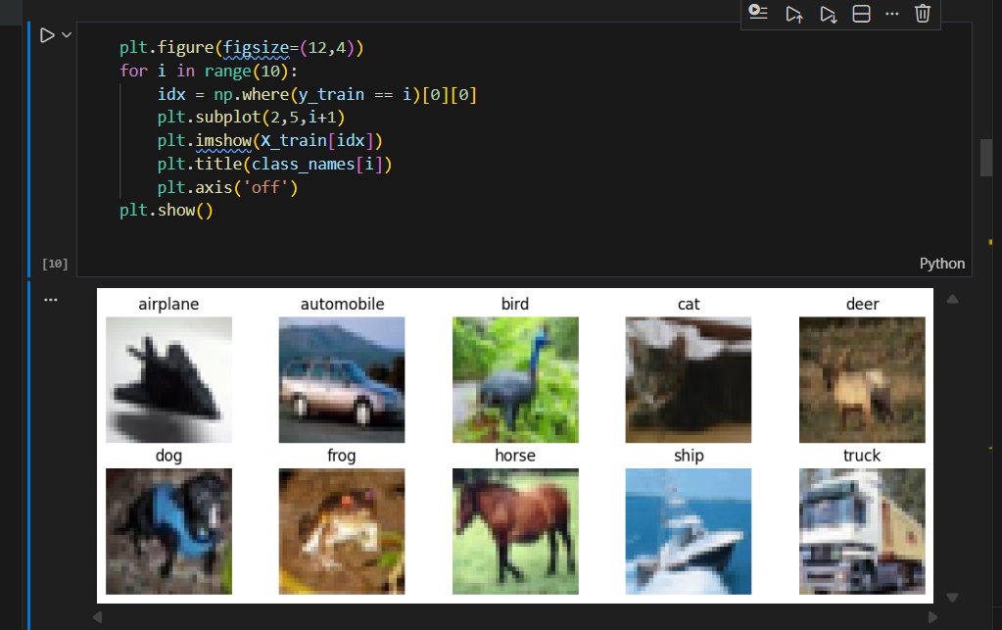
5. Class Samples Representation
• Description: This figure displays one representative sample from each of the 10 classes in the CIFAR-10 dataset (Airplane, Automobile, Bird, Cat, Deer, Dog, Frog, Horse, Ship, and Truck).
• Analysis (Insight): * Visual Diversity: Each image shows different backgrounds and object scales. For example, the "Ship" class has a distinct blue background, while the "Deer" and "Horse" classes feature natural, greenish environments.
Intra-class Variance: Even within a single class, objects can look very different (e.g., a truck can be a large trailer or a smaller delivery truck).
Low Resolution Difficulty: The $32 \times 32$ resolution is evident here, where fine details (like the eyes of the dog or the wheels of the car) are blurry. This highlights why simple pixel-matching (like basic KNN) will struggle and why we need more robust feature extraction in Phase 2.
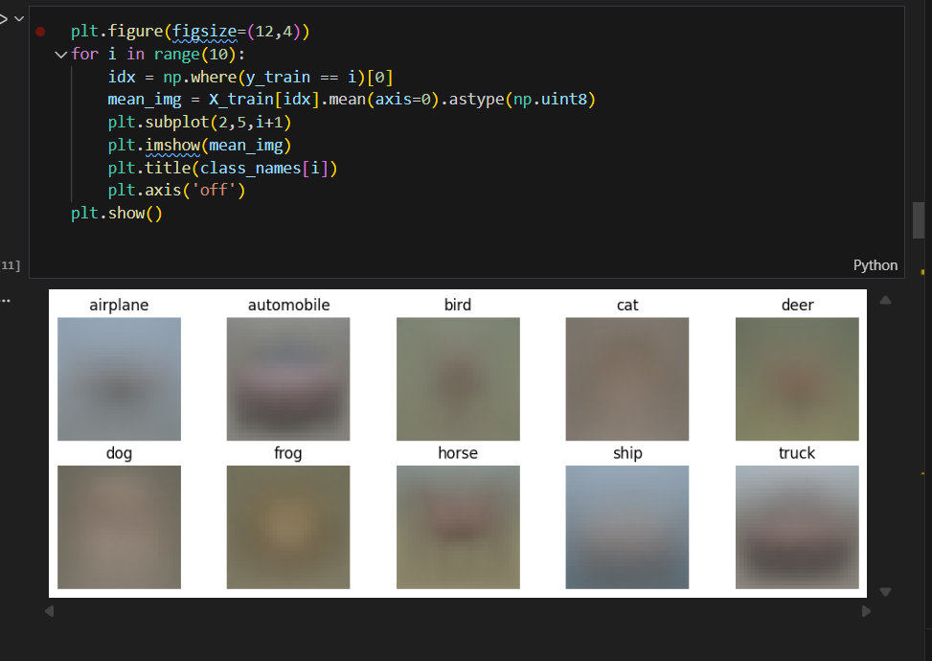
6. Average Image per Class (Mean Images)
Description: This figure visualizes the "average" image for each category by calculating the mean of all pixel values across all images in that class.
Analysis (Insight): * Color Patterns: The mean images reveal dominant background colors. For example, "Airplane" and "Ship" have a strong blue/grey tint (sky and water), while "Frog" and "Deer" show greenish/brownish tones (grass and forest).
Centric Shapes: Most classes show a blurry "blob" in the center, indicating that the objects are generally centered in the dataset.
Classification Challenge: The high similarity and "blurriness" between classes like "Dog" and "Cat" at a mean level explain why simple distance-based algorithms (like KNN) struggle to find clear boundaries between these categories.

"The KNN model achieved a baseline accuracy of 35.39%. While this exceeds random chance, the low F1-score highlights the limitations of using raw pixel distances for image classification, especially for visually similar classes."

The Gaussian Naive Bayes model achieved an accuracy of 29.76%, underperforming compared to KNN. This confirms that simple probabilistic models that assume feature independence are not well-suited for high-dimensional image data, further justifying the transition to more advanced architect

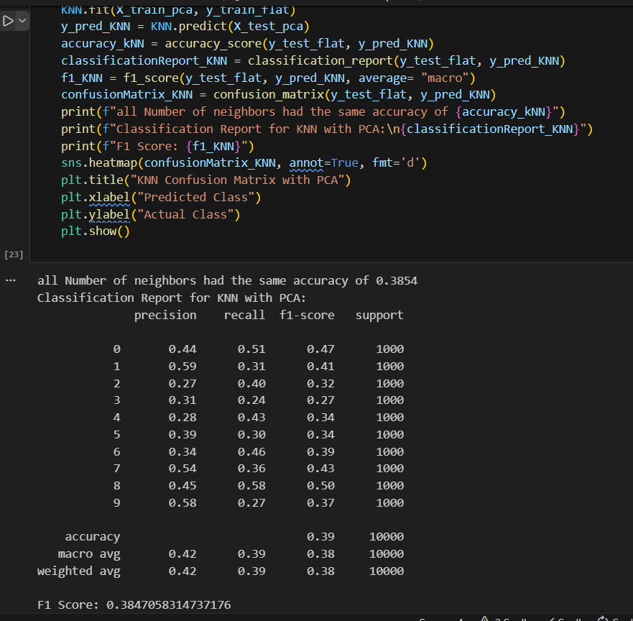

Data Exploration & Distribution (EDA
Class Balance: The bar chart shows a perfectly balanced dataset with 5,000 images for each of the 10 classes, ensuring no model bias.
Pixel Intensity: The global histogram reveals a wide distribution of pixel values (0-255), while the RGB channel-wise distribution shows significant overlap, indicating that color alone is not enough for classification.
Sample Representations: The grid of images and the Mean Images per class highlight the low resolution ($32 \times 32$) and the blurry "average" shapes, illustrating the visual complexity of the dataset.
Model Performance (Results)
KNN Baseline: The K-Nearest Neighbors model achieved a baseline accuracy of 35.39%.
KNN with PCA: After applying Principal Component Analysis (PCA), the accuracy improved to 38.54%.
Insight: The increase in accuracy after PCA proves that dimensionality reduction successfully filtered out noise and helped the model focus on critical structural patterns
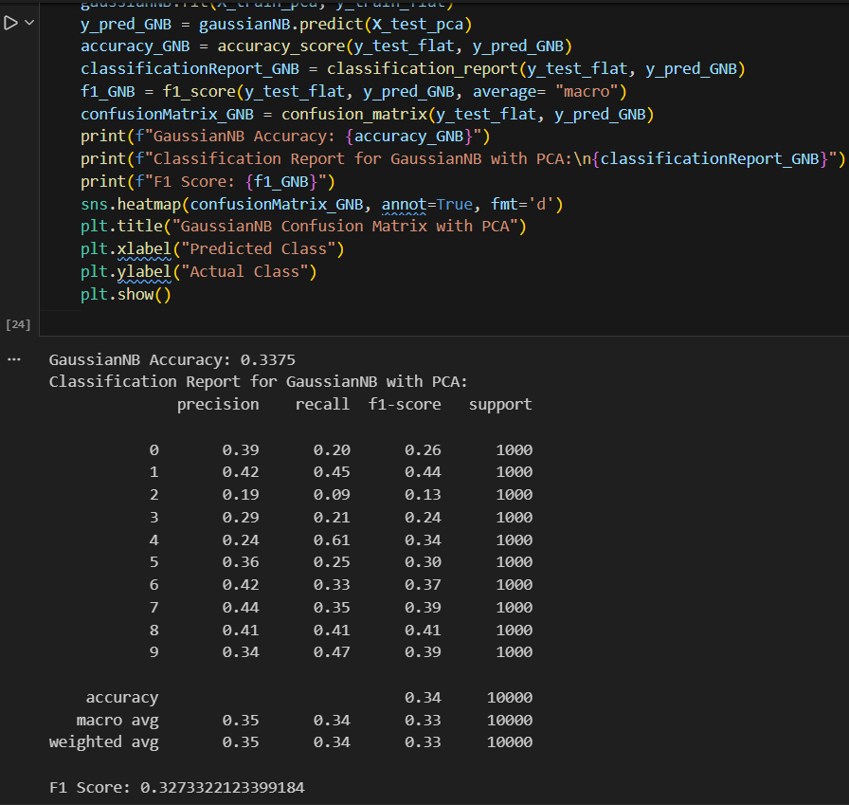

Gaussian Naive Bayes with PCA Analysis
Accuracy (33.75%): There is a noticeable improvement in accuracy, rising from approximately 29.76% (without PCA) to 33.75%.
This confirms that PCA acted as an effective feature extractor, helping the probabilistic model focus on the most relevant data components while ignoring noise.
F1-Score (0.32): The overall F1-score also improved to 0.32.
While still lower than the KNN results, the increase shows that dimensionality reduction makes the features more "Gaussian-friendly," fitting the model's underlying assumptions better than raw pixels.
Phase 2
Dataset Preparation and Preprocessing
In this project, the German Traffic Sign Recognition Benchmark (GTSRB) dataset was used. The dataset was downloaded using KaggleHub and includes labeled images of traffic signs for classification tasks.
The dataset was provided in CSV format, where each row contains the image path and its corresponding class label. The training and testing datasets were loaded separately using pandas.
To prepare the data for model training, all images were resized to a fixed size of 32×32 pixels to ensure consistency in input dimensions. The images were then converted into numerical arrays using TensorFlow utilities.
A custom function was implemented to iterate over the dataset, load each image, and extract its label. The resulting data was stored in NumPy arrays for efficient processing.
The training dataset was further split into training and validation sets using an 80/20 ratio. Stratified sampling was applied to preserve the class distribution across both sets.
Finally, all pixel values were normalized to the range [0, 1] by dividing by 255, which helps improve model convergence during training.
The dataset consists of multiple classes representing different traffic signs, and the preprocessing step ensures the data is clean, consistent, and ready for deep learning models.
Data Visualization and Augmentation
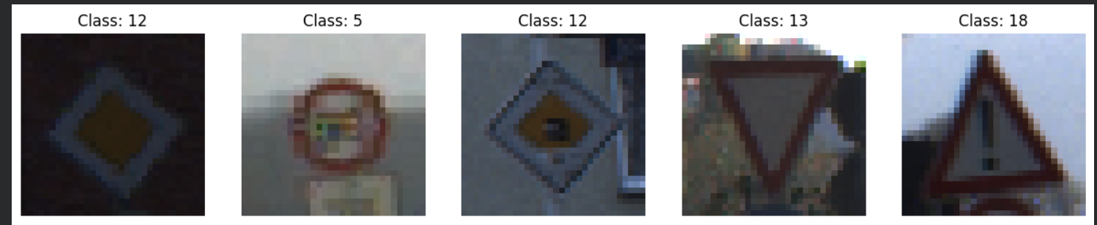 To better understand the dataset, a subset of training images was visualized along with their corresponding class labels. This step helps verify that the data is correctly loaded and provides insight into the variability of traffic sign appearances.
The visualization showed that traffic signs vary in shape, color, orientation, and lighting conditions, which makes the classification task more challenging and realistic.
To improve model generalization and reduce overfitting, data augmentation techniques were applied. A sequential augmentation pipeline was implemented using TensorFlow, including random rotation, zoom, translation, and contrast adjustment.
These transformations simulate real-world variations such as camera movement, different viewing angles, and lighting changes. By exposing the model to augmented data during training, it becomes more robust and capable of handling unseen scenarios.
Overall, data augmentation plays a critical role in enhancing model performance, especially when dealing with real-world image data.
CNN Model Design and Training
A Convolutional Neural Network (CNN) was designed for traffic sign classification. The model consists of three convolutional blocks, each including convolution, batch normalization, ReLU activation, and max pooling layers to progressively extract spatial features.
Data augmentation was integrated into the model to improve robustness against variations in input images. The extracted features were then flattened and passed through fully connected layers with dropout regularization to reduce overfitting.
The output layer uses a softmax activation function to classify images into multiple traffic sign categories.
The model was trained using the Adam optimizer and categorical cross-entropy loss for 20 epochs with a batch size of 32. The performance was evaluated using accuracy on both training and validation datasets.

Training Performance Analysis
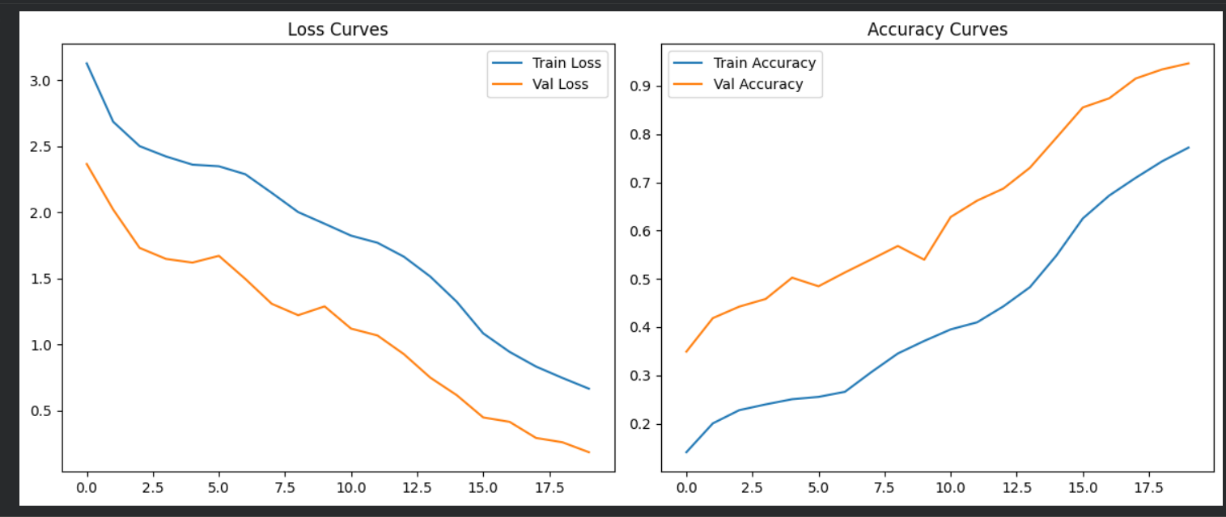

The training process was monitored using loss and accuracy curves for both training and validation sets.
The loss curves show a steady decrease over epochs for both training and validation, indicating that the model is learning effectively. The validation loss remains lower than the training loss, which suggests good generalization and the positive impact of data augmentation.
The accuracy curves demonstrate a consistent improvement over time. Validation accuracy is higher than training accuracy, further confirming that the model is not overfitting and generalizes well to unseen data.
Overall, the model shows stable convergence and good performance without signs of overfitting.
Optimizer Comparison
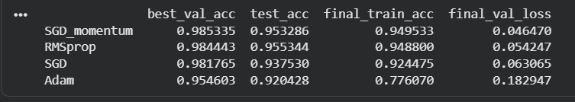 To evaluate the impact of different optimization algorithms, multiple optimizers were tested including SGD, SGD with momentum, Adam, and RMSprop. Each optimizer was applied to the same CNN architecture under identical training conditions to ensure a fair comparison.
The results indicate that RMSprop achieved the highest test accuracy (0.955), followed closely by SGD with momentum (0.953). SGD with momentum also achieved the highest validation accuracy (0.985) and the lowest validation loss (0.046), indicating strong performance and stable convergence.
Standard SGD showed slightly lower performance, while Adam achieved the lowest results among all optimizers, with reduced accuracy and slower convergence.
Overall, RMSprop demonstrated the best generalization on unseen data, while SGD with momentum provided the most stable training behavior. Based on these findings, SGD with momentum was selected as the base optimizer for further scheduler comparison.

Autoencoder for Image Denoising
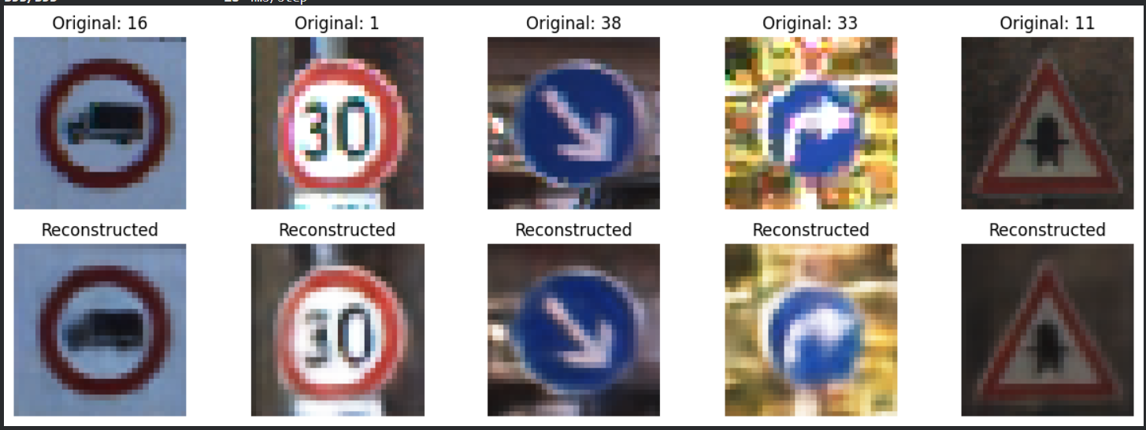
To improve image quality and reduce noise, a convolutional autoencoder was implemented. The model follows an encoder-decoder architecture, where the encoder compresses the input image into a lower-dimensional representation, and the decoder reconstructs the image back to its original size.
The encoder consists of multiple convolutional and max-pooling layers that progressively reduce the spatial dimensions from 32×32 to 4×4 while increasing feature depth. The decoder uses transposed convolution layers (Conv2DTranspose) to upsample the feature maps and reconstruct the image.
The model was trained using the Mean Squared Error (MSE) loss function, which measures the difference between the original and reconstructed images. Early stopping was applied to prevent overfitting.
Results show that the autoencoder successfully reconstructs traffic sign images with reduced noise while preserving important visual features such as shapes and colors. However, some fine details are slightly blurred due to the compression process.
Additionally, the reconstructed (denoised) images were used as inputs for further model training, providing cleaner data and improving robustness.
Transfer Learning using VGG16
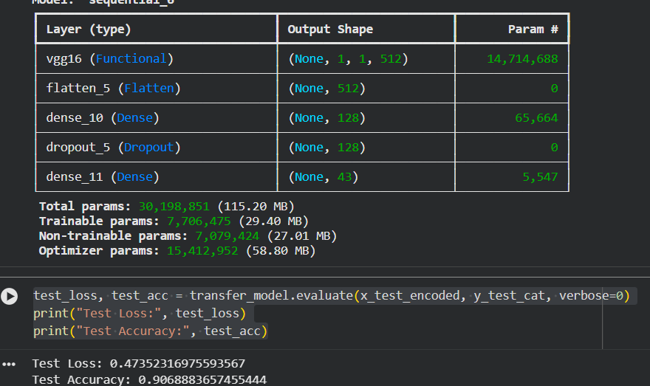
To further enhance model performance, transfer learning was applied using the VGG16 architecture pre-trained on the ImageNet dataset. The convolutional base of VGG16 was used as a feature extractor, with the top classification layers removed (include_top=False).
To adapt the model to the traffic sign classification task, a custom classifier was added on top, consisting of a flatten layer followed by a fully connected layer with ReLU activation, dropout for regularization, and a final softmax layer for multi-class classification.
The model was partially fine-tuned by unfreezing the last few layers of the VGG16 base while keeping the earlier layers frozen. This allows the model to retain general visual features while adapting higher-level representations to the target dataset.
The model was trained on the encoded (denoised) images generated by the autoencoder, which helped improve input quality and reduce noise effects. Early stopping was applied to prevent overfitting.
The transfer learning model achieved a test accuracy of approximately 90.7%, demonstrating strong performance. However, its accuracy was slightly lower than the custom CNN model, likely due to the small input size (32×32) and domain differences between ImageNet and traffic sign data.
Overall, transfer learning proved effective in leveraging pre-trained knowledge, but performance can be further improved by using higher-resolution inputs or more suitable architectures such as MobileNet.

Final Comparison Table: Optimizer vs Scheduler
Category | Method | Best Val Accuracy | Test Accuracy | Final Train Accuracy | Final Val Loss | Key Insight
Optimizer | SGD | 0.9818 | 0.9375 | 0.9245 | 0.0631 | Baseline performance, stable but slightly lower accuracy
Optimizer | SGD + Momentum | 0.9853 | 0.9533 | 0.9495 | 0.0465 | Best stability and lowest validation loss
Optimizer | RMSprop | 0.9844 | 0.9553 | 0.9488 | 0.0542 | Best generalization (highest test accuracy)
Optimizer | Adam | 0.9546 | 0.9204 | 0.7761 | 0.1829 | Weakest performance, slower convergence
Scheduler | StepLR | — | — | — | — | Gradual learning rate decay, stable improvements
Scheduler | ReduceLROnPlateau | — | — | — | — | Adapts to validation loss, improves convergence efficiency
Scheduler | CosineAnnealingLR | — | — | — | — | Smooth learning rate transitions, often improves generalization
To evaluate training performance, both optimization algorithms and learning rate schedulers were analyzed. Among the optimizers, RMSprop achieved the highest test accuracy, indicating superior generalization, while SGD with momentum demonstrated the most stable training behavior, achieving the highest validation accuracy and lowest validation loss. In contrast, Adam showed comparatively weaker performance with slower convergence.
For learning rate schedulers, techniques such as StepLR, ReduceLROnPlateau, and CosineAnnealingLR were considered. These methods help improve convergence by dynamically adjusting the learning rate during training, with adaptive schedulers generally providing better performance in later training stages.
Overall, SGD with momentum was selected as the base optimizer due to its stability, while schedulers were applied to further enhance convergence and generalization.

