Egypt EconLens
Economic Intelligence & Supply Chain Analytics Platform

Final Project Documentation

Document Structure
- 1. Executive Summary
- 2. Business Problem and Project Objectives
- 3. Full Solution Architecture
- 4. Core Stack and Technology Layers
- 5.Data Sources And SSIS ETL
- 6.Supply Chain Generated Data Handling
- 7.DWH
- 8. Fabric Warehouse Migration and Copy Job Evidence
- 9. Power BI Reporting Layer, Workspace Lineage, Semantic Model and Measures
- 10. Dashboards and Paginated Reports
- 11. Egypt EconLens Web App Interface
- 12. AI Copilot / AI Assistant
- 13. Power Automate Automation Flows
- 14. SharePoint Integration
- 15. Azure Deployment and CI/CD
- 16. Security and Governance
- 17. Testing Scenarios
- 18. Challenges and Fixes
- 19. Future Enhancements
- 20. Final Conclusion

1. Executive Summary
Egypt EconLens is an end-to-end Business Intelligence platform designed to provide economic, trade, procurement-risk and supply-chain intelligence through a unified analytical environment. The project combines data engineering, Power BI reporting, a Flask web application, an AI Copilot, Power Automate automation, SharePoint state management and Azure App Service deployment.
The platform enables users to explore interactive dashboards, open paginated reports, export PDF reports by email, subscribe to update notifications and ask business questions in natural language without writing SQL.
Capability | Description
Data engineering | Raw/generated data is transformed through SSIS and SQL logic into a governed Data Warehouse.
Reporting | Power BI dashboards and RDL paginated reports provide interactive and printable analytics.
Web access | A Flask web application embeds the Power BI assets inside a unified portal.
AI analytics | The AI assistant translates natural language into validated SQL, insights, tables and charts.
Automation | Power Automate exports reports, sends emails, tracks changes and manages subscribers.
Cloud deployment | Azure App Service hosts the application with GitHub Actions and Managed Identity.

2. Business Problem and Project Objectives
The project addresses the gap between raw economic data and decision-ready intelligence. Trade, macroeconomic, procurement-risk and supply-chain data are often scattered across sources, making it difficult to combine them into one reliable decision platform.
Problem Area | Impact | Project Response
Scattered data sources | Difficult to combine trade, macro and supply-chain context. | Centralised SQL Server / Fabric Data Warehouse.
Manual reporting | Reports require repeated export and sharing work. | Power Automate report export and email delivery.
Limited self-service analytics | Non-technical users cannot write SQL or DAX. | AI Copilot for natural-language analysis.
Report update visibility | Users do not know when reports are added or modified. | Subscriber list and scheduled notification flow.
Cloud authentication complexity | Fabric and Azure require secure authentication. | Managed Identity and Azure environment variables.

Project Objectives
- Support procurement, supply-chain, trade-analysis and executive decision-making.
- Provide trusted Power BI reporting from curated DWH views.
- Allow users to access PBIX dashboards and RDL paginated reports from one interface.
- Automate PDF export and report update notifications.
- Enable natural-language analytics in English and Arabic using a governed AI-to-SQL pipeline.

3. Full Solution Architecture
The solution follows a layered architecture: data sources feed ETL and warehouse layers; reporting is built in Power BI; the Flask application embeds reports and user actions; AI and automation components extend the reporting layer; Azure hosts and secures the deployment.
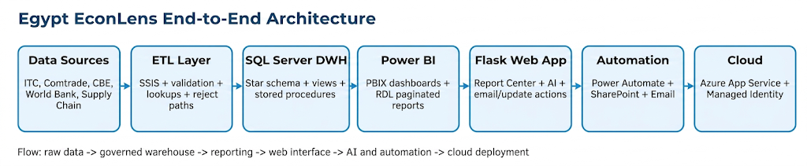
Architecture Diagram - Egypt EconLens end-to-end solution flow.
Layer | Main Components | Role
Data sources | Trade Map, UN Comtrade, CBE, World Bank, generated supply chain, social/video signals | Provide raw and reference data.
ETL | SSIS packages, lookups, derived columns, reject handling | Clean, transform and load data.
DWH | SQL Server/Fabric Warehouse, views, stored procedures | Governed analytical model.
Reporting | Power BI Desktop, Power BI Service, RDL reports | Dashboards and printable reports.
Web app | Flask, HTML, CSS, JavaScript | Unified user interface.
AI | OpenRouter, prompt builder, schema retriever, SQL validator | Natural-language analytics.
Automation | Power Automate, SharePoint, email | Exporting, tracking and notifications.
Cloud | Azure App Service, GitHub Actions, Managed Identity | Hosting and secure access.

4. Core Stack and Technology Layers
The project began as a traditional BI architecture and evolved into a complete cloud-hosted analytics platform. The original stack is shown below.

Core Stack - original technology stack defined at the beginning of the project.
Stack Area | Implemented Technology
Data Sources | ITC Trade Map, UN Comtrade, CBE exchange rates, World Bank API, generated supply-chain data, social/video media data.
ETL Layer | SQL Server Integration Services (SSIS), Python support scripts, lookup mapping, validation and reject handling.
Database / DWH | Microsoft SQL Server / Fabric Warehouse star schema, facts, dimensions, bridge table, views and stored procedures.
Reporting | Power BI Desktop, Power BI Service, PBIX dashboards, RDL paginated reports.
Web Application | Flask backend, HTML/CSS/JavaScript front-end and custom responsive UI.
AI Layer | OpenRouter API, prompt_builder.py, schema_retriever.py, sql_validator.py, sqlglot validation and chart-ready JSON.
Automation | Power Automate flows, SharePoint lists, email notifications and report export logic.
Deployment | Azure App Service Linux, Python 3.11, Gunicorn, GitHub Actions and Azure Deployment Center.

5. Original Data Sources, SSIS ETL and DWH
Important note: the following Data Sources, DWH and SSIS ETL section is inserted directly from the reference file EgyptBI_DWH_Documentation.docx. It is intentionally kept as the detailed original reference for the warehouse and ETL stage.
1. Executive Overview
The Egyptian Supply Chain & Procurement BI Platform integrates Egypt trade-flow data, generated supply-chain operational records, product and commodity classifications, country attributes, date intelligence, and Egypt macroeconomic indicators into a governed SQL Server Data Warehouse.
This documentation covers the project only up to the Data Warehouse stage. It explains the business purpose, source data, ETL design, warehouse model, integrity strategy, and technical strengths before Power BI visualization.

2. Business Target
- Support procurement, supply-chain, trade-analysis, and executive decision-making.
- Combine trade flows with operational supply-chain performance and macroeconomic context.
- Provide a governed source for trusted Power BI reporting instead of relying on scattered raw files.
- Keep the generated supply-chain data transparent using an explicit is_synthetic flag.

3. Source Data Scope
Source Area | Example Content | DWH Role
Trade data | Import/export records, partner country, HS commodity, trade value | fact_trade_flows
Generated supply-chain OLTP | Orders, order lines, shipments, statuses, product references | fact_supply_chain
Product master | Product name, category, department, price | dim_product
Country reference | Country name, region, income group, Egypt flag | dim_country
Commodity reference | HS code, description, category, strategic flag | dim_commodity
Egypt macro data | USD/EGP, GDP, GDP growth, inflation, reserves | dim_egypt_macro
Calendar data | Year, quarter, month, fiscal year, crisis flag | dim_date

4. End-to-End Pipeline
The project follows a layered flow from raw and generated sources through ETL, staging/cleansing, SQL Server DWH tables, and curated views consumed by the Power BI semantic model.
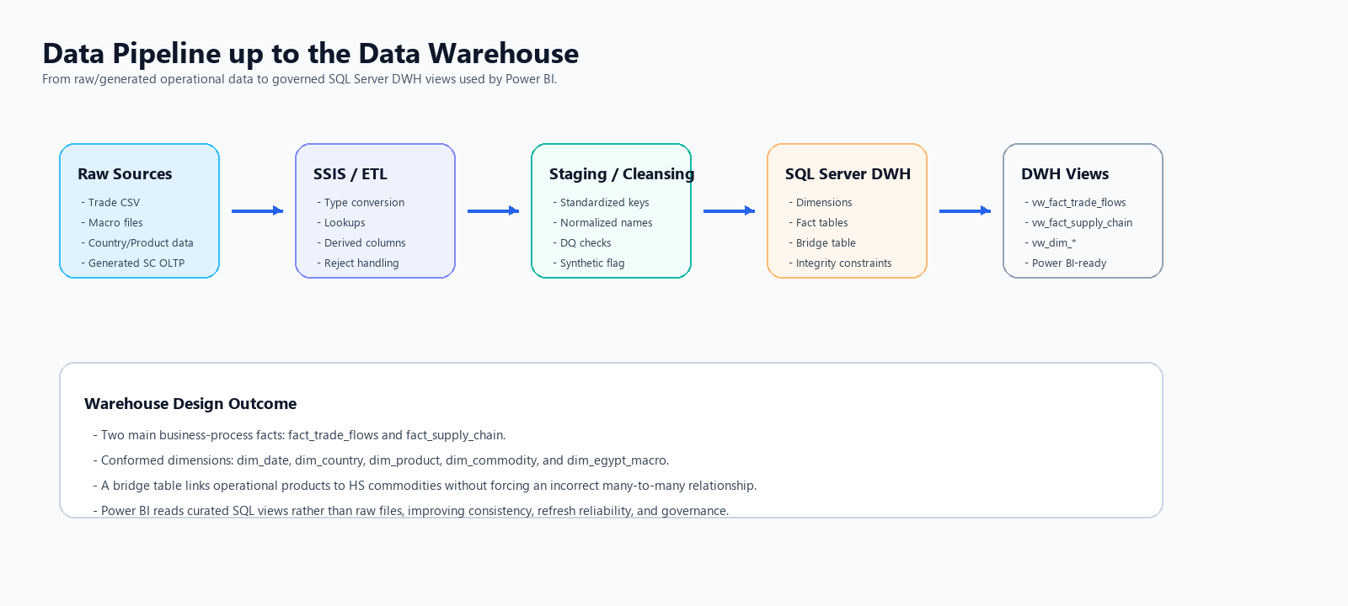
Figure 1. Data pipeline up to the Data Warehouse layer.

5. ETL and Data Loading Strategy
The ETL layer is responsible for reading raw/generated records, converting data types, resolving keys through lookups, deriving operational fields, redirecting invalid rows, and loading final DWH structures.
- Lookups resolve date_key, product_key, country_key, commodity_key, and macro_key.
- Derived columns calculate shipping_delay_days, late-delivery status, and synthetic-data flags.
- Conditional splits and reject outputs protect the warehouse from invalid or unmatched records.
- Power BI reads curated warehouse views rather than raw files.
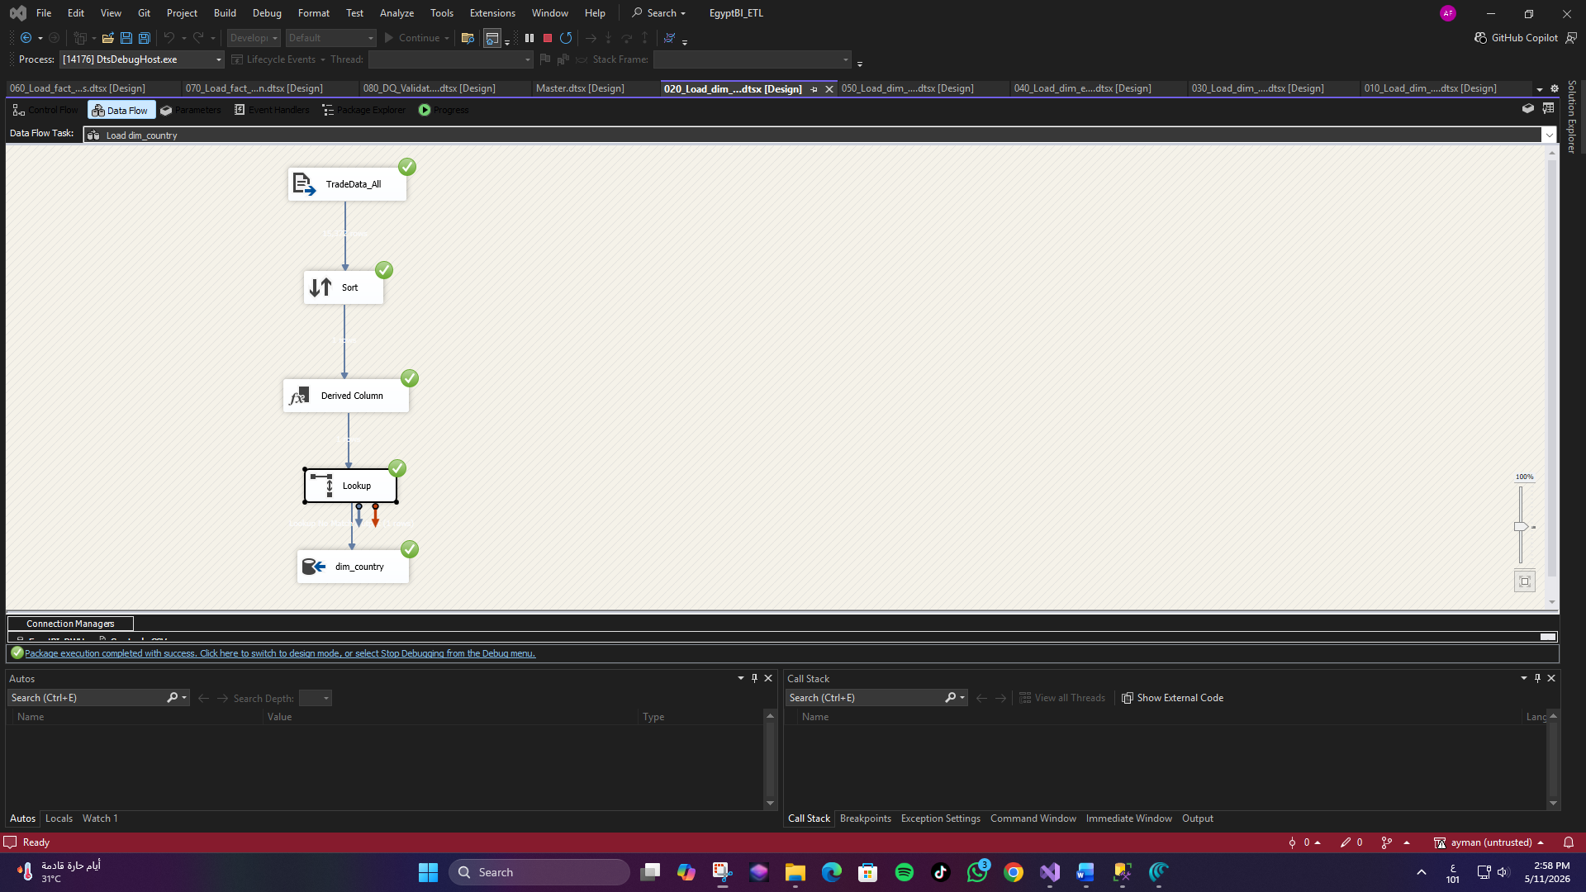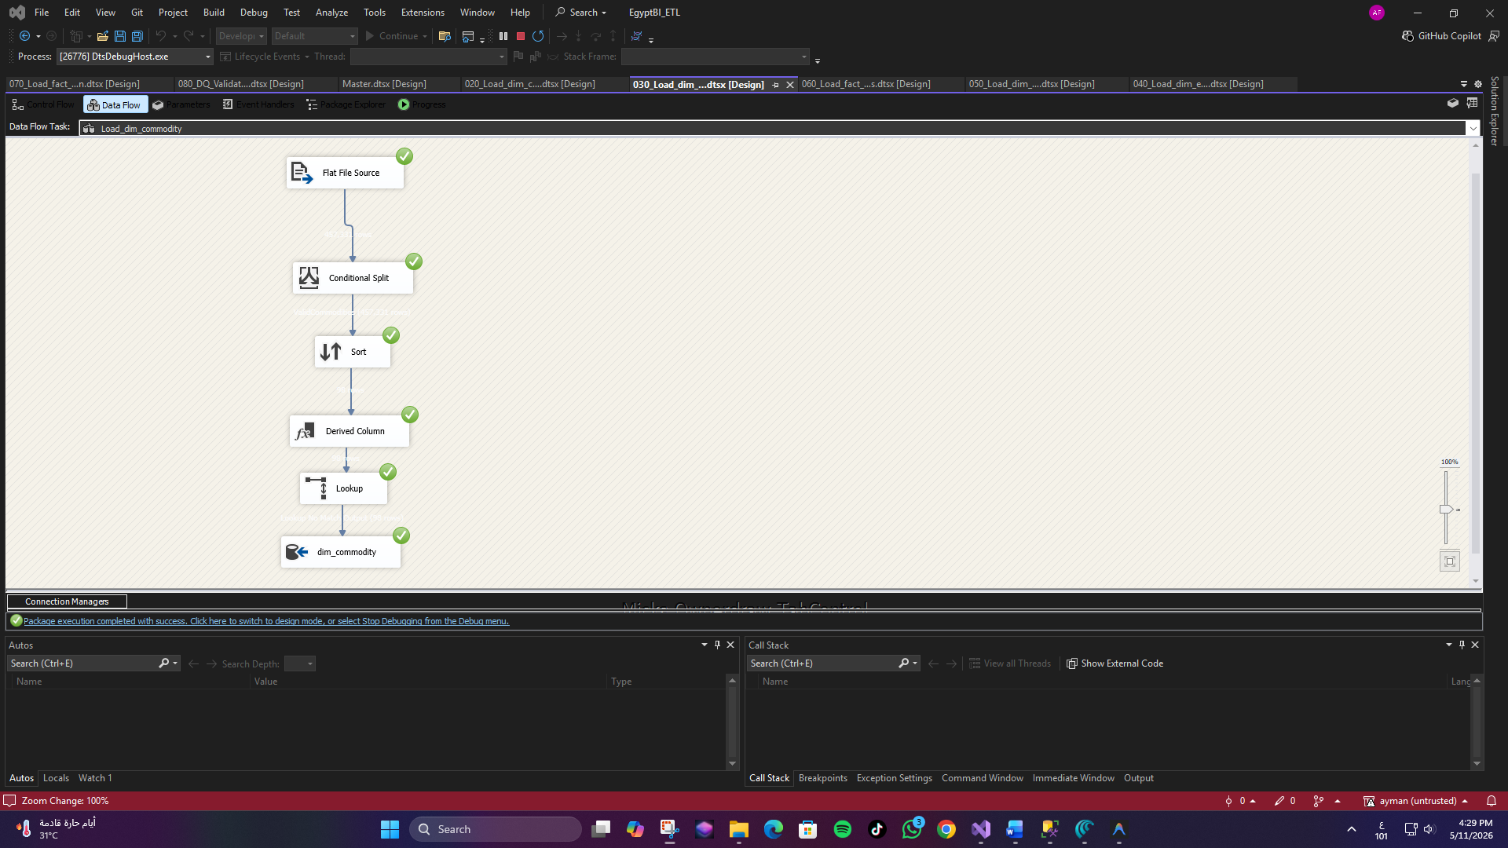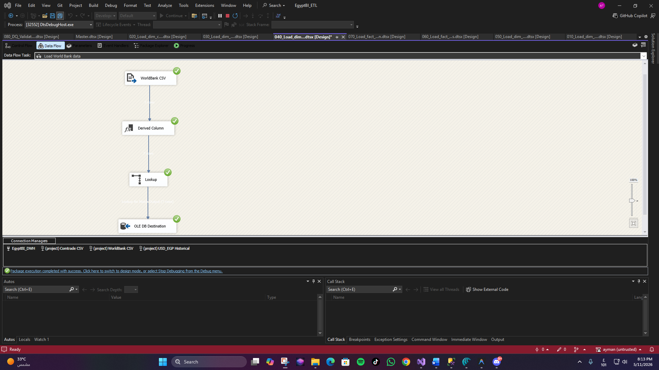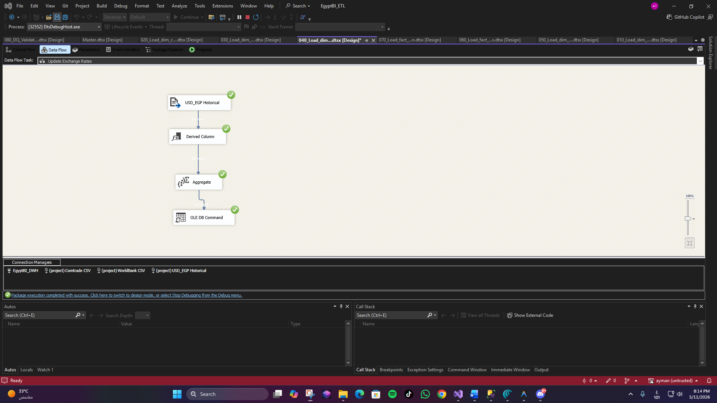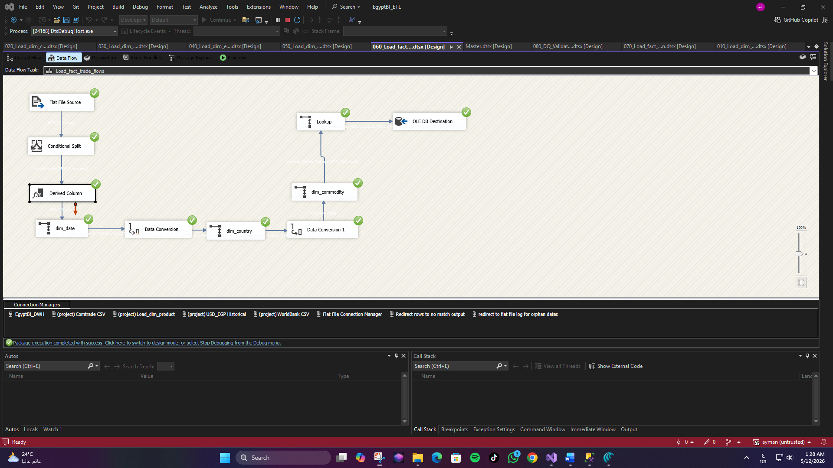
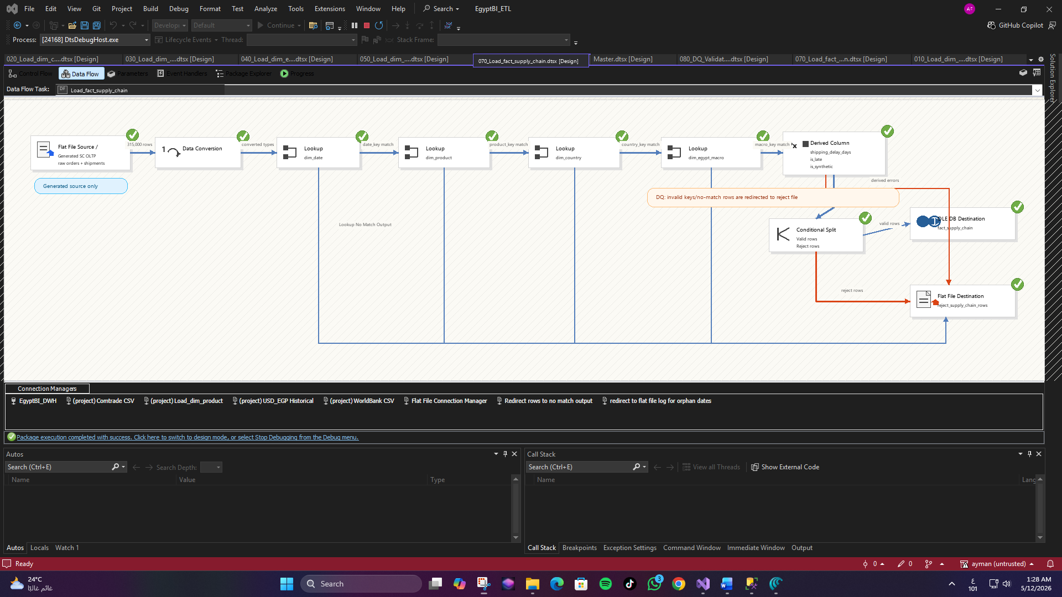
Figure 2. SSIS-style data flow for loading fact_supply_chain.

6. Supply Chain Generated Data Handling
The supply-chain operational layer is generated, but it is handled as a realistic OLTP-style source rather than being inserted directly into analytics. The ETL maps orders, products, countries, dates, and macro periods into controlled DWH keys.
- The generated source is clearly marked through fact_supply_chain[is_synthetic].
- Generated records are still validated through the same lookup and reject-handling flow.
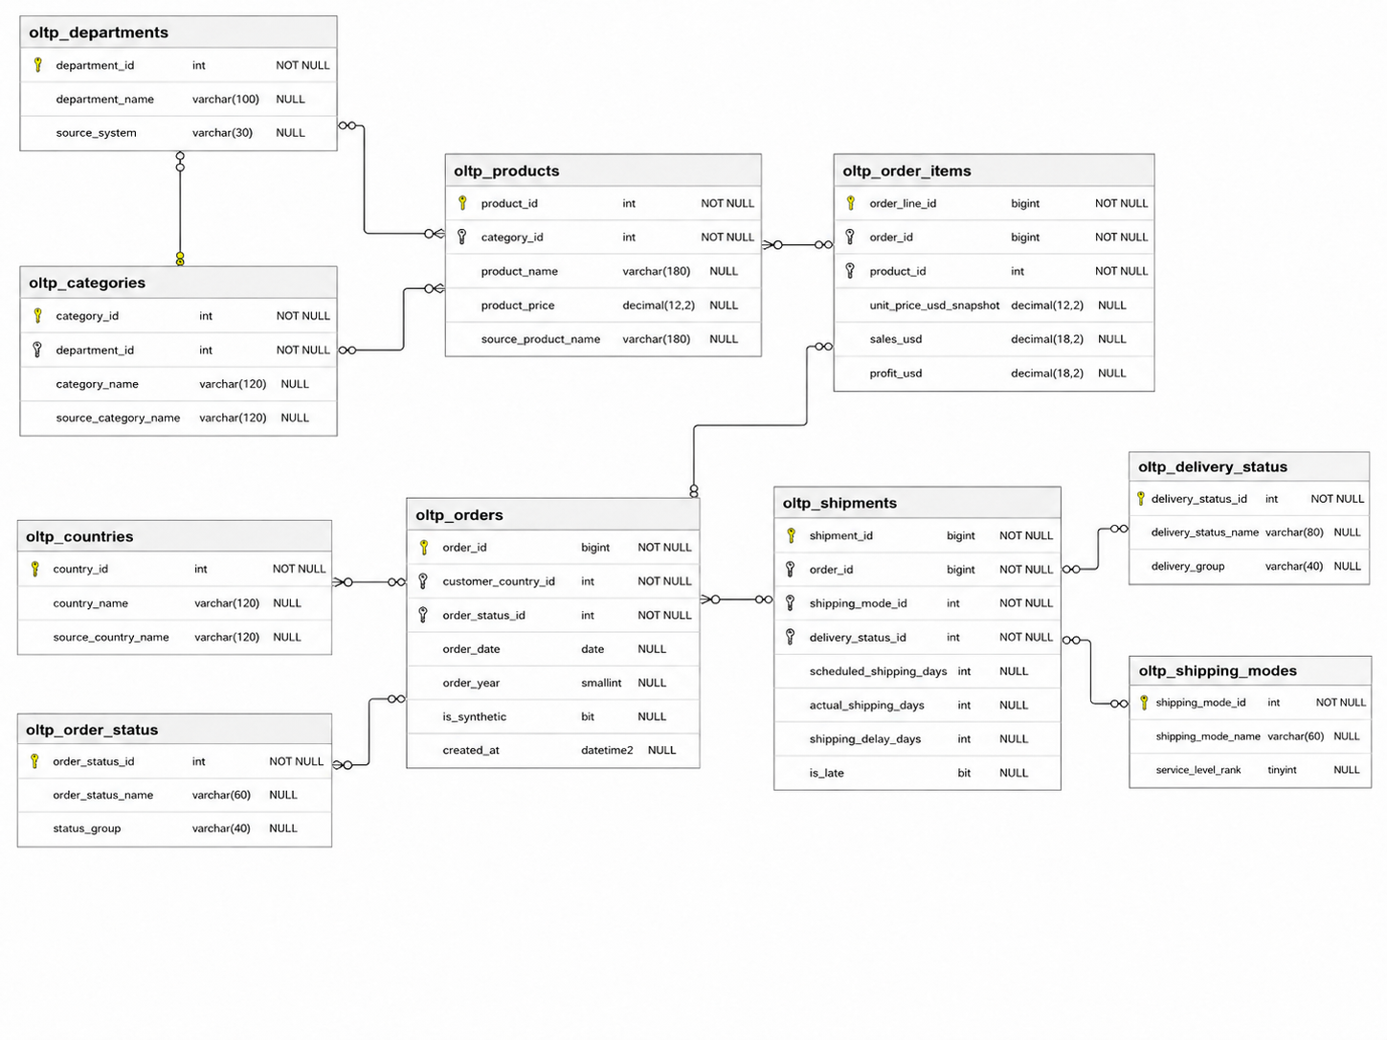
The final fact table is connected to real analytical dimensions and can be used for operational KPI analysis.

T

Figure 3. Logical

7. Data Warehouse Logical Design
he warehouse uses a star-schema-oriented model with two central fact tables, conformed dimensions, a bridge table for product-to-commodity mapping, and macroeconomic context.

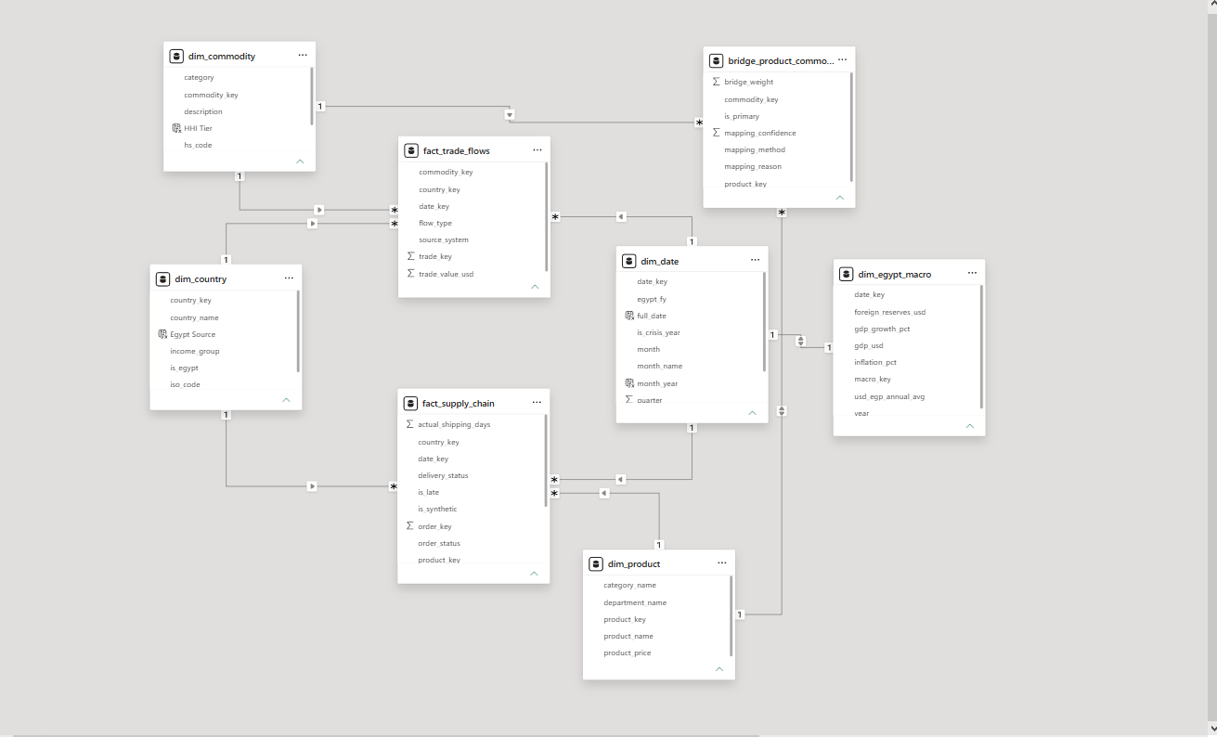

DWH schema used before the Power BI reporting layer.

7.1. Fact Tables
Fact Table | Grain | Main Analytical Use
fact_trade_flows | One trade-flow record by period, country, commodity, and flow type | Imports, exports, trade balance, partner exposure, commodity analysis
fact_supply_chain | One generated supply-chain order/fulfillment record | Sales, profit, OTIF, delay, late delivery, status monitoring, product performance

7.2. Dimensions and Bridge
Object | Purpose | Key Fields
dim_date | Time intelligence and crisis-year context | date_key, year, quarter, month, egypt_fy, is_crisis_year
dim_country | Partner geography and segmentation | country_key, country_name, region, income_group
dim_commodity | HS commodity analysis | commodity_key, hs_code, category, is_strategic
dim_product | Operational product hierarchy | product_key, product_name, category_name, product_price
dim_egypt_macro | Macroeconomic context | macro_key, date_key, usd_egp, inflation, gdp, reserves
bridge_product_commodity | Connect products to HS commodities | product_key, commodity_key, bridge_weight, mapping_confidence

7.3. Core Relationships
Relationship | Business Meaning
dim_date -> both facts | Analyze trade and operations by time
dim_country -> both facts | Analyze trade and operations by partner geography
dim_commodity -> fact_trade_flows | Analyze trade by HS commodity
dim_product -> fact_supply_chain | Analyze operations by product
dim_egypt_macro -> both facts | Attach economic context to trade and operational periods
dim_product -> bridge -> dim_commodity | Map operational products to strategic commodity groups

7.4. DWH Views Exposed to Power BI
View | Purpose
vw_fact_trade_flows | Power BI-ready trade fact
vw_fact_supply_chain | Power BI-ready supply-chain fact
vw_dim_country / vw_dim_product / vw_dim_commodity | Conformed reporting dimensions
vw_dim_egypt_macro | Macroeconomic context dimension
vw_bridge_product_commodity | Product-to-commodity analytical bridge

7.5. Current DWH Volume and Coverage
Object | Rows
vw_fact_trade_flows | 522,567
vw_fact_supply_chain | 315,000
vw_dim_product | 19,461
vw_bridge_product_commodity | 19,461
vw_dim_country | 203
vw_dim_commodity | 97
vw_dim_egypt_macro | 84
dim_date | 84

Date coverage across the main facts and macro/date dimensions is 201901 to 202512.

7.6. Data Quality and Integrity
- Dimension keys are unique and used as controlled join points.
- Fact rows are checked for orphan date, country, product, commodity, and macro keys.
- The bridge table avoids duplicate product/commodity mappings.
- ETL reject paths handle invalid or unmatched rows before they reach the DWH.
- Generated supply-chain records remain auditable through the is_synthetic field.

7.7. Technical Strengths
- Clear separation between raw/generated data, ETL, DWH, and reporting layers.
- Two fact tables preserve different business grains instead of forcing unrelated processes into one table.
- Macro indicators are modeled as a dimension and connected to both facts through macro_key.
- The bridge table solves a real product-to-HS commodity mapping problem.
- Curated views stabilize the Power BI semantic model and reduce report dependency on raw source structure.
- The generated supply-chain layer is transparent, documented, and traceable.
7.8. Stored Procedures Layer Documentation
This section documents the SQL Server stored procedures contained in stored_procedures_FIXED.sql. The procedure layer acts as a controlled SQL interface over EgyptBI_DWH1 for reporting, maintenance, search, and DWH validation.
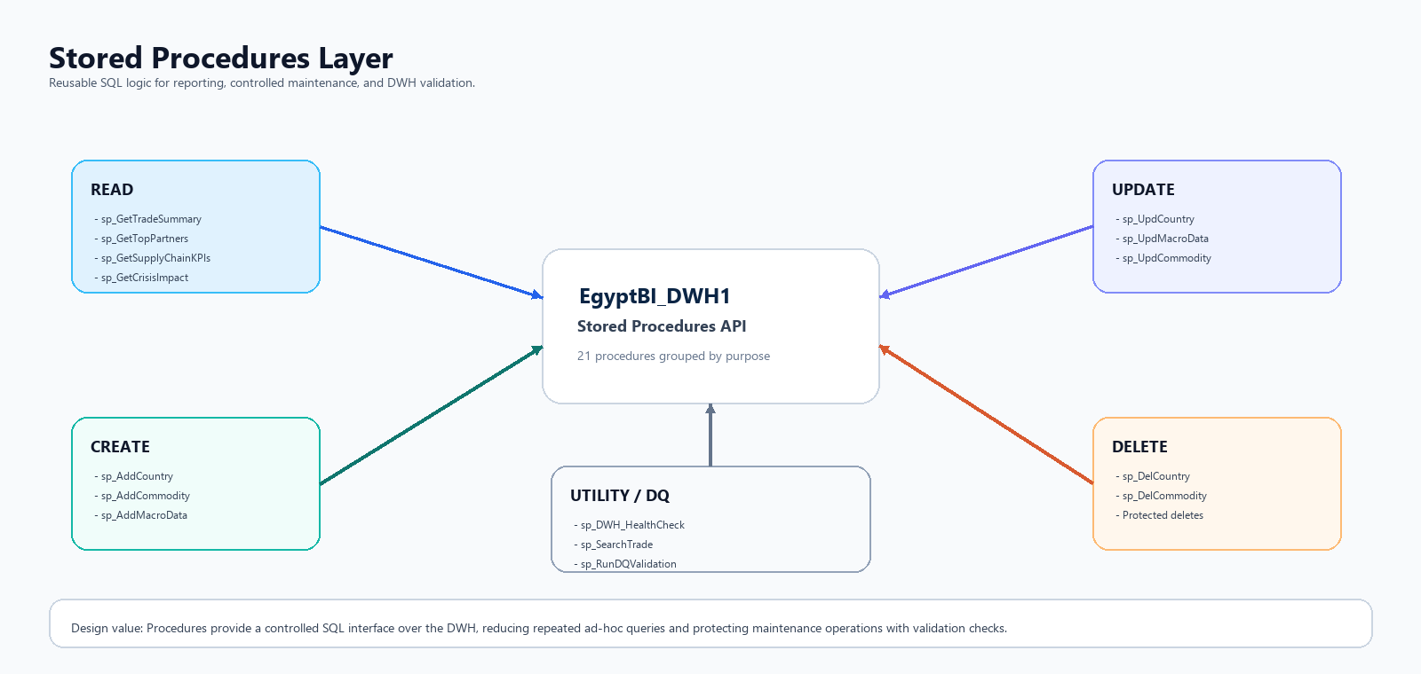
Figure 4. Stored procedure categories and their role in the DWH layer.

7.8.1 Purpose and Scope
- Standardizes recurring analytical queries for trade, macro, and supply-chain analysis.
- Supports controlled CRUD operations for selected dimensions and macro indicators.
- Protects deletes by checking fact-table references before removing dimension records.
- Provides health-check, search, and data-quality validation procedures for operational readiness.
- Creates a database-side foundation for future API, admin-screen, or Text-to-SQL integration.

7.8.2 Procedure Categories
Category | Naming Pattern | Purpose
READ | sp_Get... | Reporting and analytical query procedures
CREATE | sp_Add... | Controlled inserts for dimensions and macro data
UPDATE | sp_Upd... | Controlled updates that preserve unchanged fields
DELETE | sp_Del... | Safe deletes with reference checks
UTILITY / DQ | sp_DWH..., sp_Search..., sp_Run... | Health checks, search, and validation

7.8.3 Procedure Inventory
Procedure | Type | Parameters | Business Purpose
sp_GetTradeSummary | READ | @year | Monthly/yearly trade records by flow type, record count, and total trade value.
sp_GetTradeBalance | READ | None | Annual exports, imports, trade balance, and surplus/deficit status.
sp_GetTopPartners | READ | @flow, @year, @top | Top partner countries by trade value for imports or exports.
sp_GetTopCommodities | READ | @flow, @year, @top | Top HS commodities by trade value, including strategic flag.
sp_GetMacroIndicators | READ | @year | Annual macro indicators aggregated from monthly macro rows.
sp_GetMacroMonthly | READ | @year | Monthly macro indicators using the full 84-row date granularity.
sp_GetSupplyChainKPIs | READ | @year, @month | Orders, delivered orders, sales, profit, margin, delay, OTIF, and late rate.
sp_GetProductPerformance | READ | @year, @top | Product ranking by sales, profit, margin, order count, and late delivery rate.
sp_GetShippingAnalysis | READ | @year | Shipping-mode performance by share, days, delay, late percent, and sales.
sp_GetCrisisImpact | READ | None | Compares trade and supply-chain behavior between crisis and normal periods.
sp_AddCountry | CREATE | @name, @iso, @region, @income_group, @is_egypt, @gdp, @population | Adds a new country only if it does not already exist.
sp_AddCommodity | CREATE | @hs, @desc, @category, @strategic | Adds a new HS commodity only if the HS code does not already exist.
sp_AddMacroData | CREATE | @year, @month, @usd_egp, @gdp_usd, @gdp_growth, @inflation, @reserves | Adds one macro row after validating that the date key exists.
sp_UpdCountry | UPDATE | @name plus optional attrs | Updates country metadata while preserving unchanged fields through ISNULL.
sp_UpdMacroData | UPDATE | @year, @month plus optional indicators | Updates macro indicators for an existing year/month row.
sp_UpdCommodity | UPDATE | @hs, @category, @strategic | Updates commodity category and strategic classification.
sp_DelCountry | DELETE | @name | Deletes a country only when it is not referenced by trade or supply-chain facts.
sp_DelCommodity | DELETE | @hs | Deletes a commodity only when it is not referenced by fact_trade_flows.
sp_DWH_HealthCheck | UTILITY | None | Returns row counts for core DWH tables and expected-count hints.
sp_SearchTrade | UTILITY | @keyword, @year, @flow | Keyword search across trade data, countries, HS codes, and commodity descriptions.
sp_RunDQValidation | UTILITY | None | Rebuilds dq_validation_log with row-count, value-sum, and FK-integrity checks.

7.8.4 Reporting Procedures
The reporting procedures expose common DWH analysis directly from SQL Server. They are useful for validation, SSMS demos, API-style access, and comparison with Power BI measures.
- Trade reporting: sp_GetTradeSummary, sp_GetTradeBalance, sp_GetTopPartners, and sp_GetTopCommodities.
- Macro reporting: sp_GetMacroIndicators and sp_GetMacroMonthly.
- Supply-chain reporting: sp_GetSupplyChainKPIs, sp_GetProductPerformance, and sp_GetShippingAnalysis.
- Crisis comparison: sp_GetCrisisImpact compares normal and crisis periods across the trade and supply-chain layers.

7.8.5 CRUD and Maintenance Procedures
- sp_AddCountry, sp_AddCommodity, and sp_AddMacroData validate duplicates or date keys before inserting new records.
- sp_UpdCountry, sp_UpdMacroData, and sp_UpdCommodity support controlled updates while preserving unchanged attributes.
- sp_DelCountry and sp_DelCommodity refuse deletion when records are referenced by fact tables.

7.8.6 Utility and Data Quality Procedures
Procedure | Role
sp_DWH_HealthCheck | Returns row counts for core DWH tables and expected-count hints.
sp_SearchTrade | Searches trade records by keyword, year, and flow type.
sp_RunDQValidation | Rebuilds dq_validation_log using row-count, value-sum, and FK-integrity checks.

7.8.7 Important Fixes in stored_procedures_FIXED.sql
Fix Area | Description
Removed qty_kg references | Comtrade HS2 qty_kg is always null, so related outputs were cleaned.
Macro aggregation | sp_GetMacroIndicators aggregates monthly macro rows to annual indicators.
OTIF logic | sp_GetSupplyChainKPIs includes CLOSED as delivered and uses delivered orders as denominator.
DQ validation | sp_RunDQValidation clears the log and runs real checks.
Country insert order | sp_AddCountry column order was aligned with the actual schema.

7.8.8 Example Usage
EXEC sp_GetTradeSummary @year = 2023;
EXEC sp_GetTopPartners @flow = 'X', @year = 2023, @top = 10;
EXEC sp_GetTopCommodities @flow = 'M', @year = 2022, @top = 10;
EXEC sp_GetMacroIndicators @year = 2023;
EXEC sp_GetSupplyChainKPIs @year = 2024;
EXEC sp_GetProductPerformance @year = 2024, @top = 20;
EXEC sp_DWH_HealthCheck;
EXEC sp_SearchTrade @keyword = N'wheat', @year = 2022;
EXEC sp_RunDQValidation;

7.8.9 Design Strengths
- Encapsulates common DWH logic in reusable SQL objects.
- Supports both trade analytics and supply-chain performance analysis.
- Protects dimension maintenance through duplicate checks and safe-delete rules.
- Makes DWH validation repeatable through sp_RunDQValidation.
- Provides a SQL validation layer that can be compared against Power BI DAX results.
- Creates a foundation for future API access, Text-to-SQL, or admin screens.

7.8.10 Discussion Summary
The stored procedures layer strengthens the project by turning common DWH queries, maintenance tasks, and validation checks into reusable database operations. It demonstrates that the project is not only a Power BI report, but a more complete BI platform with database-side governance and operational readiness.

8. Fabric Warehouse Migration and Copy Job Evidence
the cloud-side warehouse migration and copy evidence without modifying the original DWH/SSIS reference section above. These screenshots show the practical deployment and data movement work after the local SQL Server DWH stage.
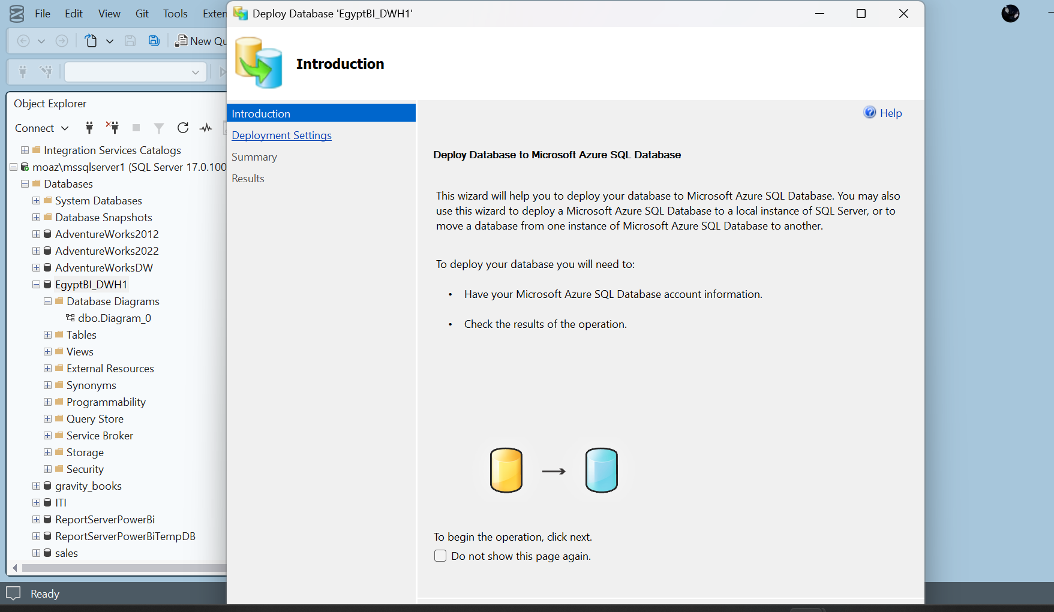
6A.1 SSMS - Deploy Database wizard for EgyptBI_DWH1.
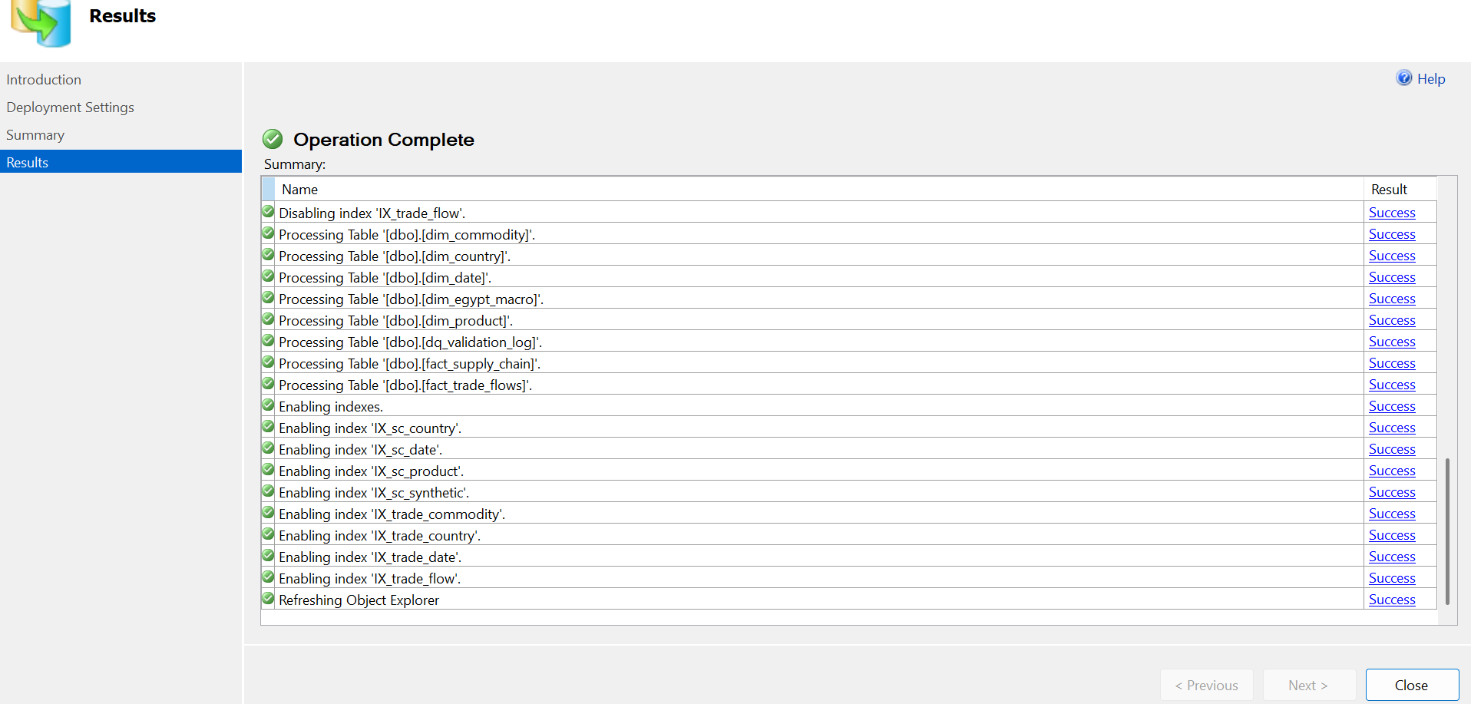
6A.2 SSMS - Deployment operation completed successfully for DWH objects and indexes.
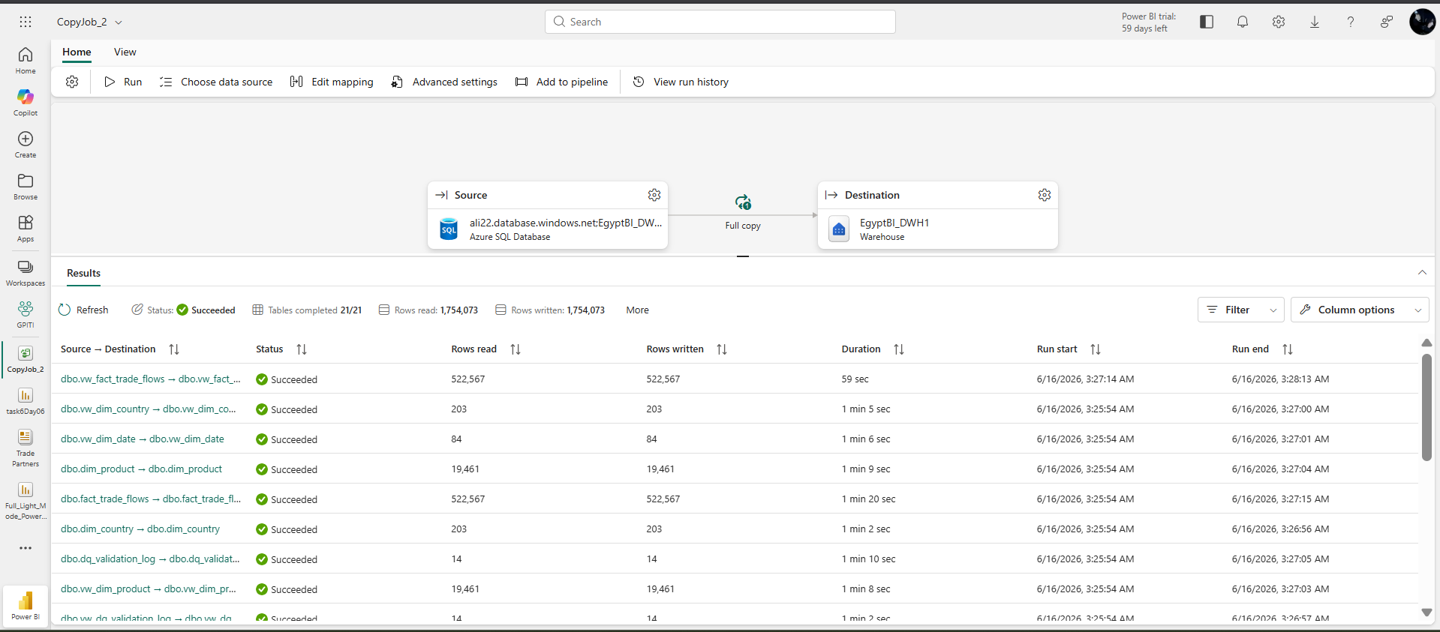
6A.3 Microsoft Fabric Copy Job - full copy from Azure SQL Database to EgyptBI_DWH1 Warehouse.
The Fabric copy job confirms that warehouse objects and reporting views were moved into the Fabric workspace successfully. The run shows completed tables, rows read and rows written, including major objects such as vw_fact_trade_flows, dim_country, dim_date and dim_product.
9. Power BI Reporting Layer, Workspace Lineage, Semantic Model and Measures
The reporting layer is built using Power BI Desktop and Power BI Service. It contains one interactive PBIX dashboard and several paginated RDL reports. The PBIX dashboard supports exploration and visual analysis; the RDL reports support structured printable outputs and PDF export.
Report Type | Purpose | Usage in the App
PBIX dashboard | Interactive analysis with visuals, filters and dashboard tabs. | Embedded in the main viewer and accessed from the Report Center.
RDL paginated report | Printable tabular reports with export parameters. | Embedded in the same viewer and exported through Power Automate.
Power BI workspace | Hosts reports, semantic model, warehouse connections and refresh state. | Provides report URLs and metadata consumed by the Flask app and automation flows.

9.1 Power BI Workspace Lineage View
The Power BI/Fabric workspace lineage view shows how the main warehouse, copy job, semantic model and published reports are connected. This screenshot is included to demonstrate the actual reporting pipeline inside the workspace, not only the final embedded web view.
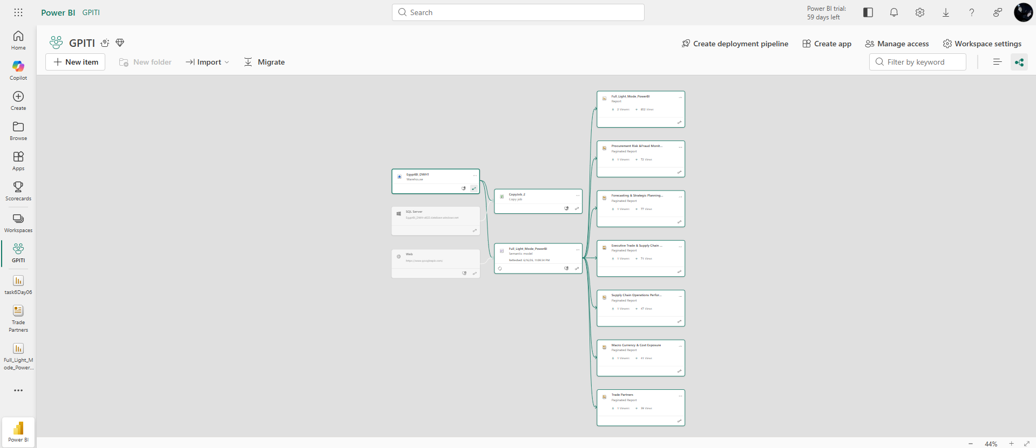
7.1 Power BI Workspace Lineage View - Warehouse, semantic model, copy job and published reports.

9.2 Power BI Desktop Development Work
The screenshots below document the report-building work inside Power BI Desktop. They show report pages, visual design, filters, and the data/fields pane where model tables and measure folders are used to build visuals.
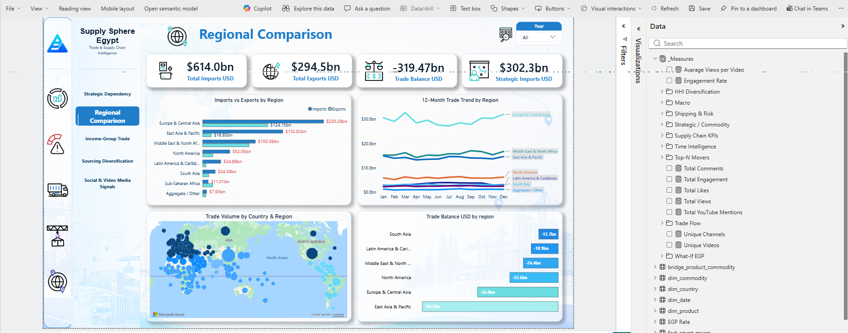
7.2.1 Power BI Desktop - Regional Comparison page with data pane.
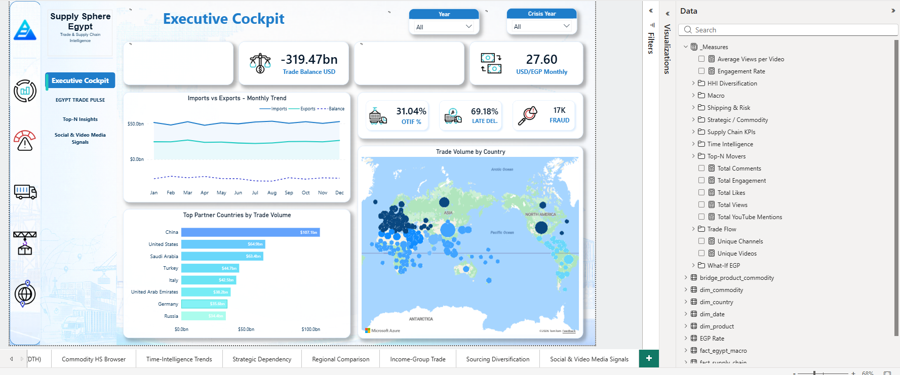
7.2.2 Power BI Desktop - Executive Cockpit page with model fields and measures.
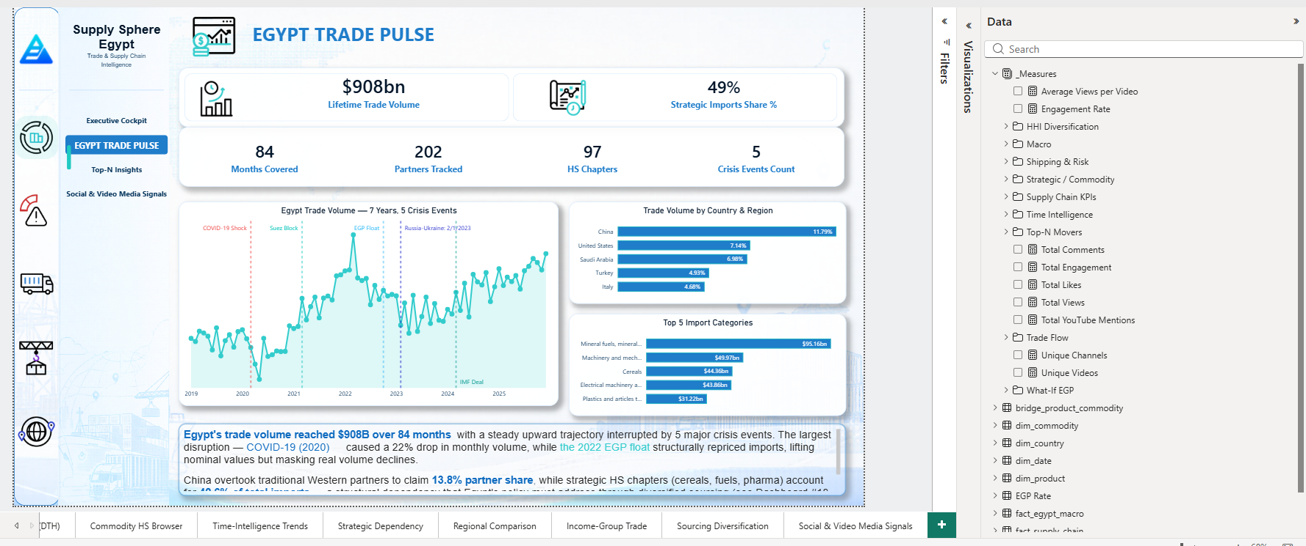
7.2.3 Power BI Desktop - Egypt Trade Pulse page with model fields and measures.

9.3 Power BI Semantic Model and Measures
The semantic model contains conformed DWH tables and a dedicated _Measures table/folder structure. The measure layer converts warehouse columns into reusable analytical calculations used across the dashboards.
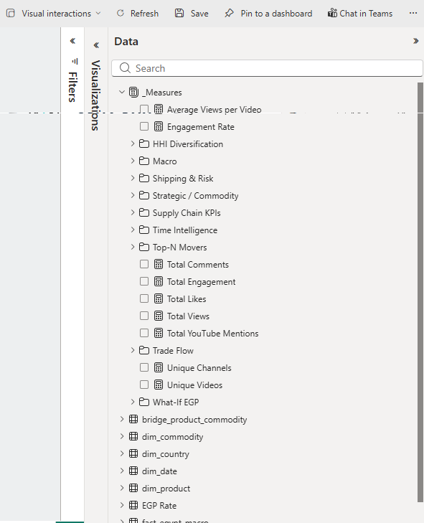
7.3 Power BI Measures and Data Pane - organized measure groups and DWH tables.
Measure / Model Area | Purpose in the Report
Trade Flow | Calculates total imports, exports, trade volume, trade balance and trade contribution KPIs.
Macro | Supports macroeconomic indicators such as GDP, inflation, reserves and exchange-rate context.
Supply Chain KPIs | Calculates orders, completed orders, canceled orders, late orders, sales, profit and margin KPIs.
Shipping & Risk | Supports late-delivery, high-risk, fraud and procurement-risk monitoring.
Strategic / Commodity | Calculates strategic import share and commodity/category-level dependency indicators.
Time Intelligence | Provides year/month analysis and period-based trend calculations.
Top-N Movers | Supports ranking pages and top/bottom partner or commodity analysis.
HHI Diversification | Supports sourcing diversification and dependency concentration analysis.
Social & Video Media | Measures total views, likes, comments, engagement, unique videos and channels.
What-If EGP | Supports scenario analysis for exchange-rate and cost exposure.

Visible measures in the data pane include examples such as Average Views per Video, Engagement Rate, Total Comments, Total Engagement, Total Likes, Total Views, Total YouTube Mentions, Unique Channels and Unique Videos. Visible DWH tables include bridge_product_commodity, dim_commodity, dim_country, dim_date, dim_product, EGP Rate, fact_egypt_macro and the main fact tables.

9.4 Embedded Report Inventory
Report | Type | Main Purpose
Full Light Mode PowerBI Dashboard | PBIX | Main interactive executive and trade analytics dashboard.
Procurement Risk & Fraud Monitoring Report | RDL | Risk, fraud, cancellation and late-order monitoring.
Forecasting & Strategic Planning Report | RDL | Planning and scenario-oriented reporting.
Executive Trade & Supply Chain Summary | RDL | Executive summary of trade and operational KPIs.
Supply Chain Operations Performance | RDL | Operational order, delay, sales and margin performance.
Macro Currency & Cost Exposure | RDL | Currency and macroeconomic exposure analysis.
Trade Partners | RDL | Trade partner performance and comparison.

10. Dashboards and Paginated Reports
The dashboards are organised around business questions such as executive trade performance, risk exposure, macro/currency behavior, strategic dependency, regional comparison and social/video media signals. Paginated reports complement dashboards by offering parameterised, exportable outputs suitable for stakeholders who need static PDF documents.
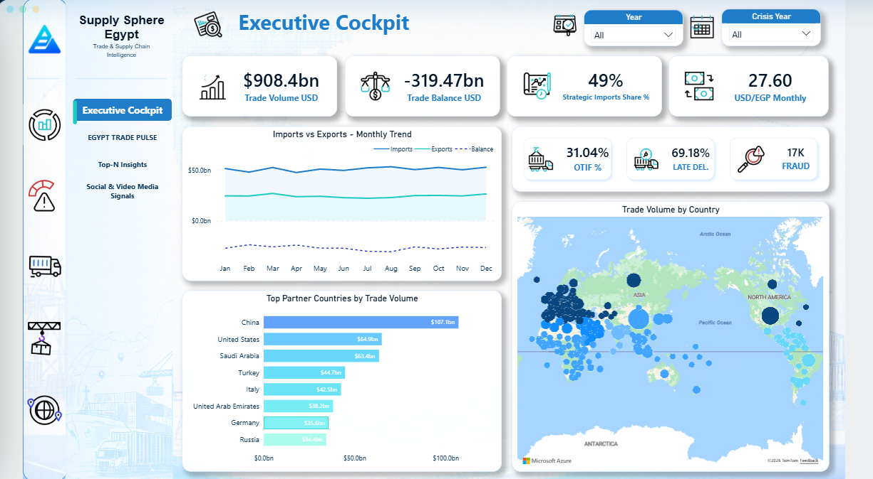
8.1 Example dashboard page - Social & Video Media Signals.
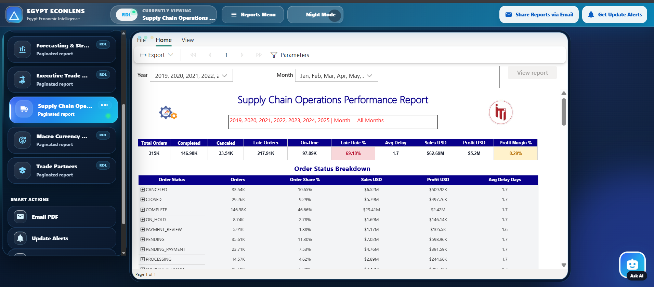
8.2 Example embedded RDL report - Supply Chain Operations Performance.
11. Egypt EconLens Web App Interface
The web application is the unified access point for the project. It wraps embedded Power BI content inside a custom interface and adds operational features such as report sharing, update alerts and the AI assistant.
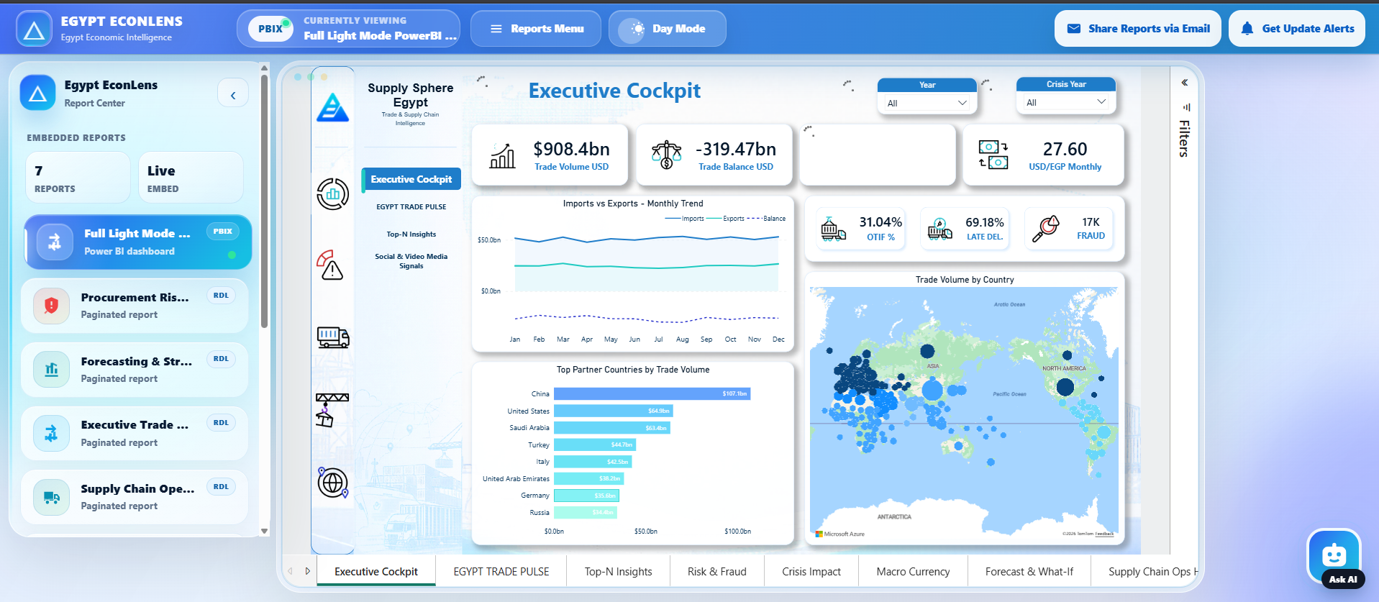
9.1 Web App - Main Interface Overview.
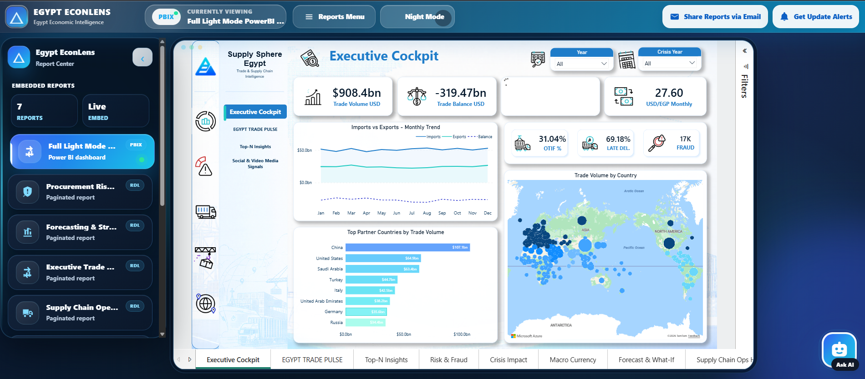
9.2 Web App - Night Mode Interface.
The interface includes a persistent header, current report state, report menu, Day/Night mode toggle, Share Reports button, Update Alerts button, side report navigation, large embedded report viewer and floating Ask AI button.
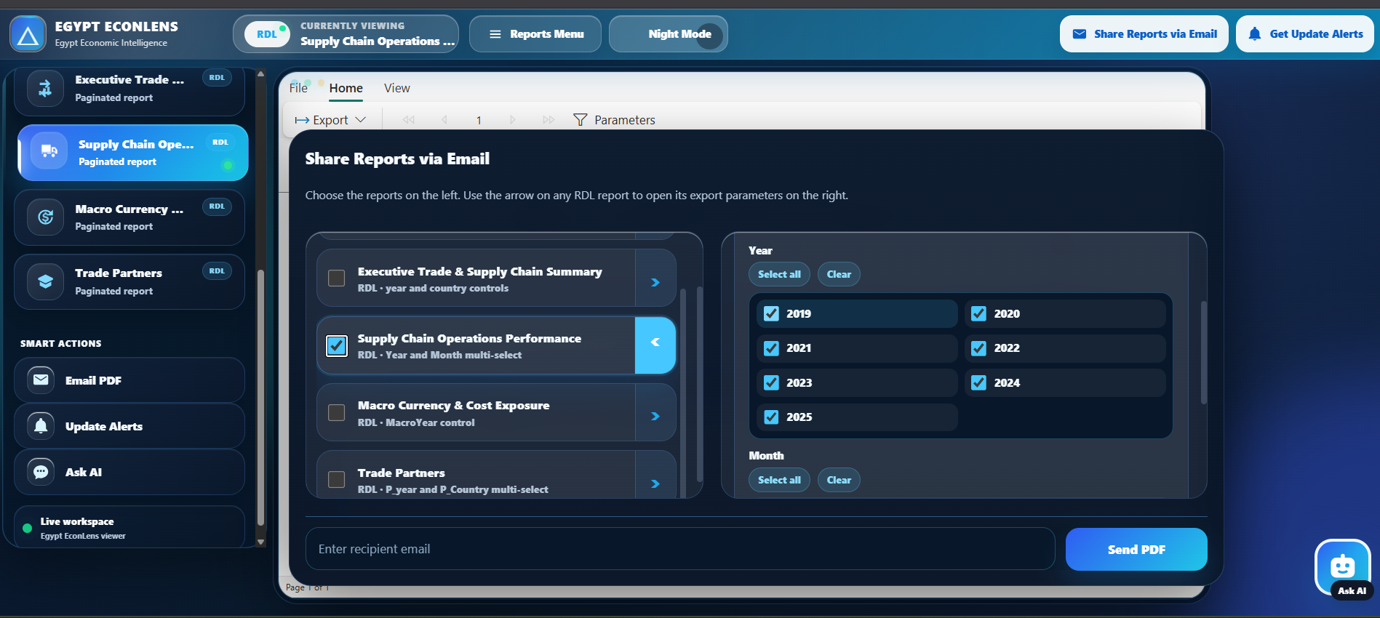
9.3 Share Reports via Email - RDL Parameter Selection.

9.4 Report Update Alerts - Subscriber Preference Form.

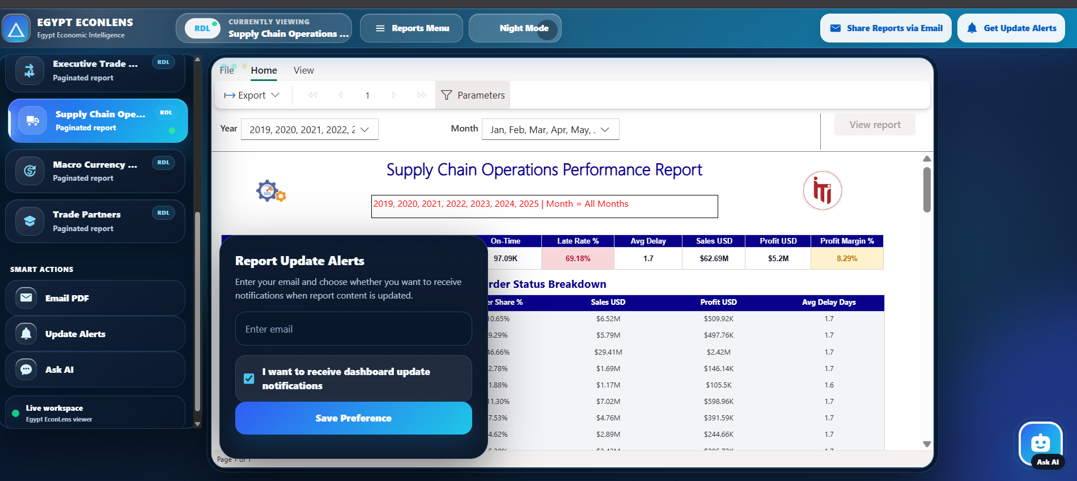

12. AI Copilot / AI Assistant
The AI Copilot is a natural-language analytics layer integrated into the web application. Users can ask business questions about trade, imports, exports, regions, macro indicators, procurement risk and supply-chain performance. The assistant returns business insights, ranked tables, charts and optional follow-up questions.
Capability | Implementation Mechanism
Question understanding | Detect user intent and identify relevant business domain.
Arabic handling | Translate or preprocess Arabic before intent detection.
Schema retrieval | Use schema metadata to select relevant views and columns.
SQL generation | Generate SELECT queries over curated DWH views.
SQL validation | Validate SQL with exact view-name rules and sqlglot parser.
SQL repair | Repair invalid SQL and retry execution when safe.
Insight generation | Summarise results into business language.
Chart output | Return chart-ready JSON for trend/ranking answers.
Conversation memory | Handle follow-up prompts such as “show the same for 2025.”
Safe logging | Log generated SQL without exposing emails, tokens or secrets.

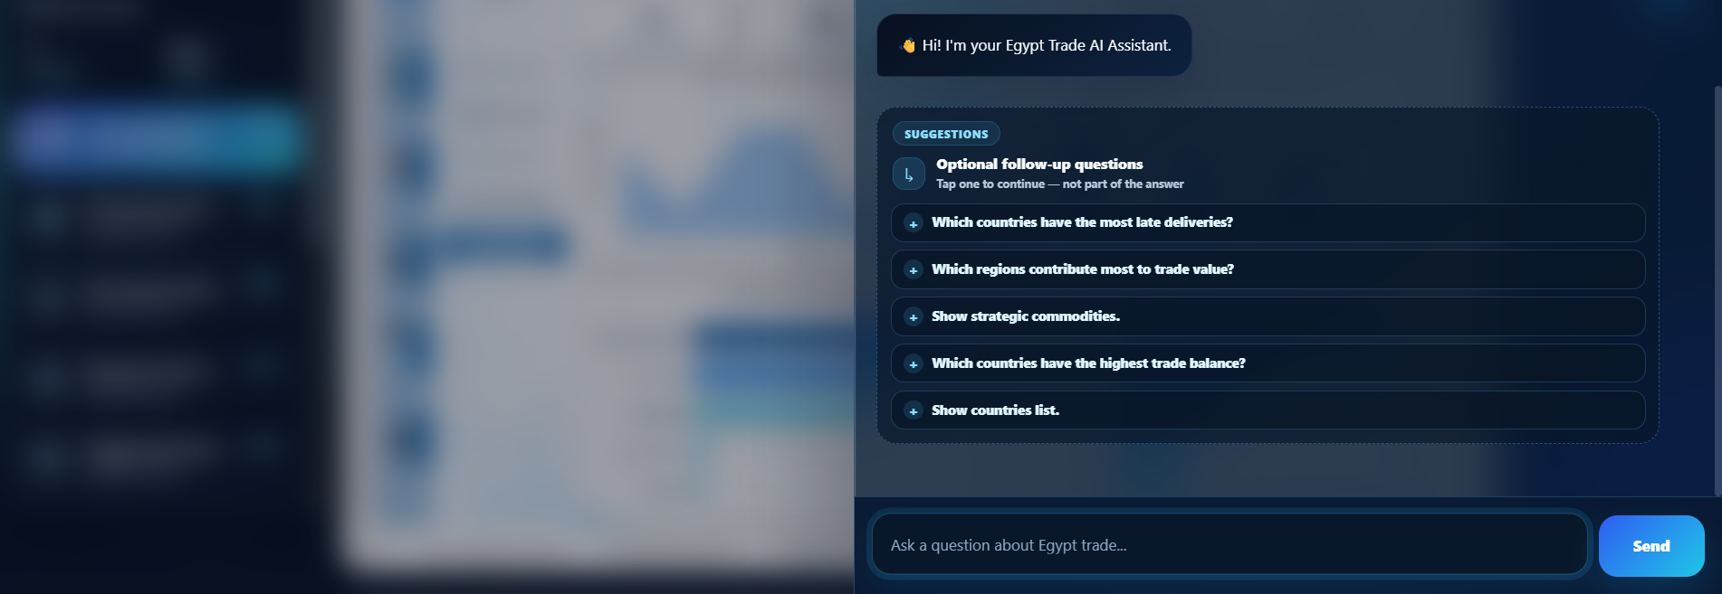
10.1 AI Assistant - Welcome Screen with Suggested Questions.

10.2 AI Assistant - Arabic Question Processing.
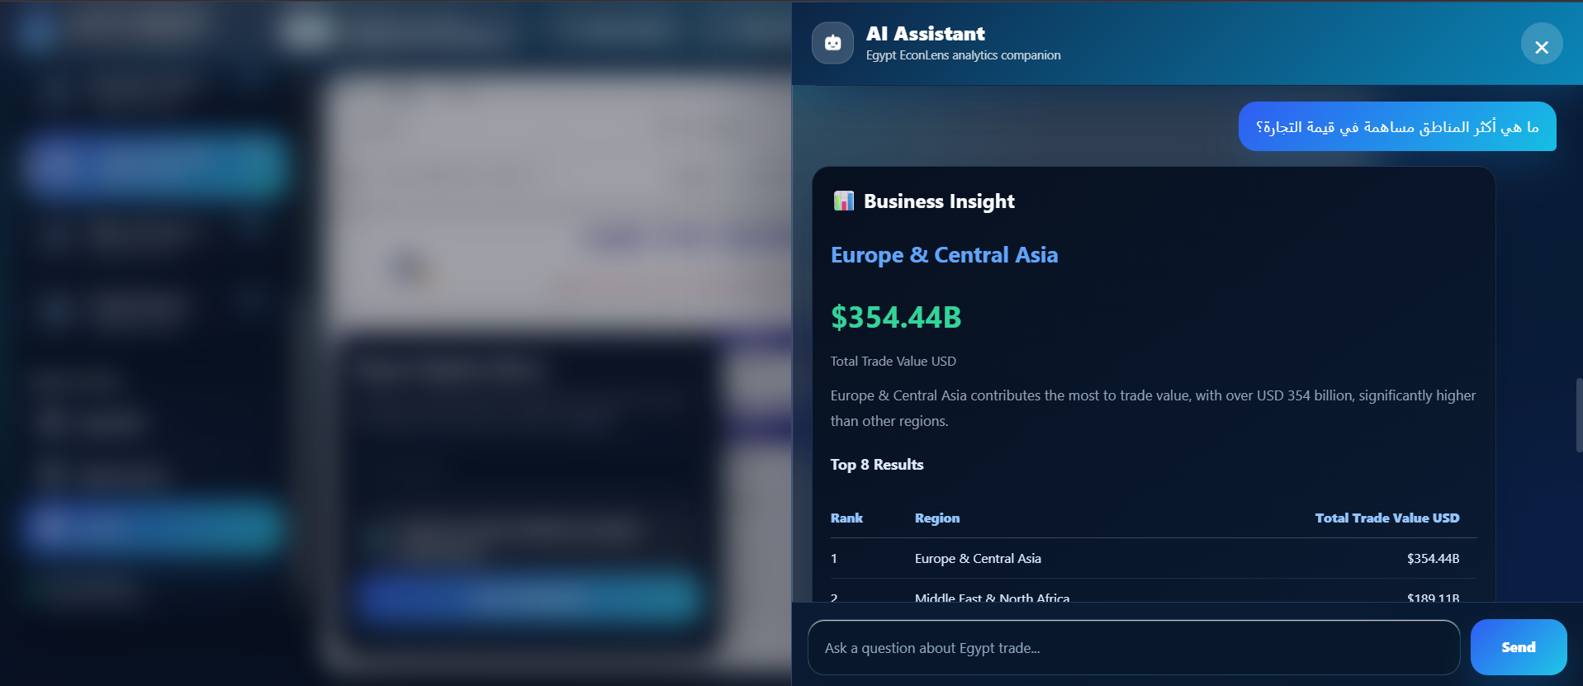
10.3 AI Assistant - Business Insight Result for Arabic Query.
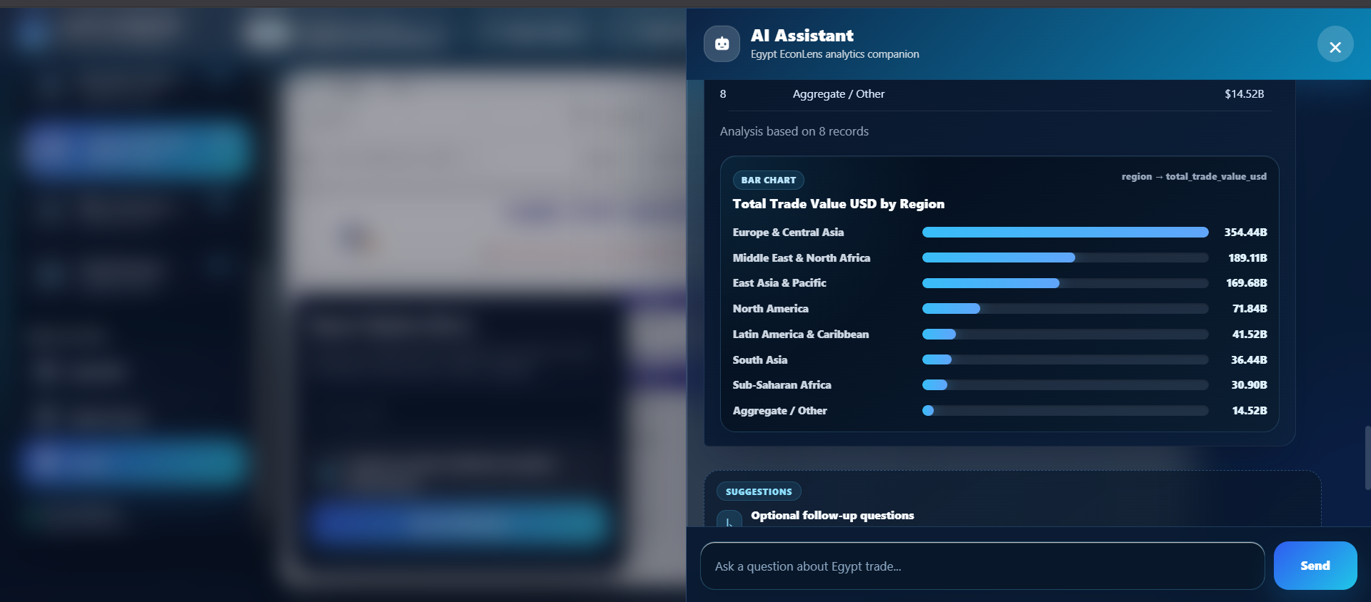
10.4 AI Assistant - Chart Visualization Output.
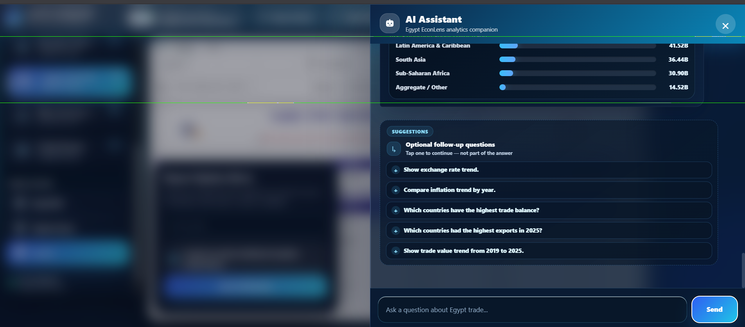
10.5 AI Assistant - Follow-up Suggestions.
13. Power Automate Automation Flows
Power Automate handles long-running operations that should not run directly inside the Flask request lifecycle. The automation layer exports reports, sends emails, monitors report changes and manages subscriber preferences.

13.1 Flow 1 - Send Dashboard And Reports by Email
Flow 1 is triggered by the report sharing action. It gets a Power BI access token, retrieves reports, filters selected reports, loops through each item, identifies the report type and uses the correct branch for PBIX or RDL export. It then creates a download/share link and sends the result to the recipient.
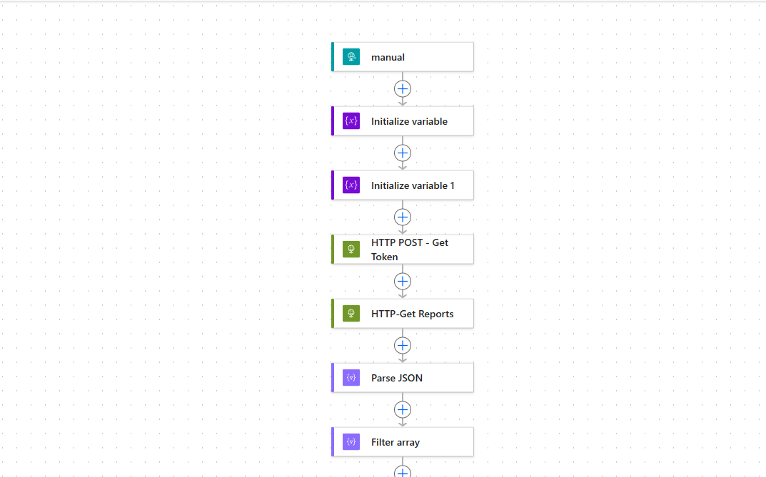
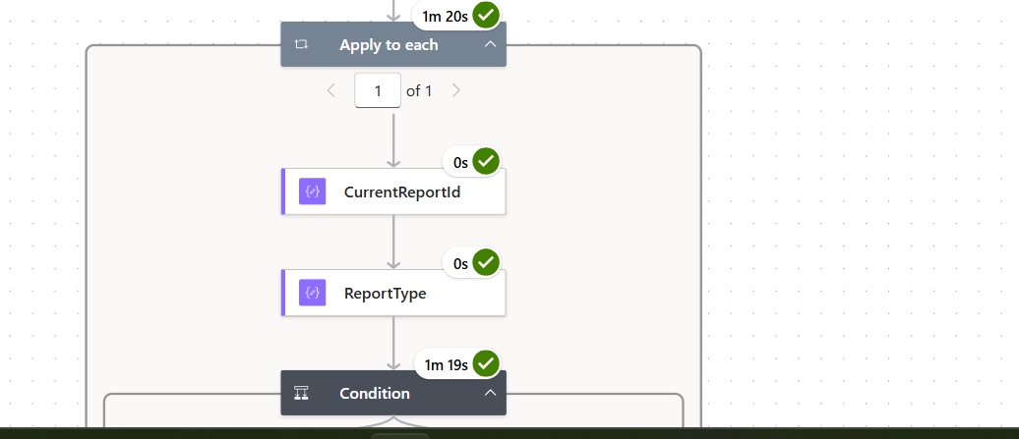
11.1 Flow 1 - Export Flow Setup and Report Retrieval.

11.2 Flow 1 - Apply to Each Selected Report.
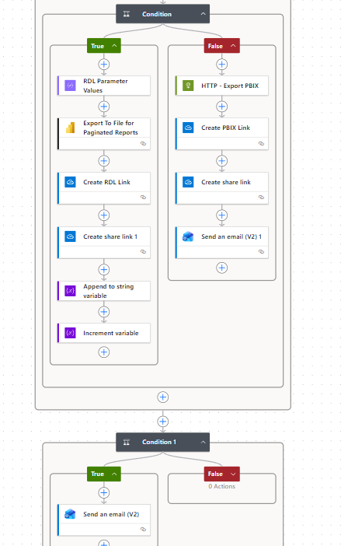
11.3 Flow 1 - RDL and PBIX Export Branches.

13.2 Flow 2 - New Reports Added / Modified Reports Notification
Flow 2 runs on a daily recurrence. It retrieves current Power BI workspace reports, reads the SharePoint tracker list, builds the active subscriber list, detects new reports or modified report names, updates the tracker list and sends notification emails when required.
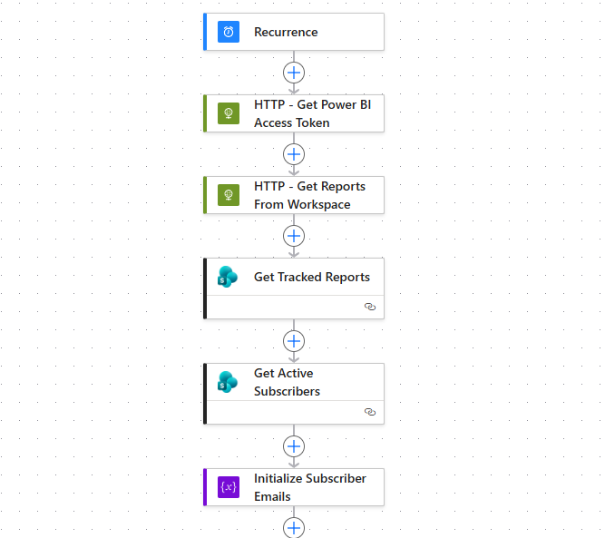
11.4 Flow 2 - Scheduled Report Monitoring Flow.
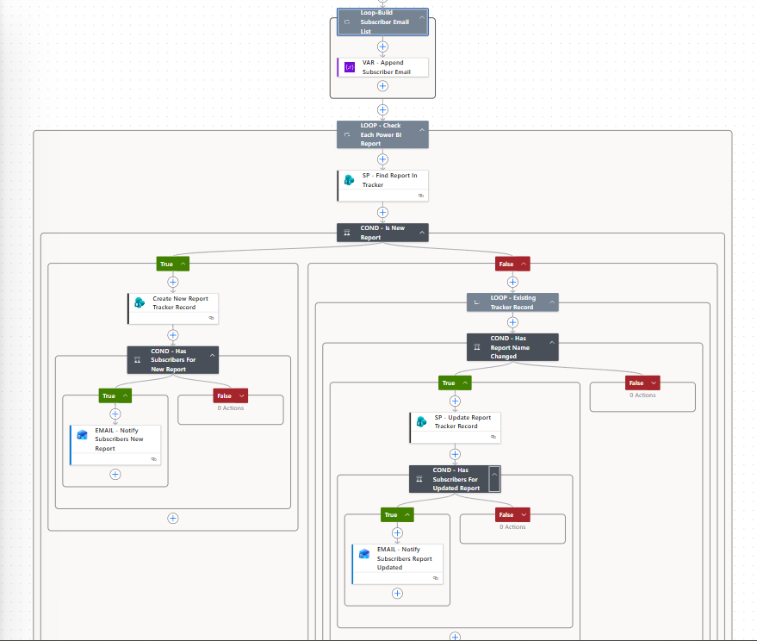
11.5 Flow 2 - New and Modified Report Detection Branches.
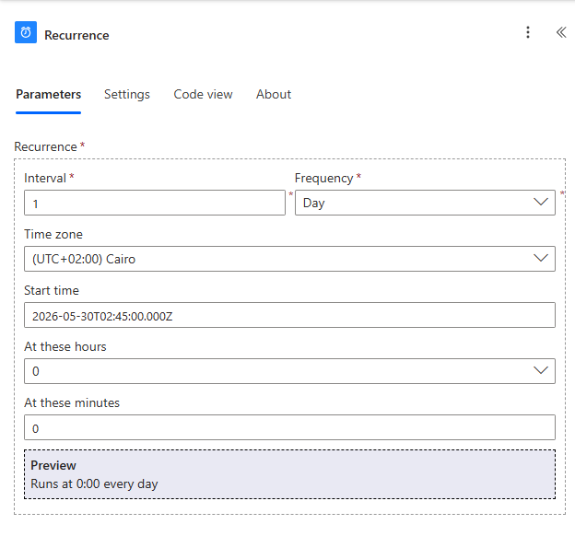
11.6 Flow 2 - Daily Recurrence Trigger.

13.3 Flow 3 - Subscriber Preference Save Flow
Flow 3 is triggered when a user saves alert preferences. It checks whether the subscriber already exists in SharePoint. New subscribers are created, while existing subscribers have their preference updated. The flow returns a response to the web application.
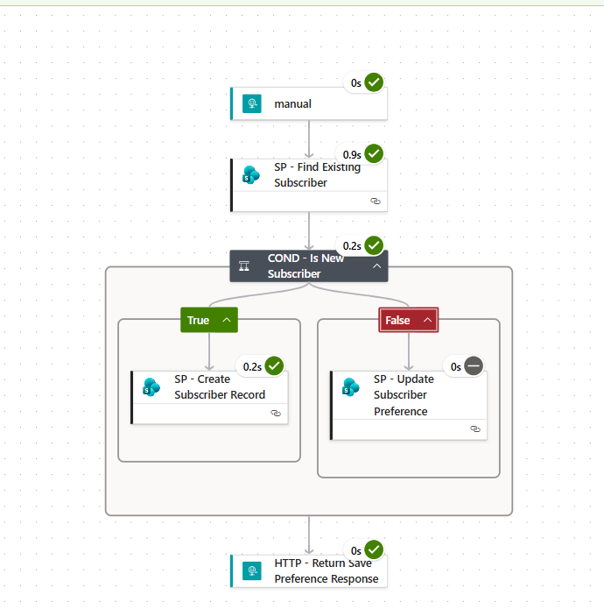
11.7 Flow 3 - Subscriber Preference Save Flow.
14. SharePoint Integration
SharePoint is used as a lightweight persistence layer for automation. It stores subscriber preferences and report version tracking state, allowing Power Automate flows to compare current report metadata with previously stored state.

14.1 ReportVersionTracker List
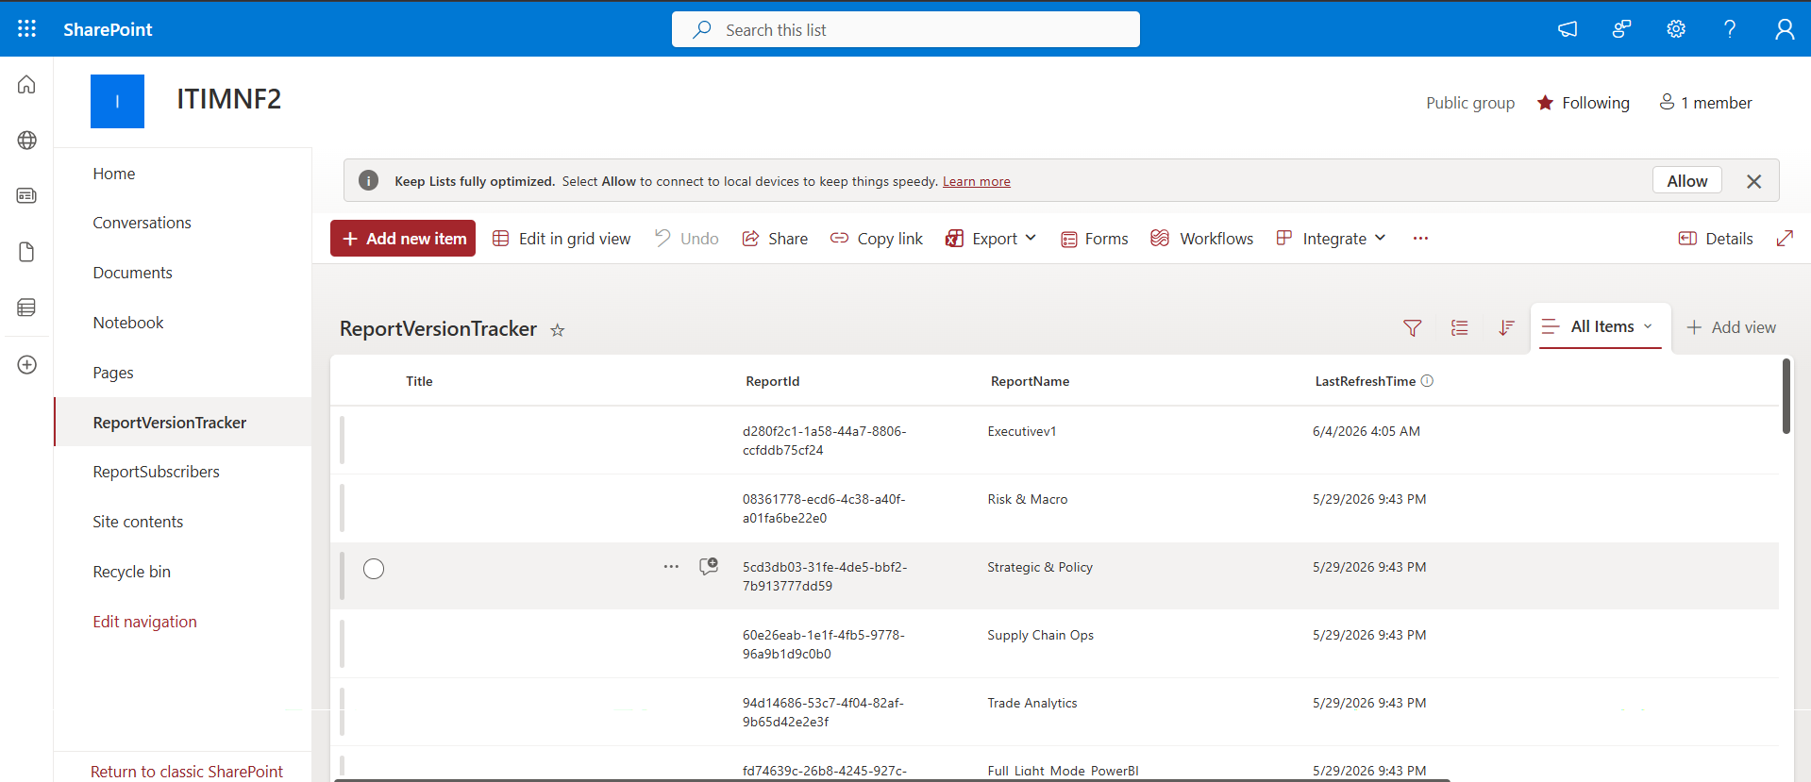
12.1 SharePoint - ReportVersionTracker List.
Column | Purpose
Title | Default SharePoint item title.
ReportId | Unique Power BI report identifier.
ReportName | Current report name tracked from the workspace.
LastRefreshTime | Last known report update/refresh timestamp.

14.2 ReportSubscribers List
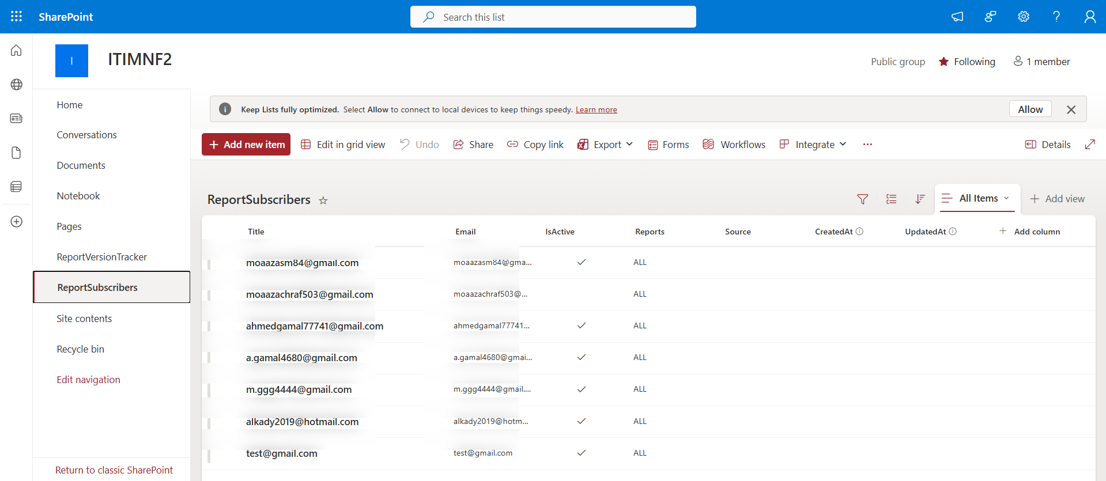
12.2 SharePoint - ReportSubscribers List (emails masked).
Column | Purpose
Title | Default SharePoint item title.
Email | Subscriber email address.
IsActive | Controls whether the subscriber receives notifications.
Reports | Report scope selected by the subscriber; currently ALL.
Source | Source of the subscription request.
CreatedAt | Creation timestamp.
UpdatedAt | Last update timestamp.

15. Azure Deployment and CI/CD
The application is deployed on Azure App Service for Linux using Python 3.11. GitHub Actions and Azure Deployment Center are used for continuous deployment. Environment variables are configured in Azure App Settings, and managed identity is used to avoid password-based database authentication.
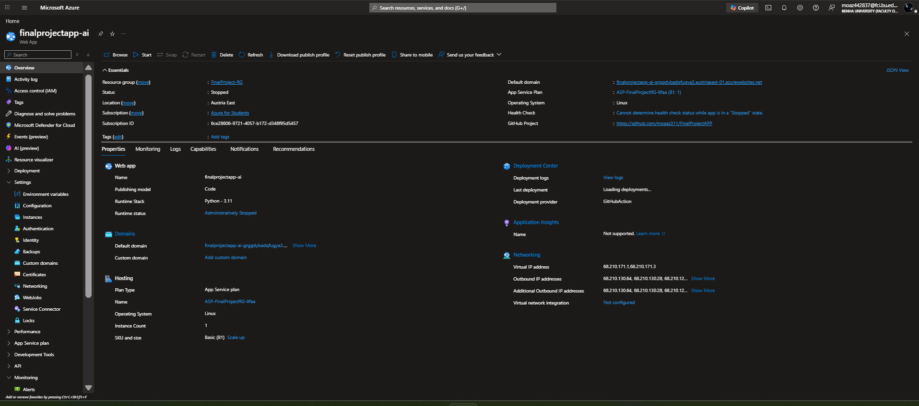
13.1 Azure App Service - Application Overview.
Item | Value
Service | Azure App Service
App Name | finalprojectapp-ai
Runtime Stack | Python 3.11
Operating System | Linux
Region | Austria East
App Service Plan | Basic B1
Deployment Provider | GitHub Action / Deployment Center
Resource Group | FinalProject-RG

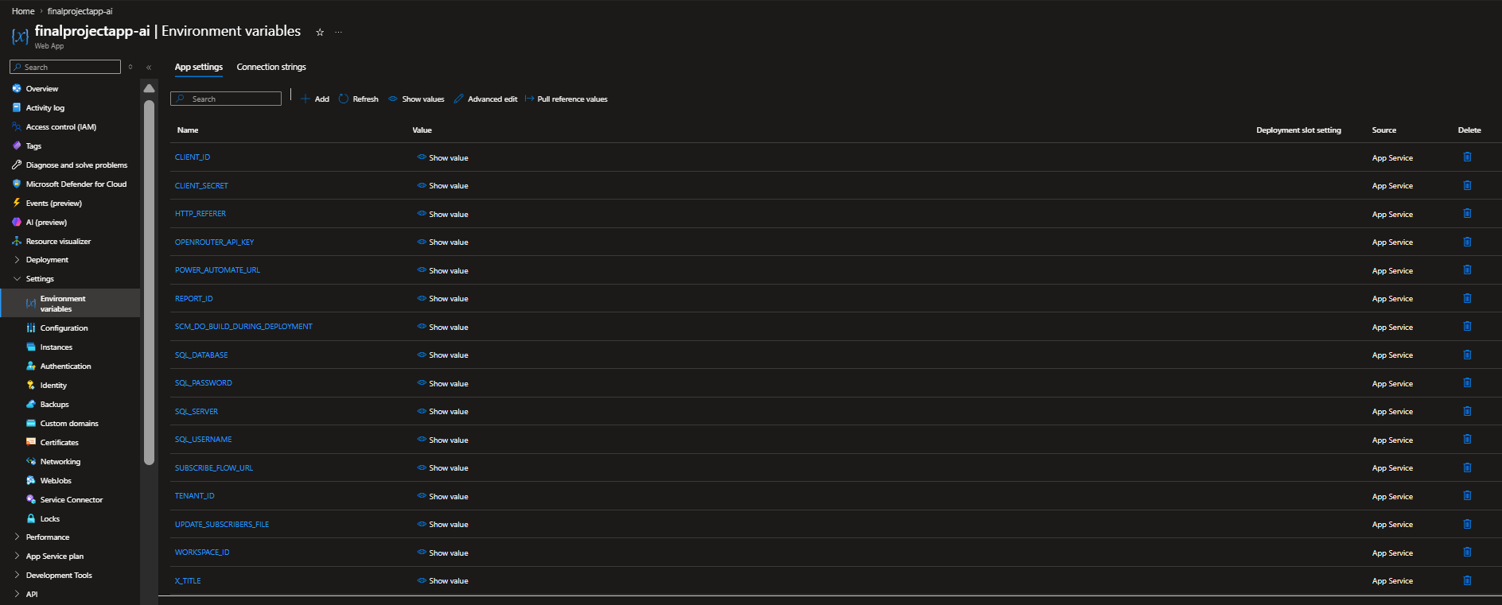
13.2 Azure App Service - Environment Variables.
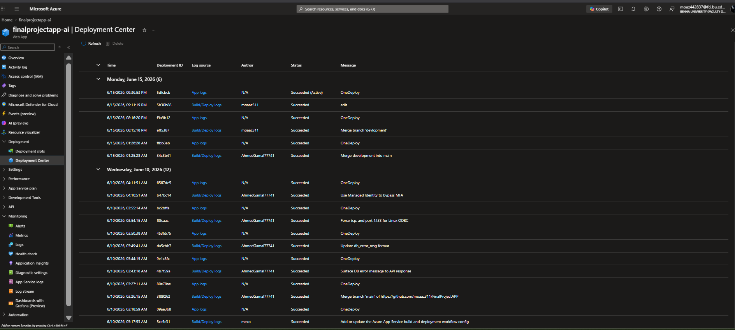
13.3 Azure Deployment Center - Deployment History.
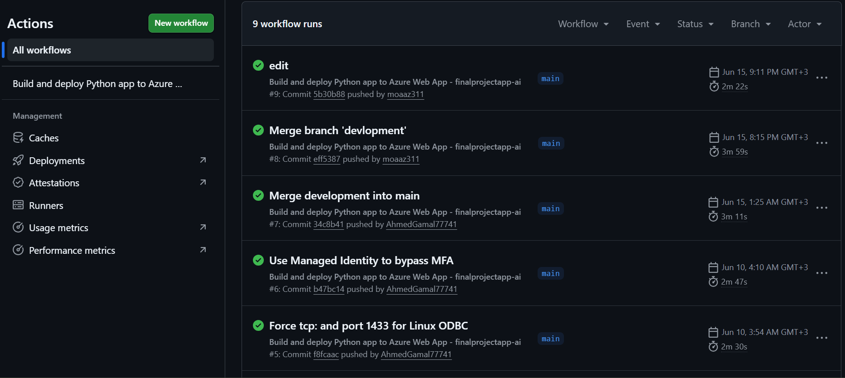
13.4 GitHub Actions - Build and Deploy Workflow Runs.
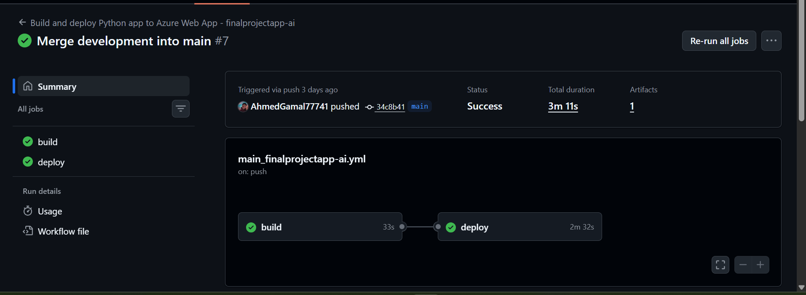
13.5 GitHub Actions - Build and Deploy Job Success.
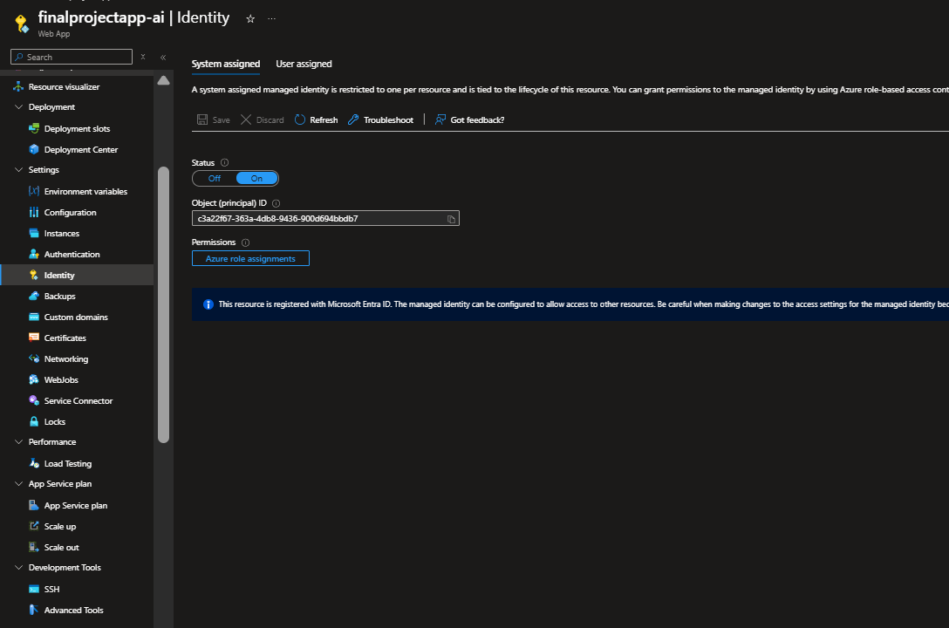
13.6 Azure App Service - System Assigned Managed Identity.
16. Security and Governance
Security is important because the platform contains a web application, AI-generated SQL, Power BI report access, Power Automate URLs, SharePoint subscriber data and Azure deployment settings. The design uses layered controls instead of relying on one mechanism.

16.1 Managed Identity and Fabric Access Control
Managed identity provides passwordless authentication. The Azure App Service identity is granted access to the Fabric workspace, allowing controlled access to the warehouse and reports without using a university email/password.
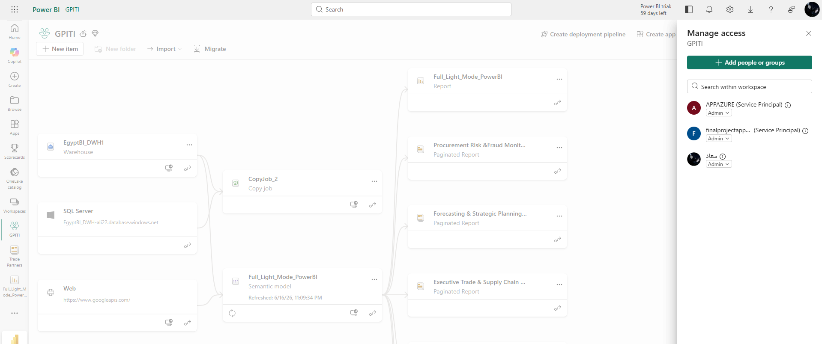
14.1 Microsoft Fabric Workspace - Managed Identity Access.
Control | Purpose
Environment variables | Store secrets and configuration outside source files.
Managed identity | Enable passwordless authentication to Fabric/Azure resources.
Fabric access control | Limit workspace access to assigned users and service principals.
Read-only AI SQL | Only SELECT-style analytics queries are allowed.
Exact view-name enforcement | Prevents hallucinated objects such as EgyptBI_DWH1.view_name.
Approved view whitelist | Restricts AI queries to curated DWH views.
sqlglot validation | Provides stronger SQL syntax and structural validation.
Dangerous command blocking | Blocks INSERT, UPDATE, DELETE, DROP, ALTER and TRUNCATE.
Safe logging | Avoids storing user emails, API keys, tokens or flow secrets in logs.

17. Testing Scenarios
Testing was organised by module to verify both standalone features and end-to-end integration.
Module | Key Tests | Status
Web App Interface | Open app, toggle theme, open reports menu, open AI drawer. | Passed
Report Switching | Open PBIX dashboard, open RDL reports, verify current report status and parameters. | Passed
Share Reports via Email | Open modal, select PBIX/RDL, select parameters, send PDF request, receive email link. | Passed
Update Alerts | Open form, save new subscriber, update existing subscriber, notify active users. | Passed
AI Copilot | Ask English/Arabic questions, generate tables/charts, validate SQL, block unsafe prompts. | Passed
Power Automate | Trigger export flow, monitor reports, update tracker, manage subscriber preferences. | Passed
Azure Deployment | GitHub push, build job, deploy job, app runtime, Managed Identity connection. | Passed
Figure 53. Feature Test — Multiple Paginated Reports Export Email

17.1 Feature Testing Screenshots Evidence
This subsection provides visual evidence for the executed feature tests listed in the Testing Scenarios table. The screenshots confirm that the main modules of the Egypt EconLens platform were tested successfully across the web interface, report navigation, Power BI embedding, AI Copilot, report export, update alerts, Power Automate, SharePoint, and Azure deployment.
Test Area | Screenshot Title | Feature Tested | Expected Result | Actual Result | Status
Report Switching | RDL Report Embedding — Macro Currency & Cost Exposure | Embedded RDL paginated report (Macro Currency & Cost Exposure) is loaded inside the web ap | The RDL report should render correctly with its parameter controls, data tables and report | The Macro Currency & Cost Exposure report loaded successfully showing the macro exposure s | Passed
Report Switching | RDL Report with Parameters — Supply Chain Operations Performance | RDL report with multi-value parameters (Year and Month) is opened and parameters are appli | The Supply Chain Operations Performance report should display with the selected year and m | The report rendered with Year 2019-2023 and All Months selected, displaying total orders, | Passed
Share Reports via Email | Share Reports Modal with Report Selection and Parameters | The Share Reports via Email modal opens and allows selection of RDL reports with their exp | The modal should display the list of available reports, allow selection, and show paramete | The Executive Trade & Supply Chain Summary report was selected with Year 2025 and Country | Passed
Share Reports via Email | Report Request Submission Confirmation | The PDF report request is submitted and a confirmation message is displayed to the user. | After clicking Send PDF, a confirmation dialog should appear indicating the request was su | The confirmation dialog appeared successfully with the message confirming report request s | Passed
Share Reports via Email | PBIX Dashboard Export Email | Power Automate Flow 1 sends a PBIX dashboard file via email after a share request is submi | The recipient should receive an email containing a download link for the requested PBIX da | The email was received with the subject 'Power BI File Ready', containing a working Downlo | Passed
Share Reports via Email | Single Paginated Report Export Email | Power Automate Flow 1 sends a single exported RDL paginated report as a downloadable PDF v | The recipient should receive an email with a download link for the single requested pagina | The email was received with the subject 'Paginated Reports Ready', containing a Download R | Passed
Share Reports via Email | Multiple Paginated Reports Export Email | Power Automate Flow 1 exports and sends multiple RDL paginated reports in a single email. | The recipient should receive one email containing individual download links for each reque | The email contained four separate download sections for Executive Trade & Supply Chain Sum | Passed
Update Alerts | Subscribe to Report Update Alerts | The Update Alerts form allows a user to enter their email and subscribe to dashboard updat | After entering an email and checking the notification checkbox, the preference should be s | The form submitted successfully with email moaazasm84@gmail.com and the green confirmation | Passed
Update Alerts | Unsubscribe from Report Update Alerts | The Update Alerts form allows a user to update their preference and unsubscribe from notif | Unchecking the notification checkbox and saving should update the subscriber record to ina | The preference was updated successfully and the message 'You are unsubscribed from report | Passed
AI Copilot | AI Assistant English Question with Business Insight | The AI Copilot processes an English question about shipping delays and returns a business | The AI should interpret the question, generate valid SQL, execute it, and return a natural | The AI returned the correct insight identifying 'Team Sports Product 437' as having the la | Passed
AI Copilot | AI Assistant Chart Visualization Output | The AI Copilot returns a bar chart visualization for a ranking query showing products by a | The AI should generate a horizontal bar chart displaying the top products ranked by their | A horizontal bar chart was rendered showing all top delayed products with Team Sports Prod | Passed
AI Copilot | AI Assistant Follow-up Suggestions | The AI Copilot displays contextual follow-up question suggestions after providing an answe | After returning a result, the AI should present relevant follow-up questions that the user | Five follow-up suggestions appeared including 'Show average shipping delay by country' and | Passed
Power Automate | Flow 1 — Send Power BI Reports Export Flow Run | Power Automate Flow 1 (Send PowerBI ReportsV2) executes successfully when triggered by an | All flow steps should complete with green checkmarks: HTTP trigger, variable initializatio | The flow ran successfully at 6/18/2026 2:12:36 PM with all nine steps completing without e | Passed
Power Automate | Flow 2 — Daily Report Monitoring Flow Run | Power Automate Flow 2 runs on daily recurrence to detect new or modified reports and notif | The flow should execute all steps successfully: recurrence trigger, token acquisition, rep | The flow ran successfully on 6/17/2026 at 11:59:59 PM with all eight steps completing, inc | Passed
Power Automate | Flow 3 — Subscriber Preference Save Flow Run | Power Automate Flow 3 saves or updates a subscriber preference when triggered from the Upd | The flow should find the existing subscriber, determine if it's new or existing, and retur | The subscriber flow ran successfully at 6/18/2026 2:05:52 PM with all four steps completin | Passed
Power Automate | New Report Added Notification Email | Flow 2 sends an automated email notification when a new report is detected in the Power BI | Subscribers should receive a formatted email with the new report name and a link to open t | The email was received with the subject 'Power BI Report Notification', showing the new re | Passed
Power Automate | Modified Report Notification Email | Flow 2 sends an automated email notification when an existing report is modified in the Po | Subscribers should receive a formatted email indicating which report was updated with a li | The email was received with the subject 'Report Updated' showing the updated report 'Trade | Passed

Figure 47. Feature Test — RDL Report Embedding — Macro Currency & Cost Exposure
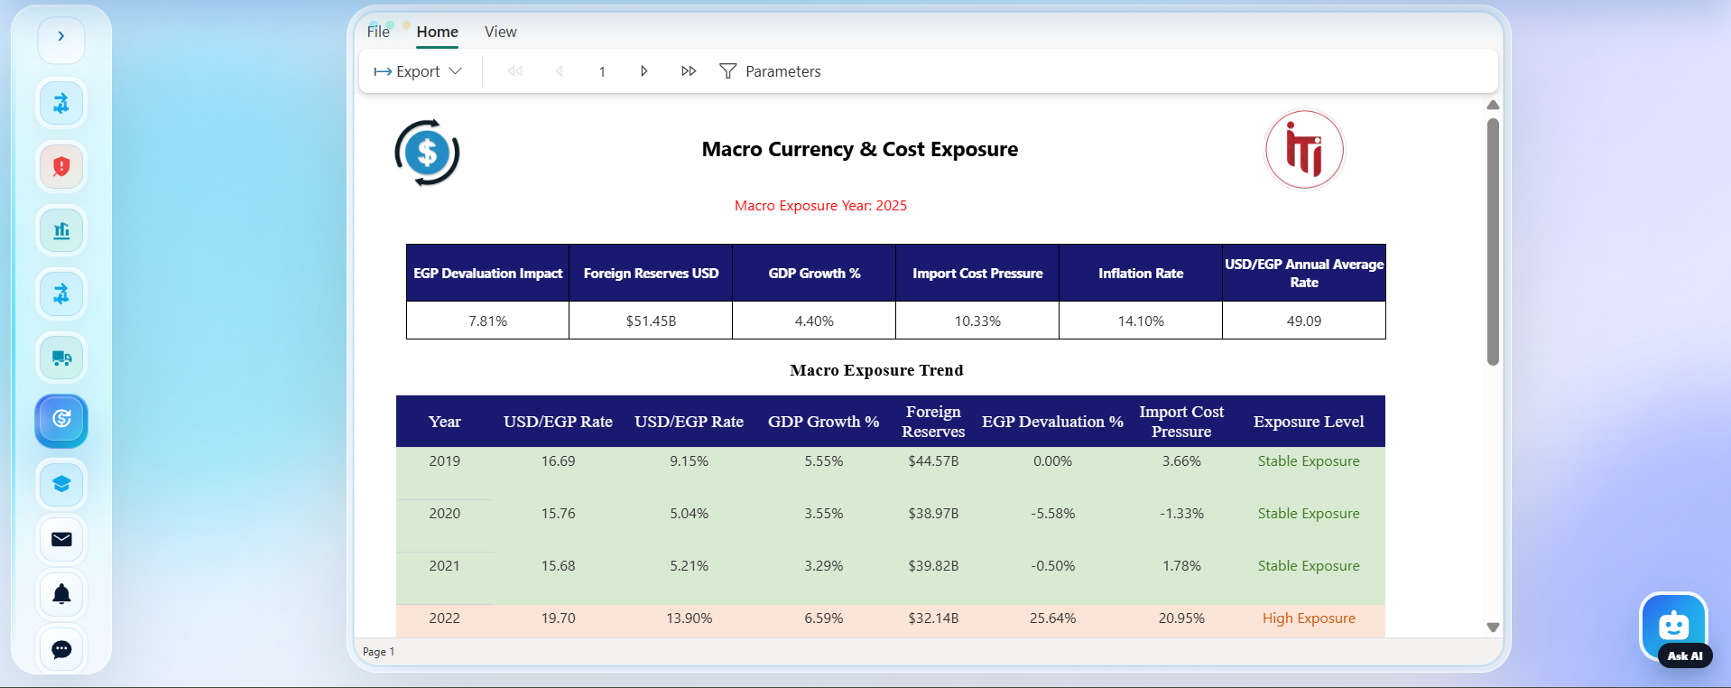
Feature Tested: Embedded RDL paginated report (Macro Currency & Cost Exposure) is loaded inside the web application viewer.
Expected Result: The RDL report should render correctly with its parameter controls, data tables and report header visible within the embedded iframe.
Actual Result: The Macro Currency & Cost Exposure report loaded successfully showing the macro exposure summary table and trend data for the selected year.
Status: Passed.

Figure 48. Feature Test — RDL Report with Parameters — Supply Chain Operations Performance
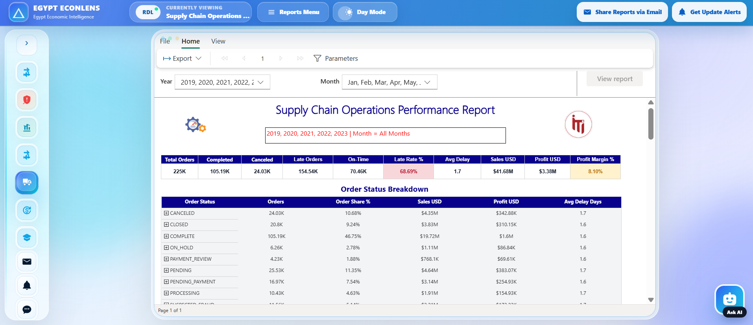
Feature Tested: RDL report with multi-value parameters (Year and Month) is opened and parameters are applied correctly.
Expected Result: The Supply Chain Operations Performance report should display with the selected year and month filters applied, showing correct KPI values.
Actual Result: The report rendered with Year 2019-2023 and All Months selected, displaying total orders, completed orders, late rate, sales and profit margin correctly.
Status: Passed.

Figure 49. Feature Test — Share Reports Modal with Report Selection and Parameters
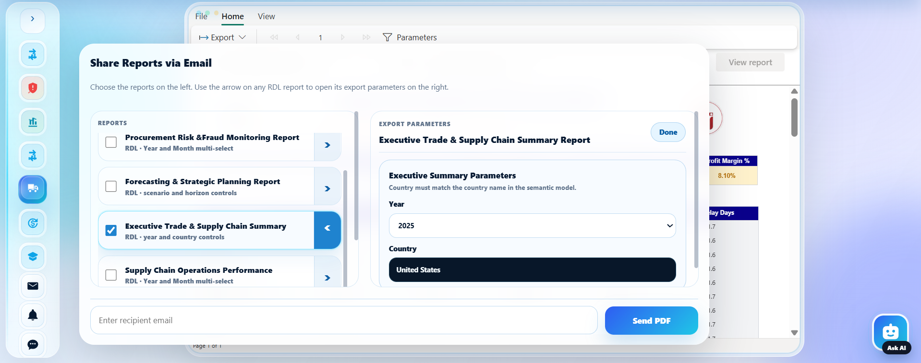
Feature Tested: The Share Reports via Email modal opens and allows selection of RDL reports with their export parameters.
Expected Result: The modal should display the list of available reports, allow selection, and show parameter inputs for the chosen RDL report.
Actual Result: The Executive Trade & Supply Chain Summary report was selected with Year 2025 and Country United States parameters visible and configurable.
Status: Passed.

Figure 50. Feature Test — Report Request Submission Confirmation
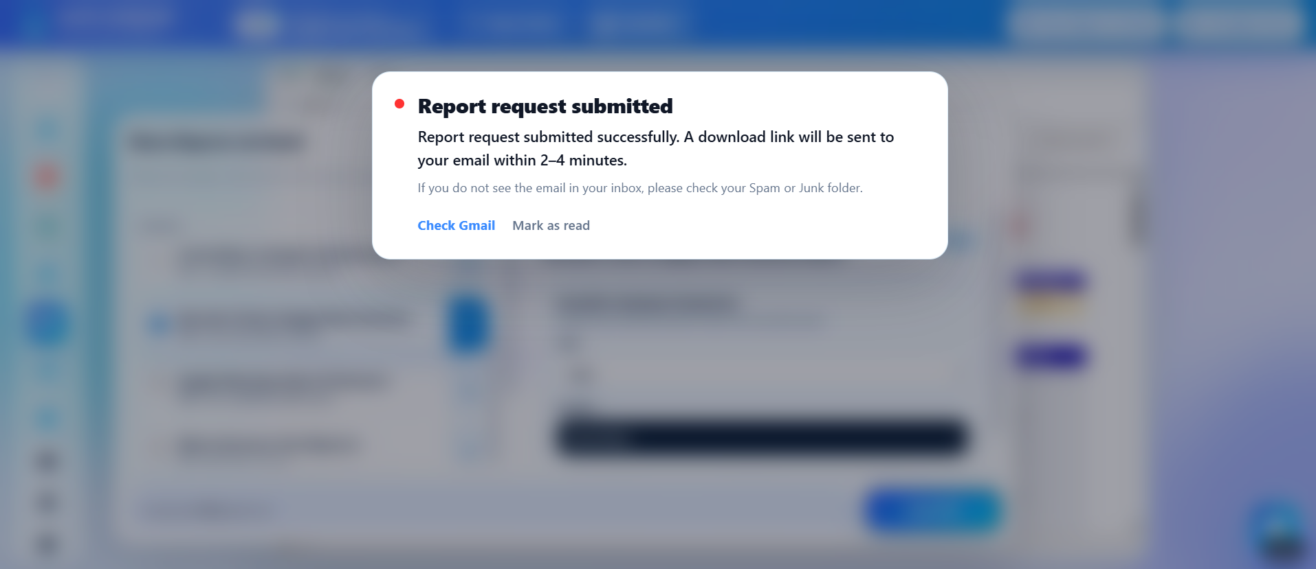
Feature Tested: The PDF report request is submitted and a confirmation message is displayed to the user.
Expected Result: After clicking Send PDF, a confirmation dialog should appear indicating the request was submitted and an email will arrive within 2-4 minutes.
Actual Result: The confirmation dialog appeared successfully with the message confirming report request submission and providing a link to check Gmail.
Status: Passed.

Figure 51. Feature Test — PBIX Dashboard Export Email
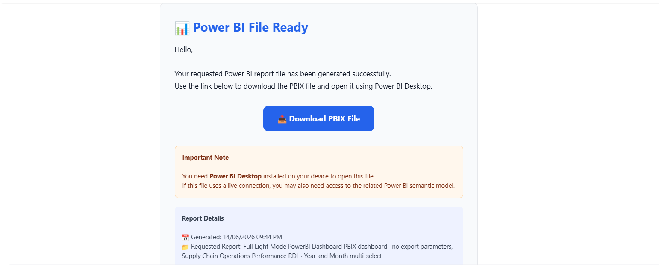
Feature Tested: Power Automate Flow 1 sends a PBIX dashboard file via email after a share request is submitted from the web app.
Expected Result: The recipient should receive an email containing a download link for the requested PBIX dashboard file.
Actual Result: The email was received with the subject 'Power BI File Ready', containing a working Download PBIX File button and report details.
Status: Passed.

Figure 52. Feature Test — Single Paginated Report Export Email
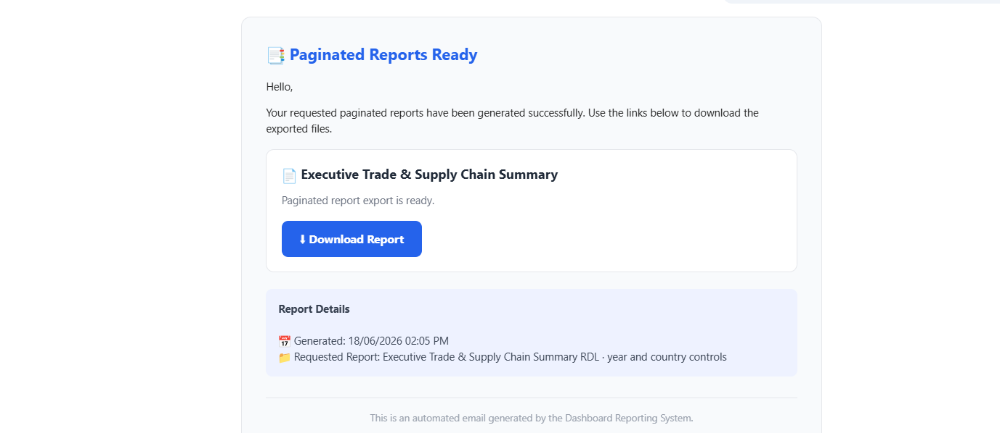
Feature Tested: Power Automate Flow 1 sends a single exported RDL paginated report as a downloadable PDF via email.
Expected Result: The recipient should receive an email with a download link for the single requested paginated report.
Actual Result: The email was received with the subject 'Paginated Reports Ready', containing a Download Report button for the Executive Trade & Supply Chain Summary report.
Status: Passed.

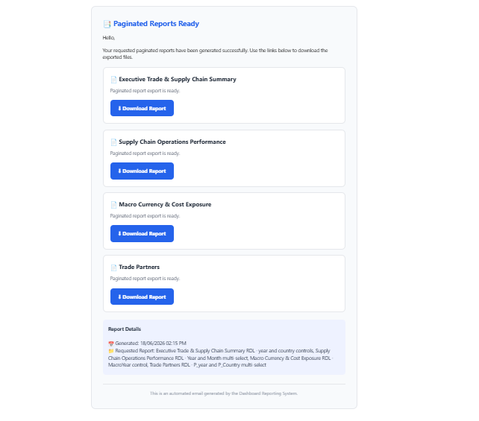
Feature Tested: Power Automate Flow 1 exports and sends multiple RDL paginated reports in a single email.
Expected Result: The recipient should receive one email containing individual download links for each requested paginated report.
Actual Result: The email contained four separate download sections for Executive Trade & Supply Chain Summary, Supply Chain Operations Performance, Macro Currency & Cost Exposure, and Trade Partners reports.
Status: Passed.

Figure 54. Feature Test — Subscribe to Report Update Alerts
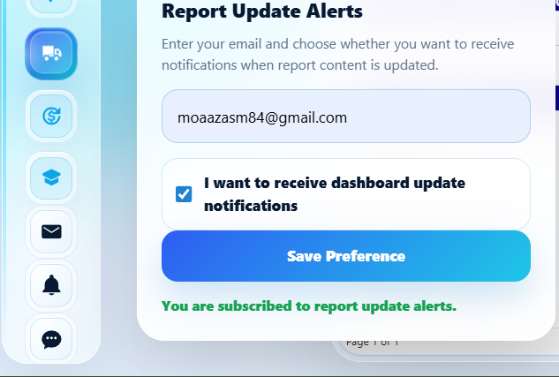
Feature Tested: The Update Alerts form allows a user to enter their email and subscribe to dashboard update notifications.
Expected Result: After entering an email and checking the notification checkbox, the preference should be saved and a confirmation message shown.
Actual Result: The form submitted successfully with email moaazasm84@gmail.com and the green confirmation message 'You are subscribed to report update alerts.' was displayed.
Status: Passed.

Figure 55. Feature Test — Unsubscribe from Report Update Alerts
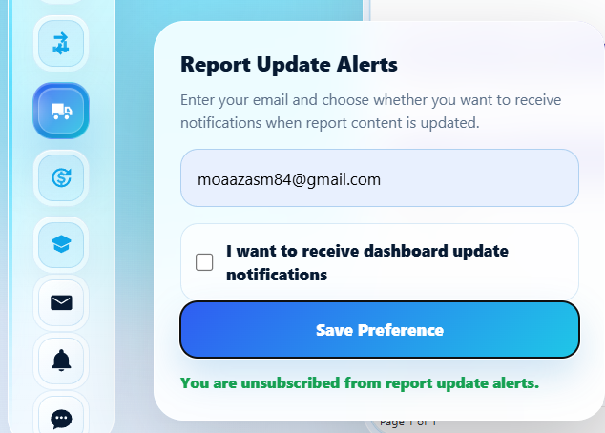
Feature Tested: The Update Alerts form allows a user to update their preference and unsubscribe from notifications.
Expected Result: Unchecking the notification checkbox and saving should update the subscriber record to inactive and show an unsubscribe confirmation.
Actual Result: The preference was updated successfully and the message 'You are unsubscribed from report update alerts.' was displayed in green.
Status: Passed.

Figure 56. Feature Test — AI Assistant English Question with Business Insight
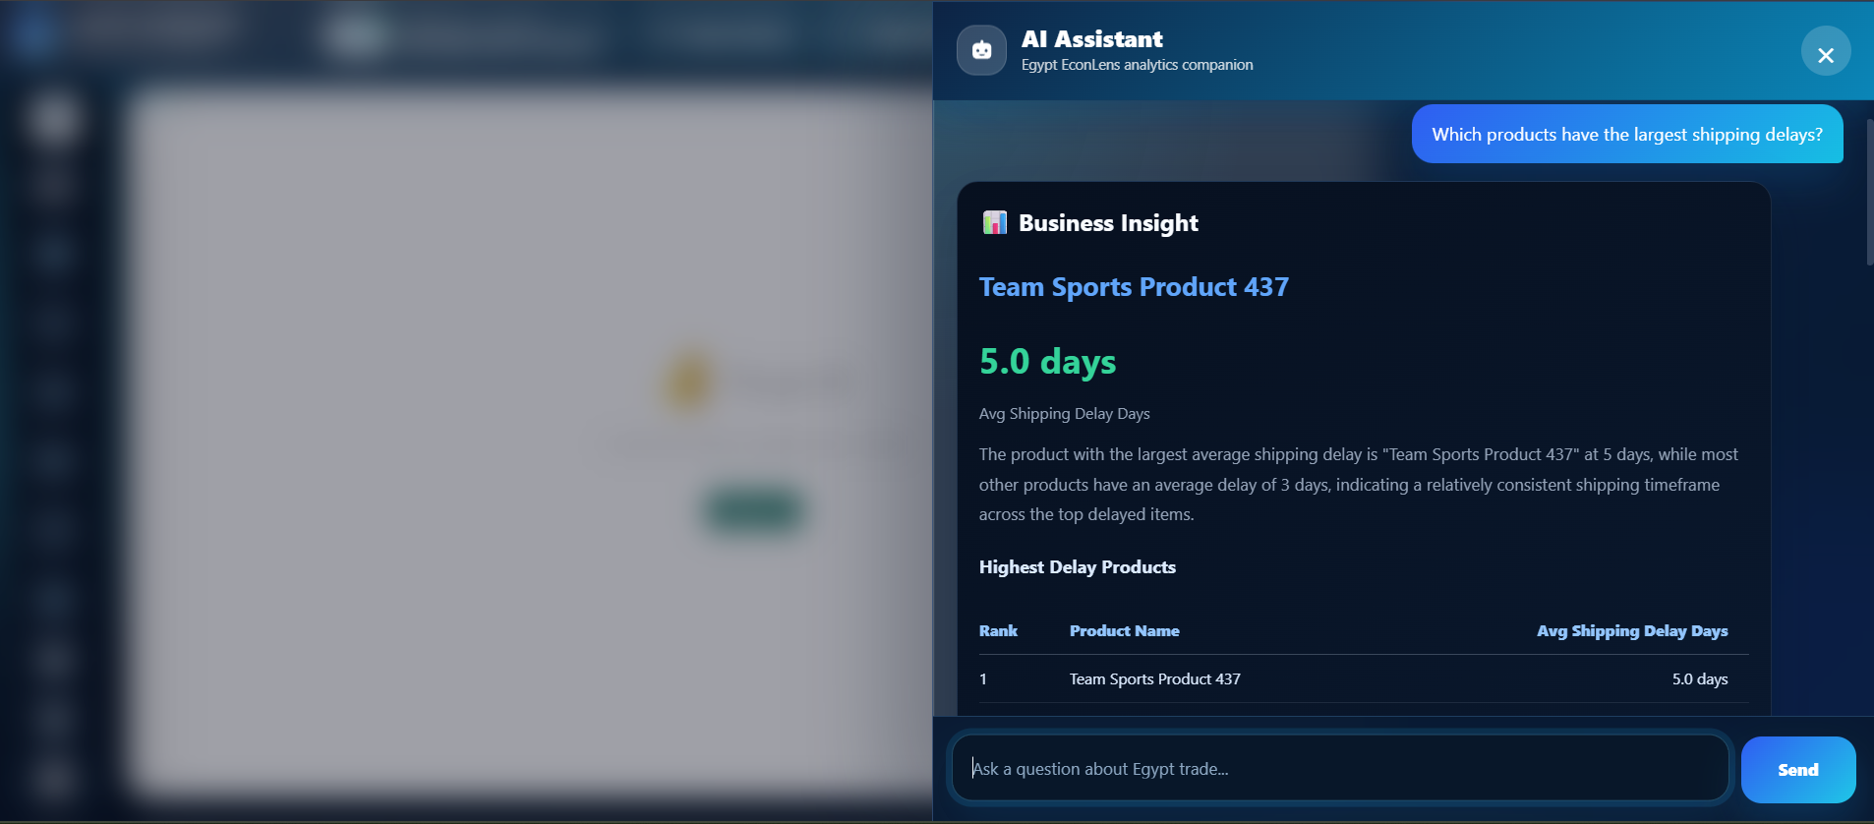
Feature Tested: The AI Copilot processes an English question about shipping delays and returns a business insight with a ranked data table.
Expected Result: The AI should interpret the question, generate valid SQL, execute it, and return a natural-language insight with a supporting data table.
Actual Result: The AI returned the correct insight identifying 'Team Sports Product 437' as having the largest average shipping delay at 5.0 days, along with a ranked table.
Status: Passed.

Figure 57. Feature Test — AI Assistant Chart Visualization Output
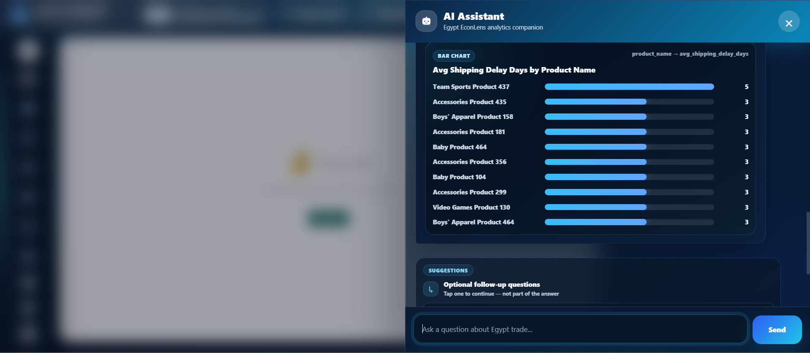
Feature Tested: The AI Copilot returns a bar chart visualization for a ranking query showing products by average shipping delay days.
Expected Result: The AI should generate a horizontal bar chart displaying the top products ranked by their average shipping delay days.
Actual Result: A horizontal bar chart was rendered showing all top delayed products with Team Sports Product 437 at 5 days and others at 3 days.
Status: Passed.

Figure 58. Feature Test — AI Assistant Follow-up Suggestions
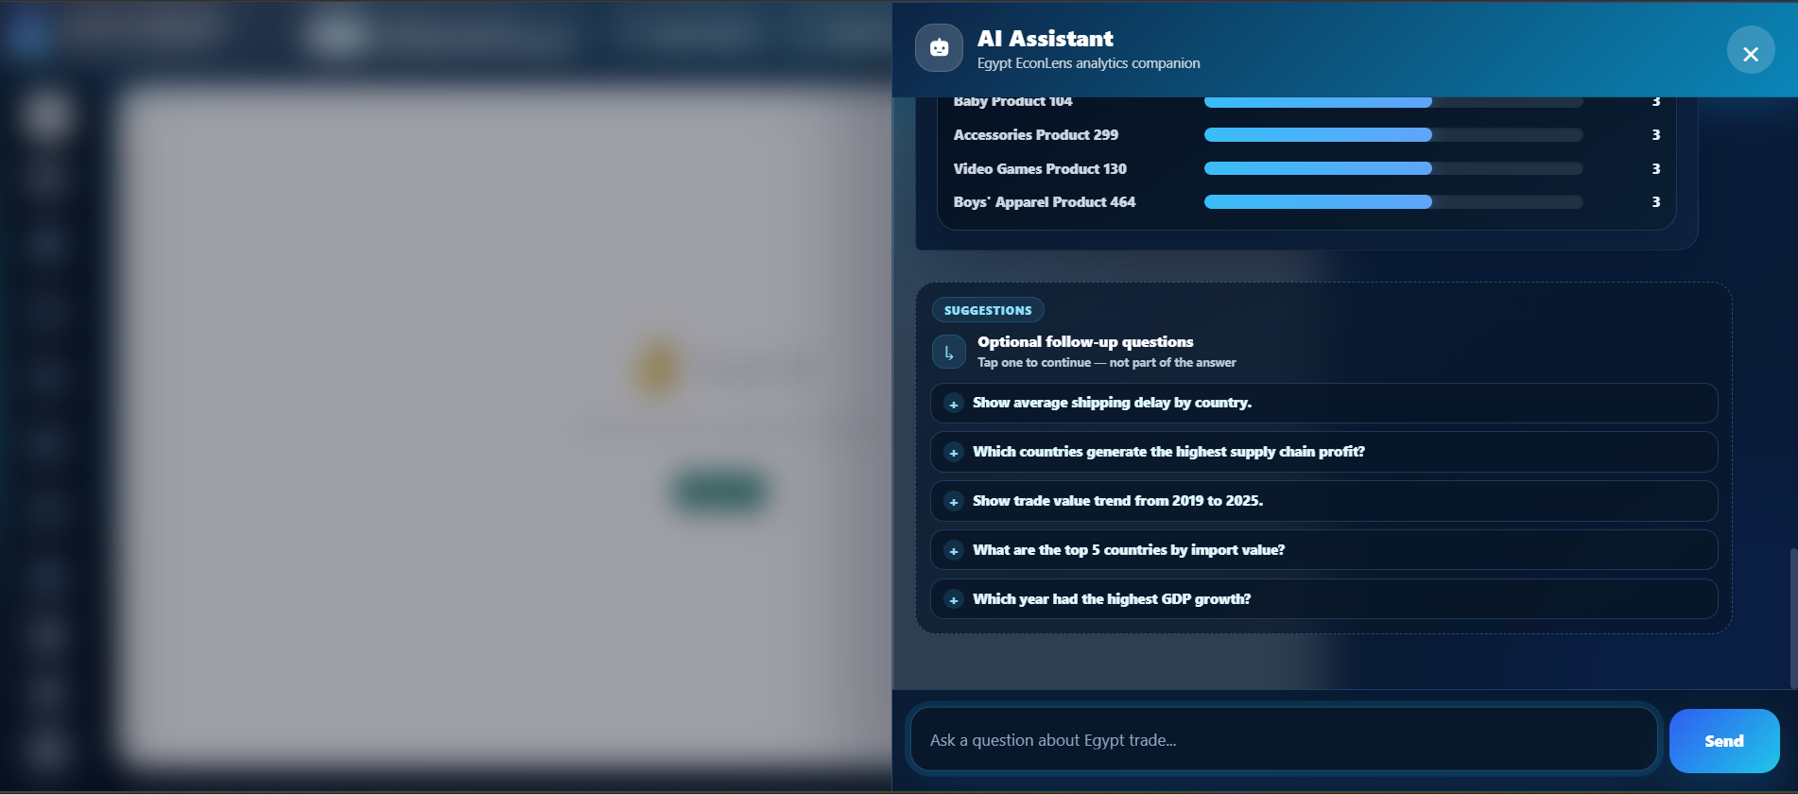
Feature Tested: The AI Copilot displays contextual follow-up question suggestions after providing an answer.
Expected Result: After returning a result, the AI should present relevant follow-up questions that the user can tap to continue the conversation.
Actual Result: Five follow-up suggestions appeared including 'Show average shipping delay by country' and 'Which countries generate the highest supply chain profit?'.
Status: Passed.

Figure 59. Feature Test — Flow 1 — Send Power BI Reports Export Flow Run
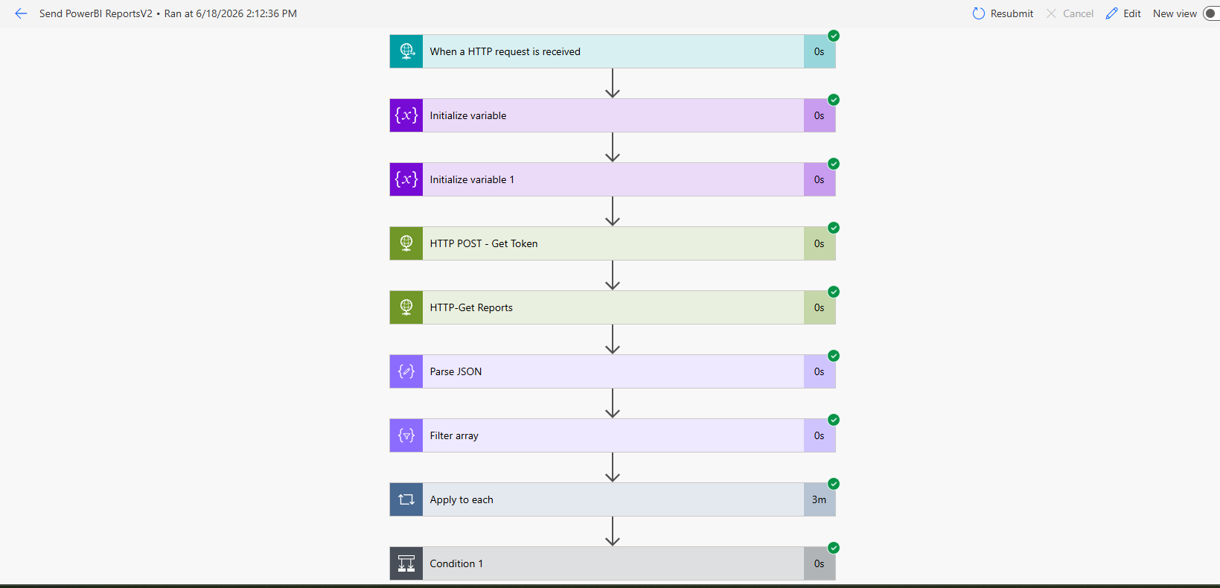
Feature Tested: Power Automate Flow 1 (Send PowerBI ReportsV2) executes successfully when triggered by an HTTP request from the web app.
Expected Result: All flow steps should complete with green checkmarks: HTTP trigger, variable initialization, token acquisition, report retrieval, JSON parsing, filtering and conditional export.
Actual Result: The flow ran successfully at 6/18/2026 2:12:36 PM with all nine steps completing without errors as shown by green checkmarks.
Status: Passed.

Figure 60. Feature Test — Flow 2 — Daily Report Monitoring Flow Run
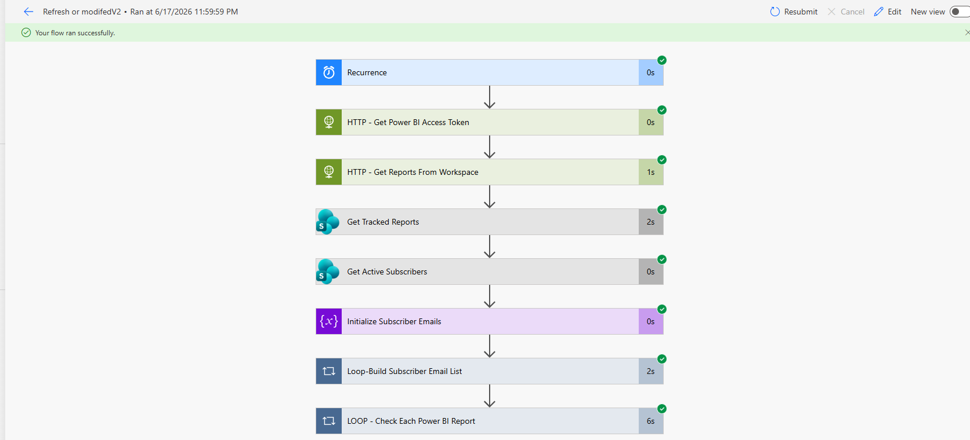
Feature Tested: Power Automate Flow 2 runs on daily recurrence to detect new or modified reports and notify subscribers.
Expected Result: The flow should execute all steps successfully: recurrence trigger, token acquisition, report retrieval, tracker comparison, subscriber list building and notification sending.
Actual Result: The flow ran successfully on 6/17/2026 at 11:59:59 PM with all eight steps completing, including the loop that checks each Power BI report.
Status: Passed.

Figure 61. Feature Test — Flow 3 — Subscriber Preference Save Flow Run
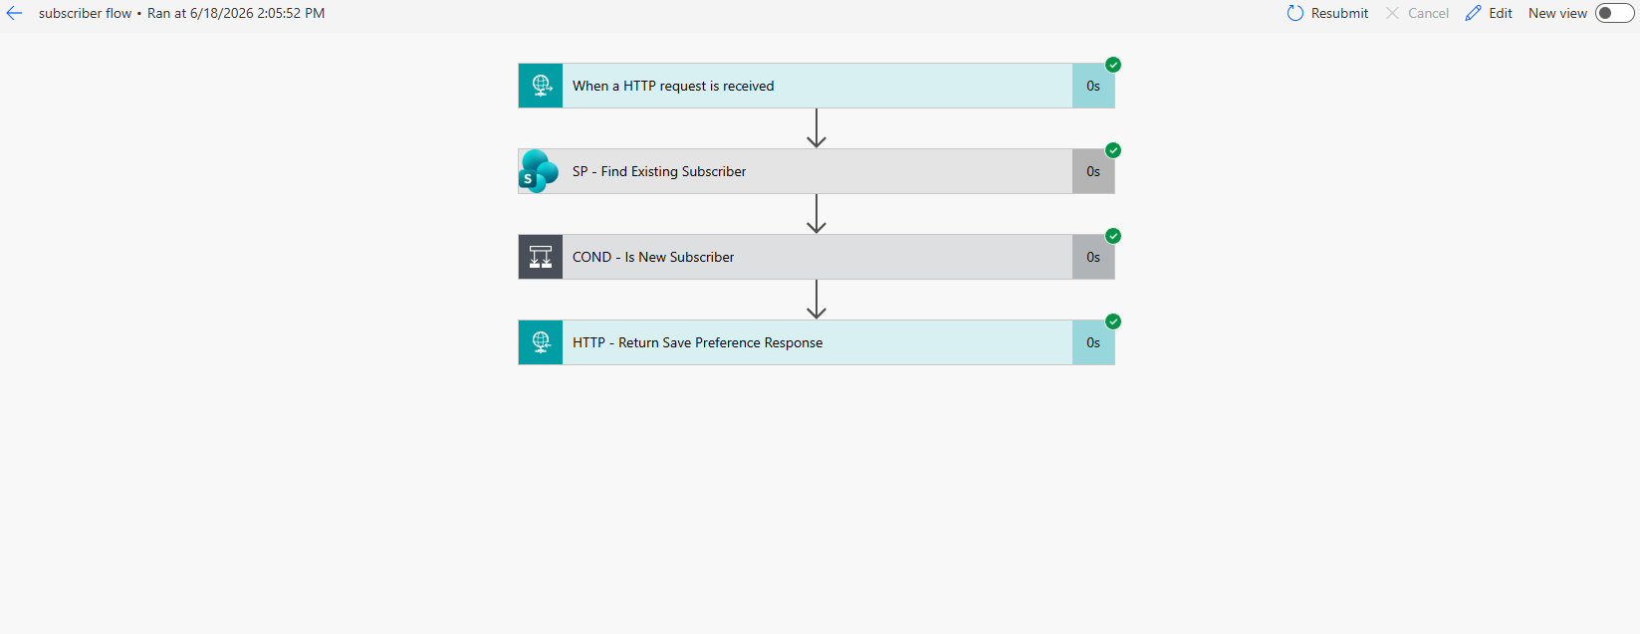
Feature Tested: Power Automate Flow 3 saves or updates a subscriber preference when triggered from the Update Alerts form.
Expected Result: The flow should find the existing subscriber, determine if it's new or existing, and return the appropriate save preference response.
Actual Result: The subscriber flow ran successfully at 6/18/2026 2:05:52 PM with all four steps completing: HTTP request, SharePoint lookup, condition check and response.
Status: Passed.

Figure 62. Feature Test — New Report Added Notification Email
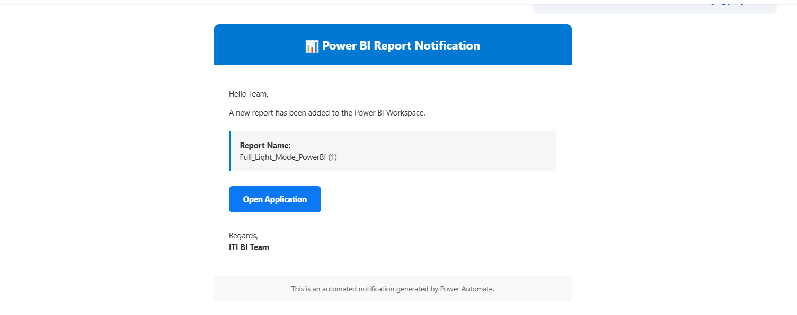
Feature Tested: Flow 2 sends an automated email notification when a new report is detected in the Power BI workspace.
Expected Result: Subscribers should receive a formatted email with the new report name and a link to open the application.
Actual Result: The email was received with the subject 'Power BI Report Notification', showing the new report name 'Full_Light_Mode_PowerBI (1)' and an Open Application button.
Status: Passed.

Figure 63. Feature Test — Modified Report Notification Email
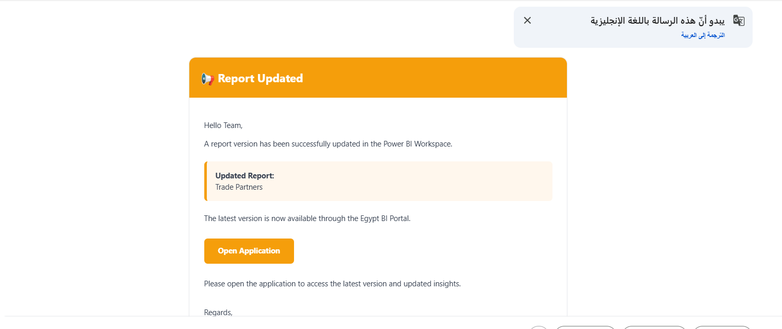
Feature Tested: Flow 2 sends an automated email notification when an existing report is modified in the Power BI workspace.
Expected Result: Subscribers should receive a formatted email indicating which report was updated with a link to access the latest version.
Actual Result: The email was received with the subject 'Report Updated' showing the updated report 'Trade Partners' and an Open Application button linking to the Egypt BI Portal.
Status: Passed.

The feature testing evidence confirms that the Egypt EconLens platform was tested across its main user-facing and integration components. The screenshots demonstrate that the web interface, embedded Power BI reports, AI Copilot, report export automation, update alerts, SharePoint persistence, Power Automate flows, and Azure deployment were executed successfully. This supports the end-to-end readiness of the platform for project demonstration and technical discussion.

17.2 Final End-to-End Test
Step | Action | Expected Result
1 | User opens Azure Web App | Egypt EconLens loads.
2 | User selects a dashboard/report | Correct Power BI asset appears.
3 | User opens AI Assistant | Chat drawer opens.
4 | User asks Arabic or English question | AI returns insight/table/chart.
5 | User opens Share Reports | Export modal opens.
6 | User selects reports and parameters | Payload prepared.
7 | User sends PDF request | Flow 1 exports and emails report link.
8 | User subscribes to updates | Flow 3 stores subscriber preference.
9 | Flow 2 runs daily | New/modified reports are detected.
10 | Subscriber receives notification | Automation cycle is complete.

18. Challenges and Fixes
During implementation, several technical challenges appeared across reporting, AI, automation, GitHub workflow and Azure deployment. Each issue was analysed and converted into a stronger design decision.
Challenge | Cause | Fix | Result
Power BI / SQL connection errors | Power BI sometimes failed to connect to SQL Server/Fabric Warehouse due to connection string, network or authentication settings. | Reviewed connection settings and used the correct Fabric/SQL endpoint configuration. | Reports were able to read from the DWH more reliably.
Fabric MFA issue | University email/password authentication failed because MFA could not be approved by the deployed Linux server. | Used Azure System Assigned Managed Identity instead of username/password. | Connection became passwordless and avoided MFA blocks.
Linux ODBC issue | Azure App Service Linux required a different ODBC connection format than local Windows development. | Used pyodbc, tcp: server prefix, port 1433 and Gunicorn startup configuration. | Flask app connected to Fabric SQL endpoint from Azure.
AI hallucinated wrong table/view names | The LLM sometimes generated non-existent objects or database-prefixed view names. | Added prompt rules and validator checks to force exact curated view names only. | AI SQL errors were reduced and query reliability improved.
Power Automate action name errors | Some flow action names contained invalid characters such as ? or special symbols. | Renamed actions using simple valid names. | Flows saved and executed without validation errors.
GitHub push/merge problems | Local and remote branches diverged, causing rejected pushes and merge conflicts. | Used fetch/pull, resolved conflicts and merged development into main. | Code integrated successfully and Azure deployment continued.
Report export parameter handling | RDL reports required different multi-value parameters such as Year and Month. | Built parameter mapping in the web app and sent values in Power Automate-compatible structure. | Paginated reports exported with correct filters.
SQL validator improvements | The original validator was limited for production SQL validation. | Added stronger sqlglot-based parsing and rules for safe SELECT-only execution. | AI-generated SQL became safer and more executable.

19. Future Enhancements
Add incremental ETL loading instead of full refresh.
Add audit tables for ETL execution logs and rejected rows.
Add supplier-level data when available.
Add real-time streaming analytics for trade/news/social signals.
Improve Power BI embedded authentication for external users.
Add role-based access control for different user types.
Add more AI chart types such as pie charts, stacked bars and KPI cards.
Add RAG-based AI answers using project documentation and report metadata.
Add voice input for the AI assistant.
Add Arabic UI mode for the web application.
Add mobile app version or PWA support.
Add admin page to manage reports, subscribers and automation settings.
Add monitoring dashboard for Power Automate flow runs.
Add CI/CD quality checks before deployment.
Add automated test suite for the Flask backend and AI pipeline.

20. Final Conclusion
Egypt EconLens represents an end-to-end Business Intelligence solution that combines data warehousing, analytical reporting, AI-assisted querying, automation and cloud deployment in one integrated platform.
The project started with a structured data foundation through SQL Server Data Warehouse and SSIS ETL processing. The warehouse integrates trade, supply-chain, country, product, commodity, date and macroeconomic data into a governed model that supports reliable analysis and reporting.
On top of the warehouse, Power BI dashboards and paginated reports provide users with interactive and printable analytics. The Flask web application brings these reports into a single interface, allowing users to navigate dashboards, export reports, subscribe to updates and interact with the AI assistant.
The final deployed solution demonstrates a complete BI architecture that connects data engineering, reporting, automation, AI and cloud hosting. It provides a practical foundation for future improvements such as real-time analytics, role-based access, enhanced AI capabilities and production-grade monitoring.

