|  |  |
| --- | --- |
|  | ***Code*: *TM112***  Tutor-Marked Assignment (TMA) Spring 22/23 |

**Cut-Off Date:** Based on the Published Deadline. **Total Marks:100** marks turned to 15 marks **Contents**

Warnings and Declaration…………………………………….………………………………......1

Question 1 ……………….…………………………………. ………………………………...…..2

Question 2 ………………………………………………………………………………….…..…..2

Question 3 ………………………………………………………………………………….…..…..2

Question 3 ………………………………………………………………………………….…..…..3

**Plagiarism Warning:**

As per AOU rules and regulations, all students are required to submit their own TMA work and avoid plagiarism. The AOU has implemented sophisticated techniques for plagiarism detection. You must provide all references in case you use and quote another person's work in your TMA. You will be penalized for any act of plagiarism as per the AOU's rules and regulations.

**Declaration of No Plagiarism by Student (to be signed and submitted by student with TMA work):**

I hereby declare that this submitted TMA work is a result of my own efforts and I have not plagiarized any other person's work. I have provided all references of information that I have used and quoted in my TMA work.

Name of Student:…………………………….. Signature:…………………………………………... Date:…………………………………………………

**Problem 1: (30 marks)**

ChatGPT is an AI language model developed by OpenAI, which is capable of generating human-like text based on the input it is given.

1. How does ChatGPT work?
2. Make a Comparison between ChatGPT and google?

Briefly, in not more than 80 to 100 words each.

**Problem 2: (20 marks)**

1. A two-hour movie requires 325 GB to be displayed on the computer. Each frame needs 2 MB. Find the frame rate (fps) used
2. A 7 × 5 block with even parity checks is received as

|  |  |  |  |  |
| --- | --- | --- | --- | --- |
| 0 | 0 | 0 | 0 | 0 |
| 0 | 0 | 0 | 0 | 0 |
| 0 | 1 | 1 | 0 | 0 |
| 0 | 1 | 0 | 0 | 1 |
| 0 | 0 | 1 | 1 | 1 |
| 1 | 1 | 0 | 0 | 0 |
| 1 | 1 | 1 | 1 | 0 |

Which bit is an error? ( redraw the corrected data matrix sent)

**Problem 3: (25 marks)**

1. Calculate the denary number of the binary number 11011.11
2. Perform the following base conversions

a. (01100110)10 = ()2

b. (11100110)2 = ()8

c. (31)10=()16

d. (23)8 = ()10

e. (1F2)16 = ()8

1. Represent the decimal number (-90) in binary using 8-bit sign magnitude
2. Construct the truth tables NOT (A AND B) and NOT A OR NOT B, and hence show that these two logic expressions are equivalent to each other.

**Problem 4: (25 marks)**

1. What are the types of relationships in database?
2. Consider the following database table:

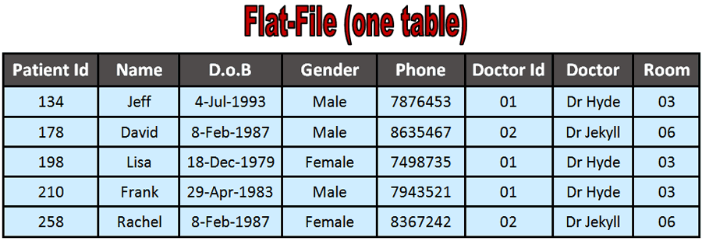

Convert this flat database table into relational database and deduce its type?