SJF vs Priority Comparison Project
Cover Sheet - Algorithm Comparison Project
Project Title | SJF vs Priority Comparison Project | Team Number
Repository URL | https://github.com/moabdelnaserr/CPU-Scheduling-Simulator

Team Members
No. | Student Name | Student ID | Contribution Area | Grade | Notes
1 | Mostafa Ahmed Gad | 20240954 | UI Design & Frontend
2 | Omar Hoassam Mohammed | 20240627 | SJF Algorithm Implementation
3 | Marwan Awad Abd Al-Galil | 20240921 | Priority Scheduling Implementation
4 | Adham Ibrahim Saied | 20240103 | Metrics Calculation, Testing & Documentation
5 | Mohammed AbdulNasser Ali Atta | 20240850 | Input Validation & Error Handling
6 | Omar Wael Mohammed | 20230381 | Gantt Chart Animation & Visualization
7

Evaluation Rubric Summary
Criterion | Marks | Specific focus | Notes for evaluator
Interface and usability | 15 | - | Clean layout, easy data entry, easy comparison workflow, readable output.
Input handling and validation | 10 | - | Reject invalid numeric input, duplicate IDs, missing values, invalid quantum/priority values.
Algorithm A correctness | 15 | SJF | Correct process selection, arrival handling, ties, completion behavior, and algorithm-specific rules.
Algorithm B correctness | 15 | Priority Scheduling | Correct process selection, arrival handling, ties, completion behavior, and algorithm-specific rules.
Gantt charts and execution visualization | 10 | - | Separate readable Gantt chart for each algorithm with correct time markers and execution order.
Metrics calculation | 10 | - | Correct WT, TAT, RT for each process and correct averages, consistent with charts.
Comparison quality and fairness | 10 | Both algorithms | Same workload, correct comparison tables, valid analysis of trade-offs and recommendation.
Required test scenarios | 5 | - | Normal case, behavior-revealing case, and invalid-input validation case are all included.
Report and technical explanation | 5 | - | Clear write-up, screenshots, assumptions, limitations, and technically correct conclusions.
Viva / team understanding | 5 | - | Team members can explain both algorithms, outputs, metrics, and design decisions.

Variant-Specific Checklist
Use this page during review. A project should not be considered complete until all variant-specific items have been checked.
Check | Checklist Item | Notes
☐ | SJF selection is based on the shortest available burst time.
☐ | Priority rule is stated clearly and applied consistently.
☐ | At least one workload shows conflict between short burst time and high priority.
☐ | Comparison tables use the same dataset for both algorithms.
☐ | Conclusion explains efficiency versus urgency trade-off.

Project-Specific Notes for Students
• Use the same workload in both algorithms.
• Assume preemptive SJF and Priority Scheduling.
• Discuss efficiency versus urgency when short jobs and high-priority jobs conflict.
• Explain whether either policy causes unfair delay.

SJF vs Priority Scheduling Comparison Project

1. Introduction:
CPU Scheduling is one of the most important concepts in Operating Systems. Scheduling algorithms determine which process gets access to the CPU and for how long.
This project implements and compares two preemptive CPU scheduling algorithms:
• Shortest Job First (SJF)
• Priority Scheduling
The system calculates and compares:
• Waiting Time (WT)
• Turnaround Time (TAT)
• Response Time (RT)
The project also visualizes execution using animated Gantt Charts.
2. Project Objectives:
The main objectives of this project are:
• Understand CPU scheduling algorithms
• Compare SJF and Priority Scheduling
• Analyze scheduling performance
• Calculate CPU scheduling metrics
• Visualize process execution using Gantt Charts
• Study fairness and efficiency trade-offs

3. Shortest Job First (SJF):
Shortest Job First Scheduling selects the process with the shortest remaining burst time.
In the preemptive version, if a new process arrives with a shorter remaining time than the currently running process, the CPU switches to the new process immediately.
Advantages:
• Reduces average waiting time
• Efficient for short processes
Disadvantages:
• Long processes may suffer starvation
• Difficult to predict future burst times
Pseudo Code:
While processes remain:
Select process with shortest remaining burst time
Execute process for 1 time unit
Update remaining time
4. Priority Scheduling:
Priority Scheduling selects the process with the smallest priority number.
In this project, the algorithm is implemented as preemptive scheduling.
If a process with higher priority arrives, the currently running process is interrupted.
In this implementation, a smaller priority number represents a higher priority level.
Advantages:
• Important tasks execute first
• Useful in real-time systems

Disadvantages:
• Low-priority processes may suffer starvation

5. Performance Metrics:
The following metrics are used to compare both algorithms:
Turnaround Time (TAT):
TAT = Completion Time - Arrival Time
Waiting Time (WT):
WT = Turnaround Time - Burst Time
Response Time (RT):
RT = First Start Time - Arrival Time
6. Technologies Used:
• HTML
• CSS
• JavaScript
• GitHub
7. System Features:
The implemented system includes:
• Dynamic process input
• Input validation
• Animated Gantt Charts
• SJF scheduling simulation
• Priority scheduling simulation
• Automatic metric calculations
• Interactive graphical user interface
8. Test Scenarios:
Test Case 1 – Normal Case
| Process | Arrival Time | Burst Time | Priority |
|----------|--------------|-------------|-----------|
| P1 | 0 | 5 | 2 |
| P2 | 1 | 3 | 1 |
| P3 | 2 | 8 | 4 |
This test case demonstrates normal execution behavior.

Test Case 2 – Conflict Between SJF and Priority
Process | Arrival Time | Burst Time | Priority
P1 | 0 | 10 | 5
P2 | 0 | 1 | 1
P3 | 1 | 2 | 2
P4 | 1 | 1 | 3

This scenario demonstrates the conflict between efficiency and urgency.
SJF prefers shorter jobs, while Priority Scheduling prefers more important jobs.
Test Case 3 – Invalid Input Validation
Examples:
• Negative burst time
• Empty input fields
• Invalid numeric values
9. Comparison Between Algorithms:
SJF Scheduling improves CPU efficiency by reducing average waiting time. However, long processes may wait for a very long time.
Priority Scheduling ensures urgent processes execute first, but low-priority processes may suffer starvation.
The project demonstrates the trade-off between efficiency and urgency.
Metric | SJF Scheduling | Priority Scheduling
Average Waiting Time | 1.75 | 2.00
Average Turnaround Time | 5.25 | 5.50
Average Response Time | 1.75 | 2.00

The comparison results show that SJF Scheduling achieved lower average waiting time and turnaround time compared to Priority Scheduling.
SJF improved CPU efficiency by executing shorter processes first, which reduced overall waiting time.
Priority Scheduling focused on executing higher-priority processes first, even when shorter jobs were available. This behavior increased waiting time for some lower-priority processes.
The results demonstrate the trade-off between efficiency and urgency in CPU scheduling algorithms.
10. Challenges Faced:
• Implementing preemptive scheduling
• Synchronizing Gantt chart animations
• Handling invalid inputs
• Calculating scheduling metrics correctly
11. Conclusion:
This project successfully implements and compares SJF and Priority Scheduling algorithms.
The system provides visual simulation, performance metrics, and execution analysis using Gantt Charts.
The comparison highlights the strengths and weaknesses of both scheduling techniques.
12. Screenshots and Execution Results:
- Screenshot1: Main Interface (without adding anything):
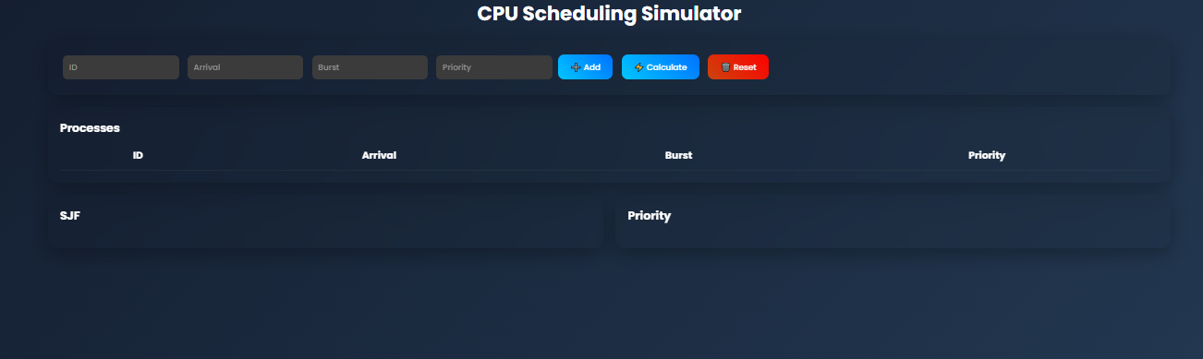
- Screenshot2: Added Processes (after adding examples):
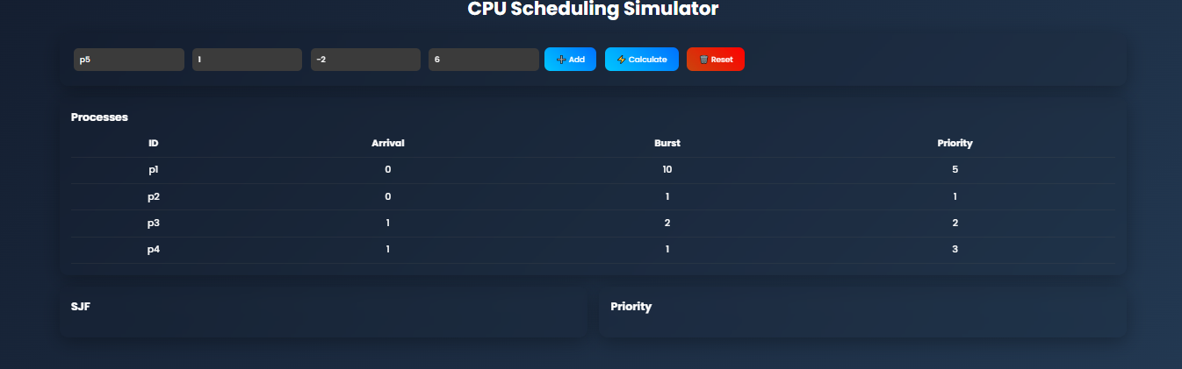
- Screenshot3: Priority Scheduling (including gantt):
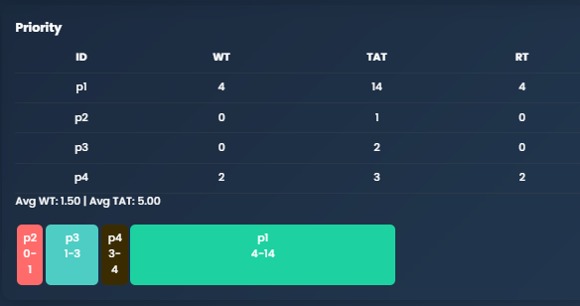
- Screenshot4: SJF Scheduling (including gantt):
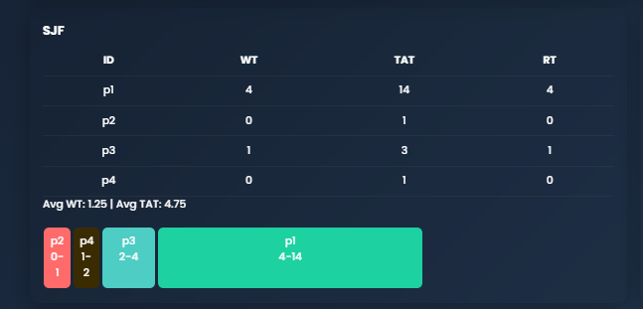
- Screenshot5: Validation (entering negative number in Burst):

- Screenshot6: All (complete output):
