Project

2022-11-10

## Reading in Data

race<- read.csv("HEsegDataviz_CollegeData_4-year_v5.csv")  
mrc<- read.csv("mrc_table1.csv")  
grad<- read.csv("cc_institution_details.csv") %>%  
subset(select = c("chronname","grad_100_percentile"))  
state <- read.csv("state_abbrev_crosswalk.csv")%>%  
 rename(state = Code)  
grad <- grad %>%  
rename(name = chronname)  
race <- race %>%  
rename(name = inst_name)  
race_mrc <- mrc %>%  
 inner_join(race, by = "name")  
college <- race_mrc %>%  
 inner_join(grad, by = "name")%>%  
 filter(year == 2013)%>%   
 filter(state == "AL"| state == "FL"| state == "GA"| state == "AR"| state == "KY"| state == "LA"| state == "MS"| state == "NC"| state == "SC"| state == "TN")  
college$grad_100_percentile <- as.numeric(college$grad_100_percentile)

## Warning: NAs introduced by coercion

college$grad_100_percentile[is.na(college$grad_100_percentile)]<-mean(college$grad_100_percentile,na.rm=TRUE)  
college <- college%>%  
 left_join(state, by = "state")  
college <- college %>%  
 rename(NAME = State)

## Initial Graphs

#Box Plot   
college %>%  
 ggplot(mapping = aes(x = grad_100_percentile, y = par_median)) +  
geom_boxplot(mapping = aes(group = cut_width(grad_100_percentile, 25))) +  
 labs(x = "4-Year Graduation Rate", y = "Median Parental Income")

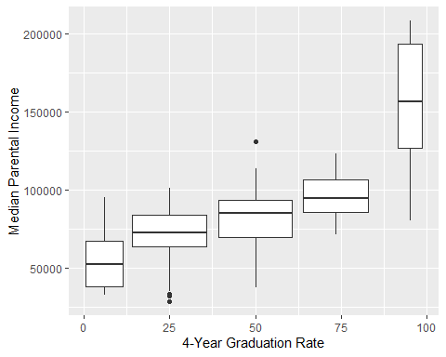

#Facet Wrap  
college %>%   
 ggplot(mapping = aes(x = grad_100_percentile , y = par_median )) + geom_point() +  
 facet_wrap(~state, nrow = 2) +  
 labs(x = "4-Year Graduation Rate", y = "Median Parental Income")

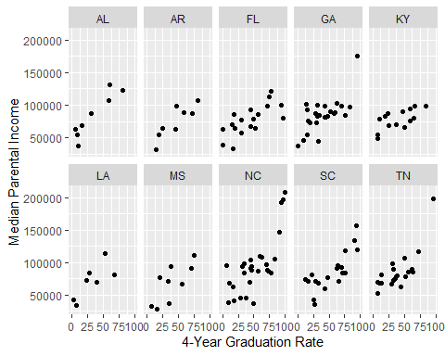

#Scatter Plot  
college %>%   
 ggplot(mapping = aes(x = grad_100_percentile , y = par_median , color = state)) + geom_point() +  
 labs(x = "4-Year Graduation Rate", y = "Median Parental Income")

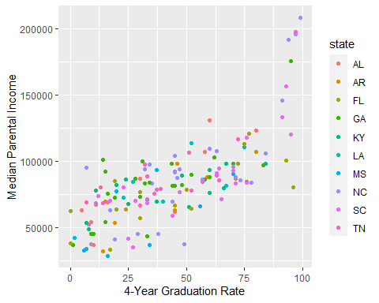 ## Initial Maps

library(tidycensus)  
library(tmap)  
library(sf)

## Linking to GEOS 3.9.1, GDAL 3.4.3, PROJ 7.2.1; sf_use_s2() is TRUE

library(rgdal)

## Loading required package: sp

## Please note that rgdal will be retired by the end of 2023,  
## plan transition to sf/stars/terra functions using GDAL and PROJ  
## at your earliest convenience.  
##   
## rgdal: version: 1.5-32, (SVN revision 1176)  
## Geospatial Data Abstraction Library extensions to R successfully loaded  
## Loaded GDAL runtime: GDAL 3.4.3, released 2022/04/22  
## Path to GDAL shared files: C:/Users/momos/AppData/Local/R/win-library/4.2/rgdal/gdal  
## GDAL binary built with GEOS: TRUE   
## Loaded PROJ runtime: Rel. 7.2.1, January 1st, 2021, [PJ_VERSION: 721]  
## Path to PROJ shared files: C:/Users/momos/AppData/Local/R/win-library/4.2/rgdal/proj  
## PROJ CDN enabled: FALSE  
## Linking to sp version:1.5-0  
## To mute warnings of possible GDAL/OSR exportToProj4() degradation,  
## use options("rgdal_show_exportToProj4_warnings"="none") before loading sp or rgdal.

library(cartogram)

## Warning: package 'cartogram' was built under R version 4.2.2

library(igraph)

## Warning: package 'igraph' was built under R version 4.2.2

##   
## Attaching package: 'igraph'

## The following objects are masked from 'package:dplyr':  
##   
## as_data_frame, groups, union

## The following objects are masked from 'package:purrr':  
##   
## compose, simplify

## The following object is masked from 'package:tidyr':  
##   
## crossing

## The following object is masked from 'package:tibble':  
##   
## as_data_frame

## The following objects are masked from 'package:stats':  
##   
## decompose, spectrum

## The following object is masked from 'package:base':  
##   
## union

library(ggraph)

## Warning: package 'ggraph' was built under R version 4.2.2

##   
## Attaching package: 'ggraph'

## The following object is masked from 'package:sp':  
##   
## geometry

us <- get_acs(geography = "state",   
 variables = "B02001_001",  
 year=2013,   
 geometry = TRUE,  
 shift_geo = TRUE)

## Getting data from the 2009-2013 5-year ACS

## Warning: The `shift_geo` argument is deprecated and will be removed in a future  
## release. We recommend using `tigris::shift_geometry()` instead.

## Using feature geometry obtained from the albersusa package

## Please note: Alaska and Hawaii are being shifted and are not to scale.

## old-style crs object detected; please recreate object with a recent sf::st_crs()

college_map <- college %>%  
 inner_join(us, by = "NAME")  
college_map_grad <- college_map %>%  
 group_by(NAME)%>%  
 summarise(NAME, geometry, `4-Year Graduation Rate` = mean(grad_100_percentile))

## `summarise()` has grouped output by 'NAME'. You can override using the  
## `.groups` argument.

st_sf(college_map_grad) %>%  
 tm_shape() +  
 tm_polygons("4-Year Graduation Rate", palette = "Greens")

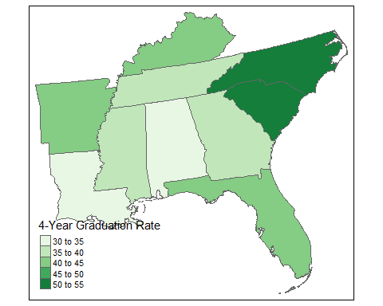

college_map_income <- college_map%>%  
 group_by(NAME)%>%  
 summarise(NAME, geometry, `Median Parental Income` = mean(par_median))

## `summarise()` has grouped output by 'NAME'. You can override using the  
## `.groups` argument.

st_sf(college_map_income) %>%  
 tm_shape() +  
 tm_polygons("Median Parental Income", palette = "Greens")

