Strip steak & roasted potatoes | hash browns.

Looking for an indulgent, protein-packed breakfast? You're in the right place. Vegetable oil, Kosher salt, plus more for seasoning to taste, Freshly ground black pepper, plus more for seasoning to taste, Smoked paprika, plus more for seasoning to taste & butter, eggs

Roasted potatoes, for serving

Parsley, for serving

Dill, for serving

Serving: 4

Prep-Time: 45min

Steps

DirectionsInstructions Checklist

Step 1

Set a rack in a rimmed baking sheet. Season the steak with 1 tablespoon of salt and transfer to the rack. Refrigerate, uncovered, overnight. Let the steak come to room temperature 30 minutes before cooking.

Step 2

Preheat the oven to 400°. Heat a large cast-iron skillet until very hot, about 5 minutes. Pat the steak dry with paper towels and season with salt and pepper. Cook the steak over moderate heat until browned and crusty, about 3 minutes. Add the butter, turn the meat and transfer the skillet to the oven. Roast until an instant-read thermometer inserted in the thickest part registers 120° for medium-rare, 12 to 15 minutes. Transfer the steak to a work surface and let rest for 10 minutes before serving.

Extras

Green Peppercorn Jus, Curry-Mustard Mayonnaise and House Steak Sauce.

Argentinean-Style Grilled Beef Short Ribs

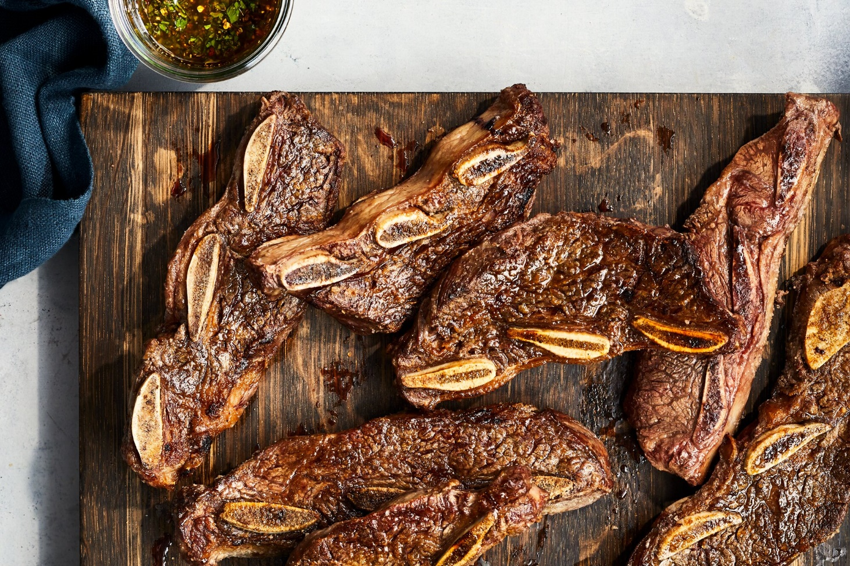

Ingredients

pounds flanken-cut 3-bone beef short ribs, at room temperature (about 6 short ribs, 11/4 inches thick)

1 ½ tablespoons coarse sea salt or sal parrillera (such as Dos Anclas)

Balsamic Chimichurri

Step 1

Preheat grill (preferably a wood fire) to medium-high (400°F to 450°F). Meanwhile, pat ribs dry with paper towels. Sprinkle all sides of ribs evenly with salt, pressing salt into meat and rubbing it on bones.

Step 2

Arrange ribs diagonally and spaced 1 inch apart on lightly oiled grill grates. Grill, uncovered and undisturbed, until bottoms of ribs are browned and release from grates, 4 to 6 minutes. Flip ribs; grill, uncovered, until browned and a thermometer inserted near the bone but not touching it registers 130°F, 2 to 4 minutes. Remove from grill, and let rest 5 to 10 minutes.

Step 3

Serve ribs whole, or, if serving with an assortment of meats for a larger group, cut each rib into thirds on the diagonal. Serve with chimichurri.

# Beef Wellington

# **Ingredients**

Beef

* Center-cut beef tenderloin roast (about 12 inches long and 3 inches in diameter), trimmed.
* 2 teaspoons kosher salt
* 1 teaspoon freshly ground black pepper
* ¼ ounce dried porcini mushrooms (5 to 6 pieces), ground to a powder in a spice grinder
* 2 tablespoons canola oil
* 1 ½ tablespoons Dijon mustard

Duxelles

* 1 ½ pounds fresh cremini mushrooms, stems trimmed, coarsely chopped (8 cups)
* 3 large shallots, roughly chopped (about 1/2 cup)
* 3 tablespoons unsalted butter
* 3 medium garlic cloves, finely chopped
* 1 tablespoon chopped fresh thyme leaves, plus thyme branches for serving
* 2 ½ tablespoons dry sherry
* ½ teaspoon teaspoon freshly ground black pepper

**Directions**

Prepare the Beef

* **Step 1**

Using kitchen twine, tie tenderloin crosswise at 2-inch intervals, starting from center and working out to ends. Sprinkle beef all over with salt and pepper. Place on a wire rack set inside a rimmed baking sheet. Let stand at room temperature 1 hour. (To make ahead, chill, uncovered, 12 hours; let stand at room temperature 1 hour before cooking.)

Prepare the duxelles

* **Step 2**

Pulse half of the cremini mushrooms and half of the shallots in a food processor until very finely chopped, about 10 pulses, stopping to scrape down sides and stir as needed so you have evenly sized pieces. Transfer mixture to a medium bowl. Repeat process with remaining creminis and shallots.

* **Step 3**

Melt butter in a large skillet over medium-high until foamy. Add cremini-shallot mixture; cook, stirring occasionally, until creminis are dry and beginning to brown and stick to bottom of skillet in spots, 25 to 30 minutes. Add garlic and thyme; cook, stirring constantly, until fragrant, about 1 minute. Add sherry and pepper, stirring to scrape up any browned bits on bottom of skillet. Cook, stirring often, until mixture is dry and just starts to stick to bottom of skillet again, 2 to 4 minutes. Remove from heat. Spread mixture out on a small baking sheet. Chill, uncovered, until cold, about 30 minutes. Cold duxelles may be stored in an airtight container in refrigerator up to 2 days.

* **Step 4**

Heat canola oil in a large skillet or a small roasting pan over medium-high until shimmering. Add tenderloin; cook, turning occasionally, until browned on all sides, 10 to 12 minutes. Transfer tenderloin to a wire rack set inside a baking sheet; let cool 15 minutes. Remove and discard twine. Brush tenderloin all over with mustard, and sprinkle all over with porcini powder. Chill beef in refrigerator, uncovered, at least 1 hour (or up to 3 hours).

* **Step 5**

Moisten a clean work surface with a damp kitchen towel, and overlap 3 pieces of plastic wrap on work surface to form a 22-inch square. Overlap the 2 phyllo sheets in center of plastic wrap to form a 13 1/2-by-12-inch rectangle, with long edge facing you. Overlap prosciutto on top of phyllo in 2 rows, leaving about a 1/2-inch border on the left and right phyllo edges. Spread duxelles evenly over prosciutto, and gently press down to form an even layer. Sprinkle with chives and parsley. Lay chilled beef lengthwise over bottom third of duxelles. Roll up beef and phyllo into a log, using plastic wrap as a guide and keeping it on the exterior of the log. Hold the outer ends of plastic wrap, and roll log on work surface back toward you to tighten. Refrigerate while you prepare the puff pastry.

* **Step 6**

Preheat oven to 425°F. Roll puff pastry out on a lightly floured work surface to a 15-by-12-inch rectangle with long edge facing you. Lightly brush top third of puff pastry with some of the beaten egg. Unwrap chilled beef log, and discard plastic wrap. Lay log lengthwise on bottom edge of puff pastry. Holding edge in place, roll up jelly-roll style until log is completely wrapped. Roll to face log seam side up, and gently press overlapping dough to seal. Fold ends of puff pastry down over beef, pinching seams to seal.

* **Step 7**

Transfer beef log, seam side down, to a baking sheet lined with parchment paper. Brush off excess flour using a pastry brush. Brush puff pastry all over with beaten egg. Using a paring knife, very light score a line lengthwise down center of puff pastry. Very lightly score 2 lines parallel to the first, 1 on either side of the center line, and each spaced 1 1/2 inches outward from the center. Very lightly score zig-zag lines across beef Wellington, spacing rows 1/2 inch apart and forming a herringbone-like pattern. Sprinkle with flaky sea salt. Using the tip of a paring knife, create 3 (1-inch-long) steam vents along center line, spaced about 3 inches apart.

* **Step 8**

Bake until puff pastry is puffed and browned and a thermometer inserted into center of beef registers 120°F, 40 to 45 minutes. Using 2 large spatulas, carefully lift beef Wellington from baking sheet, and transfer to a cutting board. Let rest 15 minutes. Using a serrated knife, cut into slices. Serve beef Wellington on a platter, garnished with thyme branches.