**Kale Juice**

Ingredients

small lemon, scrubbed

One medium bunch of curly kale, stemmed

Persian cucumbers

One 1-inch piece peeled fresh ginger

cup cilantro leaves

Kosher salt

Ice, for serving

jalapeño piece (optional)

**Total:**

10 mins

**Yield:**

One 16-ounce juice

Step 1

Using a small sharp knife, peel the lemon, removing all of the bitter white pith. In an electric juicer, juice the kale with the lemon, cucumbers, ginger, cilantro and, if using, the jalapeño. Season the juice with a pinch of salt and serve over ice.

**Cantaloupe Juice with Ginger and Lime**

**Active:**

10 mins

**Total:**

40 mins

**Yield:**

Makes two 8-ounce drinks

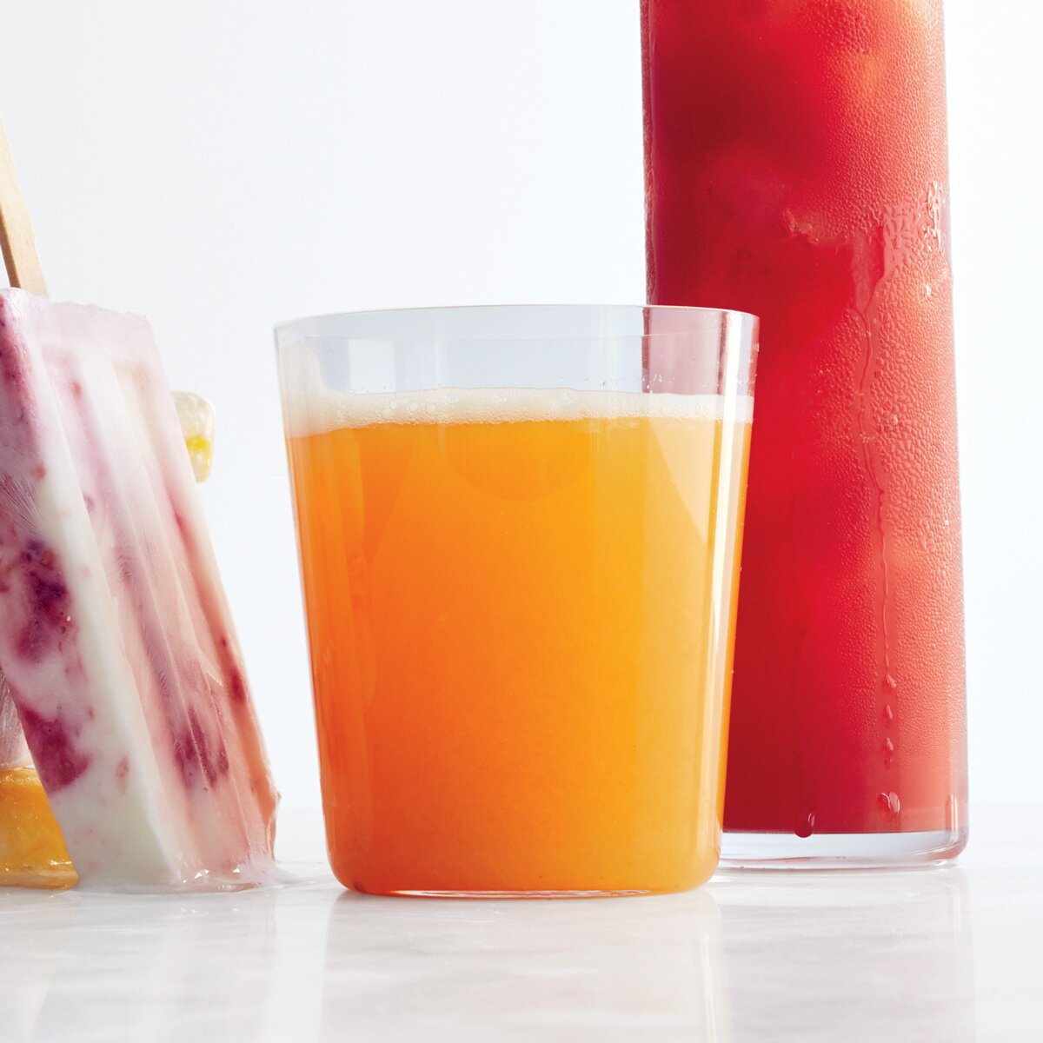

Ingredients

Ingredient Checklist

Enjoy chopped cantaloupe and pineapple

piece of fresh ginger

lime

Step 1

On a rimmed baking sheet lined with parchment paper, spread the cantaloupe and pineapple in an even layer and freeze until just frozen, about 30 minutes.

Step 2

In an electric juicer, juice the frozen fruit with the ginger and lime. Serve immediately.

**Cilantro-Celery Punch**

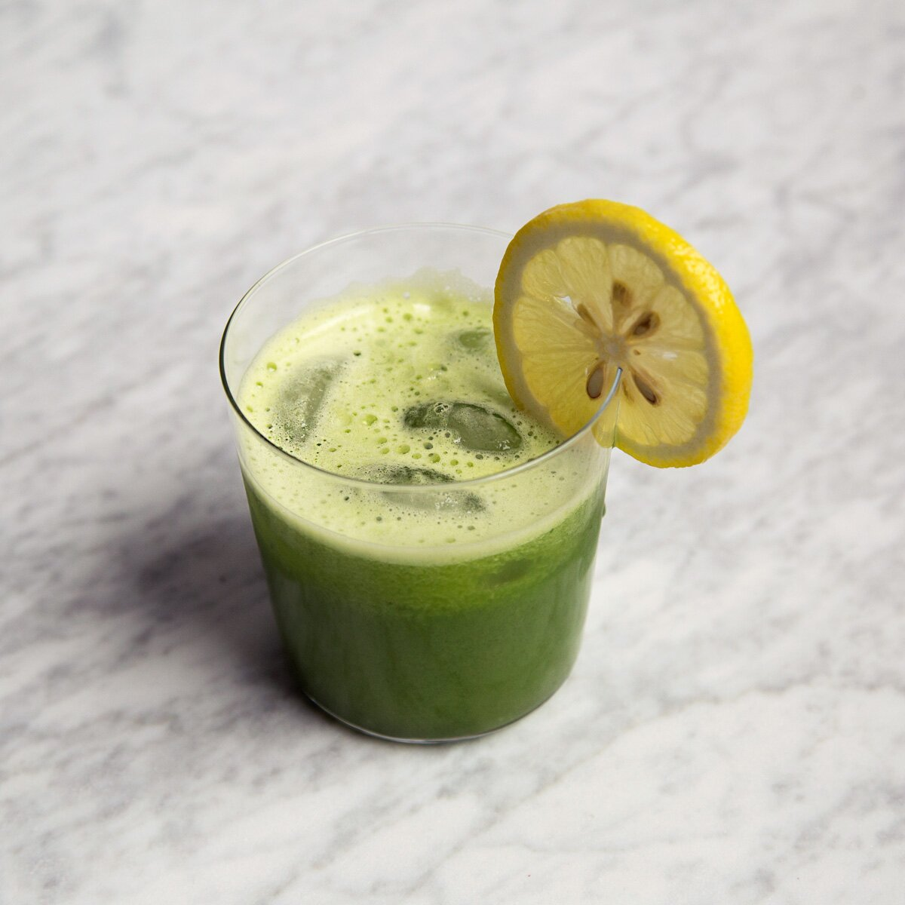

## Ingredients

Ingredient Checklist

* celery stalks with leaves
* small Granny Smith apples
* packed cilantro leaves
*  peeled ginger
*  fresh lemon juice
* Ice
* **Step 1**

In an electric juicer, juice the celery with the apples, cilantro leaves and ginger. Stir in the lemon juice. Serve over ice.

**Total:**

10 mins

**Yield:**

Two 15-ounce juices

Alcohol

**Pomegranate Margarita**  
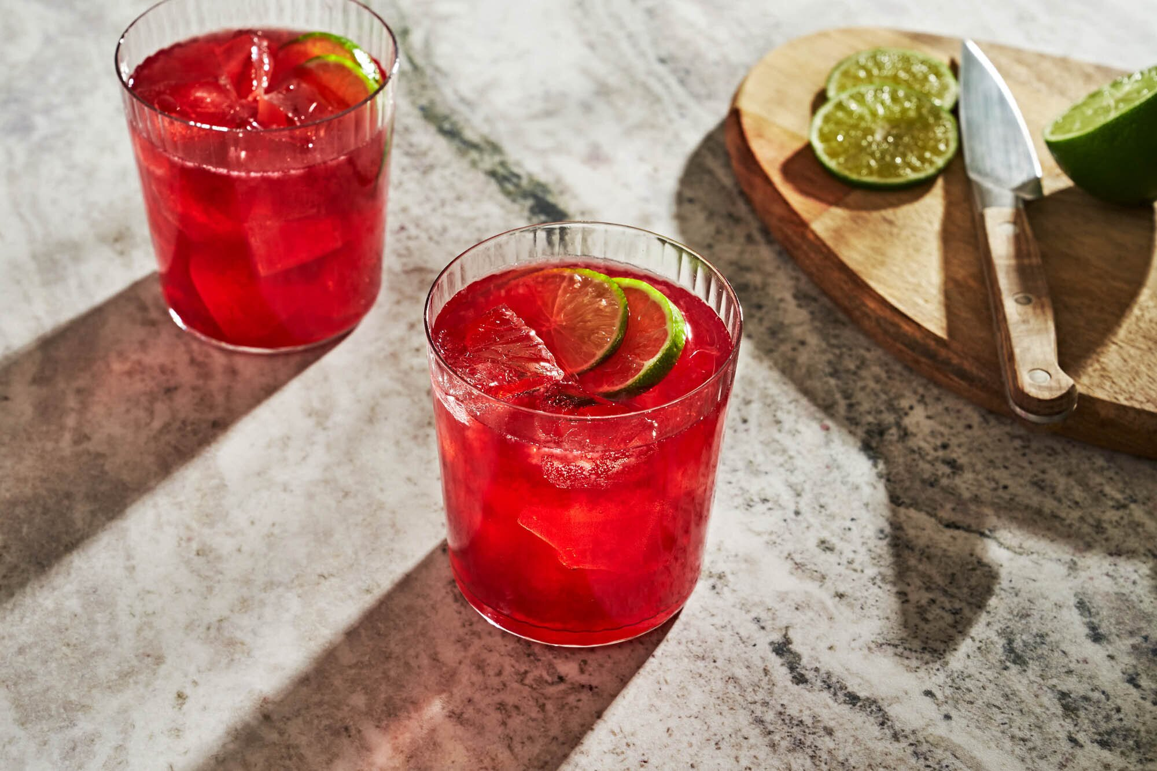

Ingredients

Ingredient Checklist

Blanco tequila, such as Teremana

;Pomegranate juice

;Fresh lime juice

;Agave nectar

;Ice

;Pinch of salt

;Lime wheel, for garnish

Step 1

Add tequila, pomegranate juice, fresh lime juice, agave nectar and salt into a cocktail shaker filled with ice. Shake vigorously until outside of shaker is frosty; strain into a rocks glass filled with ice. Garnish with lime wheel.

**Total:**

5 mins

**Yield:**

Makes 1 drink

**Birria Maria**

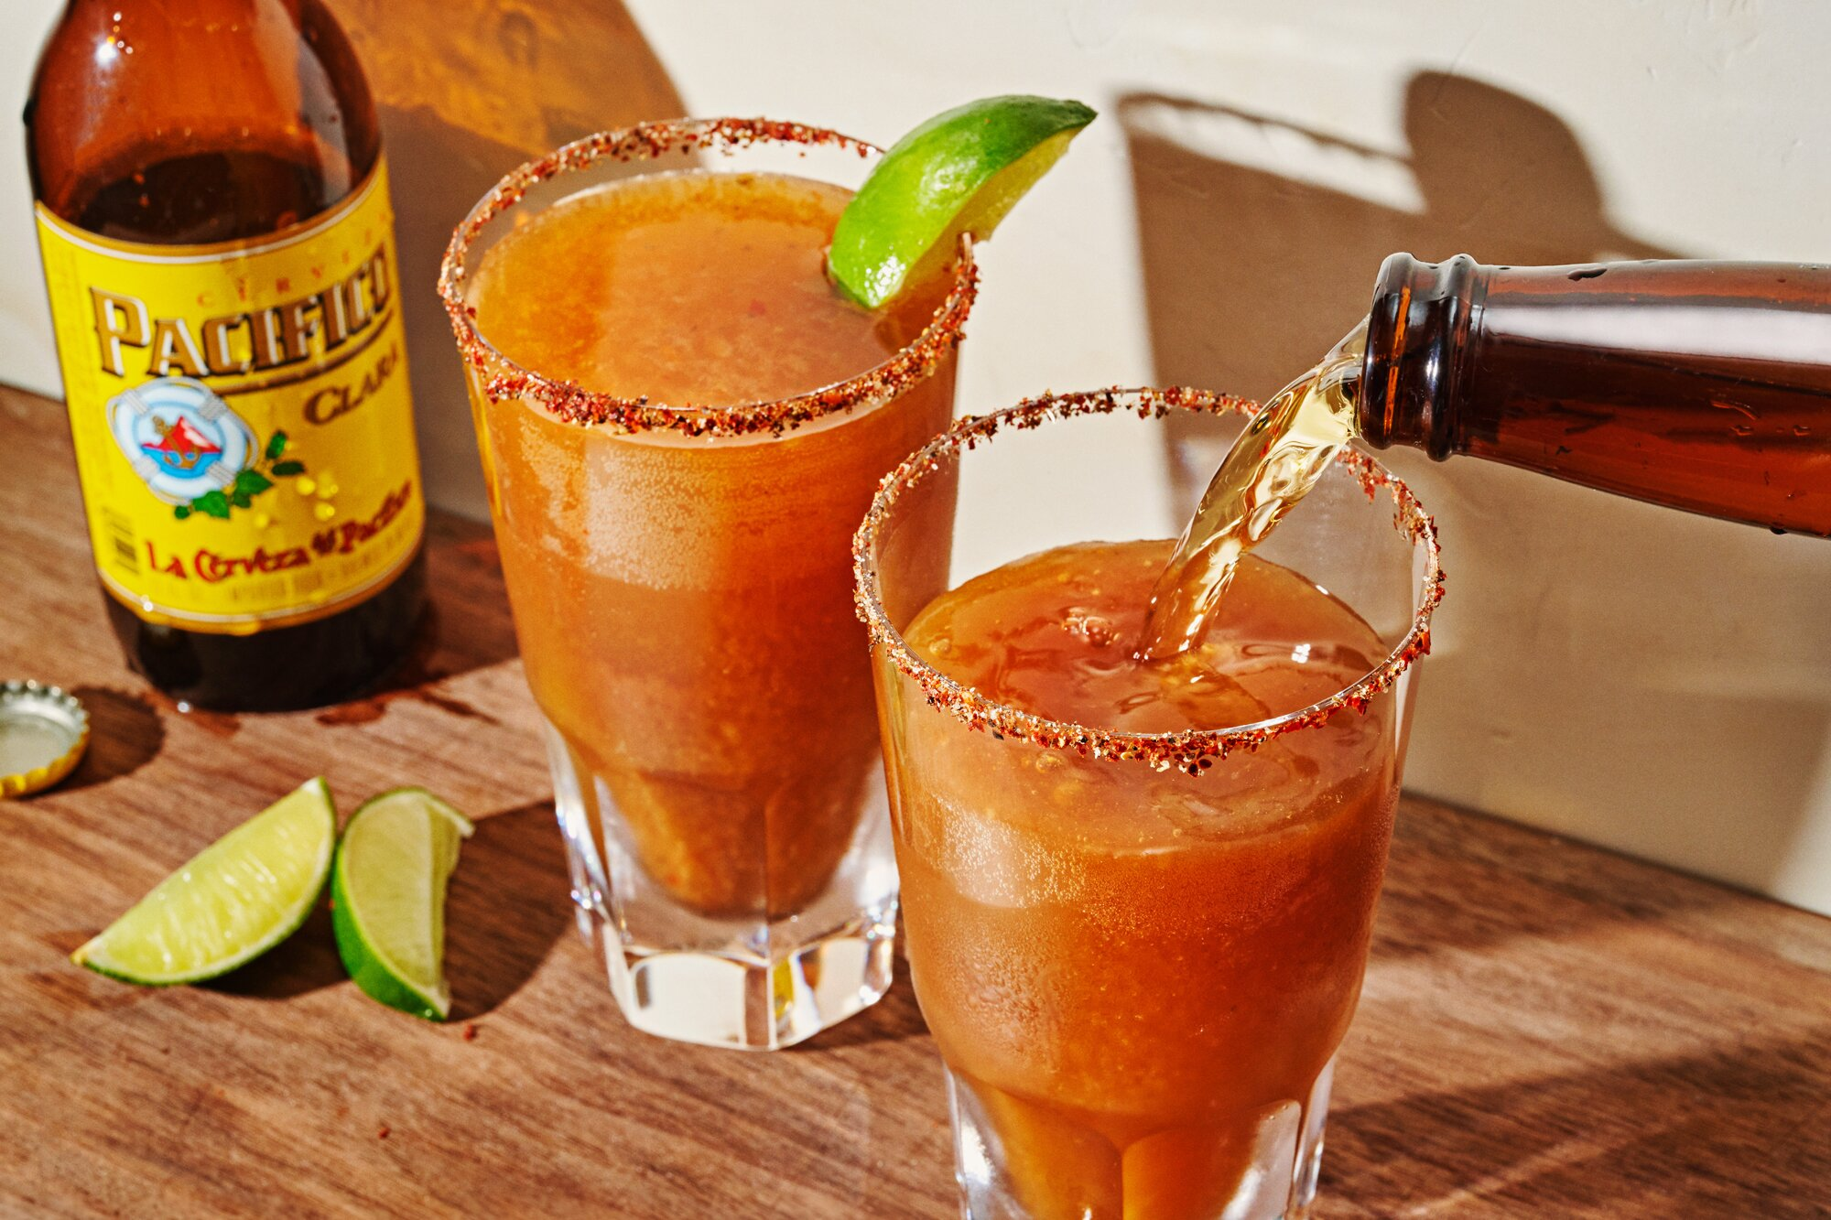

Ingredient Checklist

Chili limon (such as Tajin)

orange wedge

[cold birria broth](https://www.foodandwine.com/recipes/birria-tacos) (caldo), skimmed of all fat, strained

 fresh lime juice, optional

 fresh orange juice

 tequila blanco (such as Fortaleza)

Hot sauce (such as Valentina or Tapatio), to taste

Salsa Maggi (or Worcestershire sauce), to taste

Red wine vinegar or other fruity vinegar, to taste

Cold beer (such as Pacifico, or a saison or sour), for topping off

lime wedges, for garnishing

* **Step 1**

Place a thin layer of the chili limon on a small plate. Run the orange wedge around the rim of 2 pint glasses, then dip the rims of the glasses in the chili limon to coat. In a cocktail shaker, add the birria broth, lime juice (if using), orange juice, and tequila. Add hot sauce, Salsa Maggi, and vinegar to taste. Fill the cocktail shaker with ice and carefully secure the lid.

* **Step 2**

Shake the contents vigorously for at least 30 seconds. Strain the contents of the shaker into the glasses, dividing equally. Top off with the beer and stir to blend with a cocktail spoon. Garnish with the lime wedges.

**Active:**

10 mins

**Total:**

10 mins

**Servings:**

2

Mushroom Dumplings in Toasted Ginger and Garlic Broth

Make-ahead mushroom duxelles makes a rich filling for these tender, satisfying dumplings. The broth, infused with toasted ginger and garlic, gets an extra layer of rich mushroom flavour from dried white flower shiitake mushrooms, which have a bolder flavour than regular dried shiitakes, which are a fine substitute.

# Lunar New Year Dumplings

Plump and tender dumplings symbolize longevity and wealth. Made with a fragrant and flavorful blend of garlic, ginger, scallions, and Chinese chives bound with tender ground pork. Store-bought wonton wrappers may be substituted for freshly made dough. For an extra dash of color and heat, drizzle them with with hot chile oil and sprinkle them with with pungent Chinese chives before serving them with dipping sauce.

# Hungarian Potato Dumplings

These crispy, buttery potato dumplings are encased in a delicate breading with a tender and light center. Caramelized onions, while not traditional to shlishkes, add a bit of sweetness. Do not substitute Yukon Golds for russets, here; the starch content of russet potatoes is key to these dumplings holding their shape.