Group Member Names: Anas Mohamed, Mohamed Adem, Jimmy Parra, and Abdullah Bawazir

Course and Quarter: ENGR 114, Fall 2018

Date: 12/11/2018

Revision Number: 7

## **Motion Sensor Light**

#### ***Problem Statement:***

Our group was tasked with writing code that will turn on a lamp whenever motion was detected, and plot how often the light turned on based on how long the user wanted to run the test for.

#### ***Hardware Setup:***

**Bill of Materials:**

|  |  |  |  |  |
| --- | --- | --- | --- | --- |
| **Part Name** | **Purpose** | **Item Name** | **URL** | **Price** |
| Arduino | Connect to hardware to the computer | Arduino Uno Rev 3 | https://store.arduino.cc/usa/arduino-uno-rev3 | $ 22.00 |
| breadboard | Power the relay, motion sensor and arduino | Breadboard | https://www.adafruit.com/product/64?gclid=EAIaIQobChMIia3N9eyW3wIVoCCtBh0EIgrVEAYYASABEgLZL_D_BwE | $ 5.00 |
| Jumper Wires | Connect two points together | Jumper wires | https://www.sparkfun.com/products/11026 | $ 1.95 |
| Motion sensor | Detect if there is motion | Infrared motion detector sensor | https://www.gearbest.com/development-boards/pp_70386.html?wid=1433363&currency=USD&vip=14891995&gclid=EAIaIQobChMI8bnyo-2W3wIVEcpkCh38WQxPEAYYASABEgJ2sPD_BwE | $ 1.41 |
| Relay | Powers up the whole system | Beefcake Relay | https://www.sparkfun.com/products/13815 | $ 8.95 |
| USB cable | Connect Arduino to computer | USB cable | https://www.adafruit.com/product/62?gclid=EAIaIQobChMImY202u2W3wIVkeNkCh0sVw_WEAQYASABEgIYT_D_BwE | $ 3.95 |
| Female Wall Plug | Power up the lamp | Female wall plug | https://www.pcc.edu/ | - |
| Male wall plug | Connected to an outlet | Male wall plug | https://www.pcc.edu/ | - |
| Wire Nuts | Hold two electrical conductors together | Wire nuts | https://direct.fredmeyer.com/00783250681457.html?&cid=ps_adw_fmdPRODUCT_GROUP&gclid=EAIaIQobChMI87XziOyW3wIVyiCtBh0YVQJrEAQYBCABEgK09PD_BwE&gclsrc=aw.ds | $ 11.99 |

**Hardware Schematic:** 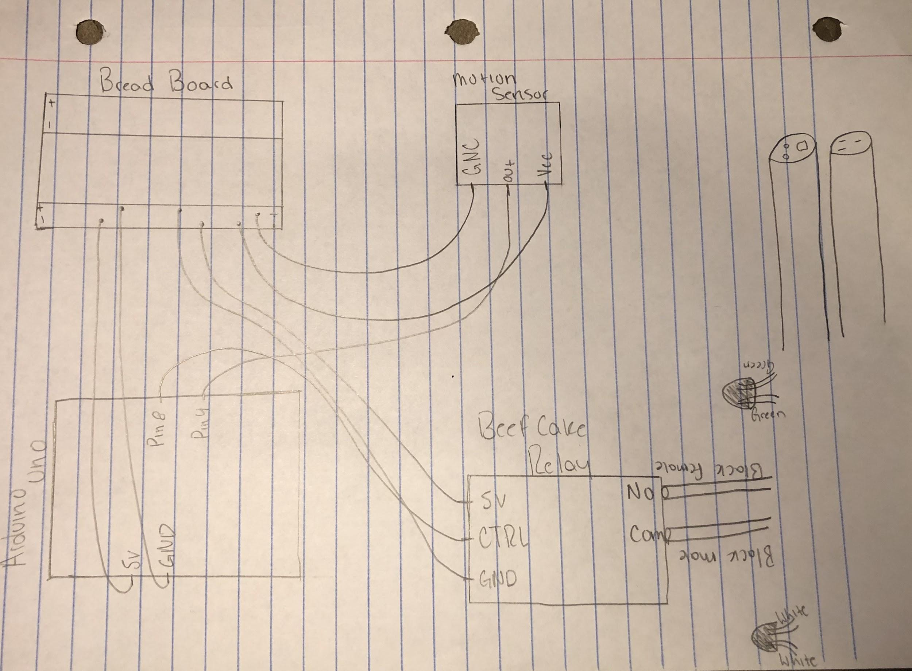

**Hookup Guide:**

|  |  |  |  |  |
| --- | --- | --- | --- | --- |
| Part | Pin | Connector | Pin | Part |
| Motion sensor | Vcc | Jumper wire | - | Breadboard |
| Motion sensor | Out | Jumper wire | 4 | Arduino |
| Motion sensor | GNC | Jumper wire | + | Breadboard |
| Relay | GND | Jumper wire | + | Breadboard |
| Relay | 5V | Jumper wire | - | Breadboard |
| Relay | CNTRL | Jumper wire | 8 | Arduino |
| Arduino | GND | Jumper wire | + | Breadboard |
| Arduino | 5V | Jumper wire | - | Breadboard |

**Image of hardware all connected:**

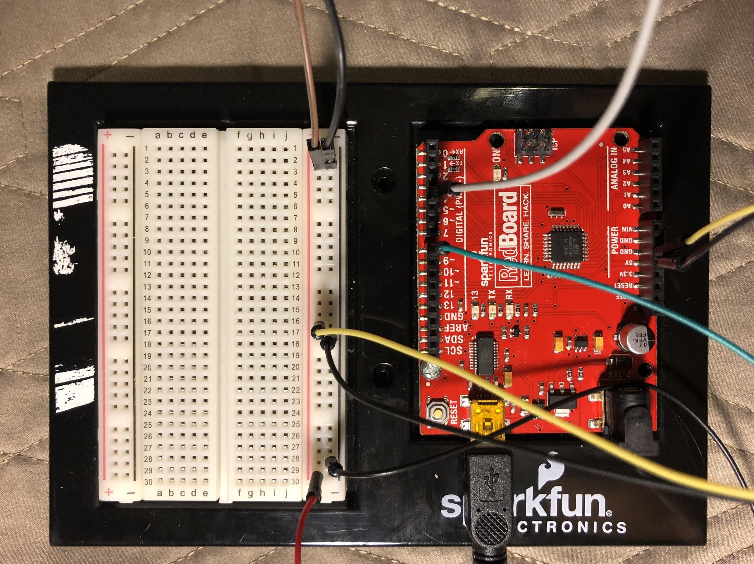

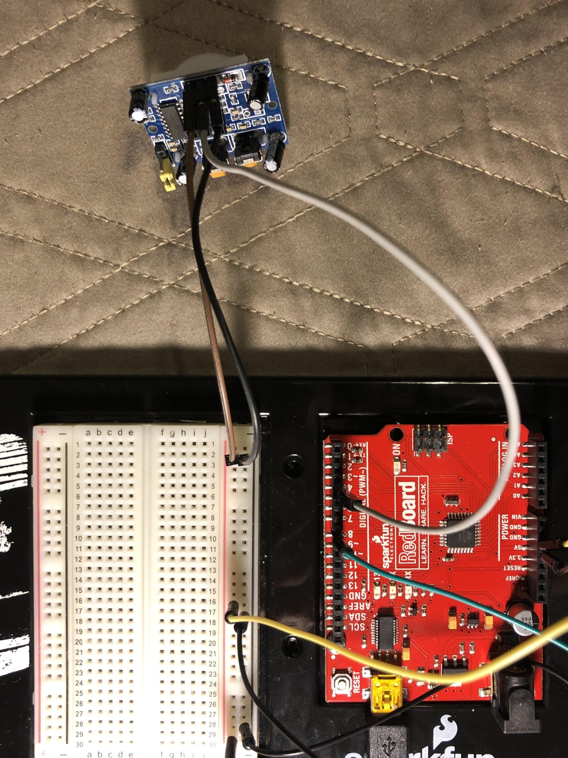

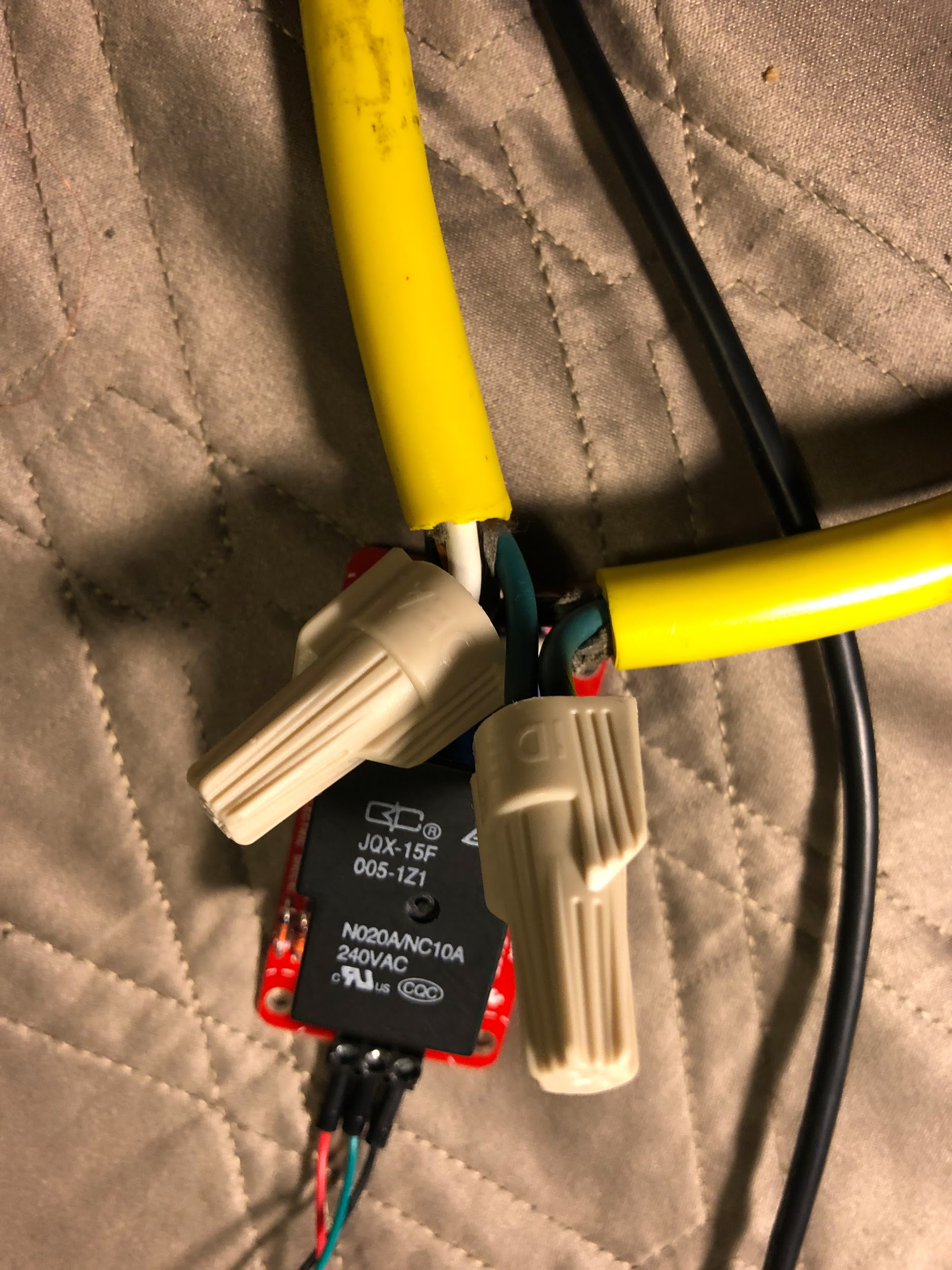

#### ***Code:***

**Matlab Code (from a .m file) -**

## **Contents**

* Clc, clear, close all
* Connect to the arduino
* Plot received data
* Close connection

## **Clc, clear, close all**

clc  
clear  
close all

## **Connect to the arduino**

Port = '/dev/cu.usbserial-DN02SM2R'; % Port the Arduino is connected to  
delete(instrfindall); % deletes any connected ports  
board = serial(Port); % connect to the Arduino in order to read information  
fopen(board); % opens the serial port  
pause(1); % pause() for 1 second to make sure a connection is made  
out = instrfind('Port',Port); % see if the port you specified is open  
disp('Serial Port is Open')  
in = input('Enter the time(in minutes)for which data will record: ');

Serial Port is Open

## **Plot received data**

figure,  
h = animatedline;  
title('PIR sensor condition');  
xlabel('time (minutes)');  
ylabel('Voltage');  
ax = gca;  
ax.YGrid = 'on'; % get current axis  
x = linspace(1,100,100); % Line spacing  
st = datetime('now'); % Array that represents points in time  
fin = datenum(clock + [0 0 0 0 in 0]); % Convert data and time  
 while datenum(clock) <= fin  
 i = 1:length(x);  
 val = fscanf(board, '%f'); % Data from arduino  
 in = datetime('now') - st; % Get current time  
 addpoints(h,datenum(in),val);  
 axi.XLim = datenum([in - seconds(15) in]);  
 datetick('x','keeplimits');  
 drawnow update;  
 end

## **Close connection**

fclose(board);  
 delete(board);  
 clear board;  
 disp('Serial port is closed');

**Arduino Code (from a .ino file) -**

int lamp = 8; // relay pin

int inputPin = 4; // Motion sensor input pin

int val = 0; // variable for reading the pin status

void setup() {

pinMode(lamp, OUTPUT); // lamp as output

pinMode(inputPin, INPUT); // sensor as input

Serial.begin(9600);

}

void loop(){

val = digitalRead(inputPin); // read input value

Serial.println(val);

if( val== 1) {

digitalWrite(lamp,HIGH); // turn ON the lamp

delay(800); // How long the lamp is on

} else {

digitalWrite(lamp,LOW); // turn OFF the lamp

delay(500); // How long the lamp is off

}

}

#### 

#### 

#### ***Results:***

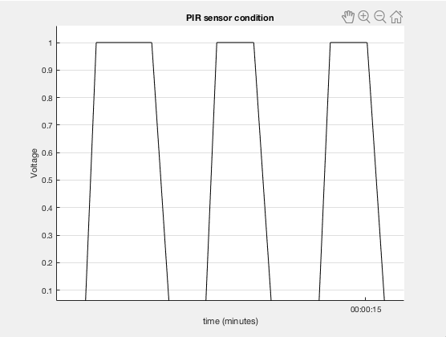

#### ***Future Work:***

Our advice for people who will do this project in the future is to get started on connecting the hardware immediately. The reason for this is because without setting up the hardware it makes it hard to do any code, because you can’t see what you are doing so you’re working blind. Our main source of help came from teachers and other students showing us examples.

#### ***License:***

BSD license