Group Member Names: Anas Mohamed, Mohamed Adem, Jimmy Parra, and Abdullah Bawazir

Course and Quarter: ENGR 114, Fall 2018

Date: 12/11/2018

Revision Number: 7

**Motion Sensor light**

***Hardware Setup:***

**Bill of Materials:**

|  |  |  |  |  |
| --- | --- | --- | --- | --- |
| **Part Name** | **Purpose** | **Item Name** | **URL** | **Price** |
| Arduino | Connect to hardware to the computer | Arduino Uno Rev 3 | https://store.arduino.cc/usa/arduino-uno-rev3 | $ 22.00 |
| breadboard | Power the relay, motion sensor and arduino | Breadboard | https://www.adafruit.com/product/64?gclid=EAIaIQobChMIia3N9eyW3wIVoCCtBh0EIgrVEAYYASABEgLZL_D_BwE | $ 5.00 |
| Jumper Wires | Connect two points together | Jumper wires | https://www.sparkfun.com/products/11026 | $ 1.95 |
| Motion sensor | Detect if there is motion | Infrared motion detector sensor | https://www.gearbest.com/development-boards/pp_70386.html?wid=1433363&currency=USD&vip=14891995&gclid=EAIaIQobChMI8bnyo-2W3wIVEcpkCh38WQxPEAYYASABEgJ2sPD_BwE | $ 1.41 |
| Relay | Powers up the whole system | Beefcake Relay | https://www.sparkfun.com/products/13815 | $ 8.95 |
| USB cable | Connect arduino to computer | USB cable | https://www.adafruit.com/product/62?gclid=EAIaIQobChMImY202u2W3wIVkeNkCh0sVw_WEAQYASABEgIYT_D_BwE | $ 3.95 |
| Female Wall Plug | Power up the lamp | Female wall plug | https://www.pcc.edu/ | - |
| Male wall plug | Connected to an outlet | Male wall plug | https://www.pcc.edu/ | - |
| Wire Nuts | Hold two electrical conductors together | Wire nuts | https://direct.fredmeyer.com/00783250681457.html?&cid=ps_adw_fmdPRODUCT_GROUP&gclid=EAIaIQobChMI87XziOyW3wIVyiCtBh0YVQJrEAQYBCABEgK09PD_BwE&gclsrc=aw.ds | $ 11.99 |

**Hardware Schematic:**

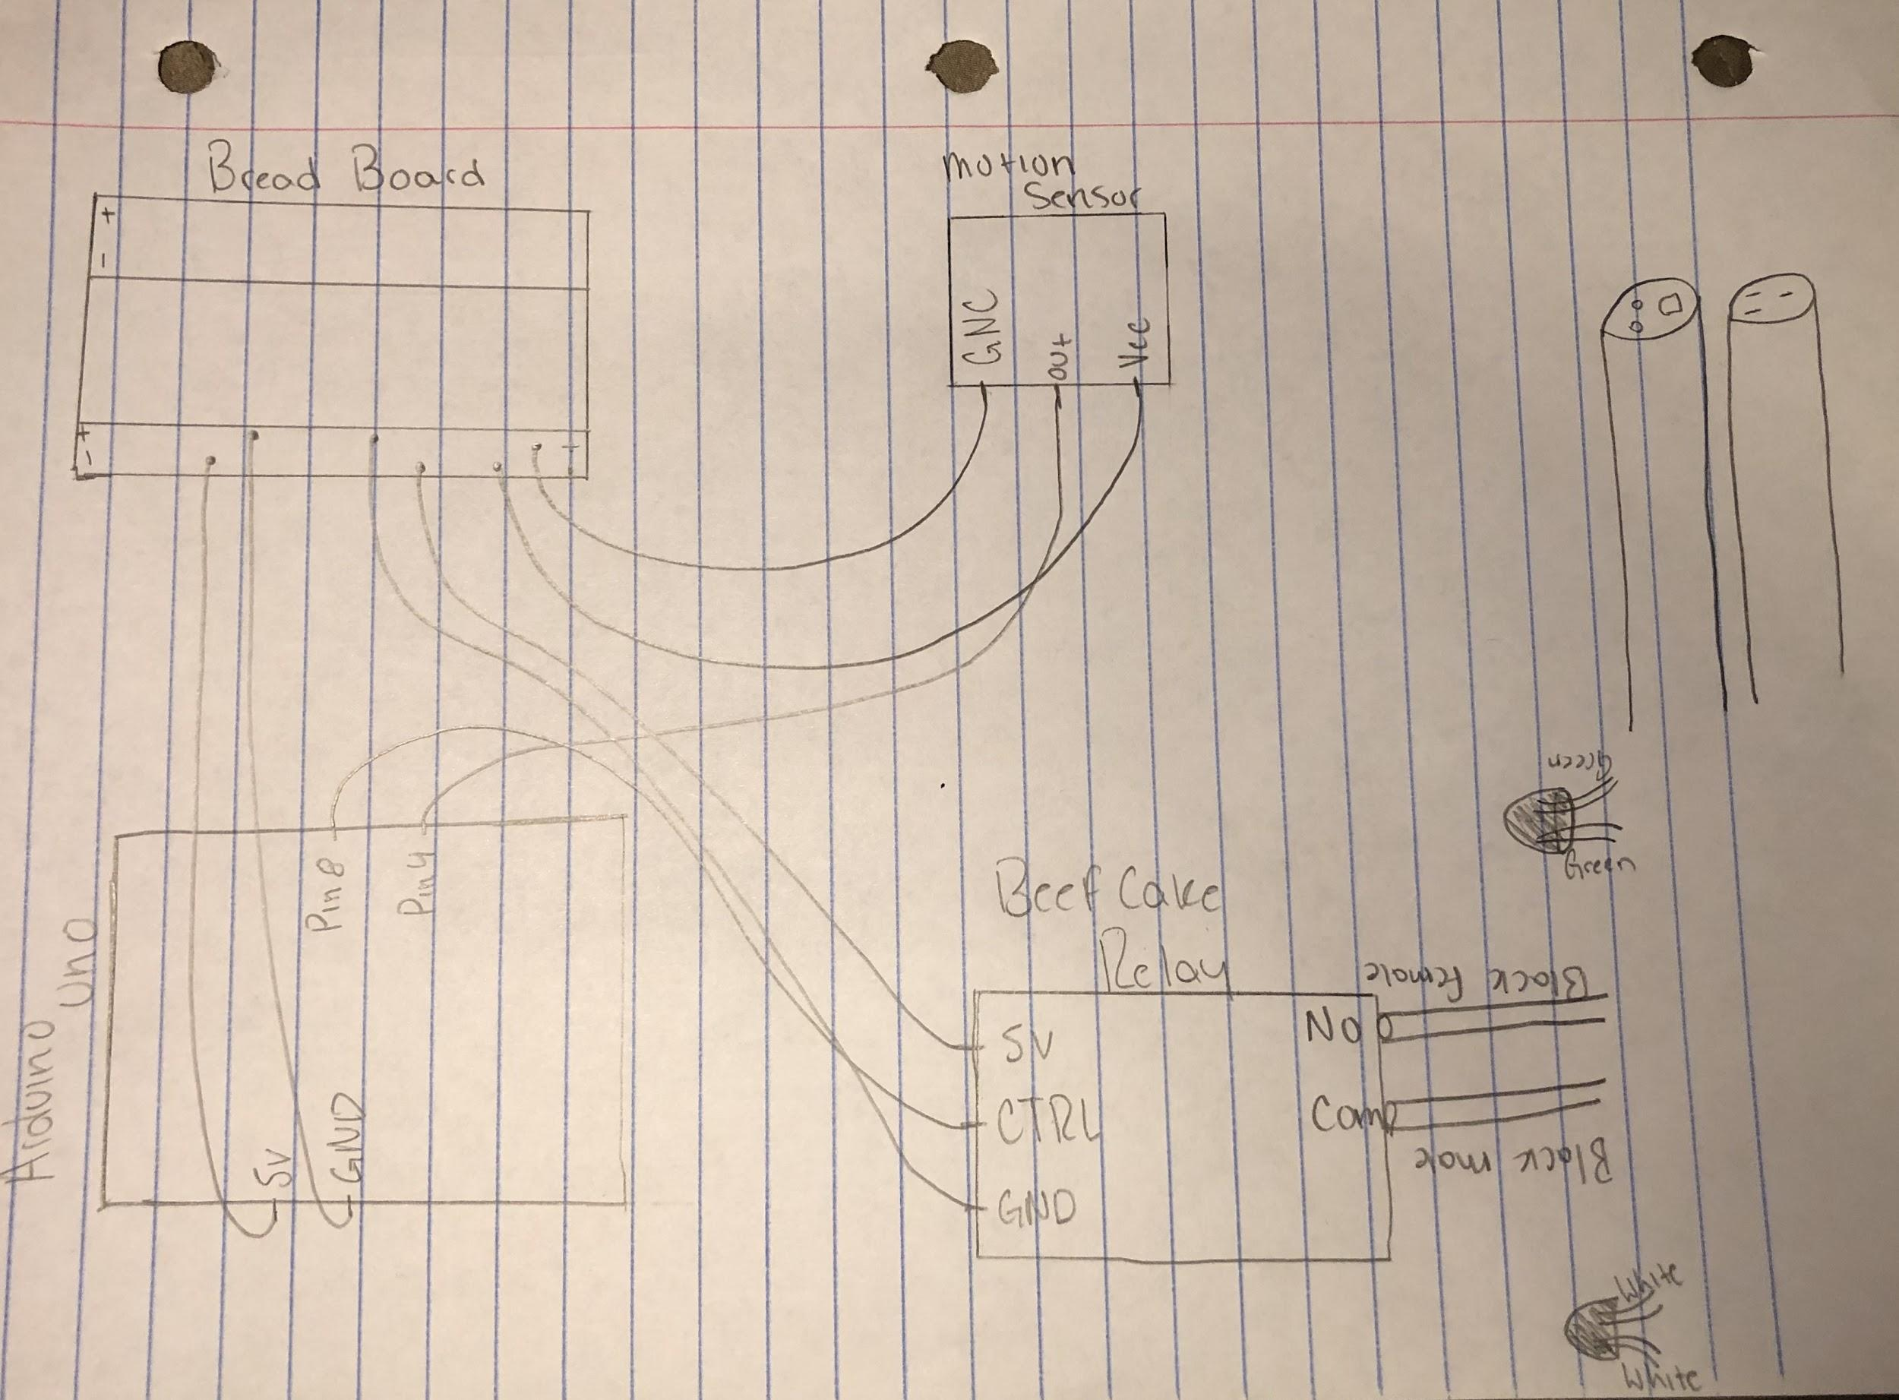

**Hookup Guide:**

|  |  |  |  |  |
| --- | --- | --- | --- | --- |
| Part | Pin | Connector | Pin | Part |
| Motion sensor | Vcc | Jumper wire | - | Breadboard |
| Motion sensor | Out | Jumper wire | 4 | Arduino |
| Motion sensor | GNC | Jumper wire | + | Breadboard |
| Relay | GND | Jumper wire | + | Breadboard |
| Relay | 5V | Jumper wire | - | Breadboard |
| Relay | CNTRL | Jumper wire | 8 | Arduino |
| Arduino | GND | Jumper wire | + | Breadboard |
| Arduino | 5V | Jumper wire | - | Breadboard |

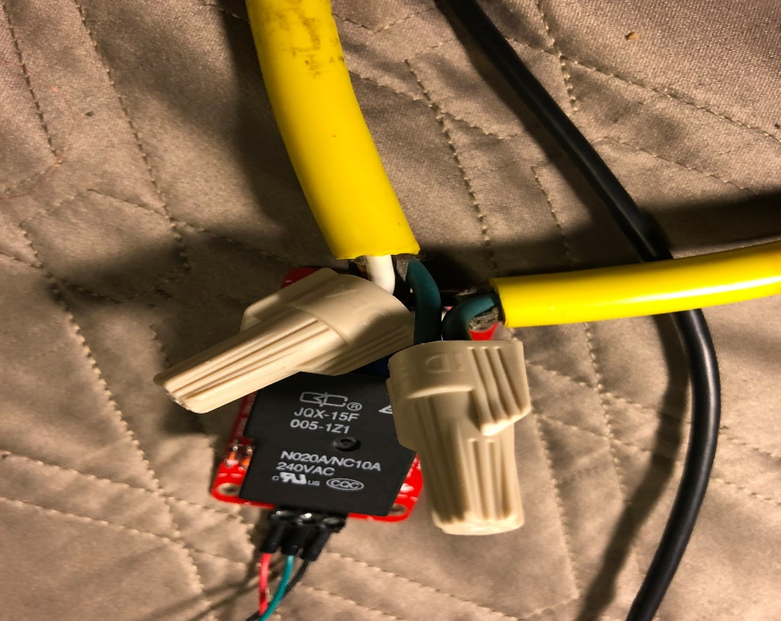

Images:

