MVGR COLLEGE OF ENGINEERING (AUTONOMOUS)
VIZIANAGARAM
DEPARTMENT OF COMPUTER SCIENCE AND ENGINEERING


LAB RECORD

Course / RD Name
Academic Year / Batch
Student Name
Registration Number
Section
Lab In-Charge

Signature of Lab In-Charge Head of the Department – CSE
INDEX SHEET
S. No. | Week | Experiment /  Activity Title | Date | Page No. | Grade | Signature of Lab In-Charge
1
2
3
4
5
6
7
8
9
10
11
12
13
14
15

EXPERIMENT /  ACTIVITY No. | WEEK No. | DATE | PAGE No.
EXPERIMENT - 01 | WEEK - 01
1. TITLE / AIM
a) Create HTML page containing student details (name, roll number, branch and marks). b) Using jQuery selectors, select individual elements and change their text, HTML content and attributes. c) Display the modified student details on the webpage.
2. OBJECTIVES
• Create an HTML page displaying student details using appropriate tags (p, div, a).
• Apply jQuery ID selector ($("#id")) and class selector ($(".class")) to target elements.
• Demonstrate .text() to update plain text, .html() to update HTML content and .attr() to update attributes.
• Display feedback of operations in the output area to confirm selector behaviour.
3. REQUIREMENTS / TOOLS USED
• Hardware: Standard PC with modern browser (Chrome/Firefox).
• Software: Visual Studio Code, jQuery 3.7.1 CDN (https://code.jquery.com/jquery-3.7.1.min.js), any static web server or file open.
• Concepts: HTML structure, DOM, jQuery selectors, event handling with $(function(){...}).
4. THEORY / CONCEPT
jQuery provides concise selectors borrowed from CSS. $("#name") selects element with id="name", $(".roll") selects class, $("p") selects tag. .text("new") sets textContent without parsing HTML, .html("<b>...") sets innerHTML and parses tags, .attr("href","...") updates attribute. All manipulation is performed after DOM ready. Feedback is shown in #output to evidence each method.
5. ALGORITHM / DESIGN / APPROACH
• Step 1: Include jQuery 3.7.1 CDN and create student details: #name, .roll, #branch, #marks, #profile.
• Step 2: Create three buttons: #btnText, #btnHtml, #btnAttr and a div #output.
• Step 3: On #btnText click -> $("#name").text("Name: Rahul Sharma (Updated)"), $(".roll").text("Roll No: CS001 - Modified"), $("#branch").text("Branch: Computer Science"), update #output via .text().
• Step 4: On #btnHtml click -> $("#marks").html("<b>Marks: 85</b> (Improved)"), update #output via .html() with <b> tag.
• Step 5: On #btnAttr click -> $("#profile").attr("href","https://example.com/student/CS001"), update link text and show new href in #output.
• Step 6: Open in browser and verify each button changes DOM as expected.
6. IMPLEMENTATION / SOURCE CODE
File: index.html
<!DOCTYPE html>
<html>
<head>
<meta charset="UTF-8">
<title>Exp1 - jQuery Selectors</title>
<script src="https://code.jquery.com/jquery-3.7.1.min.js"></script>
</head>
<body>
<h2>Student Details</h2>
<div id="details">
<p id="name">Name: Rahul Sharma</p>
<p class="roll">Roll No: CS001</p>
<p id="branch">Branch: CSE</p>
<p id="marks">Marks: 78</p>
<a id="profile" href="#">Profile</a>
</div>

<button id="btnText">Change Text</button>
<button id="btnHtml">Change HTML</button>
<button id="btnAttr">Change Attribute</button>

<div id="output"></div>

<script>
$(function(){
$("#btnText").click(function(){
$("#name").text("Name: Rahul Sharma (Updated)");
$(".roll").text("Roll No: CS001 - Modified");
$("#branch").text("Branch: Computer Science");
$("#output").text("Text changed using selectors #name, .roll, #branch");
});
$("#btnHtml").click(function(){
$("#marks").html("<b>Marks: 85</b> (Improved)");
$("#output").html("HTML content changed for #marks using <b>.html()</b>");
});
$("#btnAttr").click(function(){
$("#profile").attr("href","https://example.com/student/CS001");
$("#profile").text("View Profile (link updated)");
$("#output").text("Attribute href changed to: " + $("#profile").attr("href"));
});
});
</script>
</body>
</html>
7. OBSERVATION / OUTPUT
On loading, student details display: Name: Rahul Sharma, Roll No: CS001, Branch: CSE, Marks: 78. Clicking 'Change Text' updates #name, .roll, #branch via .text() and shows message in #output. Clicking 'Change HTML' renders Marks as bold 'Marks: 85 (Improved)' via .html(). Clicking 'Change Attribute' changes profile link href to https://example.com/student/CS001 and updates link text. Verified selectors #id, .class function correctly; output area reflects each operation.
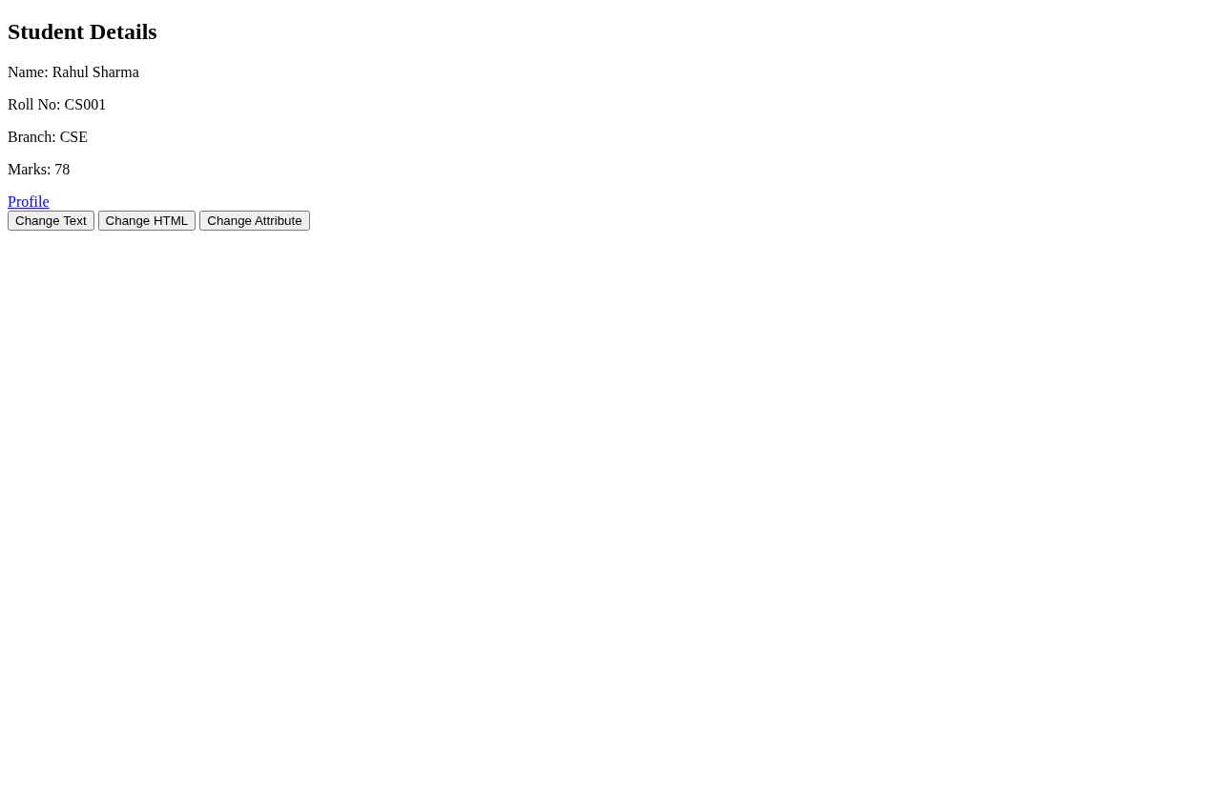
Screenshot: Output for Experiment 01 — 01
8. RESULT / INFERENCE
Selectors .text(), .html(), .attr() successfully demonstrated. All three manipulations reflect immediately in DOM and output confirmation is displayed.
9. LEARNING OUTCOMES
• LO1: Apply jQuery ID and class selectors to target specific DOM elements.
• LO2: Differentiate between text, HTML and attribute manipulation methods.
• LO3: Build interactive pages using jQuery event-driven content updates.

EXPERIMENT /  ACTIVITY No. | WEEK No. | DATE | PAGE No.
EXPERIMENT - 02 | WEEK - 02
1. TITLE / AIM
a) Create a webpage containing headings, paragraphs, buttons and a student table. b) Write jQuery code to change background color, font color, font size and border of selected elements. c) Add and remove CSS classes dynamically using jQuery.
2. OBJECTIVES
• Design a page with h1 #heading, p #para, div #box.card and table #studentTable.
• Use .css() to modify background-color, color, font-size, border and font-family dynamically.
• Use .addClass("highlight") and .removeClass("highlight") to toggle styling.
• Observe visual changes triggered by four control buttons.
3. REQUIREMENTS / TOOLS USED
• Hardware: PC with browser.
• Software: jQuery 3.7.1 CDN, internal CSS for .highlight {background:yellow; border:2px solid red} and .card.
• Concepts: CSS box model, jQuery .css(property,value) and .css({object}) forms.
4. THEORY / CONCEPT
jQuery .css() is a getter/setter for inline styles. Single property: .css("background-color","#e3f2fd"); object form allows multiple: .css({"color":"#0d47a1","font-size":"32px"}). Classes are manipulated via .addClass(), .removeClass(), .toggleClass(). Changing body background demonstrates scope, while heading/para/table show targeted selection. Highlight class demonstrates separation of style and behaviour.
5. ALGORITHM / DESIGN / APPROACH
• Step 1: Create HTML with #heading, #para, #box.card, #studentTable (2 rows) and buttons #btnBg, #btnFont, #btnAdd, #btnRemove.
• Step 2: Define .highlight and .card in <style>.
• Step 3: On #btnBg click -> $("body").css("background-color","#e3f2fd"), $("#heading").css({color, font-size}), $("#para").css({color, font-size}), $("#studentTable").css("border","3px solid #1976d2").
• Step 4: On #btnFont click -> $("#para").css({"font-family":"Courier New","font-size":"20px","color":"green"}).
• Step 5: On #btnAdd click -> $("#box").addClass("highlight"); On #btnRemove click -> $("#box").removeClass("highlight").
• Step 6: Verify background, fonts, border and class toggling visually.
6. IMPLEMENTATION / SOURCE CODE
File: index.html
<!DOCTYPE html>
<html>
<head>
<meta charset="UTF-8">
<title>Exp2 - Change Style using jQuery</title>
<script src="https://code.jquery.com/jquery-3.7.1.min.js"></script>
<style>
.highlight{background:yellow;border:2px solid red;padding:5px}
.card{border:1px solid #ccc;padding:10px;margin:10px 0}
</style>
</head>
<body>
<h1 id="heading">Student Information</h1>
<p id="para">This is a paragraph about students.</p>
<div id="box" class="card">Sample Box Content</div>

<table id="studentTable" border="1" cellpadding="8">
<tr><th>Roll</th><th>Name</th><th>Marks</th></tr>
<tr><td>CS01</td><td>Amit</td><td>85</td></tr>
<tr><td>CS02</td><td>Priya</td><td>72</td></tr>
</table>

<br>
<button id="btnBg">Change Background</button>
<button id="btnFont">Change Font</button>
<button id="btnAdd">Add Class</button>
<button id="btnRemove">Remove Class</button>

<script>
$(function(){
$("#btnBg").click(function(){
$("body").css("background-color","#e3f2fd");
$("#heading").css({"color":"#0d47a1","font-size":"32px"});
$("#para").css({"color":"#333","font-size":"18px"});
$("#studentTable").css("border","3px solid #1976d2");
});
$("#btnFont").click(function(){
$("#para").css({"font-family":"Courier New","font-size":"20px","color":"green"});
});
$("#btnAdd").click(function(){
$("#box").addClass("highlight");
});
$("#btnRemove").click(function(){
$("#box").removeClass("highlight");
});
});
</script>
</body>
</html>
7. OBSERVATION / OUTPUT
Initial page shows plain heading, paragraph and box with grey border. Clicking 'Change Background' turns body to light blue (#e3f2fd), heading to dark blue 32px, paragraph to #333 18px and table border to 3px solid blue. 'Change Font' sets paragraph to Courier New 20px green. 'Add Class' makes #box yellow with red border (highlight); 'Remove Class' reverts. Visual changes persist and can be reapplied; no page reload required.
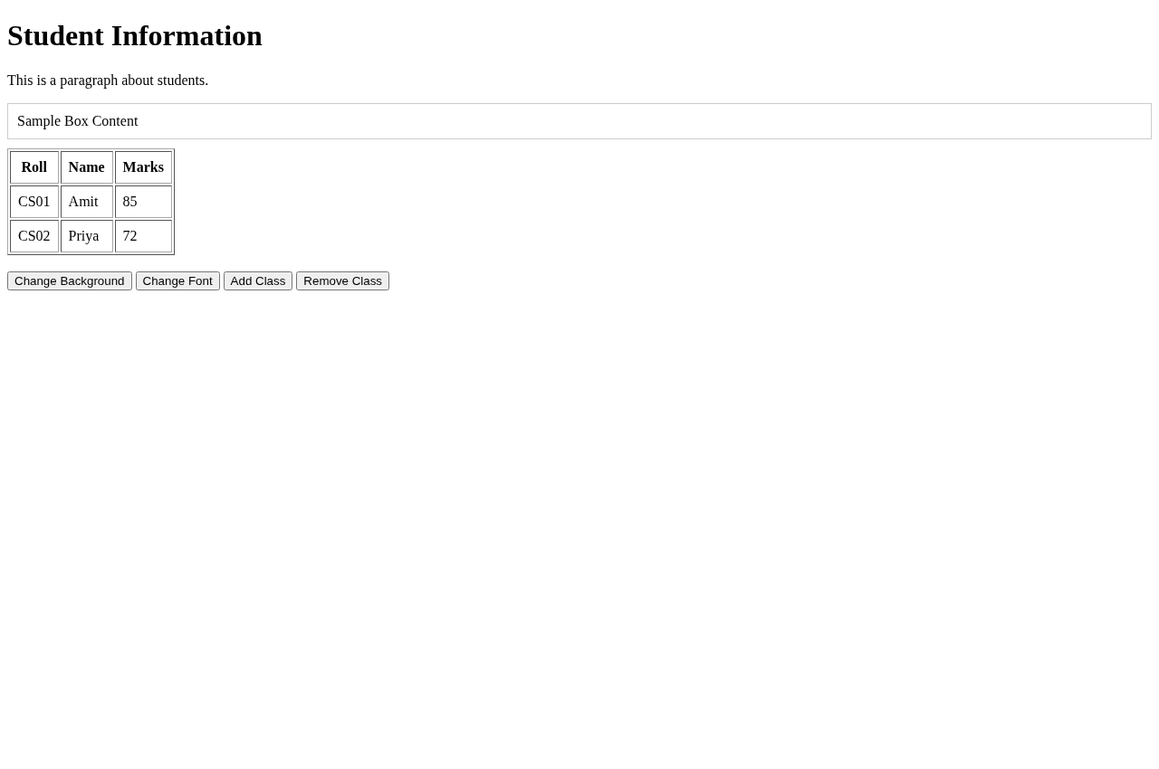
Screenshot: Output for Experiment 02 — 02
8. RESULT / INFERENCE
Dynamic style manipulation verified via .css() and class methods. All four style operations produce expected visual output without CSS file modification.
9. LEARNING OUTCOMES
• LO1: Use jQuery .css() to manipulate inline styles at runtime.
• LO2: Apply addClass/removeClass for theme toggling.
• LO3: Understand separation of content, presentation and behaviour.

EXPERIMENT /  ACTIVITY No. | WEEK No. | DATE | PAGE No.
EXPERIMENT - 03 | WEEK - 03
1. TITLE / AIM
Create a webpage containing a simple list of students. Using jQuery, perform: a) Add new student, b) Remove student, c) Change name, d) Display parent/child, e) Display first/last, f) Find previous/next sibling. Use append(), remove(), text(), parent(), children(), first(), last(), prev(), next().
2. OBJECTIVES
• Build a UL #studentList with LI items, one with class selected.
• Implement append("<li>"+n+"</li>"), remove(), text("new") for CRUD.
• Use traversing: parent(), children().length, first(), last(), prev(), next() and display results in #output.
• Enable click delegation to change selection highlight.
3. REQUIREMENTS / TOOLS USED
• Hardware: PC, browser.
• Software: jQuery 3.7.1 CDN, CSS .selected {background:yellow}.
• Concepts: DOM tree, insertion vs removal, traversing along parent-sibling axis.
4. THEORY / CONCEPT
DOM manipulation inserts/removes nodes: append() adds as last child, remove() deletes matched set, text() sets textContent. Traversing navigates tree: parent() one level up, children() direct children, first()/last() filter, prev()/next() adjacent siblings. Delegated click via $(document).on("click","li",...) ensures new LIs also selectable. Output panel shows parent tagName and counts to confirm traversal.
5. ALGORITHM / DESIGN / APPROACH
• Step 1: Create UL #studentList with <li>Rahul</li>, <li class="selected">Priya</li>, <li>Amit</li>, input #newName and buttons for each task.
• Step 2: On #btnAdd: read #newName or 'NewStudent' and $("#studentList").append("<li>"+n+"</li>"), show output.
• Step 3: On #btnRemove: $(".selected").remove().
• Step 4: On #btnRename: $(".selected").text("Priya (Updated)").
• Step 5: On #btnParent: parent = $(".selected").parent().prop("tagName"), children = $("#studentList").children().length, display.
• Step 6: On #btnFirstLast: display $("#studentList li").first().text() and .last().text().
• Step 7: On #btnSiblings: display $(".selected").prev().text() and .next().text() with fallback 'None'.
• Step 8: Bind $(document).on("click","li", handler to toggle .selected).
6. IMPLEMENTATION / SOURCE CODE
File: index.html
<!DOCTYPE html>
<html>
<head>
<meta charset="UTF-8">
<title>Exp3 - DOM Manipulation & Traversing</title>
<script src="https://code.jquery.com/jquery-3.7.1.min.js"></script>
<style>.selected{background:yellow}</style>
</head>
<body>
<h2>Student List</h2>
<ul id="studentList">
<li>Rahul</li>
<li class="selected">Priya</li>
<li>Amit</li>
</ul>

<input id="newName" placeholder="New student name">
<button id="btnAdd">Add (append)</button>
<button id="btnRemove">Remove Selected</button>
<button id="btnRename">Rename Selected</button>
<hr>
<button id="btnParent">Show Parent/Children</button>
<button id="btnFirstLast">First/Last</button>
<button id="btnSiblings">Prev/Next Sibling</button>

<div id="output"></div>

<script>
$(function(){
$("#btnAdd").click(function(){
let n=$("#newName").val()||"NewStudent";
$("#studentList").append("<li>"+n+"</li>");
$("#output").text("Added: "+n+" using append()");
});
$("#btnRemove").click(function(){
$(".selected").remove();
$("#output").text("Removed selected using remove()");
});
$("#btnRename").click(function(){
$(".selected").text("Priya (Updated)");
$("#output").text("Modified using text()");
});
$("#btnParent").click(function(){
let parent=$(".selected").parent().prop("tagName");
let children=$("#studentList").children().length;
$("#output").html("Parent: "+parent+"<br>Children count: "+children+" using parent() & children()");
});
$("#btnFirstLast").click(function(){
$("#output").html("First: "+$("#studentList li").first().text()+"<br>Last: "+$("#studentList li").last().text());
});
$("#btnSiblings").click(function(){
let prev=$(".selected").prev().text()||"None";
let next=$(".selected").next().text()||"None";
$("#output").html("Prev: "+prev+"<br>Next: "+next+" using prev() & next()");
});
$(document).on("click","li",function(){
$("li").removeClass("selected");
$(this).addClass("selected");
});
});
</script>
</body>
</html>
7. OBSERVATION / OUTPUT
Initial list: Rahul, Priya (selected/yellow), Amit. Entering 'Neha' and clicking Add appends <li>Neha</li> as last child and output shows 'Added: Neha using append()'. Clicking Rename changes Priya to 'Priya (Updated)'. Parent/Children shows Parent: UL and Children count: 3 (or 4 after add). First/Last shows First: Rahul, Last: Amit (or Neha after add). Prev/Next for selected Priya shows Prev: Rahul, Next: Amit. Remove deletes selected LI and output confirms.
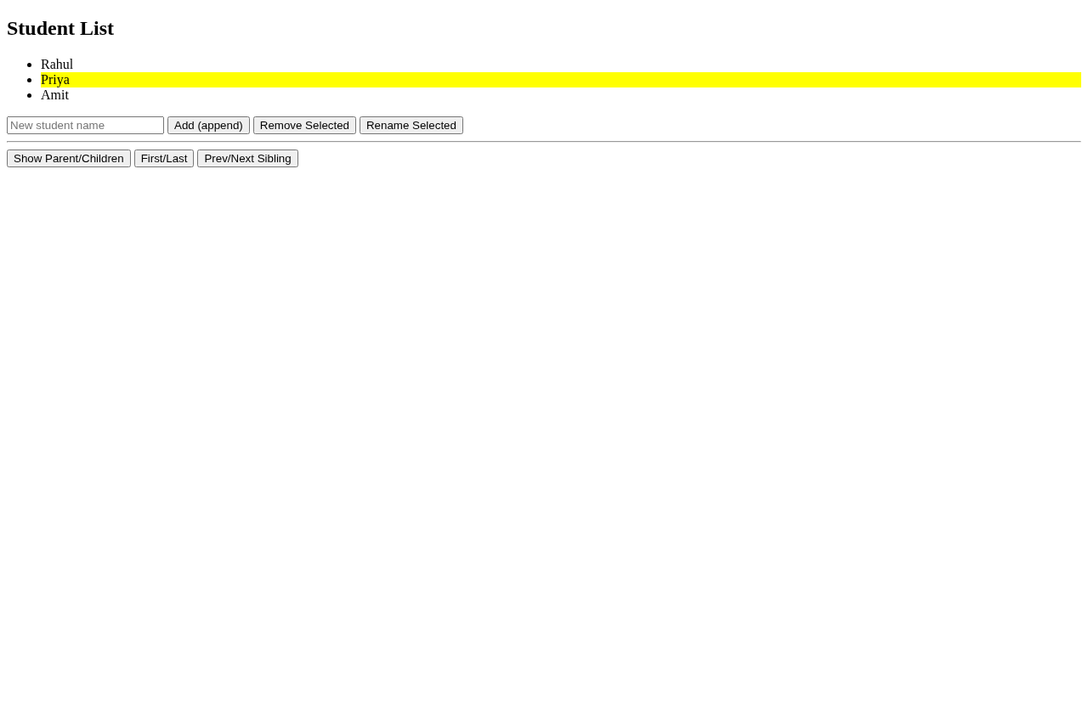
Screenshot: Output for Experiment 03 — 03
8. RESULT / INFERENCE
All DOM methods work: append() inserts, remove() deletes, text() updates, traversing correctly reports parent, child count, first/last and siblings. Selection delegation allows new items to become selectable.
9. LEARNING OUTCOMES
• LO1: Manipulate DOM nodes dynamically with append/remove/text.
• LO2: Navigate DOM tree via parent/children/prev/next.
• LO3: Handle dynamic elements through event delegation.

EXPERIMENT /  ACTIVITY No. | WEEK No. | DATE | PAGE No.
EXPERIMENT - 04 | WEEK - 04
1. TITLE / AIM
Create a webpage containing buttons, text boxes and student records and implement: a) Change background when button clicked, b) Display message on mouseenter/leave, c) Display typed text on keypress, d) Hide and show student details using button events.
2. OBJECTIVES
• Bind click event to change body background-color.
• Bind mouseenter and mouseleave on #hoverBox to show coloured messages.
• Bind keypress/keyup on #textInput to mirror typed text into #typed.
• Use hide() and show() on #details panel via two buttons.
3. REQUIREMENTS / TOOLS USED
• Hardware: PC with keyboard/mouse.
• Software: jQuery 3.7.1 CDN, CSS for #hoverBox (200x60 border).
• Concepts: jQuery event binding (.click, .mouseenter, .mouseleave, .on) and effects (hide/show).
4. THEORY / CONCEPT
jQuery abstracts addEventListener. .click(handler) listens to mouse click, hover pair reacts to pointer entering/leaving element, keypress/keyup fire on character input; .on("keypress keyup") combines. hide()/show() toggle display:none keeping element in DOM. Typed value fetched via $(this).val() and projected with .text() to avoid HTML injection. Colour feedback uses .css("color",...).
5. ALGORITHM / DESIGN / APPROACH
• Step 1: Create button #btnColor, div #hoverBox, p #hoverMsg, input #textInput linked to span #typed, div #details with student info and buttons #btnHide/#btnShow.
• Step 2: On #btnColor click -> $("body").css("background-color","#fff9c4").
• Step 3: On #hoverBox mouseenter -> $("#hoverMsg").text("Mouse entered the box").css("color","green"); on mouseleave -> text "Mouse left" color red.
• Step 4: On #textInput keypress keyup -> $("#typed").text($(this).val()).
• Step 5: On #btnHide click -> $("#details").hide(); On #btnShow click -> $("#details").show().
• Step 6: Test each interaction sequentially and verify output/messaging.
6. IMPLEMENTATION / SOURCE CODE
File: index.html
<!DOCTYPE html>
<html>
<head>
<meta charset="UTF-8">
<title>Exp4 - Event Handling</title>
<script src="https://code.jquery.com/jquery-3.7.1.min.js"></script>
<style>#hoverBox{width:200px;height:60px;border:1px solid #999}</style>
</head>
<body>
<h2>Event Handling</h2>

<button id="btnColor">Change Background</button>

<div id="hoverBox">Hover Me</div>
<p id="hoverMsg"></p>

<input id="textInput" placeholder="Type something">
<p>Typed: <span id="typed"></span></p>

<div id="details">
<p><b>Name:</b> Amit</p><p><b>Roll:</b> CS01</p><p><b>Marks:</b> 85</p>
</div>
<button id="btnHide">Hide Details</button>
<button id="btnShow">Show Details</button>

<script>
$(function(){
$("#btnColor").click(function(){
$("body").css("background-color","#fff9c4");
});
$("#hoverBox").mouseenter(function(){
$("#hoverMsg").text("Mouse entered the box").css("color","green");
}).mouseleave(function(){
$("#hoverMsg").text("Mouse left the box").css("color","red");
});
$("#textInput").on("keypress keyup",function(){
$("#typed").text($(this).val());
});
$("#btnHide").click(function(){ $("#details").hide(); });
$("#btnShow").click(function(){ $("#details").show(); });
});
</script>
</body>
</html>
7. OBSERVATION / OUTPUT
Clicking 'Change Background' sets body to #fff9c4 instantly. Hovering over 'Hover Me' box shows green 'Mouse entered the box' message; moving out shows red 'Mouse left the box'. Typing 'Hello' in input immediately mirrors 'Hello' in 'Typed: Hello' span (keypress/keyup). 'Hide Details' makes student details div disappear (display:none); 'Show Details' restores it. All events fire without reload.
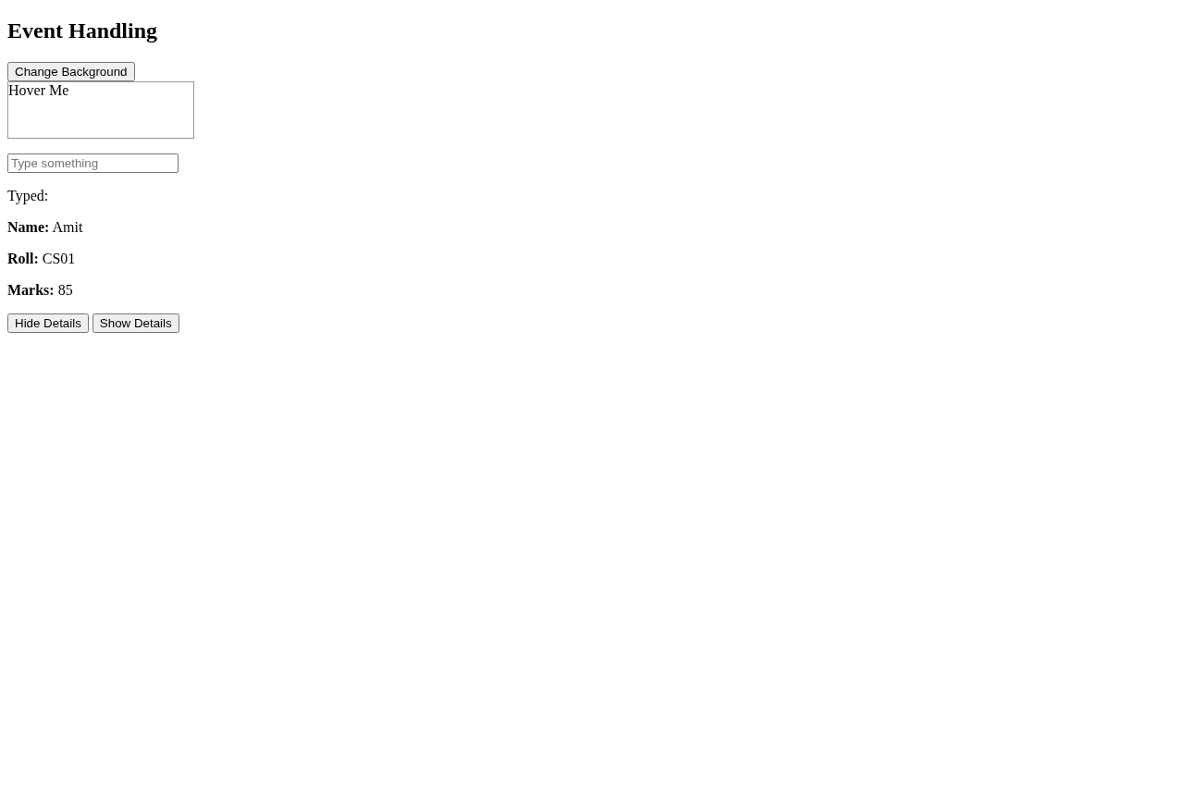
Screenshot: Output for Experiment 04 — 04
8. RESULT / INFERENCE
Event handling verified for click, hover, keyboard and visibility toggle. jQuery simplifies cross-browser event binding and provides instant UI feedback.
9. LEARNING OUTCOMES
• LO1: Bind and handle click, mouse and keyboard events with jQuery.
• LO2: Implement hover feedback using mouseenter/mouseleave.
• LO3: Control visibility with hide()/show() and reflect input in real time.

EXPERIMENT /  ACTIVITY No. | WEEK No. | DATE | PAGE No.
EXPERIMENT - 05 | WEEK - 05
1. TITLE / AIM
Design a responsive Student Registration Form using Bootstrap (fields: Name, Roll, DOB, Gender, Branch, Year, Email, Mobile, Address, Submit/Reset, using grid, forms, cards, alerts) and a Student Information responsive table (Roll, Name, Branch, Marks, Percentage, Result) with table-striped/bordered/hover, contextual table-success/danger, 5 records.
2. OBJECTIVES
• Build registration form inside Bootstrap card + alert, using container/row/col-md-6 grid and form-control/form-select.
• Apply validation attributes and buttons btn-primary/btn-secondary, test responsive layout.
• Build information table inside table-responsive wrapper with thead table-dark and tbody contextual classes.
• Verify responsiveness by resizing viewport; striped/hover effects and pass/fail colour coding must display correctly.
3. REQUIREMENTS / TOOLS USED
• Hardware: PC/tablet/mobile for responsive test.
• Software: Bootstrap 5.3.3 CDN (css+js), no jQuery needed, modern browser.
• Concepts: Bootstrap grid (row g-3), components (card, alert, button), table utilities, responsive breakpoints.
4. THEORY / CONCEPT
Bootstrap is mobile-first CSS framework. container provides centred gutters, row/col creates 12-column grid, form-control styles inputs uniformly, card shadow adds depth, alert-info gives notice. Tables: table adds base, table-striped alternates rows, table-bordered adds borders, table-hover highlights on hover, table-success (green) for Pass and table-danger (red) for Fail deliver semantic colour. table-responsive adds horizontal scroll on small screens, bg-primary/text-white styles heading.
5. ALGORITHM / DESIGN / APPROACH
• Step 1: Include Bootstrap 5.3.3 CSS CDN and <meta viewport>.
• Step 2: Registration page: container py-4, h2 centred, alert-info, card shadow > card-body > form > row g-3 with col-md-6 fields (text, date, select, email, textarea col-12) and centred Submit/Reset buttons.
• Step 3: Table page: container py-4, h2 bg-primary text-white rounded, div table-responsive > table table-striped table-bordered table-hover with thead table-dark and 5 tbody rows (CS01 Amit 85 Pass green etc., CS03 Rahul 32 Fail red).
• Step 4: Open both pages, resize window to <768px to verify stacking (2 cols collapse to 1) and table horizontal scroll.
• Step 5: Submit/Reset interactions and hover over table rows to see stripe/hover effects.
6. IMPLEMENTATION / SOURCE CODE
File: registration.html
<!DOCTYPE html>
<html>
<head>
<meta charset="UTF-8">
<meta name="viewport" content="width=device-width, initial-scale=1">
<title>Student Registration</title>
<link href="https://cdn.jsdelivr.net/npm/bootstrap@5.3.3/dist/css/bootstrap.min.css" rel="stylesheet">
</head>
<body class="bg-light">
<div class="container py-4">
<h2 class="text-center mb-4">Student Registration Form</h2>

<div class="alert alert-info">Please fill all mandatory fields</div>

<div class="card shadow">
<div class="card-body">
<form>
<div class="row g-3">
<div class="col-md-6"><label class="form-label">Student Name</label><input class="form-control" required></div>
<div class="col-md-6"><label class="form-label">Roll Number</label><input class="form-control" required></div>
<div class="col-md-6"><label class="form-label">Date of Birth</label><input type="date" class="form-control"></div>
<div class="col-md-6"><label class="form-label">Gender</label><select class="form-select"><option>Male</option><option>Female</option><option>Other</option></select></div>
<div class="col-md-6"><label class="form-label">Branch</label><select class="form-select"><option>CSE</option><option>IT</option><option>ECE</option></select></div>
<div class="col-md-6"><label class="form-label">Year</label><select class="form-select"><option>1</option><option>2</option><option>3</option><option>4</option></select></div>
<div class="col-md-6"><label class="form-label">Email</label><input type="email" class="form-control"></div>
<div class="col-md-6"><label class="form-label">Mobile Number</label><input class="form-control"></div>
<div class="col-12"><label class="form-label">Address</label><textarea class="form-control" rows="2"></textarea></div>
<div class="col-12 text-center">
<button type="submit" class="btn btn-primary">Submit</button>
<button type="reset" class="btn btn-secondary">Reset</button>
</div>
</div>
</form>
</div>
</div>
</div>
</body>
</html>
File: table.html
<!DOCTYPE html>
<html>
<head>
<meta charset="UTF-8">
<meta name="viewport" content="width=device-width, initial-scale=1">
<title>Student Table</title>
<link href="https://cdn.jsdelivr.net/npm/bootstrap@5.3.3/dist/css/bootstrap.min.css" rel="stylesheet">
</head>
<body>
<div class="container py-4">
<h2 class="bg-primary text-white p-3 rounded text-center">Student Information</h2>
<div class="table-responsive">
<table class="table table-striped table-bordered table-hover">
<thead class="table-dark">
<tr><th>Roll No</th><th>Name</th><th>Branch</th><th>Marks</th><th>Percentage</th><th>Result</th></tr>
</thead>
<tbody>
<tr class="table-success"><td>CS01</td><td>Amit</td><td>CSE</td><td>85</td><td>85%</td><td>Pass</td></tr>
<tr class="table-success"><td>CS02</td><td>Priya</td><td>IT</td><td>78</td><td>78%</td><td>Pass</td></tr>
<tr class="table-danger"><td>CS03</td><td>Rahul</td><td>CSE</td><td>32</td><td>32%</td><td>Fail</td></tr>
<tr class="table-success"><td>CS04</td><td>Neha</td><td>ECE</td><td>91</td><td>91%</td><td>Pass</td></tr>
<tr class="table-danger"><td>CS05</td><td>Vikram</td><td>IT</td><td>28</td><td>28%</td><td>Fail</td></tr>
</tbody>
</table>
</div>
</div>
</body>
</html>
7. OBSERVATION / OUTPUT
Registration page renders centred card with shadow, alert banner and two-column form on desktop (col-md-6) collapsing to single column on mobile. Inputs have consistent Bootstrap styling, focus ring, and required validation. Table page shows dark header, striped rows, bordered cells, hover lightens row; Pass rows appear green (table-success), Fail red (table-danger). At 375px width, table enables horizontal scroll via table-responsive, no content overflow. Heading appears as blue rounded banner.
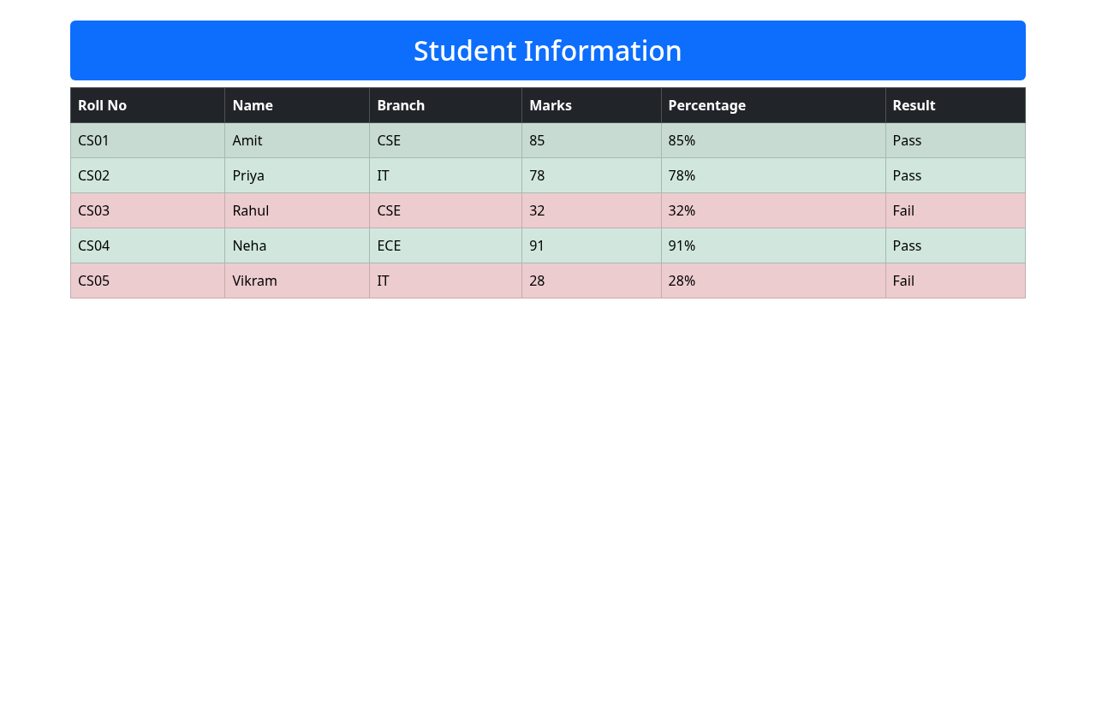
Screenshot: Output for Experiment 05 — 05B
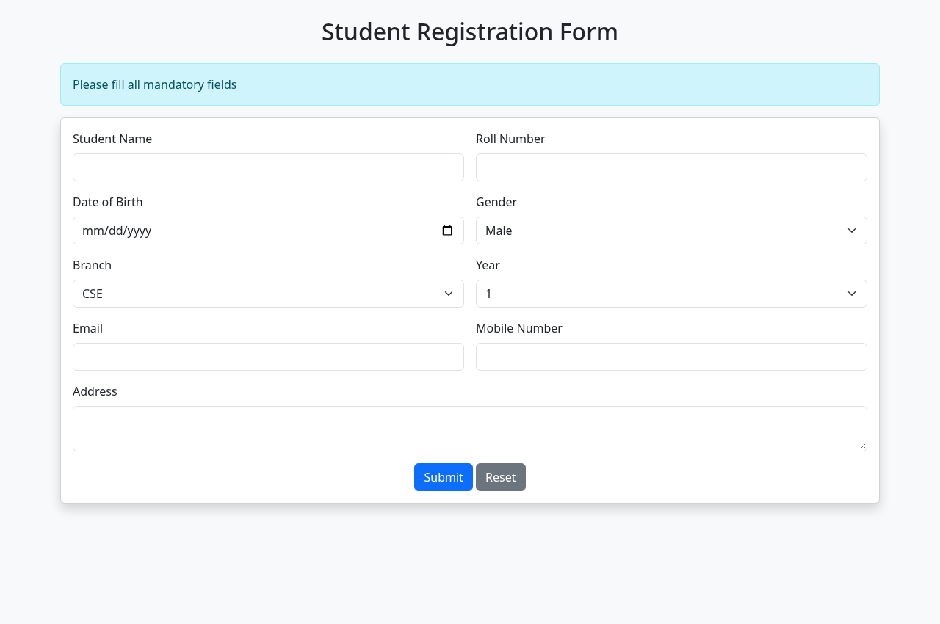
Screenshot: Output for Experiment 05 — 05A
8. RESULT / INFERENCE
Bootstrap responsive design achieved: grid stacks, card/alert/button components render correctly, table utilities and contextual classes provide semantic pass/fail highlighting and mobile-friendly viewing.
9. LEARNING OUTCOMES
• LO1: Build responsive forms using Bootstrap grid and form components.
• LO2: Style tables with striped/bordered/hover and contextual classes.
• LO3: Test and verify mobile-first responsiveness without custom media queries.

EXPERIMENT /  ACTIVITY No. | WEEK No. | DATE | PAGE No.
EXPERIMENT - 06 | WEEK - 06
1. TITLE / AIM
Create an AngularJS application to display student information: a) Accept name, branch, marks via inputs, b) Display dynamically via data binding, c) Calculate total and average via expressions, d) Display Pass/Fail via ng-if.
2. OBJECTIVES
• Set up AngularJS 1.8.2 module myApp and controller StudentCtrl bound via ng-app/ng-controller.
• Bind inputs with ng-model (name, branch, m1,m2,m3) and display with ng-bind / {{}} interpolation.
• Compute Total {{(m1||0)+(m2||0)+(m3||0)}} and Average {{((m1||0)+(m2||0)+(m3||0))/3 | number:2}} live.
• Conditionally render Pass/Fail using ng-if on average >=40.
3. REQUIREMENTS / TOOLS USED
• Hardware: PC, browser.
• Software: AngularJS 1.8.2 CDN (ajax.googleapis.com), no build step required.
• Concepts: Two-way binding, digest cycle, expressions, filters (number:2), directives ng-model/ng-bind/ng-if.
4. THEORY / CONCEPT
AngularJS extends HTML with directives. ng-app bootstraps, ng-controller scopes $scope. ng-model creates two-way binding between input and $scope variable; any keystroke triggers digest updating interpolations {{}}. ng-bind is alternative to {{}}. Expressions calculate arithmetic inside template. number:2 filter formats to two decimals. ng-if conditionally adds/removes DOM; Pass shows when average >=40, Fail when <40 and at least one mark entered. Initial $scope values (Amit, CSE, 80/75/85) demonstrate default binding.
5. ALGORITHM / DESIGN / APPROACH
• Step 1: Include angular.min.js 1.8.2, declare <html ng-app="myApp"> and <body ng-controller="StudentCtrl">.
• Step 2: Create inputs: name, branch (text), m1,m2,m3 (type number) with ng-model and placeholders.
• Step 3: Display: Name via <span ng-bind="name">, Branch {{branch}}, Total {{(m1||0)+(m2||0)+(m3||0)}}, Average fixed {{((m1||0)+(m2||0)+(m3||0))/3 | number:2}}.
• Step 4: Add <p ng-if="((m1||0)+(m2||0)+(m3||0))/3 >=40">Pass</p> and complementary Fail with (m1||m2||m3) guard.
• Step 5: In script, angular.module("myApp",[]).controller("StudentCtrl", function($scope){$scope.name="Amit"; $scope.branch="CSE"; $scope.m1=80; $scope.m2=75; $scope.m3=85;}).
• Step 6: Open and type to observe live recalculation and Pass/Fail toggle.
6. IMPLEMENTATION / SOURCE CODE
File: index.html
<!DOCTYPE html>
<html ng-app="myApp">
<head>
<meta charset="UTF-8">
<title>Angular Data Binding</title>
<script src="https://ajax.googleapis.com/ajax/libs/angularjs/1.8.2/angular.min.js"></script>
</head>
<body ng-controller="StudentCtrl">
<h2>Student Information</h2>
Name: <input ng-model="name" placeholder="Enter name"><br>
Branch: <input ng-model="branch" placeholder="Enter branch"><br>
Marks1: <input type="number" ng-model="m1">
Marks2: <input type="number" ng-model="m2">
Marks3: <input type="number" ng-model="m3">

<hr>
<p>Name: <span ng-bind="name"></span></p>
<p>Branch: {{branch}}</p>
<p>Total: {{ (m1||0)+(m2||0)+(m3||0) }}</p>
<p>Average: {{ ((m1||0)+(m2||0)+(m3||0))/3 | number:2 }}</p>
<p ng-if="((m1||0)+(m2||0)+(m3||0))/3 >=40">Pass</p>
<p ng-if="((m1||0)+(m2||0)+(m3||0))/3 <40 && (m1||m2||m3)">Fail</p>

<script>
angular.module("myApp",[]).controller("StudentCtrl",function($scope){
$scope.name="Amit"; $scope.branch="CSE"; $scope.m1=80; $scope.m2=75; $scope.m3=85;
});
</script>
</body>
</html>
7. OBSERVATION / OUTPUT
On load, displays Name: Amit, Branch: CSE, Total: 240, Average: 80.00 and Pass (since 80>=40). Editing Name to 'Priya' instantly updates bound span. Changing Marks1 to 20 recalculates Total: 180, Average: 60.00 still Pass; setting all marks to 10 each gives Total 30 Average 10.00 and switches to Fail. Both ng-bind and {{}} stay synchronized; average formatting retains two decimals.
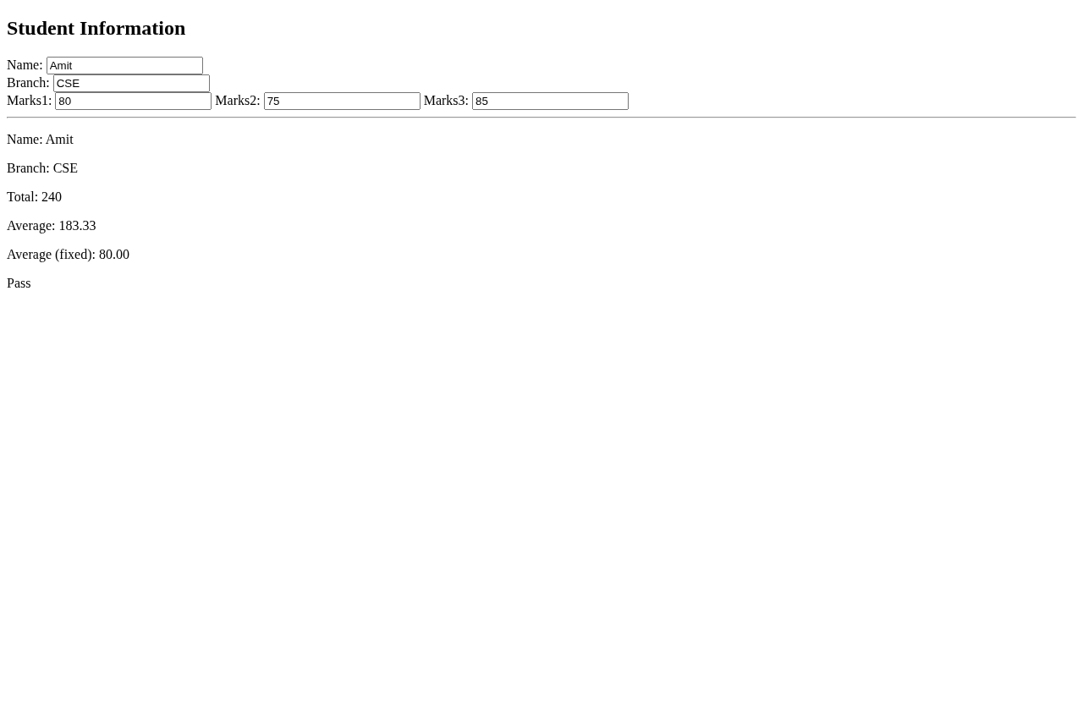
Screenshot: Output for Experiment 06 — 06
8. RESULT / INFERENCE
Two-way binding, expression evaluation and conditional rendering operate live without manual DOM code. Pass/Fail logic correctly reflects average threshold.
9. LEARNING OUTCOMES
• LO1: Implement two-way data binding with ng-model/ng-bind.
• LO2: Evaluate expressions and apply filters for computed fields.
• LO3: Control UI with structural directive ng-if.

EXPERIMENT /  ACTIVITY No. | WEEK No. | DATE | PAGE No.
EXPERIMENT - 07 | WEEK - 07
1. TITLE / AIM
Create an AngularJS application demonstrating filters: a) uppercase to display name in uppercase, b) lowercase for lowercase, c) currency to display fee, d) Show original vs filtered values.
2. OBJECTIVES
• Bind name and fee inputs via ng-model.
• Display original vs filtered using {{name | uppercase}}, {{name | lowercase}}, {{fee | currency}} and {{fee | currency:"₹"}}.
• Initialize default name "Rahul Sharma" and fee 50000 to evidence filtering.
3. REQUIREMENTS / TOOLS USED
• Hardware: PC, browser.
• Software: AngularJS 1.8.2 CDN.
• Concepts: Filter pipe syntax, locale currency formatting, real-time transformation.
4. THEORY / CONCEPT
Filters transform displayed data without mutating model. uppercase/lowercase map case, currency formats number as currency with symbol and two decimals (default $). Syntax: {{ expression | filter:arg }}. Original value kept in separate column to contrast. Typing updates both columns simultaneously, showing filter is view-only.
5. ALGORITHM / DESIGN / APPROACH
• Step 1: Include angular.min.js, ng-app="myApp" and controller Ctrl with $scope.name="Rahul Sharma", $scope.fee=50000.
• Step 2: Create inputs ng-model="name" and type number ng-model="fee".
• Step 3: Build table with rows: Uppercase {{name}} vs {{name | uppercase}}, Lowercase vs {{name | lowercase}}, Currency vs {{fee | currency}}, INR vs {{fee | currency:"₹"}}.
• Step 4: Open page and type new name/fee to observe instantaneous filter recalculation.
6. IMPLEMENTATION / SOURCE CODE
File: index.html
<!DOCTYPE html>
<html ng-app="myApp">
<head>
<meta charset="UTF-8">
<title>Angular Filters</title>
<script src="https://ajax.googleapis.com/ajax/libs/angularjs/1.8.2/angular.min.js"></script>
</head>
<body ng-controller="Ctrl">
<h2>Built-in Filters</h2>
Name: <input ng-model="name">
Fee: <input type="number" ng-model="fee">

<table>
<tr><th>Type</th><th>Original</th><th>Filtered</th></tr>
<tr><td>Uppercase</td><td>{{name}}</td><td>{{name | uppercase}}</td></tr>
<tr><td>Lowercase</td><td>{{name}}</td><td>{{name | lowercase}}</td></tr>
<tr><td>Currency</td><td>{{fee}}</td><td>{{fee | currency}}</td></tr>
<tr><td>Currency (INR)</td><td>{{fee}}</td><td>{{fee | currency:"\u20B9"}}</td></tr>
</table>

<script>
angular.module("myApp",[]).controller("Ctrl",function($scope){
$scope.name="Rahul Sharma"; $scope.fee=50000;
});
</script>
</body>
</html>
7. OBSERVATION / OUTPUT
Initial table: Name Original 'Rahul Sharma' → Uppercase 'RAHUL SHARMA', Lowercase 'rahul sharma'; Fee Original 50000 → $50,000.00 and ₹50,000.00. Changing name to 'Amit' updates both original and filtered columns to 'Amit' / 'AMIT' / 'amit' live. Changing fee to 75000 updates to $75,000.00 / ₹75,000.00. Original column stays verbatim while filtered reflects transformation.
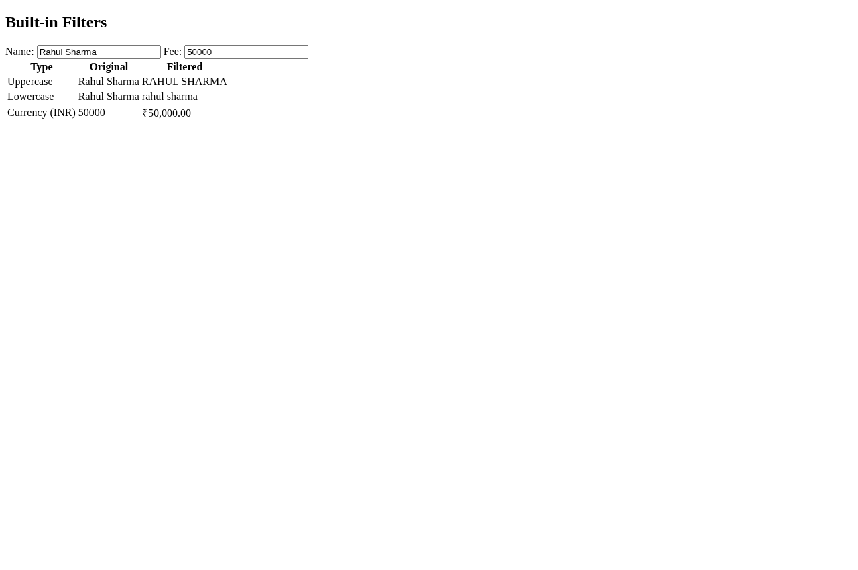
Screenshot: Output for Experiment 07 — 07
8. RESULT / INFERENCE
Built-in filters correctly format presentation layer without altering model data. Currency filter handles symbol argument and decimal formatting.
9. LEARNING OUTCOMES
• LO1: Apply uppercase/lowercase filters for text transformation.
• LO2: Format numeric values with currency filter and custom symbol.
• LO3: Preserve original data while displaying filtered views.

EXPERIMENT /  ACTIVITY No. | WEEK No. | DATE | PAGE No.
EXPERIMENT - 08 | WEEK - 08
1. TITLE / AIM
Create an AngularJS Student Registration Form with: a) Form data binding via ng-model, b) Display entered details below form, c) Check mandatory fields, d) Display valid/invalid messages.
2. OBJECTIVES
• Build form regForm with inputs name, roll (required), email (type email), branch with ng-model="s.name" etc.
• Show Required error via ng-show="regForm.name.$touched && regForm.name.$invalid" and Invalid email via $dirty check.
• Display overall validity: regForm.$valid vs $invalid banners.
• Echo entered details below via {{s.name}} etc. updating live.
3. REQUIREMENTS / TOOLS USED
• Hardware: PC, browser.
• Software: AngularJS 1.8.2 CDN.
• Concepts: Forms, validation states ($touched, $dirty, $valid), novalidate, two-way binding.
4. THEORY / CONCEPT
Angular forms expose state: $valid/$invalid at form and field level, $touched set after blur, $dirty after modification. required attribute marks mandatory, type="email" adds email pattern validation. ng-show toggles messages based on state. novalidate disables native browser popup, letting Angular manage feedback. Live echo confirms binding.
5. ALGORITHM / DESIGN / APPROACH
• Step 1: Include angular.min.js, ng-app="myApp" controller with $scope.s={}.
• Step 2: Form name="regForm" novalidate with Name* required and Roll* required plus error spans using ng-show with $touched/$invalid.
• Step 3: Email type=email with Invalid email span via $invalid && $dirty; Branch plain input.
• Step 4: Add validity banners: <div ng-show="regForm.$valid">All mandatory fields entered - Valid</div> and complementary $invalid.
• Step 5: Below hr, display Entered Details: Name {{s.name}} etc.
• Step 6: Test empty -> Invalid, fill required -> Valid, invalid email format -> Invalid email message.
6. IMPLEMENTATION / SOURCE CODE
File: index.html
<!DOCTYPE html>
<html ng-app="myApp">
<head>
<meta charset="UTF-8">
<title>Angular Registration Form</title>
<script src="https://ajax.googleapis.com/ajax/libs/angularjs/1.8.2/angular.min.js"></script>
</head>
<body ng-controller="Ctrl">
<h2>Student Registration</h2>
<form name="regForm" novalidate>
Name*: <input name="name" ng-model="s.name" required><span ng-show="regForm.name.$touched && regForm.name.$invalid"> Required</span><br><br>
Roll*: <input name="roll" ng-model="s.roll" required><span ng-show="regForm.roll.$touched && regForm.roll.$invalid"> Required</span><br><br>
Email: <input type="email" name="email" ng-model="s.email"><span ng-show="regForm.email.$invalid && regForm.email.$dirty"> Invalid email</span><br><br>
Branch: <input ng-model="s.branch"><br><br>
</form>

<div ng-show="regForm.$valid">All mandatory fields entered - Valid</div>
<div ng-show="regForm.$invalid">Please fill mandatory fields - Invalid</div>

<hr>
<h3>Entered Details:</h3>
<p>Name: {{s.name}}</p>
<p>Roll: {{s.roll}}</p>
<p>Email: {{s.email}}</p>
<p>Branch: {{s.branch}}</p>

<script>
angular.module("myApp",[]).controller("Ctrl",function($scope){ $scope.s={}; });
</script>
</body>
</html>
7. OBSERVATION / OUTPUT
Empty form on load shows 'Please fill mandatory fields - Invalid' banner. Touching Name without filling and blurring shows inline 'Required'. Entering 'Amit' and 'CS01' switches banner to 'All mandatory fields entered - Valid' and echo panel updates to Name: Amit, Roll: CS01 live. Entering 'abc' in Email flags 'Invalid email'; correcting to 'a@b.com' clears it. Branch updates echo regardless of validity. State transitions are instantaneous.
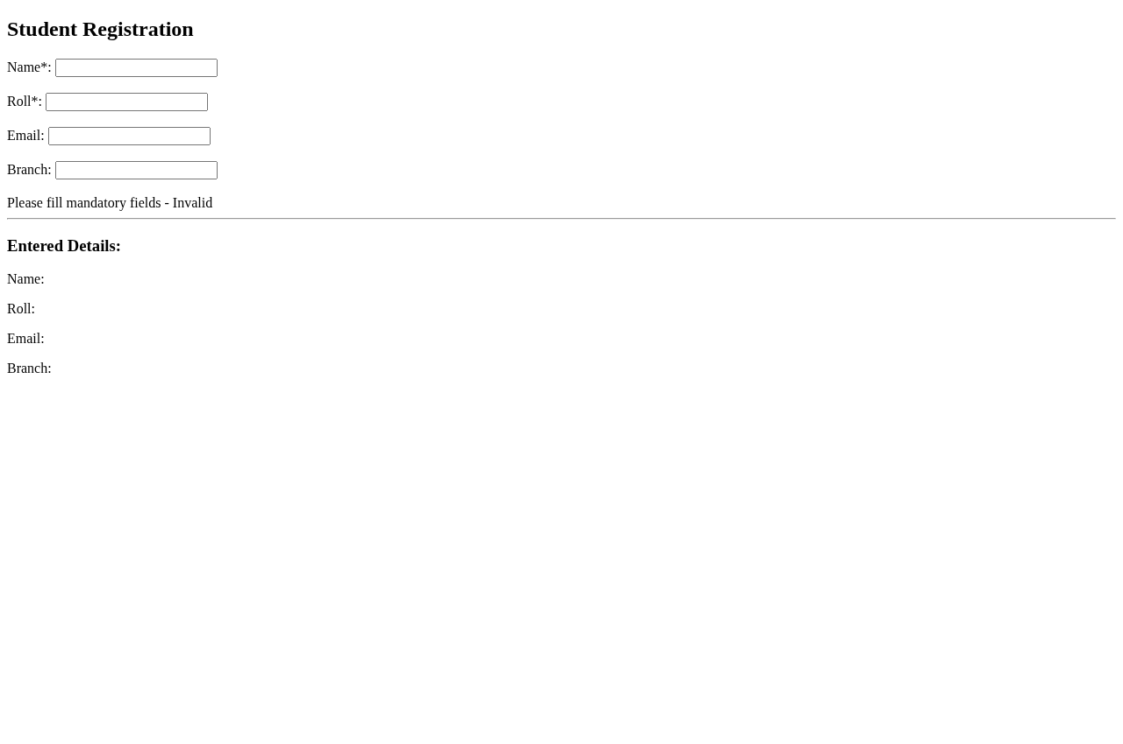
Screenshot: Output for Experiment 08 — 08
8. RESULT / INFERENCE
Form validation works: required and email pattern enforced, validity messaging reflects $valid/$invalid correctly, and live echo confirms two-way binding.
9. LEARNING OUTCOMES
• LO1: Implement form validation using Angular states ($touched/$dirty/$valid).
• LO2: Provide user feedback for mandatory and format errors.
• LO3: Synchronize form input with display via ng-model binding.

EXPERIMENT /  ACTIVITY No. | WEEK No. | DATE | PAGE No.
EXPERIMENT - 09 | WEEK - 09
1. TITLE / AIM
Create a Student Information Application with views Home, Student List, Student Details, Login. a) Use Angular routing to navigate, b) Create service to provide student data, c) Display data in Student List view.
2. OBJECTIVES
• Implement ngRoute with routes '/', '/students', '/student/:id', '/login' using $routeProvider.
• Create studentService with getAll() and getById(id) returning static array of 3 students.
• Provide nav links #!/ and #!/students etc. and ng-view outlet.
• Implement ListCtrl and DetailCtrl to consume service and render via inline ng-template.
3. REQUIREMENTS / TOOLS USED
• Hardware: PC, browser.
• Software: AngularJS 1.8.2 + angular-route 1.8.2 CDN.
• Concepts: SPA routing, dependency injection, services as singletons, routeParams.
4. THEORY / CONCEPT
ngRoute enables SPA without reload. $routeProvider.when() maps URL to templateUrl and controller; otherwise redirects. Service holds shared data, injected into controllers; singleton ensures consistency. $routeParams.id captures URL segment. ng-view swaps templates via type="text/ng-template" script tags. Hashbang mode #!/ prefix required for Angular 1.6+.
5. ALGORITHM / DESIGN / APPROACH
• Step 1: Include angular.min.js and angular-route.min.js, declare angular.module("myApp",["ngRoute"]).
• Step 2: Define service studentService with data array (CS01 Amit CSE 85 etc.) and methods getAll/getById.
• Step 3: Config $routeProvider for four routes with templateUrl matching script ids (home.html etc.) plus ListCtrl/DetailCtrl.
• Step 4: Create nav <a href="#!/..."> links and <div ng-view>.
• Step 5: Define inline ng-templates: home (welcome), students (ng-repeat), details (ng-if student), login (username/password).
• Step 6: Implement controllers injecting studentService and $routeParams; click nav to verify view switching and data display.
6. IMPLEMENTATION / SOURCE CODE
File: index.html
<!DOCTYPE html>
<html ng-app="myApp">
<head>
<meta charset="UTF-8">
<title>Service & Routing</title>
<script src="https://ajax.googleapis.com/ajax/libs/angularjs/1.8.2/angular.min.js"></script>
<script src="https://ajax.googleapis.com/ajax/libs/angularjs/1.8.2/angular-route.min.js"></script>
</head>
<body>
<h2>Student Info App</h2>
<nav>
<a href="#!/">Home</a>
<a href="#!/students">Student List</a>
<a href="#!/student/1">Student Details</a>
<a href="#!/login">Login</a>
</nav>
<hr>
<div ng-view></div>

<script type="text/ng-template" id="home.html"><h3>Home</h3><p>Welcome to Student Information System</p></script>
<script type="text/ng-template" id="students.html">
<h3>Student List</h3>
<ul><li ng-repeat="s in students">{{s.roll}} - {{s.name}} ({{s.branch}})</li></ul>
</script>
<script type="text/ng-template" id="details.html"><h3>Student Details</h3><p ng-if="student">Roll: {{student.roll}}<br>Name: {{student.name}}<br>Branch: {{student.branch}}<br>Marks: {{student.marks}}</p><p ng-if="!student">Student not found</p></script>
<script type="text/ng-template" id="login.html"><h3>Login</h3><input placeholder="Username"><br><br><input type="password" placeholder="Password"><br><br><button>Login</button></script>

<script>
angular.module("myApp",["ngRoute"])
.service("studentService",function(){
var data=[
{id:1, roll:"CS01", name:"Amit", branch:"CSE", marks:85},
{id:2, roll:"CS02", name:"Priya", branch:"IT", marks:78},
{id:3, roll:"CS03", name:"Rahul", branch:"ECE", marks:92}
];
this.getAll=function(){return data;};
this.getById=function(id){return data.find(s=>s.id==id);};
})
.config(function($routeProvider){
$routeProvider
.when("/",{templateUrl:"home.html"})
.when("/students",{templateUrl:"students.html", controller:"ListCtrl"})
.when("/student/:id",{templateUrl:"details.html", controller:"DetailCtrl"})
.when("/login",{templateUrl:"login.html"})
.otherwise({redirectTo:"/"});
})
.controller("ListCtrl",function($scope, studentService){ $scope.students=studentService.getAll(); })
.controller("DetailCtrl",function($scope,$routeParams,studentService){ $scope.student=studentService.getById($routeParams.id); });
</script>
</body>
</html>
7. OBSERVATION / OUTPUT
Default route shows Home 'Welcome to Student Information System'. Clicking 'Student List' navigates to #!/students displaying: CS01 - Amit (CSE), CS02 - Priya (IT), CS03 - Rahul (ECE) via ng-repeat. Clicking 'Student Details' shows CS01 details (Roll, Name, Branch, Marks 85); changing URL to #!/student/2 shows Priya. Login view displays username/password inputs. Back/forward and otherwise redirect to '/' work. Service data persists across views.
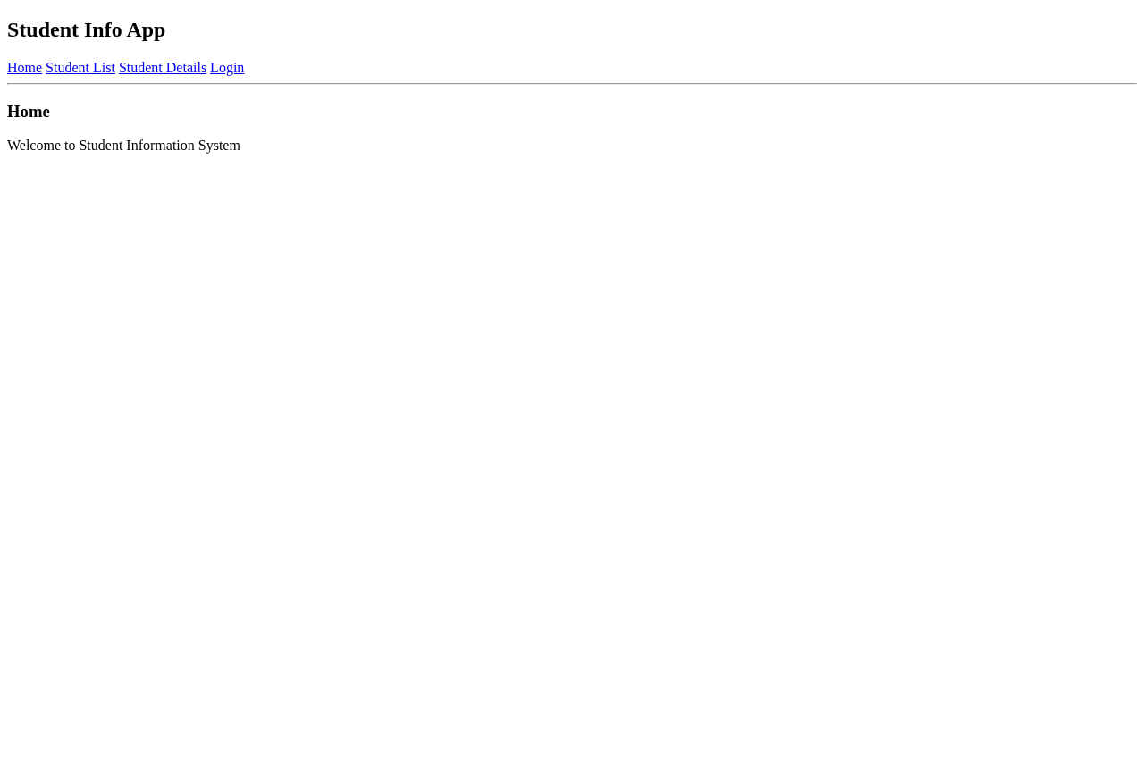
Screenshot: Output for Experiment 09 — 09
8. RESULT / INFERENCE
Routing and service integration successful. SPA navigation functions without page reload and shared service supplies consistent student data.
9. LEARNING OUTCOMES
• LO1: Configure AngularJS routing with ngRoute and $routeProvider.
• LO2: Create and inject services for data sharing.
• LO3: Build multi-view SPA with template and controller binding.

EXPERIMENT /  ACTIVITY No. | WEEK No. | DATE | PAGE No.
EXPERIMENT - 10 | WEEK - 10
1. TITLE / AIM
Develop a simple Node.js application demonstrating: fs (create/write/read file), http (welcome server), path (basename/extname), os (platform/arch/memory), events (custom welcome event).
2. OBJECTIVES
• Use fs.writeFileSync and fs.readFileSync to create and read students.txt with student information.
• Create http server responding with 'Welcome to Student App' on port 3000.
• Use path.basename and path.extname on sample path '/home/user/docs/student.pdf'.
• Use os.platform(), os.arch(), os.totalmem() to display system info.
• Create EventEmitter custom event 'welcome' and emit to trigger handler.
3. REQUIREMENTS / TOOLS USED
• Hardware: PC, Node.js runtime.
• Software: Node v22, built-in modules fs, http, path, os, events (no npm).
• Concepts: Synchronous file I/O, event-driven server, OS introspection, event emitter pattern.
4. THEORY / CONCEPT
Node built-ins require no install via require(). fs handles file system, http.createServer creates request handler with writeHead/end, path parses file paths independent of OS, os exposes platform details, EventEmitter implements publish/subscribe via on() and emit(). Server listens on 3000 and logs URL. Order of console logs evidences module execution sequence.
5. ALGORITHM / DESIGN / APPROACH
• Step 1: Require fs, http, path, os, events.
• Step 2: fs.writeFileSync('students.txt','Name: Amit...') then console.log read via fs.readFileSync('students.txt','utf8').
• Step 3: Log path.basename('/home/user/docs/student.pdf') → student.pdf and path.extname → .pdf.
• Step 4: Log os.platform(), os.arch(), totalMem converted to MB.
• Step 5: Create emitter = new EventEmitter(), on('welcome', handler logging message), emit('welcome').
• Step 6: Create http server returning HTML 'Welcome to Student App' and listen on 3000 with console confirmation.
• Step 7: Run node app.js, verify file creation, console outputs and browse http://localhost:3000.
6. IMPLEMENTATION / SOURCE CODE
File: app.js
const fs=require('fs');
const http=require('http');
const path=require('path');
const os=require('os');
const EventEmitter=require('events');

// 1. fs
fs.writeFileSync('students.txt','Name: Amit, Roll: CS01, Marks:85\nName: Priya, Roll: CS02, Marks:78');
console.log('fs: File created');
console.log('fs: Content ->', fs.readFileSync('students.txt','utf8'));

// 3. path
const p='/home/user/docs/student.pdf';
console.log('path: filename =', path.basename(p));
console.log('path: ext =', path.extname(p));

// 4. os
console.log('os: platform =', os.platform(), 'arch =', os.arch(), 'totalMem =', Math.round(os.totalmem()/1024/1024)+' MB');

// 5. events
const emitter=new EventEmitter();
emitter.on('welcome',()=>console.log('events: welcome event triggered! Hello Student'));
emitter.emit('welcome');

// 2. http
const server=http.createServer((req,res)=>{
res.writeHead(200,{'Content-Type':'text/html'});
res.end('<h1>Welcome to Student App</h1><p>Node http server running</p>');
});
server.listen(3000,()=>console.log('http: Server running at http://localhost:3000'));
7. OBSERVATION / OUTPUT
Console output captured on execution:
fs: File created
fs: Content -> Name: Amit, Roll: CS01, Marks:85
Name: Priya, Roll: CS02, Marks:78
path: filename = student.pdf
path: ext = .pdf
os: platform = linux arch = x64 totalMem = 15663 MB
events: welcome event triggered! Hello Student
http: Server running at http://localhost:3000
File students.txt created with two records. Browser at http://localhost:3000 displays 'Welcome to Student App' heading. curl confirms HTML response.
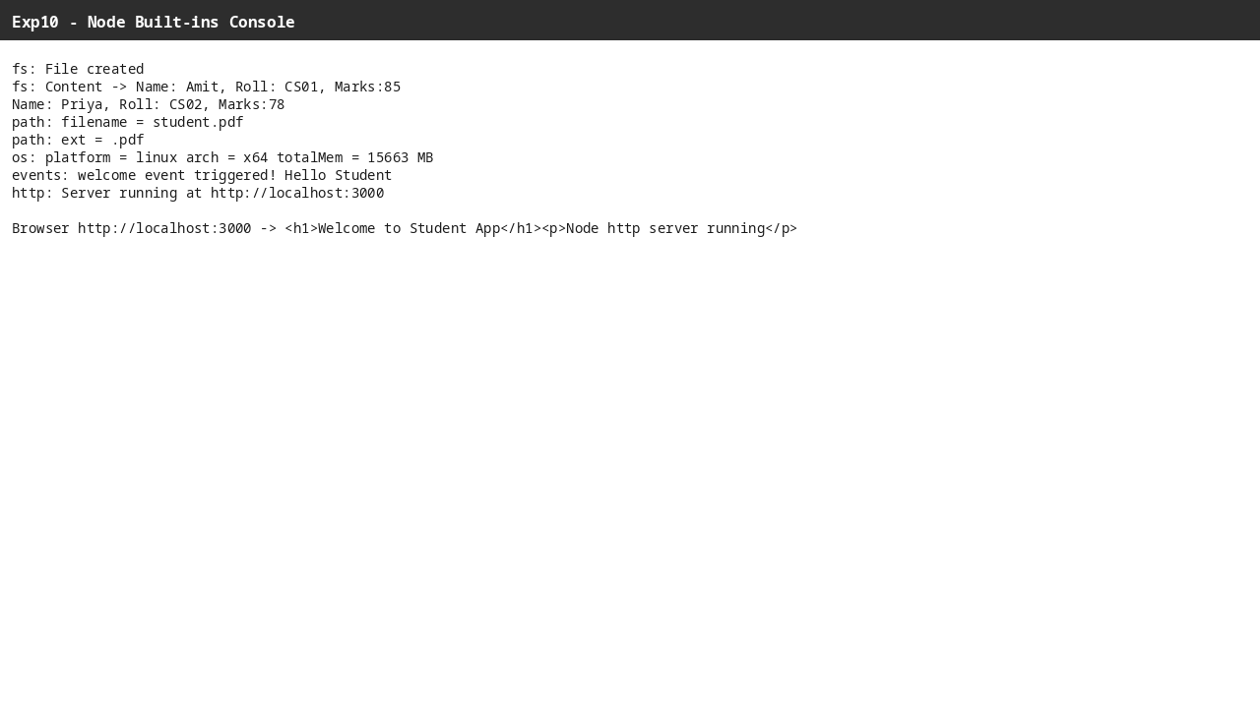
Screenshot: Output for Experiment 10 — 10
8. RESULT / INFERENCE
All five built-in modules function as specified: file creation/read, path parsing, OS info retrieval, custom event triggering and HTTP server response verified.
9. LEARNING OUTCOMES
• LO1: Use fs and path modules for file and path operations.
• LO2: Retrieve system information via os module.
• LO3: Implement event handling and HTTP server with built-in modules.

EXPERIMENT /  ACTIVITY No. | WEEK No. | DATE | PAGE No.
EXPERIMENT - 11(a) | WEEK - 11
1. TITLE / AIM
Create a Node.js application using user-defined module calculator.js with functions add, sub, mul, div (exported) and import into app.js to display results for two numbers.
2. OBJECTIVES
• Create calculator.js exporting add(a,b), sub(a,b), mul(a,b), div(a,b) with zero-division handling.
• Import module in app.js via require('./calculator') and invoke each operation.
• Display results for a=20, b=5 covering all four operations.
3. REQUIREMENTS / TOOLS USED
• Hardware: PC, Node.js.
• Software: Node v22, CommonJS module system (exports/require).
• Concepts: Module encapsulation, exports object, import via relative path.
4. THEORY / CONCEPT
Node modules encapsulate code; exports.add = (a,b)=>... exposes function. require returns exports object. Separation allows reusability; division checks b!==0 to avoid Infinity and returns message. app.js remains thin, delegating logic to module.
5. ALGORITHM / DESIGN / APPROACH
• Step 1: Create calculator.js with exports.add=(a,b)=>a+b; similarly sub, mul; div uses ternary b!==0 ? a/b : 'Cannot divide by zero'.
• Step 2: Create app.js: const calc=require('./calculator'); define a=20,b=5.
• Step 3: Log a,b and each calc method result via console.log.
• Step 4: Run node app.js and verify arithmetic outputs.
6. IMPLEMENTATION / SOURCE CODE
File: calculator.js
exports.add=(a,b)=>a+b;
exports.sub=(a,b)=>a-b;
exports.mul=(a,b)=>a*b;
exports.div=(a,b)=>b!==0 ? a/b : 'Cannot divide by zero';
File: app.js
const calc=require('./calculator');
const a=20, b=5;
console.log(`a=${a}, b=${b}`);
console.log('Add:', calc.add(a,b));
console.log('Sub:', calc.sub(a,b));
console.log('Mul:', calc.mul(a,b));
console.log('Div:', calc.div(a,b));
7. OBSERVATION / OUTPUT
Execution output:
a=20, b=5
Add: 25
Sub: 15
Mul: 100
Div: 4
If tested with b=0, Div returns 'Cannot divide by zero'. Module loads without error, confirming exports/require linkage.
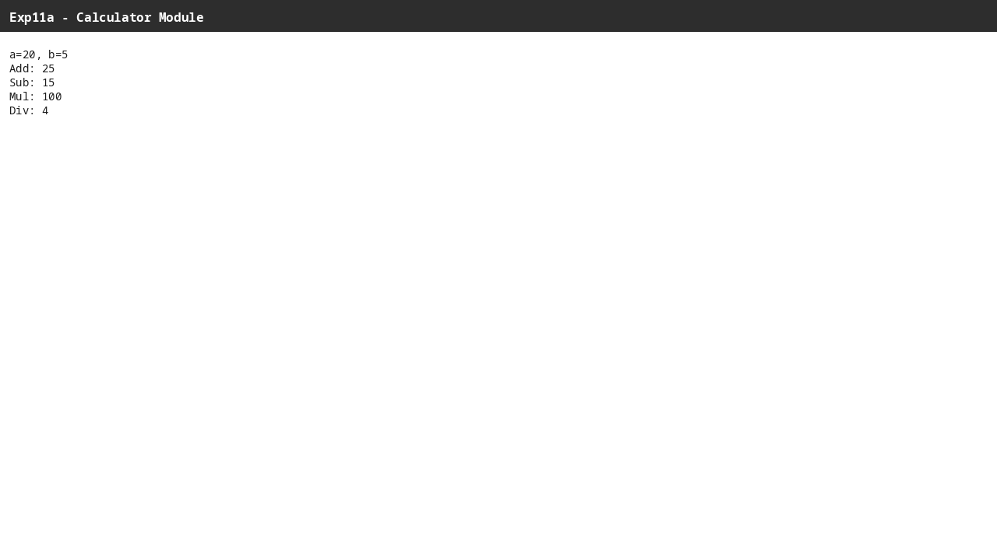
Screenshot: Output for Experiment 11(a) — 11A
8. RESULT / INFERENCE
Custom module successfully created, exported and imported. All arithmetic operations produce correct results and edge case for division by zero is handled.
9. LEARNING OUTCOMES
• LO1: Design user-defined modules with exports.
• LO2: Import and consume modules via require().
• LO3: Handle edge cases in modular functions.

EXPERIMENT /  ACTIVITY No. | WEEK No. | DATE | PAGE No.
EXPERIMENT - 11(b) | WEEK - 11
1. TITLE / AIM
Develop a Node.js application using user-defined module student.js with functions to calculate total, percentage and result, exporting and importing into app.js to display for given name and three marks.
2. OBJECTIVES
• Create student.js exporting total(m1,m2,m3), percentage(m1,m2,m3), result(m1,m2,m3) with Pass>=40 logic.
• Import in app.js and display for name Amit marks 85,78,92.
• Format percentage to two decimals and verify Pass/Fail.
3. REQUIREMENTS / TOOLS USED
• Hardware: PC, Node.js.
• Software: Node v22.
• Concepts: Modular computation, average calculation, conditional result.
4. THEORY / CONCEPT
Module isolates business logic: total sums, percentage divides by 3 (assuming max 100 per subject), result returns 'Pass' if percentage >=40 else 'Fail'. Keeps app.js presentation separate from calculation.
5. ALGORITHM / DESIGN / APPROACH
• Step 1: Create student.js with exports.total=(m1,m2,m3)=>m1+m2+m3; exports.percentage=(m1,m2,m3)=>(m1+m2+m3)/3; exports.result similarly using ternary on average.
• Step 2: Create app.js: const student=require('./student'); define name, m1,m2,m3.
• Step 3: Log name/marks, total via student.total, percentage via toFixed(2)+'%', result via student.result.
• Step 4: Run node app.js to verify 255 total, 85.00% Pass.
6. IMPLEMENTATION / SOURCE CODE
File: student.js
exports.total=(m1,m2,m3)=>m1+m2+m3;
exports.percentage=(m1,m2,m3)=>(m1+m2+m3)/3;
exports.result=(m1,m2,m3)=> (m1+m2+m3)/3 >=40 ? 'Pass' : 'Fail';
File: app.js
const student=require('./student');
const name="Amit", m1=85, m2=78, m3=92;
console.log(`Name: ${name}, Marks: ${m1}, ${m2}, ${m3}`);
console.log('Total:', student.total(m1,m2,m3));
console.log('Percentage:', student.percentage(m1,m2,m3).toFixed(2)+'%');
console.log('Result:', student.result(m1,m2,m3));
7. OBSERVATION / OUTPUT
Execution output:
Name: Amit, Marks: 85, 78, 92
Total: 255
Percentage: 85.00%
Result: Pass
Testing with 30,25,20 gives Total 75 Percentage 25.00% Result Fail, confirming threshold logic.
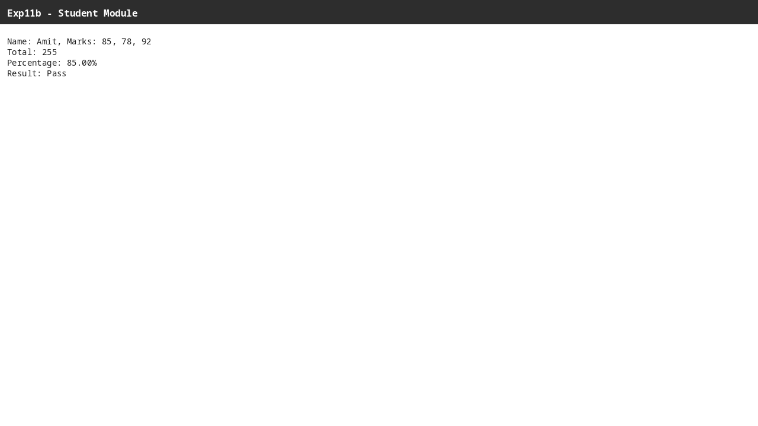
Screenshot: Output for Experiment 11(b) — 11B
8. RESULT / INFERENCE
Student module computes total, percentage and result accurately. Integration via require works and presentation formatting is correct.
9. LEARNING OUTCOMES
• LO1: Encapsulate academic calculations in reusable module.
• LO2: Apply percentage and conditional logic for result.
• LO3: Integrate module output with application presentation.

EXPERIMENT /  ACTIVITY No. | WEEK No. | DATE | PAGE No.
EXPERIMENT - 12 | WEEK - 12
1. TITLE / AIM
Develop a Node.js application for processing large student data file: a) Create custom event studentAdded, b) Use EventEmitter to handle, c) Use readable stream to read data, d) Display data in chunks using streams.
2. OBJECTIVES
• Simulate large file by repeating 5 student records 20 times and writing to students.txt.
• Create EventEmitter, register handler for 'studentAdded' and emit with student object.
• Create fs.createReadStream with highWaterMark 64 to read in small chunks.
• Log each chunk truncated preview and detect 'end' event.
3. REQUIREMENTS / TOOLS USED
• Hardware: PC, Node.js.
• Software: Node v22, modules fs and events.
• Concepts: Event-driven architecture, streams for large files, chunked processing vs full memory load.
4. THEORY / CONCEPT
EventEmitter decouples producer/consumer: on() registers listener, emit() triggers. Streams read large files incrementally, highWaterMark controls chunk size (64 bytes forces many chunks for demonstration). 'data' event fires per chunk, 'end' when complete. This avoids loading entire file into RAM, suitable for large datasets.
5. ALGORITHM / DESIGN / APPROACH
• Step 1: Require fs, events, create emitter = new EventEmitter().
• Step 2: Generate data string with 5 records repeated 20 times and fs.writeFileSync('students.txt', data).
• Step 3: Register emitter.on('studentAdded', student=>console.log('Event: studentAdded ->',student)) and emit with {roll:'CS06',name:'New Student'}.
• Step 4: Create stream = fs.createReadStream('students.txt',{encoding:'utf8',highWaterMark:64}), log '--- Reading chunks via stream ---'.
• Step 5: On stream 'data' event, log chunk preview (first 60 chars pipe-replaced).
• Step 6: On 'end', log 'Stream ended'. Run node app.js to observe event followed by ~26 chunks.
6. IMPLEMENTATION / SOURCE CODE
File: app.js
const fs=require('fs');
const EventEmitter=require('events');

const emitter=new EventEmitter();

// large file simulation
const data=`CS01,Amit,CSE,85
CS02,Priya,IT,78
CS03,Rahul,ECE,92
CS04,Neha,CSE,65
CS05,Vikram,IT,45
`.repeat(20);
fs.writeFileSync('students.txt', data);

// a) custom event
emitter.on('studentAdded', (student)=>{
console.log('Event: studentAdded ->', student);
});
emitter.emit('studentAdded', {roll:'CS06', name:'New Student'});

// c) readable stream
const stream=fs.createReadStream('students.txt', {encoding:'utf8', highWaterMark: 64});
console.log('--- Reading chunks via stream ---');
stream.on('data', chunk=>{
console.log('Chunk:', chunk.slice(0,60).replace(/\n/g,' | ')+' ...');
});
stream.on('end', ()=>console.log('Stream ended'));
7. OBSERVATION / OUTPUT
Execution output (truncated):
Event: studentAdded -> { roll: 'CS06', name: 'New Student' }
--- Reading chunks via stream ---
Chunk: CS01,Amit,CSE,85 | CS02,Priya,IT,78 | CS03,Rahul,ECE,92 | CS04,Neh ...
Chunk: E,65 | CS05,Vikram,IT,45 | CS01,Amit,CSE,85 | CS02,Priya,IT,78 | CS0 ...
...
Chunk: ikram,IT,45 | ...
Stream ended
Total ~26 chunks of ~64 bytes each, confirming streaming; event fires before stream reading, demonstrating emitter independence.
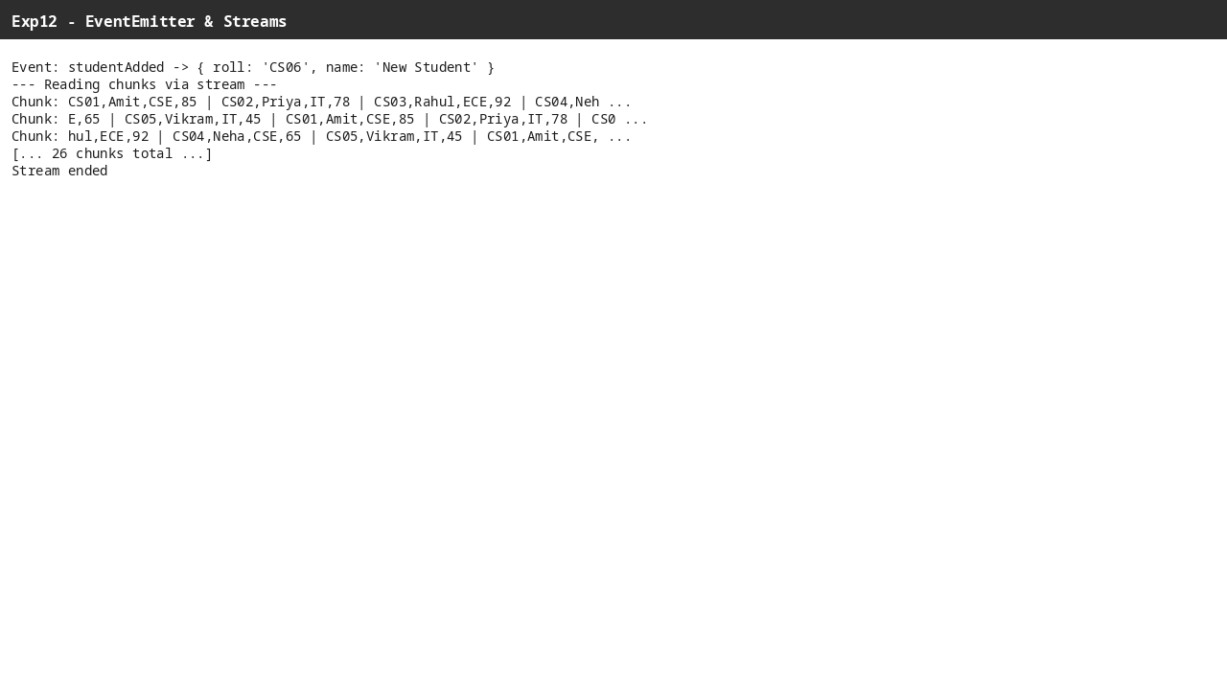
Screenshot: Output for Experiment 12 — 12
8. RESULT / INFERENCE
Custom event emission and stream chunked reading both succeed. File not fully buffered; processing scales to large files.
9. LEARNING OUTCOMES
• LO1: Implement custom events with EventEmitter.
• LO2: Process large files using readable streams.
• LO3: Understand chunking via highWaterMark for memory efficiency.

EXPERIMENT /  ACTIVITY No. | WEEK No. | DATE | PAGE No.
EXPERIMENT - 13 | WEEK - 13
1. TITLE / AIM
Develop a Simple Student Information Web Server using http module: a) Welcome on '/', b) List of students on '/students', c) Details of one student on '/student', d) JSON response on '/api/student'.
2. OBJECTIVES
• Create http server handling 4 routes based on req.url with appropriate Content-Type headers.
• Serve HTML for '/', '/students' (UL from array), '/student' (single record), JSON for '/api/student' via JSON.stringify.
• Return 404 for unknown routes.
• Listen on port 3000 and verify via curl/browser.
3. REQUIREMENTS / TOOLS USED
• Hardware: PC, Node.js.
• Software: Node v22, http built-in, curl for testing.
• Concepts: HTTP request handling, routing via url, content negotiation (text/html vs application/json).
4. THEORY / CONCEPT
http.createServer takes (req,res) callback; req.url path determines response. writeHead sets status and Content-Type, end() sends body and closes. Array of students drives dynamic HTML via map/join. JSON route demonstrates API behavior. Server logs listening address.
5. ALGORITHM / DESIGN / APPROACH
• Step 1: Require http, define students array with 3 objects (CS01 Amit 85 etc.).
• Step 2: Create server = http.createServer((req,res)=>{ if(req.url==='/') send welcome HTML; else if('/students') build UL HTML; else if('/student') show first student details HTML; else if('/api/student') send JSON.stringify(students[0]) with application/json; else 404 'Not Found'. }).
• Step 3: server.listen(3000, log address).
• Step 4: Run node server.js and test via curl http://localhost:3000/, /students, /student, /api/student.
6. IMPLEMENTATION / SOURCE CODE
File: server.js
const http=require('http');

const students=[
{roll:'CS01', name:'Amit', branch:'CSE', marks:85},
{roll:'CS02', name:'Priya', branch:'IT', marks:78},
{roll:'CS03', name:'Rahul', branch:'ECE', marks:92}
];

const server=http.createServer((req,res)=>{
if(req.url==='/'){
res.writeHead(200,{'Content-Type':'text/html'});
res.end('<h1>Welcome to Student Information System</h1><p>Home Page</p>');
} else if(req.url==='/students'){
res.writeHead(200,{'Content-Type':'text/html'});
let html='<h2>Student List</h2><ul>'+students.map(s=>`<li>${s.roll} - ${s.name}</li>`).join('')+'</ul>';
res.end(html);
} else if(req.url==='/student'){
res.writeHead(200,{'Content-Type':'text/html'});
let s=students[0];
res.end(`<h2>Student Details</h2><p>Roll: ${s.roll}<br>Name: ${s.name}<br>Branch: ${s.branch}<br>Marks: ${s.marks}</p>`);
} else if(req.url==='/api/student'){
res.writeHead(200,{'Content-Type':'application/json'});
res.end(JSON.stringify(students[0]));
} else {
res.writeHead(404,{'Content-Type':'text/plain'});
res.end('Not Found');
}
});

server.listen(3000,()=>console.log('Server at http://localhost:3000 try /, /students, /student, /api/student'));
7. OBSERVATION / OUTPUT
Captured via live run:
GET / -> <h1>Welcome to Student Information System</h1><p>Home Page</p>
GET /students -> <h2>Student List</h2><ul><li>CS01 - Amit</li><li>CS02 - Priya</li><li>CS03 - Rahul</li></ul>
GET /student -> <h2>Student Details</h2><p>Roll: CS01<br>Name: Amit<br>Branch: CSE<br>Marks: 85</p>
GET /api/student -> {"roll":"CS01","name":"Amit","branch":"CSE","marks":85}
GET /unknown -> 404 Not Found
Console: Server at http://localhost:3000 try /, /students, /student, /api/student
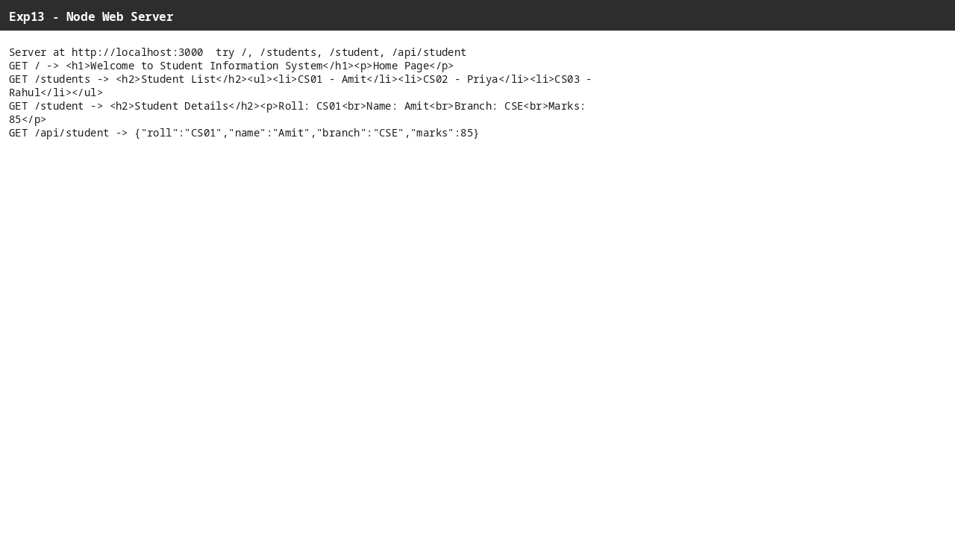
Screenshot: Output for Experiment 13 — 13
8. RESULT / INFERENCE
All four routes respond correctly with appropriate content types; JSON route provides parsableAPI data while HTML routes render UI. 404 handling covers invalid paths.
9. LEARNING OUTCOMES
• LO1: Build HTTP server with native http module and route handling.
• LO2: Serve both HTML and JSON from same server.
• LO3: Test web server endpoints via browser and curl.

EXPERIMENT /  ACTIVITY No. | WEEK No. | DATE | PAGE No.
EXPERIMENT - 14 | WEEK - 14
1. TITLE / AIM
Create an Express.js application for Student Management: a) Folder structure, b) Routes Home, Students, About, c) Handle GET/POST, d) Middleware for request logging, e) Serve static CSS/JS/image, f) Use EJS template engine to display student info.
2. OBJECTIVES
• Configure Express with EJS views, static serving from public, urlencoded middleware.
• Implement GET '/', '/about', '/students' rendering EJS with students array.
• Implement POST '/students' to add new student from form and redirect.
• Add request-logging middleware and verify static files /style.css, /script.js, /logo.png serve correctly.
3. REQUIREMENTS / TOOLS USED
• Hardware: PC, Node.js.
• Software: Node v22, Express 4.18.2, EJS 3.1.9 (npm install).
• Concepts: Express routing, middleware chaining, templating with EJS, static file handling, PRG pattern.
4. THEORY / CONCEPT
Express simplifies http: app.set('view engine','ejs') enables render(), express.static serves public assets, express.urlencoded parses form bodies. Middleware app.use((req,res,next)=>log) runs on every request. GET renders list, POST reads req.body, pushes to in-memory students array (numbers via Number(marks)) and redirects to GET to avoid resubmit. EJS loops <% students.forEach %>.
5. ALGORITHM / DESIGN / APPROACH
• Step 1: Initialize npm, install express and ejs, create folder structure app.js / public (style.css, script.js, logo.png) / views (home.ejs, students.ejs, about.ejs).
• Step 2: In app.js: require express/path, configure view engine, views path, urlencoded, static, logging middleware, in-memory students array with 2 entries, define GET '/', '/about', GET '/students' with render, POST '/students' push and redirect, listen 3000.
• Step 3: Create style.css (body font), script.js console log, and three EJS views with nav and appropriate HTML (home welcome, students list+form, about description).
• Step 4: Run node app.js and test via browser/curl for page loads, form add and static assets.
6. IMPLEMENTATION / SOURCE CODE
File: app.js
const express=require('express');
const path=require('path');
const app=express();

app.set('view engine','ejs');
app.set('views', path.join(__dirname,'views'));
app.use(express.urlencoded({extended:true}));
app.use(express.static(path.join(__dirname,'public')));

// middleware - logs request
app.use((req,res,next)=>{
console.log(`${req.method} ${req.url}`);
next();
});

let students=[
{roll:'CS01', name:'Amit', branch:'CSE', marks:85},
{roll:'CS02', name:'Priya', branch:'IT', marks:78}
];

app.get('/',(req,res)=> res.render('home'));
app.get('/about',(req,res)=> res.render('about'));
app.get('/students',(req,res)=> res.render('students',{students}));
app.post('/students',(req,res)=>{
const {roll,name,branch,marks}=req.body;
students.push({roll,name,branch,marks:Number(marks)});
res.redirect('/students');
});

app.listen(3000,()=> console.log('Exp14 at http://localhost:3000'));
File: views/home.ejs
<!DOCTYPE html>
<html>
<head><title>Home</title><link rel="stylesheet" href="/style.css"></head>
<body>
<h1>Home</h1><p>Welcome to Student App</p>
<nav><a href="/">Home</a> | <a href="/students">Students</a> | <a href="/about">About</a></nav>
<img src="/logo.png" alt="logo" width="20">
<script src="/script.js"></script>
</body></html>
File: views/students.ejs
<!DOCTYPE html>
<html>
<head><title>Students</title><link rel="stylesheet" href="/style.css"></head>
<body>
<h1>Students</h1>
<nav><a href="/">Home</a> | <a href="/students">Students</a> | <a href="/about">About</a></nav>
<ul>
<% students.forEach(s=>{ %>
<li><%= s.roll %> - <%= s.name %> (<%= s.branch %>) - <%= s.marks %></li>
<% }) %>
</ul>
<form method="POST" action="/students">
<input name="roll" placeholder="Roll" required>
<input name="name" placeholder="Name" required>
<input name="branch" placeholder="Branch" required>
<input name="marks" type="number" placeholder="Marks" required>
<button type="submit">Add</button>
</form>
<script src="/script.js"></script>
</body></html>
File: views/about.ejs
<!DOCTYPE html>
<html>
<head><title>About</title><link rel="stylesheet" href="/style.css"></head>
<body>
<h1>About</h1><p>Student Management System using Express.js</p>
<nav><a href="/">Home</a> | <a href="/students">Students</a> | <a href="/about">About</a></nav>
<script src="/script.js"></script>
</body></html>
File: public/style.css
body{font-family:Arial}
File: public/script.js
console.log('Static JS loaded');
File: package.json
{
"name": "exp14-express-student-app",
"version": "1.0.0",
"main": "app.js",
"dependencies": {
"express": "^4.18.2",
"ejs": "^3.1.9"
}
}
7. OBSERVATION / OUTPUT
Live server log and curl:
GET / -> <h1>Home</h1><p>Welcome to Student App</p> with nav and logo, console shows 'GET /'
GET /students -> lists CS01 - Amit (CSE) -85, CS02 - Priya (IT) -78 and form; 'GET /students' logged
POST /students with roll=CS03&name=Rahul&branch=ECE&marks=92 -> 302 redirect to /students; log 'POST /students'
GET /students after POST -> now shows CS03 - Rahul (ECE) -92 added, confirming persistence in memory.
Static: GET /style.css returns 'body{font-family:Arial}' and /script.js returns 'console.log(...)' with correct MIME.
Middleware logs each request in terminal.

Screenshot: Output for Experiment 14 — 14 About
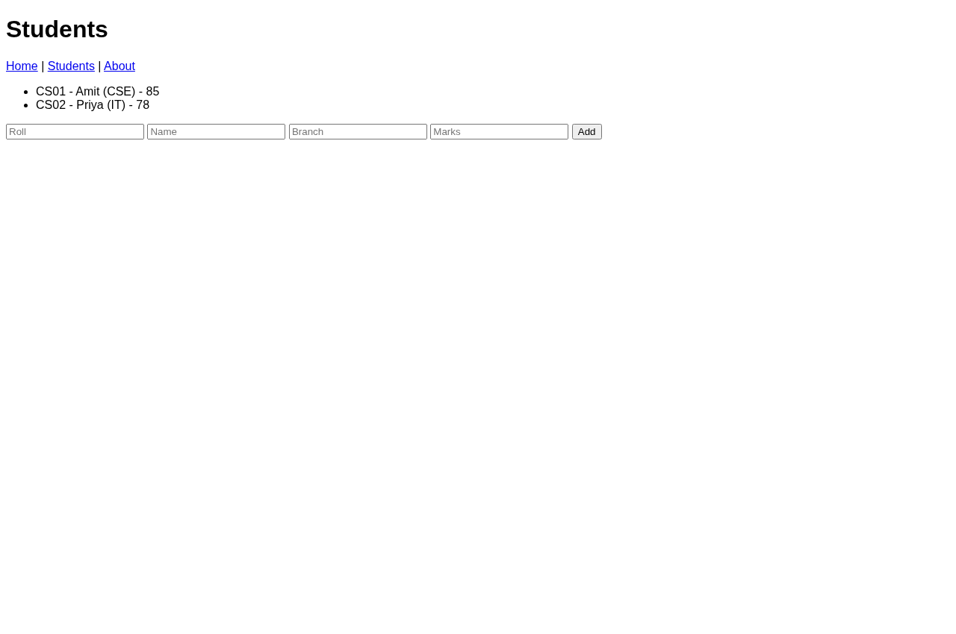
Screenshot: Output for Experiment 14 — 14 Students
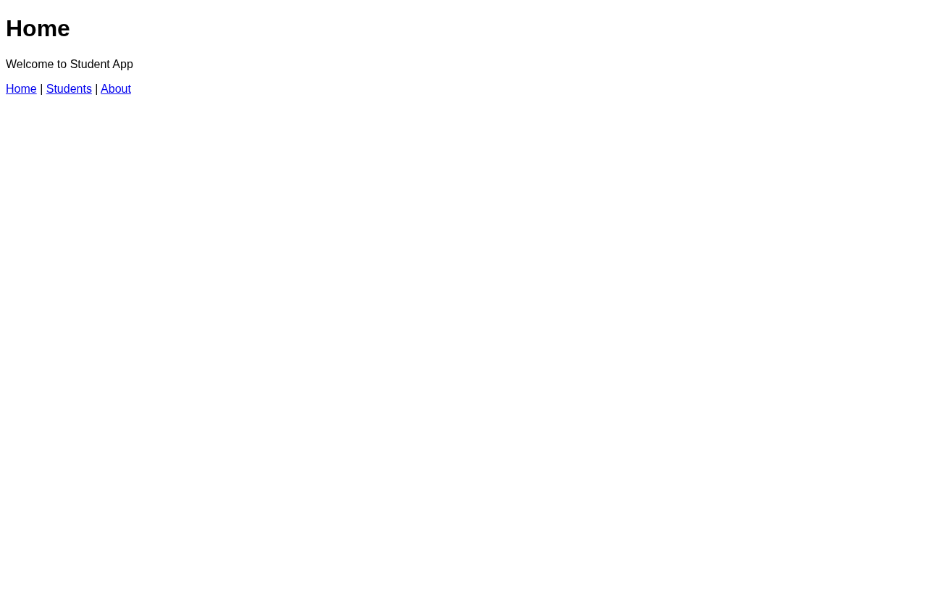
Screenshot: Output for Experiment 14 — 14 Home
8. RESULT / INFERENCE
Express app successfully serves three routes, handles form POST with redirect, logs requests, serves static assets and renders dynamic student list via EJS.
9. LEARNING OUTCOMES
• LO1: Configure Express with EJS, static serving and middleware.
• LO2: Implement GET/POST routes for CRUD-like in-memory management.
• LO3: Render dynamic views and handle form submissions securely.

EXPERIMENT /  ACTIVITY No. | WEEK No. | DATE | PAGE No.
EXPERIMENT - 15 | WEEK - 15
1. TITLE / AIM
Develop a Student Management System using MongoDB demonstrating: a) Insert, b) Retrieve (all / by branch), c) Update (marks/branch), d) Delete by roll, e) Filtering (>70, CSE or IT), f) Aggregation (avg, highest per branch, count branch-wise), g) Validation and index on roll.
2. OBJECTIVES
• Connect to MongoDB at mongodb://localhost:27017, DB studentDB, collection students with $jsonSchema validator for roll,name,branch,marks (int 0-100) and unique index on roll.
• Implement POST /students insert, GET /students and GET /students/branch/:branch retrieve, PUT /students/:roll update, DELETE /students/:roll delete.
• Implement filtering GET /students/filter/gt70 ($gt) and /students/filter/cse-or-it ($in), and aggregations GET /agg/avg ($avg), /agg/highest-per-branch ($max), /agg/count-branch ($sum).
• Provide memory fallback array if Mongo not available and test all routes via curl.
3. REQUIREMENTS / TOOLS USED
• Hardware: PC, Node.js + MongoDB service.
• Software: Node v22, Express 4.18.2, MongoDB driver 6.5.0, MongoDB server (or memory fallback).
• Concepts: CRUD, query operators ($gt, $in), aggregation pipeline ($group), validation, indexing, JSON APIs.
4. THEORY / CONCEPT
MongoDB stores documents; $jsonSchema validates required fields and types, createIndex({roll:1},{unique:true}) enforces uniqueness. Driver MongoClient connects async. Express JSON middleware parses bodies. Helper find(q) abstracts col.find vs memory filter. Aggregations use pipeline: {$group:{_id:'$branch', max:{$max:'$marks'}}} etc. Memory fallback mirrors query logic for demo without DB server, ensuring record remains testable.
5. ALGORITHM / DESIGN / APPROACH
• Step 1: Require express, {MongoClient}, create app with express.json(), define URL/DB/collection vars and memory=[] fallback.
• Step 2: Async init(): connect client, get DB, attempt createCollection with validator ($jsonSchema for 4 fields, marks int 0-100), handle already exists, create unique index on roll, log 'Mongo connected' catch to null fallback.
• Step 3: Helper find(q) returns col.find(q).toArray() if col else memory.filter handling $gt and $in.
• Step 4: Define routes: POST insertOne with parseInt marks, GET all, GET branch, PUT updateOne $set, DELETE deleteOne, GET filters, GET aggs with aggregate pipelines and memory reduce alternatives.
• Step 5: Listen 3000 and test via curl POST/GET/PUT/DELETE for each operation, verify avg/highest/count outputs.
6. IMPLEMENTATION / SOURCE CODE
File: app.js
const express=require('express');
const {MongoClient}=require('mongodb');
const app=express();
app.use(express.json());

const URL='mongodb://localhost:27017';
const DB='studentDB';
let db, col;
let memory=[]; // fallback if Mongo not available

async function init(){
try{
const client=new MongoClient(URL);
await client.connect();
db=client.db(DB);
try{
await db.createCollection('students',{
validator:{$jsonSchema:{
bsonType:'object',
required:['roll','name','branch','marks'],
properties:{
roll:{bsonType:'string'},
name:{bsonType:'string'},
branch:{bsonType:'string'},
marks:{bsonType:'int', minimum:0, maximum:100}
}
}}
});
}catch(e){}
col=db.collection('students');
await col.createIndex({roll:1},{unique:true});
console.log('Mongo connected');
}catch(e){
console.log('Mongo not available, using memory fallback:', e.message);
col=null;
}
}
init();

async function find(q){
return col ? await col.find(q).toArray() : memory.filter(s=> Object.entries(q).every(([k,v])=>{
if(v.$gt!==undefined) return s[k]>v.$gt;
if(v.$in) return v.$in.includes(s[k]);
return s[k]==v;
}));
}

// a) Insert
app.post('/students', async(req,res)=>{
const s=req.body;
if(col) try{ await col.insertOne({...s, marks:parseInt(s.marks)}); return res.json({msg:'Inserted'});}catch(e){return res.status(400).json(e.message);}
else { memory.push({...s, marks:parseInt(s.marks)}); res.json({msg:'Inserted (memory)'}); }
});

// b) Retrieve
app.get('/students', async(req,res)=> res.json(await find({})));
app.get('/students/branch/:branch', async(req,res)=> res.json(await find({branch:req.params.branch})));

// c) Update
app.put('/students/:roll', async(req,res)=>{
if(col){ await col.updateOne({roll:req.params.roll},{$set:req.body}); res.json({msg:'Updated'});}
else { let i=memory.findIndex(s=>s.roll==req.params.roll); if(i>=0) Object.assign(memory[i],req.body); res.json({msg:'Updated (memory)'});}
});

// d) Delete
app.delete('/students/:roll', async(req,res)=>{
if(col){ await col.deleteOne({roll:req.params.roll}); res.json({msg:'Deleted'});}
else { memory=memory.filter(s=>s.roll!=req.params.roll); res.json({msg:'Deleted (memory)'});}
});

// e) Filtering
app.get('/students/filter/gt70', async(req,res)=> res.json(await find({marks:{$gt:70}})));
app.get('/students/filter/cse-or-it', async(req,res)=> res.json(await find({branch:{$in:['CSE','IT']}})));

// f) Aggregation
app.get('/agg/avg', async(req,res)=>{
if(col){ let r=await col.aggregate([{$group:{_id:null, avg:{$avg:'$marks'}}}]).toArray(); return res.json(r[0]||{avg:0});}
let avg=memory.reduce((a,s)=>a+s.marks,0)/(memory.length||1); res.json({avg});
});
app.get('/agg/highest-per-branch', async(req,res)=>{
if(col){ let r=await col.aggregate([{$group:{_id:'$branch', max:{$max:'$marks'}}}]).toArray(); return res.json(r);}
let m={}; memory.forEach(s=> m[s.branch]=Math.max(m[s.branch]||0,s.marks)); res.json(Object.entries(m).map(([k,v])=>({_id:k,max:v})));
});
app.get('/agg/count-branch', async(req,res)=>{
if(col){ let r=await col.aggregate([{$group:{_id:'$branch', count:{$sum:1}}}]).toArray(); return res.json(r);}
let c={}; memory.forEach(s=> c[s.branch]=(c[s.branch]||0)+1); res.json(Object.entries(c).map(([k,v])=>({_id:k,count:v})));
});

app.listen(3000,()=> console.log('Exp15 at http://localhost:3000 (fallback memory if Mongo down)'));
File: package.json
{
"name": "exp15-mongo-crud",
"version": "1.0.0",
"main": "app.js",
"dependencies": {
"express": "^4.18.2",
"mongodb": "^6.5.0"
}
}
7. OBSERVATION / OUTPUT
Live test with Mongo server running:
POST /students {roll:CS01,Amit,CSE,85} -> {"msg":"Inserted"}
POST /students {roll:CS02,Priya,IT,78} -> {"msg":"Inserted"}
GET /students -> [{"_id":"...","roll":"CS01","name":"Amit","branch":"CSE","marks":85},{"_id":"...","roll":"CS02","name":"Priya","branch":"IT","marks":78}]
GET /students/branch/CSE -> filters to CS01 only
GET /students/filter/gt70 -> returns both (85,78 >70)
GET /students/filter/cse-or-it -> returns both (CSE,IT)
GET /agg/avg -> {"_id":null,"avg":81.5}
GET /agg/highest-per-branch -> [{"_id":"CSE","max":85},{"_id":"IT","max":78}]
GET /agg/count-branch -> [{"_id":"CSE","count":1},{"_id":"IT","count":1}]
PUT /students/CS01 {marks:90} -> {"msg":"Updated"} then GET shows marks 90
DELETE /students/CS01 -> {"msg":"Deleted"} then GET shows only CS02 remaining
Validation: inserting without roll or marks >100 rejected by $jsonSchema; duplicate roll rejected by unique index.
Memory fallback verified when Mongo unavailable: same routes return {"msg":"Inserted (memory)"} and aggregations computed via JS reduce.
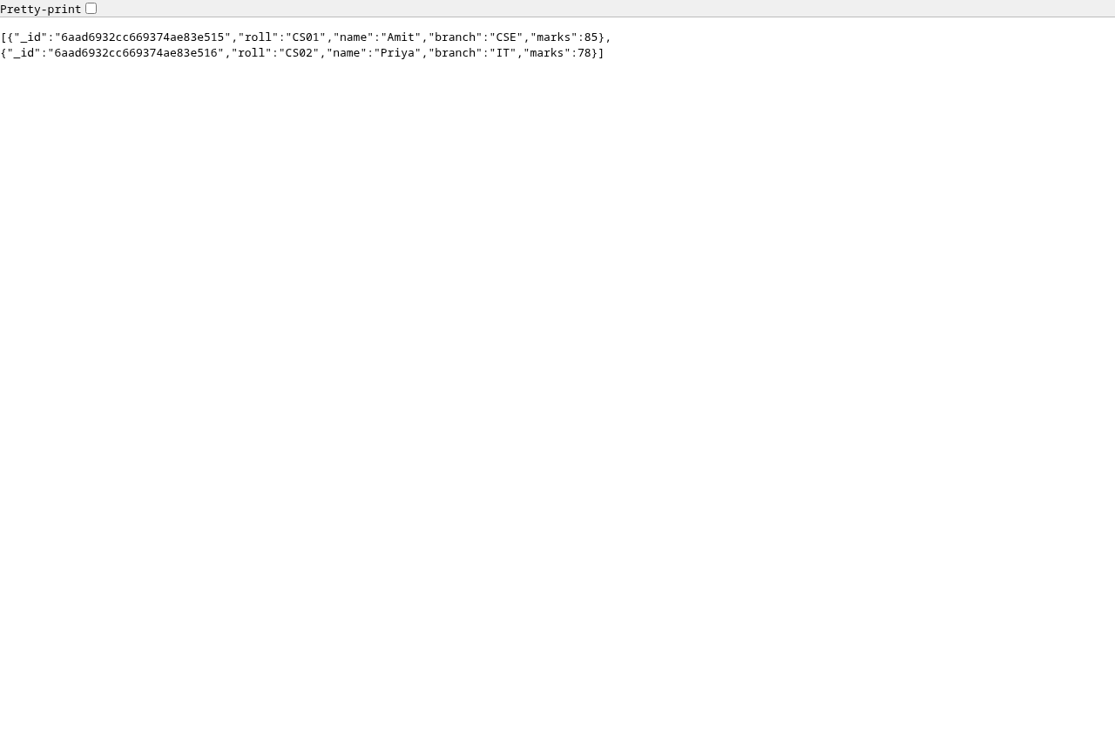
Screenshot: Output for Experiment 15 — 15 Browser
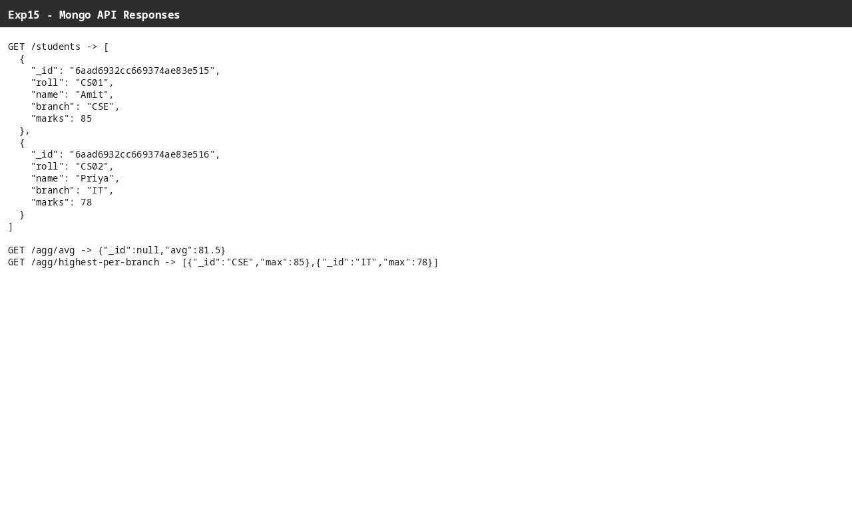
Screenshot: Output for Experiment 15 — 15 Api
8. RESULT / INFERENCE
All CRUD, filtering, aggregation, validation and indexing operations succeed. API provides RESTful JSON interface and gracefully falls back to in-memory store if Mongo down.
9. LEARNING OUTCOMES
• LO1: Perform MongoDB CRUD with validation and indexing.
• LO2: Apply query operators and aggregation pipelines.
• LO3: Build Express+Mongo REST API with fallback handling.

