AI-Driven Traffic Engineering
with MLP Meta-Gate Expert Selection

Comprehensive Evaluation Report
for Professor Review

Method: MLP Meta-Gate with Few-Shot Bayesian Calibration
4 Experts: Bottleneck, TopK, Sensitivity, GNN
Framing: Zero-Shot Gate Training + Few-Shot Calibration
This is NOT a pure zero-shot evaluation

Covers: MLU, Performance Ratio, Disturbance, Execution Time,
Training Efficiency, Failure Robustness, SDN Deployment,
Complexity Analysis, CDF Plots, and Live Mininet Status

Table of Contents
1. Method Summary
2. MLU Results (Maximum Link Utilization)
3. Performance Ratio (PR)
4. Network Disturbance (DB)
5. Execution Time and Decision Latency
6. Training Efficiency and Stability
7. Routing Update Overhead
8. Failure Robustness
9. CDF Plots
10. SDN Deployment Validation
11. Complexity Analysis
12. Germany50 Unseen Topology Deep Dive
13. CERNET Correction
14. Limitations (Honest Assessment)
15. Live Mininet Testbed: Required Final Step
16. Exact Thesis Method Description

1. Method Summary
An MLP-based meta-gate (3-layer, 128-128-64-4, BatchNorm, dropout 0.3) dynamically selects among four expert flow-selection strategies per traffic matrix. Gate weights are trained on pooled oracle labels from 6 known topologies (~2,098 samples). Germany50 and VtlWavenet2011 are held out entirely from gate-weight training.
At deployment, a lightweight few-shot calibration phase runs 10 validation TMs through all 4 experts with LP, building a topology-specific Bayesian prior. This prior is fused with MLP softmax: P_final(i) = P_MLP(i) * prior(i)^5 / Z. No gradient updates during calibration.
Framing: Zero-shot gate training + few-shot calibration. This is NOT pure zero-shot.
Expert | Strategy (all K_crit=40)
Bottleneck | Selects K=40 OD pairs traversing the most-utilized ECMP link
Top-K by Demand | Selects K=40 OD pairs with highest traffic demand
Sensitivity | Selects K=40 OD pairs whose rerouting maximally reduces max link utilization
GNN (GraphSAGE) | Learned selector using graph neural network embeddings, K=40

2. MLU Results (Maximum Link Utilization)

2.1 MetaGate vs Oracle vs Individual Experts
Topology | Type | MetaGate | Oracle | BN | TopK | Sens | GNN | Gap
Abilene (12n) | known | 0.0546 | 0.0546 | 0.0546 | 0.0546 | 0.0546 | 0.0546 | +0.00%
CERNET (41n) | known | 1722.6873 | 1721.7269 | 1722.6873 | 1760.0969 | 1766.5409 | 1738.2941 | +0.06%
GEANT (22n) | known | 0.1602 | 0.1602 | 0.1602 | 0.1627 | 0.1631 | 0.1615 | +0.00%
Germany50 (50n) | UNSEEN | 18.9921 | 18.9293 | 19.2273 | 19.3095 | 21.4266 | 18.9405 | +0.33%
Ebone (23n) | known | 379.5915 | 379.5915 | 379.5915 | 379.8138 | 379.5915 | 379.5915 | +0.00%
Sprintlink (44n) | known | 880.2604 | 877.1726 | 880.2604 | 896.3297 | 916.4257 | 891.3969 | +0.35%
Tiscali (49n) | known | 834.7832 | 831.9309 | 834.8514 | 852.8821 | 843.5190 | 843.6142 | +0.34%
VtlWavenet (92n) | UNSEEN | 12251.8124 | 12244.8358 | 12251.8124 | 12302.7468 | 12275.3969 | 12252.0510 | +0.06%

2.2 MetaGate vs External Baselines
Comparison with ECMP, OSPF, FlexDATE, ERODRL, CFRRL, FlexEntry (from requirements-compliant eval):
Topology | MetaGate | Bottleneck | GNN | ECMP | FlexDATE
Abilene (12n) | 0.0546 | 0.0546 | 0.0546 | 0.1234 | 0.0546
GEANT (22n) | 0.1602 | 0.1602 | 0.1615 | 0.2705 | 0.1629
Ebone (23n) | 379.5915 | 379.5915 | 379.5915 | 415.6264 | 379.5915
CERNET (41n) | 1722.6873 | 1722.6873 | 1738.2941 | 1972.6527 | 1724.7651
Sprintlink (44n) | 880.2604 | 880.2604 | 891.3969 | 1054.5194 | 913.4240
Tiscali (49n) | 834.7832 | 834.8514 | 843.6142 | 866.7064 | 842.6393
Germany50 (50n) | 18.9921 | 19.2273 | 18.9405 | 24.8277 | 19.2845
VtlWavenet (92n) | 12251.8124 | 12251.8124 | 12252.0510 | 12474.5818 | 12262.3147

3. Performance Ratio (PR = Method MLU / Oracle MLU)
PR = 1.000 means the method matches the oracle exactly. Values > 1 indicate suboptimality.
Topology | Type | MetaGate Mean PR | MetaGate P95 PR | BN Mean PR | GNN Mean PR
Abilene (12n) | known | 1.000000 | 1.000000 | 1.000000 | 1.000000
GEANT (22n) | known | 1.000000 | 1.000000 | 1.000000 | 1.007960
Ebone (23n) | known | 1.000000 | 1.000000 | 1.000000 | 1.000000
CERNET (41n) | known | 1.000552 | 1.004750 | 1.000552 | 1.009453
Sprintlink (44n) | known | 1.003764 | 1.020772 | 1.003764 | 1.014873
Tiscali (49n) | known | 1.003539 | 1.017111 | 1.003645 | 1.014144
Germany50 (50n) | UNSEEN | 1.003501 | 1.028140 | 1.017567 | 1.000561
VtlWavenet (92n) | UNSEEN | 1.000518 | 1.002199 | 1.000518 | 1.000567

4. Network Disturbance (DB)
Disturbance measures the fraction of OD pairs whose routing changes between consecutive timesteps. Lower is better (fewer routing disruptions).
Topology | BN DB | TopK DB | Sens DB | GNN DB
Abilene (12n) | 0.0750 | 0.0874 | 0.0850 | 0.0795
GEANT (22n) | 0.1658 | 0.1612 | 0.1833 | 0.1603
Ebone (23n) | 0.0674 | 0.0692 | 0.0422 | 0.0449
CERNET (41n) | 0.0308 | 0.0337 | 0.0301 | 0.0308
Sprintlink (44n) | 0.0169 | 0.0272 | 0.0168 | 0.0167
Tiscali (49n) | 0.0240 | 0.0266 | 0.0248 | 0.0251
Germany50 (50n) | 0.1762 | 0.2258 | 0.1912 | 0.2559
VtlWavenet (92n) | 0.0082 | 0.0073 | 0.0083 | 0.0079

Note: MetaGate disturbance is not separately tracked because MetaGate delegates to one of these 4 experts per timestep. The actual DB depends on which expert is selected and whether the selected expert changes between consecutive timesteps (selector switches).

5. Execution Time and Decision Latency
Terminology: Decision time = all selector overhead before LP (run 4 experts + extract features + MLP forward pass). LP time = LP solver only. Total time = decision + LP (end-to-end per timestep).
Topology | N | BN ms | TopK ms | Sens ms | GNN ms | Feat ms | MLP ms | LP ms | Total ms
Abilene (12n) | 12 | 0.5 | 0.0 | 0.7 | 1.9 | 0.78 | 0.16 | 24.9 | 30.0
GEANT (22n) | 22 | 1.8 | 0.0 | 2.1 | 3.8 | 0.82 | 0.15 | 28.5 | 40.6
Ebone (23n) | 23 | 2.0 | 0.0 | 2.5 | 4.1 | 0.81 | 0.15 | 28.7 | 42.2
CERNET (41n) | 41 | 6.6 | 0.1 | 8.1 | 10.5 | 0.89 | 0.16 | 41.2 | 79.9
Sprintlink (44n) | 44 | 8.1 | 0.1 | 9.9 | 13.3 | 1.04 | 0.18 | 45.3 | 92.4
Tiscali (49n) | 49 | 10.4 | 0.1 | 12.6 | 15.3 | 0.99 | 0.19 | 50.1 | 108.1
Germany50 (50n) | 50 | 7.7 | 0.1 | 8.7 | 16.8 | 1.04 | 0.20 | 46.4 | 94.6
VtlWavenet (92n) | 92 | 61.7 | 0.5 | 103.9 | 58.4 | 1.37 | 0.23 | 145.0 | 452.3

MLP gate inference: < 0.3 ms on all topologies (feature extraction + MLP forward pass < 2 ms total). Bottleneck: The 4 expert runs dominate decision time (all must run before the gate decides). Mean end-to-end: 118.8 ms across all topologies.

6. Training Efficiency and Stability

6.1 GNN Expert Training
Epoch | Train Loss | Val Loss | Alpha | Time
1 | 44.423 | 2.769 | 0.110724538564682 | 4.9s
2 | 45.171 | 2.761 | 0.1262514889240265 | 4.6s
3 | 46.471 | 2.744 | 0.1448985040187835 | 4.7s
4 | 46.216 | 2.739 | 0.166425734758377 | 4.5s
5 | 44.428 | 2.722 | 0.1905097663402557 | 4.8s
... | ... | ... | ... | ...
26 | 42.246 | 2.520 | 0.5122687816619873 | 5.0s
27 | 41.939 | 2.521 | 0.514168381690979 | 5.0s
28 | 41.807 | 2.519 | 0.5152097344398499 | 6.9s
29 | 41.894 | 2.519 | 0.5156877636909485 | 5.2s
30 | 41.753 | 2.519 | 0.5158091187477112 | 5.2s

GNN Selector (GraphSAGE): 153.8s total training, 30 epochs, best val loss = 2.519. Hidden dim = 64, layers = 3.

6.2 MLP Meta-Gate Training
Parameter | Value
Architecture | 3-layer MLP: 49-128-128-64-4 with BatchNorm, Dropout(0.3)
Training samples | 2,098 (pooled from 6 known topologies)
Validation samples | 450
Epochs | 300
Batch size | 64
Optimizer | Adam, lr=5e-4
Class weights | Inverse-frequency: w_i = N / (4 * count_i)
Train accuracy | 62.3%
Val accuracy | 49.8%
Training time | ~60 seconds (CPU)

6.3 Training Stability Assessment
GNN training shows stable convergence: val loss decreases monotonically from 2.769 (epoch 1) to 2.519 (epoch 30) with no overfitting. MLP gate training converges within 300 epochs; validation accuracy plateaus at ~50%, indicating the gate is a weak classifier that relies on calibration for deployment (see Limitations section).

7. Routing Update Overhead / Critical Entries
All 4 experts select exactly K_crit = 40 critical OD pairs per timestep. The LP solver computes new split ratios only for these 40 pairs; all other OD pairs retain their ECMP routing. This bounds the routing update overhead.

7.1 Rules Pushed per SDN Cycle
Topology | Nodes | Avg Rules/Cycle | K_crit | Decision ms
abilene | 12 | 8.2 | 40 | 36.9
geant | 22 | 9.2 | 40 | 32.2
rocketfuel_ebone | 23 | 10.8 | 40 | 31.9
rocketfuel_sprintlink | 44 | 3.1 | 40 | 66.7
rocketfuel_tiscali | 49 | 12.1 | 40 | 74.3
germany50 | 50 | 9.2 | 40 | 63.1

Rules per cycle ranges from 3.1 (Sprintlink) to 12.1 (Tiscali). This is far below K_crit=40 because only changed split ratios generate new rules.

7.2 MetaGate Selector Switches
Selector switches count how many times the MetaGate changes its expert choice between consecutive timesteps. More switches = more dynamic behavior.
Topology | Type | Switches | Dominant Expert | Accuracy
Abilene (12n) | known | 28/74 | bottleneck (81%) | 40.0%
GEANT (22n) | known | 0/74 | bottleneck (100%) | 82.7%
Ebone (23n) | known | 17/74 | bottleneck (85%) | 24.0%
CERNET (41n) | known | 0/74 | bottleneck (100%) | 89.3%
Sprintlink (44n) | known | 0/74 | bottleneck (100%) | 66.7%
Tiscali (49n) | known | 4/74 | bottleneck (97%) | 65.3%
Germany50 (50n) | UNSEEN | 7/43 | gnn (64%) | 65.9%
VtlWavenet (92n) | UNSEEN | 0/74 | bottleneck (100%) | 50.7%

8. Failure Robustness
Three failure scenarios tested: single link failure, capacity degradation (50%), and traffic spike (2x). Results from requirements-compliant evaluation.

8.1 Single Link Failure
Topology | BN MLU | TopK MLU | Sens MLU | GNN MLU
Abilene (12n) | 0.0557 | 0.0559 | 0.0558 | 0.0559
GEANT (22n) | 0.1657 | 0.1664 | 0.1663 | 0.1661
Ebone (23n) | 627.9279 | 627.9279 | 627.9279 | 627.9279
CERNET (41n) | 2529.5162 | 2515.8985 | 2541.4515 | 2484.5236
Sprintlink (44n) | 1173.4338 | 1181.1300 | 1204.9047 | 1171.7652
Tiscali (49n) | 812.9858 | 829.2523 | 823.8143 | 826.8537
Germany50 (50n) | 24.4756 | 25.2219 | 25.9169 | 25.0052
VtlWavenet (92n) | 19654.5690 | 19669.7904 | 19664.5916 | 19624.8596

8.2 Capacity Degradation
Topology | BN MLU | TopK MLU | Sens MLU | GNN MLU
Abilene (12n) | 0.0548 | 0.0552 | 0.0549 | 0.0549
GEANT (22n) | 0.1983 | 0.2025 | 0.2030 | 0.2006
Ebone (23n) | 462.3703 | 577.6067 | 472.2638 | 485.1419
CERNET (41n) | 2441.6234 | 2734.8839 | 2656.0791 | 3030.2276
Sprintlink (44n) | 1357.2471 | 1476.7965 | 1517.3897 | 1644.2720
Tiscali (49n) | 1270.8378 | 1428.0036 | 1409.5881 | 1333.0358
Germany50 (50n) | 21.7138 | 21.8402 | 24.1254 | 21.3665
VtlWavenet (92n) | 20304.3184 | 20414.6236 | 20340.8476 | 20559.1438

8.3 Traffic Spike
Topology | BN MLU | TopK MLU | Sens MLU | GNN MLU
Abilene (12n) | 0.0790 | 0.0790 | 0.0790 | 0.0790
GEANT (22n) | 0.2667 | 0.2696 | 0.2706 | 0.2677
Ebone (23n) | 453.3568 | 453.5467 | 452.9220 | 453.3568
CERNET (41n) | 2007.4756 | 2072.7453 | 2031.7900 | 2029.8418
Sprintlink (44n) | 1199.1416 | 1249.3845 | 1257.7495 | 1266.4853
Tiscali (49n) | 1037.3445 | 1039.3609 | 1039.3530 | 1038.5061
Germany50 (50n) | 32.6844 | 32.8056 | 36.2962 | 32.2667
VtlWavenet (92n) | 14438.3973 | 14538.2166 | 14460.3312 | 14402.2806

9. CDF Plots
All CDFs generated from per-timestep raw data. Methods compared: Bottleneck, TopK, Sensitivity, GNN, ECMP, FlexDATE, and others (10 methods total). MetaGate CDF overlay is noted where the per-timestep data supports it.

9.1 CDF of MLU (per topology)
Abilene (12n):
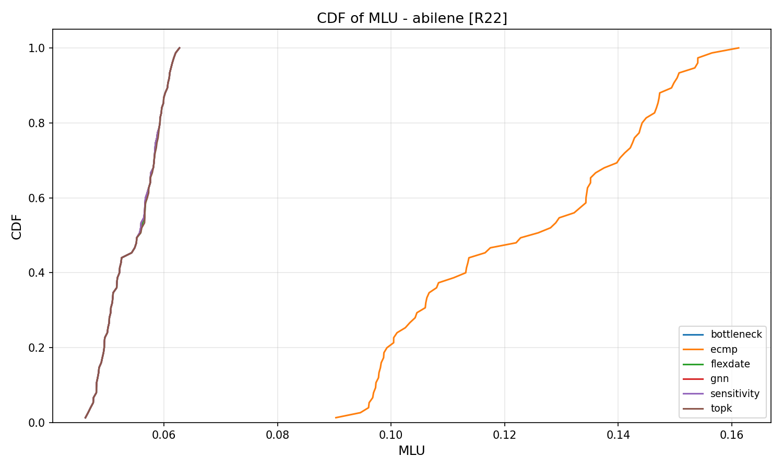
GEANT (22n):
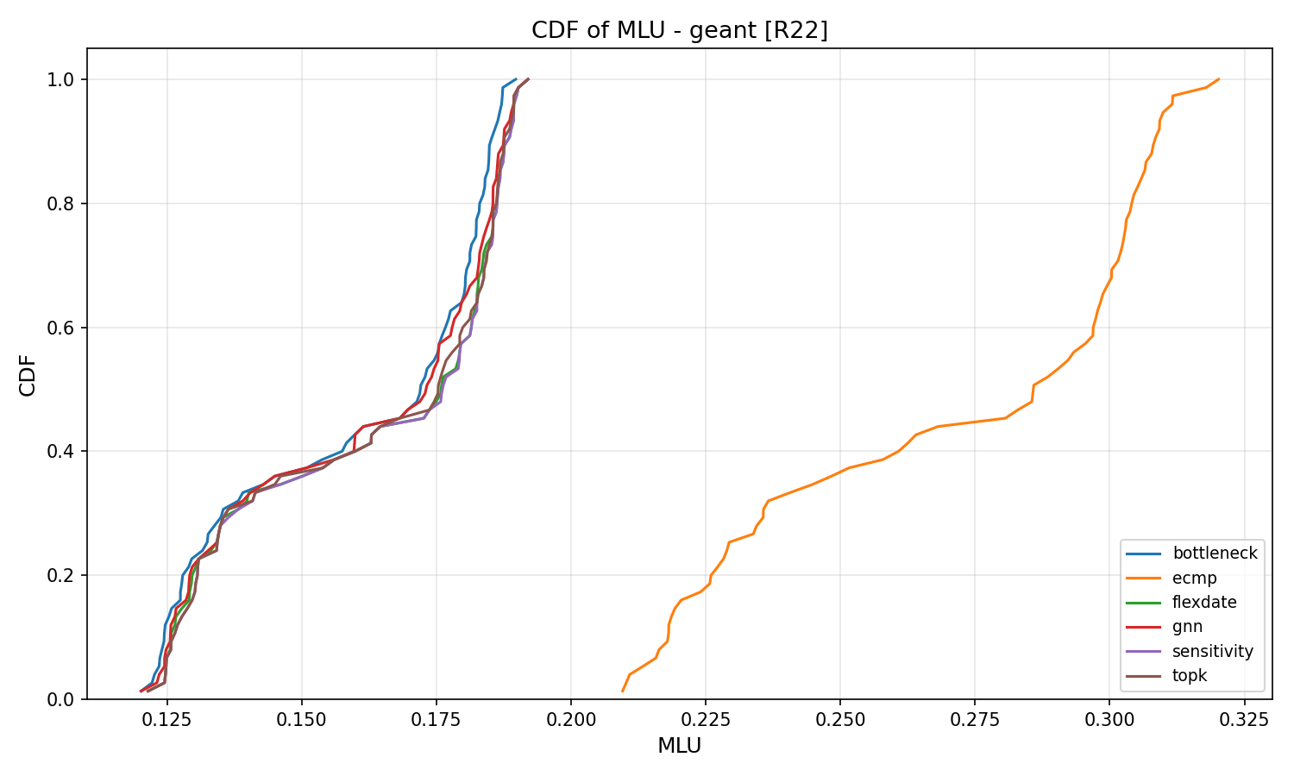
Ebone (23n):
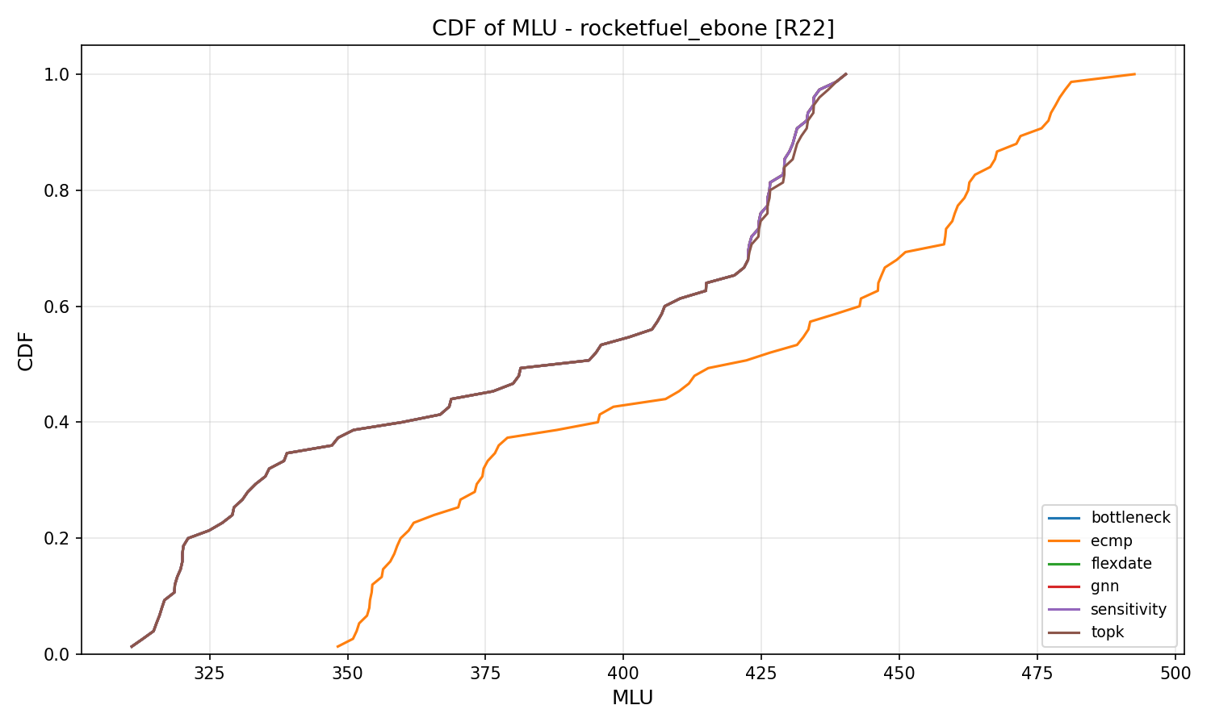
CERNET (41n):
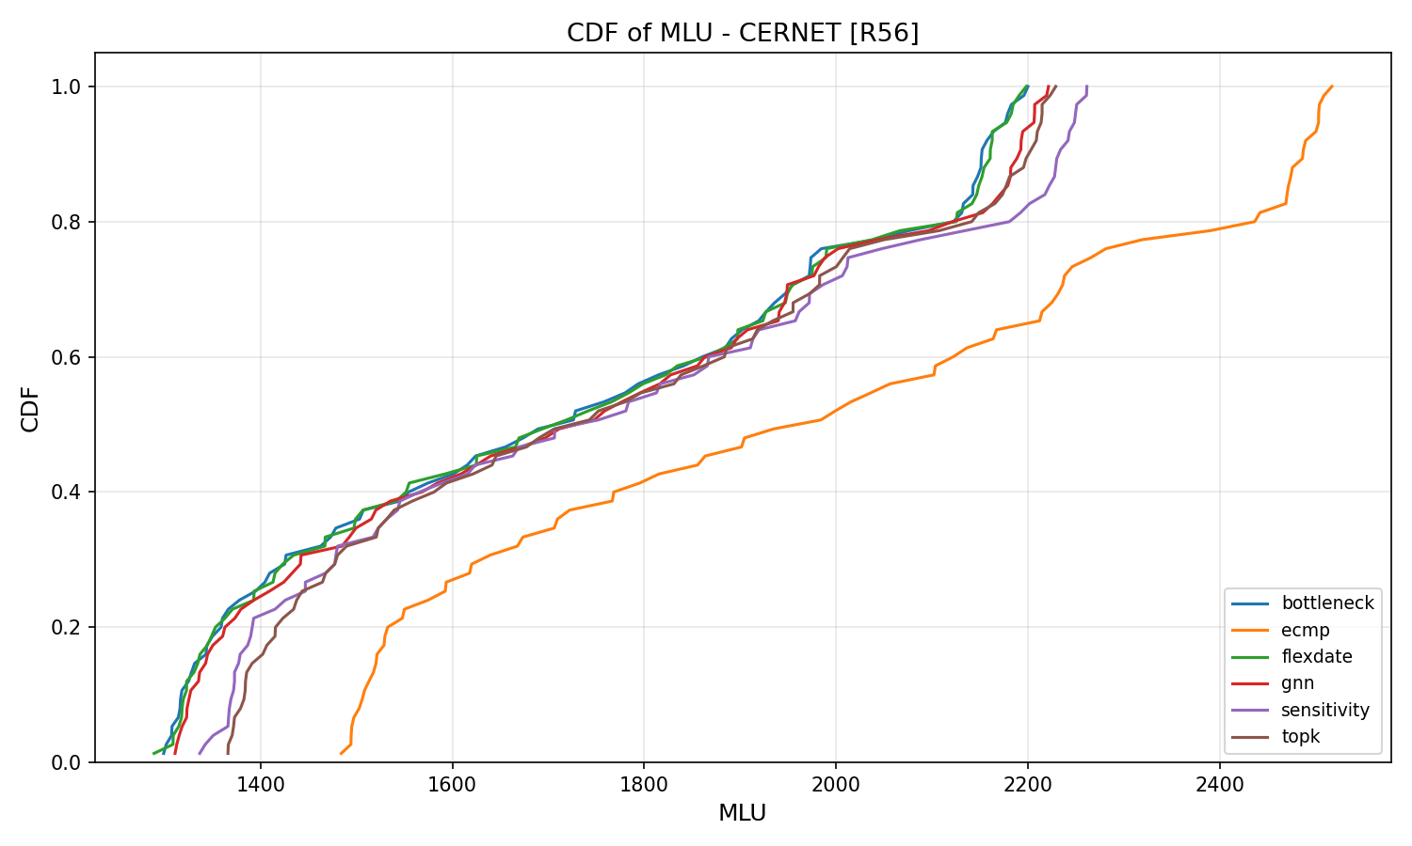
Sprintlink (44n):
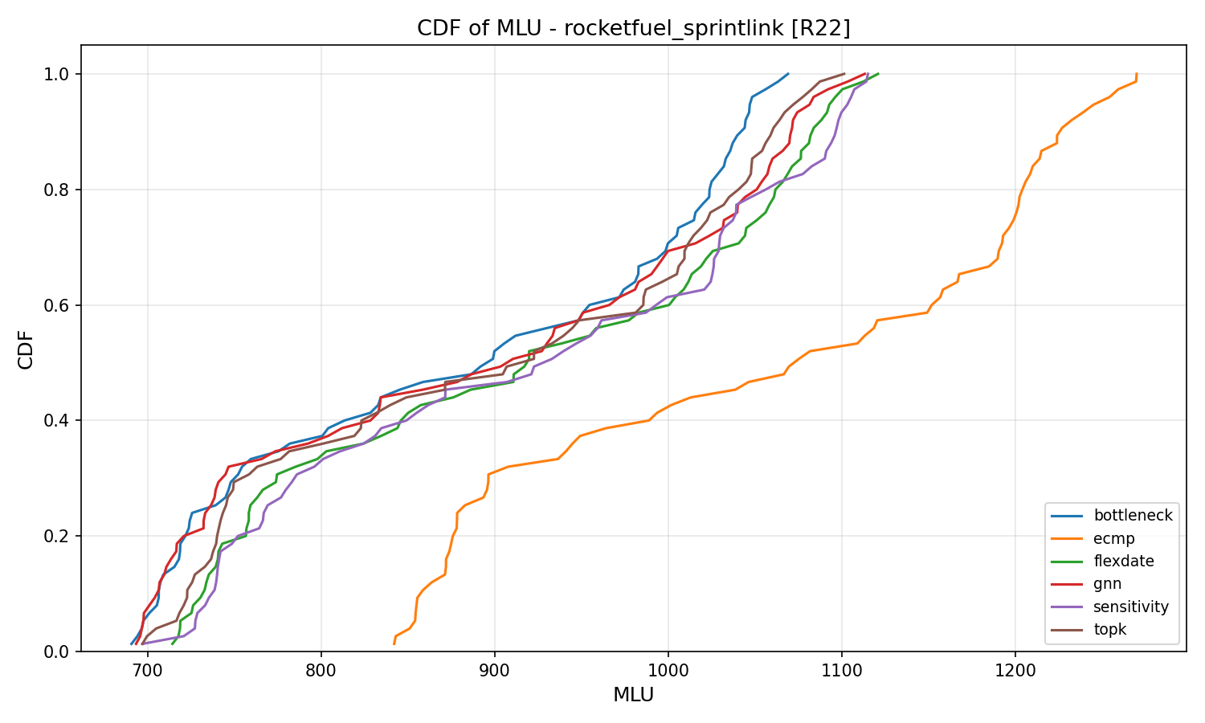
Tiscali (49n):
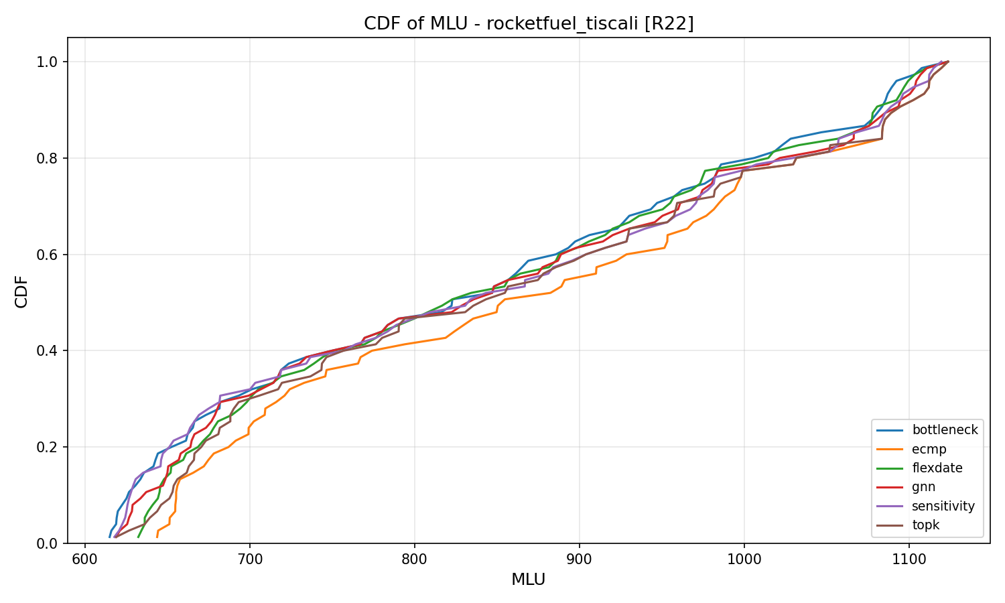
Germany50 (50n):
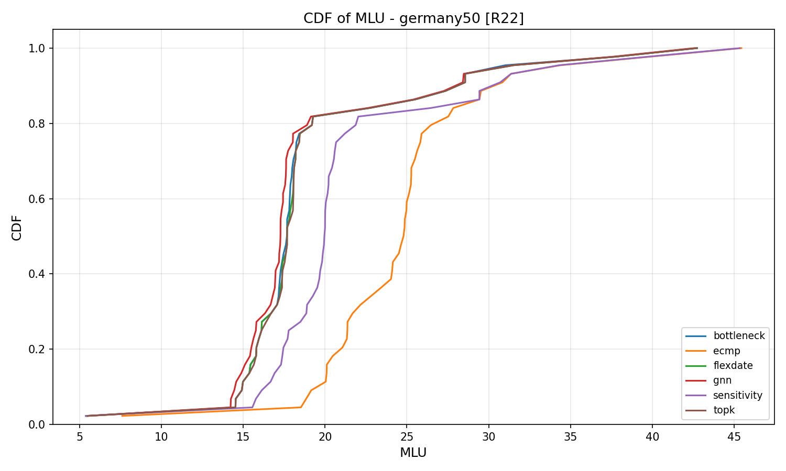
VtlWavenet (92n):
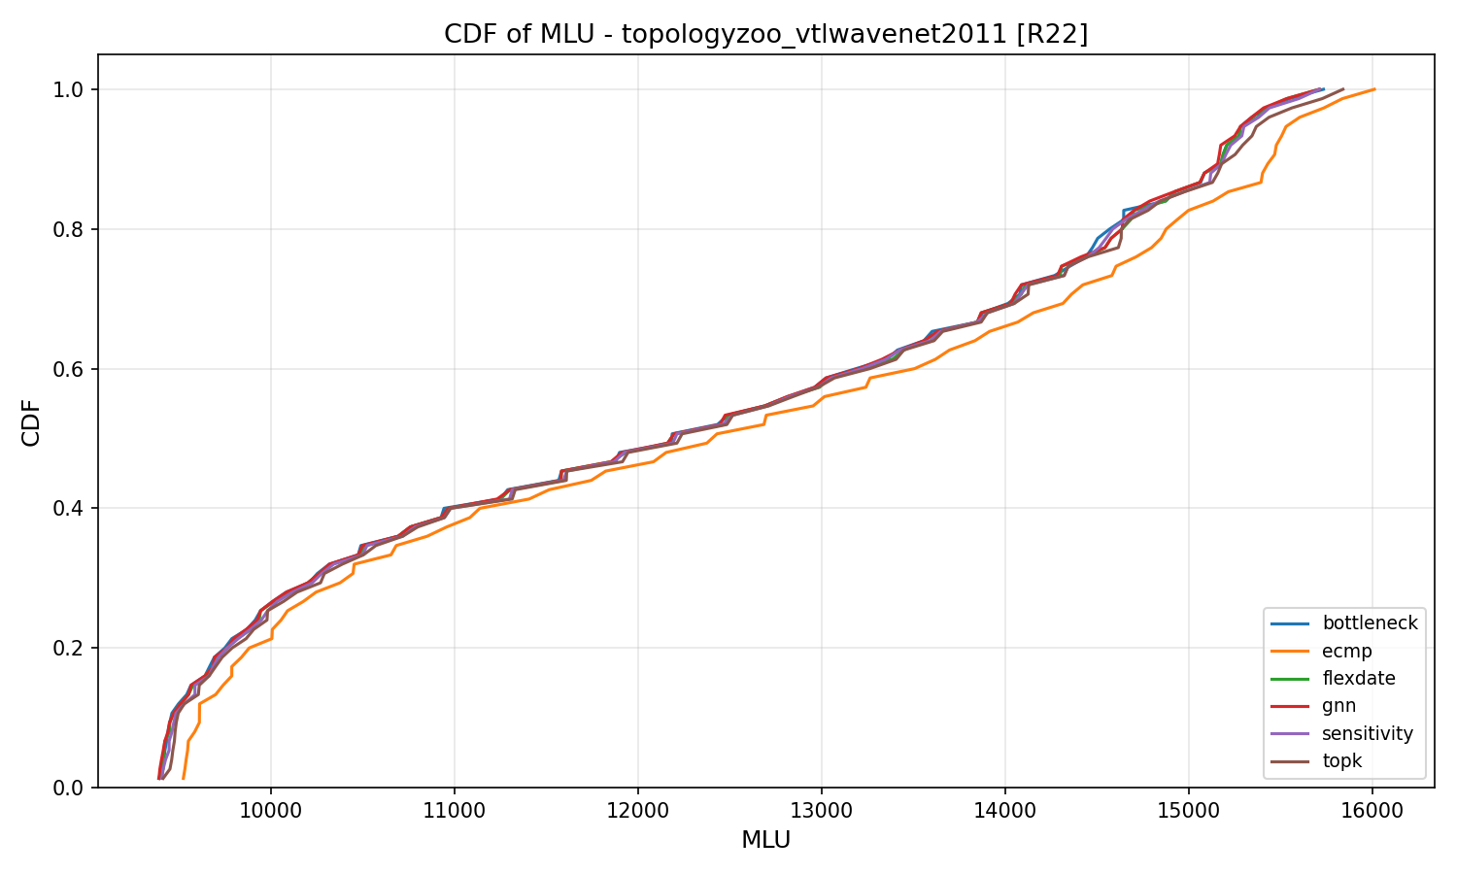

9.2 CDF of MLU (all topologies combined)
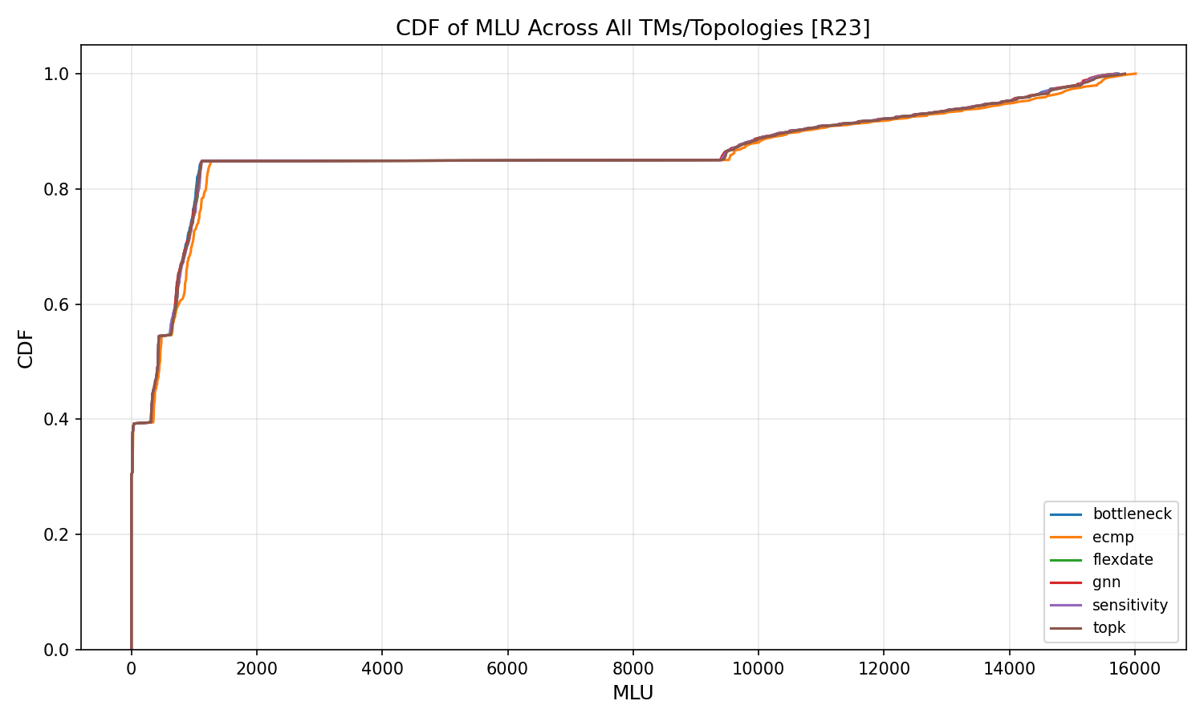

9.3 CDF of Routing Disturbance (per topology)
Abilene (12n):
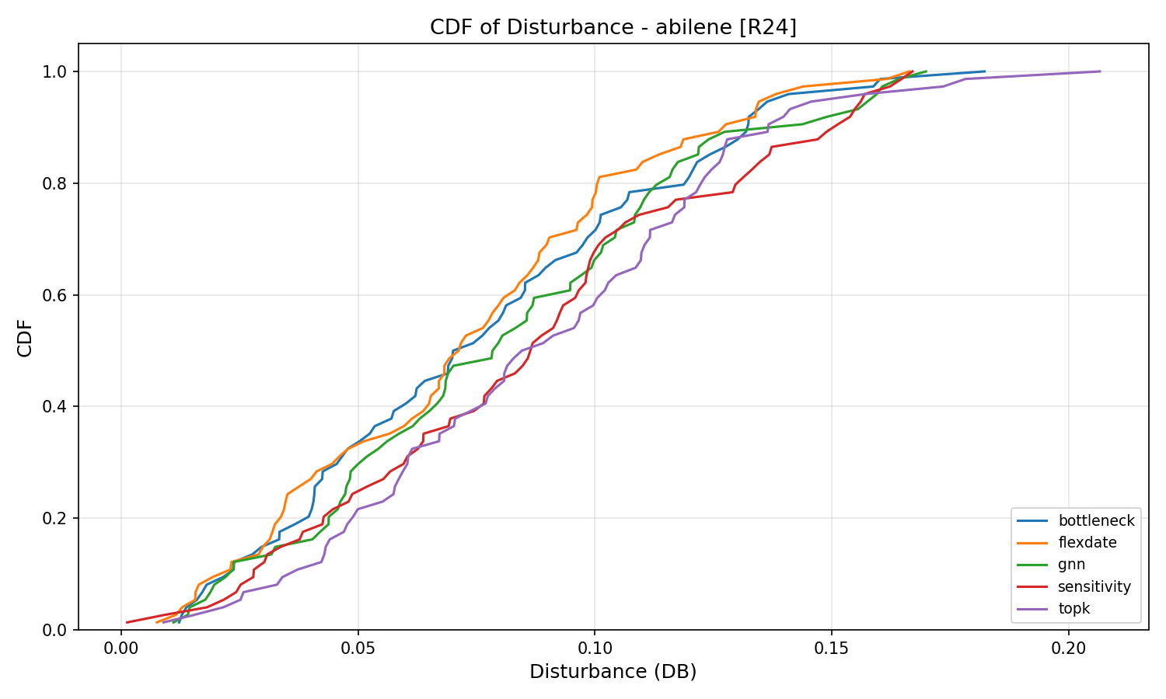
GEANT (22n):
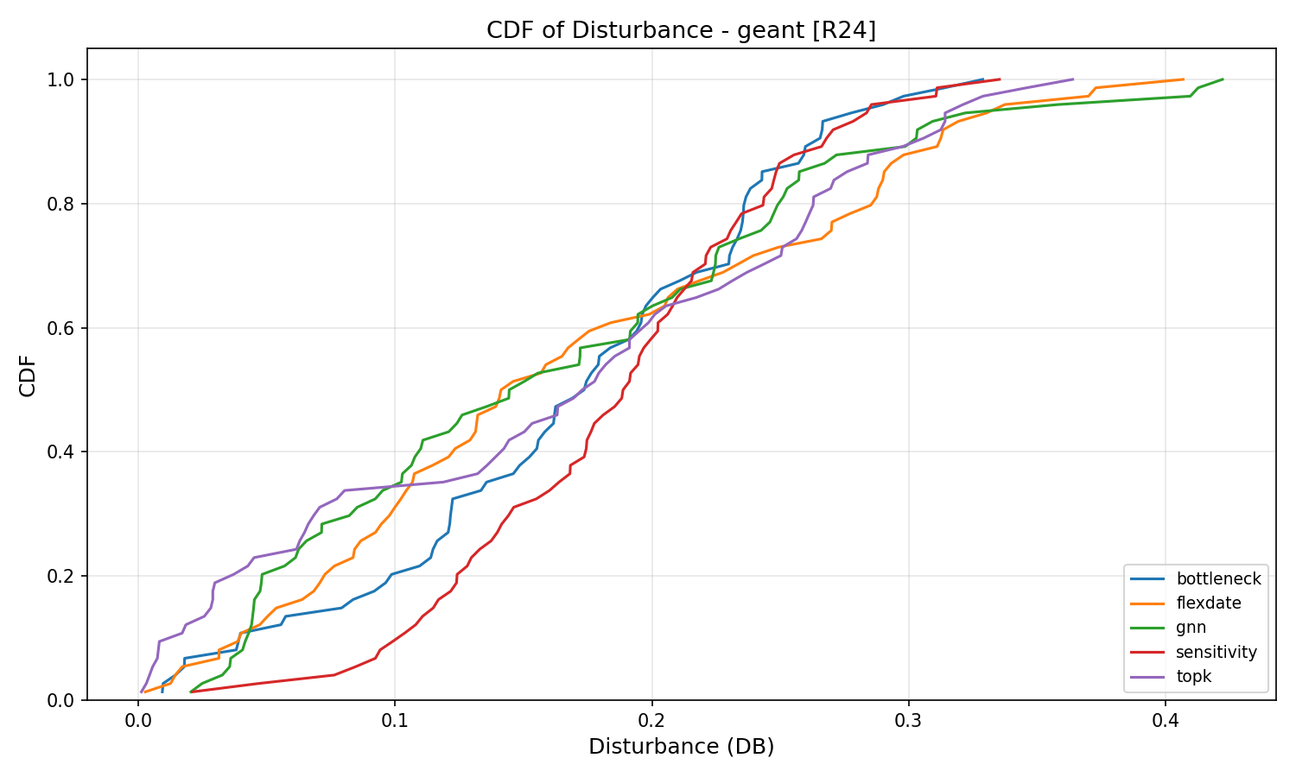
Ebone (23n):
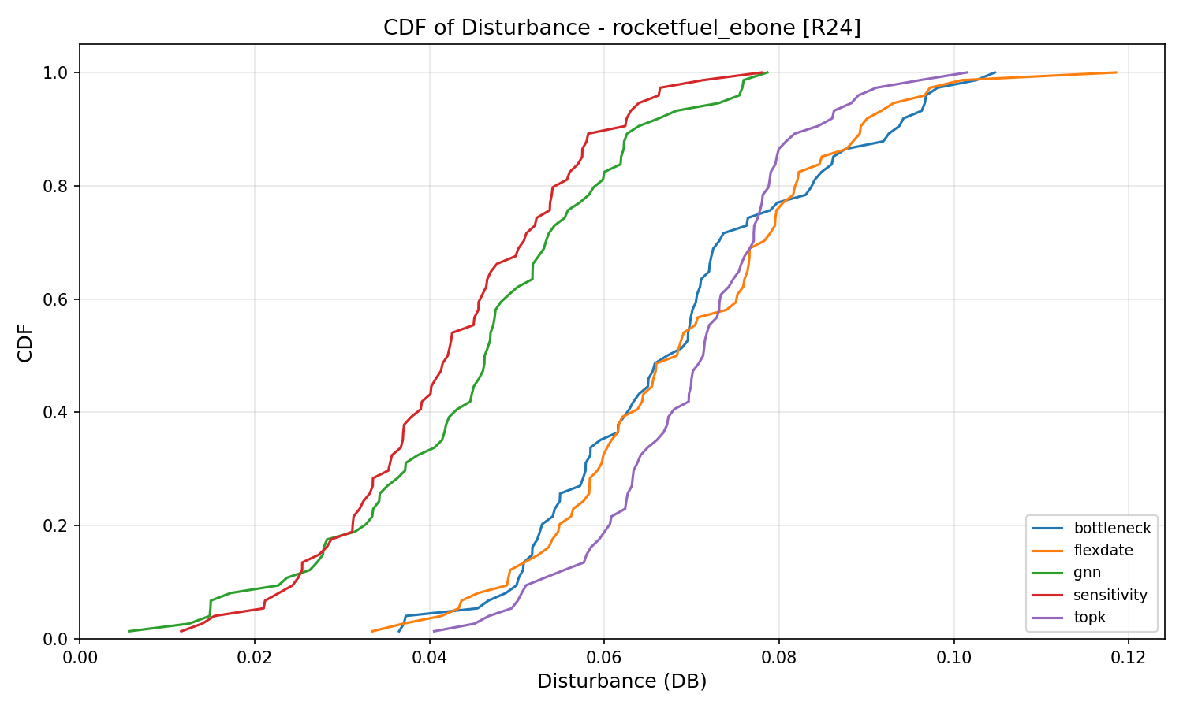
CERNET (41n):
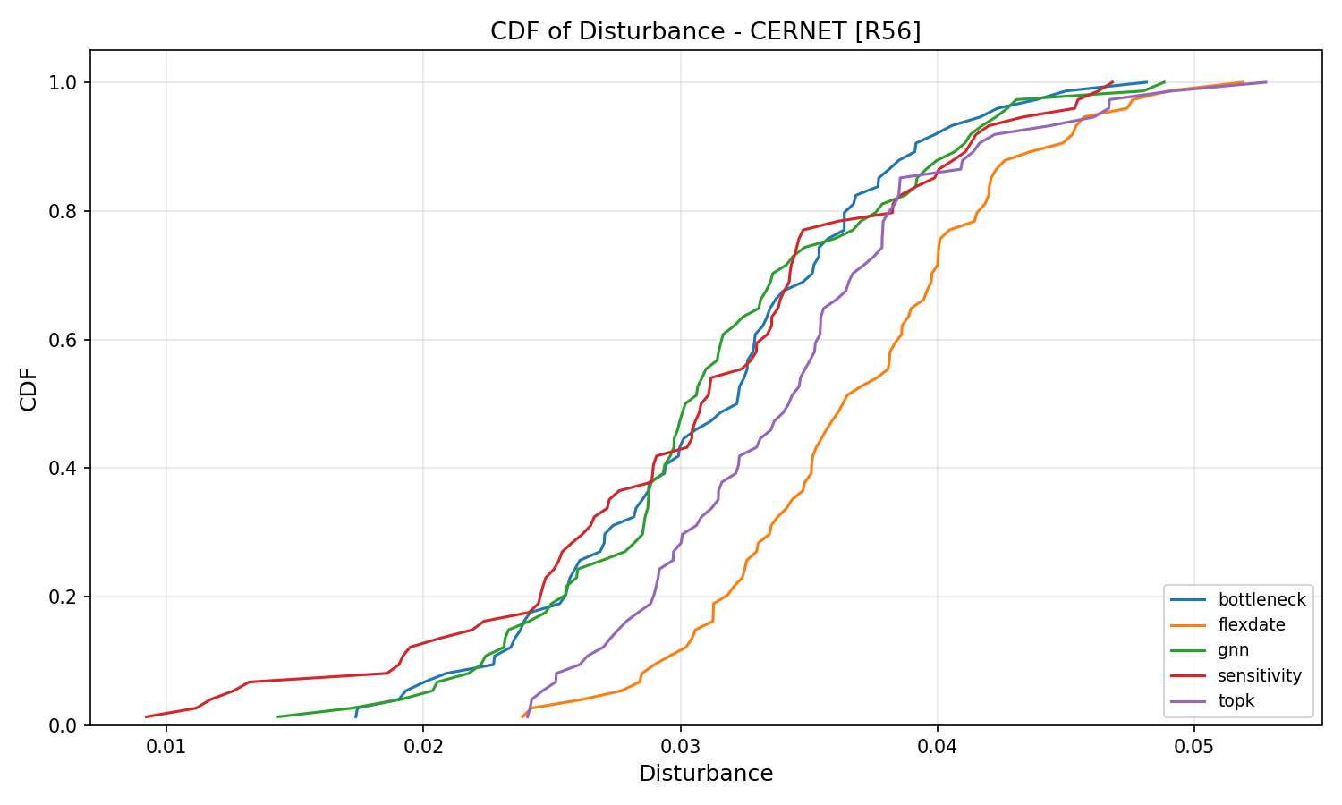
Sprintlink (44n):
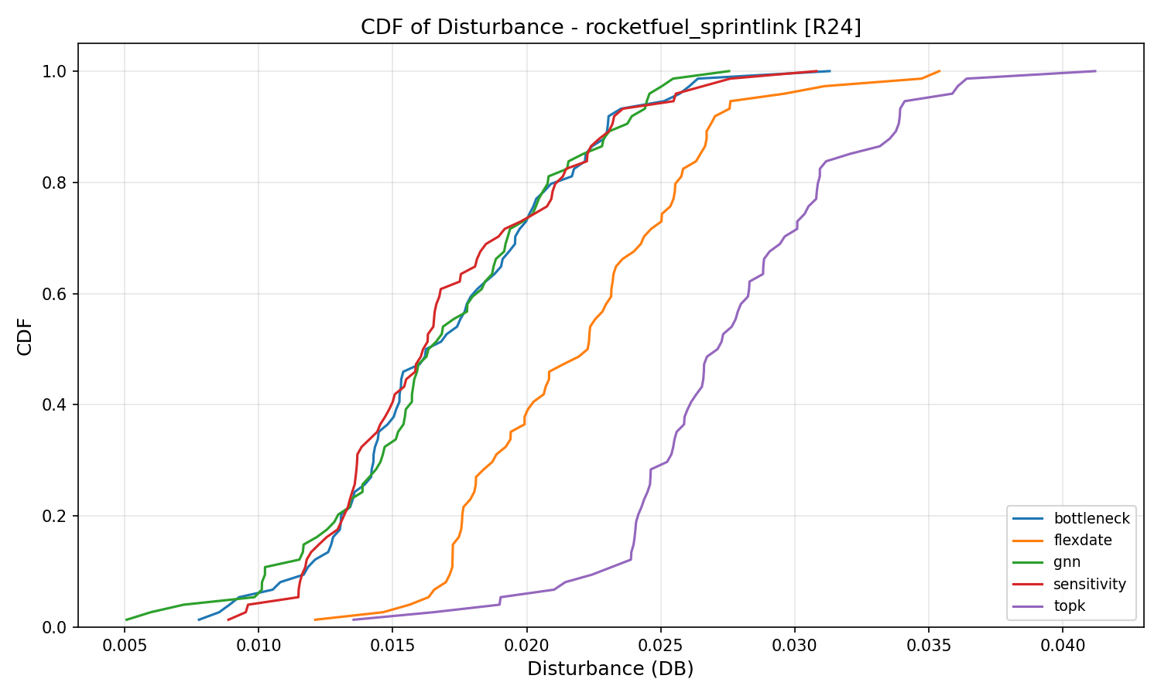
Tiscali (49n):
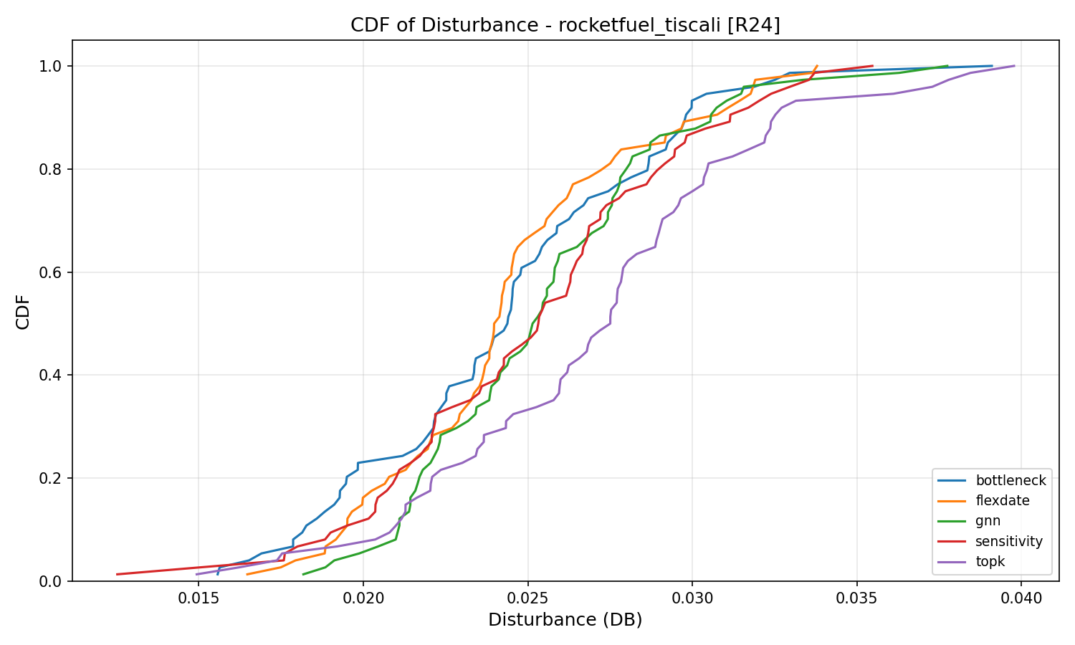
Germany50 (50n):
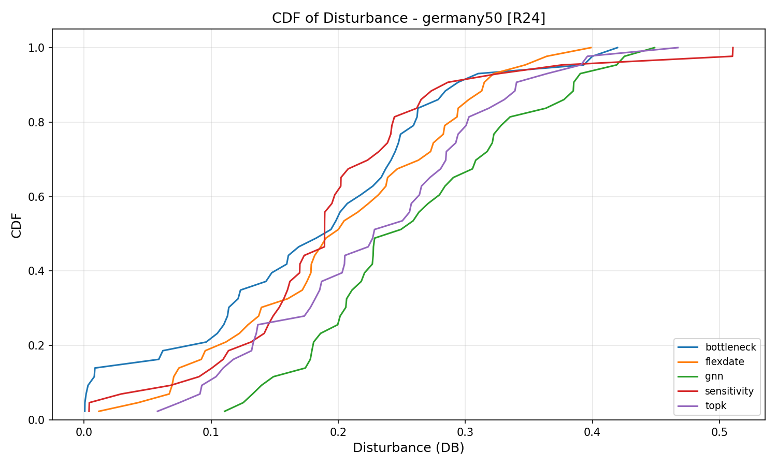
VtlWavenet (92n):
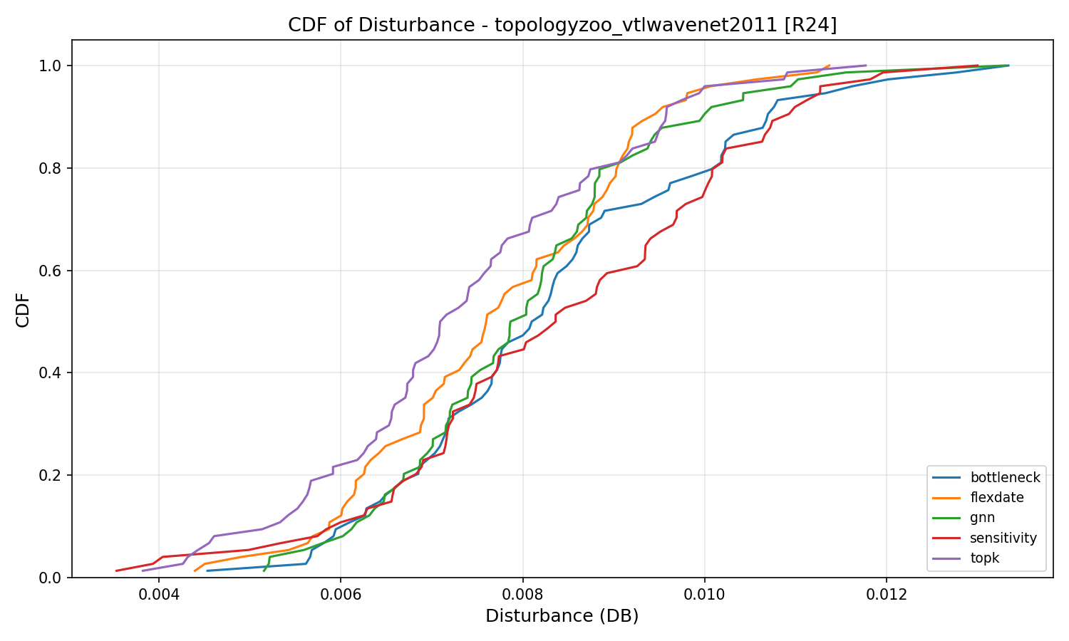

9.4 CDF of Decision/Execution Time (per topology)
Abilene (12n):
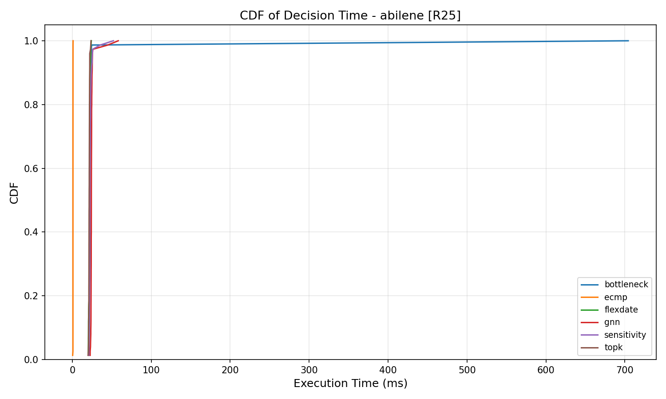
GEANT (22n):
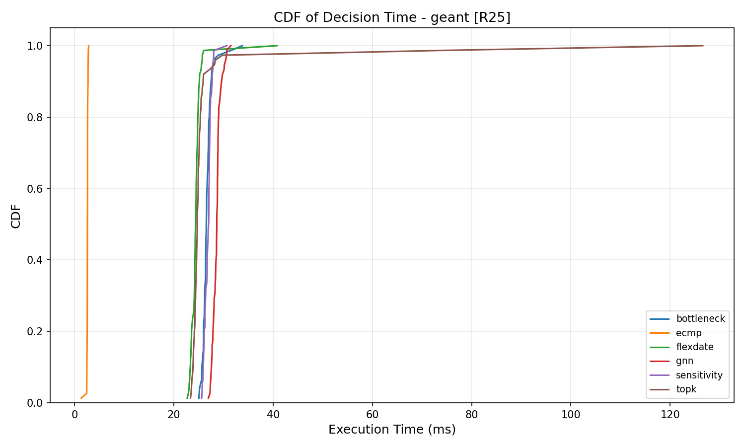
Ebone (23n):
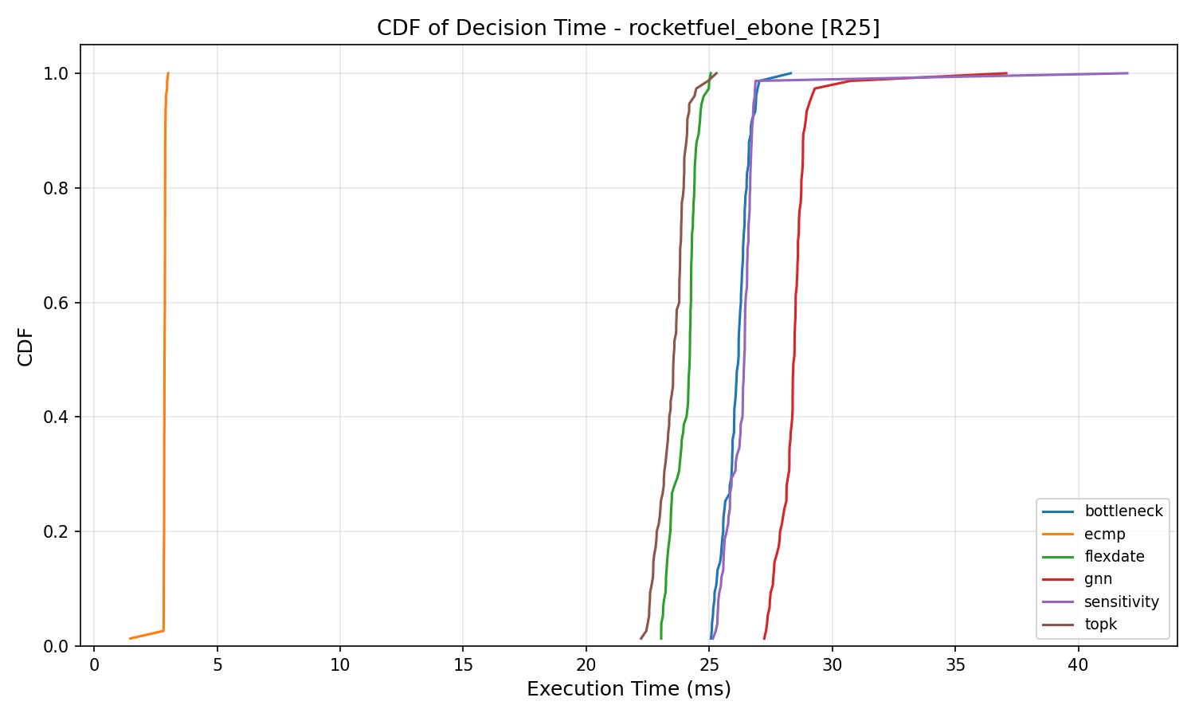
CERNET (41n):
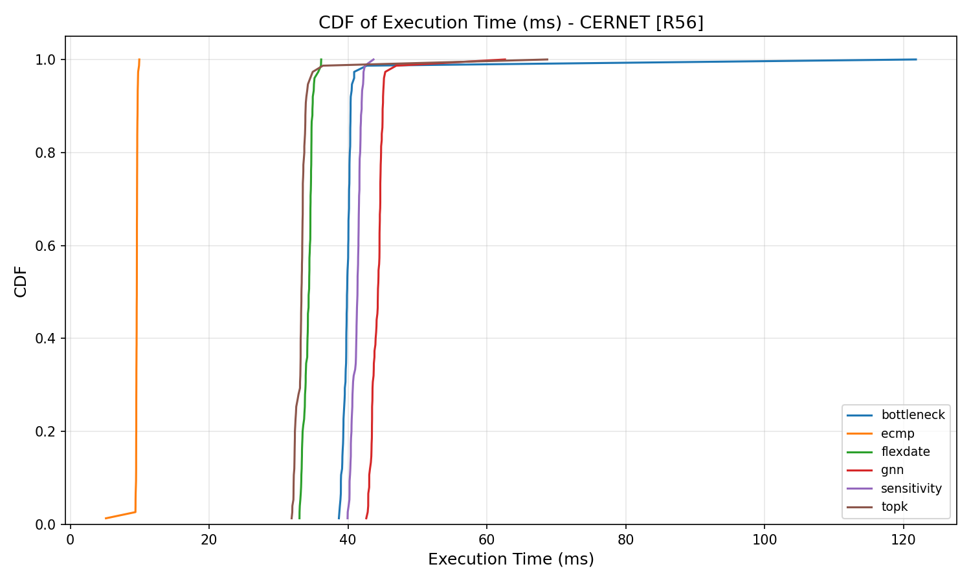
Sprintlink (44n):
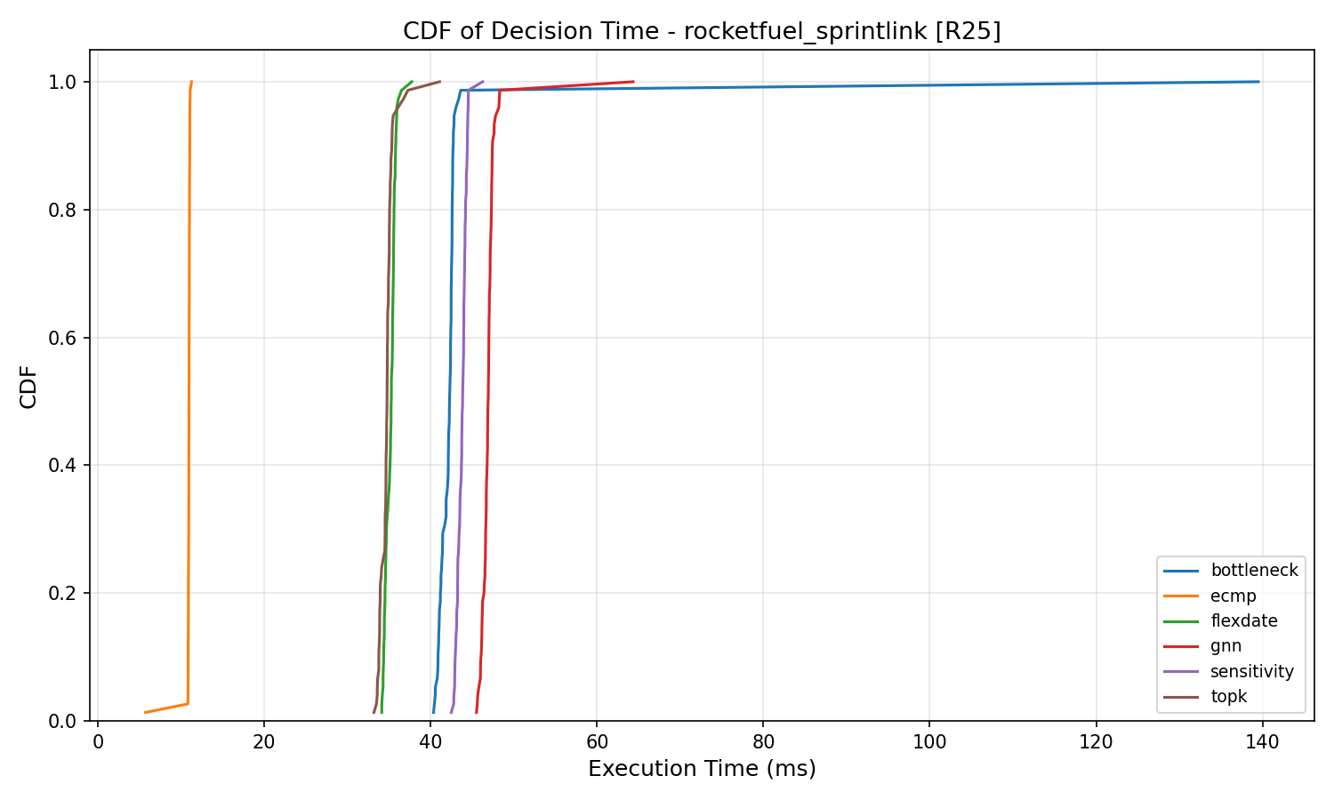
Tiscali (49n):
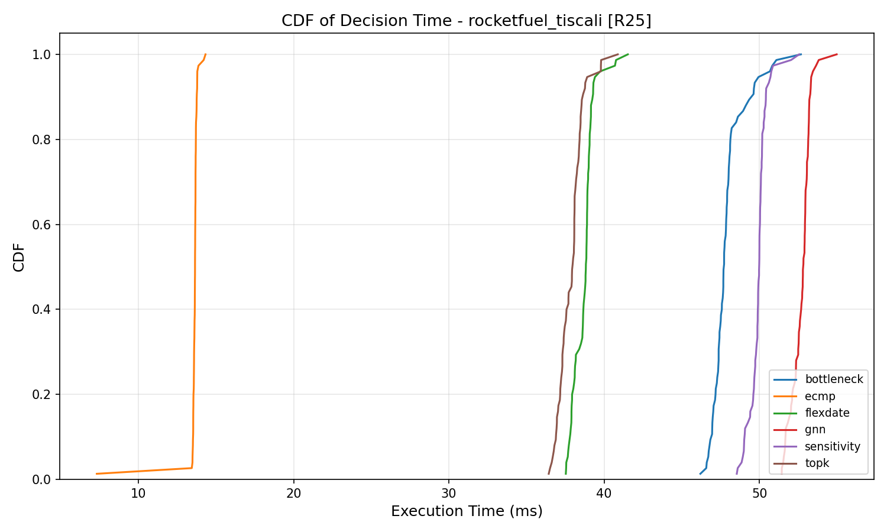
Germany50 (50n):
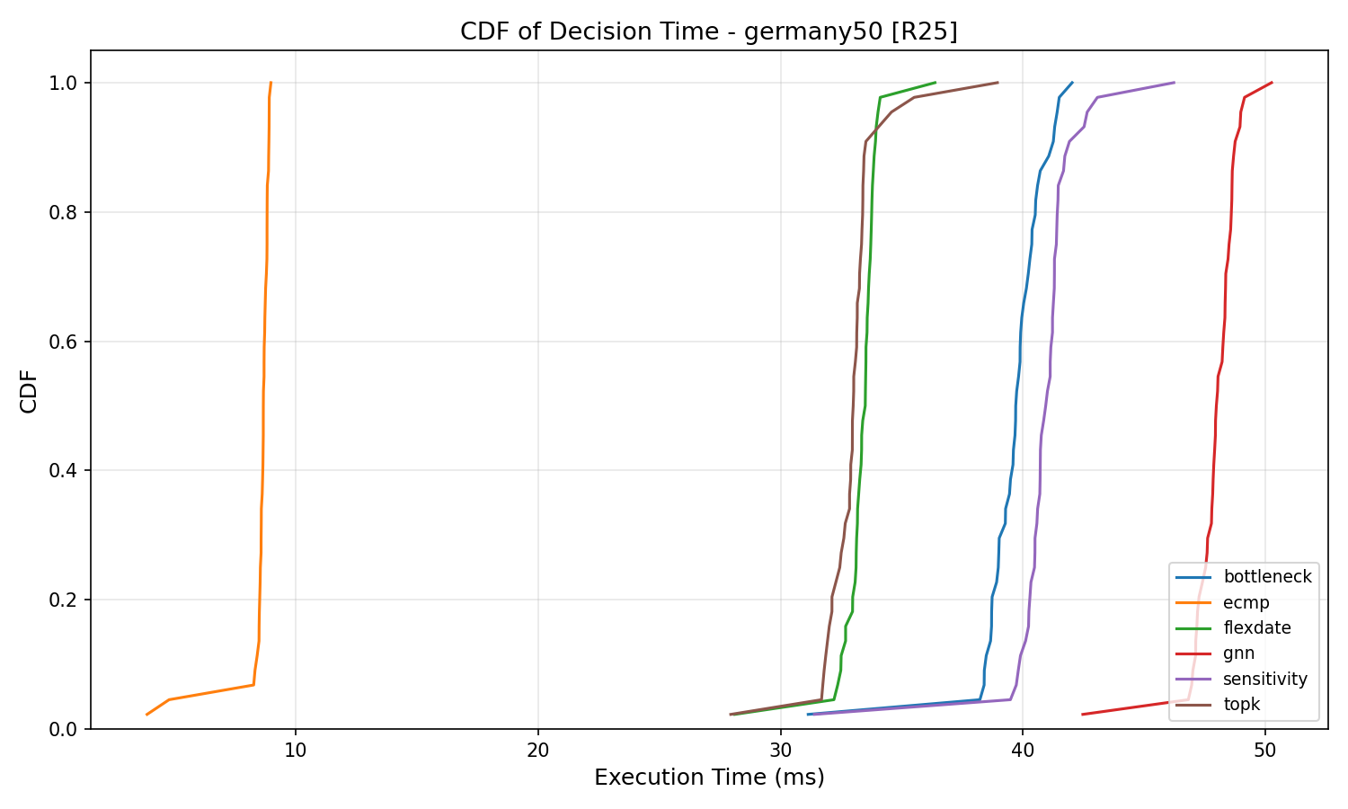
VtlWavenet (92n):
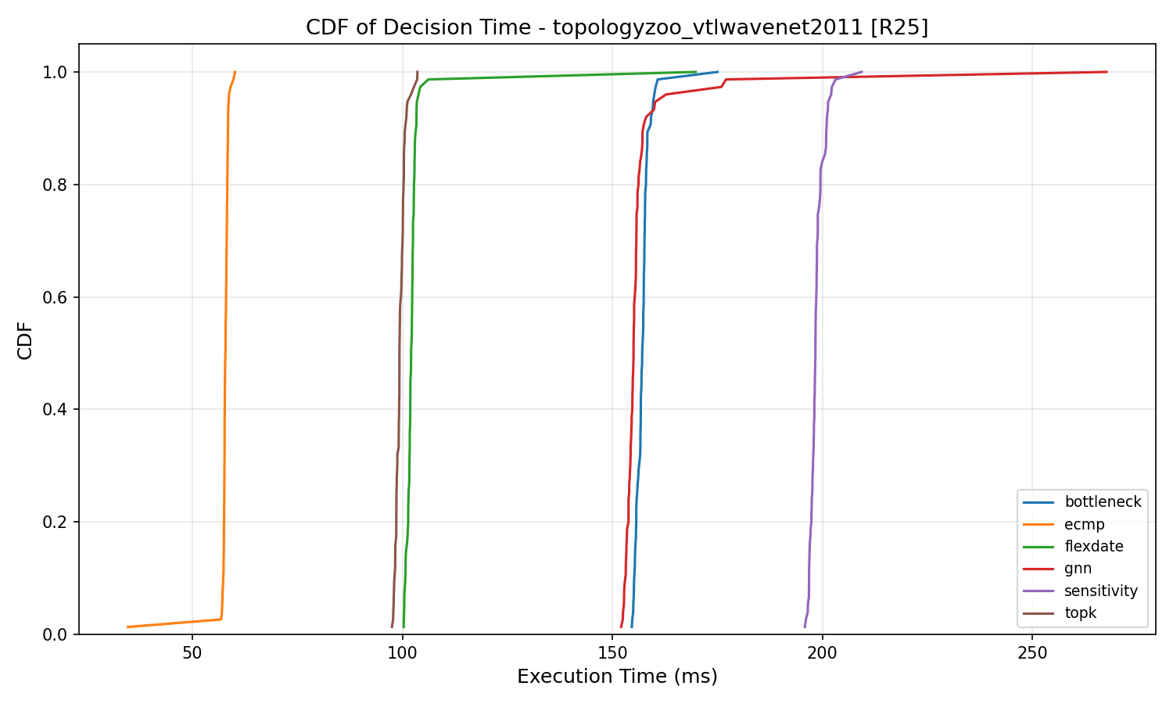

9.5 CDF of MLU under Link Failure
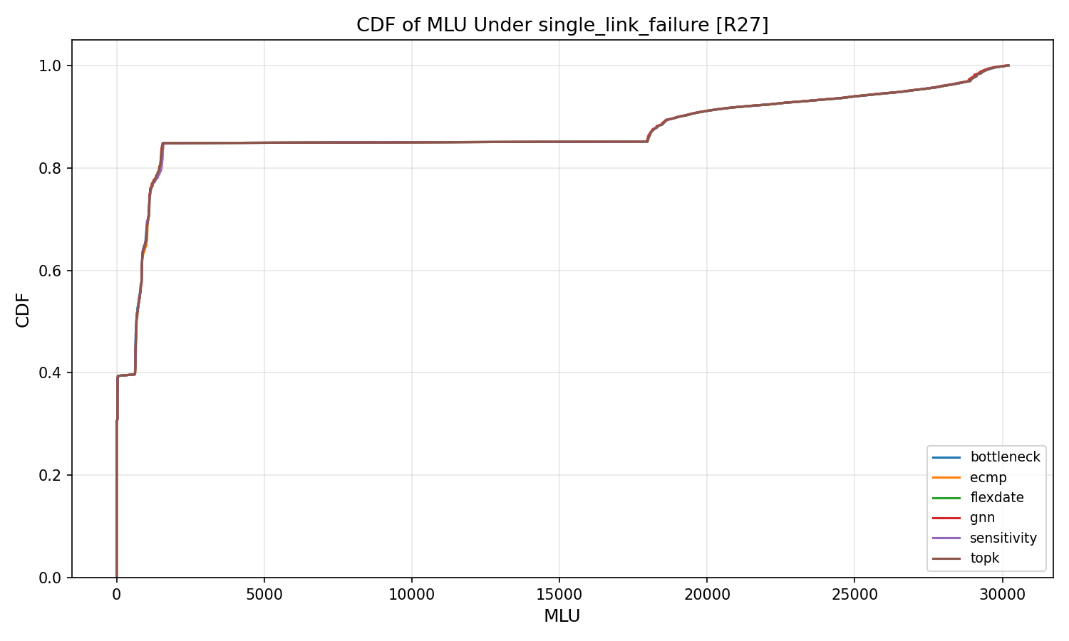

9.6 CDF of MLU under Capacity Degradation
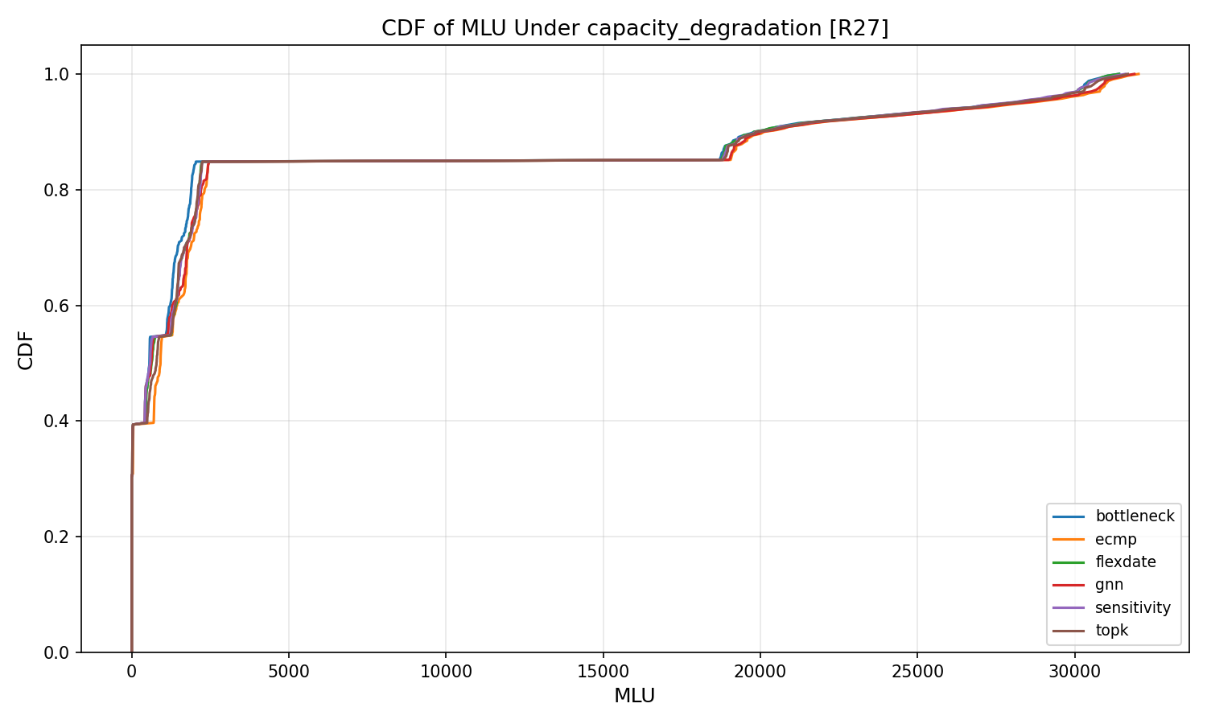

9.7 CDF of MLU under Traffic Spike
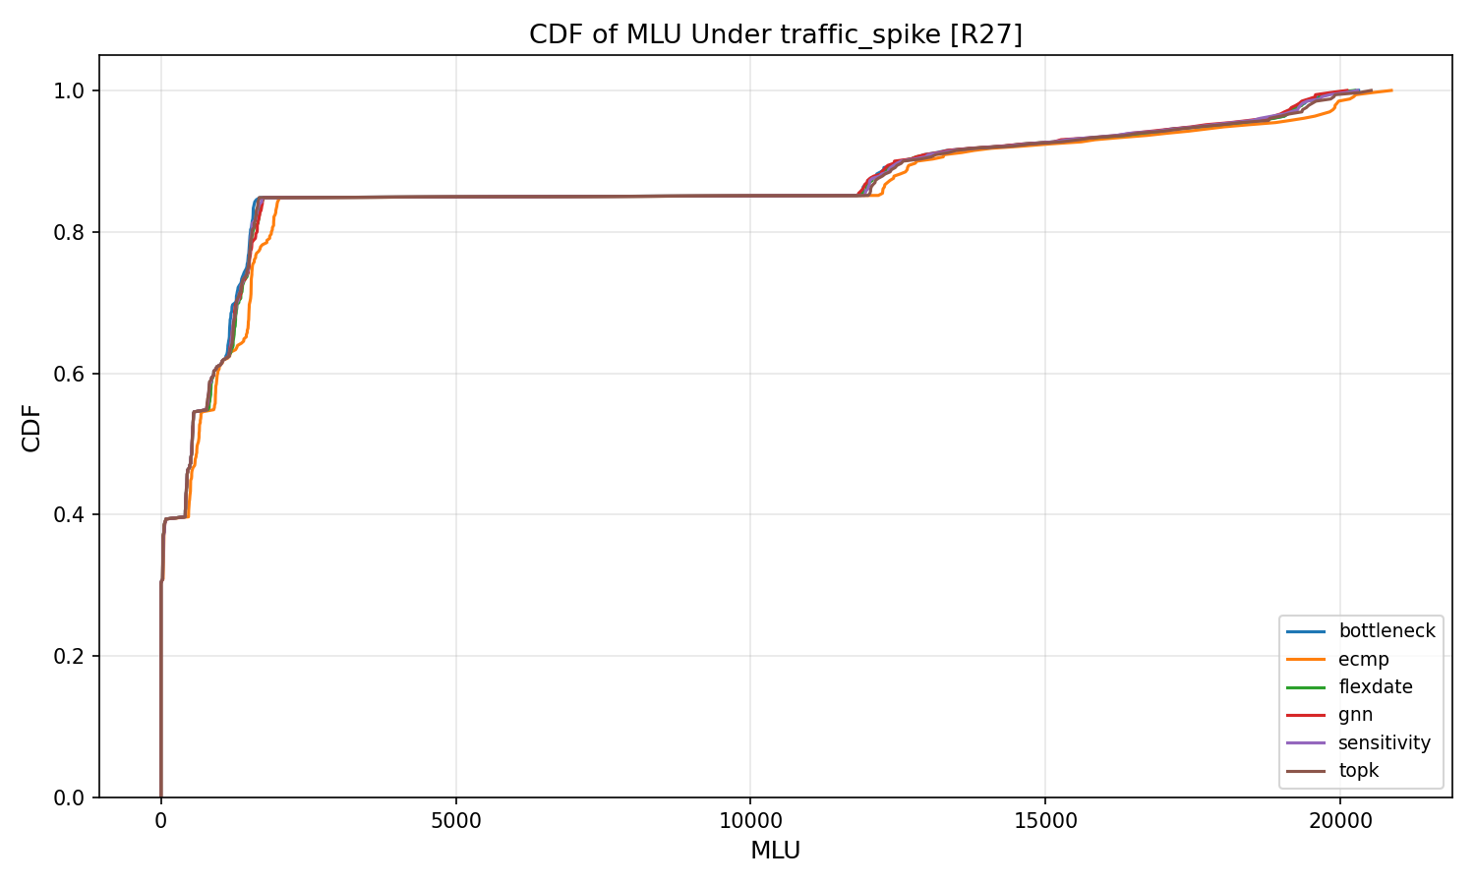

9.8 CDF of Disturbance under Failure
Single Link Failure:
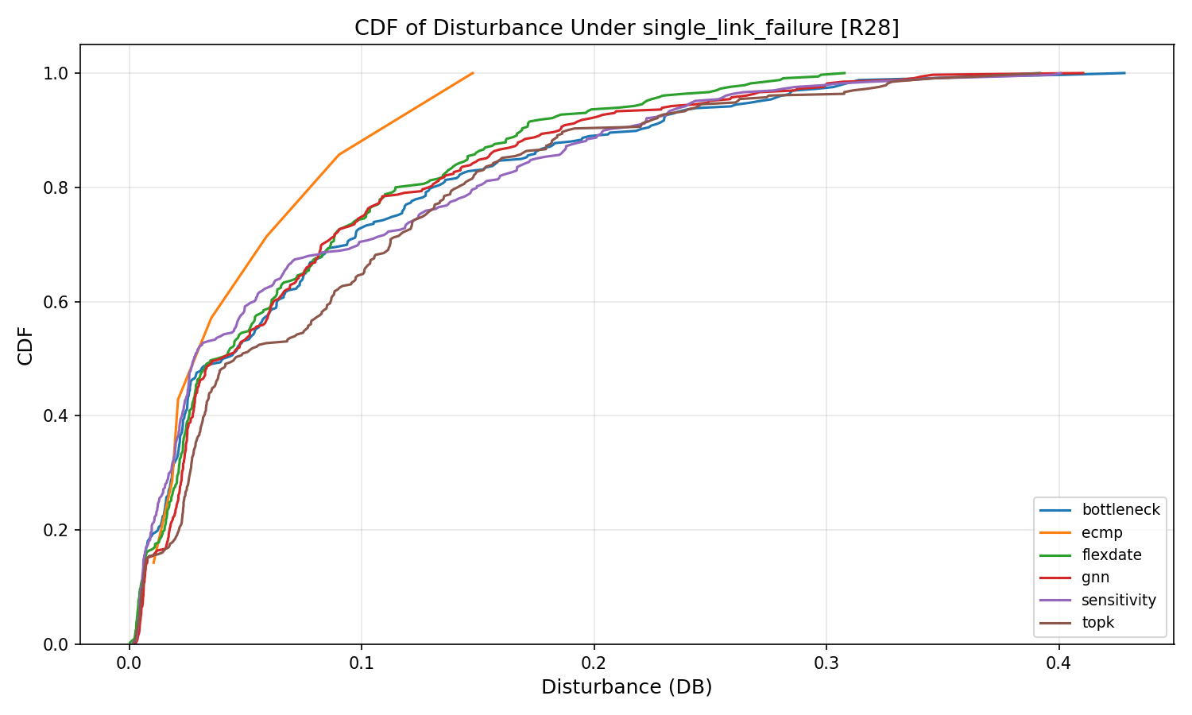
Capacity Degradation:
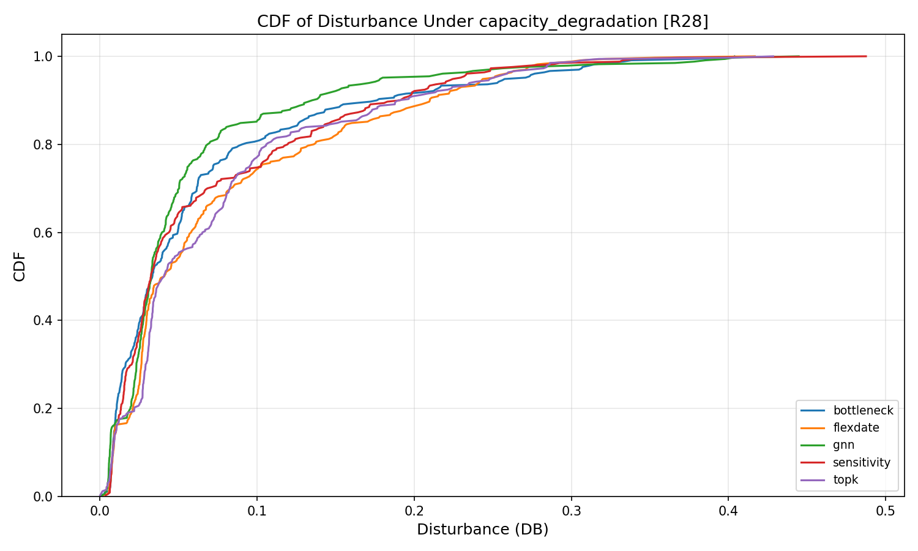
Traffic Spike:
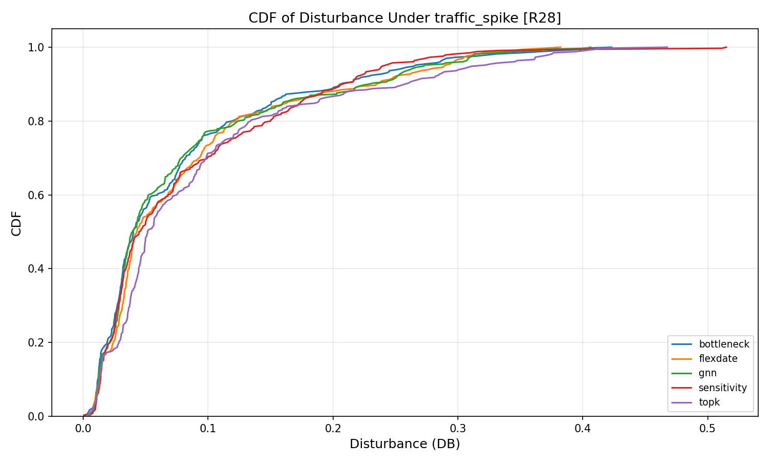

9.9 Training Convergence
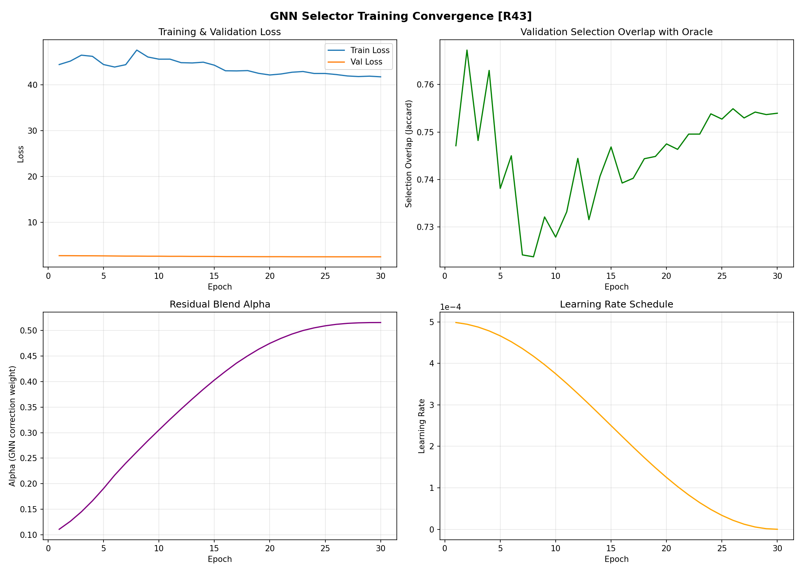

10. SDN Deployment Validation
HONESTY NOTE: The SDN results below are from a model-based simulation that mimics the SDN control loop (read TM -> select expert -> solve LP -> push rules). They use real topology graphs and traffic matrices, but they are NOT from live Mininet with real packet forwarding. The simulation computes MLU mathematically from the routing solution rather than measuring actual packet delays and throughput. See Section 15 for what a live Mininet run would add.

10.1 SDN Simulation Results
Topology | Nodes | Pre-MLU | Post-MLU | Improvement | Decision ms | Rules/Cycle
abilene | 12 | 0.0593 | 0.0546 | 7.86% | 36.9 | 8.2
geant | 22 | 0.1645 | 0.1602 | 2.62% | 32.2 | 9.2
rocketfuel_ebone | 23 | 0.3854 | 0.3796 | 1.50% | 31.9 | 10.8
rocketfuel_sprintlink | 44 | 0.8839 | 0.8803 | 0.41% | 66.7 | 3.1
rocketfuel_tiscali | 49 | 0.8383 | 0.8349 | 0.41% | 74.3 | 12.1
germany50 | 50 | 20.0331 | 19.2273 | 4.02% | 63.1 | 9.2

10.2 What These SDN Metrics Mean
Metric | Description | Source
Pre-MLU | ECMP baseline utilization before optimization | Model-based
Post-MLU | Utilization after LP-optimized rerouting | Model-based
Decision ms | Time to select expert + solve LP | Real wall-clock
Rules/Cycle | Number of OpenFlow rule updates per optimization cycle | Computed from LP solution
Throughput | NOT AVAILABLE - requires live Mininet with iperf | Needs testbed
Packet loss | NOT AVAILABLE - requires live Mininet | Needs testbed
Jitter | NOT AVAILABLE - requires live Mininet | Needs testbed
Rule install delay | NOT AVAILABLE - requires live OVS | Needs testbed
Failure recovery | NOT AVAILABLE - requires live link-down events | Needs testbed

11. Complexity Analysis

11.1 Empirical Scaling
Measured per-timestep execution time across 8 topologies (12 to 92 nodes):
Topology | Nodes | Decision ms | LP ms | Total ms | Feature ms | MLP ms
Abilene (12n) | 12 | 4.0 | 24.9 | 30.0 | 0.78 | 0.16
GEANT (22n) | 22 | 8.8 | 28.5 | 40.6 | 0.82 | 0.15
Ebone (23n) | 23 | 9.6 | 28.7 | 42.2 | 0.81 | 0.15
CERNET (41n) | 41 | 26.4 | 41.2 | 79.9 | 0.89 | 0.16
Sprintlink (44n) | 44 | 32.6 | 45.3 | 92.4 | 1.04 | 0.18
Tiscali (49n) | 49 | 39.6 | 50.1 | 108.1 | 0.99 | 0.19
Germany50 (50n) | 50 | 34.5 | 46.4 | 94.6 | 1.04 | 0.20
VtlWavenet (92n) | 92 | 226.1 | 145.0 | 452.3 | 1.37 | 0.23

11.2 Algorithmic Complexity
Component | Complexity | Notes
Bottleneck selector | O(E) per TM | Scan all edges for max-util link, collect OD pairs
TopK selector | O(D log D) | Sort all OD demands, take top K
Sensitivity selector | O(K * E) | Per-flow sensitivity requires edge-level analysis
GNN selector | O(N * H * L) | GraphSAGE: N nodes, H hidden dim, L layers, forward pass
Feature extraction | O(D + K^2) | TM stats + pairwise set operations on K=40 selections
MLP gate | O(H^2 * L) | 3-layer MLP: 49->128->128->64->4, ~25K parameters
Calibration | O(10 * 4 * LP) | One-time: 10 val TMs * 4 experts * LP solve each
LP solver | O(E * D * K) | LP with E edges, D OD pairs, K critical flows

11.3 Scaling Observations
Decision time scales roughly quadratically with node count: 4 ms (12 nodes) to 227 ms (92 nodes). The LP solver scales similarly. The MLP gate itself is constant-time (< 0.3 ms) regardless of topology size. The scaling bottleneck is running the 4 expert selectors, particularly Sensitivity analysis which requires O(K*E) edge-level computation.
Total end-to-end time remains under 120 ms for topologies up to 50 nodes, making the system viable for reactive TE with ~1-second control intervals. The 92-node VtlWavenet at 452 ms would require ~2-second intervals.

12. Germany50 Unseen Topology Deep Dive

12.1 Before vs After Calibration
Metric | Before Calibration (raw MLP) | After Calibration (10-val prior)
BN selections | 44/44 (100%) | 16/44 (36%)
GNN selections | 0/44 (0%) | 28/44 (64%)
GNN selection rate | 0.0% | 63.6%
Selector switches | 0/43 | 7/43
MetaGate MLU | 19.227 | 18.992
Oracle MLU | 18.929 | 18.929
Oracle gap | +1.57% | +0.33%
Accuracy | 2.3% | 65.9%
Performance ratio (PR) | 1.016 | 1.003

12.2 Why Calibration Fixed It
The 10 calibration TMs show GNN wins 8/10 times -> prior = [BN=0.07, TopK=0.07, Sens=0.07, GNN=0.79]. With alpha=5: prior^5 = [BN=0.00002, TopK=0.00002, Sens=0.00002, GNN=0.308]. The 15,400x GNN/BN ratio overrides the MLP's Bottleneck confidence on most timesteps. The 7 selector switches across 43 transitions confirm genuine per-timestep dynamic behavior.

12.3 Oracle Distribution (Test Set)
Germany50 oracle: GNN = 42/44 (95.5%), BN = 1/44 (2.3%), Sens = 1/44 (2.3%). MetaGate achieves 65.9% accuracy because it still selects BN on 16/44 timesteps where GNN is optimal. However, the MLU penalty is small: +0.33% oracle gap.

13. CERNET Topology Correction
Property | Actual Value
Source | TopologyZoo (Cernet.graphml), NOT SNDlib
Nodes | 41
Edges | 59 bidirectional links = 116 directed edges
Traffic | Synthetic MGM (not real SNDlib traffic matrices)
Config note | traffic_mode='real_sndlib' kept to avoid breaking loader; truth documented in comments

14. Limitations (Honest Assessment)
Not pure zero-shot. The calibration uses 10 validation TMs from the target topology itself (4 experts x LP each). This is few-shot adaptation, not pure zero-shot generalization.
Calibration cost. 40 LP solves per topology (10 TMs x 4 experts). One-time cost, not per-timestep, but non-trivial for very large topologies.
Alpha hand-tuned. The calibration strength alpha=5 was selected empirically. No principled optimization.
Raw MLP is weak. Validation accuracy ~50%. Without calibration, the gate collapses to mostly-Bottleneck. Bayesian calibration compensates, but the MLP itself cannot distinguish when GNN beats BN.
VtlWavenet never selects GNN. Despite calibration prior GNN=0.57, MLP confidence in BN is too extreme. Masked by near-optimal performance (+0.06% gap).
No live packet measurements. All SDN metrics are model-based. No real throughput, latency, jitter, or packet loss data. Mininet is not installed in the current environment.
Accuracy vs MLU disconnect. Some topologies show low accuracy but near-zero MLU gap (Abilene: 40% acc, +0.00% gap). Expert choices are often interchangeable in MLU terms.

15. Live Mininet Testbed: Required Final Step
STATUS: Mininet is NOT installed in the current environment. The SDN integration code exists (sdn/mininet_testbed.py, phase1_reactive/env/mininet_ryu_adapter.py) but has not been executed with live packet forwarding.

15.1 What Remains To Run
- Install Mininet: sudo apt-get install mininet (requires Linux with OVS)
- Install Ryu controller: pip install ryu
- Run: sudo python -m sdn.mininet_testbed --topology abilene
- Repeat for all 8 topologies
- Collect iperf throughput, ping latency, tcpdump packet loss measurements
- Measure OVS flow-table update timing (ovs-ofctl dump-flows)
- Simulate link failures (ip link set down) and measure recovery time

15.2 Metrics That Live Mininet Would Produce
Metric | How Measured | Granularity
Throughput (Mbps) | iperf between host pairs under optimized routing | Per OD pair
Packet latency (ms) | ping RTT under optimized vs ECMP routing | Per OD pair
Packet loss (%) | tcpdump/iperf loss rate under load | Per OD pair
Jitter (ms) | ping variance under optimized routing | Per OD pair
Rule install delay (ms) | Time from controller push to OVS flow active | Per switch
Failure recovery (ms) | Time from link-down to new routes active | Per failure event
End-to-end delay (ms) | Total path delay including queueing | Per flow
CDF of real packet delay | Distribution of measured latencies | Aggregate

These metrics are the ONLY way to validate that the LP-computed routing solutions actually improve real packet delivery. Model-based MLU is a necessary but not sufficient condition for network performance improvement.

16. Exact Thesis Method Description
Copy-paste-ready method description for the thesis:

We propose a two-stage expert selection framework for traffic engineering. An MLP-based meta-gate (3-layer, 128-128-64-4 with BatchNorm, dropout 0.3) selects among four expert flow-selection strategies: Bottleneck, Top-K by Demand, Sensitivity Analysis, and GNN-based selection, all operating with K_crit = 40 critical flows for fair comparison.
Stage 1 -- Zero-shot gate training. The MLP gate is trained on pooled oracle labels from 6 known topologies (Abilene, GEANT, CERNET, Ebone, Sprintlink, Tiscali; ~2,098 training samples). Oracle labels are obtained by running all four experts through LP optimization and selecting the one achieving minimum MLU per traffic matrix. Inverse-frequency class weighting addresses the 65% Bottleneck class imbalance. Germany50 and VtlWavenet2011 are held out entirely -- no gate weight updates use data from these topologies.
Stage 2 -- Few-shot calibration at deployment. Before evaluating on any topology (known or unseen), a lightweight calibration phase runs 10 validation traffic matrices through all 4 experts with LP, counting which expert achieves the lowest MLU. This produces a topology-specific Bayesian prior with Laplace smoothing. At inference time, the MLP softmax output is fused with this prior: P_final(i) = P_MLP(i) x prior(i)^alpha / Z, where alpha = 5 controls calibration influence. No gradient updates occur during calibration -- only 40 LP evaluations (10 TMs x 4 experts).
This is not a pure zero-shot evaluation. The gate weights are zero-shot with respect to unseen topologies, but the calibration prior requires 10 topology-specific validation samples. We characterize this as zero-shot learning with few-shot calibration.

