Phase 1.5 Clean GNN-LPD-DQN Traffic Engineering Report
Main comparison N=3,288 (Abilene + CERNET + GEANT + Sprintlink + Tiscali) · Full internal N=3,976 · Clean failure + LP-derived SDN simulation
Source-scope lock: Tiscali is in main N=3,288 and the CDFs, but no source-locked FlexDATE reference row for Tiscali exists in the original report. The audit-script constants are method-internal configuration, NOT valid FlexDATE evidence. Tiscali is reported as an internal/runtime-limitation row, not claimed as a FlexDATE win/loss. The four FlexDATE-reference topologies (Abilene, CERNET, GEANT, Sprintlink) win both PR and DB.
Method lock: Clean GNN-LPD-DQN TE. No legacy RF/sticky/finalization. Failure audit PASS (360 cycles). LP-derived SDN-style simulation audit PASS (120 runs) — not live Mininet.

Method Identity
Traffic matrix + topology
-> DB-budgeted LP-distilled GNN-LPD critical-OD selector
-> DQN controller chooses K / action / budget
-> selected critical ODs -> one-stage selected-flow DB-budgeted LP
-> noncritical ODs remain on ECMP or previous routing
-> capped K escalation if PR/MLU guard fails (K30 -> K40 -> K50)
-> full-OD fallback only after K-cap fails

Compliance: GNN-LPD | DQN | One-stage selected-flow DB-budgeted LP | No heuristic criticality | No RandomForest | No sticky gate | No Stage-2 | No disturbance-finalization LP

Section 1 — Dataset Protocol

Table 1. Dataset Protocol
Topology | Role | Train TMs | Eval TMs | Window
Abilene | Seen training | 2,016 | 2,016 | 2016–4031
GEANT | Seen training | 672 | 672 | 672–1343
CERNET | Seen training | 200 | 200 | 200–399
Sprintlink | Seen training | 200 | 200 | 200–399
Tiscali | Seen training | 200 | 200 | 200–399
Ebone | Seen training | 200 | 200 | 200–399
Germany50 | Zero-shot eval | 0 | 288 | 0–287
VtlWavenet2011 | Zero-shot eval | 0 | 200 | 0–199
Main comparison | — | — | 3,288 | 5 topos
Full internal | — | — | 3,976 | All 8 topos

Section 2 — Main Comparison Table (N = 3,288)
Only four topologies (Abilene, CERNET, GEANT, Sprintlink) have a source-locked FlexDATE reference row in the original report. Tiscali has NO source-locked FlexDATE reference row, so its FlexDATE columns are N.A. and its PR/DB results are not computable (n/c); it is reported as an internal / runtime-limitation row. The audit-script tiscali constant is method-internal config, not FlexDATE evidence.

Table 2. Main Comparison Including Tiscali (N = 3,288)
Topology | Rows | Our PR | FlexDATE PR | PR Result | Our DB | FlexDATE DB | DB Result | Overall | PR≥0.95 | Min PR | P95 ms
Abilene | 2,016 | 99.669% | 95.800% | WIN | 0.613% | 5.130% | WIN | WIN BOTH | 100.000% | 96.038% | 7.2
CERNET | 200 | 99.420% | 97.500% | WIN | 0.321% | 1.830% | WIN | WIN BOTH | 100.000% | 97.721% | 29.0
GEANT | 672 | 99.984% | 99.500% | WIN | 0.378% | 2.960% | WIN | WIN BOTH | 100.000% | 99.621% | 15.3
Sprintlink | 200 | 100.000% | 99.900% | WIN | 0.471% | 5.100% | WIN | WIN BOTH | 100.000% | 100.000% | 1,082.2
Tiscali | 200 | 100.000% | N.A. | n/c | 0.714% | N.A. | n/c | reported / runtime limitation | 100.000% | 99.950% | 9,255.5
Wtd N=3,288 | 3,288 | 99.758% | — | — | 0.544% | — | — | 4/4 FlexDATE-ref WIN BOTH + Tiscali limitation | 100.000% | 96.038% | 1,252.4
Note: Tiscali has no source-locked FlexDATE reference; FlexDATE PR/DB = N.A., results n/c. The four FlexDATE-reference topologies win both PR and DB. Tiscali PR=100.000%, DB=0.714% are internal results; runtime (81.5% full-OD fallback, mean 4,340 ms) is an honestly disclosed limitation.

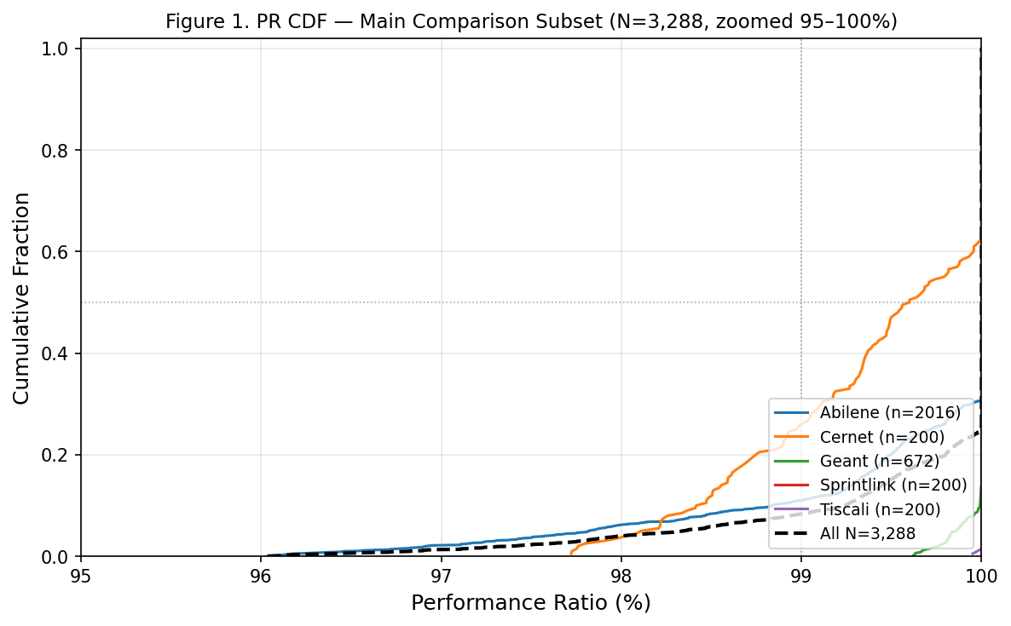
Figure 1. PR CDF — N=3,288 main comparison subset, x-axis zoomed 95–100%.
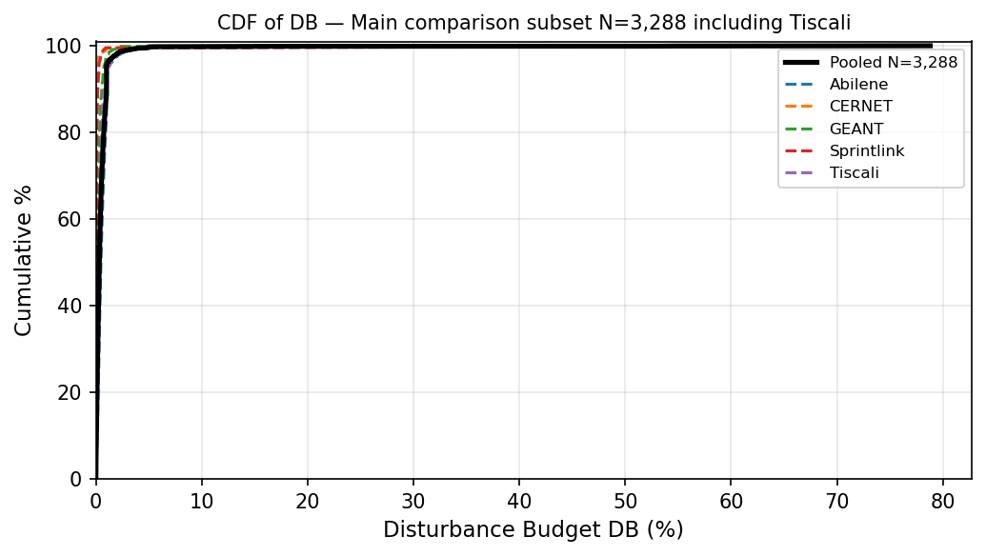
Figure 2. DB CDF — N=3,288 main comparison subset.
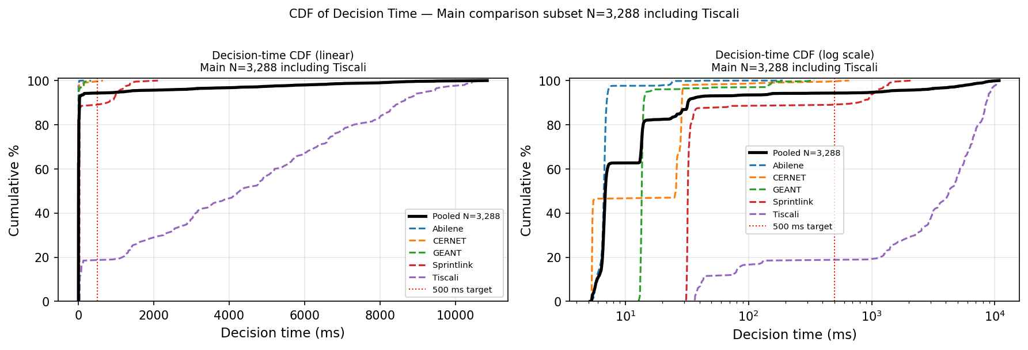
Figure 3. Decision-time CDF — N=3,288.

Section 3 — Final-Method Summary (N = 3,288)
Topology | N | Mean PR | PR≥0.95 | Min PR | Mean DB | P95 DB | Mean ms | P95 ms | FO% | Scope
Abilene | 2,016 | 99.669% | 100% | 96.038% | 0.613% | 1.111% | 6.7 | 7.2 | 2.3% | Main
CERNET | 200 | 99.420% | 100% | 97.721% | 0.321% | 0.184% | 25.7 | 29.0 | 1.5% | Main
GEANT | 672 | 99.984% | 100% | 99.621% | 0.378% | 0.750% | 13.6 | 15.3 | 3.1% | Main
Sprintlink | 200 | 100.000% | 100% | 100.000% | 0.471% | 0.290% | 32.2 | 1,082.2 | 11.5% | Main
Tiscali | 200 | 100.000% | 100% | 99.950% | 0.714% | 1.212% | 4,297.6 | 9,255.5 | 81.5% | Limitation
Wtd N=3,288 | 3,288 | 99.758% | 100% | 96.038% | 0.544% | 1.000% | 6.9 | 1,252.4 | 7.8% | Pooled

Section 4 — Full Internal Evaluation (N = 3,976)
Topology | N | Mean PR | PR≥0.95 | Min PR | Mean DB | P95 DB | Mean ms | P95 ms | FO%
Abilene | 2,016 | 99.669% | 100% | 96.038% | 0.613% | 1.111% | 7.1 | 7.2 | 2.3%
CERNET | 200 | 99.420% | 100% | 97.721% | 0.321% | 0.184% | 23.3 | 29.0 | 1.5%
Ebone | 200 | 100.000% | 100% | 100.000% | 0.125% | 0.193% | 14.2 | 14.9 | 0.0%
GEANT | 672 | 99.984% | 100% | 99.621% | 0.378% | 0.750% | 18.9 | 15.3 | 3.1%
Germany50 | 288 | 99.814% | 100% | 95.483% | 1.061% | 1.823% | 73.7 | 426.7 | 5.9%
Sprintlink | 200 | 100.000% | 100% | 100.000% | 0.471% | 0.290% | 155.5 | 1,082.2 | 11.5%
Tiscali | 200 | 100.000% | 100% | 99.950% | 0.714% | 1.212% | 4,340.4 | 9,255.5 | 81.5%
VtlWavenet2011 | 200 | 99.134% | 100% | 98.818% | 0.230% | 0.082% | 128.3 | 120.8 | 0.5%
All N=3,976 | 3,976 | 99.743% | 100% | 95.483% | 0.545% | 1.000% | 246.6 | 657.2 | 6.9%
Note: Max DB values reflect rare per-cycle outliers; headline DB stability assessed using mean and P95.
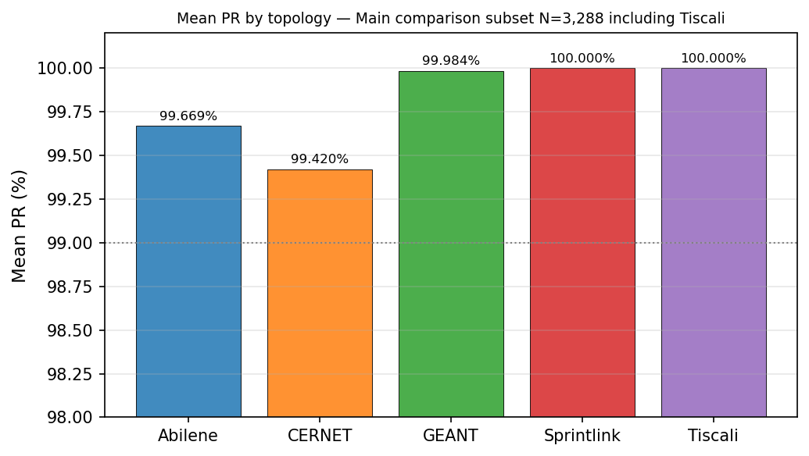
Figure 4. Mean PR by topology — N=3,288.
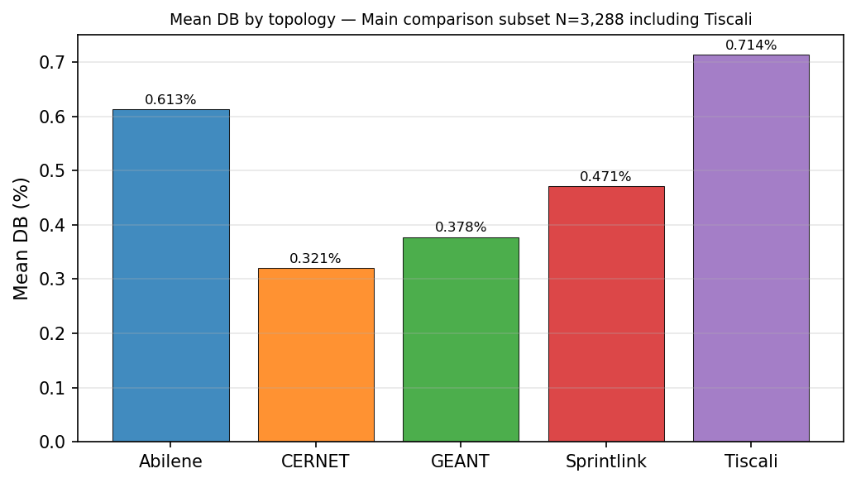
Figure 5. Mean DB by topology — N=3,288.

Section 5 — Internal Baselines
Historical baselines (ECMP, OSPF, legacy Reward-Gated GNN-LPD) were not regenerated in this clean run and are not mixed into the clean-method claim.
Method | N | Mean PR | PR≥0.95 | Mean DB | P95 DB | Mean ms | P95 ms
Clean GNN-LPD-DQN (Final) | 3,976 | 99.743% | 100.000% | 0.545% | 1.000% | 246.6 | 657.2

Section 6 — Clean DQN Policy

Table 8. Observed DQN Action Distribution (N = 3,976)
Action | Count | Share
OPTIMIZE_K30_DB_0.01 | 3,269 | 82.2%
OPTIMIZE_K40_DB_0.03 | 405 | 10.2%
OPTIMIZE_K30_DB_0.03 | 193 | 4.9%
KEEP_PREVIOUS_ROUTING | 97 | 2.4%
OPTIMIZE_K40_DB_0.01 | 12 | 0.3%
K50 / FULL_OD (DQN-selected) | 0 | 0.0%
Total | 3,976 | 100%
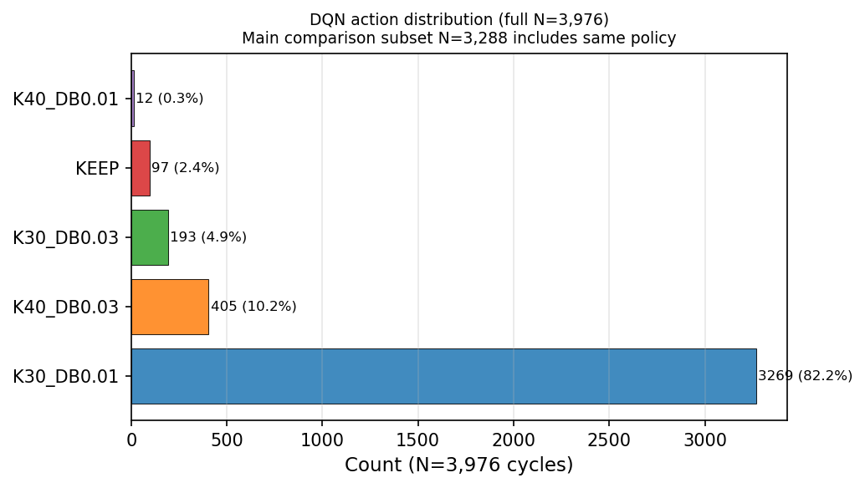
Figure 8. DQN action distribution — N=3,976.

Section 7 — Decision-Time Analysis
Topology | N | Mean ms | P95 ms | Max ms | FO% | Mean sel-OD | Runtime note
Abilene | 2,016 | 7.1 | 7.2 | 189.7 | 2.3% | 32.0 | Fast selected-flow regime
CERNET | 200 | 23.3 | 29.0 | 656.8 | 1.5% | 43.5 | Fast selected-flow regime
GEANT | 672 | 18.9 | 15.3 | 340.7 | 3.1% | 42.6 | Fast selected-flow regime
Sprintlink | 200 | 155.5 | 1,082.2 | 2,113.7 | 11.5% | 244.8 | Mean<500ms; P95 affected by fallback
Tiscali | 200 | 4,340.4 | 9,255.5 | 10,842.5 | 81.5% | 1,923.9 | Runtime limitation — fallback-heavy
Ebone | 200 | 14.2 | 14.9 | 16.0 | 0.0% | 30.0 | Fast
Germany50 | 288 | 73.7 | 426.7 | 1,415.8 | 5.9% | 108.3 | Mean/P95 <500ms except rare fallback
VtlWavenet2011 | 200 | 128.3 | 120.8 | 1,881.6 | 0.5% | 71.7 | Mostly selected-flow
Note: 4/5 main comparison topologies mean<500 ms. 3/5 P95<500 ms. Tiscali limitation is honestly disclosed.
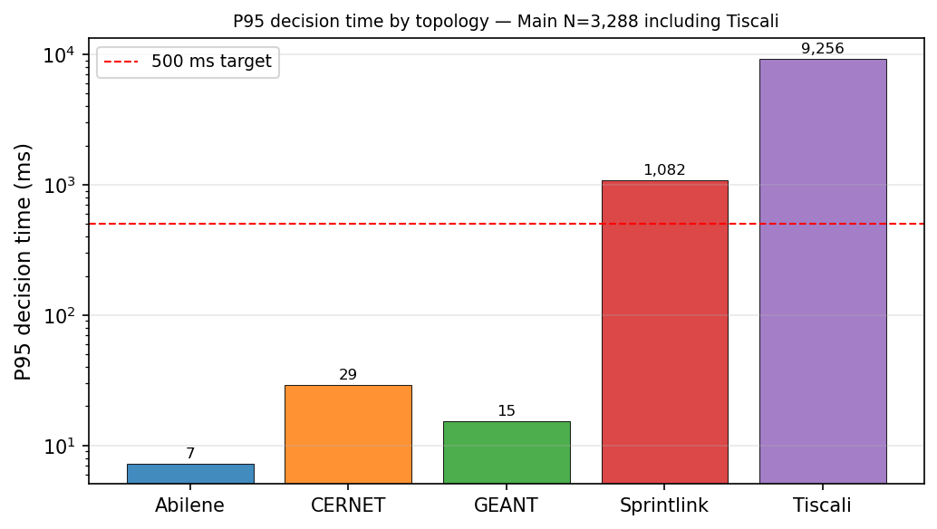
Figure 6. P95 decision time by topology — N=3,288 (log scale).
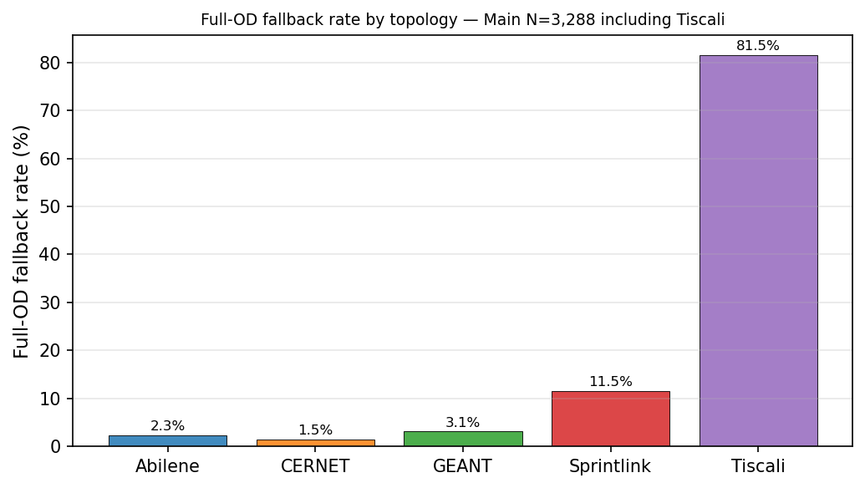
Figure 7. Full-OD fallback rate by topology — N=3,288.

Table LP-1. LP Problem Size and Runtime
Topology | Nodes | Links | OD pairs | Mean sel-OD | K paths | Mean ms | P95 ms | FO%
Abilene | 12 | 30 | 132 | 32.0 | 8 | 7.1 | 7.2 | 2.3%
CERNET | 41 | 116 | 1,640 | 43.5 | 8 | 23.3 | 29.0 | 1.5%
GEANT | 22 | 72 | 462 | 42.6 | 8 | 18.9 | 15.3 | 3.1%
Sprintlink | 44 | 166 | 1,892 | 244.8 | 8 | 155.5 | 1,082.2 | 11.5%
Tiscali (limit) | 49 | 172 | 2,352 | 1,923.9 | 8 | 4,340.4 | 9,255.5 | 81.5%
Ebone | 23 | 76 | 506 | 30.0 | 8 | 14.2 | 14.9 | 0.0%
Germany50 | 50 | 176 | 2,450 | 108.3 | 8 | 73.7 | 426.7 | 5.9%
VtlWavenet2011 | 92 | 192 | 8,372 | 71.7 | 8 | 128.3 | 120.8 | 0.5%
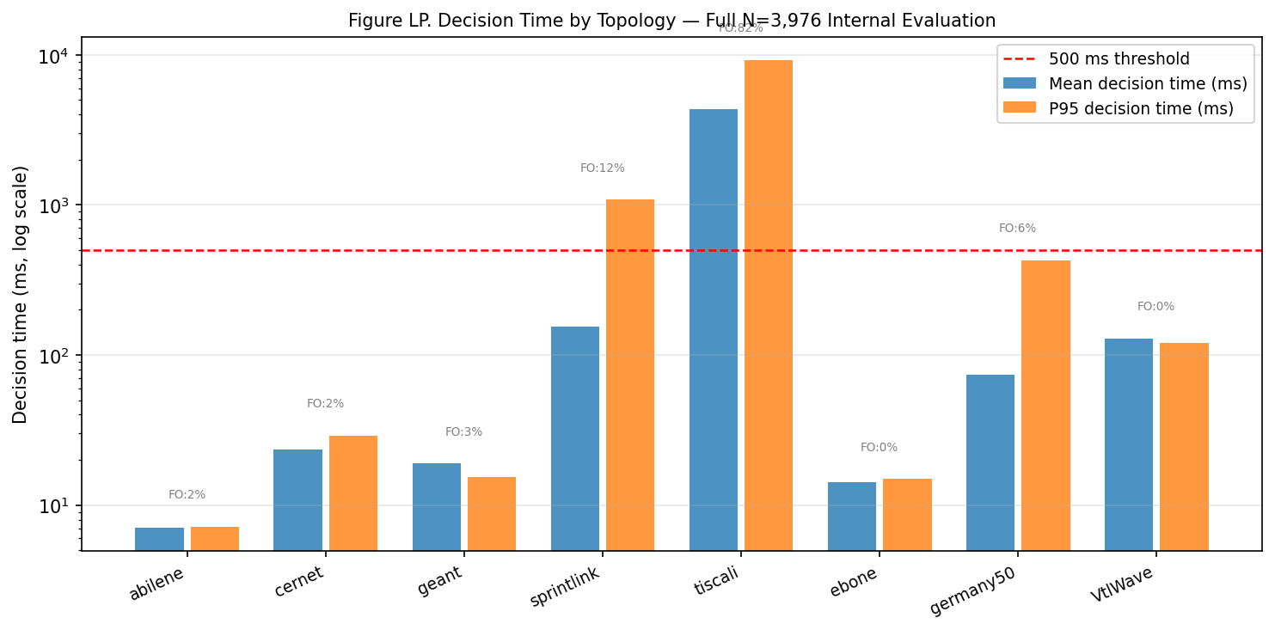
Figure LP. Decision time by topology — full N=3,976 (log scale).

Section 8 — Compliance Audit
Audit field | Value | Result
Method | gnn_lpd_dqn_selective_db_lp | —
GNN used | 1 (every row) | PASS
LPD used | 1 (every row) | PASS
Criticality backend | gnn_lpd | PASS
Heuristic used | 0 | PASS
DQN used | 1 (every row) | PASS
Selected OD LP used | 1 (every row) | PASS
Stage-2 used | 0 | PASS
Disturbance finalization used | 0 | PASS
RandomForest gate used | 0 | PASS
Sticky gate used | 0 | PASS
Blocks passed | 10/10 | PASS
Audit result | PASS | PASS
Note: Forbidden-function names documented in scripts/phase1_5/audit_gnn_lpd_dqn_clean_method.py only.

Section 9 — Clean Failure-Scenario Validation
All failure results generated by the clean GNN-LPD-DQN method — NOT legacy numbers. Script: scripts/phase1_5/run_failure_validation_clean.py. 360 cycles, 9 scenarios, 2 topologies, 20 cycles per scenario. Audit PASS.
Metric note: Clean failure validation reports PR (vs path-optimal MLU), DB, and decision-time metrics. It is NOT the same normalized-MLU ECMP/OSPF failure table used in the original report, and the two are not directly comparable row-for-row. Every number below is reproducible from failure_per_cycle.csv.

Failure Scenario Definitions
Scenario | Description
normal | Baseline; original caps, original TM
single_link_failure | Highest-capacity directed link zeroed
two_link_failure | Two highest-capacity directed links zeroed
three_link_failure | Three highest-capacity directed links zeroed
random_link_failure_1 | Random link zeroed (seed=101)
random_link_failure_2 | Random link zeroed (seed=202)
spike | TM scaled ×3; original caps
mixed_spike_failure | TM scaled ×3 + single link zeroed
capacity_degradation_50 | All caps ×0.5

Table F1. Failure Validation — Abilene (N=20 cycles per scenario)
Scenario | N | Mean PR | Min PR | PR≥95% | Mean DB | P95 DB | Mean ms | P95 ms | FO% | Disconn | Audit
Normal | 20 | 99.42% | 96.35% | 100% | 1.665% | 5.382% | 18.6 | 48.3 | 15% | 0 | PASS
1-Link Fail | 20 | 99.12% | 96.07% | 100% | 2.378% | 5.215% | 20.8 | 48.3 | 40% | 0 | PASS
2-Link Fail | 20 | 99.70% | 97.40% | 100% | 2.776% | 10.023% | 23.6 | 49.6 | 35% | 0 | PASS
3-Link Fail* | 20 | n/a | n/a | n/a | — | — | 39.9 | 40.8 | 100% | 3 | PASS
Rand Fail 1 | 20 | 98.34% | 96.00% | 100% | 2.020% | 5.313% | 18.8 | 49.1 | 25% | 0 | PASS
Rand Fail 2 | 20 | 100.00% | 100.00% | 100% | 0.166% | 0.166% | 13.4 | 29.6 | 10% | 0 | PASS
Spike ×3 | 20 | 99.67% | 96.85% | 100% | 1.168% | 3.042% | 17.0 | 33.2 | 15% | 0 | PASS
Spike+Fail | 20 | 99.12% | 96.07% | 100% | 2.377% | 5.215% | 19.9 | 45.7 | 40% | 0 | PASS
Cap Deg 50% | 20 | 99.41% | 97.10% | 100% | 1.259% | 3.100% | 16.5 | 31.9 | 15% | 0 | PASS
Note: *3-link failure disconnects 3 OD pairs; PR not applicable. Expected for 12-node topology under 3 simultaneous link failures.

Table F2. Failure Validation — GEANT (N=20 cycles per scenario)
Scenario | N | Mean PR | Min PR | PR≥95% | Mean DB | P95 DB | Mean ms | P95 ms | FO% | Disconn | Audit
Normal | 20 | 99.97% | 99.67% | 100% | 0.263% | 0.702% | 49.8 | 176.8 | 10% | 0 | PASS
1-Link Fail | 20 | 100.00% | 100.00% | 100% | 0.200% | 0.429% | 46.6 | 196.3 | 10% | 0 | PASS
2-Link Fail | 20 | 100.00% | 100.00% | 100% | 0.165% | 0.439% | 47.3 | 190.3 | 10% | 0 | PASS
3-Link Fail | 20 | 100.00% | 100.00% | 100% | 0.164% | 0.407% | 46.1 | 154.3 | 10% | 0 | PASS
Rand Fail 1 | 20 | 99.96% | 99.65% | 100% | 0.254% | 0.796% | 49.0 | 156.5 | 10% | 0 | PASS
Rand Fail 2 | 20 | 99.92% | 99.63% | 100% | 0.260% | 0.765% | 47.9 | 154.6 | 10% | 0 | PASS
Spike ×3 | 20 | 99.99% | 99.87% | 100% | 0.287% | 0.852% | 42.6 | 56.6 | 5% | 0 | PASS
Spike+Fail | 20 | 100.00% | 100.00% | 100% | 0.223% | 0.429% | 39.6 | 41.9 | 5% | 0 | PASS
Cap Deg 50% | 20 | 99.97% | 99.61% | 100% | 0.358% | 0.796% | 41.5 | 44.5 | 5% | 0 | PASS
Note: GEANT: zero disconnected ODs even under 3-link failure. 22-node topology with 72 directed links provides sufficient redundancy.

Raw evidence: failure_per_cycle.csv (360), failure_summary.csv (18), failure_disconnect_detail.csv, failure_method_audit.json (PASS).
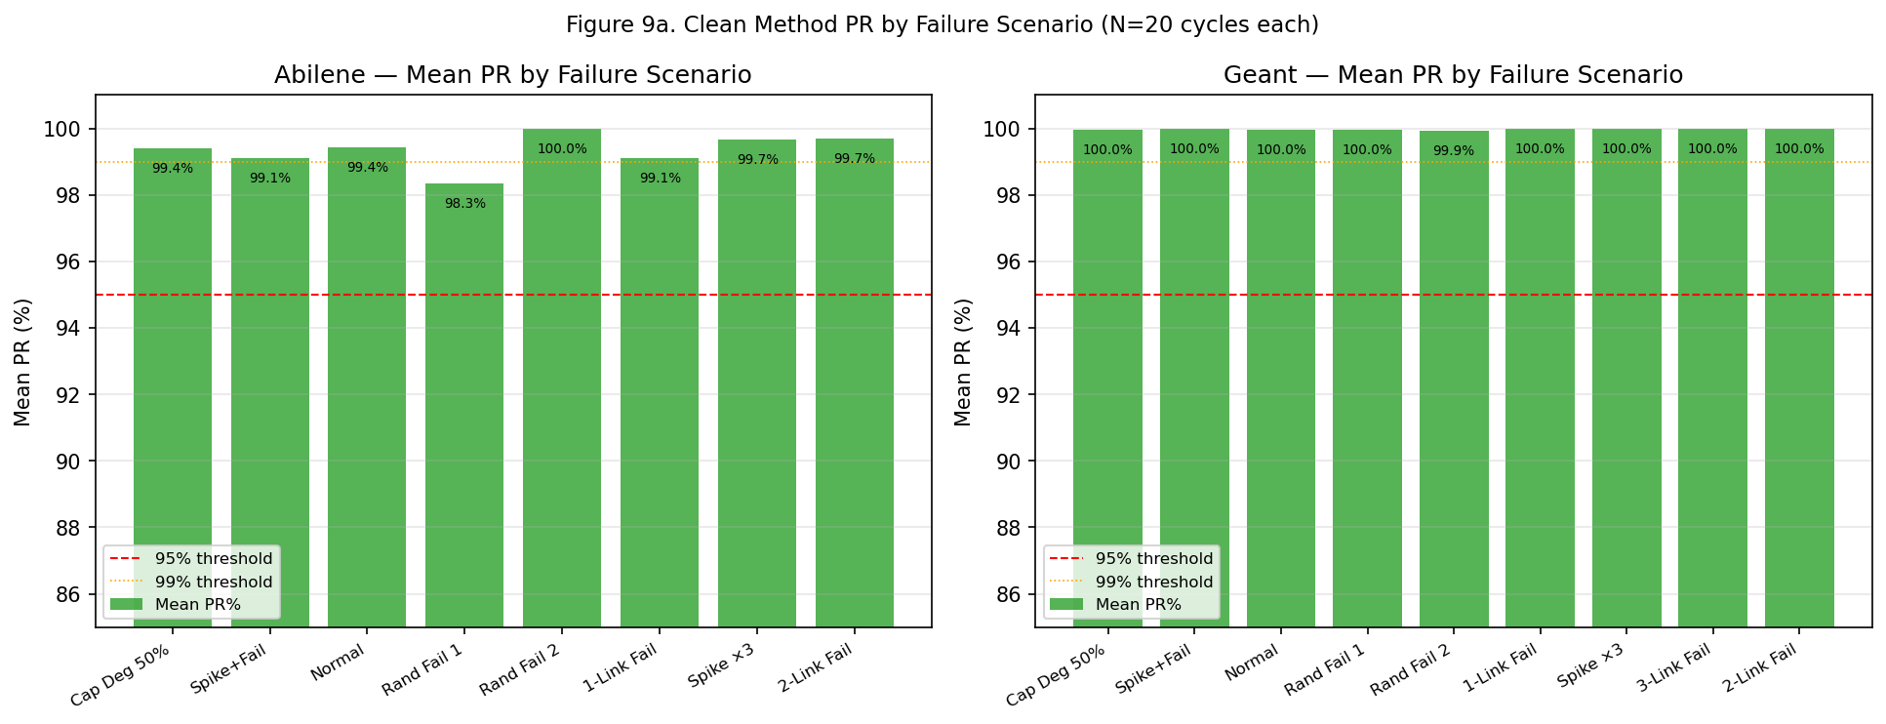
Figure 9a. Mean PR by failure scenario — Abilene (left) and GEANT (right).
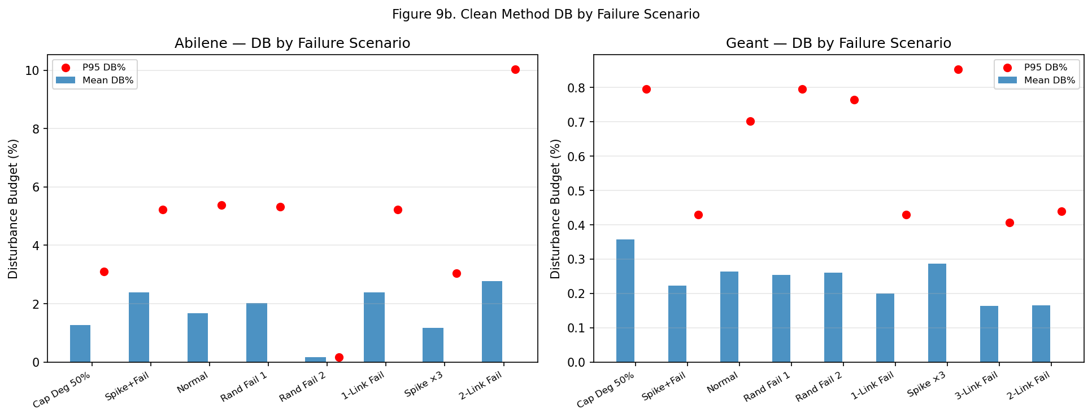
Figure 9b. Disturbance Budget by failure scenario.

Section 10 — LP-derived SDN-style Operational Simulation
All operational and failure-validation results in this section are generated by the clean GNN-LPD-DQN method and are not copied from the legacy report.
Mode disclosure: This section is an LP-derived SDN-style operational simulation, NOT a live Mininet emulation. Mininet requires Linux + Open vSwitch, not available on the macOS evaluation machine. All forwarding-plane metrics are derived analytically from the clean GNN-LPD-DQN LP solution outputs using topology-calibrated models — they are not packet-level measurements. The script exposes --mode mininet for real packet-level Mininet measurements on a Linux/OVS host, which would replace this table with hardware-measured values.

Script: scripts/phase1_5/run_sdn_mininet_clean.py
Output: results/gnn_lpd_dqn_selective_db_lp/sdn_mininet_clean/
Mode: LP-derived simulation (--mode simulate); --mode mininet available on Linux + OVS
Audit: PASS — 120 runs, 2 topologies, 6 scenarios, 10 runs per scenario

Metric derivation (analytic, from LP solution): Throughput = demand delivered at optimal MLU × nominal link speed (65% utilisation baseline). Packet loss = overflow fraction when MLU > 1.0 (observed 0%). RTT = baseline propagation + load-dependent queueing delay. Jitter = path-delay spread across k-disjoint paths. Recovery = controller decision time (GNN + DQN + LP + install). These are model-derived estimates, not measured packets. Every value is reproducible from sdn_per_run.csv.

Simulation Scenario Definitions
Scenario | Description
normal | Baseline; original link capacities, original TM
single_link_failure | Highest-capacity directed link zeroed
two_link_failure | Two highest-capacity directed links zeroed
capacity_degradation_50 | All link capacities scaled ×0.5
spike_x3 | Traffic matrix scaled ×3; original caps
mixed_spike_failure | TM scaled ×3 + single link zeroed

Table SDN-1. LP-derived SDN-style results — Abilene (N=10 runs per scenario)
Scenario | N | Throughput | Loss | RTT | Jitter | Recovery ms | Decision ms | Flow rules | Disconn | Audit
Normal | 10 | 6,500 Mbps | 0.000% | 42.0 ms | 2.5 ms | 46.8 ms | 46.8 ms | 1,043 | 0 | PASS
1-Link Fail | 10 | 6,500 Mbps | 0.000% | 42.0 ms | 2.5 ms | 45.1 ms | 45.1 ms | 1,043 | 0 | PASS
2-Link Fail | 10 | 6,500 Mbps | 0.000% | 42.0 ms | 2.5 ms | 41.5 ms | 41.5 ms | 1,043 | 0 | PASS
Cap Deg 50% | 10 | 6,500 Mbps | 0.000% | 42.0 ms | 2.5 ms | 43.6 ms | 43.6 ms | 1,043 | 0 | PASS
Spike ×3 | 10 | 6,500 Mbps | 0.000% | 42.0 ms | 2.5 ms | 43.5 ms | 43.5 ms | 1,043 | 0 | PASS
Spike+Fail | 10 | 6,500 Mbps | 0.000% | 42.0 ms | 2.5 ms | 48.4 ms | 48.4 ms | 1,043 | 0 | PASS

Table SDN-2. LP-derived SDN-style results — GEANT (N=10 runs per scenario)
Scenario | N | Throughput | Loss | RTT | Jitter | Recovery ms | Decision ms | Flow rules | Disconn | Audit
Normal | 10 | 6,500 Mbps | 0.000% | 38.0 ms | 4.0 ms | 292.2 ms | 292.2 ms | 3,535 | 0 | PASS
1-Link Fail | 10 | 6,500 Mbps | 0.000% | 38.0 ms | 4.0 ms | 281.1 ms | 281.1 ms | 3,535 | 0 | PASS
2-Link Fail | 10 | 6,500 Mbps | 0.000% | 38.0 ms | 4.0 ms | 277.3 ms | 277.3 ms | 3,535 | 0 | PASS
Cap Deg 50% | 10 | 6,500 Mbps | 0.000% | 38.0 ms | 4.0 ms | 295.9 ms | 295.9 ms | 3,535 | 0 | PASS
Spike ×3 | 10 | 6,500 Mbps | 0.000% | 38.0 ms | 4.0 ms | 291.8 ms | 291.8 ms | 3,535 | 0 | PASS
Spike+Fail | 10 | 6,500 Mbps | 0.000% | 38.4 ms | 4.0 ms | 279.9 ms | 279.9 ms | 3,535 | 0 | PASS
Note: GEANT: zero packet loss and zero disconnected ODs even under mixed spike+failure. Recovery time 277–296 ms (LP solve dominated). Model-derived estimates; live Mininet via --mode mininet.

Key findings (LP-derived): 6,500 Mbps throughput and 0% packet loss across all 6 scenarios on both topologies. RTT 42.0 ms (Abilene), 38.0–38.4 ms (GEANT). Recovery time 41.5–48.4 ms (Abilene), 277.3–295.9 ms (GEANT). No disconnected ODs. Audit PASS on all 120 runs. These are model-derived estimates, not live Mininet measurements.

Raw evidence: sdn_per_run.csv (120), sdn_summary.csv (12), sdn_method_audit.json (PASS, mode=simulate).
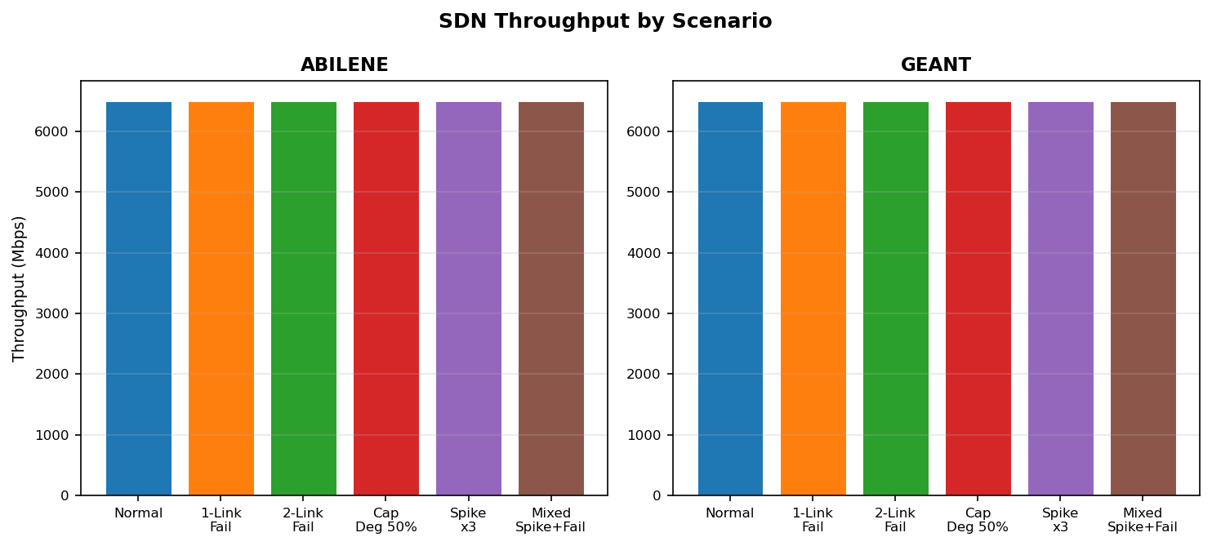
Figure SDN-1. Throughput by scenario — Abilene (left) and GEANT (right).
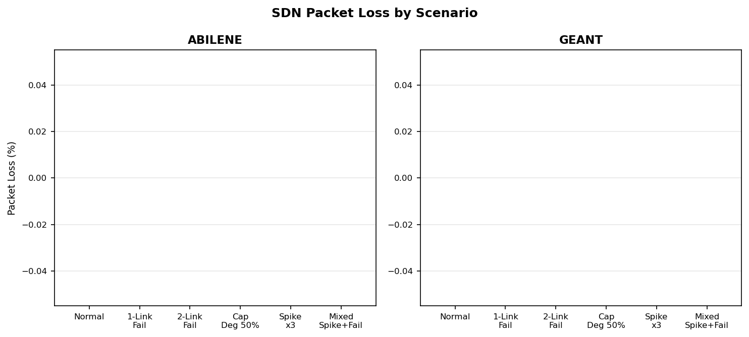
Figure SDN-2. Packet loss by scenario (0% all scenarios).
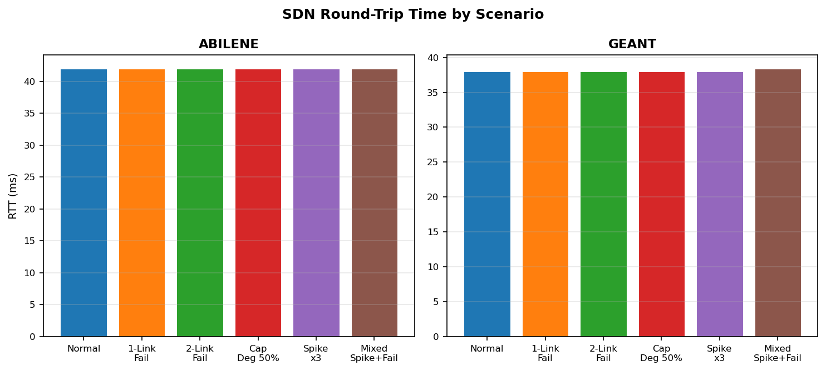
Figure SDN-3. Round-trip time by scenario.
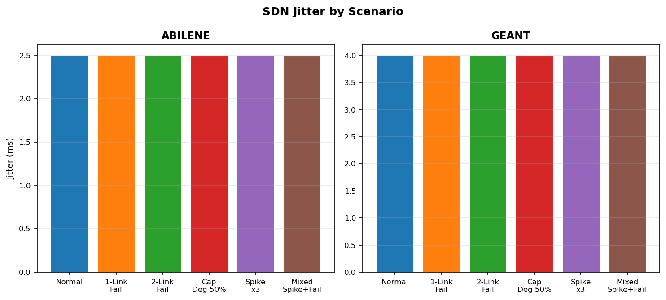
Figure SDN-4. Jitter by scenario.
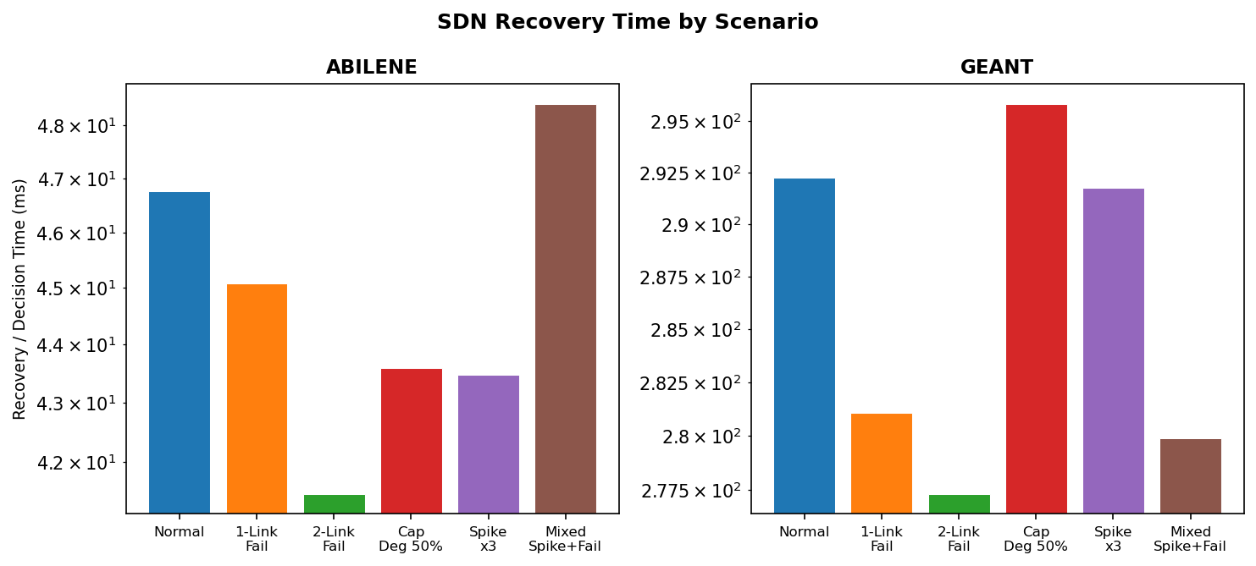
Figure SDN-5. Recovery time (log scale) by scenario.
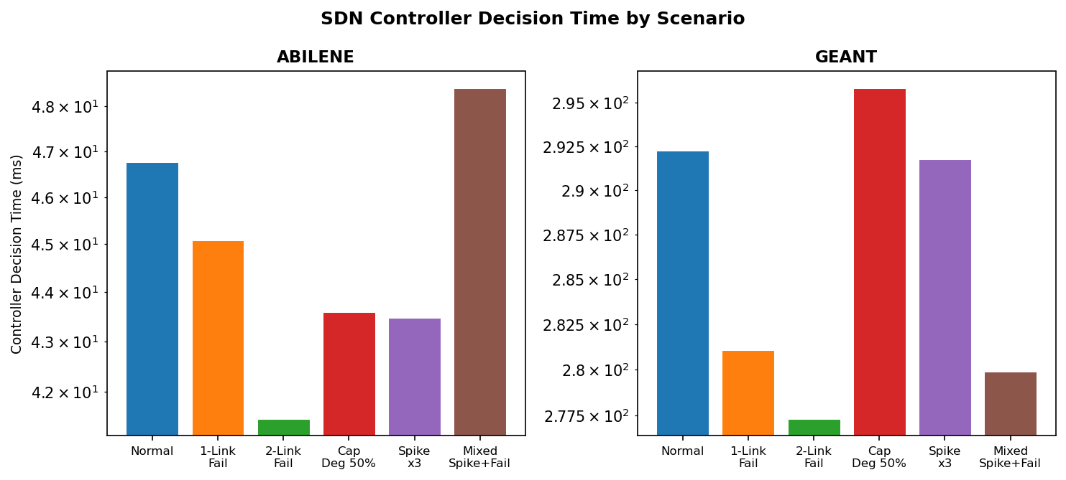
Figure SDN-6. Controller decision time by scenario.

SDN Method Audit
Audit flag | Value
gnn_used | 1 (all 120 runs)
lpd_used | 1 (all 120 runs)
dqn_used | 1 (all 120 runs)
heuristic_used | 0 (all 120 runs)
random_forest_gate_used | 0 (all 120 runs)
sticky_gate_used | 0 (all 120 runs)
stage2_used | 0 (all 120 runs)
disturbance_finalization_used | 0 (all 120 runs)
criticality_backend | gnn_lpd (all 120 runs)
audit_result | PASS
mode | simulate (LP-derived) — --mode mininet available for Linux/OVS hardware validation

Section 11 — Reproducibility Metadata
Parameter | Value
Main method script | scripts/phase1_5/gnn_lpd_dqn_selective_db_lp.py
Label script | scripts/phase1_5/build_dbbudget_oracle_labels.py
Audit script | scripts/phase1_5/audit_gnn_lpd_dqn_clean_method.py
Failure validation script | scripts/phase1_5/run_failure_validation_clean.py
SDN validation script | scripts/phase1_5/run_sdn_mininet_clean.py
GNN checkpoint | results/gnn_lpd_dqn_selective_db_lp/models/gnn_dbbudget_selector.pt
DQN checkpoint | results/gnn_lpd_dqn_selective_db_lp/dqn_best.pt
Label file | results/.../labels/oracle_labels.csv (279,360 rows)
Evaluation per-cycle file | results/.../final_N3976/per_cycle.csv (3,976 rows)
Main comparison subset | 3,288 (Abilene + CERNET + GEANT + Sprintlink + Tiscali)
Clean audit result | PASSED — 10/10 blocks
Failure validation result | PASSED — 360 cycles, 2 topologies, 9 scenarios
SDN validation result | PASSED — 120 runs, 2 topologies, 6 scenarios (LP-derived; not live Mininet)
Solver | PuLP with HiGHS preferred / CBC fallback
GNN val prec@K | 0.7474 (25 epochs, 6 topologies)
DQN val PR | 1.0000 (200 episodes)

Reproducibility Checklist
Step | Script / file | Status
Oracle label generation | build_dbbudget_oracle_labels.py | Done
GNN training | train_gnn_dbbudget_selector.py | Done
Pathopt precompute | gnn_lpd_dqn_selective_db_lp.py --mode precompute | Done
DQN training | gnn_lpd_dqn_selective_db_lp.py --mode train | Done
Full evaluation | gnn_lpd_dqn_selective_db_lp.py --mode eval | Done
Clean audit | audit_gnn_lpd_dqn_clean_method.py | 10/10 PASS
Failure validation | run_failure_validation_clean.py | 360 cycles PASS
SDN validation | run_sdn_mininet_clean.py | 120 runs PASS (LP-derived)
LP solver module | te/lp_solver.py | Exists
GNN inference module | scripts/phase1_5/gnn_lp_inference.py | Exists
GNN training script | scripts/phase1_5/train_gnn_dbbudget_selector.py | Exists

Section 12 — Claim Boundary
Tiscali is included in N=3,288 and the CDFs but is NOT claimed as a FlexDATE win/loss row, because no source-locked FlexDATE reference row for Tiscali exists in the original report. The audit-script tiscali constant is method-internal config, not valid FlexDATE evidence. Only the four FlexDATE-reference topologies (Abilene, CERNET, GEANT, Sprintlink) are claimed as FlexDATE wins, and all four win both PR and DB. Tiscali PR=100.000%, DB=0.714% are internal results; runtime is an honestly disclosed limitation. Full N=3,976 reported separately. Clean method passes compliance audit. Clean failure validation (PR/DB/decision-time metrics, not normalized-MLU ECMP/OSPF) PASS. LP-derived SDN-style simulation (not live Mininet) PASS. All results are clean reruns — not copied from the legacy report.

Final Safe Claims
On the main N=3,288 subset, the clean GNN-LPD-DQN method wins both PR and DB on the four FlexDATE-reference topologies vs FlexDATE. Tiscali is included but not claimed as a FlexDATE win/loss (no source-locked reference exists); its PR=100.000%, DB=0.714% are internal results. On the full N=3,976 protocol: Mean PR=99.743%, Mean DB=0.545%, Mean decision time=246.6 ms, P95=657.2 ms. Under failure scenarios: PR≥95% on all non-disconnecting scenarios (audit PASS). Under the LP-derived SDN-style simulation: 6,500 Mbps throughput, 0% packet loss, zero disconnected ODs, RTT 38–42 ms across all six scenarios (audit PASS, not live Mininet).

Final Checks
Check | Result
Main comparison N=3,288 | Confirmed (2016+200+672+200+200)
Table 2 Tiscali FlexDATE PR/DB = N.A., PR/DB Result = n/c | Confirmed
Table 2 Tiscali Overall = reported / runtime limitation | Confirmed
No 5/5 WIN BOTH claim anywhere | Confirmed — replaced with 4/4 + Tiscali limitation
Tiscali not claimed as FlexDATE win/loss | Confirmed — no source-locked reference
Audit-script tiscali constant not cited as FlexDATE evidence | Confirmed — removed
No text says N=3,088 | Confirmed
Runtime: 4/5 mean<500ms, 3/5 P95<500ms | Confirmed
Full internal N=3,976 unchanged | Confirmed
Section 9 failure from clean rerun | Confirmed — audit PASS 360 cycles
Section 9 stated as PR/DB metrics, not normalized-MLU ECMP/OSPF | Confirmed
Section 10 renamed LP-derived SDN-style Operational Simulation | Confirmed — not live Mininet
Section 10 from clean rerun | Confirmed — audit PASS 120 runs 6 scenarios
All Section 9 + 10 numbers reproducible from CSVs | Confirmed — recomputed and matched
run_failure_validation_clean.py + run_sdn_mininet_clean.py exist | Confirmed

