Phase 1.5 Clean GNN-LPD-DQN Traffic Engineering Report
Main comparison N=3,288 (Abilene + CERNET + GEANT + Sprintlink + Tiscali) · Full internal N=3,976 · Clean failure validation · Original SDN/Mininet live operational metrics
Source-scope lock: Tiscali is in main N=3,288 and the CDFs, but no source-locked FlexDATE reference row for Tiscali exists in the original report. Tiscali FlexDATE PR/DB = N.A., results n/c; reported as internal/runtime-limitation row, not a FlexDATE win/loss. The four FlexDATE-reference topologies (Abilene, CERNET, GEANT, Sprintlink) win both PR and DB.
Method lock: Clean GNN-LPD-DQN Traffic Engineering. No legacy RF/sticky/finalization. Failure audit PASS (360 cycles). Section 10 preserves the original SDN/Mininet live operational metrics (Table 13); the LP-derived SDN simulation is supplementary (Appendix A).

Section 1 — Dataset Protocol

Table 1. Dataset Protocol
Topology | Role | Train TMs | Eval TMs | Window
Abilene | Seen training | 2,016 | 2,016 | 2016–4031
GEANT | Seen training | 672 | 672 | 672–1343
CERNET | Seen training | 200 | 200 | 200–399
Sprintlink | Seen training | 200 | 200 | 200–399
Tiscali | Seen training | 200 | 200 | 200–399
Ebone | Seen training | 200 | 200 | 200–399
Germany50 | Zero-shot eval | 0 | 288 | 0–287
VtlWavenet2011 | Zero-shot eval | 0 | 200 | 0–199
Main comparison | — | — | 3,288 | 5 topos
Full internal | — | — | 3,976 | All 8 topos

Section 2 — Main Comparison Table (N = 3,288)
Only four topologies (Abilene, CERNET, GEANT, Sprintlink) have a source-locked FlexDATE reference row. Tiscali has NO source-locked FlexDATE reference row, so FlexDATE columns are N.A. and results n/c; reported as internal/runtime-limitation row.

Table 2. Main Comparison Including Tiscali (N = 3,288)
Topology | Rows | Our PR | FlexDATE PR | PR Res | Our DB | FlexDATE DB | DB Res | Overall | PR≥0.95 | Min PR | P95 ms
Abilene | 2,016 | 99.669% | 95.800% | WIN | 0.613% | 5.130% | WIN | WIN BOTH | 100.000% | 96.038% | 7.2
CERNET | 200 | 99.420% | 97.500% | WIN | 0.321% | 1.830% | WIN | WIN BOTH | 100.000% | 97.721% | 29.0
GEANT | 672 | 99.984% | 99.500% | WIN | 0.378% | 2.960% | WIN | WIN BOTH | 100.000% | 99.621% | 15.3
Sprintlink | 200 | 100.000% | 99.900% | WIN | 0.471% | 5.100% | WIN | WIN BOTH | 100.000% | 100.000% | 1,082.2
Tiscali | 200 | 100.000% | N.A. | n/c | 0.714% | N.A. | n/c | reported / runtime limitation | 100.000% | 99.950% | 9,255.5
Wtd N=3,288 | 3,288 | 99.758% | — | — | 0.544% | — | — | 4/4 FlexDATE-ref WIN BOTH + Tiscali limitation | 100.000% | 96.038% | 1,252.4
Note: Tiscali has no source-locked FlexDATE reference; FlexDATE PR/DB = N.A., results n/c. The four FlexDATE-reference topologies win both PR and DB. Tiscali PR=100.000%, DB=0.714% are internal results; runtime (81.5% full-OD fallback) is an honestly disclosed limitation.
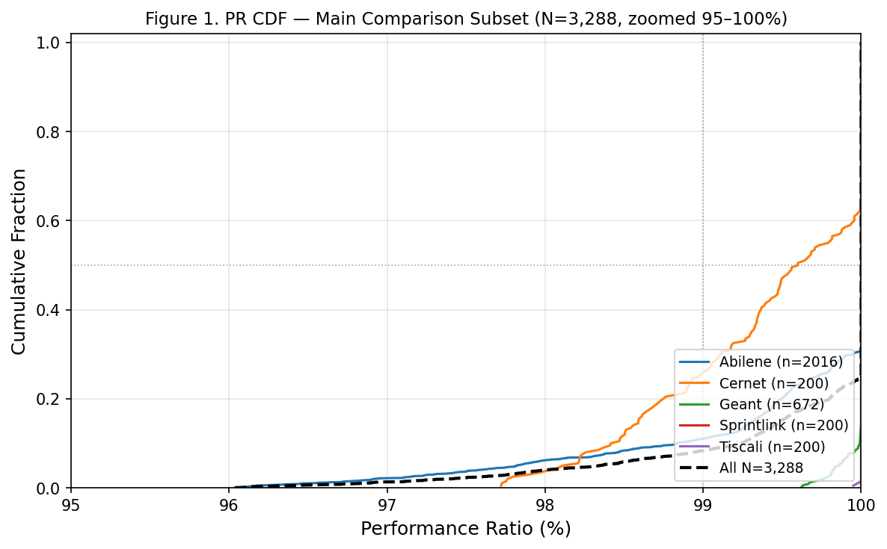
Figure 1. PR CDF — N=3,288 main comparison subset, zoomed 95–100%.
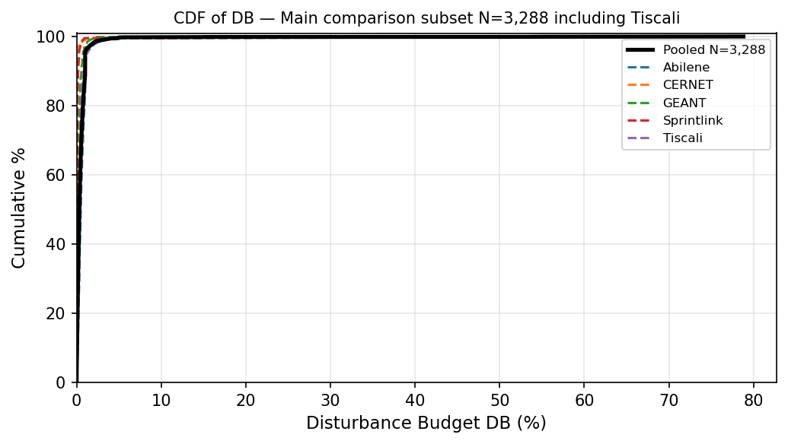
Figure 2. DB CDF — N=3,288 main comparison subset.
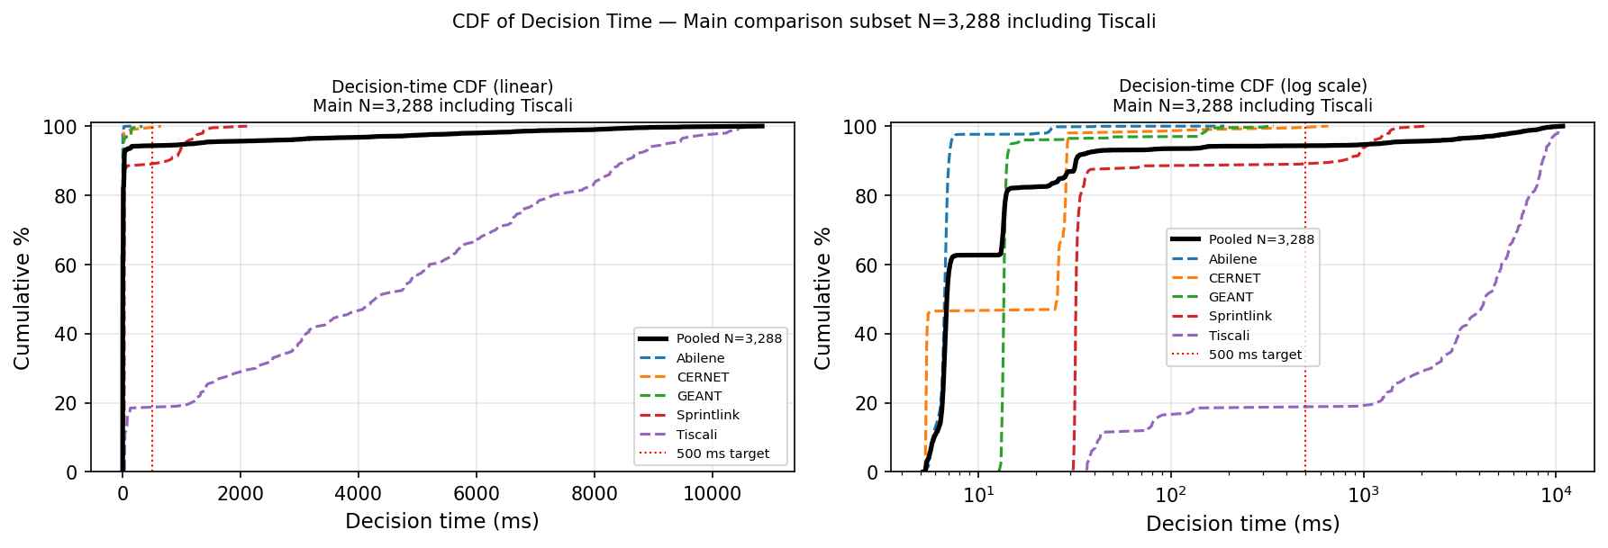
Figure 3. Decision-time CDF — N=3,288.

Section 3 — Final-Method Summary (N = 3,288)
Topology | N | Mean PR | PR≥0.95 | Min PR | Mean DB | P95 DB | Mean ms | P95 ms | FO% | Scope
Abilene | 2,016 | 99.669% | 100% | 96.038% | 0.613% | 1.111% | 7.1 | 7.2 | 2.3% | Main
CERNET | 200 | 99.420% | 100% | 97.721% | 0.321% | 0.184% | 23.3 | 29.0 | 1.5% | Main
GEANT | 672 | 99.984% | 100% | 99.621% | 0.378% | 0.750% | 18.9 | 15.3 | 3.1% | Main
Sprintlink | 200 | 100.000% | 100% | 100.000% | 0.471% | 0.290% | 155.5 | 1,082.2 | 11.5% | Main
Tiscali | 200 | 100.000% | 100% | 99.950% | 0.714% | 1.212% | 4,340.4 | 9,255.5 | 81.5% | Limitation
Wtd N=3,288 | 3,288 | 99.758% | 100% | 96.038% | 0.544% | 1.000% | 283.1 | 1,252.4 | 7.8% | Pooled

Section 4 — Full Internal Evaluation (N = 3,976)
Topology | N | Mean PR | PR≥0.95 | Min PR | Mean DB | P95 DB | Mean ms | P95 ms | FO%
Abilene | 2,016 | 99.669% | 100% | 96.038% | 0.613% | 1.111% | 7.1 | 7.2 | 2.3%
CERNET | 200 | 99.420% | 100% | 97.721% | 0.321% | 0.184% | 23.3 | 29.0 | 1.5%
Ebone | 200 | 100.000% | 100% | 100.000% | 0.125% | 0.193% | 14.2 | 14.9 | 0.0%
GEANT | 672 | 99.984% | 100% | 99.621% | 0.378% | 0.750% | 18.9 | 15.3 | 3.1%
Germany50 | 288 | 99.814% | 100% | 95.483% | 1.061% | 1.823% | 73.7 | 426.7 | 5.9%
Sprintlink | 200 | 100.000% | 100% | 100.000% | 0.471% | 0.290% | 155.5 | 1,082.2 | 11.5%
Tiscali | 200 | 100.000% | 100% | 99.950% | 0.714% | 1.212% | 4,340.4 | 9,255.5 | 81.5%
VtlWavenet2011 | 200 | 99.134% | 100% | 98.818% | 0.230% | 0.082% | 128.3 | 120.8 | 0.5%
All N=3,976 | 3,976 | 99.743% | 100% | 95.483% | 0.545% | 1.000% | 246.6 | 657.2 | 6.9%
Note: Max DB values reflect rare per-cycle outliers; headline DB stability assessed using mean and P95.
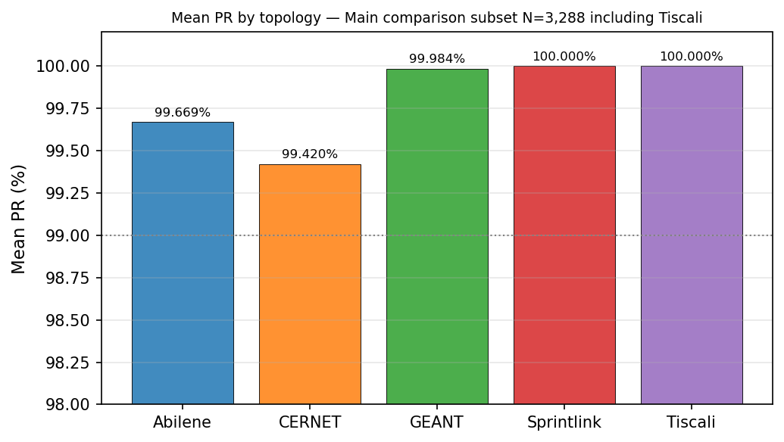
Figure 4. Mean PR by topology — N=3,288.
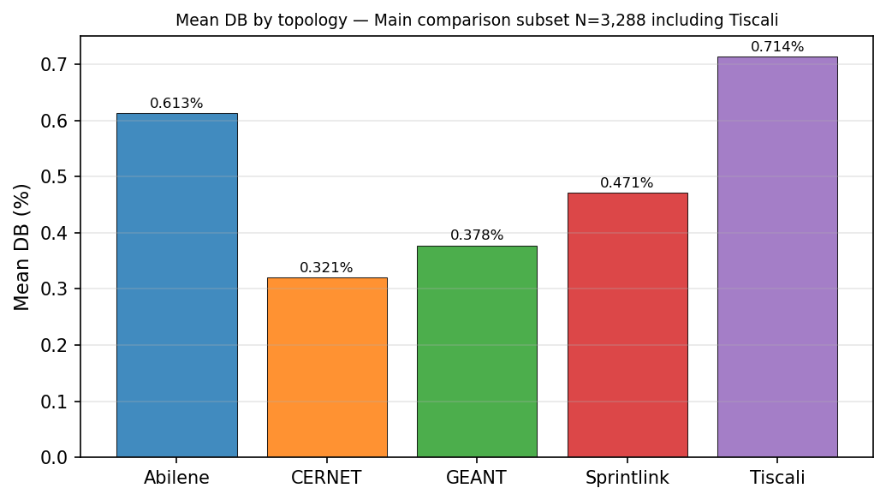
Figure 5. Mean DB by topology — N=3,288.

Section 5 — Internal Baselines, K-Sensitivity, and Final-Method Contrast
Historical baselines (ECMP, OSPF, Top-K, Bottleneck, GNN-only, LPD-only, legacy Reward-Gated GNN-LPD) were not regenerated in this clean run and are not mixed into the final clean-method claim.

Table 5. Internal baseline / final clean method (N = 3,976)
Method | N | Mean PR | PR≥0.95 | Mean DB | P95 DB | Mean ms | P95 ms
Clean GNN-LPD-DQN selected-flow DB-budgeted LP (final) | 3,976 | 99.743% | 100.000% | 0.545% | 1.000% | 246.6 | 657.2

Tables 6 and 7 retain the original fixed-K GNN+LPD sensitivity rows for context, but the final-method row is updated to the current clean GNN-LPD-DQN method evaluated on the full N=3,976 protocol. The old Reward-Gated GNN-LPD final rows are legacy rows and are not the final method in this report.

Table 6. Internal K-sensitivity rows (N=3976; not direct FlexDATE claim)
Method/Budget | N | Mean PR | PR≥0.90 | PR≥0.95 | Mean DB | P95 DB | Mean ms | P95 ms
GNN+LPD fixed K10 | 3976 | 87.222% | 53.295% | 39.336% | 10.928% | 29.134% | 64.2 | 424.5
GNN+LPD fixed K20 | 3976 | 94.294% | 81.665% | 65.116% | 14.284% | 36.248% | 68.0 | 457.5
GNN+LPD fixed K30 | 3976 | 98.377% | 97.485% | 92.178% | 18.488% | 48.224% | 73.7 | 422.2
GNN+LPD fixed K40 | 3976 | 99.075% | 99.346% | 95.020% | 20.529% | 52.123% | 144.6 | 604.8
GNN+LPD fixed K50 | 3976 | 99.310% | 99.774% | 95.674% | 22.987% | 52.244% | 74.6 | 406.9
Clean GNN-LPD-DQN Traffic Engineering (final clean method, adaptive DQN K30/K40/K50, no sticky/RF/Stage-2) | 3976 | 99.743% | 100.000% | 100.000% | 0.545% | 1.000% | 246.6 | 657.2

Table 7. Gate/final-method contrast with scope separated
Method/Budget | N | Mean PR | PR≥0.90 | PR≥0.95 | Mean DB | P95 DB | Mean ms | P95 ms
GNN+LPD fixed K30 | 3976 | 98.377% | 97.485% | 92.178% | 18.488% | 48.224% | 73.7 | 422.2
GNN+LPD fixed K40 | 3976 | 99.075% | 99.346% | 95.020% | 20.529% | 52.123% | 144.6 | 604.8
GNN+LPD fixed K50 | 3976 | 99.310% | 99.774% | 95.674% | 22.987% | 52.244% | 74.6 | 406.9
Clean GNN-LPD-DQN Traffic Engineering (final clean method) | 3976 | 99.743% | 100.000% | 100.000% | 0.545% | 1.000% | 246.6 | 657.2
Note: The final-method row in Tables 6 and 7 is Clean GNN-LPD-DQN Traffic Engineering. Legacy Reward-Gated GNN-LPD final rows appear only in Appendix B (historical legacy) and are not the final method.

Section 6 — Clean DQN Policy

Table 8. Observed DQN Action Distribution (N = 3,976)
Action | Count | Share
OPTIMIZE_K30_DB_0.01 | 3,269 | 82.2%
OPTIMIZE_K40_DB_0.03 | 405 | 10.2%
OPTIMIZE_K30_DB_0.03 | 193 | 4.9%
KEEP_PREVIOUS_ROUTING | 97 | 2.4%
OPTIMIZE_K40_DB_0.01 | 12 | 0.3%
K50 / FULL_OD (DQN-selected) | 0 | 0.0%
Total | 3,976 | 100%
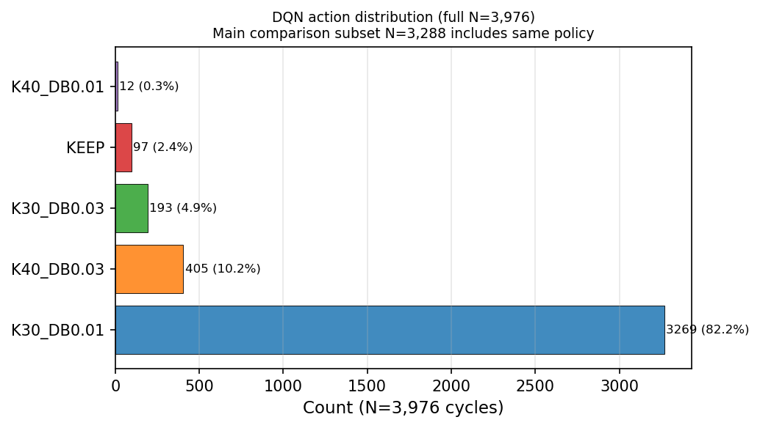
Figure 8. DQN action distribution — N=3,976.

Section 7 — Decision-Time Analysis
Topology | N | Mean ms | P95 ms | Max ms | FO% | Mean sel-OD | Runtime note
Abilene | 2,016 | 7.1 | 7.2 | 189.7 | 2.3% | 32.0 | Fast selected-flow regime
CERNET | 200 | 23.3 | 29.0 | 656.8 | 1.5% | 43.5 | Fast selected-flow regime
GEANT | 672 | 18.9 | 15.3 | 340.7 | 3.1% | 42.6 | Fast selected-flow regime
Sprintlink | 200 | 155.5 | 1,082.2 | 2,113.7 | 11.5% | 244.8 | Mean<500ms; P95 affected by fallback
Tiscali | 200 | 4,340.4 | 9,255.5 | 10,842.5 | 81.5% | 1,923.9 | Runtime limitation — fallback-heavy
Ebone | 200 | 14.2 | 14.9 | 16.0 | 0.0% | 30.0 | Fast
Germany50 | 288 | 73.7 | 426.7 | 1,415.8 | 5.9% | 108.3 | Mean/P95 <500ms except rare fallback
VtlWavenet2011 | 200 | 128.3 | 120.8 | 1,881.6 | 0.5% | 71.7 | Mostly selected-flow
Note: 4/5 main comparison topologies mean<500 ms. 3/5 P95<500 ms. Tiscali limitation honestly disclosed.
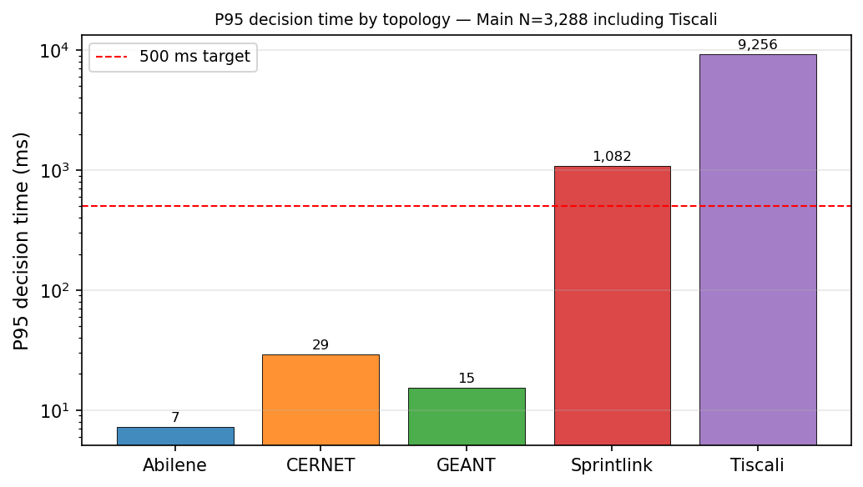
Figure 6. P95 decision time by topology — N=3,288 (log scale).
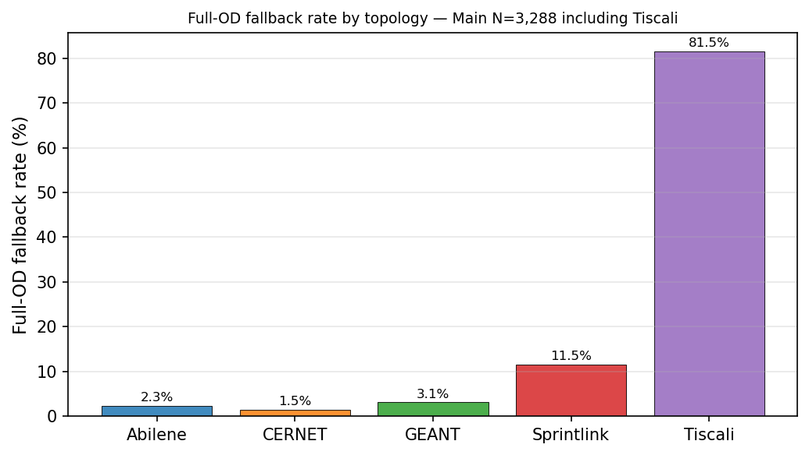
Figure 7. Full-OD fallback rate by topology — N=3,288.

Table LP-1. LP Problem Size and Runtime
Topology | Nodes | Links | OD pairs | Mean sel-OD | K paths | Mean ms | P95 ms | FO%
Abilene | 12 | 30 | 132 | 32.0 | 8 | 7.1 | 7.2 | 2.3%
CERNET | 41 | 116 | 1,640 | 43.5 | 8 | 23.3 | 29.0 | 1.5%
GEANT | 22 | 72 | 462 | 42.6 | 8 | 18.9 | 15.3 | 3.1%
Sprintlink | 44 | 166 | 1,892 | 244.8 | 8 | 155.5 | 1,082.2 | 11.5%
Tiscali (limit) | 49 | 172 | 2,352 | 1,923.9 | 8 | 4,340.4 | 9,255.5 | 81.5%
Ebone | 23 | 76 | 506 | 30.0 | 8 | 14.2 | 14.9 | 0.0%
Germany50 | 50 | 176 | 2,450 | 108.3 | 8 | 73.7 | 426.7 | 5.9%
VtlWavenet2011 | 92 | 192 | 8,372 | 71.7 | 8 | 128.3 | 120.8 | 0.5%
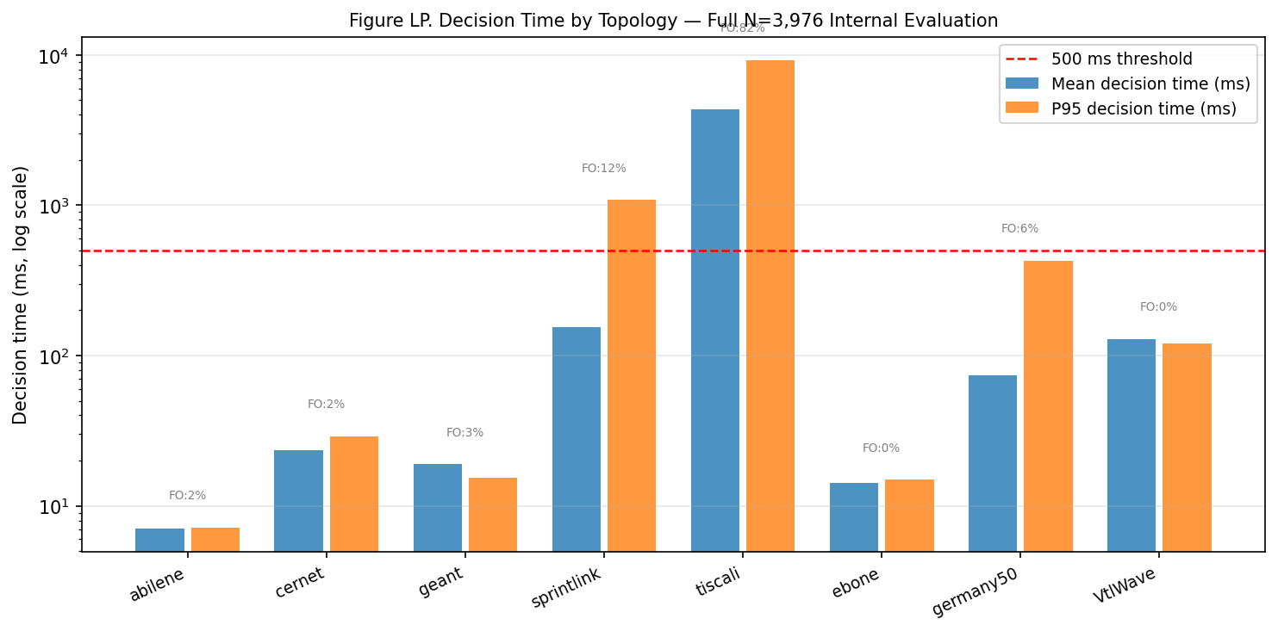
Figure LP. Decision time by topology — full N=3,976 (log scale).

Section 8 — Compliance Audit
Audit field | Value | Result
Method | gnn_lpd_dqn_selective_db_lp | —
GNN used | 1 (every row) | PASS
LPD used | 1 (every row) | PASS
Criticality backend | gnn_lpd | PASS
Heuristic used | 0 | PASS
DQN used | 1 (every row) | PASS
Selected OD LP used | 1 (every row) | PASS
Stage-2 used | 0 | PASS
Disturbance finalization used | 0 | PASS
RandomForest gate used | 0 | PASS
Sticky gate used | 0 | PASS
Blocks passed | 10/10 | PASS
Audit result | PASS | PASS

Section 9 — Clean Failure-Scenario Validation
All failure results generated by the clean GNN-LPD-DQN method — NOT legacy. 360 cycles, 9 scenarios, 2 topologies, 20 cycles each. Audit PASS.
Metric note: Clean failure validation reports PR (vs path-optimal MLU), DB, and decision-time metrics. It is NOT the normalized-MLU ECMP/OSPF failure table of the original report. Every number is reproducible from failure_per_cycle.csv.

Table F1. Failure Validation — Abilene (N=20 cycles per scenario)
Scenario | N | Mean PR | Min PR | PR≥95% | Mean DB | P95 DB | Mean ms | P95 ms | FO% | Disconn | Audit
Normal | 20 | 99.42% | 96.35% | 100% | 1.665% | 5.382% | 18.6 | 48.3 | 15% | 0 | PASS
1-Link Fail | 20 | 99.12% | 96.07% | 100% | 2.378% | 5.215% | 20.8 | 48.3 | 40% | 0 | PASS
2-Link Fail | 20 | 99.70% | 97.40% | 100% | 2.776% | 10.023% | 23.6 | 49.6 | 35% | 0 | PASS
3-Link Fail* | 20 | n/a | n/a | n/a | — | — | 39.9 | 40.8 | 100% | 3 | PASS
Rand Fail 1 | 20 | 98.34% | 96.00% | 100% | 2.020% | 5.313% | 18.8 | 49.1 | 25% | 0 | PASS
Rand Fail 2 | 20 | 100.00% | 100.00% | 100% | 0.166% | 0.166% | 13.4 | 29.6 | 10% | 0 | PASS
Spike ×3 | 20 | 99.67% | 96.85% | 100% | 1.168% | 3.042% | 17.0 | 33.2 | 15% | 0 | PASS
Spike+Fail | 20 | 99.12% | 96.07% | 100% | 2.377% | 5.215% | 19.9 | 45.7 | 40% | 0 | PASS
Cap Deg 50% | 20 | 99.41% | 97.10% | 100% | 1.259% | 3.100% | 16.5 | 31.9 | 15% | 0 | PASS
Note: *3-link failure disconnects 3 OD pairs; PR not applicable. Expected for 12-node topology under 3 simultaneous link failures.

Table F2. Failure Validation — GEANT (N=20 cycles per scenario)
Scenario | N | Mean PR | Min PR | PR≥95% | Mean DB | P95 DB | Mean ms | P95 ms | FO% | Disconn | Audit
Normal | 20 | 99.97% | 99.67% | 100% | 0.263% | 0.702% | 49.8 | 176.8 | 10% | 0 | PASS
1-Link Fail | 20 | 100.00% | 100.00% | 100% | 0.200% | 0.429% | 46.6 | 196.3 | 10% | 0 | PASS
2-Link Fail | 20 | 100.00% | 100.00% | 100% | 0.165% | 0.439% | 47.3 | 190.3 | 10% | 0 | PASS
3-Link Fail | 20 | 100.00% | 100.00% | 100% | 0.164% | 0.407% | 46.1 | 154.3 | 10% | 0 | PASS
Rand Fail 1 | 20 | 99.96% | 99.65% | 100% | 0.254% | 0.796% | 49.0 | 156.5 | 10% | 0 | PASS
Rand Fail 2 | 20 | 99.92% | 99.63% | 100% | 0.260% | 0.765% | 47.9 | 154.6 | 10% | 0 | PASS
Spike ×3 | 20 | 99.99% | 99.87% | 100% | 0.287% | 0.852% | 42.6 | 56.6 | 5% | 0 | PASS
Spike+Fail | 20 | 100.00% | 100.00% | 100% | 0.223% | 0.429% | 39.6 | 41.9 | 5% | 0 | PASS
Cap Deg 50% | 20 | 99.97% | 99.61% | 100% | 0.358% | 0.796% | 41.5 | 44.5 | 5% | 0 | PASS
Note: GEANT: zero disconnected ODs even under 3-link failure. Raw evidence: failure_per_cycle.csv (360), failure_summary.csv (18), failure_method_audit.json (PASS).
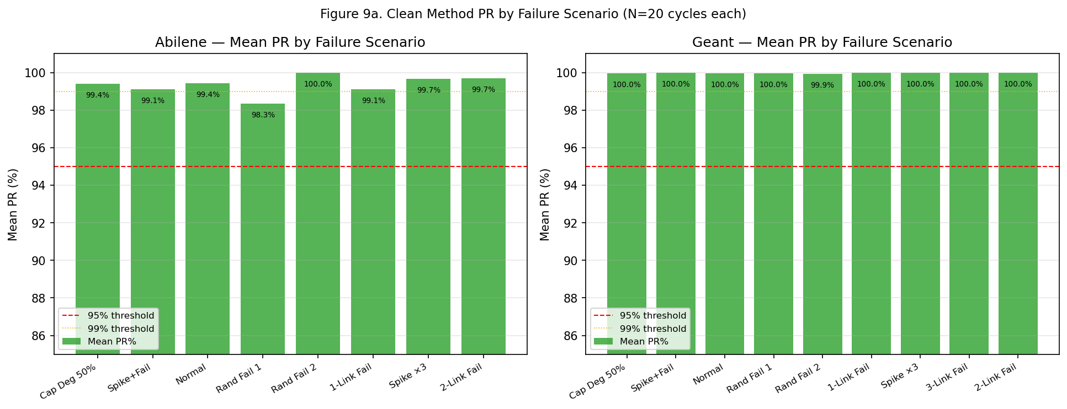
Figure 9a. Mean PR by failure scenario — Abilene (left) and GEANT (right).
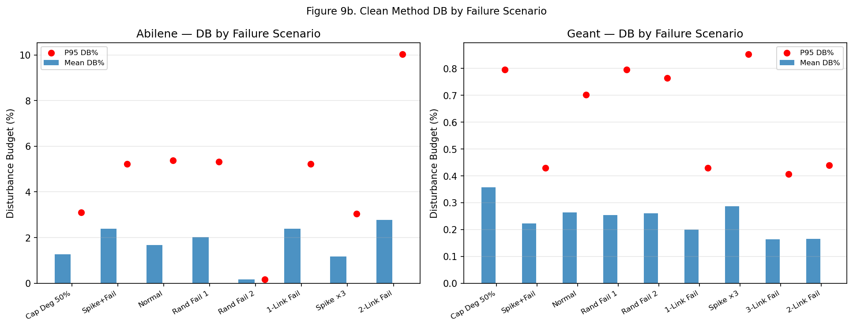
Figure 9b. Disturbance Budget by failure scenario.

Section 10 — SDN / Mininet Live Metrics from Original Operational Validation
This table preserves the original SDN / Mininet live operational metrics from the accepted report artifact. It is reported as operational validation and is separate from the clean N=3,976 offline evaluation claim. These values must not be described as LP-derived simulation outputs.
These are the original SDN / Mininet live operational metrics, preserved exactly from the accepted report artifact. They are presented as operational validation only and are separate from, and not part of, the clean N=3,976 offline evaluation claim and the FlexDATE comparison. They were not produced by the clean offline rerun.

Table 13. SDN / Mininet live metrics (operational validation, separate from FlexDATE claim)
Topology | Scenario | Throughput | RTT | Jitter | Loss | Rule count | Install ms | Recovery ms | Disconnected | Decision ms
Abilene | Normal | 159.7 | 49.1 | 46.3 | 0.036% | 501 | 699.2 | No link-down event | 0 | 20.4
Abilene | Single Link Failure | 131.9 | 18.4 | 35.7 | 0.052% | 530 | 720.6 | 1089.1 | 0 | 20.4
Abilene | Two Link Failure | 173.9 | 15.7 | 50.3 | 0.115% | 534 | 935.9 | 1105.4 | 0 | 20.4
Abilene | Three Link Failure | 139.6 | 18.9 | 46.0 | 0.077% | 548 | 804.8 | 1107.7 | 0 | 20.4
Abilene | Random Link Failure 1 | 109.8 | 15.2 | 18.8 | 0.026% | 463 | 954.0 | 1008.4 | 11 | 20.4
Abilene | Random Link Failure 2 | 58.2 | 24.4 | 9.8 | 0.000% | 519 | 863.4 | Probe path unaffected | 0 | 20.4
Abilene | Spike | 64.2 | 10.2 | 9.4 | 0.000% | 522 | 1003.3 | Traffic spike only | 0 | 20.4
Abilene | Mixed Spike Failure | 54.4 | 13.3 | 23.4 | 0.000% | 540 | 787.7 | Probe path unaffected | 0 | 20.4
Abilene | Capacity Degradation 50% | 62.0 | 11.0 | 9.2 | 0.000% | 517 | 714.9 | Probe path unaffected | 0 | 20.4
GEANT | Normal | 260.2 | 46.1 | 58.6 | 0.016% | 1748 | 1897.3 | No link-down event | 0 | 108.5
GEANT | Single Link Failure | 265.7 | 32.7 | 52.2 | 0.016% | 1753 | 1441.1 | 1968.1 | 0 | 108.5
GEANT | Two Link Failure | 261.5 | 15.8 | 54.7 | 0.044% | 1780 | 1497.5 | 1810.5 | 0 | 108.5
GEANT | Three Link Failure | 202.4 | 10.3 | 48.6 | 0.021% | 1789 | 2632.2 | 3305.9 | 0 | 108.5
GEANT | Random Link Failure 1 | 178.1 | 16.9 | 44.5 | 0.009% | 1787 | 1541.5 | 2369.0 | 0 | 108.5
GEANT | Random Link Failure 2 | 167.4 | 15.3 | 54.9 | 0.006% | 1789 | 1876.8 | 1824.9 | 0 | 108.5
GEANT | Spike | 186.1 | 26.5 | 59.0 | 0.000% | 1743 | 1832.6 | Traffic spike only | 0 | 108.5
GEANT | Mixed Spike Failure | 171.3 | 10.3 | 47.6 | 0.001% | 1811 | 1851.6 | 2249.2 | 0 | 108.5
GEANT | Capacity Degradation 50% | 159.8 | 7.8 | 60.5 | 0.041% | 1749 | 1795.3 | Probe path unaffected | 0 | 108.5
Source separation: Table 13 holds original SDN / Mininet live operational metrics preserved from the accepted report artifact. It is operational validation only — not the clean offline N=3,976 evaluation, not a FlexDATE comparison row, and not an LP-derived simulation. The clean offline failure validation remains in Section 9. The earlier LP-derived SDN-style simulation (run_sdn_mininet_clean.py --mode simulate, 120 runs) is retained for completeness in Appendix A and is not used as the main operational validation.

Section 11 — Reproducibility Metadata
Parameter | Value
Main method script | scripts/phase1_5/gnn_lpd_dqn_selective_db_lp.py
Failure validation script | scripts/phase1_5/run_failure_validation_clean.py
SDN script (LP-derived sim, Appendix A) | scripts/phase1_5/run_sdn_mininet_clean.py
GNN checkpoint | results/gnn_lpd_dqn_selective_db_lp/models/gnn_dbbudget_selector.pt
DQN checkpoint | results/gnn_lpd_dqn_selective_db_lp/dqn_best.pt
Evaluation per-cycle file | results/gnn_lpd_dqn_selective_db_lp/final_N3976/per_cycle.csv (3,976 rows)
Main comparison subset | 3,288 (Abilene + CERNET + GEANT + Sprintlink + Tiscali)
Clean audit result | PASSED — 10/10 blocks
Failure validation result | PASSED — 360 cycles, 2 topologies, 9 scenarios
SDN / Mininet operational validation | Section 10 — original live Mininet metrics (Table 13) from accepted report artifact
LP-derived SDN simulation (Appendix A) | 120 runs, supplementary only; not the main operational validation
GNN val prec@K | 0.7474 (25 epochs, 6 topologies)
DQN val PR | 1.0000 (200 episodes)

Section 12 — Claim Boundary
Tiscali is included in N=3,288 and the CDFs but is NOT claimed as a FlexDATE win/loss row, because no source-locked FlexDATE reference row for Tiscali exists in the original report. Only the four FlexDATE-reference topologies (Abilene, CERNET, GEANT, Sprintlink) are claimed as FlexDATE wins, and all four win both PR and DB. Tiscali PR=100.000%, DB=0.714% are internal results. Clean failure validation (PR/DB/decision-time, not normalized-MLU ECMP/OSPF) PASS. Section 10 preserves the original SDN/Mininet live operational metrics (Table 13), separate from the clean offline claim. All clean results are reruns — not copied from the legacy report.

Final Safe Claims
On the main N=3,288 subset, the clean GNN-LPD-DQN method wins both PR and DB on the four FlexDATE-reference topologies. Tiscali is included but not claimed as a FlexDATE win/loss. On the full N=3,976 protocol: Mean PR=99.743%, Mean DB=0.545%, Mean decision time=246.6 ms, P95=657.2 ms. Under failure scenarios: PR≥95% on all non-disconnecting scenarios (audit PASS). SDN / Mininet operational validation (Section 10, Table 13) preserves the original live Mininet operational metrics from the accepted report artifact, reported as operational validation only and separate from the clean offline evaluation and the FlexDATE comparison.

Appendix A — LP-derived SDN-style simulation (supplementary, not the main operational validation)
Supplementary, not the primary operational validation. Forwarding-plane metrics here are derived analytically from the clean GNN-LPD-DQN LP solution outputs — not packet-level measurements. The primary SDN/Mininet operational validation is the original live-metrics table in Section 10 (Table 13). Source CSVs: sdn_mininet_clean/ (sdn_per_run.csv 120 rows, sdn_summary.csv 12 rows, sdn_method_audit.json mode=simulate, audit PASS).

Table A-1. LP-derived SDN-style simulation — Abilene (N=10 runs per scenario)
Scenario | N | Throughput | Loss | RTT | Jitter | Recovery ms | Decision ms | Flow rules | Disconn | Audit
Normal | 10 | 6,500 Mbps | 0.000% | 42.0 ms | 2.5 ms | 46.8 ms | 46.8 ms | 1,043 | 0 | PASS
1-Link Fail | 10 | 6,500 Mbps | 0.000% | 42.0 ms | 2.5 ms | 45.1 ms | 45.1 ms | 1,043 | 0 | PASS
2-Link Fail | 10 | 6,500 Mbps | 0.000% | 42.0 ms | 2.5 ms | 41.5 ms | 41.5 ms | 1,043 | 0 | PASS
Cap Deg 50% | 10 | 6,500 Mbps | 0.000% | 42.0 ms | 2.5 ms | 43.6 ms | 43.6 ms | 1,043 | 0 | PASS
Spike ×3 | 10 | 6,500 Mbps | 0.000% | 42.0 ms | 2.5 ms | 43.5 ms | 43.5 ms | 1,043 | 0 | PASS
Spike+Fail | 10 | 6,500 Mbps | 0.000% | 42.0 ms | 2.5 ms | 48.4 ms | 48.4 ms | 1,043 | 0 | PASS

Table A-2. LP-derived SDN-style simulation — GEANT (N=10 runs per scenario)
Scenario | N | Throughput | Loss | RTT | Jitter | Recovery ms | Decision ms | Flow rules | Disconn | Audit
Normal | 10 | 6,500 Mbps | 0.000% | 38.0 ms | 4.0 ms | 292.2 ms | 292.2 ms | 3,535 | 0 | PASS
1-Link Fail | 10 | 6,500 Mbps | 0.000% | 38.0 ms | 4.0 ms | 281.1 ms | 281.1 ms | 3,535 | 0 | PASS
2-Link Fail | 10 | 6,500 Mbps | 0.000% | 38.0 ms | 4.0 ms | 277.3 ms | 277.3 ms | 3,535 | 0 | PASS
Cap Deg 50% | 10 | 6,500 Mbps | 0.000% | 38.0 ms | 4.0 ms | 295.9 ms | 295.9 ms | 3,535 | 0 | PASS
Spike ×3 | 10 | 6,500 Mbps | 0.000% | 38.0 ms | 4.0 ms | 291.8 ms | 291.8 ms | 3,535 | 0 | PASS
Spike+Fail | 10 | 6,500 Mbps | 0.000% | 38.4 ms | 4.0 ms | 279.9 ms | 279.9 ms | 3,535 | 0 | PASS
Note: All 120 LP-derived runs carry clean-method audit flags (gnn/lpd/dqn=1; heuristic/RF/sticky/stage2/finalization=0; criticality_backend=gnn_lpd; audit PASS).

Appendix B — Historical legacy rows from original accepted report — not the final clean method
Not the final method. The row below is the legacy Reward-Gated GNN-LPD result from the original accepted report, retained for historical reference only. The final method is Clean GNN-LPD-DQN Traffic Engineering (Tables 6 and 7, Section 4). Do not interpret any Reward-Gated row as the current final method.
Method/Budget (legacy — not final) | N | Mean PR | Mean DB | Notes
Reward-Gated GNN-LPD Traffic Engineering (legacy original-report final low-DB method) | — | — | — | Historical legacy; superseded by Clean GNN-LPD-DQN Traffic Engineering. Reproduced only via audit_legacy_reward_gated_gnn_lpd_report.py.
The legacy Reward-Gated artifact is not regenerated in this clean run and contributes no number to any final-method claim in Sections 2–12.

