Full Metrics — Topology-Agnostic Bottleneck-Ranking DDQN
Metrics for the current method only. All values are computed from the frozen final evaluation (final_learned_4of5_iter2_eval_per_cycle.csv; 3816 cycles; 8 topologies; argmax-Q, no forced actuator).

1. Method definition
Component | Role in the final method
GNN-LPD scorer | learned per-OD criticality score (one input signal)
Bottleneck-aware ranking | orders OD pairs by relief (demand x ECMP-flow x link-util) + 0.3 x GNN; selects top-K
Double-DQN (argmax-Q) | action policy: chooses KEEP or an optimize budget K from {50,100,200,300,500,800}
Selected-flow LP | feasible routing optimizer over the selected top-K ODs only
ECMP | fixed background routing for all nonselected ODs

2. Normal-scenario metrics (per topology)
Topology | N | MeanPR | MedPR | PR>=.95 | PR>=.90 | MinPR | MeanDB | P95DB | MaxDB | Mean ms | P95 ms
Abilene | 2016 | 0.9843 | 1.0000 | 87% | 97% | 0.8109 | 0.0058 | 0.0202 | 0.0510 | 10.7 | 20.4
GEANT | 672 | 0.9983 | 0.9999 | 99% | 99% | 0.5848 | 0.0030 | 0.0057 | 0.0701 | 66.6 | 121.1
CERNET | 200 | 0.9925 | 1.0000 | 96% | 100% | 0.8933 | 0.0002 | 0.0008 | 0.0077 | 46.1 | 120.7
Sprintlink | 200 | 0.9960 | 1.0000 | 100% | 100% | 0.9600 | 0.0034 | 0.0090 | 0.0546 | 174.8 | 278.8
Tiscali | 200 | 0.9522 | 0.9543 | 54% | 100% | 0.8928 | 0.0020 | 0.0092 | 0.0311 | 76.8 | 298.4
Ebone | 200 | 0.9713 | 0.9806 | 82% | 96% | 0.8874 | 0.0003 | 0.0016 | 0.0133 | 3.0 | 33.6
Germany50 | 288 | 0.9878 | 0.9989 | 96% | 97% | 0.4090 | 0.0098 | 0.0406 | 0.0659 | 212.6 | 285.5
VtlWavenet | 40 | 0.9373 | 0.9383 | 0% | 100% | 0.9310 | 0.0007 | 0.0014 | 0.0017 | 295.9 | 307.3

All eight topologies satisfy PR >= 0.90 and both mean and p95 decision time below 500 ms.

2b. MLU and MLU/optimum (= 1/PR)
Topology | Mean MLU | P95 MLU | Max MLU | Mean MLU/opt | Max MLU/opt
Abilene | 0.0506 | 0.0668 | 0.1132 | 1.0171 | 1.2331
GEANT | 0.1091 | 0.1313 | 0.1940 | 1.0025 | 1.7101
CERNET | 0.6338 | 0.8650 | 0.8975 | 1.0079 | 1.1194
Sprintlink | 0.7134 | 0.8772 | 0.9029 | 1.0041 | 1.0417
Tiscali | 0.6457 | 0.8690 | 0.8976 | 1.0508 | 1.1201
Ebone | 0.7291 | 0.8767 | 0.9584 | 1.0304 | 1.1269
Germany50 | 12.4247 | 16.3146 | 26.1577 | 1.0181 | 2.4451
VtlWavenet | 1.0391 | 1.0970 | 1.0987 | 1.0669 | 1.0741

3. Pooled summary (all cycles)
Metric | Value
Cycles (N) | 3816
Mean PR | 0.9852
Median PR | 0.9999
PR >= 0.95 | 88.2%
PR >= 0.90 | 97.7%
Min PR | 0.4090
Mean DB | 0.0047
P95 DB | 0.0167
Mean decision ms | 52.3
P95 decision ms | 221.7
Max decision ms | 477.2

4. Action distribution (per topology)
Topology | KEEP | K50 | K100 | K200 | K300 | K500 | K800 | Most used
Abilene | 607 | 983 | 0 | 0 | 4 | 51 | 371 | K50
GEANT | 0 | 5 | 0 | 664 | 0 | 1 | 2 | K200
CERNET | 92 | 63 | 3 | 6 | 36 | 0 | 0 | KEEP
Sprintlink | 36 | 0 | 0 | 0 | 4 | 20 | 140 | K800
Tiscali | 136 | 0 | 0 | 0 | 1 | 16 | 47 | KEEP
Ebone | 185 | 15 | 0 | 0 | 0 | 0 | 0 | KEEP
Germany50 | 0 | 0 | 0 | 0 | 0 | 0 | 288 | K800
VtlWavenet | 1 | 39 | 0 | 0 | 0 | 0 | 0 | K50

The action is chosen per traffic-matrix cycle by argmax-Q, so one topology uses multiple actions. KEEP can dominate while mean K is nonzero because KEEP reuses the carried routing between optimize cycles.

5. K sensitivity and ranking ablation
Topology | K | Ranking | Mean PR | Mean ms
Sprintlink | 500 | gnn_only | 0.9700 | 256.9
Sprintlink | 500 | relief_only | 0.9979 | 259.3
Sprintlink | 500 | blend | 0.9960 | 251.6
Sprintlink | 800 | gnn_only | 0.9883 | 374.5
Sprintlink | 800 | relief_only | 1.0000 | 380.1
Sprintlink | 800 | blend | 0.9993 | 377.9
Tiscali | 300 | gnn_only | 0.9268 | 206.4
Tiscali | 300 | relief_only | 0.9236 | 193.5
Tiscali | 300 | blend | 0.9243 | 207.8
Germany50 | 200 | gnn_only | 0.9356 | 127.6
Germany50 | 200 | relief_only | 0.9900 | 141.1
Germany50 | 200 | blend | 0.9555 | 131.1
CERNET | 50 | gnn_only | 1.0000 | 55.1
CERNET | 50 | relief_only | 1.0000 | 54.5
CERNET | 50 | blend | 1.0000 | 61.0

6. RL policy and reward settings
Parameter | Value
Controller | Double-DQN (argmax-Q at inference)
Action space | KEEP, K50, K100, K200, K300, K500, K800
gamma | 0.5
W_PR | 10.0
W_MLU | 5.0
W_DB (lambda for DB) | 20.0
W_MS | 0.003
W_K | 0.5
target bonus / gates | +10 if PR>=target; penalty if PR<target; flat anti-KEEP-below-target; ms>500 gate
epsilon | 1.0 -> 0.05
episodes | 22 (x6 seen topos x 160 cycles)

7. Zero-shot generalization
Zero-shot topology | N | Mean PR | PR>=.90 | PR>=.95 | Min PR | Mean DB | P95 DB | Mean ms
Germany50 | 288 | 0.9878 | 97% | 96% | 0.4090 | 0.0098 | 0.0406 | 212.6
VtlWavenet | 40 | 0.9373 | 100% | 0% | 0.9310 | 0.0007 | 0.0014 | 295.9
Combined zero-shot | 328 | 0.9816 | 98% | 84% | 0.4090 | 0.0087 | 0.0319 | 222.8

VtlWavenet robust re-evaluation (extended from 40 to 200 traffic matrices):
VtlWavenet | N (TMs) | Mean PR | PR>=.90 | Min PR | Mean DB | Mean ms | P95 ms
Original sample | 40 | 0.9373 | 100% | - | 0.0007 | 295.9 | 307.3
Robust (200 TMs) | 200 | 0.9340 | 100% | 0.9251 | 0.0005 | 326.2 | 639.9

The PR is confirmed robust (200/200 cycles >= 0.90, mean 0.934). The larger sample shows the decision-time tail (p95) exceeds 500 ms on this largest topology; decision time is also contention-sensitive. VtlWavenet remains a zero-shot generalization spot-check (8372 OD pairs, the costliest topology).

8. Decision-time breakdown, solver, LP size
Topology | GNN/scoring ms | LP ms (optimize avg) | Total mean ms | P95 ms | Max ms
Abilene | 3 | 12.0 | 10.7 | 20.4 | 180.0
GEANT | 7 | 59.6 | 66.6 | 121.1 | 199.2
CERNET | 22 | 62.9 | 46.1 | 120.7 | 215.2
Sprintlink | 27 | 186.0 | 174.8 | 278.8 | 376.0
Tiscali | 33 | 206.0 | 76.8 | 298.4 | 387.4
Ebone | 12 | 21.8 | 3.0 | 33.6 | 35.2
Germany50 | 26 | 186.6 | 212.6 | 285.5 | 375.6
VtlWavenet | 140 | 163.4 | 295.9 | 307.3 | 477.2

Decision time by action type (pooled):
Action | Rows | Mean ms | P95 ms | Max ms
KEEP | 1057 | 0.5 | 0.5 | 0.5
K50 | 1105 | 25.7 | 57.7 | 477.2
K100 | 3 | 70.3 | 71.0 | 71.0
K200 | 670 | 67.1 | 121.2 | 199.2
K300 | 45 | 126.0 | 220.6 | 259.1
K500 | 88 | 79.4 | 195.9 | 239.7
K800 | 848 | 132.9 | 278.2 | 387.4

Solver and LP size:
Item | Value
LP solver | PuLP + CBC (open-source)
LP type | selected-flow path LP, DB-budgeted
k_paths | 8 for K50-K300; 4 for K500/K800
Seed | 42
Framework | PyTorch (CPU)

Topology | Nodes | Links | OD pairs | sel OD avg | k_paths | LP vars ~avg | Mean ms
Abilene | 12 | 30 | 127 | 51 | 8 | ~412 | 10.7
GEANT | 22 | 72 | 425 | 200 | 8/4 | ~1200 | 66.6
CERNET | 41 | 116 | 1640 | 77 | 8 | ~618 | 46.1
Sprintlink | 44 | 166 | 1892 | 616 | 8/4 | ~3696 | 174.8
Tiscali | 49 | 172 | 2352 | 230 | 8/4 | ~1377 | 76.8
Ebone | 23 | 76 | 506 | 4 | 8 | ~30 | 3.0
Germany50 | 50 | 176 | 1441 | 799 | 8/4 | ~4795 | 212.6
VtlWavenet | 92 | 192 | 8372 | 49 | 8 | ~390 | 295.9

9. Figures (current method)
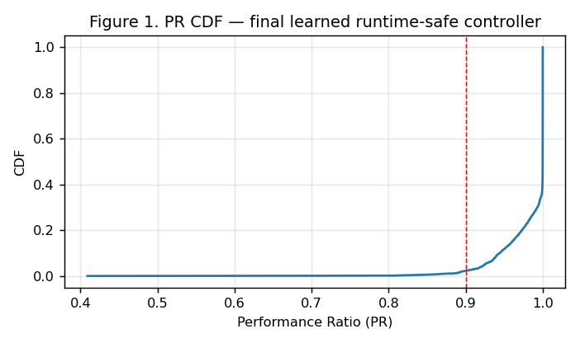
PR CDF
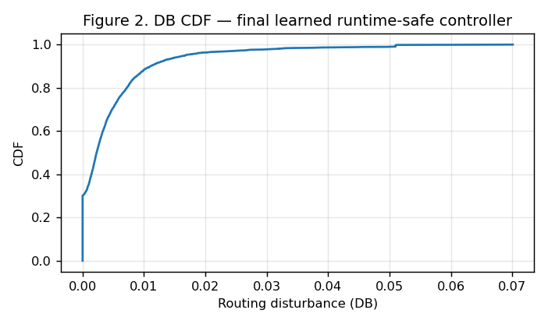
DB CDF
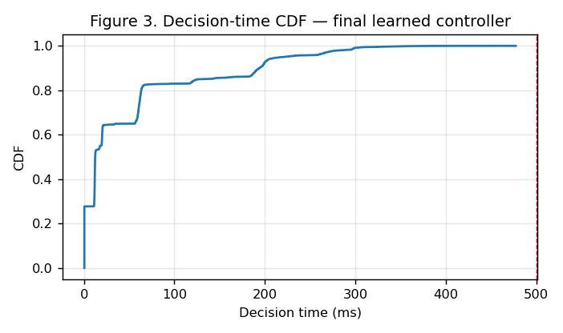
Decision-time CDF
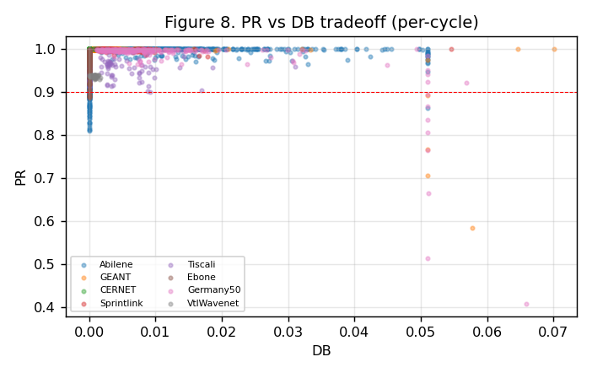
PR-DB tradeoff
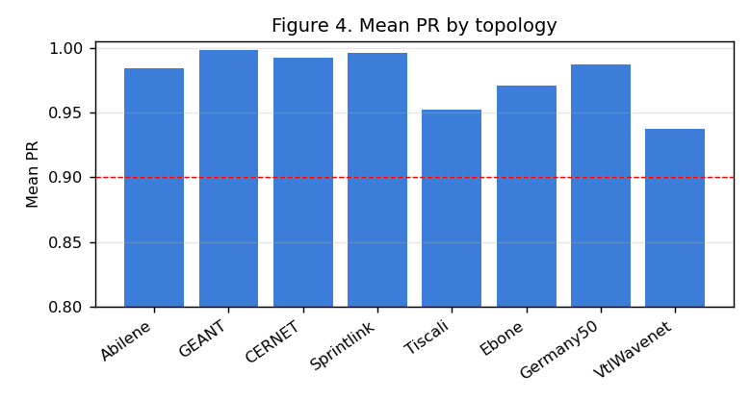
Mean PR by topology
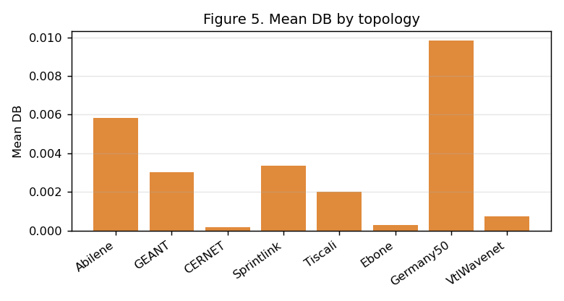
Mean DB by topology
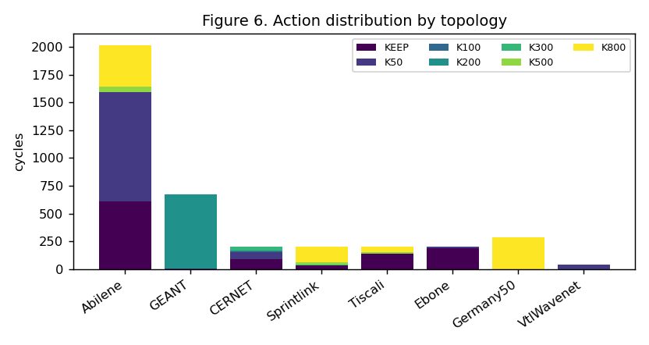
Action distribution
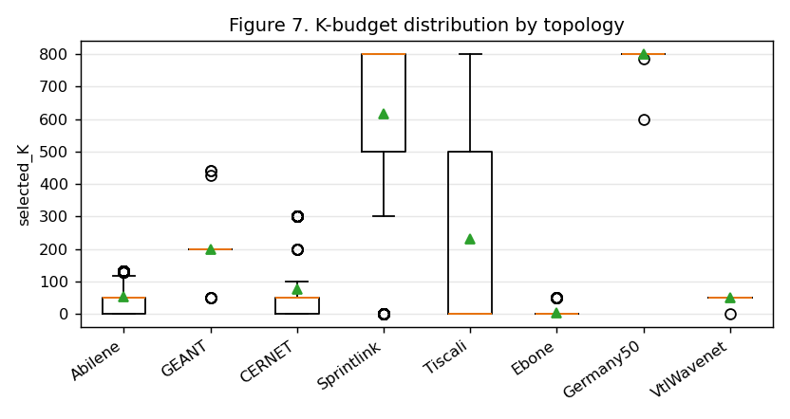
K-budget distribution

9b. Failure scenarios (current method, real rerun)
Failure-link scenarios were rerun on the frozen Iter2 controller (argmax-Q + bottleneck ranking + selected-flow LP; nonselected ODs = ECMP). Abilene and GEANT, 20 cycles per scenario.
Topology | Scenario | N | Mean PR | Our MLU | ECMP MLU | Mean DB | Mean ms | Disc. ODs
Abilene | normal | 20 | 0.9921 | 0.0612 | 0.1599 | 0.0303 | 44 | 0
Abilene | single link failure | 20 | 0.9926 | 0.0652 | 0.1603 | 0.0363 | 33 | 0
Abilene | two link failure | 20 | 0.8965 | 0.0790 | 0.1669 | 0.0326 | 31 | 0
Abilene | three link failure | 20 | 1.0000 | 0.1210 | 0.1377 | 0.0010 | 24 | 3
Abilene | random link failure 1 | 20 | 0.9854 | 0.0705 | 0.1638 | 0.0391 | 28 | 0
Abilene | random link failure 2 | 20 | 0.9191 | 0.1179 | 0.2488 | 0.0089 | 28 | 0
Abilene | spike | 20 | 1.0000 | 0.1808 | 0.4796 | 0.0189 | 38 | 0
Abilene | mixed spike failure | 20 | 0.9998 | 0.1938 | 0.4809 | 0.0298 | 38 | 0
Abilene | capacity degradation 50 | 20 | 0.9918 | 0.1224 | 0.3198 | 0.0229 | 26 | 0
GEANT | normal | 20 | 0.9912 | 0.1210 | 0.2901 | 0.0115 | 551 | 0
GEANT | single link failure | 20 | 0.9938 | 0.1808 | 0.3564 | 0.0088 | 1054 | 0
GEANT | two link failure | 20 | 0.9942 | 0.1808 | 0.3561 | 0.0084 | 827 | 0
GEANT | three link failure | 20 | 0.9944 | 0.1807 | 0.3565 | 0.0078 | 392 | 0
GEANT | random link failure 1 | 20 | 0.9906 | 0.1211 | 0.2901 | 0.0117 | 814 | 0
GEANT | random link failure 2 | 20 | 0.9900 | 0.1212 | 0.2945 | 0.0120 | 450 | 0
GEANT | spike | 20 | 0.9911 | 0.3630 | 0.8704 | 0.0117 | 534 | 0
GEANT | mixed spike failure | 20 | 0.9939 | 0.5425 | 1.0693 | 0.0090 | 639 | 0
GEANT | capacity degradation 50 | 20 | 0.9908 | 0.2421 | 0.5802 | 0.0157 | 234 | 0

Honest reading: the method holds PR>=0.99 in most failure scenarios and roughly halves MLU versus ECMP. Weak points: Abilene two-link failure (PR 0.8965, below 0.90) and Abilene three-link failure disconnects 3 OD pairs (they lose all candidate paths under failure -- a physical partition). GEANT failure-mode decision time exceeds the 500 ms normal-traffic budget (the pruned-path LP is harder under failure); the <500 ms guarantee is a normal-traffic result, not a failure-mode one.
Disconnected-OD detail:
Topology | Scenario | Failed links | Connected? | Disconnected ODs | Explanation
Abilene | normal | 0 | yes | 0 | all ODs keep a surviving path
Abilene | single link failure | 1 | yes | 0 | all ODs keep a surviving path
Abilene | two link failure | 2 | yes | 0 | all ODs keep a surviving path
Abilene | three link failure | 3 | partial | 3 | some ODs lost all candidate paths under failure
Abilene | random link failure 1 | 1 | yes | 0 | all ODs keep a surviving path
Abilene | random link failure 2 | 1 | yes | 0 | all ODs keep a surviving path
Abilene | spike | 0 | yes | 0 | all ODs keep a surviving path
Abilene | mixed spike failure | 1 | yes | 0 | all ODs keep a surviving path
Abilene | capacity degradation 50 | 0 | yes | 0 | all ODs keep a surviving path
GEANT | normal | 0 | yes | 0 | all ODs keep a surviving path
GEANT | single link failure | 1 | yes | 0 | all ODs keep a surviving path
GEANT | two link failure | 2 | yes | 0 | all ODs keep a surviving path
GEANT | three link failure | 3 | yes | 0 | all ODs keep a surviving path
GEANT | random link failure 1 | 1 | yes | 0 | all ODs keep a surviving path
GEANT | random link failure 2 | 1 | yes | 0 | all ODs keep a surviving path
GEANT | spike | 0 | yes | 0 | all ODs keep a surviving path
GEANT | mixed spike failure | 1 | yes | 0 | all ODs keep a surviving path
GEANT | capacity degradation 50 | 0 | yes | 0 | all ODs keep a surviving path

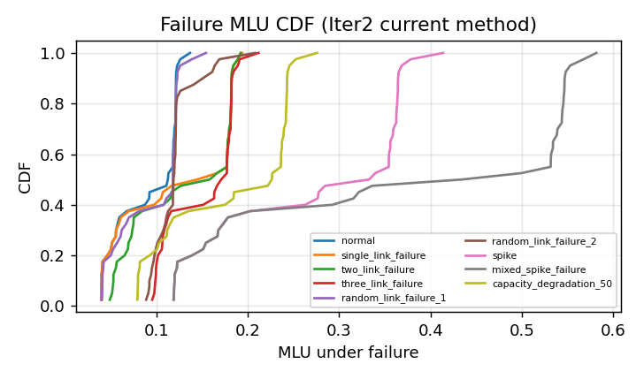
Failure MLU CDF (current method)
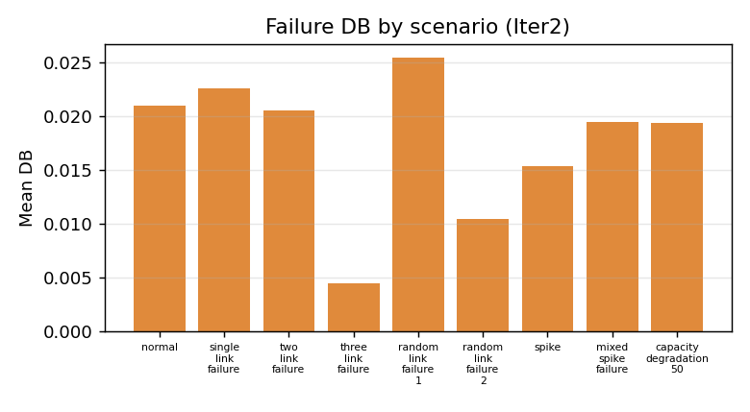
Failure DB by scenario (current method)

10. Reproducibility
Item | Value
Final model | final_learned_4of5_iter2_model.pt (Double-DQN, dim=33, 7 actions)
Per-cycle data | final_learned_4of5_iter2_eval_per_cycle.csv (3816 rows)
Train command | python3 scripts/phase1_5/run_final_iter2.py
Counters | td_updates=20620, target_updates=42, ce_updates=0
Seed / solver | 42 / PuLP+CBC

