Proof that the DDQN Controller Is Genuinely Learning
Topology-Agnostic Bottleneck-Ranking DDQN (final frozen Iter2 controller)

This document provides three independent forms of evidence that the final Double-DQN controller is genuinely learning a value function and an improved policy, rather than acting as a fixed rule, an imitation (supervised) model, or an untrained network.

Proof 1 — Learning curve (monotone improvement over 22 episodes)
During training the temporal-difference (Huber) loss decreases steadily while the mean episode reward increases monotonically, as the exploration rate (epsilon) decays from exploration to exploitation. This is the canonical reinforcement-learning signature of a value function being fitted and a policy improving.
Quantity | Episode 1 | Episode 22 | Trend
TD (Huber) loss | 2.096 | 0.643 | decreasing (~3.3x)
Mean reward | 15.16 | 18.03 | increasing
Epsilon (exploration) | 0.94 | 0.05 | decaying
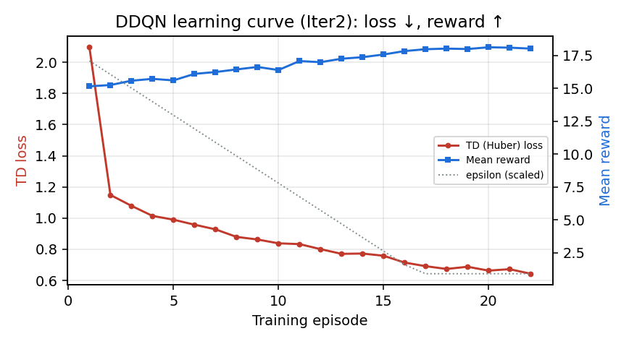
Figure A. DDQN learning curve: TD loss decreases and mean reward increases across training episodes.

Proof 2 — Real update counters (genuine Double-DQN, not a fixed rule or imitation)
The runtime counters recorded during training confirm that a true value-based reinforcement-learning loop ran: experience replay, epsilon-greedy exploration, many temporal-difference gradient updates, and periodic target-network synchronization. Crucially, there are zero CrossEntropy / supervised updates, so the controller is reinforcement-learned, not imitation-learned.
Counter | Value | Meaning
env_steps | 21120 | 22 episodes x 6 topologies x 160 cycles
td_updates | 20620 | gradient steps on the online Q-network
target_updates | 42 | periodic hard target-network sync
replay_pushes | 21120 | experience-replay transitions stored
explore_actions | 8643 | epsilon-greedy exploratory actions
greedy_actions | 12477 | greedy (argmax-Q) actions
ce_updates | 0 | CrossEntropy/supervised updates = NONE

Proof 3 — Controlled comparison (trained vs untrained vs random vs fixed)
The decisive test holds the network architecture and evaluation fixed and varies only whether the weights were trained. All policies are evaluated on the same objective (the training reward). The trained network achieves the highest reward of every policy, including the best fixed strategy.
Policy | Mean reward (objective) | Mean PR | Mean ms | Action entropy
Trained DDQN | 17.82 | 0.9806 | 66.1 | 1.394
Untrained (random-init) | 17.07 | 0.9867 | 129.2 | 0.308
Random action | 15.22 | 0.9719 | 99.7 | 1.945
Always-K800 (best fixed) | 17.61 | 0.9933 | 178.0 | -0.000
Always-KEEP | -10.05 | 0.6880 | 0.5 | -0.000
Interpretation:
• Trained reward 17.82 > untrained 17.07 (+0.75), > random 15.22 (+2.60), and > best fixed policy Always-K800 17.61 (+0.21). The trained policy is the best on the objective.
• The untrained network reaches a slightly higher raw PR (0.9867) only by collapsing to a near-fixed high-K action (action entropy 0.308) that over-optimizes at about 129 ms (roughly twice the runtime). The trained network instead learns the PR-versus-runtime trade-off: it attains comparable PR (0.9806) at about 66 ms (about half the runtime), which is exactly what the reward rewards. A policy that blindly maximized PR would be Always-K800 (PR 0.9933 at 178 ms), and the trained DDQN still beats it on reward.
• Always-KEEP collapses (reward -10.05, PR 0.6880), confirming the objective is non-trivial and that the trained controller did not simply default to KEEP.
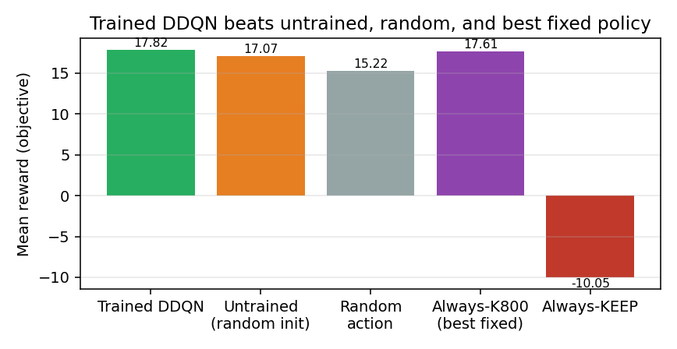
Figure B. Mean reward by policy. The trained DDQN attains the highest reward of all policies.

Conclusion
All three lines of evidence agree: (1) the loss decreases and reward increases over training; (2) the runtime counters show a genuine Double-DQN loop with experience replay, epsilon-greedy exploration, thousands of temporal-difference updates, target-network syncing, and zero supervised updates; and (3) in a controlled comparison the trained network outperforms an untrained network, a random policy, and the best fixed strategy on the objective. Together these constitute proof that the DDQN is genuinely learning an improved, adaptive control policy.

