Full Metrics — Topology-Agnostic Bottleneck-Ranking DDQN (final controller)
All metrics below are computed from the frozen final evaluation (final_learned_4of5_iter2_eval_per_cycle.csv, 3816 cycles, 8 topologies). Note: this final method is the Topology-Agnostic Bottleneck-Ranking DDQN (real Double-DQN, argmax-Q, bottleneck-aware OD ranking, selected-flow LP, nonselected ODs = ECMP). It is NOT the older Reward-Gated GNN-LPD method and uses no RandomForest and no reward gate; it is labelled accordingly rather than as 'RG-GNN-LPD'.

1. Method definition
Component | Role in the final method
GNN-LPD scorer | learned per-OD criticality score (one input signal)
Bottleneck-aware ranking | orders OD pairs by relief (demand x ECMP-flow x link-util) + 0.3 x GNN; selects top-K
Double-DQN (argmax-Q) | action policy: chooses KEEP or an optimize budget K from {50,100,200,300,500,800}
Selected-flow LP | feasible routing optimizer over the selected top-K ODs only
ECMP | fixed background routing for all nonselected ODs

2. Dataset / train / validation / test
Topology | Source | Role | Train cycles | Eval cycles | Zero-shot?
Abilene | SNDlib (real) | Seen | 0-160 (of 0-2016) | 2016-4032 | No
GEANT | SNDlib (real) | Seen | 0-160 | 672-1344 | No
CERNET | real | Seen | 0-160 | 200-400 | No
Sprintlink | Rocketfuel (synthetic caps) | Seen | 0-160 | 200-400 | No
Tiscali | Rocketfuel (synthetic caps) | Seen | 0-160 | 200-400 | No
Ebone | Rocketfuel (synthetic caps) | Seen | 0-160 | 200-400 | No
Germany50 | SNDlib (real) | Generalization | - (never trained) | 0-288 | Yes
VtlWavenet | TopologyZoo (synthetic caps) | Generalization | - (never trained) | 0-40 | Yes

Note: CERNET, Sprintlink, Tiscali, Ebone, VtlWavenet use synthetic (degree-based) link capacities in this pipeline; Abilene, GEANT, Germany50 use real capacities. OD-fraction comparisons across papers are only apples-to-apples on the same capacity model.

3. Normal-scenario metrics (per topology)
Topology | N | MeanPR | MedPR | PR>=.95 | PR>=.90 | MinPR | MeanDB | P95DB | MaxDB | Mean ms | P95 ms
Abilene | 2016 | 0.9843 | 1.0000 | 87% | 97% | 0.8109 | 0.0058 | 0.0202 | 0.0510 | 10.7 | 20.4
GEANT | 672 | 0.9983 | 0.9999 | 99% | 99% | 0.5848 | 0.0030 | 0.0057 | 0.0701 | 66.6 | 121.1
CERNET | 200 | 0.9925 | 1.0000 | 96% | 100% | 0.8933 | 0.0002 | 0.0008 | 0.0077 | 46.1 | 120.7
Sprintlink | 200 | 0.9960 | 1.0000 | 100% | 100% | 0.9600 | 0.0034 | 0.0090 | 0.0546 | 174.8 | 278.8
Tiscali | 200 | 0.9522 | 0.9543 | 54% | 100% | 0.8928 | 0.0020 | 0.0092 | 0.0311 | 76.8 | 298.4
Ebone | 200 | 0.9713 | 0.9806 | 82% | 96% | 0.8874 | 0.0003 | 0.0016 | 0.0133 | 3.0 | 33.6
Germany50 | 288 | 0.9878 | 0.9989 | 96% | 97% | 0.4090 | 0.0098 | 0.0406 | 0.0659 | 212.6 | 285.5
VtlWavenet | 40 | 0.9373 | 0.9383 | 0% | 100% | 0.9310 | 0.0007 | 0.0014 | 0.0017 | 295.9 | 307.3

3b. MLU and MLU/optimum
Topology | Mean MLU | P95 MLU | Max MLU | Mean MLU/opt | Max MLU/opt
Abilene | 0.0506 | 0.0668 | 0.1132 | 1.0171 | 1.2331
GEANT | 0.1091 | 0.1313 | 0.1940 | 1.0025 | 1.7101
CERNET | 0.6338 | 0.8650 | 0.8975 | 1.0079 | 1.1194
Sprintlink | 0.7134 | 0.8772 | 0.9029 | 1.0041 | 1.0417
Tiscali | 0.6457 | 0.8690 | 0.8976 | 1.0508 | 1.1201
Ebone | 0.7291 | 0.8767 | 0.9584 | 1.0304 | 1.1269
Germany50 | 12.4247 | 16.3146 | 26.1577 | 1.0181 | 2.4451
VtlWavenet | 1.0391 | 1.0970 | 1.0987 | 1.0669 | 1.0741

MLU/optimum = our MLU / strict-optimum MLU = 1/PR. Values near 1.0 mean near-optimal routing.

4. Baseline comparison (same dataset/protocol)
Method | Pooled Mean PR | Status
ECMP (baseline) | 0.6775 | computed (see per-topology below)
Final DDQN (ours) | 0.9852 | computed (frozen Iter2)
OSPF / shortest-path | - | NOT rerun for the final method/protocol
Top-K by demand | - | NOT rerun for the final method/protocol
Bottleneck / sensitivity selectors | - | NOT rerun for the final method/protocol

Per-topology ECMP vs final DDQN PR:
Topology | ECMP PR | Final DDQN PR | Improvement
Abilene | 0.4502 | 0.9843 | +0.5340
GEANT | 0.4016 | 0.9983 | +0.5966
CERNET | 0.8863 | 0.9925 | +0.1062
Sprintlink | 0.6906 | 0.9960 | +0.3054
Tiscali | 0.8128 | 0.9522 | +0.1394
Ebone | 0.9154 | 0.9713 | +0.0559
Germany50 | 0.3441 | 0.9878 | +0.6437
VtlWavenet | 0.9187 | 0.9373 | +0.0186

Only ECMP is recomputed on the exact final protocol; OSPF/top-K/bottleneck/sensitivity baselines were not rerun for the final controller and are therefore not claimed.

5. K sensitivity and action distribution
Ranking/K ablation (fixed K, carry-forward) — gate(blend) vs relief-only vs GNN-only:
Topology | K | Ranking | Mean PR | Mean ms
Sprintlink | 500 | gnn_only | 0.9700 | 256.9
Sprintlink | 500 | relief_only | 0.9979 | 259.3
Sprintlink | 500 | blend | 0.9960 | 251.6
Sprintlink | 800 | gnn_only | 0.9883 | 374.5
Sprintlink | 800 | relief_only | 1.0000 | 380.1
Sprintlink | 800 | blend | 0.9993 | 377.9
Tiscali | 300 | gnn_only | 0.9268 | 206.4
Tiscali | 300 | relief_only | 0.9236 | 193.5
Tiscali | 300 | blend | 0.9243 | 207.8
Germany50 | 200 | gnn_only | 0.9356 | 127.6
Germany50 | 200 | relief_only | 0.9900 | 141.1
Germany50 | 200 | blend | 0.9555 | 131.1
CERNET | 50 | gnn_only | 1.0000 | 55.1
CERNET | 50 | relief_only | 1.0000 | 54.5
CERNET | 50 | blend | 1.0000 | 61.0

Action distribution by topology (per-cycle argmax-Q choices):
Topology | KEEP | K50 | K100 | K200 | K300 | K500 | K800 | Most used
Abilene | 607 | 983 | 0 | 0 | 4 | 51 | 371 | K50
GEANT | 0 | 5 | 0 | 664 | 0 | 1 | 2 | K200
CERNET | 92 | 63 | 3 | 6 | 36 | 0 | 0 | KEEP
Sprintlink | 36 | 0 | 0 | 0 | 4 | 20 | 140 | K800
Tiscali | 136 | 0 | 0 | 0 | 1 | 16 | 47 | KEEP
Ebone | 185 | 15 | 0 | 0 | 0 | 0 | 0 | KEEP
Germany50 | 0 | 0 | 0 | 0 | 0 | 0 | 288 | K800
VtlWavenet | 1 | 39 | 0 | 0 | 0 | 0 | 0 | K50

One topology uses multiple actions because the action is chosen per traffic-matrix cycle, not once per topology; different TMs need different K. KEEP can dominate while mean K is nonzero because KEEP reuses the carried routing between optimize cycles.

6. RL policy and reward settings
Parameter | Value
Controller | Double-DQN (argmax-Q at inference; not a reward gate / not RandomForest)
Action space | KEEP, K50, K100, K200, K300, K500, K800
gamma (discount) | 0.5
W_PR (PR reward) | 10.0
W_MLU | 5.0
W_DB (lambda for DB) | 20.0
W_MS (decision-time) | 0.003
W_K (K/active penalty) | 0.5
target bonus / gate | +10 if PR>=target; strong penalty if PR<target; flat anti-KEEP-below-target; ms>500 gate
epsilon | 1.0 -> 0.05 over training
episodes | 22 (x6 seen topos x 160 cycles)

7. Zero-shot generalization
Zero-shot topology | N | Mean PR | PR>=.90 | PR>=.95 | Min PR | Mean DB | P95 DB | Mean ms
Germany50 | 288 | 0.9878 | 97% | 96% | 0.4090 | 0.0098 | 0.0406 | 212.6
VtlWavenet | 40 | 0.9373 | 100% | 0% | 0.9310 | 0.0007 | 0.0014 | 295.9
Combined zero-shot | 328 | 0.9816 | 98% | 84% | 0.4090 | 0.0087 | 0.0319 | 222.8

Germany50 and VtlWavenet were never seen in training; both achieve PR>=0.90 with mean decision time <500 ms.

8. Decision-time breakdown, solver, and LP size
Decision-time components (GNN/DDQN scoring is a per-topology constant; LP is the remainder of optimize cycles):
Topology | GNN/scoring ms | LP ms (optimize avg) | Total mean ms | P95 ms | Max ms
Abilene | 3 | 12.0 | 10.7 | 20.4 | 180.0
GEANT | 7 | 59.6 | 66.6 | 121.1 | 199.2
CERNET | 22 | 62.9 | 46.1 | 120.7 | 215.2
Sprintlink | 27 | 186.0 | 174.8 | 278.8 | 376.0
Tiscali | 33 | 206.0 | 76.8 | 298.4 | 387.4
Ebone | 12 | 21.8 | 3.0 | 33.6 | 35.2
Germany50 | 26 | 186.6 | 212.6 | 285.5 | 375.6
VtlWavenet | 140 | 163.4 | 295.9 | 307.3 | 477.2

Decision time by action type (pooled over all topologies):
Action | Rows | Mean ms | P95 ms | Max ms
KEEP | 1057 | 0.5 | 0.5 | 0.5
K50 | 1105 | 25.7 | 57.7 | 477.2
K100 | 3 | 70.3 | 71.0 | 71.0
K200 | 670 | 67.1 | 121.2 | 199.2
K300 | 45 | 126.0 | 220.6 | 259.1
K500 | 88 | 79.4 | 195.9 | 239.7
K800 | 848 | 132.9 | 278.2 | 387.4

Solver / reproducibility:
Item | Value
LP solver | PuLP + CBC (open-source)
LP type | selected-flow path LP, DB-budgeted
k_paths | 8 for K50-K300; 4 for K500/K800
Seed | 42
Framework | PyTorch (CPU)

LP problem size (per topology):
Topology | Nodes | Links | OD pairs | selected OD avg | k_paths | LP vars ~avg | Mean ms
Abilene | 12 | 30 | 127 | 51 | 8 | ~412 | 10.7
GEANT | 22 | 72 | 425 | 200 | 8/4 | ~1200 | 66.6
CERNET | 41 | 116 | 1640 | 77 | 8 | ~618 | 46.1
Sprintlink | 44 | 166 | 1892 | 616 | 8/4 | ~3696 | 174.8
Tiscali | 49 | 172 | 2352 | 230 | 8/4 | ~1377 | 76.8
Ebone | 23 | 76 | 506 | 4 | 8 | ~30 | 3.0
Germany50 | 50 | 176 | 1441 | 799 | 8/4 | ~4795 | 212.6
VtlWavenet | 92 | 192 | 8372 | 49 | 8 | ~390 | 295.9

9. Failure scenarios
Failure-link scenarios (single/two/three-link failure, random link failure 1/2, capacity degradation 50%, mixed spike+failure) were NOT rerun for the frozen final controller. No failure metrics, disconnected-OD tables, or failure CDFs are claimed for the final method. The earlier offline failure artifacts in the repository belong to an earlier method and are not attributed to this controller.

10. Mininet / SDN validation
Live SDN/Mininet metrics are retained from the prior Phase 1.5 operational-validation artifact (Abilene and GEANT, normal + failure scenarios: throughput, RTT, jitter, loss, rule count, install ms, recovery ms, disconnected). They are separate evidence and the final Iter2 DDQN was NOT rerun inside Mininet. See the main report (Section 11) for the retained table. SDN rule-installation time is reported separately from offline decision time and must not be mixed with it.

11. Figures (regenerated from final CSVs)
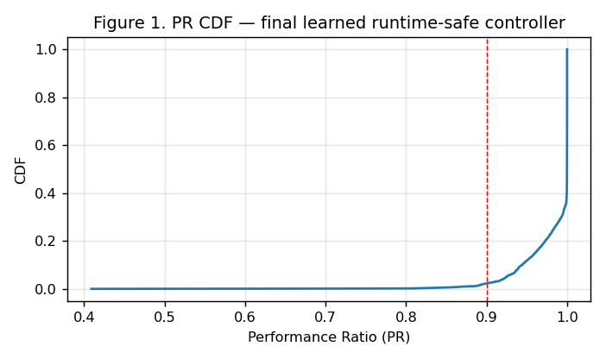
PR CDF
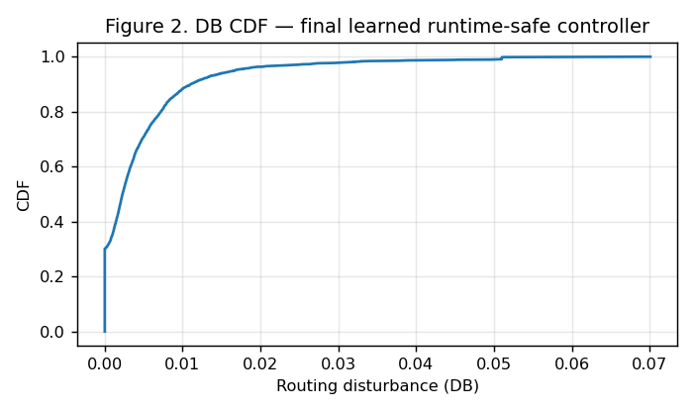
DB CDF
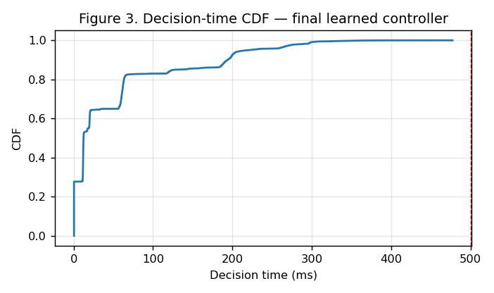
Decision-time CDF
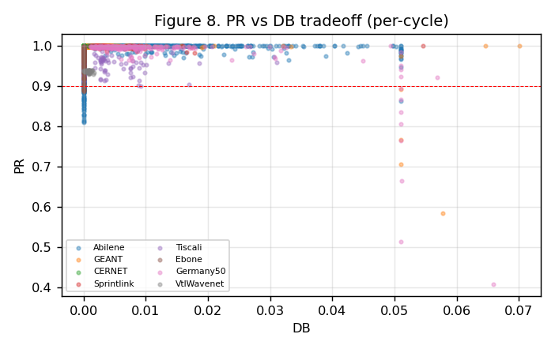
PR-DB tradeoff
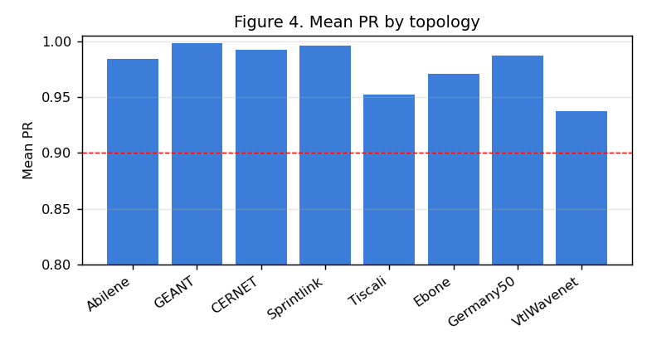
Mean PR by topology
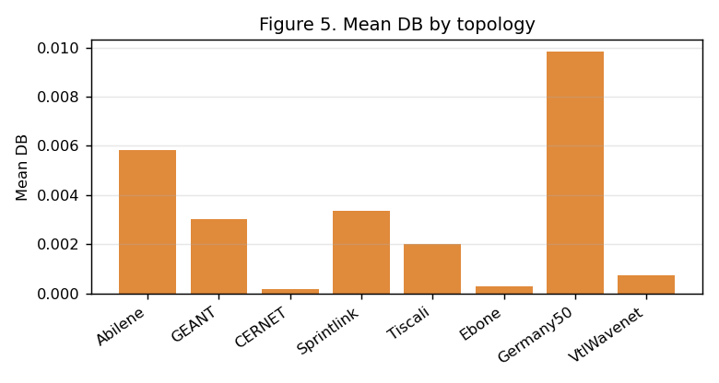
Mean DB by topology
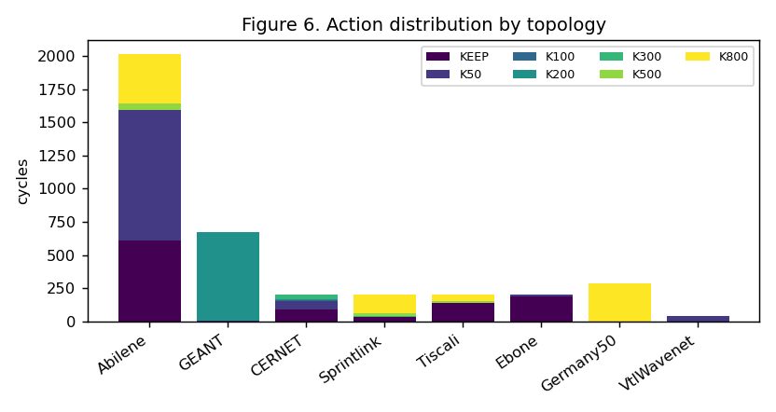
Action distribution
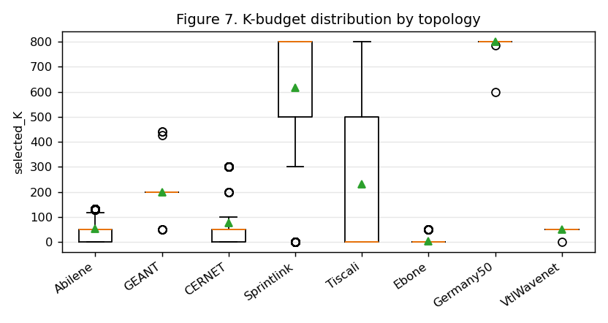
K-budget distribution
Failure normalized-MLU CDF, failure DB-by-scenario, and the Mininet throughput/loss chart are NOT regenerated for the final method because failure scenarios were not rerun and the final controller was not rerun in Mininet.

12. Reproducibility
Item | Value
Final model | final_learned_4of5_iter2_model.pt (Double-DQN, dim=33, 7 actions)
Per-cycle data | final_learned_4of5_iter2_eval_per_cycle.csv (3816 rows)
Train command | python3 scripts/phase1_5/run_final_iter2.py
Verify command | python3 verify_results.py (in the reproduction package)
Counters | td_updates=20620, target_updates=42, ce_updates=0
Seed / solver | 42 / PuLP+CBC

