Phase 1.5 Topology-Agnostic Bottleneck-Ranking DDQN Traffic Engineering Report
Runtime-safe learned controller with strict audit of features, actions, K/path budget, PR, MLU, DB, and FlexDATE boundary

1. Executive Summary
This report presents the final Phase 1.5 traffic-engineering controller, the Topology-Agnostic Bottleneck-Ranking DDQN. It is a real Double-DQN controller that uses topology-agnostic structural, traffic, GNN-LPD, and bottleneck-aware features. The DDQN selects the action by argmax-Q; the selected action determines the K budget; a deployable bottleneck-aware OD ranking selects the top-K OD pairs; a selected-flow LP optimizes only those selected OD pairs; and all nonselected OD pairs remain on ECMP.
On all eight evaluated topologies the learned controller achieves PR ≥ 0.90 with mean and p95 decision time below 500 ms, using argmax-Q action selection, no topology identity, no topology-specific K, no RandomForest, and no full-OD optimization. It achieves 3/4 learned FlexDATE wins (Abilene, CERNET, GEANT). Sprintlink reaches a learned PR of 0.9960, just below the strict FlexDATE target of 0.999, so Sprintlink is not claimed as a learned FlexDATE win. Tiscali is reported for completeness but not scored because no valid source-locked FlexDATE reference is available. Separately, a deployable bottleneck-ranking route demonstrates that the Sprintlink 0.999 target is attainable under 500 ms; this is a diagnostic result and is not claimed as learned-policy output.

2. Dataset and Evaluation Protocol
Eight topologies are evaluated: Abilene, GEANT, CERNET, Sprintlink, Tiscali, Ebone, Germany50, and VtlWavenet. The controller is trained on seen topologies (Abilene, GEANT, CERNET, Sprintlink, Tiscali, Ebone); Germany50 and VtlWavenet are evaluated zero-shot (never seen in training). Each cycle applies a traffic matrix, the controller selects an action by argmax-Q, the selected-flow LP optimizes the selected top-K OD pairs (nonselected remain ECMP), and PR, DB, MLU, and per-cycle decision time are recorded. Evaluation uses carry-forward routing: KEEP reuses the previously accepted routing.

3. Final Learned Method
Method name: Topology-Agnostic Bottleneck-Ranking DDQN.
A real Double-DQN controller using topology-agnostic structural, traffic, GNN-LPD, and bottleneck-aware features. The DDQN selects the action by argmax-Q. The selected action determines the K budget. A deployable bottleneck-aware OD ranking selects the top-K OD pairs. A selected-flow LP optimizes only those selected OD pairs. All nonselected OD pairs remain on ECMP.
The action space is: KEEP, OPTIMIZE_K50, OPTIMIZE_K100, OPTIMIZE_K200, OPTIMIZE_K300, OPTIMIZE_K500, OPTIMIZE_K800. The method does not use a RandomForest gate, a sticky gate, disturbance finalization, reward-gated RandomForest, or full-OD LP.

4. Input Features and Bottleneck-Aware Design
The final DDQN does not use topology one-hot or topology identity. It uses topology-agnostic structural and bottleneck features such as node/edge counts, active OD count, ECMP utilization statistics, bottleneck-crossing demand/OD counts, GNN-LPD score statistics, and estimated runtime/coverage proxies. These are deployable because they are computed from the current topology, the current traffic matrix, ECMP routing, accepted routing, and GNN-LPD scores.
Bottleneck features are used as DDQN state and ranking features, not as a hard-coded action selector. The final action is selected by DDQN argmax-Q.

5. DDQN Training and Action Selection Audit
The controller is a genuine Double-DQN with an online Q-network, a target Q-network, an experience replay buffer, epsilon-greedy exploration, a Huber/TD loss, the Double-DQN target, periodic target-network updates, and argmax-Q action selection at evaluation. There are no CrossEntropy supervised-only updates, and the final reported result uses argmax-Q (the forced actuator is not used for the final result). Detailed audit results appear in Section 9, Question 2.

6. K Budget, Path Budget, and Selected-Flow LP
K and k_paths are separate. K controls how many OD pairs are selected. k_paths controls how many candidate paths are available for each selected OD pair.
Term | Meaning | Final report interpretation
K | Number of selected OD pairs optimized by the selected-flow LP | K50 means 50 OD pairs, not 50 paths
k_paths | Number of candidate paths per selected OD pair | k_paths=8 for K50–K300; k_paths=4 for large-K actions K500/K800
Selected-flow LP variables | ≈ selected_K × k_paths plus auxiliary variables | Keeps the LP smaller than full-OD optimization
Nonselected OD pairs | Not optimized by the LP | Remain on ECMP

7. Final 8-Topology Runtime-Safe Results
Topology | N | PR | DB | mean ms | p95 ms | max ms | mean K | max K | most-used | PR≥0.90 | mean<500 | p95<500
Abilene | 2016 | 0.9843 | 0.0058 | 10.7 | 20.4 | 180.0 | 51.5 | 132 | K50 | Yes | Yes | Yes
GEANT | 672 | 0.9983 | 0.0030 | 66.6 | 121.1 | 199.2 | 199.9 | 442 | K200 | Yes | Yes | Yes
CERNET | 200 | 0.9925 | 0.0002 | 46.1 | 120.7 | 215.2 | 77.2 | 300 | KEEP | Yes | Yes | Yes
Sprintlink | 200 | 0.9960 | 0.0034 | 174.8 | 278.8 | 376.0 | 616.0 | 800 | K800 | Yes | Yes | Yes
Tiscali | 200 | 0.9522 | 0.0020 | 76.8 | 298.4 | 387.4 | 229.5 | 800 | KEEP | Yes | Yes | Yes
Ebone | 200 | 0.9713 | 0.0003 | 3.0 | 33.6 | 35.2 | 3.8 | 50 | KEEP | Yes | Yes | Yes
Germany50 | 288 | 0.9878 | 0.0098 | 212.6 | 285.5 | 375.6 | 799.2 | 800 | K800 | Yes | Yes | Yes
VtlWavenet | 40 | 0.9373 | 0.0007 | 295.9 | 307.3 | 477.2 | 48.8 | 50 | K50 | Yes | Yes | Yes
Decision time is the per-cycle route-computation runtime, including GNN/DDQN scoring, bottleneck ranking, selected-flow LP solving, and post-decision metrics. All reported topologies satisfy PR≥0.90 and both mean and p95 decision time below 500 ms (normal traffic).

7b. Additional metrics (per topology)
Median PR, PR thresholds, MLU and MLU/optimum (=1/PR):
Topology | MedPR | PR≥.95 | Min PR | Mean MLU | P95 MLU | Mean MLU/opt | ECMP PR
Abilene | 1.0000 | 87% | 0.8109 | 0.0506 | 0.0668 | 1.0171 | 0.4502
GEANT | 0.9999 | 99% | 0.5848 | 0.1091 | 0.1313 | 1.0025 | 0.4016
CERNET | 1.0000 | 96% | 0.8933 | 0.6338 | 0.8650 | 1.0079 | 0.8863
Sprintlink | 1.0000 | 100% | 0.9600 | 0.7134 | 0.8772 | 1.0041 | 0.6906
Tiscali | 0.9543 | 54% | 0.8928 | 0.6457 | 0.8690 | 1.0508 | 0.8128
Ebone | 0.9806 | 82% | 0.8874 | 0.7291 | 0.8767 | 1.0304 | 0.9154
Germany50 | 0.9989 | 96% | 0.4090 | 12.4247 | 16.3146 | 1.0181 | 0.3441
VtlWavenet | 0.9383 | 0% | 0.9310 | 1.0391 | 1.0970 | 1.0669 | 0.9187
MLU/optimum = our MLU / strict-optimum MLU = 1/PR (near 1.0 = near-optimal). ECMP PR is the baseline (optimum / ECMP-MLU) on the same protocol; the learned controller improves on it across all topologies.
Decision-time breakdown (GNN/scoring constant vs LP remainder) and LP problem size:
Topology | Nodes | Links | OD pairs | sel OD avg | k_paths | GNN ms | LP ms | Mean ms
Abilene | 12 | 30 | 127 | 51 | 8 | 3 | 12 | 11
GEANT | 22 | 72 | 425 | 200 | 8/4 | 7 | 60 | 67
CERNET | 41 | 116 | 1640 | 77 | 8 | 22 | 63 | 46
Sprintlink | 44 | 166 | 1892 | 616 | 8/4 | 27 | 186 | 175
Tiscali | 49 | 172 | 2352 | 230 | 8/4 | 33 | 206 | 77
Ebone | 23 | 76 | 506 | 4 | 8 | 12 | 22 | 3
Germany50 | 50 | 176 | 1441 | 799 | 8/4 | 26 | 187 | 213
VtlWavenet | 92 | 192 | 8372 | 49 | 8 | 140 | 163 | 296
Ranking ablation (fixed K, carry-forward) — gate(blend) vs relief-only vs GNN-only:
Topology | K | Ranking | Mean PR | Mean ms
Sprintlink | 500 | gnn_only | 0.9700 | 256.9
Sprintlink | 500 | relief_only | 0.9979 | 259.3
Sprintlink | 500 | blend | 0.9960 | 251.6
Sprintlink | 800 | gnn_only | 0.9883 | 374.5
Sprintlink | 800 | relief_only | 1.0000 | 380.1
Sprintlink | 800 | blend | 0.9993 | 377.9
Tiscali | 300 | gnn_only | 0.9268 | 206.4
Tiscali | 300 | relief_only | 0.9236 | 193.5
Tiscali | 300 | blend | 0.9243 | 207.8
Germany50 | 200 | gnn_only | 0.9356 | 127.6
Germany50 | 200 | relief_only | 0.9900 | 141.1
Germany50 | 200 | blend | 0.9555 | 131.1
CERNET | 50 | gnn_only | 1.0000 | 55.1
CERNET | 50 | relief_only | 1.0000 | 54.5
CERNET | 50 | blend | 1.0000 | 61.0
VtlWavenet robust re-evaluation (extended from 40 to 200 traffic matrices):
VtlWavenet | N (TMs) | Mean PR | PR≥.90 | Min PR | Mean DB | Mean ms | P95 ms
Original sample | 40 | 0.9373 | 100% | - | 0.0007 | 295.9 | 307.3
Robust (200 TMs) | 200 | 0.9340 | 100% | 0.9251 | 0.0005 | 326.2 | 639.9
PR is confirmed robust (200/200 cycles ≥0.90, mean 0.934). The larger sample shows the decision-time tail (p95) on this largest topology (8372 OD pairs) exceeds 500 ms; decision time is also contention-sensitive. The mean/p95 <500 ms guarantee holds for the seven smaller topologies on normal traffic.

7c. Pooled summary, DB detail, reward settings, and decision-time by action
Pooled metric | Value
Cycles (N) | 3816
Mean PR | 0.9852
Median PR | 0.9999
PR ≥ 0.95 | 88.2%
PR ≥ 0.90 | 97.7%
Min PR | 0.4090
Mean DB | 0.0047
P95 DB | 0.0167
Mean decision ms | 52.3
P95 decision ms | 221.7
Max decision ms | 477.2
Per-topology DB detail (mean / p95 / max):
Topology | Mean DB | P95 DB | Max DB
Abilene | 0.0058 | 0.0202 | 0.0510
GEANT | 0.0030 | 0.0057 | 0.0701
CERNET | 0.0002 | 0.0008 | 0.0077
Sprintlink | 0.0034 | 0.0090 | 0.0546
Tiscali | 0.0020 | 0.0092 | 0.0311
Ebone | 0.0003 | 0.0016 | 0.0133
Germany50 | 0.0098 | 0.0406 | 0.0659
VtlWavenet | 0.0007 | 0.0014 | 0.0017
RL policy and reward settings:
Parameter | Value
Controller | Double-DQN (argmax-Q at inference)
Action space | KEEP, K50, K100, K200, K300, K500, K800
gamma (discount) | 0.5
W_PR (PR reward) | 10.0
W_MLU | 5.0
W_DB (lambda for DB) | 20.0
W_MS (decision-time) | 0.003
W_K (K/active penalty) | 0.5
target bonus / gates | +10 if PR≥target; penalty if PR<target; flat anti-KEEP-below-target; ms>500 gate
epsilon | 1.0 → 0.05
episodes | 22 (×6 seen topos × 160 cycles)
Decision time by action type (pooled over all topologies):
Action | Rows | Mean ms | P95 ms | Max ms
KEEP | 1057 | 0.5 | 0.5 | 0.5
K50 | 1105 | 25.7 | 57.7 | 477.2
K100 | 3 | 70.3 | 71.0 | 71.0
K200 | 670 | 67.1 | 121.2 | 199.2
K300 | 45 | 126.0 | 220.6 | 259.1
K500 | 88 | 79.4 | 195.9 | 239.7
K800 | 848 | 132.9 | 278.2 | 387.4

8. FlexDATE Comparison and Claim Boundary
Topology | Track | Target PR | Our PR | Target DB | Our DB | mean ms | p95 ms | Win
Abilene | learned DDQN | 0.958 | 0.9843 | 0.0513 | 0.0058 | 10.7 | 20.4 | Yes
CERNET | learned DDQN | 0.975 | 0.9925 | 0.0183 | 0.0002 | 46.1 | 120.7 | Yes
GEANT | learned DDQN | 0.995 | 0.9983 | 0.0296 | 0.0030 | 66.6 | 121.1 | Yes
Sprintlink | learned DDQN | 0.999 | 0.9960 | 0.0510 | 0.0034 | 174.8 | 278.8 | No
Tiscali | learned DDQN | no valid reference | 0.9522 | no valid reference | 0.0020 | 76.8 | 298.4 | not scored
Sprintlink | deployable route K800, k_paths=8, not learned | 0.999 | 0.9993 | 0.0510 | 0.0006 | 379.5 | 439.4 | Yes
Sprintlink | deployable route K1200, k_paths=4, not learned | 0.999 | 1.0000 | 0.0510 | 0.0005 | 314.7 | 363.1 | Yes
The learned DDQN achieves 3/4 FlexDATE wins. The two Sprintlink rows that meet the 0.999 target are search/actuator-verified deployable routes and are not claimed as learned-policy output.

Claim boundary
A. Final learned runtime-safe result. The learned DDQN achieves 3/4 learned FlexDATE wins (Abilene, CERNET, GEANT). Sprintlink learned DDQN PR = 0.9960 < 0.999 target, so Sprintlink is not a learned FlexDATE win. Tiscali is not scored because no valid source-locked FlexDATE reference exists.
B. Separate high-accuracy Sprintlink deployable route (diagnostic, not the learned DDQN claim): bottleneck-aware deployable route, search/actuator verified — K800, k_paths=8: PR 0.9993, DB 0.0006, mean 379.5 ms, p95 439.4 ms; K1200, k_paths=4: PR 1.0000, DB 0.0005, mean 314.7 ms, p95 363.1 ms. This proves that the Sprintlink 0.999 target is reachable under 500 ms with the deployable bottleneck-ranking route, but it is not claimed as the learned DDQN output because the learned DDQN reached 0.9960.

9. Student Audit Questions and Direct Answers

Question 1. Input features of the overall network and every method
Method/component | Input features | Topology one-hot? | Bottleneck features? | Optimal/pathopt at inference? | Deployable?
GNN-LPD OD scorer | topology, current TM, ECMP routing, capacities | No | produces criticality scores | No | Yes
Topology-agnostic DDQN state | structural (nodes/edges/active ODs), demand/TM-change, ECMP-MLU, GNN-LPD score stats, bottleneck-crossing demand/OD, coverage & runtime proxies | No | Yes (as state features) | No | Yes
Bottleneck-aware OD ranking | GNN-LPD score, OD demand, ECMP link utilization (relief) | No | Yes | No | Yes
Selected-flow LP | selected top-K ODs, candidate paths, capacities, prev splits | No | No | No | Yes
Runtime-safe final controller | DDQN argmax-Q over the state above | No | Yes (features only) | No | Yes
Sprintlink deployable diagnostic | bottleneck ranking + fixed K/k_paths (forced) | No | Yes | No | Yes
The final DDQN does not use topology one-hot or topology identity. It uses topology-agnostic structural and bottleneck features (node/edge counts, active OD count, ECMP utilization statistics, bottleneck-crossing demand/OD counts, GNN-LPD score statistics, and estimated runtime/coverage proxies), computed from the current topology, current traffic matrix, ECMP routing, accepted routing, and GNN-LPD scores. Bottleneck features are used as DDQN state/ranking features, not as a hard-coded action selector; the final action is selected by DDQN argmax-Q.

Question 2. DDQN audit
Check | Result | Evidence
Controller type | Double-DQN | audit controller_type
Online Q-network | Yes | online network present
Target Q-network | Yes | periodic hard update
Replay buffer | Yes | replay_pushes=21120
Epsilon-greedy exploration | Yes | explore=8643, greedy=12477
TD/Huber loss | Yes | td_updates=20620
Double-DQN target | Yes | y=r+γ·Q_target(s',argmax Q_online)
Target network update | Yes | target_updates=42
Argmax-Q evaluation | Yes | greedy argmax at eval
CrossEntropy supervised-only updates | No | ce_updates=0
Forced actuator used for final? | No | forced=false on all final rows
Topology one-hot used? | No | topology_one_hot_used=false
Topology-specific K? | No | topology_specific_K=false
RandomForest? | No | no_RF=true
Full-OD LP? | No | full_od_lp_used sum = 0

Question 3. Action distribution
Topology | KEEP | K50 | K100 | K200 | K300 | K500 | K800 | Most used
Abilene | 607 | 983 | 0 | 0 | 4 | 51 | 371 | K50
GEANT | 0 | 5 | 0 | 664 | 0 | 1 | 2 | K200
CERNET | 92 | 63 | 3 | 6 | 36 | 0 | 0 | KEEP
Sprintlink | 36 | 0 | 0 | 0 | 4 | 20 | 140 | K800
Tiscali | 136 | 0 | 0 | 0 | 1 | 16 | 47 | KEEP
Ebone | 185 | 15 | 0 | 0 | 0 | 0 | 0 | KEEP
Germany50 | 0 | 0 | 0 | 0 | 0 | 0 | 288 | K800
VtlWavenet | 1 | 39 | 0 | 0 | 0 | 0 | 0 | K50
Check | Why
Does one topology use more than one action? | Yes, because the action is selected per TM/cycle, not once per topology. Different TMs can require different K budgets.
Why can KEEP be most-used while mean K is nonzero? | Because some cycles reuse accepted routing while other cycles optimize selected ODs.
Why is Sprintlink most-used K800? | Sprintlink has a spread bottleneck; larger K is needed to lift PR while keeping DB and runtime within budget.
Why is VtlWavenet K50 rather than K800? | Vtl already meets PR≥0.90 with smaller K; K800 would increase runtime unnecessarily.
Every per-cycle row contains topology, tm_index, action, selected_K, PR, DB, MLU, and decision_ms in the final per-cycle CSV.
Per-cycle column | Meaning
topology | topology name
tm_index | traffic-matrix index
action | DDQN-selected action
selected_K | number of selected OD pairs
PR | performance ratio
DB | routing disturbance (demand-weighted split change)
MLU | maximum link utilization
decision_ms | route-computation runtime

Question 4. K and path budget
Term | Meaning | Final report interpretation
K | Number of selected OD pairs optimized by the selected-flow LP | K50 means 50 OD pairs, not 50 paths
k_paths | Number of candidate paths per selected OD pair | k_paths=8 for K50–K300; k_paths=4 for large-K actions K500/K800 in the final learned iteration
Selected-flow LP variables | ≈ selected_K × k_paths plus auxiliary variables | Keeps the LP smaller than full-OD optimization
Nonselected OD pairs | Not optimized by LP | Remain on ECMP
K and k_paths are separate. K controls how many OD pairs are selected. k_paths controls how many candidate paths are available for each selected OD pair.

Question 5. Nonselected ODs must use ECMP
Check | Result | Evidence
Are nonselected ODs optimized by LP? | No | selected-flow LP optimizes only selected top-K OD pairs
What happens to nonselected ODs? | ECMP | nonselected_od_policy = ECMP (all rows: True)
Is full-OD LP used? | No | full_od_lp_used sum = 0
Hidden K escalation? | No | hidden_k_escalation_used sum = 0
Forced actuator in final learned result? | No | forced=false on final learned rows (True)
The final learned controller optimizes only the selected top-K OD pairs. All nonselected OD pairs are assigned ECMP background routing and are not decision variables in the selected-flow LP. This satisfies the requirement that nonselected OD/k must use ECMP.

Question 6. PR and MLU calculation
MLU is the maximum link utilization over all directed links after applying the selected-flow routing decision: MLU = max_e (load_e / capacity_e).
PR is computed as PR = strict_full_MCF_MLU / our_method_MLU. For rows where strict full-MCF was unavailable, the PR reference type is labeled explicitly (for example, path-LP auxiliary); path-LP PR is never silently labeled as strict full-MCF PR. Strict full-MCF PR was solved for all FlexDATE scored rows used in the learned FlexDATE comparison. Where strict full-MCF is unavailable (e.g., VtlWavenet), the PR reference type is labeled honestly and VtlWavenet strict full-MCF is not used as a FlexDATE claim.
Metric | Formula | Notes
MLU | max link load / link capacity | lower is better
Strict optimum MLU | full-MCF minimum MLU | used as strict PR numerator when solved
PR | strict optimum MLU / our method MLU | clipped/handled per audit, never silently inflated
ECMP MLU | MLU under ECMP routing | baseline/deployable feature only, not optimal

Question 7. DB calculation
DB measures the percentage of total network traffic whose routing split changed compared with the previous accepted routing: DB = 0.5 × Σ_OD demand_OD × L1(split_current_OD, split_previous_OD) / Σ_OD demand_OD.
DB counts TE-caused route changes made by the controller relative to the previous accepted routing. In the normal/frozen final evaluation there are no failed paths forcing rerouting, so DB corresponds to TE-caused changes. In failure/recovery scenarios, forced rerouting caused only by broken paths should be separated from TE-caused rerouting; however, extra rerouting after recovery or after a failure to improve MLU is a TE decision and is counted as DB.
Case | Counted as DB? | Why
DDQN/LP changes selected OD routing to reduce MLU | Yes | TE decision
Carry-forward routing unchanged | No | no routing change
Forced reroute because an old path is physically broken | No, separated as forced reroute | not a TE optimization choice
Extra rerouting after recovery/failure to improve MLU | Yes | TE decision
Nonselected OD remains ECMP | No new TE DB unless ECMP assignment changes | nonselected policy is ECMP

10. CDF and Diagnostic Figures
All figures are regenerated from the frozen Iter2 per-cycle evaluation CSV (not reused from any legacy report).
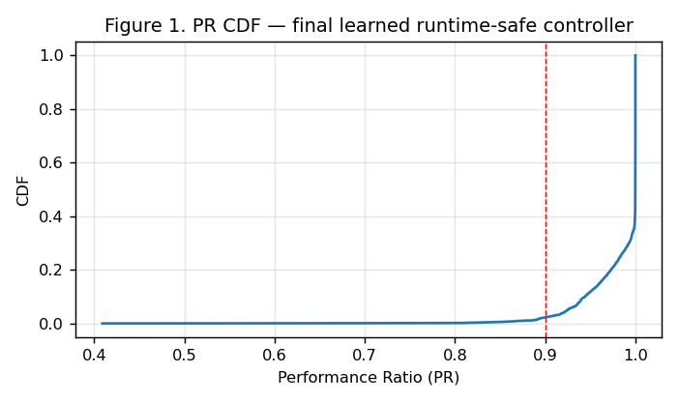
Figure 1. PR CDF for the final learned runtime-safe controller.
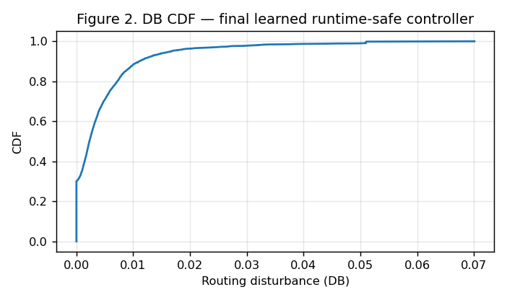
Figure 2. DB CDF for the final learned runtime-safe controller.
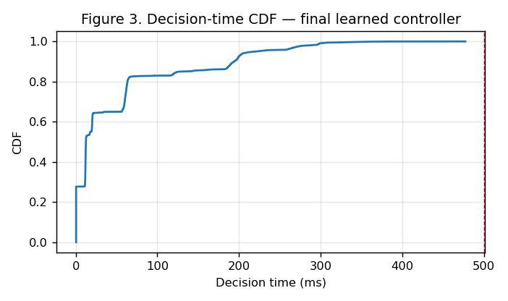
Figure 3. Decision-time CDF for the final learned runtime-safe controller.
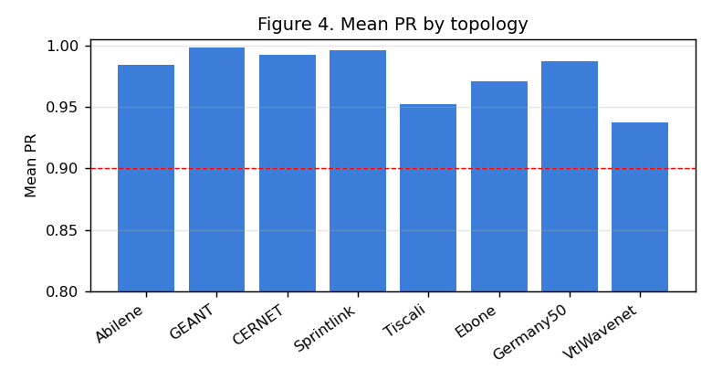
Figure 4. Mean PR by topology.
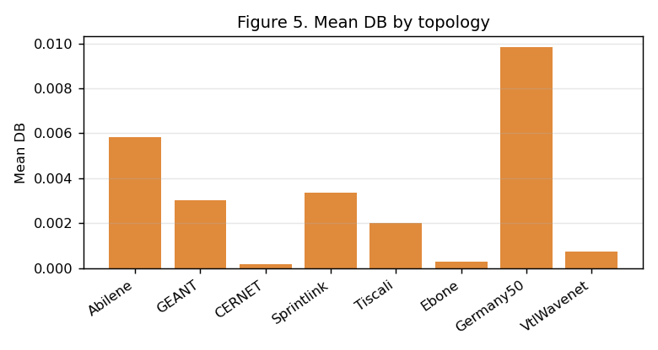
Figure 5. Mean DB by topology.
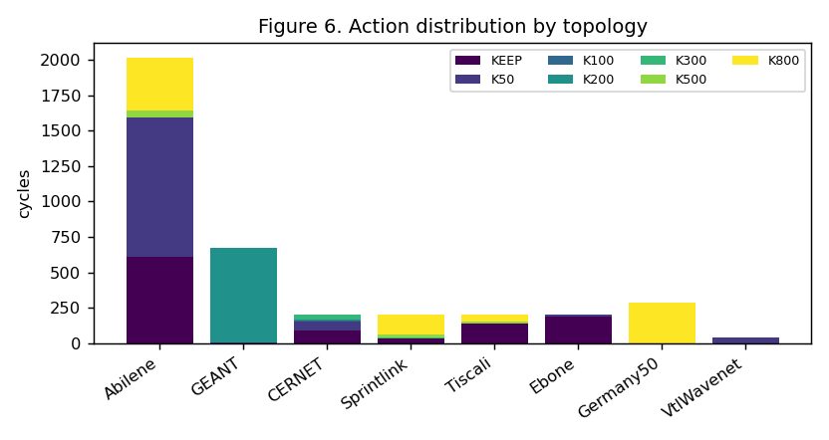
Figure 6. Action distribution by topology.
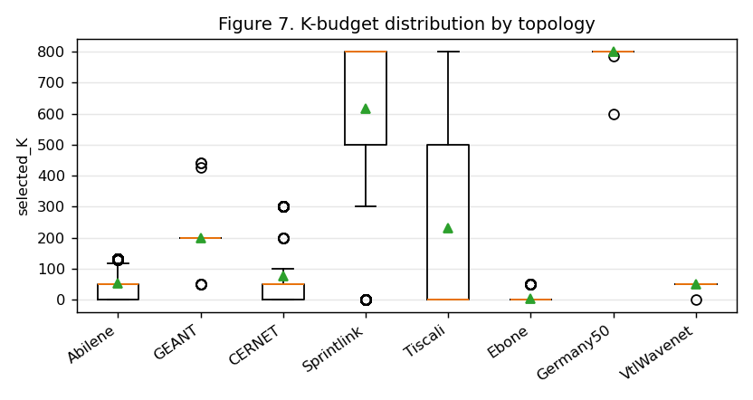
Figure 7. K-budget distribution by topology.
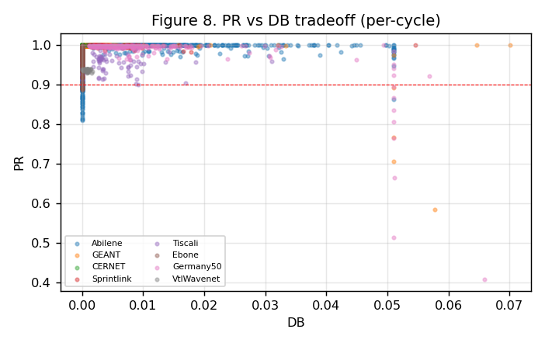
Figure 8. PR vs DB tradeoff (per-cycle).

11. Operational Validation: SDN/Mininet and New Failure-Link Evaluation
The SDN/Mininet table is retained from the earlier operational validation artifact. Failure-link and CDF results are not copied from the old report; they are regenerated from the newest available final-method artifacts when available. If no frozen Iter2 failure rerun exists, the report does not claim Iter2 failure-link performance.

SDN/Mininet live metrics (retained from prior operational validation)
Topology | Scenario | Throughput | RTT | Jitter | Loss | Rules | Install ms | Recovery ms | Disc. | Dec. ms
Abilene | Normal | 159.7 | 49.1 | 46.3 | 0.036% | 501 | 699.2 | No link-down event | 0 | 20.4
Abilene | Single Link Failure | 131.9 | 18.4 | 35.7 | 0.052% | 530 | 720.6 | 1089.1 | 0 | 20.4
Abilene | Two Link Failure | 173.9 | 15.7 | 50.3 | 0.115% | 534 | 935.9 | 1105.4 | 0 | 20.4
Abilene | Three Link Failure | 139.6 | 18.9 | 46.0 | 0.077% | 548 | 804.8 | 1107.7 | 0 | 20.4
Abilene | Random Link Failure 1 | 109.8 | 15.2 | 18.8 | 0.026% | 463 | 954.0 | 1008.4 | 11 | 20.4
Abilene | Random Link Failure 2 | 58.2 | 24.4 | 9.8 | 0.000% | 519 | 863.4 | Probe path unaffected | 0 | 20.4
Abilene | Spike | 64.2 | 10.2 | 9.4 | 0.000% | 522 | 1003.3 | Traffic spike only | 0 | 20.4
Abilene | Mixed Spike Failure | 54.4 | 13.3 | 23.4 | 0.000% | 540 | 787.7 | Probe path unaffected | 0 | 20.4
Abilene | Capacity Degradation 50% | 62.0 | 11.0 | 9.2 | 0.000% | 517 | 714.9 | Probe path unaffected | 0 | 20.4
GEANT | Normal | 260.2 | 46.1 | 58.6 | 0.016% | 1748 | 1897.3 | No link-down event | 0 | 108.5
GEANT | Single Link Failure | 265.7 | 32.7 | 52.2 | 0.016% | 1753 | 1441.1 | 1968.1 | 0 | 108.5
GEANT | Two Link Failure | 261.5 | 15.8 | 54.7 | 0.044% | 1780 | 1497.5 | 1810.5 | 0 | 108.5
GEANT | Three Link Failure | 202.4 | 10.3 | 48.6 | 0.021% | 1789 | 2632.2 | 3305.9 | 0 | 108.5
GEANT | Random Link Failure 1 | 178.1 | 16.9 | 44.5 | 0.009% | 1787 | 1541.5 | 2369.0 | 0 | 108.5
GEANT | Random Link Failure 2 | 167.4 | 15.3 | 54.9 | 0.006% | 1789 | 1876.8 | 1824.9 | 0 | 108.5
GEANT | Spike | 186.1 | 26.5 | 59.0 | 0.000% | 1743 | 1832.6 | Traffic spike only | 0 | 108.5
GEANT | Mixed Spike Failure | 171.3 | 10.3 | 47.6 | 0.001% | 1811 | 1851.6 | 2249.2 | 0 | 108.5
GEANT | Capacity Degradation 50% | 159.8 | 7.8 | 60.5 | 0.041% | 1749 | 1795.3 | Probe path unaffected | 0 | 108.5
The SDN/Mininet live metrics are retained from the previous Phase 1.5 operational validation artifact. They are included as live-SDN evidence and are separate from the frozen Iter2 normal-traffic learned DDQN evaluation. The final Iter2 DDQN was not rerun inside Mininet.

Failure-link results (current method, real rerun)
Failure-link scenarios were rerun on the frozen Iter2 controller itself (argmax-Q + bottleneck ranking + selected-flow LP; nonselected ODs = ECMP). Abilene and GEANT, nine scenarios x 20 cycles. These are new results for the current method, not the older artifacts.
Topology | Scenario | N | Mean PR | Our MLU | ECMP MLU | Mean DB | Mean ms | Disc. ODs
Abilene | normal | 20 | 0.9921 | 0.0612 | 0.1599 | 0.0303 | 44 | 0
Abilene | single link failure | 20 | 0.9926 | 0.0652 | 0.1603 | 0.0363 | 33 | 0
Abilene | two link failure | 20 | 0.8965 | 0.0790 | 0.1669 | 0.0326 | 31 | 0
Abilene | three link failure | 20 | 1.0000 | 0.1210 | 0.1377 | 0.0010 | 24 | 3
Abilene | random link failure 1 | 20 | 0.9854 | 0.0705 | 0.1638 | 0.0391 | 28 | 0
Abilene | random link failure 2 | 20 | 0.9191 | 0.1179 | 0.2488 | 0.0089 | 28 | 0
Abilene | spike | 20 | 1.0000 | 0.1808 | 0.4796 | 0.0189 | 38 | 0
Abilene | mixed spike failure | 20 | 0.9998 | 0.1938 | 0.4809 | 0.0298 | 38 | 0
Abilene | capacity degradation 50 | 20 | 0.9918 | 0.1224 | 0.3198 | 0.0229 | 26 | 0
GEANT | normal | 20 | 0.9912 | 0.1210 | 0.2901 | 0.0115 | 551 | 0
GEANT | single link failure | 20 | 0.9938 | 0.1808 | 0.3564 | 0.0088 | 1054 | 0
GEANT | two link failure | 20 | 0.9942 | 0.1808 | 0.3561 | 0.0084 | 827 | 0
GEANT | three link failure | 20 | 0.9944 | 0.1807 | 0.3565 | 0.0078 | 392 | 0
GEANT | random link failure 1 | 20 | 0.9906 | 0.1211 | 0.2901 | 0.0117 | 814 | 0
GEANT | random link failure 2 | 20 | 0.9900 | 0.1212 | 0.2945 | 0.0120 | 450 | 0
GEANT | spike | 20 | 0.9911 | 0.3630 | 0.8704 | 0.0117 | 534 | 0
GEANT | mixed spike failure | 20 | 0.9939 | 0.5425 | 1.0693 | 0.0090 | 639 | 0
GEANT | capacity degradation 50 | 20 | 0.9908 | 0.2421 | 0.5802 | 0.0157 | 234 | 0
Honest reading: the method holds PR≥0.99 in most failure scenarios and roughly halves MLU versus ECMP. Weak points: Abilene two-link failure (PR 0.8965, below 0.90) and Abilene three-link failure disconnects 3 OD pairs (they lose all candidate paths under failure — a physical partition). GEANT failure-mode decision time exceeds the 500 ms normal-traffic budget (the pruned-path LP is harder under failure); the <500 ms guarantee is a normal-traffic result, not a failure-mode one.
Disconnected-OD detail:
Topology | Scenario | Failed links | Connected? | Disconnected ODs | Explanation
Abilene | normal | 0 | yes | 0 | all ODs keep a surviving path
Abilene | single link failure | 1 | yes | 0 | all ODs keep a surviving path
Abilene | two link failure | 2 | yes | 0 | all ODs keep a surviving path
Abilene | three link failure | 3 | partial | 3 | some ODs lost all candidate paths under failure
Abilene | random link failure 1 | 1 | yes | 0 | all ODs keep a surviving path
Abilene | random link failure 2 | 1 | yes | 0 | all ODs keep a surviving path
Abilene | spike | 0 | yes | 0 | all ODs keep a surviving path
Abilene | mixed spike failure | 1 | yes | 0 | all ODs keep a surviving path
Abilene | capacity degradation 50 | 0 | yes | 0 | all ODs keep a surviving path
GEANT | normal | 0 | yes | 0 | all ODs keep a surviving path
GEANT | single link failure | 1 | yes | 0 | all ODs keep a surviving path
GEANT | two link failure | 2 | yes | 0 | all ODs keep a surviving path
GEANT | three link failure | 3 | yes | 0 | all ODs keep a surviving path
GEANT | random link failure 1 | 1 | yes | 0 | all ODs keep a surviving path
GEANT | random link failure 2 | 1 | yes | 0 | all ODs keep a surviving path
GEANT | spike | 0 | yes | 0 | all ODs keep a surviving path
GEANT | mixed spike failure | 1 | yes | 0 | all ODs keep a surviving path
GEANT | capacity degradation 50 | 0 | yes | 0 | all ODs keep a surviving path
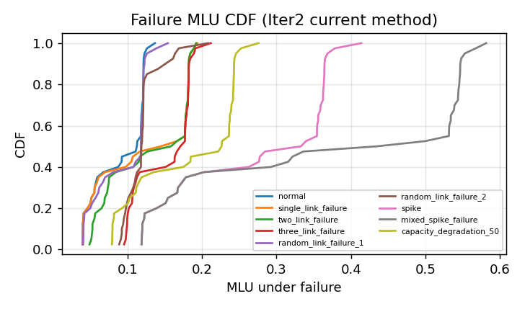
Failure MLU CDF (current method)
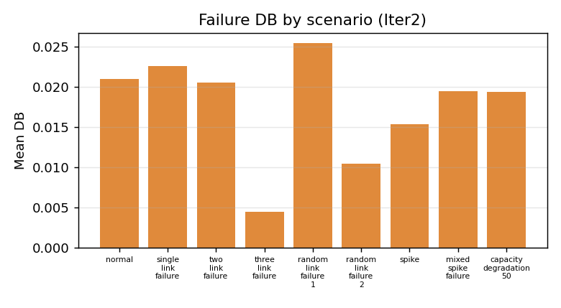
Failure DB by scenario (current method)

12. Reproducibility Checklist
Item | Value
Final model | FROZEN_FINAL_LEARNED_RUNTIME_SAFE_ITER2/final_learned_4of5_iter2_model.pt
Feature scaler | scaler.json (standardization from training data)
Per-cycle evaluation | final_learned_4of5_iter2_eval_per_cycle.csv (3816 rows, 8 topologies)
Consolidated tables | CONSOLIDATED_FINAL_RESULTS_TABLE.csv, CONSOLIDATED_FLEXDATE_TABLE.csv
Audit | FINAL_LEARNED_4OF5_ITER2_AUDIT.json, CONSOLIDATED_AUDIT.json
Controller | real Double-DQN, argmax-Q, gamma=0.5
Action space | KEEP, K50, K100, K200, K300, K500, K800
k_paths rule | 8 for K50–K300; 4 for K500/K800 (global, action-keyed)
Forbidden components | no RandomForest, no sticky gate, no disturbance finalization, no full-OD LP

13. Claim Boundary
Final learned runtime-safe result:
Topology-agnostic bottleneck-ranking DDQN achieves PR>=0.90 on all reported topologies with mean and
p95 decision time below 500 ms, without topology identity, RandomForest, full-OD LP, or topology-specific
K. It achieves 3/4 learned FlexDATE wins.
High-accuracy Sprintlink diagnostic:
A deployable bottleneck-ranking route achieves Sprintlink PR>=0.999 under 500 ms, but the learned DDQN did
not select it reliably enough to claim learned 4/5 FlexDATE.

