It is necessary to automate the script, which is shown in the video “Script for automation**.mp4”.**

* 1) To do this, open a Google search:

[*https://www.google.com/search*](https://www.google.com/search)

* 2) Then enter the following link into the search bar:

[*https://www.guinnessworldrecords.com/account/register*](https://www.guinnessworldrecords.com/account/register)*?*

Open a suitable link in a new window, which will be displayed in the results.

* 3) Then enter the following link into the search bar:

[*https://www.hyrtutorials.com/p/alertsdemo.html*](https://www.hyrtutorials.com/p/alertsdemo.html)

Open a suitable link in a new window that will be displayed in the results.

* 4) Open the following link in the active window:

[*https://www.w3schools.com/html/tryit.asp?filename=tryhtml_form_submit*](https://www.w3schools.com/html/tryit.asp?filename=tryhtml_form_submit)

* In the open window, fill in the fields with your first and last name and click the button ‘**Submit**’.

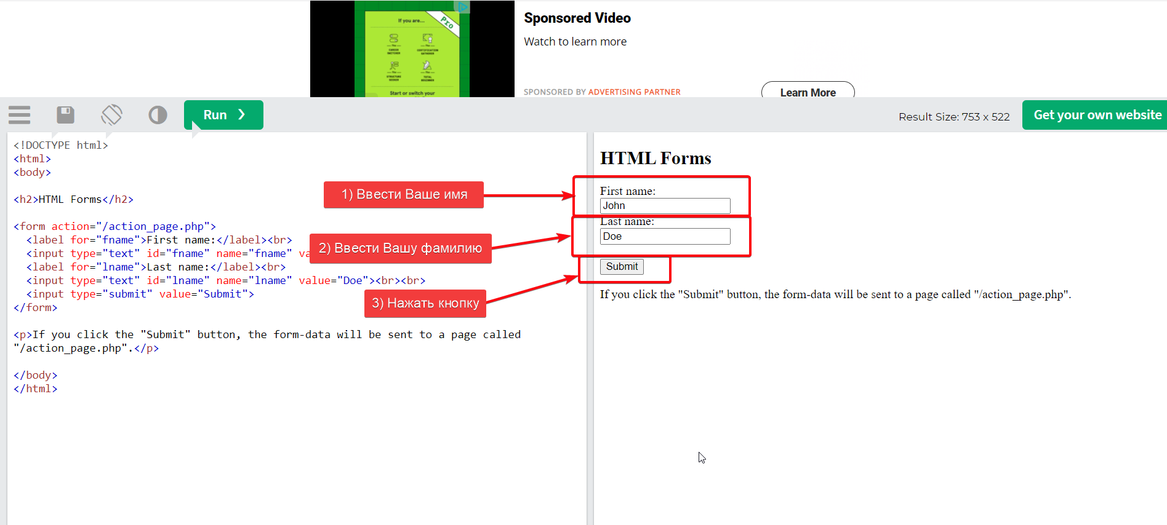

* Then output the text of this element to the console:

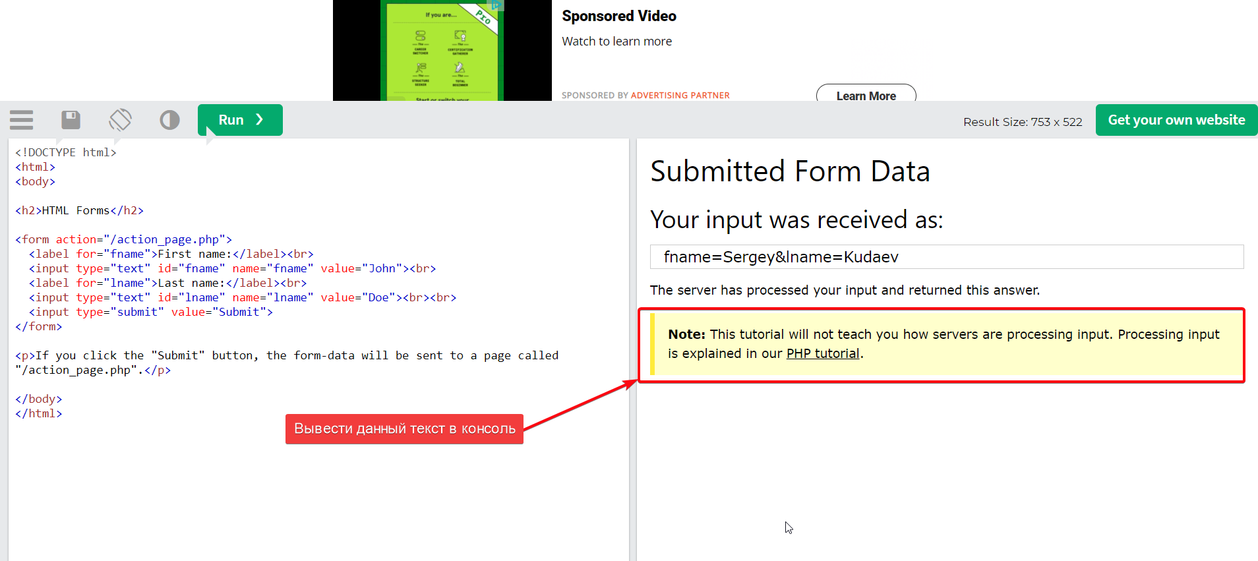

* 5) Switch to the window with the following link open:

[*https://www.guinnessworldrecords.com/account/register*](https://www.guinnessworldrecords.com/account/register)*?*

In this window, fill in all fields with the relevant information. In the Password and Confirm Password fields, enter various random passwords. In order for a notification to appear that these passwords do not match.

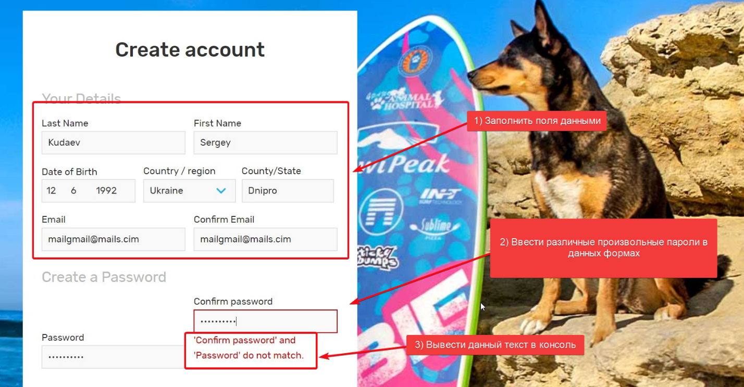

* Print this message to the console.
* 6) Switch to the window with the following link open:

[*https://www.hyrtutorials.com/p/alertsdemo.html*](https://www.hyrtutorials.com/p/alertsdemo.html)

Press the following buttons one by one:

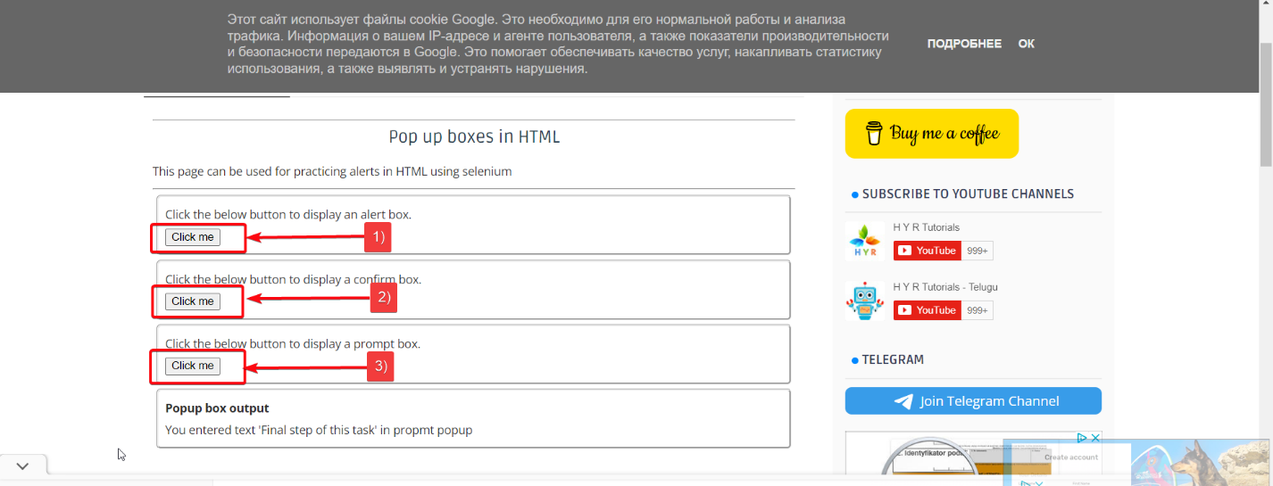

* After pressing each button, modal windows will appear on the screen.
* After clicking the first button, click “Ok” on the modal window and display a message in the console in the module “**Popup box output**”.
* After clicking the second button, click “Cancel” on the modal window and display a message in the console in the module “**Popup box output**”.
* After clicking on the third button, enter the text “Final step of this task” in the modal window and click “Ok”. Print a message to the console in the module “**Popup box output**”.

