


Smart Assessment Platform

Team Members :
- Mo'men Osman Mohamed
- Sayed Osama Sayed
- Ahmed Mohamed Ahmed Atta
- Ahmed Eid

Table of Contents

Project Description: 4
Problem Statement: 4
Proposed Solution: 4
Stakeholders: 5
Target Users: 5
Functional Requirements: 5
Non- Functional Requirements: 6
System Scope: 6
Use Case Diagram: 7
Class Diagram: 11
ERD: 12
Agile Methodology: 13
GitHub repo: 13
References: 13

Project Description:
Smart Assessment Platform is an intelligent backend-focused system designed to manage online examinations. The system provides secure authentication, automated grading, randomized exams, and performance analytics.

Problem Statement:
Traditional examination systems face several challenges including manual grading inefficiencies, high risk of cheating, lack of scalability, and limited performance analysis capabilities. These issues negatively impact both students and instructors.

Proposed Solution:
This project proposes a secure and scalable online examination system that supports automated grading, role-based access control, anti-cheating mechanisms, and advanced performance analytics using modern backend technologies.

Stakeholders:
- Students: Need secure and fair exams
- Instructors: Need tools for exam creation and grading
- Academic Administrators: Need monitoring and performance insights

Target Users:
- University Students
- Teaching Staff
- System Administrators

Functional Requirements:
- User Registration and Login
- Role-Based Access Control
- Create and Manage Exams
- Add and Manage Questions
- Randomize Exam Questions
- Start and Submit Exams
- Automatic Grading
- View Results
- Generate Reports

Non- Functional Requirements:
- Security (JWT Authentication)
- Performance (Response time < 300ms)
- Availability (System uptime ≥ 99%)
- Scalability
- Reliability

System Scope:
In Scope:
- Online examination system
- Automated grading
- Performance analytics
Out of Scope:
- Offline exams
- Manual grading

Use Case Diagram:
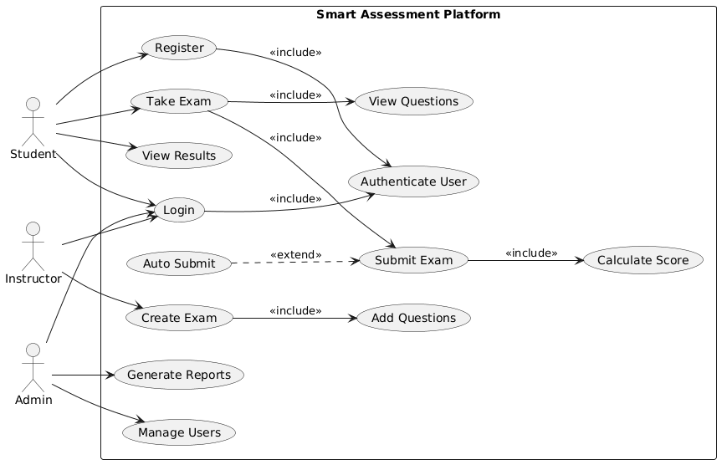

Use Case Table:
Element | Detail
Name | Login
ID | UC-01
Description | Allows the user to access the system using email and password.
Actors | Student, Instructor, Admin
Organization Benefits | Secure access control to the system.
Frequency of Use | High
Triggers | User wants to access the system.
Preconditions | User must have a registered account.
Postconditions | User is successfully logged into the system.
Main Course | 1. User enters email  2. User enters password  3. System validates credentials  4. System authenticates user  5. System redirects to dashboard
Alternate Course | A1: Invalid credentials → System shows error → User retries A2: Empty fields → System prompts user to fill fields
Exception Course | E1: System error → Display "Try again later"

Element | Detail
Name | Take Exam
ID | UC-02
Description | Allows the student to attempt an exam by answering questions.
Actors | Student
Organization Benefits | Enables online examination and reduces manual effort.
Frequency of Use | High
Triggers | Student selects an exam.
Preconditions | Student must be logged in Exam must be available
Postconditions | Answers are saved.
Main Course | 1. Student selects exam  2. System loads questions  3. System starts timer  4. Student answers questions  5. Student navigates between questions
Alternate Course | A1: Skip question → Remains unanswered A2: Exit exam → System saves progress A3: Time expires → Auto submit
Exception Course | E1: Connection lost → System attempts auto-save

Element | Detail
Name | Submit Exam
ID | UC-03
Description | Allows the student to submit answers for grading.
Actors | Student
Organization Benefits | Provides automated grading and fast result generation.
Frequency of Use | High
Triggers | Student clicks submit button.
Preconditions | Student has attempted the exam.
Postconditions | Final result is generated and stored.
Main Course | 1. Student clicks submit  2. System confirms submission  3. System saves answers  4. System calculates score  5. System stores result  6. System displays result
Alternate Course | A1: Cancel submission → Return to exam A2: Auto submit → When time ends
Exception Course | E1: Submission failure → System retries

Element | Detail
Name | Create Exam
ID | UC-04
Description | Allows the instructor to create a new exam.
Actors | Instructor
Organization Benefits | Enables instructors to prepare exams efficiently.
Frequency of Use | Medium
Triggers | Instructor chooses to create a new exam.
Preconditions | Instructor must be logged in.
Postconditions | Exam is created successfully.
Main Course | 1. Instructor selects create exam  2. System requests exam details  3. Instructor enters exam information  4. System validates data  5. System saves exam
Alternate Course | A1: Missing data → System asks to complete fields A2: Invalid data → System shows validation error
Exception Course | E1: System failure → Exam not saved

Element | Detail
Name | Add Questions
ID | UC-05
Description | Allows the instructor to add questions to an exam.
Actors | Instructor
Organization Benefits | Supports exam content creation.
Frequency of Use | Medium
Triggers | Instructor opens exam to add questions.
Preconditions | Exam must exist.
Postconditions | Questions are added to the exam.
Main Course | 1. Instructor selects exam  2. Instructor adds question  3. System saves question  4. Repeat until done
Alternate Course | A1: Invalid question format → Error shown
Exception Course | E1: Database error → Question not saved

Element | Detail
Name | View Results
ID | UC-06
Description | Allows users to view exam results.
Actors | Student, Instructor
Organization Benefits | Provides performance insights.
Frequency of Use | High
Triggers | User requests to view results.
Preconditions | Results must be available.
Postconditions | Results are displayed.
Main Course | 1. User selects results  2. System retrieves results  3. System displays results
Alternate Course | A1: No results available → Show message
Exception Course | E1: System error → Cannot load results

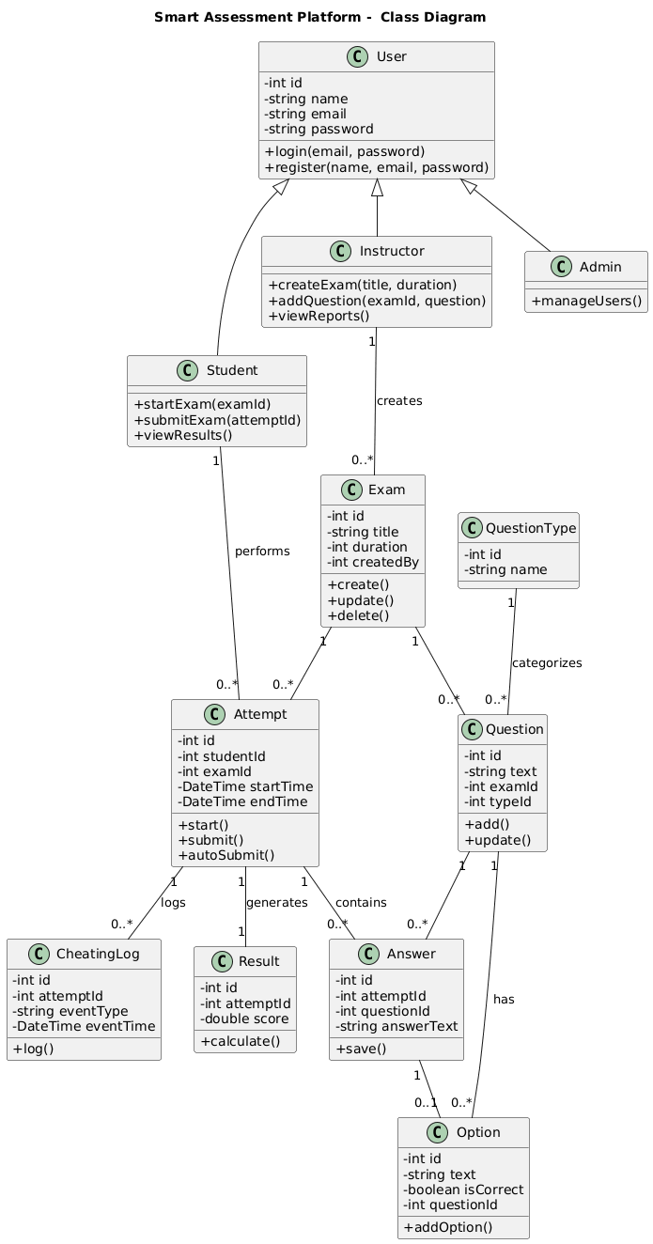
Class Diagram:

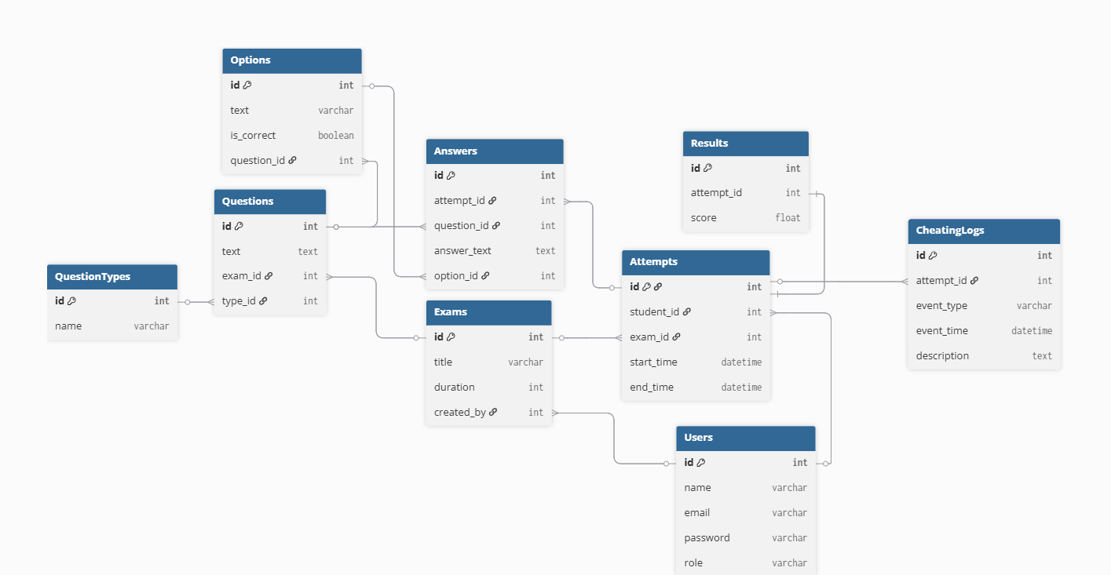
ERD:

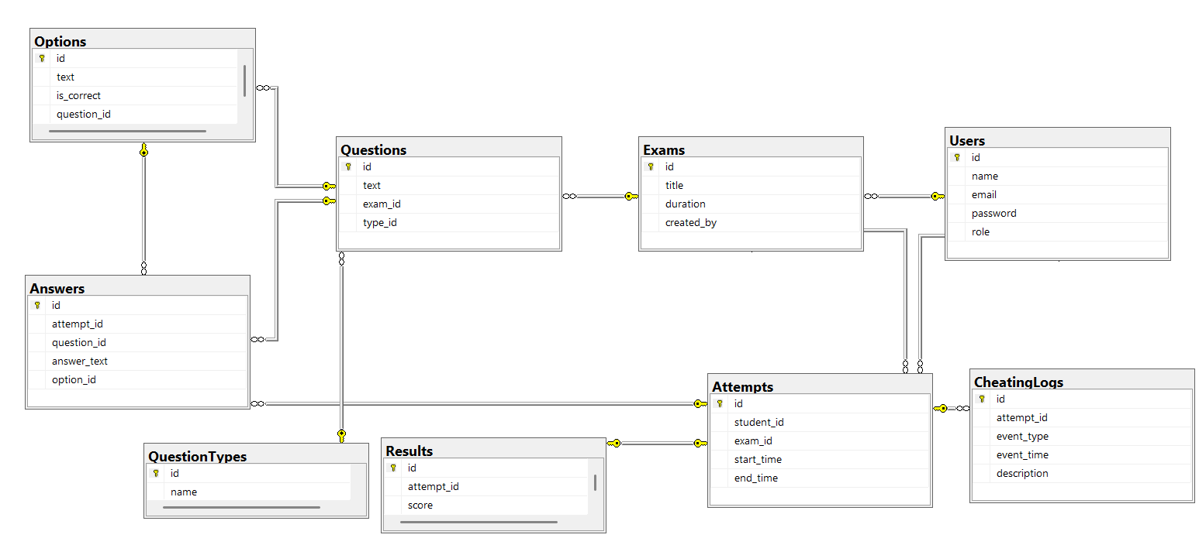

Sequence Diagram:
Login

GitHub repo:

https://github.com/moamenosman/Smart-Assessment-Platform

References:

