Vaccine Research and
Development Database

Course | Fundamentals of Databases
Selected topic | Vaccine Research & Development Database
DBMS | MySQL 8.0+ (InnoDB)
Name | moamn dwidar
ID | 221001481

1. Executive Summary
The Vaccine Research & Development Database is a normalized relational database designed to manage the lifecycle of vaccine candidates in a research organization. The system connects scientific development records with manufacturing, clinical-trial operations, participant enrollment, laboratory testing, and safety surveillance. Its main purpose is to turn a complex biotechnology workflow into a structured, queryable, and integrity-controlled data model suitable for a database course project and a realistic research setting.
The submitted implementation uses MySQL 8.0+ with the InnoDB storage engine and contains 13 entities. Two many-to-many relationships are explicitly resolved through associative tables: vaccine candidates to antigens, and participants to clinical study phases. The schema combines primary keys, foreign keys, UNIQUE constraints, CHECK constraints, ENUM domains, and controlled ON DELETE/ON UPDATE behavior to protect data quality and represent real operational rules.
The project also goes beyond basic table creation. It includes 13 populated tables with at least 10 records in each main table, three reporting views, two triggers, one stored procedure, one database function, and a structured query suite covering filtering, multi-table joins, aggregation, subqueries, INSERT, UPDATE, and guarded DELETE operations. Together, these features demonstrate the complete database development lifecycle expected by the course guidelines.

2. Introduction and Problem Statement

2.1 Background
Vaccine development is a multi-stage process in which scientific, manufacturing, clinical, and safety information must remain connected. A candidate may be associated with several antigens and formulations, each formulation may generate multiple production batches, and the same candidate may progress through preclinical studies and multiple clinical phases at different sites. Clinical phases generate participant enrollments, which in turn produce laboratory results and adverse-event records.
A flat or fragmented data structure would make it difficult to preserve relationships among these records, maintain consistency, or answer operational questions such as which vaccine candidates are in Phase III, which sites have recruitment capacity, which batches have failed quality control, or which candidates have recorded serious adverse events.

2.2 Problem Statement
The project addresses the need for a single relational system that can represent the full vaccine R&D pipeline while enforcing meaningful scientific and operational rules. The database must support traceability from a vaccine candidate to its components, manufacturing records, study phases, participants, laboratory tests, and safety events, while also preventing logically invalid states such as an over-enrolled study phase or a newly inserted batch being marked immediately as Released.

2.3 Objectives
- Identify the major entities, attributes, keys, and relationships involved in vaccine R&D.
- Convert the conceptual model into a normalized relational schema reaching at least Third Normal Form.
- Implement the design in MySQL using constraints, indexes, views, and advanced database objects.
- Load realistic test data at sufficient volume to demonstrate meaningful queries.
- Provide retrieval, join, aggregation, subquery, and data-modification operations.
- Demonstrate integrity and business-rule enforcement through triggers, a stored procedure, and a function.

3. Project Scope, Requirements, and Assumptions

3.1 Functional Scope
The database scope is deliberately broad enough to cover both R&D preparation and clinical execution, but narrow enough to remain coherent as a course project. The model includes researcher and site management, vaccine candidates and antigens, formulation and batch tracking, preclinical work, clinical phases, participants and enrollment, laboratory testing, and adverse-event monitoring.

3.2 Core Requirements Mapped to the Implementation
Course requirement | How the project addresses it
Requirements and business rules | Documented in the README and encoded in DDL constraints plus advanced SQL objects.
Conceptual design | 13-entity ERD with cardinalities and two associative tables for M:N relationships.
Relational mapping | Primary keys, foreign keys, UNIQUE constraints, CHECK constraints, ENUM domains, and referential actions.
Normalization | Schema designed to at least 3NF, with repeating/multi-valued relationships separated into related entities.
Implementation | MySQL 8.0+ / InnoDB with dedicated SQL scripts for creation, data loading, views, advanced objects, and queries.
Test data | 10–30 records per table in the supplied load script.
SQL operations | Retrieval, joins, aggregation, subqueries, INSERT, UPDATE, and guarded DELETE examples.
Advanced objects | Three views, two triggers, one stored procedure, and one scalar function.
Testing | Built-in demonstration calls for the triggers, procedure, and function; full runtime screenshots were not included in the supplied archive.

3.3 Assumptions
- Participant identifiers are anonymized; the database is not intended to store direct personal identifiers.
- Clinical study phases are represented as phase records tied to a single vaccine candidate, site, and principal investigator.
- Manufacturing sites are stored as free text because the project treats manufacturing facilities as conceptually distinct from trial sites.
- The database represents operational and analytical records; regulatory submission workflows and external pharmacovigilance systems are outside the course scope.
- Runtime execution is assumed to occur on MySQL 8.0+ with InnoDB and a standard MySQL client.

3.4 Major Business Rules
- A vaccine candidate code, formulation code, batch number, protocol number, participant anonymized code, and researcher email must be unique.
- A batch cannot have an expiry date on or before its manufacture date.
- Study and clinical-phase end dates cannot precede their corresponding start dates.
- Participant withdrawal cannot precede the original enrollment date.
- Concentrations, dose volumes, target enrollments, and produced quantities must be positive.
- A clinical phase cannot accept new participants after reaching its target enrollment; the stored procedure also requires the phase to be Recruiting or Active.
- A new batch may not be inserted directly with the Released status; the trigger requires QC progression first.
- Severe, life-threatening, and fatal adverse events are automatically marked serious by a trigger.

4. Conceptual Design and Entity-Relationship Model

4.1 ERD Overview
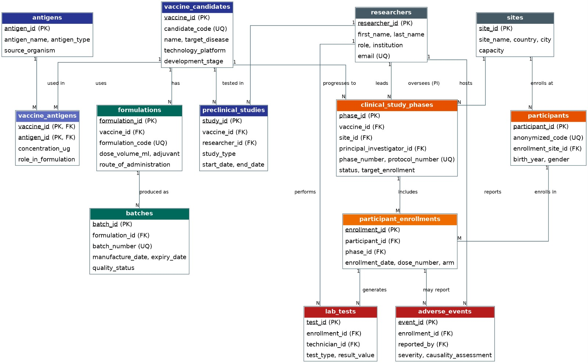
Figure 1. Final Entity-Relationship Diagram for the Vaccine R&D Database.
The ERD contains 13 entities connected through a combination of one-to-many and many-to-many relationships. The design follows a clear pipeline: vaccine candidates use antigens; candidates receive formulations; formulations generate batches; candidates are evaluated in preclinical studies and clinical study phases; phases take place at sites and are led by researchers; participants enroll in phases; and enrollments generate laboratory tests and adverse events.

4.2 Many-to-Many Relationships
Relationship | Cardinality | Associative table | Why the table is needed
Vaccine candidate to antigen | M:N | vaccine_antigens | A candidate can contain multiple antigens, and one antigen can be reused across multiple candidates. Concentration and formulation role belong to the relationship.
Participant to clinical phase | M:N | participant_enrollments | A participant can be enrolled in multiple study phases, while each phase contains many participants. Arm, dose number, enrollment date, and withdrawal information belong to the enrollment relationship.

4.3 Participation and Cardinality Logic
The database uses foreign keys to encode the main participation rules. For example, every formulation must reference an existing vaccine candidate, every batch must reference an existing formulation, every preclinical study references both a candidate and a researcher, and every clinical phase references a candidate, site, and principal investigator. Downstream records such as laboratory tests and adverse events depend on an existing participant enrollment.

5. Relational Schema and Database Structure

5.1 Entity Inventory
Table | Role in the system | Primary key | Loaded rows
researchers | People responsible for PI, coordination, laboratory, data, and safety roles. | researcher_id | 10
sites | Clinical trial locations, geography, capacity, and contact information. | site_id | 10
vaccine_candidates | Core pipeline entity with platform, sponsor, disease, and development stage. | vaccine_id | 10
antigens | Reusable catalog of antigen components. | antigen_id | 12
vaccine_antigens | M:N bridge between candidates and antigens; stores concentration and role. | (vaccine_id, antigen_id) | 13
formulations | Dose, adjuvant, storage, route, and regimen details for a candidate. | formulation_id | 12
batches | Manufactured lots with QC status, dates, quantity, and manufacturing site. | batch_id | 15
preclinical_studies | In vitro and animal study records linked to candidates and researchers. | study_id | 12
clinical_study_phases | Phase I–IV trial records by vaccine, site, and PI. | phase_id | 13
participants | Anonymized trial participants. | participant_id | 20
participant_enrollments | M:N bridge between participants and clinical phases; stores arm/dose/history. | enrollment_id | 25
lab_tests | Laboratory results attached to participant enrollments. | test_id | 30
adverse_events | Safety events attached to participant enrollments and reported by researchers. | event_id | 15

5.2 Key Constraints and Referential Actions
The DDL deliberately distinguishes between records that can be safely cascaded and records that should be protected for audit/history. Associative and dependent operational records use CASCADE where the child has little independent meaning without its parent. More historically important reference records, such as researchers and antigens used by studies, are protected with RESTRICT. This creates a practical balance between cleanup convenience and preservation of scientific traceability.
Constraint class | Examples in the project | Design purpose
Primary keys | All 13 tables have a primary key; bridge tables use a composite primary key where appropriate. | Stable row identity.
UNIQUE constraints | Researcher email, candidate code, formulation code, batch number, protocol number, anonymized participant code. | Prevent duplicate operational identities.
CHECK constraints | Positive concentrations/quantities, non-negative site capacity, valid date order, valid regimen size. | Prevent logically invalid values.
ENUM domains | Roles, technology platforms, stages, study status, trial arms, test types, result flags, event severity. | Restrict categorical values to the intended domain.
Foreign keys | Every relationship in the ERD is mapped to a foreign key in the relational schema. | Maintain referential integrity.
ON DELETE / UPDATE | CASCADE for dependent records; RESTRICT where preserving parent history is important. | Control lifecycle behavior of related data.

6. Implementation in MySQL

6.1 Technology Stack
Component | Selection | Reason
RDBMS | MySQL 8.0+ | Supports the required relational features, constraints, views, triggers, stored procedures, and functions.
Storage engine | InnoDB | Suitable for transactional relational workloads and foreign-key enforcement.
Character set | utf8mb4 / utf8mb4_unicode_ci | Supports broad Unicode text storage and consistent collation.
Client | MySQL Workbench or mysql CLI | Standard tools for running and demonstrating the SQL scripts.

6.2 Script Organization
Script | Primary purpose | Execution order
create_tables.sql | Creates the database, all tables, keys, constraints, and indexes. | 1
load_data.sql | Loads realistic test data into the schema. | 2
views.sql | Creates the three reporting views. | 3
triggers_procedures.sql | Creates triggers, the enrollment procedure, the adverse-event function, and demonstration calls. | 4
queries.sql | Runs the retrieval, join, aggregation, subquery, and DML examples. | 5

6.3 Representative DDL
CANDIDATE TABLE EXCERPT
CREATE TABLE vaccine_candidates (
vaccine_id INT AUTO_INCREMENT PRIMARY KEY,
candidate_code VARCHAR(20) NOT NULL,
name VARCHAR(150) NOT NULL,
target_disease VARCHAR(120) NOT NULL,
technology_platform ENUM('mRNA','Viral Vector','Protein Subunit',
'Inactivated','Live Attenuated','DNA','VLP') NOT NULL,
sponsor_organization VARCHAR(150) NOT NULL,
development_stage ENUM('Discovery','Preclinical','Phase I','Phase II',
'Phase III','Approved','Discontinued') NOT NULL,
date_initiated DATE NOT NULL,
CONSTRAINT uq_vaccine_code UNIQUE (candidate_code)
) ENGINE=InnoDB;

6.4 Index and Constraint Strategy
The project uses primary keys for identity, unique constraints for business identifiers, and foreign keys for join paths. Because the schema is intended for a course-scale workload, the design does not attempt to over-index every column. Primary and unique keys naturally support several common lookups, while the major relationship columns are represented by foreign keys that can be indexed as part of the key structures in InnoDB.

7. Test Data and Data Coverage
The supplied load_data.sql file provides the following records. Each main entity satisfies or exceeds the course expectation of at least 10 meaningful test records, while associative and event-oriented tables also contain enough rows to demonstrate joins and aggregation.
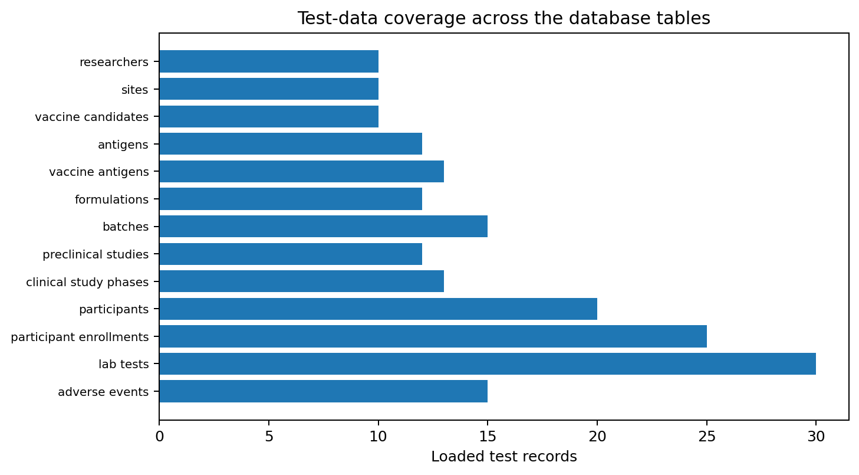
Figure 2. Number of records loaded into each project table, based on load_data.sql.
Table | Rows | Interpretation
researchers | 10 | Adequate volume for representative queries and relationship testing.
sites | 10 | Adequate volume for representative queries and relationship testing.
vaccine_candidates | 10 | Adequate volume for representative queries and relationship testing.
antigens | 12 | Adequate volume for representative queries and relationship testing.
vaccine_antigens | 13 | Adequate volume for representative queries and relationship testing.
formulations | 12 | Adequate volume for representative queries and relationship testing.
batches | 15 | Adequate volume for representative queries and relationship testing.
preclinical_studies | 12 | Adequate volume for representative queries and relationship testing.
clinical_study_phases | 13 | Adequate volume for representative queries and relationship testing.
participants | 20 | Adequate volume for representative queries and relationship testing.
participant_enrollments | 25 | Adequate volume for representative queries and relationship testing.
lab_tests | 30 | Adequate volume for representative queries and relationship testing.
adverse_events | 15 | Adequate volume for representative queries and relationship testing.

7.1 Data Realism
The test data is structured to resemble a realistic operational dataset rather than a collection of isolated rows. Candidate records connect to antigens, formulations, and studies; formulations connect to batches; clinical phases connect to sites and investigators; enrollments connect participants to phases; and downstream laboratory and safety records connect back to enrollment. This relational linkage is what enables the more advanced analytical queries in the project.

8. SQL Query Portfolio and Analytical Capabilities
The query suite is organized into five groups (A–E), matching the course requirement for varied SQL operations. Together, the queries demonstrate that the database is not only a storage structure but also a source of operational and analytical insight.
Query group | Coverage | Example business question
A — Basic retrieval and filtering | A1–A3 | Phase III candidates, active/recruiting phases, expired or failed/recalled batches.
B — Multi-table joins | B1–B4 | Candidate–antigen composition, full clinical-phase context, adverse-event traceability, and enrollment counts including zero-participant phases.
C — Aggregation | C1–C4 | Counts by development stage, production statistics by QC state, adverse-event summaries, and enrollment distributions by site and arm.
D — Subqueries | D1–D4 | Candidates without serious events, most recent abnormal/critical tests, above-average antibody titers, and sites with above-average phase counts.
E — DML operations | E1–E6 | Insert candidate, insert lab result, advance development stage, close a phase, recall expired released batches, and perform a guarded delete.

8.1 Representative Analytical Query
D3 — ABOVE-AVERAGE ANTIBODY TITER
SELECT vc.candidate_code, vc.name,
ROUND(AVG(lt.result_value), 1) AS avg_titer
FROM lab_tests lt
JOIN participant_enrollments pe ON pe.enrollment_id = lt.enrollment_id
JOIN clinical_study_phases cp ON cp.phase_id = pe.phase_id
JOIN vaccine_candidates vc ON vc.vaccine_id = cp.vaccine_id
WHERE lt.test_type = 'Antibody Titer'
GROUP BY vc.vaccine_id, vc.candidate_code, vc.name
HAVING AVG(lt.result_value) > (
SELECT AVG(result_value)
FROM lab_tests
WHERE test_type = 'Antibody Titer'
)
ORDER BY avg_titer DESC;

This query illustrates a useful analytical pattern: records are joined across the clinical and laboratory layers, grouped at candidate level, and then filtered against a subquery-derived overall average. It demonstrates both relational navigation and comparative analysis in SQL.

9. Views and Reusable Reporting Logic
Three database views were implemented to make recurring reporting tasks easier to query. Instead of repeating long multi-table joins in every analysis, the views expose curated representations that correspond to common management and safety use cases.
View | What it exposes | Primary use
vw_vaccine_pipeline_summary | One row per vaccine candidate with counts of antigens, formulations, batches, clinical phases, and adverse events. | Pipeline overview and dashboard-style summary.
vw_adverse_event_report | Denormalized safety report joining participant, vaccine, phase, site, reporting researcher, severity, causality, seriousness, and outcome. | Safety review and pharmacovigilance-style reporting.
vw_active_recruitment | Active/recruiting phases with target enrollment, current enrollment, and remaining spots. | Recruitment monitoring and site planning.

Design benefit The views improve readability for repeated reporting tasks without denormalizing the underlying source tables. The normalized schema remains the system of record while the views provide reusable reporting interfaces.

10. Triggers, Stored Procedure, and Function
Object | Type | Behavior | Business value
trg_batch_before_insert | BEFORE INSERT trigger | Rejects a batch inserted directly as Released; new batches must begin in an intermediate QC state. | Protects manufacturing/QC workflow integrity.
trg_ae_serious_flag | BEFORE INSERT trigger | Automatically sets serious_event = TRUE for Severe, Life-threatening, or Fatal events. | Standardizes safety classification.
sp_enroll_participant | Stored procedure | Checks that the phase exists, is Recruiting/Active, and has capacity before creating an enrollment; returns a human-readable status. | Prevents invalid or over-capacity enrollment.
fn_adverse_event_rate | Scalar function | Calculates adverse-event rate per 100 enrolled participants for a vaccine candidate. | Supports reusable safety analytics.

10.1 Trigger Example
QUALITY-CONTROL TRIGGER
CREATE TRIGGER trg_batch_before_insert
BEFORE INSERT ON batches
FOR EACH ROW
BEGIN
IF NEW.quality_status = 'Released' THEN
SIGNAL SQLSTATE '45000'
SET MESSAGE_TEXT =
'A batch cannot be inserted as Released. It must start as Pending QC or Passed, then be updated after QC review.';
END IF;
END;

10.2 Enrollment Procedure Logic
The stored procedure is particularly valuable because it converts a multi-step validation rule into a single reusable operation. It first reads the target phase and its current status, then counts existing enrollments. Only when the phase is open and the target has not been reached does it perform the INSERT. Otherwise, it returns a descriptive error message through an OUT parameter.

10.3 Safety-rate Function
The function calculates the number of adverse events per 100 enrolled participants for a selected vaccine. It counts distinct enrollments associated with the vaccine, counts adverse events linked to those enrollments, and returns zero when no participants have been enrolled. This makes the metric easy to reuse inside SELECT statements and reporting queries.

11. Normalization to Third Normal Form (3NF)
The schema is designed to at least Third Normal Form. The important design decisions are visible in the way repeating or many-valued relationships were separated and in the placement of attributes on the entity or relationship where they logically belong.

11.1 First Normal Form (1NF)
All tables use atomic attributes and do not store repeating lists inside a single field. For example, multiple antigens are not stored as a comma-separated string inside vaccine_candidates; they are represented through vaccine_antigens. Multiple participant enrollments are likewise represented through participant_enrollments.

11.2 Second Normal Form (2NF)
Tables with composite keys are structured so that their non-key attributes depend on the complete key. In vaccine_antigens, concentration_ug and role_in_formulation depend on the combined vaccine_id + antigen_id relationship. They would not be meaningful as attributes of either entity alone.

11.3 Third Normal Form (3NF)
The design minimizes transitive dependency by keeping descriptive attributes with their proper entities. For example, site geography is stored in sites rather than repeated in clinical_study_phases or participants. Researchers are stored once and referenced by foreign keys rather than duplicated across study records. Candidate-specific information remains in vaccine_candidates, while formulation-specific and batch-specific details are maintained in their own tables.
Normalization decision | Before normalization risk | Final design
Multiple antigens per candidate | Repeated or comma-separated antigen data. | vaccine_antigens associative table.
Multiple phases per participant | Repeated phase columns or nested lists. | participant_enrollments associative table.
Researcher details repeated in studies | Update anomalies and duplicate contact data. | researchers table + foreign keys.
Site data repeated across phases | Inconsistent city/country/capacity values. | sites table + site_id foreign key.
Batch attributes mixed into formulation | Difficult batch-level QC/expiry tracking. | Dedicated batches table.

12. Testing and Verification Strategy
The project includes explicit test logic in triggers_procedures.sql and query examples in queries.sql. Because the uploaded archive does not contain execution screenshots or a database dump from a live MySQL server, this section records the implemented verification scenarios and the expected behavior that should be demonstrated during the live defense.

12.1 Test Cases
ID | Test | Action | Expected behavior
T1 | Adverse-event seriousness trigger | Insert a Severe adverse event with serious_event = FALSE. | Row should be stored with serious_event = TRUE.
T2 | Enrollment procedure – valid phase | Call sp_enroll_participant for an open phase with available capacity. | New enrollment should be created and a SUCCESS message returned.
T3 | Enrollment procedure – closed phase | Call the procedure for a non-open phase. | No enrollment should be created; a descriptive ERROR message should be returned.
T4 | Enrollment procedure – capacity reached | Set or use a phase whose enrollment has reached target. | New enrollment should be rejected with a capacity error.
T5 | Batch QC trigger | Attempt to INSERT a batch with quality_status = Released. | INSERT should fail with SQLSTATE 45000 and the custom business-rule message.
T6 | Adverse-event function | Evaluate fn_adverse_event_rate for a known vaccine candidate. | Function should return adverse events per 100 enrolled participants.
T7 | Referential integrity | Attempt to insert child data using a non-existent parent key. | Foreign-key enforcement should reject the invalid record.
T8 | Date/domain validation | Attempt an invalid expiry/manufacture order or invalid positive-value field. | CHECK constraint should reject the invalid value where supported by the selected MySQL version.

12.2 Verification Evidence Available in the Archive
- triggers_procedures.sql contains explicit demonstration INSERT/CALL/SELECT statements for the advanced objects.
- queries.sql contains the full query suite and examples of both safe and analytical DML operations.
- load_data.sql provides sufficient linked records to exercise joins and aggregation.
- The README documents the intended execution order and describes the testing logic.

13. Limitations and Future Enhancements
Current limitation | Why it matters | Recommended future enhancement
No row-level security or role-based access control | Different user roles may require different data visibility in a real deployment. | Add MySQL users/roles and least-privilege permissions.
Manufacturing site stored as free text | Text can become inconsistent and cannot provide FK-level governance. | Create a dedicated manufacturing_sites table if manufacturing traceability expands.
No connected front-end application in the supplied archive | Users interact directly with SQL tools. | Build a lightweight web/desktop UI for data entry, dashboards, and validation.
No audit/history tables | Some state changes are visible only in the current row. | Add change-history or temporal audit tables for critical entities.
No explicit regulatory document model | Protocol and safety workflows are simplified for coursework. | Add document metadata, approvals, versions, and submission tracking if the scope grows.

13.1 Possible Bonus UI Direction
A future user interface could expose the existing views as dashboards and the stored procedure as a safe enrollment workflow. Candidate search, active recruitment monitoring, batch QC status, laboratory results, and adverse-event review are natural user-facing modules because the relational structure already supports them. The course guidelines also identify a connected UI as a potential bonus component, provided it uses the actual database rather than static data.

14. Conclusion
The Vaccine Research & Development Database provides a coherent, normalized, and operationally meaningful relational model for a biotechnology workflow. Its strength is not simply the number of tables, but the way those tables work together: candidates are linked to antigens and formulations, manufacturing is connected to QC batches, research activities continue into clinical phases, and participant-level laboratory and safety data remain traceable to the trial context that generated them.
From a database-design perspective, the project meets the core structural expectations of the course: it contains more than the minimum number of meaningful entities, resolves multiple M:N relationships, reaches at least 3NF, and demonstrates substantial SQL functionality. The advanced objects add real business value by enforcing quality and enrollment rules and by supporting reusable safety analytics.
The main remaining step for a submission-ready defense is runtime evidence: execute the scripts in a clean MySQL 8.0+ environment, capture representative query results and constraint/error messages, and place those screenshots alongside the conceptual and relational design discussion. With that addition, the project provides a strong end-to-end demonstration of database requirements analysis, design, implementation, querying, and verification.

15. References
Fundamentals of Databases. (2026). Biotechnology Database Project Guidelines. Course project document supplied with the submission archive.
Vaccine Research & Development Database. (2026). README.md: Project overview, schema summary, execution instructions, testing notes, normalization notes, and limitations. Supplied with the submission archive.
Vaccine Research & Development Database. (2026). ERD.jpeg: Final entity-relationship diagram. Supplied with the submission archive.
Vaccine Research & Development Database. (2026). SQL scripts: create_tables.sql, load_data.sql, views.sql, triggers_procedures.sql, and queries.sql. Supplied with the submission archive.

Appendix A. Repository and Execution Structure
PROJECT STRUCTURE DOCUMENTED IN README.MD
.
├── README.md
├── report.docx
├── presentation.pptx
├── diagrams/
│ └── ERD.jpeg
└── sql/
├── create_tables.sql
├── load_data.sql
├── views.sql
├── triggers_procedures.sql
└── queries.sql

A.1 Execution Order
- Run create_tables.sql to create a clean vaccine_rd_db database and all tables/constraints.
- Run load_data.sql inside vaccine_rd_db to populate the test dataset.
- Run views.sql to create the reusable reporting views.
- Run triggers_procedures.sql to create the advanced objects and execute their built-in demo tests.
- Run queries.sql to demonstrate retrieval, joins, aggregation, subqueries, INSERT/UPDATE/DELETE, and analytical reporting.

Appendix B. Selected SQL Excerpts

B.1 Active Recruitment View
REPORTING VIEW EXCERPT
CREATE OR REPLACE VIEW vw_active_recruitment AS
SELECT
cp.protocol_number,
vc.candidate_code,
vc.name AS vaccine_name,
cp.phase_number,
s.site_name,
cp.status,
cp.target_enrollment,
COUNT(pe.enrollment_id) AS current_enrollment,
cp.target_enrollment - COUNT(pe.enrollment_id) AS spots_remaining
FROM clinical_study_phases cp
JOIN vaccine_candidates vc
ON vc.vaccine_id = cp.vaccine_id
JOIN sites s
ON s.site_id = cp.site_id
LEFT JOIN participant_enrollments pe
ON pe.phase_id = cp.phase_id
WHERE cp.status IN ('Recruiting', 'Active')
GROUP BY cp.phase_id, cp.protocol_number, vc.candidate_code,
vc.name, cp.phase_number, s.site_name,
cp.status, cp.target_enrollment;

B.2 Safe Delete Pattern
GUARDED DML EXCERPT
DELETE FROM participant_enrollments
WHERE enrollment_id = 12
AND withdrawal_date IS NOT NULL
AND NOT EXISTS (
SELECT 1 FROM lab_tests
WHERE enrollment_id = 12
)
AND NOT EXISTS (
SELECT 1 FROM adverse_events
WHERE enrollment_id = 12
);

B.3 Adverse-event Trigger Test
BUILT-IN TRIGGER DEMONSTRATION
INSERT INTO adverse_events
(enrollment_id, reported_by, event_description, severity,
onset_date, causality_assessment, serious_event, outcome)
VALUES
(3, 5, 'Trigger test: anaphylaxis reported', 'Severe', CURDATE(),
'Probable', FALSE, 'Under review');
SELECT event_id, severity, serious_event
FROM adverse_events
WHERE event_description = 'Trigger test: anaphylaxis reported';

