# REAL-TIME PROJECT EXERCISE

# Transport System Project

# Objectives:

# To develop a software application that support specific to the project travel agency automation that can solve all tedious task related to ticket booking in a travel agency.

# API Landscape

**Step:1:- database tables:**

. travelontip : routes and schedules

.fastgo :routes and schedules

**Travelontip-external api:**

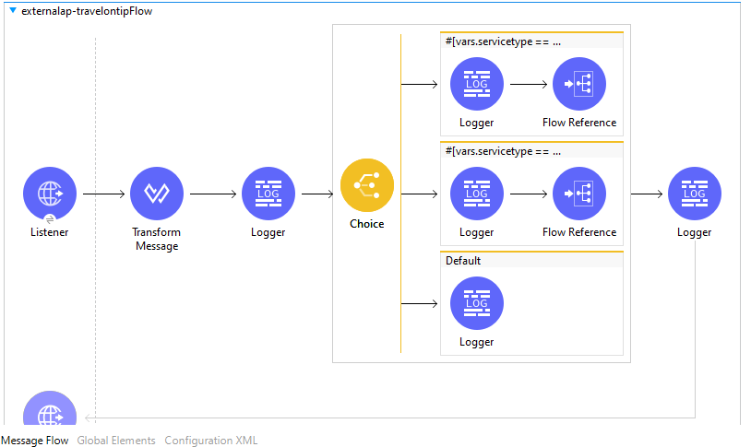

The flow represents the process of external api fastgo:

1.In transform message we pass a variable =service type

2.And in choice we give conditions like routes,schedules and default conditions.

3.when we give service type = routes, then the first condition in choice will execute.

4.when we give service type=schedules,then the second condition in choice willexecute.By flow reference we add a sub-flow for routes and schedules.

1.In select we write a query for retrieving data from database. And in payload we get the details of the selected query.

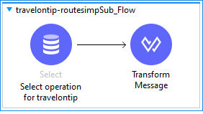

These is the sub-flow for travelontip routes.these will retrieve the data from database by select connector and the required output in transform message payload.

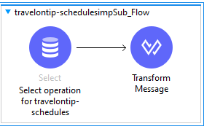

These is the sub-flow for travelontip routes.these will retrieve the data from database by select connector and the required output in transform message payload.

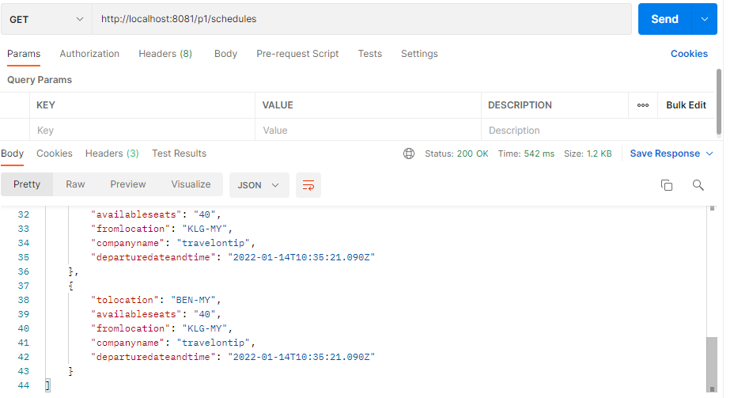

**Externalapi for fastgo:**

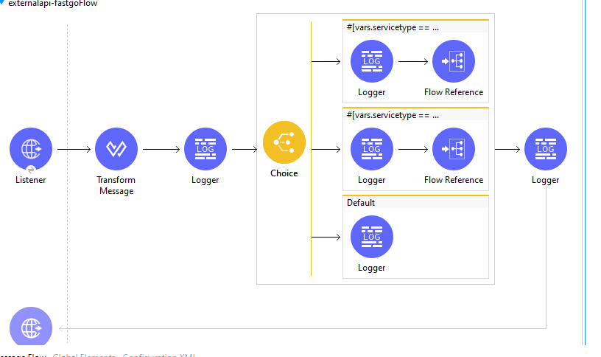

Same as above flow,we implemented for travelontip.

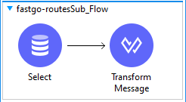

**These is the sub-flow for travelontip routes.these will retrieve the data from database by select connector and the required output in transform message payload.**

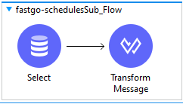

**These is the sub-flow for travelontip routes.these will retrieve the data from database by select connector and the required output in transform message payload.**

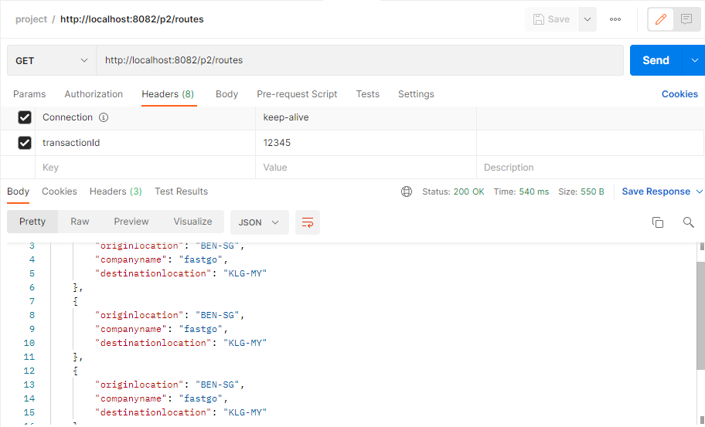

**Systemapi-fastgo**

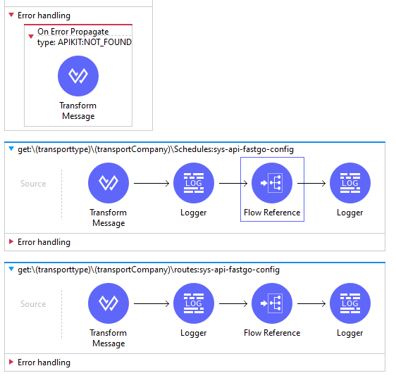

**Imported raml file from any point studio and in transform message = transactionId and in flow reference we connect the sub flow.**

**In sub flow we invoke the url of external layer for fastgo**

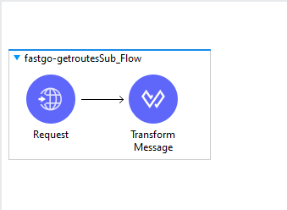

**These is the sub-flow for travelontip routes.these will retrieve the data from database by select connector and the required output in transform message payload.**

**Sub flow for schedules:**

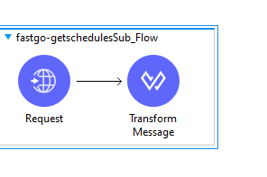

**These is the sub-flow for travelontip routes.these will retrieve the data from database by select connector and the required output in transform message payload.**

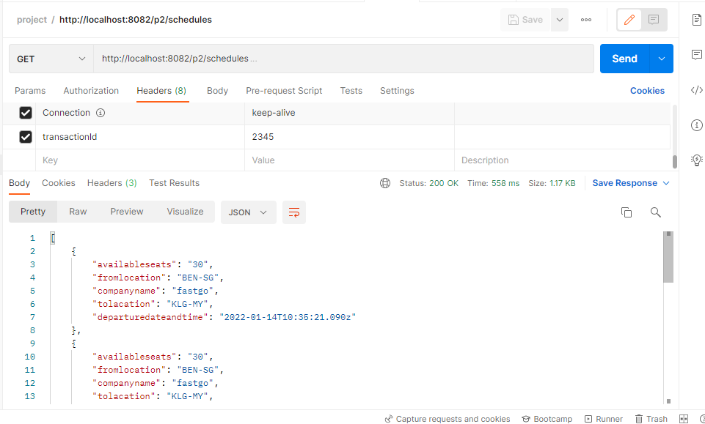

**System api for travelontip:**

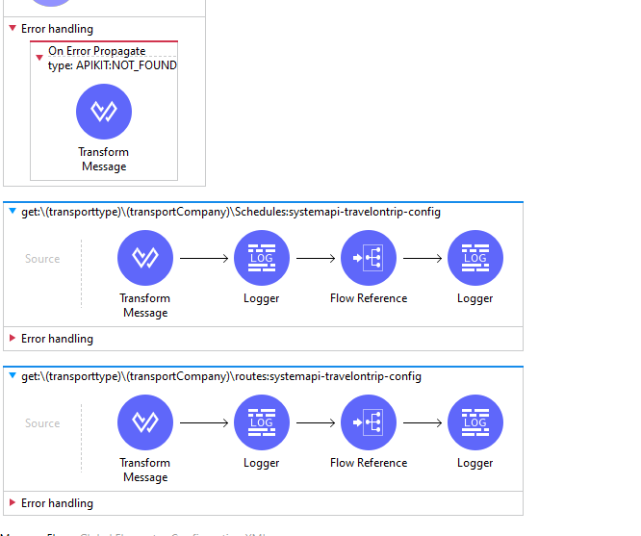

**Import raml file from any point platform**

**In transform message we set a variable = transactionId and in flow reference of schedules we created in sub flow**

**For fastgo schedules:**

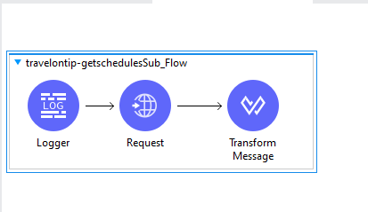

**In Request we pass the url of external api of fastgo and in transform message the required payload.**

**Fastgo-routes:**

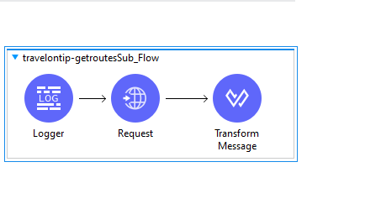

**Request component for routes.**

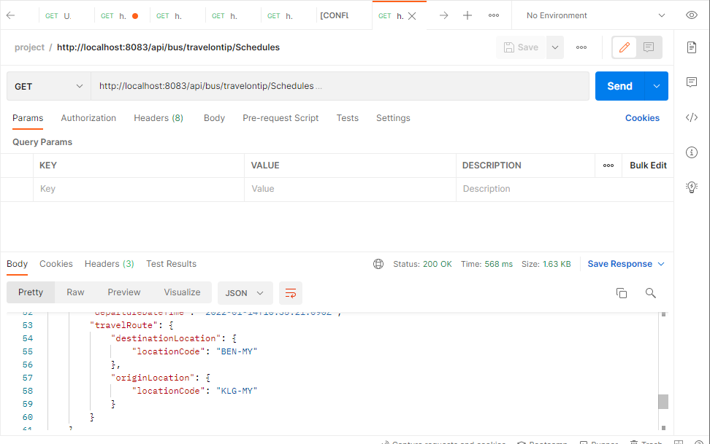

**Process api for travelontip and fastgo**

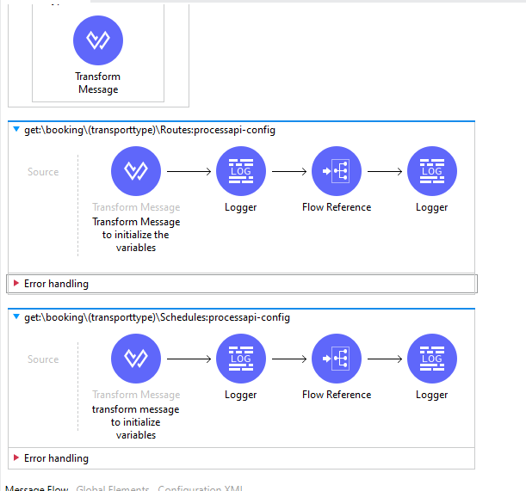

**In transform message is set a variable = destinationLocation.And in flow reference we connect with sub flow of routes.**

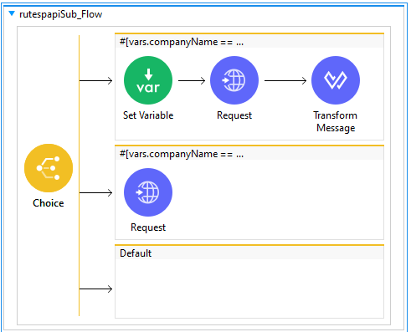

**In choice condition for first flow (If company name=fastgo)**

**We pass the systemapi of fastgo url in request component**

**If company name = travelontip the second flow will be executed.**

**And in request component we pass the url of travelontip systemapi.**

**For fastgo:**

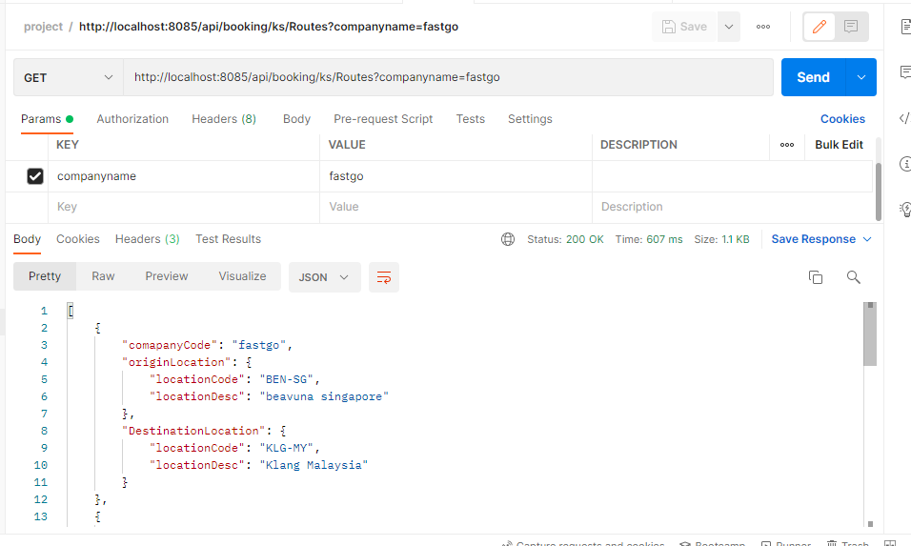

**For travelontip:**

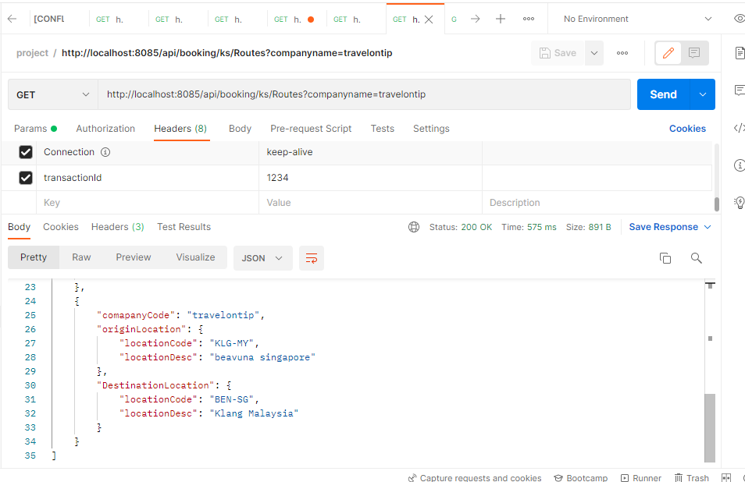

**Externalapi -web application:**

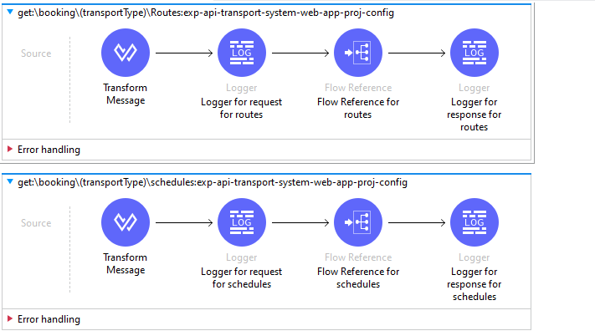

**Import raml into anypoint studio in transform message=destination location and a flow reference**

**Experience api routes:**

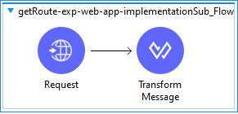

**1.In request connector we pass the process api url to consume the data from process api**

**2.And a transform message to display the required output**

**Schedules:**

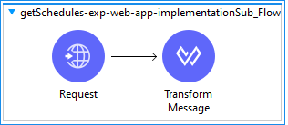

**1.In request connector we pass the process api url to consume the data from process api**

**2.And a transform message to display the required output**

**Externalapi for mobile application:**

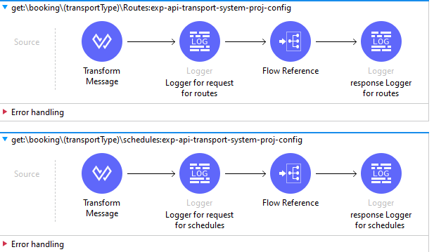

**Import raml into anypoint studio in transform message=destination location and a flow reference**

**For routes:**

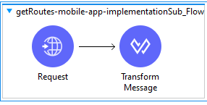

**1.In request connector we pass the process api url to consume the data from process api**

**2.And a transform message to display the required output**

**For schedules:**

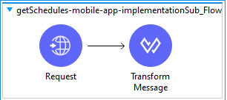

**1.In request connector we pass the process api url to consume the data from process api**

**2.And a transform message to display the required output**

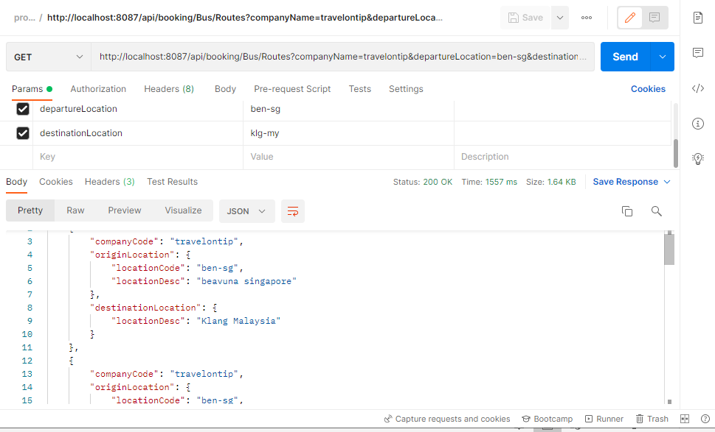

**https://github.com/moanusha/transport-system**