(Answer)  
  
1.

|  |  |  |  |  |  |
| --- | --- | --- | --- | --- | --- |
|  | Mean | Median | St. Dev. | Min | Max |
| Units | 70.18 | 30 | 135.129 | 1 | 3378 |
| YearBuilt | 1967.46 | 1986 | 40.155 | 1825 | 2010 |
| SqFt | 82763 | 38456 | 144023.718 | 478 | 3364977 |
| MarketValue | 12977808 | 4026500 | 23745284.664 | 30000 | 295182007 |
| ValueperSqFt | 131.19 | 112.22 | 68.546 | 10.66 | 399.38 |

2. You want to know how the market value per square foot varies by boroughs. To do so, you want to compute the average, median, standard deviation, minimum and maximum of the variable ValueperSqFt by the variable Boro. Write an R script that does the task. You may want to use ***summaryBy*** command, in ***library(doBy)***,to calculate those values by Boro. What do you find?

3. 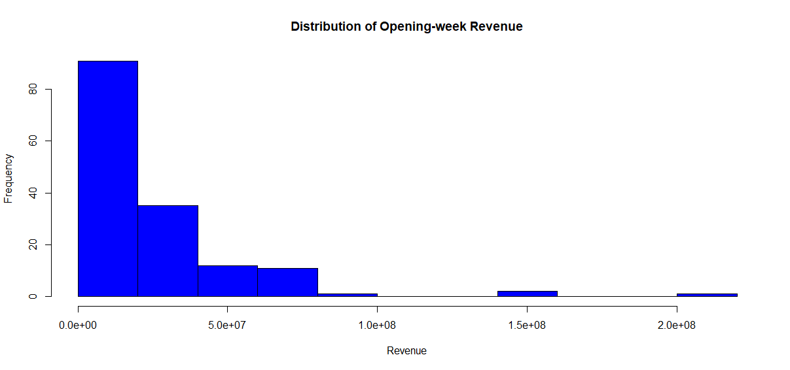

4.   
(1) breaks = 20  
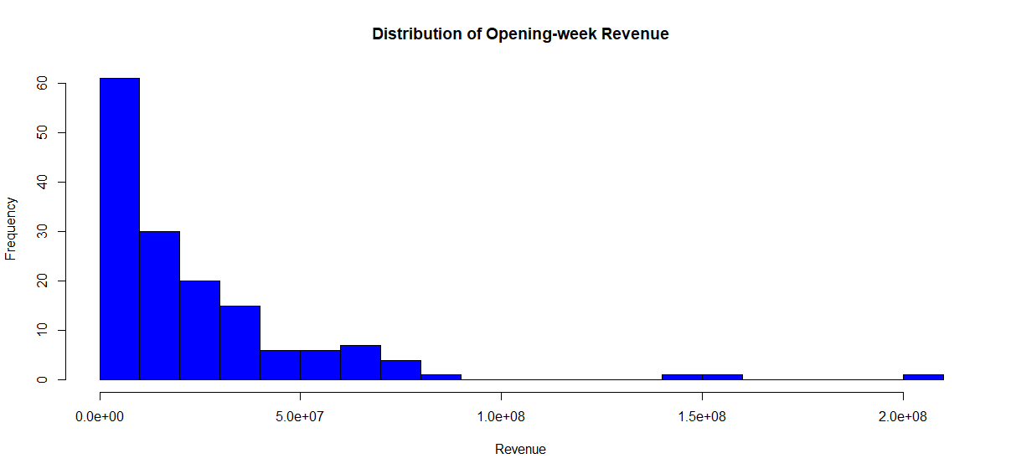

(2) breaks = 50

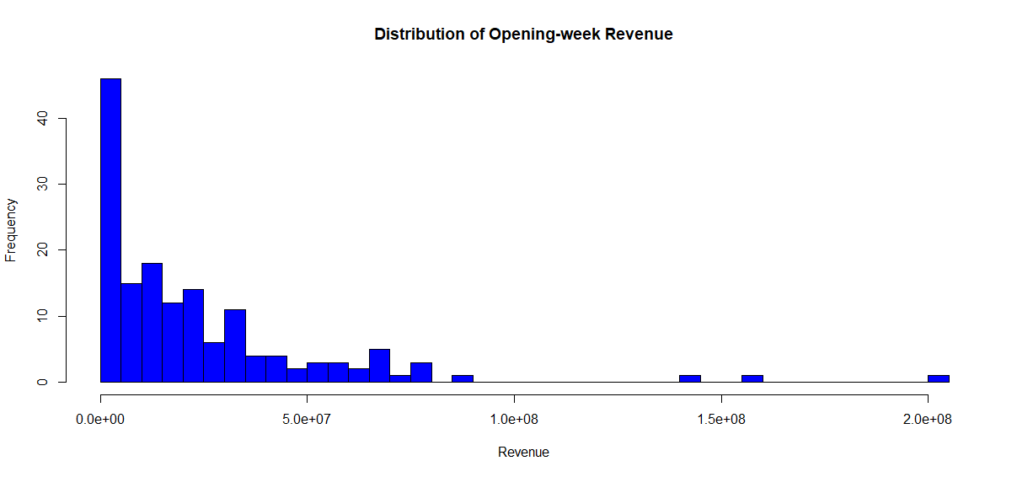

(3) breaks = 100  
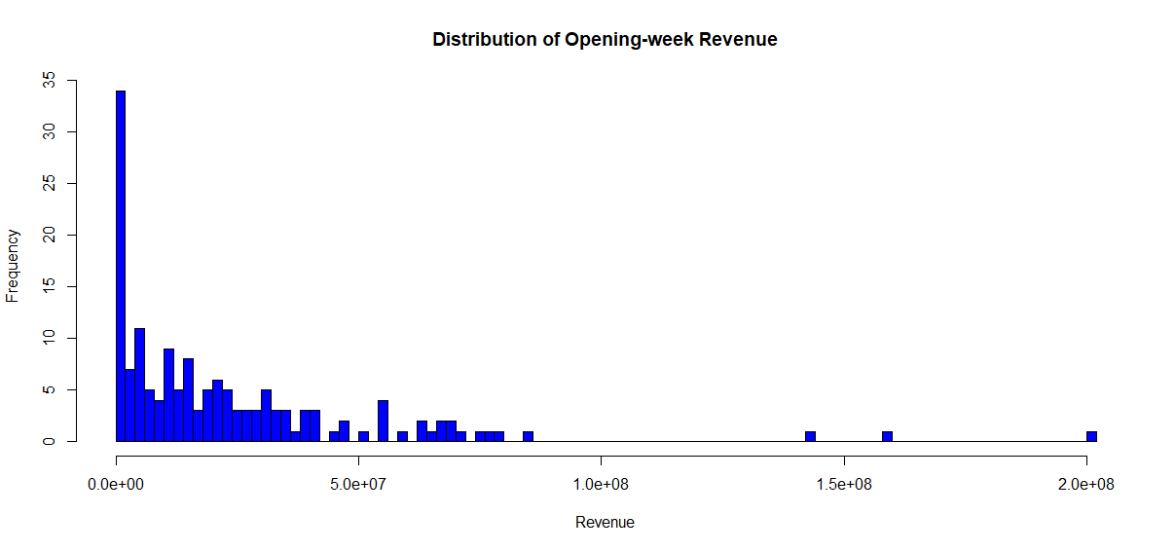

5.   
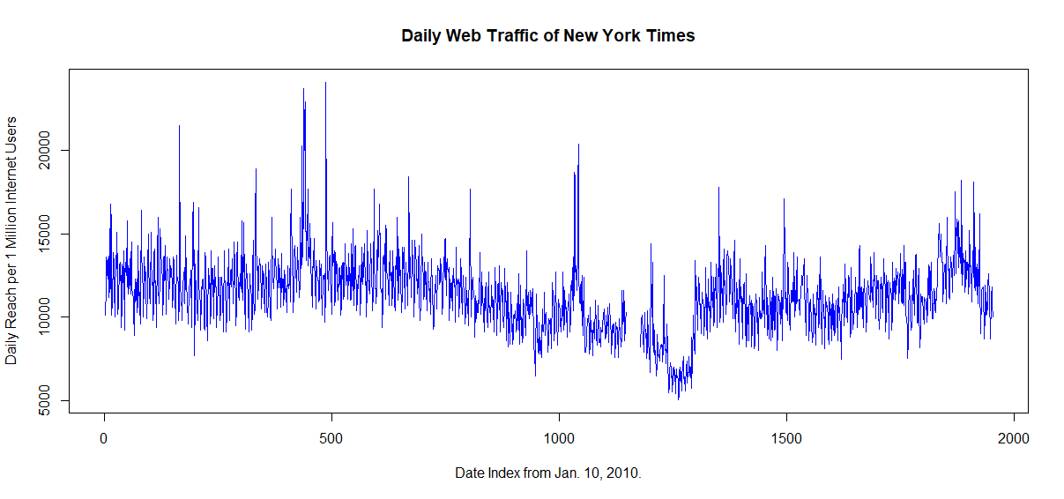

6.   
