Project Proposal
Neural Network-Based Character Recognition Across Multiple Fonts
Artificial Neural Networks — Istanbul Atlas University
Submitted by: Mohamed Alaa Shebl Mohamed | 230504583 | Date: March 2025
Programming Language | Python
Dataset | Alphabet Characters Fonts Dataset (A–Z in different fonts)
Algorithm | Perceptron & MLP with Backpropagation
Libraries (data only) | NumPy, Pandas, Matplotlib
Interface | Simple GUI — adjustable parameters, uploadable datasets
Bonus | Logic gates with Perceptron + Decision boundary visualization

1. Objective
My goal for this project is to build a neural network system capable of recognizing characters (A–Z) printed in 3 different fonts. The system will be trained to correctly classify letter images regardless of the font style used, using a Perceptron and a Multi-Layer Perceptron (MLP) with backpropagation.
To ensure I fully understand the underlying math, I will write the core neural network logic entirely from scratch, rather than relying on pre-built machine learning libraries like Scikit-Learn or TensorFlow.
2. Dataset
The dataset used in this project is the Alphabet Characters Fonts Dataset, available on Kaggle:
- Source: kaggle.com/datasets/thomasqazwsxedc/alphabet-characters-fonts-dataset
- Contains images of characters A–Z printed in multiple font styles
- I will focus on three specific fonts to test different typographic features: Arial (sans-serif), Times New Roman (serif), and Courier (monospaced).
- Each character is represented as a grayscale image, resized to 28×28 pixels for input into the network.
- I will split the dataset into standard training and testing sets to properly evaluate how well the model is learning.
If the Kaggle dataset proves too messy or doesn't format well, my backup plan is to generate the dataset myself using Python's PIL library by rendering A–Z characters in 3 chosen fonts, giving full control over image size, style, and quantity.
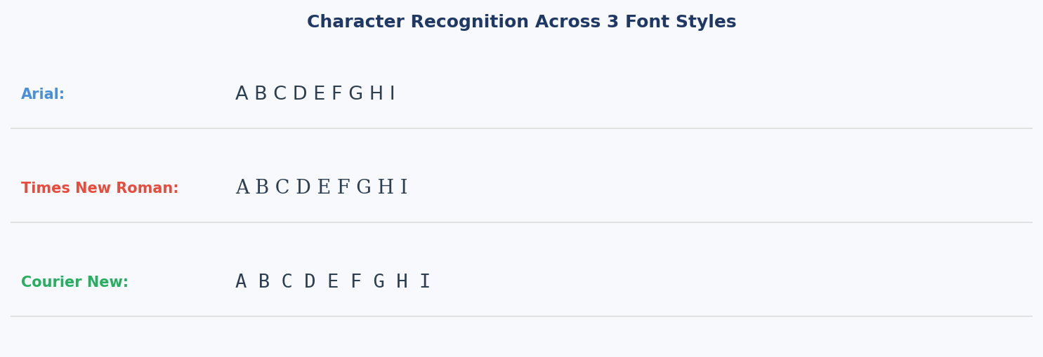
Figure 1: Characters A–Z rendered in 3 different font styles used for training
3. Methodology
I will implement two neural network architectures:
A. Multi-Layer Perceptron (MLP) with Backpropagation
- Input layer: 784 neurons (28×28 pixel values flattened)
- One or more hidden layers with configurable neuron count
- Output layer: 26 neurons representing letters A–Z
- Training via forward pass, error calculation, and weight updates using backpropagation
- I plan to write the math for the Sigmoid activation function first, and depending on how the model trains, I may also code ReLU to compare performance.
- The model will be trained and tested on characters from 3 different fonts to evaluate generalization across font styles
B. Single-Layer Perceptron
- Since this simpler model can't handle 26 complex classes, I will use it for a simpler binary classification task, like determining if a letter is a vowel or a consonant.
- Trained using the Perceptron Learning Rule
- I will use Matplotlib to visualize the decision boundaries and demonstrate the concept of linear separability.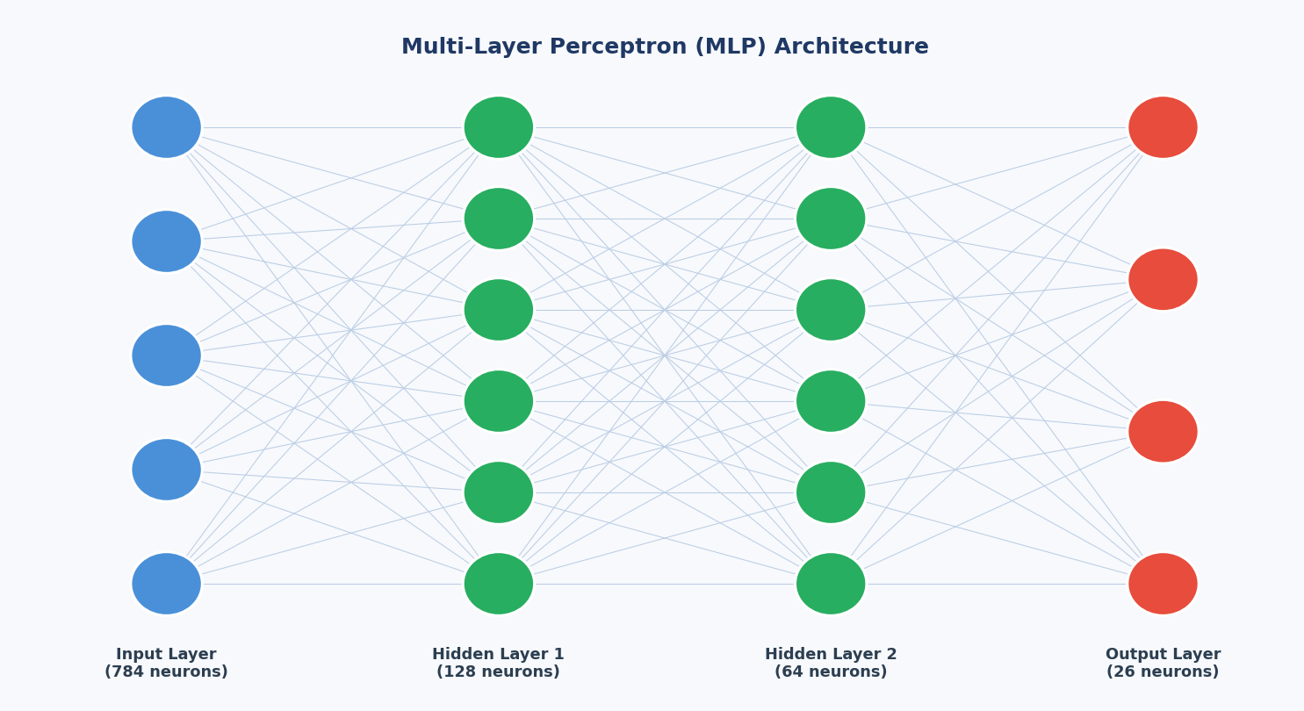
Figure 2: MLP Architecture — Input (784) → Hidden Layers → Output (26 classes A–Z)
4. Programming Language, Libraries & Tools
The project will be developed in Python. The following libraries will be used strictly for data handling and visualization — no machine learning algorithms will be imported as pre-built functions:
- NumPy — matrix operations and numerical computation
- Pandas — dataset loading and preprocessing
- Matplotlib — training curves, accuracy plots, and decision boundary visualization
All neural network components — weight initialization, forward propagation, loss calculation, backpropagation, and parameter updates — will be written manually in Python.
5. Interface
To make the model easier to interact with and test, I plan to build a straightforward graphical user interface (GUI) using Python's Tkinter (or PyQt). This interface will streamline my workflow by allowing me to:
- Upload a custom dataset or quickly select from the preloaded test samples I’ve set up.
- Adjust key hyperparameters on the fly—such as the learning rate, number of epochs, and the size of the hidden layers—without having to constantly edit the source code.
- View the training curves and accuracy updates in real time to ensure the network is actively learning and not just memorizing the data.
- Test the model on a single input image and see the predicted output.
6. Bonus: Logic Gates with Perceptron
As a bonus component, the project will implement basic logic gates (AND, OR, NAND, XOR) using a single-layer Perceptron. For each gate:
- The Perceptron will be trained on the gate's truth table
- Decision boundaries will be drawn to show how the model separates classes
- The XOR case will be used to motivate the need for multi-layer networks, since it is not linearly separable
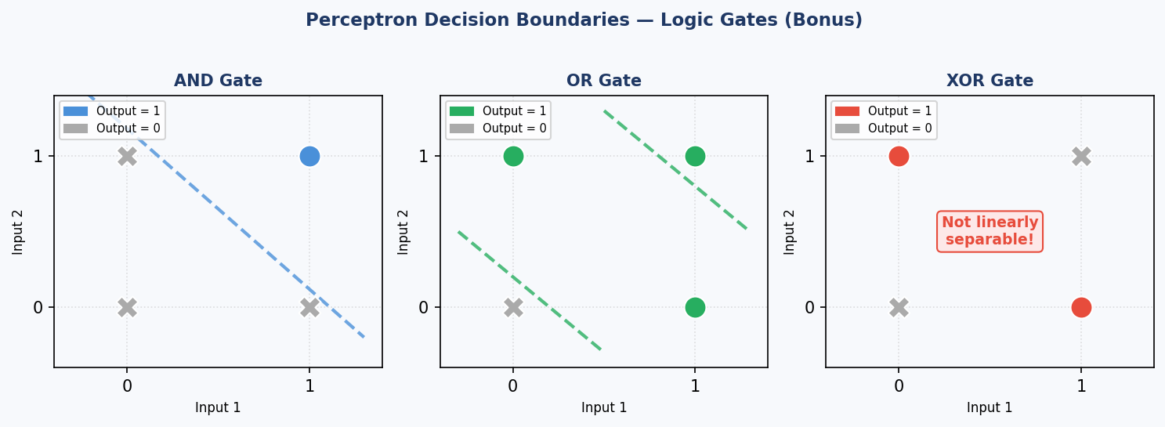
Figure 3: Perceptron decision boundaries for AND, OR, and XOR logic gates
7. Expected Results
The MLP model is expected to correctly classify characters A–Z across 3 different font styles with reasonable accuracy after training. The project will demonstrate the ability of neural networks to generalize across visual variations of the same characters. The bonus section will visually reinforce core concepts, particularly how the Perceptron handles linearly separable problems and why multi-layer networks are needed for more complex ones.

Submission deadline: March 18, 2025 | Final project deadline: April 22, 2025

