|  |
| --- |
| **Mechanical and Mechatronics Engineering Department**  **Mechanical Vibrations Laboratory (10621416)**  **Report Grading Sheet** |

|  |  |
| --- | --- |
| **Instructor Name: ayman mosafer** | **Experiment** **#1**: Natural Frequency of Single-Degree-of-Freedom Systems |
| **Academic Year:** 2019 | **ILo’s:** 3 |
| **Semester:** 2nd |

|  |  |  |  |
| --- | --- | --- | --- |
| **Students:** | | | |
| 1. Fawzi abufarha | 1. Ameen abo-hijle | | |
| 1. Zaid kharim | 1. Mohammad Yameen | | |
|  |  | | |
| **Evaluation Criterion** | | **Grade** | **Points** |
| AbstractShow over all experiment ideas in simple words. | | 10 |  |
| Introduction and Theory Provide simple introduction and theory about the experiment. | | 5 |  |
| Used Apparatus and Procedure List used apparatus and the procedure of experiment | | 5 |  |
| Experimental Results and DiscussionResults analyzed and discussed correctly. Experimental findings adequately and specifically summarized, in graphical, tabular, and/or written form, with explanation to those results. | | 50 |  |
| Conclusions and RecommendationsConclusions summarize the major findings from the experimental results with adequate specificity. Recommendations appropriate in light of conclusions. Correct grammar. | | 10 |  |
| References and appendix You have to use reference for the information you provide | | 5 |  |
| Appearance Title page is complete, page numbers applied, content is well organized, correct spelling, fonts are consistent, good visual appeal. | | 15 |  |
| Total | | 100 |  |

**Abstract**

This experiment aims to measure the natural frequencies of different types of systems, all considered as one-degree-of-freedom systems.As well as that, it aims to compare the measured values with the theoretical ones, which indicates the error percentage in the experiment.

**Introduction**

The experiment is done using three types of systems, which are explained as:

**1-Thread Pendulums**

Which is considered as the simplest pendulum system. It consists of a concentrated mass tied to a thread of negligible weight. Two kinds of balls are used as the mass; steel and wooden balls. The steel ball has a higher mass (520 g) than the wooden one (50 g).Part two: Cam and Follower Mechanism

**2-Rod Pendulums**

Which is the system where the pendulum mass is not concentrated at one point. Since this type of systems explains most reality problems, which means that it’s not possible to achieve the ideal and perfect concentration of mass. And to establish the equation of motion, a moment equilibrium is formed about the suspension point.

To do the experiment with this type of systems, a rod of length equals to 800mm and a mass of 316 g are used, as well as a threaded pendulum with length of 400m with a ball.

**3-Natural oscillation – bar oscillator**

Which is basically the non-influenced oscillation – free vibration to a system in its natural state. The experiment is done by initially deflecting the system out of its equilibrium position, which forces it to oscillate about one position until it’s brought to rest again by damping.

To do the experiment with this type of systems, a beam of dimensions (25*12*700mm) is needed among three different tension-compression springs with retaining screws. As well as that, a vibration limiter, Vernier depth gauge with a holder and a mass holder with its guide rod (mass=1010g) are needed. Additional masses are used as needed.

**Theory**

$$ω_{n,exp}=\frac{2π}{T} \\ ω_{n,theoretical}=\sqrt{\frac{g}{L}}$$ for wooden and steel balls. $ω_{n,theoretical}=\sqrt{\frac{3}{2}*\frac{g}{L}}$ 
 for rod pendulum   
  
Error = $\left|\frac{exparimantal-theortical}{theortical}\right|*100\%$ 
  
where: T is the time period  
 g is gravitational acceleration   
 L is the thread or rod length $ω_{n}$  
 is the natural frequency

**Apparatus**

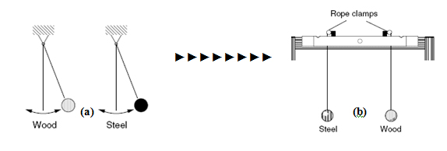

Fig1.1 The apparatus for thread pendulum

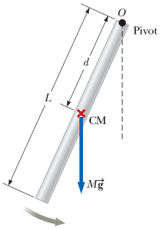

Fig 1.2: The apparatus for Rod pendulum

**Procedure  
Part one: Thread Pendulums**1-The wooden ball with the thread was suspended to lab’s device.   
2- The wooden ball was given an initial force with a small angle.  
3- The time of 20 oscillations for the wooden ball was measured.  
4- The previous steps was repeated for the steel ball.  
  
**Part two: Rod Pendulums**1- The Rod pendulum was suspended to lab’s device.  
2- The Rod pendulum was given an initial force with a small angle.  
3- The time of 20 oscillations for the Rod pendulum was measured

**Experimental Results and Data Calculations**

**Part 1: Thread Pendulums:**

Table 1.1: datasheet for the time of 20 oscillations for wood and steel ball.

|  |  |  |
| --- | --- | --- |
| length of pendulum(cm) | time for wood ball(s) | time for steel ball(s) |
| 40 | 23.35 | 24.77 |
| 50 | 26.92 | 27.53 |

Table 1.2: calculation of natural frequency for Steel and Wood ball.

|  |  |  |  |  |  |
| --- | --- | --- | --- | --- | --- |
| Wn,exp (rad/sec) for wood | Wn,theo (rad/sec) for wood | error for wood | Wn,exp (rad/sec) for steel | Wn,theo (rad/sec) for steel | error for steel |
|
| 5.381743304 | 4.949747468 | 8.73% | 5.073221887 | 4.949747468 | 2.49% |
| 4.668042576 | 4.427188724 | 5.44% | 4.56460974 | 4.427188724 | 3.10% |

**Part 2: Rod Pendulums:**  
  
 Table 1.3: datasheet for the time of 20 oscillations for Rod Pendulum.

|  |  |  |
| --- | --- | --- |
| trial | length of rod(cm) | time(s) |
| 1 | 80 | 29.11 |
| 2 | 80 | 28.33 |

Table 1.4: calculation of natural frequency of Rod Pendulum.

|  |  |  |
| --- | --- | --- |
| Wn,exp (rad/sec) for rod | Wn,theo (rad/sec) for rod | error for rod |
|
| 4.316856961 | 4.288793537 | 0.65% |
| 4.435711477 | 4.288793537 | 3.43% |

**Part 3: Rod with spring :**

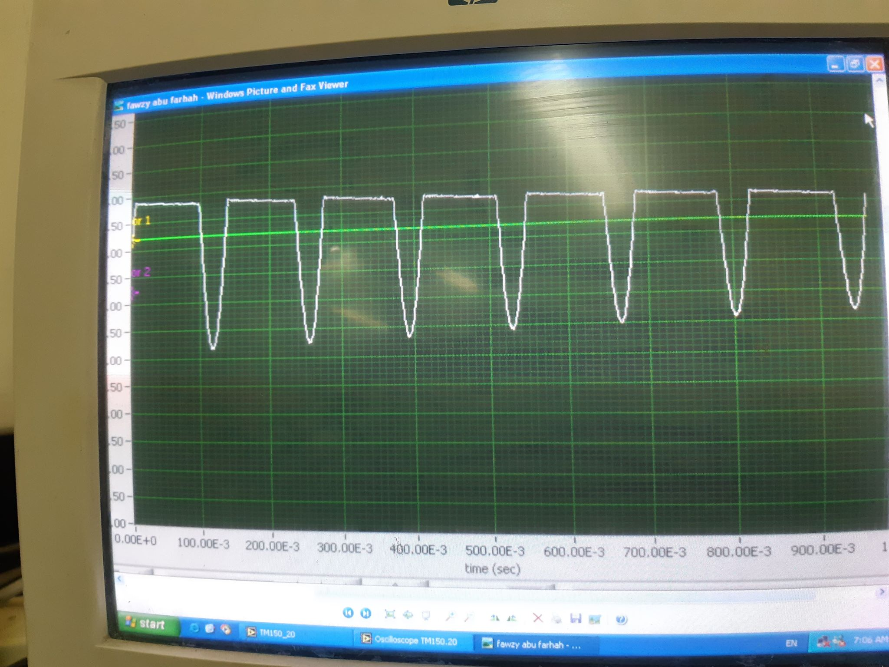

fig1.3: the time for the rod with spring

**Sample of calculation  
  
Part 1: Thread Pendulum:**

Table 1.2 for wood ball.

$ω_{n,exp}=\frac{2π}{T}=\frac{2π}{23.35/20}=4.31 rad/sec$

$ω_{n,theoretical}=\sqrt{\frac{g}{L}}=\sqrt{\frac{9.81}{0.4}}=4.952 rad/sec$

1. Error = $\left|\frac{exparimantal-theortical}{theortical}\right|*100\%=\left|\frac{4.31-4.952}{4.952}\right|*100\%=0.65\%$

**Part 2: Rod Pendulum:**

Table 1.4 for Rod pendulum.

$ω_{n,exp}=\frac{2π}{T}=\frac{2π}{29.11/20}=4.31 rad/sec$

$ω_{n,theoretical}=\sqrt{\frac{3}{2}\frac{g}{L}}=\sqrt{\frac{3}{2}\frac{9.81}{0.6}}=4.952 rad/sec$

1. Error = $\left|\frac{exparimantal-theortical}{theortical}\right|*100\%=\left|\frac{4.31-4.952}{4.952}\right|*100\%=9.245\%$

**Part 3: Rod Pendulum:**

1. The period between to bottom ($T$)= 530*10-3(s)- 390*10-3(s)-=0.14 sec

2 .

3. 🡺 44.857= =635.84 (rad/sec)2.Kg

**Discussion**

**1-THREAD PENDULUM**

The natural frequency for thread pendulum with steel and wood ball was almost the same, because the natural frequency doesn’t depend on the mass of material which it suspended on the thread so that $ω_{n,theoretical}=\sqrt{\frac{g}{L}}$ it depend on the gravitational acceleration and length of thread represented by the length between center of mass suspended and pivot point. It has an opposite relation with natural frequency which mean increasing thread length caused decreasing natural frequency. Error caused by human accuracy and accuracy for stop watch so founded that error was in range of one to five percent in both wood and steel case.

**2-ROD PENDULUM**

The natural frequency of the rod pendulum was equals that of the threaded pendulum with a ball according to the parameter of natural frequency which they are the length of the rode and the gravitational acceleration represented by $ω_{n,theoretical}=\sqrt{\frac{3}{2}\frac{g}{L}}$. Which it implies an opposite relation between the length of rod and natural frequency. Error caused by human accuracy and accuracy for stop watch so founded that error was in range of one to five percent in both wood and steel case.

**Conclusion and Recommendation:**

This experiment contains two parts enhanced the concept and effective parameter of natural frequency according to vibrations analysis during use mode of single degree of freedom.

A ball (wood and steel) was suspended on thread with some length and, applying a small theta to get time period of oscillation so that calculate experimental natural frequency.

Founding that natural frequency doesn’t depend on the mass of material which it suspended on the thread and rod pendulum were it depends on rod or thread length and gravitational acceleration.

**References**

1. Mechanical vibrations by g.k. grover
2. Wikipedia
3. Vibrations problem solving companion by rao v. dukkipati and j.srinivas .
4. Lab Manual