**Team 55:**

Mazen Fayad Mohamed Hosni Ahmed Issa 49-3422

Moataz Tarek Hosny Amin 49-14392

Mohammed Tarek Elsayed Abdallah 49-12309

Mazen Alaa Ahmed Aly Mostafa 49-10827 [mazen.mostafa@student.guc.edu](mailto:mazen.mostafa@student.guc.edu)

Mohamed Medhat Mohamed Elbehiri Abdelfatah 49-3306

**Fire Alarm system:**

The project’s idea is a fire alarm system that produces red light and operates a fan to notify the user whenever a flame or smoke are detected nearby.

**Tools used:**

* Flame sensor
* Smoke sensor
* Red light
* Fan
* Breadboard
* Jumping wires

**Code:**

**Pin Assignment:**

**Project Picture:**

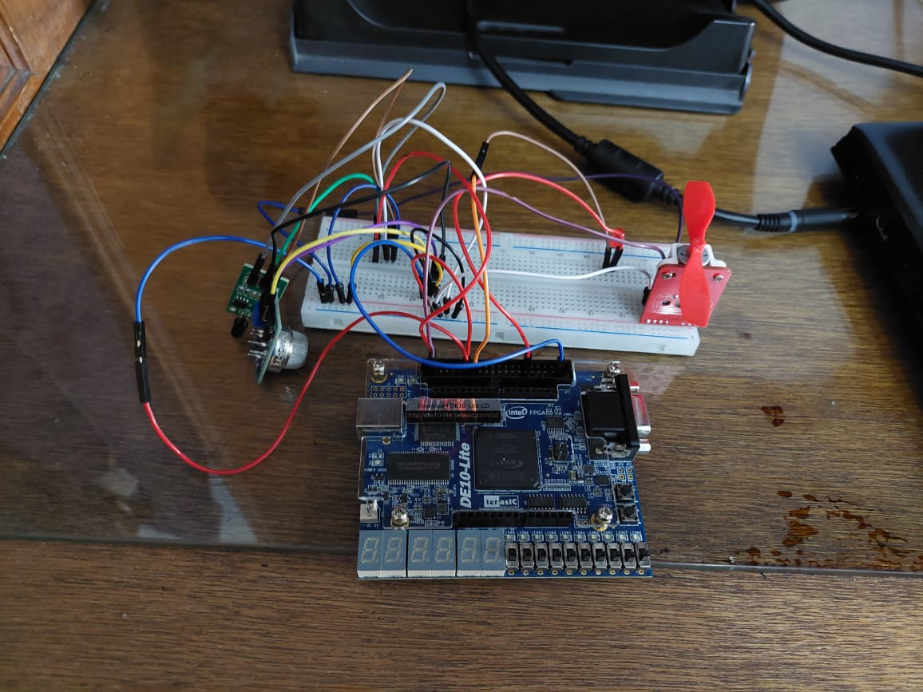

**Results:**

If smoke is detected or flame is detected, the fan operates and the lamp produces red light. If any of the sensors detect smoke or flame, the lamp and the fan also operate.