

Badr University in Cairo
Faculty of Business
Business Information System Department

Smart Municipal Reporting Platform
FixCity – Mobile Application

Submitted by:
Ahmed Wael Ali – 2022011556
Shehab El-Amir – 202020662
Moataz Ahmed Shaker – 2022016323
Mohamed Salaheldin – 2022015331
Mohamed Ahmed Abdel-Salam – 2022007776
George Armia – 2022008530

Submitted to:
Prof. Dr. Wafaa el-Shereif
Prof. Dr. Mohamed Mandoh
TA. Sammer Emad

Acknowledgments
We would like to express our sincere gratitude to Prof. Dr. Wafaa for her continuous and exceptional guidance, valuable feedback, and support throughout the development of this project.
We also extend our appreciation to the Badr University Business Information System Department for providing the resources and environment necessary to complete this work.

Table of Contents
Contents
Acknowledgments 2
Table of Contents 3
List of Figures 7
List of Tables 7
Abstract 8
1. Introduction 9
1.1 General Background 9
1.2 Problem Statement 9
1.2.1 The Inaccessibility of Reporting 9
1.2.2 Operational Inefficiency 9
1.2.3 The Transparency Gap 10
1.3 Project Motivation 10
1.4 Research Objectives 10
1.4.1 Primary Objectives 10
1.4.2 Secondary Objectives 11
1.5 Alignment with UN Sustainable Development Goals (SDGs) 11
1.6 Project Scope 12
1.6.1 Domain Scope 12
1.6.2 Geographic Scope 12
1.6.3 Functional Scope 13
1.7 Project Limitations 13
1.8 Definitions of Key Terms 13
1.9 Report Organization 14
2. Background & Literature Review 15
2.1 Introduction 15
2.2 Theoretical Foundation 15
2.2.1 Mobile Application Development Framework 15
2.2.2 Database Management Systems 15
2.2.3 User-Centered Design (UCD) 15
2.3 Related Work and Competitive Analysis 15
2.3.1 International Benchmark: FixMyStreet (UK) 16
2.3.2 Local Alternative: Municipal Contact Forms 16
2.3.3 Informal Alternative: Social Media Groups 16
2.3.4 Comparative Analysis Matrix 16
2.4 Technological Foundation 17
2.4.1 Frontend Framework: Flutter 17
2.4.2 Backend Infrastructure: Supabase 17
2.4.3 Map Services: CartoDB / OpenStreetMap 17
2.5 Summary 17
3. Business Model and Marketing Plan 19
3.1 Introduction 19
3.2 Value Proposition 19
3.2.1 For Citizens 19
3.2.2 Channels 19
3.3 Business Model Canvas 19
3.3.1 Customer Segments 20
3.3.2 Customer Relationships 21
3.3.3 Key Partners 21
3.3.4 Key Activities and Resources 21
3.4 Financial Analysis 21
3.4.1 Cost Structure 21
3.4.2 Revenue Streams 22
3.5 Marketing and Implementation Plan 22
3.5.1 Phase 1: Awareness Building (Months 1–3) 22
3.5.2 Phase 2: Pilot Implementation (Months 4–6) 22
3.5.3 Phase 3: Regional Expansion (Months 7–12) 22
3.5.4 Key Performance Indicators (KPIs) 22
3.6 SWOT Analysis 23
4. System Analysis 24
4.1 Introduction 24
4.2 Requirements Elicitation 24
4.2.1 Data Collection Methodology 24
4.3 Functional Requirements 24
4.3.1 Citizen Module (Frontend) 24
4.3.2 Administration Module (Backend Dashboard) 25
4.3.3 System Automation 25
4.4 Non-Functional Requirements 25
4.5 Use Case Analysis 25
4.5.1 System Actors 25
4.5.2 Detailed Use Case Descriptions 26
4.6 Data Modeling 27
4.6.1 Data Dictionary 27
4.6.2 Entity Relationships 29
5. System Design & Implementation 32
5.1 Introduction 32
5.2 System Architecture 32
5.2.1 Client Layer (Mobile App) 32
5.2.2 Backend Layer (Supabase) 33
5.2.3 Data Layer (Persistence) 33
5.2.4 AI Integration Layer (Google Gemini) 33
5.3 User Interface Design 34
5.3.1 Homepage & Reporting Form 38
5.3.2 Submission Confirmation 38
5.3.3 Administrative Dashboard 39
5.3.4 Status Tracking Page 39
5.4 Implementation Details 39
5.4.1 Development Environment 39
5.4.2 Database Schema Implementation 39
5.4.3 Security Measures 39
5.5 Testing and Quality Assurance 40
5.6 Deployment Strategy 40
5.7 Conclusion and Future Work 40
6. Testing & Quality Assurance 41
6.1 Testing Strategy 41
6.2 Unit Testing 41
6.3 Integration Testing 41
6.4 User Acceptance Testing (UAT) 42
6.4.1 UAT Participants 42
6.4.2 UAT Task Results 43
6.4.3 UAT Findings & Actions 43
6.5 Device Compatibility Testing 43
6.6 Performance Testing 43
6.7 Security Testing 44
7. Conclusion & Future Work 45
7.1 Project Summary 45
7.2 Achievement of Objectives 45
7.3 Research Contributions 45
7.4 Limitations 45
7.5 Future Work 46
7.5.1 Phase 2 Features (Short-Term) 46
7.5.2 Phase 3 Features (Long-Term) 46
7.6 Final Conclusion 46
8. References 48
9. Appendices 49
Appendix A: User Survey Questionnaire and Results Summary 49
Appendix B: System Implementation Timeline and Task Breakdown 52
Appendix C: Database Schema Detailed Design 52
Appendix D: User Interface Mockups and Wireframes 53
Appendix E: Source Code Documentation and Repository Information 53
Appendix F: Testing Plan and Quality Assurance Procedures 53

List of Figures
Figure 1: UN Sustainable Development Goals (SDGs) 11
Figure 2: FixCity Business Model 20
Figure 3: Use Case Diagram 26
Figure 4: Entity Relationship Diagram (ERD) 29
Figure 5: System Architecture Data Flow Diagram (DFD) 31
Figure 6: Mobile App Title Screen 33
Figure 7: Sign In / Sign Up Screen 34
Figure 8: Home Page Dashboard 35
Figure 9: Report Submission Interface 36
Figure 10: Status Tracking 37
Figure 11: Survey Response – User Preference on Application Type 48
Figure 12: Survey Response – User Preference on Device for reporting 49
Figure 13: Survey Response – User Experience on Infrastructure Problems & Reports 50

List of Tables
Table 1: System Comparison 17
Table 2: Startup vs. Operational Costs 22
Table 3: Database Schema 38
Table 4: Unit Test Results 40
Table 5: Integration Test Results 41
Table 6: UAT Participants 42
Table 7: UAT Task Results 42
Table 8: Device Compatibility Testing Results 43
Table 9: Performance Testing Results 43
Table 10: Achievement of Objectives 44
Table 11: System Implementation Timeline (Phased Rollout) 51

Abstract
In the context of rapid urbanization and the national push for digital transformation in Egypt, the disconnect between citizens and municipal authorities remains a critical barrier to effective public service delivery. Traditional methods of reporting urban infrastructure failures—such as potholes, broken lighting, and sanitation issues—are characterized by inefficiency, lack of transparency, and low public engagement.
This project presents FixCity, a native mobile application built upon Flutter and Supabase, and enhanced with Google Gemini AI for intelligent category classification. The system democratizes the reporting process, allowing citizens to submit geo-tagged, visually verified problem reports. The project was accepted into the Gemini for Graduation Projects program (Cohort III) by Gemini Africa, in partnership with the Academy of Scientific Research and Technology.
By applying Business Process Digitalization principles, FixCity transforms unstructured citizen complaints into structured, actionable data for municipal decision-makers. The research demonstrates that a Minimum Viable Product (MVP) approach can deliver a cost-effective, scalable solution that enhances operational efficiency and fosters civic trust. This report details the comprehensive system analysis, business modeling, and technical implementation required to deploy such a solution within the resource constraints of small-to-medium Egyptian municipalities.

Keywords: Civic Technology, Digital Transformation, Smart Cities, Urban Reporting, E-Government, Business Process Improvement, Minimum Viable Product (MVP), Flutter, Supabase, Google Gemini AI.

1. Introduction

1.1 General Background
The concept of the "Smart City" has transitioned from a futuristic ideal to a necessary framework for managing modern urbanization. As population densities in metropolitan areas increase, the strain on traditional public infrastructure—roads, lighting, sanitation, and utilities—grows exponentially. In the context of the Arab Republic of Egypt, this challenge is compounded by rapid urban expansion and the legacy of manual administrative systems.
Digital Transformation (DX) has emerged as a primary national objective, aiming to modernize government services and enhance the quality of life for citizens. However, while high-level government services (such as tax filing or vehicle licensing) have seen significant digitization, the "last mile" of municipal management—specifically the maintenance of local urban infrastructure—often remains reliant on outdated, paper-based workflows.
This disconnect creates a "Digital Divide" between the government's strategic goals and the citizen's daily reality. Civic Technology, defined as digital tools designed to enhance citizen engagement, offers a bridge. By leveraging accessible mobile technologies, municipalities can decentralize the monitoring of infrastructure, effectively turning every citizen with a smartphone into a sensor for the city.
This project, "FixCity," proposes a mobile-based solution to this specific problem. It is not merely a software application but a Business Process Improvement (BPI) initiative designed to streamline the workflow of problem reporting, tracking, and resolution.

1.2 Problem Statement
The core problem addressed by this research is the inefficiency of current communication channels between urban residents and municipal authorities in Egyptian cities.

1.2.1 The Inaccessibility of Reporting
Currently, residents facing common infrastructure failures—such as dangerous potholes, uncollected waste, or broken streetlights—have limited options for reporting these issues. The primary mechanisms are:
- Physical Visits: Requiring citizens to travel to municipal offices during working hours.
- Phone Calls: Often routed to general switchboards without dedicated tracking systems.
- Informal Complaints: Lodged through personal connections or local representatives.
These methods present a high barrier to entry for the average citizen. As a result, data collected during the preliminary research for this project indicates that approximately 70% of urban problems go unreported simply due to the difficulty of the reporting process. This "silent majority" of unreported issues leads to the gradual degradation of urban environments.

1.2.2 Operational Inefficiency
From the municipal perspective, the reliance on manual inputs results in severe operational bottlenecks. When complaints are received via phone or paper, they lack standardization. A citizen might report a "hole in the road" without specifying the exact location or severity. Municipal workers are then forced to spend valuable time on administrative triage—clarifying details, transcribing forms, and manually routing tasks—rather than focusing on problem resolution. This manual handling frequently leads to lost information and delays.

1.2.3 The Transparency Gap
Perhaps the most damaging aspect of the current system is the lack of feedback loops. Citizens who do take the time to report an issue rarely receive confirmation that their report was received, let alone updates on its resolution status. This lack of transparency fosters civic apathy and erodes trust between the public and service providers.

1.3 Project Motivation
The motivation for developing FixCity stems from the urgent need to apply Business Process Digitalization to the municipal sector.
- Improving Public Safety & Quality of Life: Unresolved infrastructure issues are not mere inconveniences; they pose genuine safety risks. A deep pothole can damage vehicles or cause accidents; unlit streets can encourage crime; accumulated trash poses health hazards. Accelerating the reporting loop directly contributes to a safer urban environment.
- Resource Optimization: By shifting from unstructured manual complaints to structured digital data (e.g., GPS coordinates, categorized drop-downs), municipalities can optimize their resource allocation. Workers can group repairs by location rather than responding to ad-hoc phone calls.
- Democratizing Access: Smartphone penetration in Egypt is high across various socioeconomic demographics. A mobile-first platform removes the socio-economic barriers of "knowing the right person" to get a pothole fixed, allowing any citizen with internet access to participate in urban maintenance.

1.4 Research Objectives
This project aims to design, develop, and validate a Minimum Viable Product (MVP) that demonstrates the viability of digital urban reporting in the Egyptian context.

1.4.1 Primary Objectives
- Develop a Functional Mobile Application: To engineer a native mobile application using Flutter that allows users to submit standardized reports including location data, problem categories, and photographic evidence.
- Implement a Cloud Backend: To utilize Supabase as a scalable backend infrastructure to manage user authentication, data storage, and real-time status updates without complex server maintenance.
- Establish a Feedback Loop: To create an automated notification system that informs citizens of the status of their reports (New → In Progress → Resolved), thereby ensuring transparency.

1.4.2 Secondary Objectives
- Validate User Acceptance: To conduct user surveys (sample size n=150) confirming that the proposed digital solution aligns with citizen preferences for mobile engagement.
- Analyze Business Viability: To provide a cost structure analysis proving that such a system can be implemented with a startup capital as low as $350, making it accessible for small municipalities.


1.5 Alignment with UN Sustainable Development Goals (SDGs)
Figure 1: UN Sustainable Development Goals (SDGs)

This project extends beyond technical implementation; it is designed to align with and contribute to the United Nations Sustainable Development Goals (SDGs). By modernizing urban management in Egypt, FixCity directly addresses critical challenges related to health, infrastructure, and community resilience. The platform actively contributes to the following four goals:
SDG 3: Good Health and Well-being
Poorly managed urban environments act as catalysts for public health crises. Accumulated garbage, stagnant water due to broken drainage, and open sewage systems are primary breeding grounds for disease vectors. By significantly accelerating the reporting and resolution cycle of these environmental hazards, FixCity mitigates public health risks and contributes to cleaner, healthier living conditions for urban residents.
SDG 6: Clean Water and Sanitation
Water scarcity is a pressing national issue. Traditional, slow reporting mechanisms for water main bursts or sewage overflows result in significant resource wastage and sanitation hazards. FixCity provides an immediate channel for reporting water infrastructure failures, enabling faster municipal response times to conserve water resources and ensure proper sanitation management.
SDG 9: Industry, Innovation, and Infrastructure
This project represents a direct application of digital innovation to modernize legacy infrastructure management. By replacing outdated, reactive paper-based workflows with a proactive, data-driven digital platform, FixCity enhances the efficiency, resilience, and sustainability of critical urban infrastructure.
SDG 11: Sustainable Cities and Communities
This is the primary overarching goal of the FixCity initiative. The platform democratizes urban governance by empowering citizens to actively participate in maintaining their environment. Furthermore, by streamlining waste and infrastructure management, it directly contributes to reducing the adverse per capita environmental impact of cities, fostering safer, more inclusive, and resilient urban communities.

1.6 Project Scope
Defining the boundaries of the project is essential to manage expectations and ensure the successful delivery of the Minimum Viable Product (MVP). The scope is delineated across three dimensions: Domain, Geography, and Functionality.

1.6.1 Domain Scope
The FixCity project is situated at the intersection of Civic Technology and Business Information Systems. Specifically, it addresses the domain of Digital Government Services, focusing on "Citizen Engagement Platforms." It utilizes principles of Business Process Digitalization to transform manual municipal workflows into automated digital systems. The project does not aim to reinvent municipal policy but rather to provide the technological infrastructure to execute existing policies more efficiently.

1.6.2 Geographic Scope
While the underlying technology is location-agnostic, the system design is tailored specifically for the Egyptian urban context.
- Interface Localization: The user interface supports Arabic as the primary language to ensure accessibility for local residents, with English available for administrative components.
- Infrastructure Typology: The reporting categories (e.g., "Potholes," "Trash Accumulation") are selected based on the most frequent complaints cited in Egyptian municipal studies.
- Implementation Level: The current scope is limited to a conceptual implementation for a single district or small municipality rather than a nationwide deployment.

1.6.3 Functional Scope
The system is designed to support the complete lifecycle of a non-emergency infrastructure report.
- In-Scope: Mobile reporting interface (Android), photo uploads via camera/gallery, geolocation tagging via device sensors, administrative dashboard, and real-time status tracking.
- Out-of-Scope: Emergency services dispatch (police/fire/ambulance), integration with payment gateways (for fines or fees), or complex GIS mapping for urban planning.

1.7 Project Limitations
It is critical to acknowledge the constraints under which this research was conducted. These limitations frame the interpretation of the results and the functionality of the final artifact.
- Academic Simulation: The integration with municipal workflows is simulated for academic purposes. A real-world deployment would require complex API integrations with legacy government systems and bureaucratic approval processes that are beyond the scope of a graduation project.
- MVP Functionality: The system represents a Minimum Viable Product (MVP). Advanced features such as AI-driven image recognition for automated severity assessment or blockchain for immutable audit logs were excluded to ensure the project remained feasible within the development timeline.
- Digital Literacy Assumption: The solution presupposes a baseline level of digital literacy among users (specifically, the ability to operate a smartphone). While mobile penetration is high, this reliance may inadvertently exclude older or economically disadvantaged demographics.

1.8 Definitions of Key Terms
- Civic Technology (Civic Tech): Digital tools and platforms specifically designed to enhance citizen engagement with government services and improve the delivery of public goods. FixCity is a "Citizen-to-Government" (C2G) Civic Tech application.
- Business Process Digitalization: The transformation of manual, paper-based workflows into digital systems to improve efficiency, accuracy, and accessibility. This differs from simple "digitization" (scanning papers) as it fundamentally reorganizes the process flow.
- Minimum Viable Product (MVP): A development technique where a new product is built with sufficient features to satisfy early adopters while collecting feedback for future development. This iterative approach reduces the risk of building features that users do not need.

1.9 Report Organization
The remainder of this report is organized as follows:
- Chapter 2: Background & Literature Review establishes the theoretical framework, reviewing the history of digital government in Egypt and analyzing existing solutions like FixMyStreet.
- Chapter 3: Business Model & Marketing Plan details the operational strategy, including the Business Model Canvas, cost structure analysis, and a phased implementation roadmap.
- Chapter 4: System Analysis documents the requirements engineering process, including stakeholder interviews, functional specifications, and data modeling.
- Chapter 5: System Design & Implementation details the technical architecture, user interface design, and AI integration layer of the FixCity platform.

2. Background & Literature Review

2.1 Introduction
The development of FixCity relies on established principles of mobile application development and public administration. This chapter provides the theoretical underpinning for the project. It begins by exploring the technological foundations—specifically the selection of the Flutter/Supabase framework and database strategies. It then moves to a critical literature review, surveying existing solutions such as international platforms (FixMyStreet) and local informal channels (social media groups) to identify the specific market gaps this project aims to address.

2.2 Theoretical Foundation

2.2.1 Mobile Application Development Framework
The technical architecture of FixCity is built upon the Flutter/Supabase framework.
- Selection Justification: Flutter was selected for its cross-platform capability, compiling to native Android code from a single Dart codebase. Supabase was selected as the backend for its production-ready PostgreSQL database, built-in authentication, real-time subscriptions, and file storage buckets — eliminating the need for dedicated server management.
- Scalability: While used here for an MVP, Flutter/Supabase is industry-proven and capable of scaling to handle high traffic loads, ensuring the project's logic is future-proof.

2.2.2 Database Management Systems
Effective data management is the backbone of any reporting system. FixCity employs PostgreSQL as its primary database engine, hosted on the Supabase cloud platform.
PostgreSQL is an object-relational database management system (ORDBMS) renowned for its reliability, data integrity, and support for complex queries. It is particularly well-suited for a live municipal environment handling concurrent user requests and geospatial data. Its use in both development and production environments eliminates compatibility issues, ensuring a seamless deployment pipeline.

2.2.3 User-Centered Design (UCD)
The project adheres to User-Centered Design principles, prioritizing the needs and constraints of the end-user.
- Responsive Design: Given that the majority of potential reports are expected to originate from mobile devices, the frontend utilizes Google's Material Design principles. This ensures the application is responsive, automatically adjusting layout and navigation elements to fit screen sizes ranging from small smartphones to large tablet screens, and performs smoothly on a wide range of devices utilizing native hardware features like GPS and camera.

2.3 Related Work and Competitive Analysis
To position FixCity effectively, it is necessary to analyze the current landscape of urban reporting tools.

2.3.1 International Benchmark: FixMyStreet (UK)
FixMyStreet is a pioneering platform launched in the United Kingdom that allows citizens to report street-level infrastructure problems on a map.
- Strengths: It has achieved widespread public adoption and offers seamless integration with local council back-office systems. It sets the standard for transparency and usability in the Civic Tech space.
- Weaknesses: The platform is technically complex and resource-intensive. Implementing a similar system in Egypt would require significant IT infrastructure upgrades at the municipal level, which is often financially unfeasible for smaller districts.

2.3.2 Local Alternative: Municipal Contact Forms
Various Egyptian governorates have digitized their complaints process by adding web forms to their official portals.
- Strengths: These channels carry the authority of the official government.
- Weaknesses: They typically function as simple email relays. They lack tracking capabilities, meaning citizens receive no feedback. Furthermore, the user experience is often poor, with non-responsive designs that are difficult to use on mobile devices.

2.3.3 Informal Alternative: Social Media Groups
In the absence of effective official tools, citizens have turned to Facebook groups and WhatsApp communities to report issues.
- Strengths: High accessibility and immediate community validation.
- Weaknesses: The data is unstructured and informal. Reports are often buried under other content, and there is no official mechanism for the municipality to acknowledge or resolve these "posts".

2.3.4 Comparative Analysis Matrix
Table 1: System Comparison
Aspect | FixCity | Municipal Contact Forms | Social Media Groups | FixMyStreet (UK)
Problem Focus | Urban infrastructure | General inquiries | Community discussions | Street problems
Workflow | Basic tracking system | Email forwarding | No formal workflow | Advanced workflow
Technical Level | Native mobile application | Basic HTML forms | Platform-dependent | Complex system
Accessibility | Mobile-responsive | Variable | High | High
Cost | Low implementation | Low | Free | High
Customization | Flexible | Limited | None | Extensive
Official Response | Simulated integration | Direct email | Informal | Formal integration
Transparency | Status tracking | Limited | High | Comprehensive

This analysis confirms that FixCity fills a critical gap: it offers the structured data and tracking of an advanced system like FixMyStreet but retains the low cost and simplicity required for the Egyptian context.

2.4 Technological Foundation
The selection of the technology stack for FixCity was driven by the need for high performance, cross-platform compatibility, and rapid development cycles.

2.4.1 Frontend Framework: Flutter
The mobile application is developed using Flutter, an open-source UI software development kit created by Google.
- Justification: Unlike web-based solutions that rely on browser rendering, Flutter compiles to native machine code for both Android and iOS from a single codebase (Dart). This ensures high performance (60 FPS rendering) and provides a consistent, native user experience across different devices without the cost of maintaining two separate development teams.

2.4.2 Backend Infrastructure: Supabase
For the backend, the project utilizes Supabase, an open-source Backend-as-a-Service (BaaS) platform.
- Justification: Supabase provides a production-ready PostgreSQL database, instant APIs, and robust authentication out of the box. This eliminates the need to manually configure and maintain a dedicated server, allowing the development team to focus on application logic rather than infrastructure management. It also supports real-time subscriptions, enabling instant status updates for users.

2.4.3 Map Services: CartoDB / OpenStreetMap
To handle geolocation and mapping without incurring the high costs of Google Maps API, the system integrates CartoDB tile layers via the flutter_map package. CartoDB was specifically chosen after OpenStreetMap's tile servers blocked the application due to usage policy restrictions, making CartoDB the production-ready, unrestricted alternative.
- Justification: This open-source alternative provides sufficient accuracy for urban reporting while keeping the project's operational costs near zero, aligning with the budget constraints of small municipalities.

2.5 Summary
The literature review confirms a distinct gap in the current market: a lack of affordable, structured, and transparent reporting tools for small-to-medium municipalities. While international solutions are too complex and local social media is too chaotic, FixCity leverages modern, lightweight technologies to offer a balanced, efficient solution. This theoretical and technical foundation paves the way for the specific Business Model discussions in the following chapter.

3. Business Model and Marketing Plan

3.1 Introduction
While FixCity is a technical solution, its long-term success depends on a sustainable business model that addresses the economic realities of Egyptian municipalities. This chapter transitions from the technical architecture to the operational strategy. It outlines how the platform creates, delivers, and captures value. Using the Business Model Canvas framework, we analyze the customer segments, key resources, and cost structures required to launch and maintain the system. Furthermore, this chapter presents a phased marketing plan designed to overcome the inertia often associated with adopting new technologies in the public sector.

3.2 Value Proposition
The core value of FixCity lies in its ability to solve the "last mile" problem of urban communication. The platform offers distinct value propositions for its two primary stakeholders: the citizens who report problems and the municipalities that resolve them.

3.2.1 For Citizens
For the urban resident, FixCity transforms the abstract frustration of living with poor infrastructure into actionable, trackable solutions.
- Empowerment: It provides a direct channel for residents who previously felt ignored by bureaucracy, giving them a voice in their local environment.
- Convenience: It eliminates the need for physical visits to government offices or navigating complex phone trees, allowing reports to be filed in under two minutes via smartphone.
- Transparency: Unlike traditional "black box" complaint methods, FixCity provides real-time status updates (e.g., "Received," "In Progress," "Resolved"), building trust that the system is working.

3.2.2 Channels
FixCity employs a multi-channel approach to reach these segments.
- Direct Municipal Outreach: The primary channel involves direct presentations to city council members.
- App Store Distribution: The platform is distributed via APK files or the Google Play Store, ensuring easy access for any Android user.
- Community Partnerships: Collaborating with local NGOs to facilitate grassroots adoption.

3.3 Business Model Canvas
Figure 2: FixCity Business Model

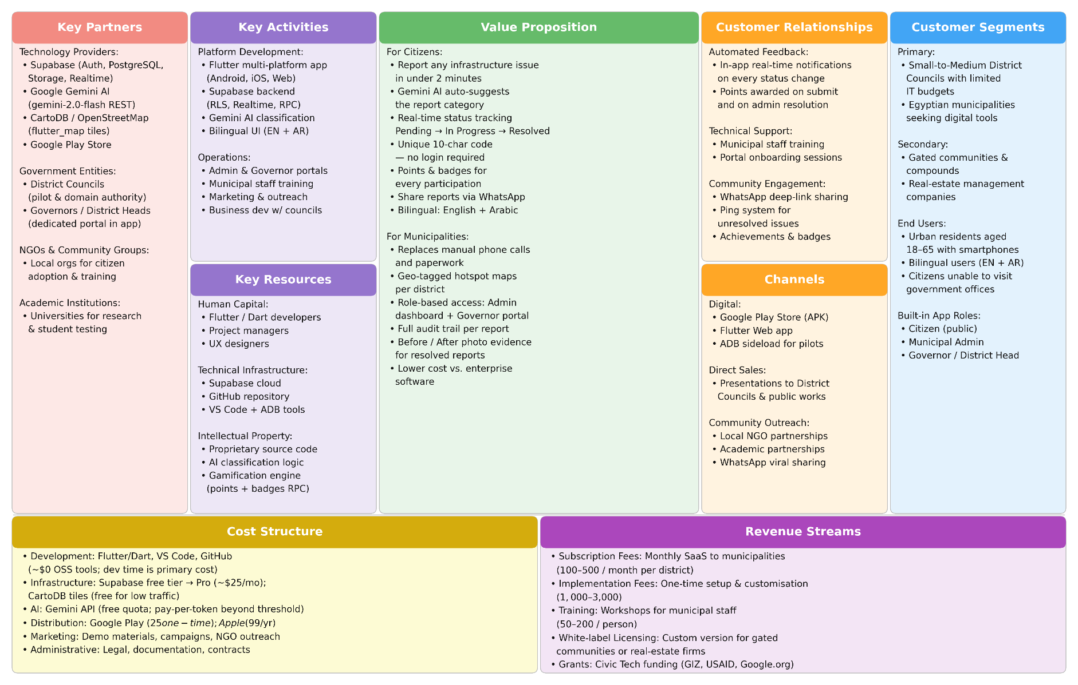
3.3.1 Customer Segments
The project targets a specific niche within the broader public sector market.
- Primary Customers: Small to medium-sized municipal governments (or district councils) in Egypt. These entities face high pressure to improve services but often possess the most limited IT budgets and technical resources.
- Secondary Customers: Community organizations, neighborhood associations (NGOs), and residential compounds looking to formalize problem reporting within their specific jurisdictions.
- End Users: The actual users of the software are urban residents (ages 18–65) experiencing infrastructure problems and seeking efficient reporting channels.

3.3.2 Customer Relationships
Building long-term relationships is critical for retention in the government sector.
- Municipal Support: The business model includes provisions for basic training, responsive technical assistance, and regular software updates to ensure security and stability.
- Citizen Engagement: For end-users, the relationship is maintained through transparent status notifications and continuous UX improvements based on feedback surveys.
- Stakeholder Feedback: Regular progress reporting to community organizations and periodic satisfaction surveys guide platform enhancements.

3.3.3 Key Partners
To minimize operational overhead, FixCity relies on strategic partnerships.
- Technology Providers: Supabase (for backend infrastructure), Google Gemini AI (for category classification), and CartoDB (for mapping services) are critical technology partners that lower operational costs.
- Academic Institutions: Universities play a dual role as research partners and potential pilot testing grounds.
- NGOs & Community Groups: Local organizations act as intermediaries to facilitate user testing and drive grassroots adoption among less digitally literate populations.
- Government Entities: Municipal departments offer domain expertise and opportunities for pilot implementation.

3.3.4 Key Activities and Resources
The core activities required to sustain the business include Platform Development (coding, feature enhancement), User Support (resolving technical issues), and Business Development (securing municipal contracts). Executing these activities requires specific resources:
- Technical Infrastructure: Reliable cloud hosting environments, development tools, and testing frameworks.
- Human Capital: A team combining software development expertise with project management skills and public administration domain knowledge.
- Intellectual Property: The proprietary source code, deployment methodologies, and best-practice documentation developed during the project.
- Partnership Networks: Established relationships with municipal contacts, academic advisors, and community organizations.

3.4 Financial Analysis

3.4.1 Cost Structure
The financial model for FixCity is designed to be "lean," minimizing upfront capital expenditure to make the solution affordable for smaller municipalities.
Table 3.1: Startup vs. Monthly Operational Costs
Table 2: Startup vs. Operational Costs
Cost Category | Startup Costs | Monthly Operational Costs | Description
Technology | $25 | $5 | App Store Developer Fees & Cloud Database Tiers.
Development | $100 | $30 | Development tools, software licenses, and ongoing code maintenance.
Administrative | $50 | $20 | Legal registration, basic communications, and documentation.
Marketing | $50 | $25 | Creation of demo materials and targeted digital outreach.
Total | $350 | $120 | Low entry barrier.

3.4.2 Revenue Streams
To ensure sustainability, the project proposes a diversified revenue model.
- Municipal Licensing: A subscription-based model charging $100–$500 monthly, scaled according to the size of the municipality and the feature set required.
- Implementation Services: One-time fees ($1,000–$3,000) for setting up the system, migrating existing data, and customizing the dashboard for specific local needs.
- Training Programs: Revenue generated by conducting training workshops for municipal staff to ensure digital literacy and system competence ($50–$200 per participant).
- Grant Funding: Pursuing non-dilutive funding from international organizations supporting civic technology and digital governance initiatives.

3.5 Marketing and Implementation Plan

3.5.1 Phase 1: Awareness Building (Months 1–3)
The initial phase focuses on establishing credibility. Activities include developing professional project documentation, presenting at local government technology forums, and establishing an online presence to showcase the prototype's capabilities.

3.5.2 Phase 2: Pilot Implementation (Months 4–6)
The goal of this phase is to secure a single municipal partner for a "Beta" deployment. This controlled environment will allow the team to document the implementation process, gather real-world performance metrics, and generate case studies that prove the system's value.

3.5.3 Phase 3: Regional Expansion (Months 7–12)
Armed with success stories from the pilot, the marketing focus shifts to regional expansion. This involves targeting adjacent municipalities (who often mimic successful neighbors) and developing a formal partnership program with community organizations to scale support.

3.5.4 Key Performance Indicators (KPIs)
Success will be measured against specific metrics within the first year:
- Adoption: Securing 2 municipal partnerships and achieving 5,000 active citizen users.
- Impact: Achieving a 30% reduction in problem resolution time compared to the pre-digital baseline.
- Satisfaction: Maintaining a user satisfaction score of 80% or higher to ensure long-term retention.

3.6 SWOT Analysis
To further validate the business model, a SWOT analysis was conducted to identify internal strengths and weaknesses, as well as external opportunities and threats.
- Strengths: Low implementation cost, agile MVP development, and a user-friendly interface tailored to the local language (Arabic).
- Weaknesses: As a new entrant, the project lacks the brand recognition of established competitors. The team also has limited initial resources for large-scale marketing.
- Opportunities: The Egyptian government's current push for "Digital Transformation" provides a favorable political climate. There is also a growing market for "Smart City" solutions in developing nations.
- Threats: Bureaucratic resistance to change is a significant barrier. Additionally, long procurement cycles in the public sector can strain cash flow for startup ventures.

4. System Analysis

4.1 Introduction
System analysis serves as the bridge between business needs and technical implementation. This chapter details the rigorous requirements engineering process undertaken for FixCity. It begins by outlining the data collection methodologies used to understand user needs, including quantitative surveys and qualitative stakeholder interviews. Following this, it presents a detailed breakdown of both Functional and Non-Functional Requirements, ensuring the system meets necessary performance and usability standards. Finally, the chapter defines the system's logical structure through Use Case analysis and Data Modeling, providing the blueprint for the design phase.

4.2 Requirements Elicitation
To ensure FixCity addresses real-world problems rather than theoretical ones, a user-centered requirements elicitation process was conducted.

4.2.1 Data Collection Methodology
- Online Surveys: A digital questionnaire was distributed to a diverse group of urban residents, garnering 167 responses. The survey assessed current reporting behaviors, identifying that the majority of users prefer mobile-based reporting over traditional phone or in-person methods.
- Stakeholder Interviews: Structured interviews were conducted with 8 municipal workers to understand the friction points in their daily workflows. These sessions revealed that "incomplete information" (e.g., reports without exact locations) was the primary cause of delay in problem resolution.
- Process Mapping: The team documented the existing manual workflows ("As-Is" process) to identify bottlenecks, such as the lack of feedback loops, which informed the "To-Be" digital process.

4.3 Functional Requirements
Functional requirements define the specific behaviors and functions the system must support. Based on the analysis, the following core functions were identified.

4.3.1 Citizen Module (Frontend)
- FR1 – Problem Submission: The system shall allow users to submit a new report containing mandatory fields: category (e.g., Pothole, Trash), precise location coordinates, and a text description of the issue.
- FR2 – Media Evidence: To validate reports, the system shall support optional photo uploads. The system must enforce validation rules, restricting file sizes to a maximum of 5MB to optimize storage.
- FR3 – Tracking Mechanism: Upon successful submission, the system shall automatically generate a unique, alphanumeric tracking ID. This ID allows users to query the status of their report later without needing to create a full account.

4.3.2 Administration Module (Backend Dashboard)
- FR4 – Dashboard Visualization: The system shall provide a secure dashboard for municipal workers to view a paginated list of all submitted problems.
- FR5 – Advanced Filtering: Admins must be able to filter reports based on specific criteria, such as Category (to route issues to the correct department), Status (New vs. Resolved), and Submission Date.
- FR6 – Workflow Management: The system shall enable authorized staff to update the status of a report. The defined status lifecycle is: New → In Progress → Resolved.

4.3.3 System Automation
- FR7 – Automated Notifications: To ensure transparency, the system shall trigger automated in-app notifications to the reporter whenever the status of their reported item changes.
- FR8 – Audit Trail: The system shall maintain a chronological history of all status updates, recording the timestamp and the specific changes made to ensure accountability.

4.4 Non-Functional Requirements
Non-functional requirements (NFRs) define the quality attributes of the system, ensuring it is reliable, efficient, and secure.
- NFR1 – Performance: The application shall render screens at 60 frames per second (FPS) to ensure smooth interaction. Data submission should complete within 3 seconds on standard 4G networks.
- NFR2 – Device Compatibility: The application must be compatible with Android devices running Android 8.0 (Oreo) and above.
- NFR3 – Security: Row Level Security (RLS) shall be enforced at the database layer; role-based access control shall ensure only authenticated admins can modify report statuses or access the admin dashboard.
- NFR4 – Reliability: The application shall handle network interruptions gracefully, displaying appropriate error states and allowing users to retry failed submissions without data loss.

4.5 Use Case Analysis

4.5.1 System Actors
- Citizen (Public User): An authenticated user who has registered via the Sign Up screen. Citizens can submit reports, track their own report status by code, and view their full report history in the My Reports page.
- Admin (Municipal Worker): An authenticated user responsible for reviewing, managing, and resolving reports.
Figure 3: Use Case Diagram
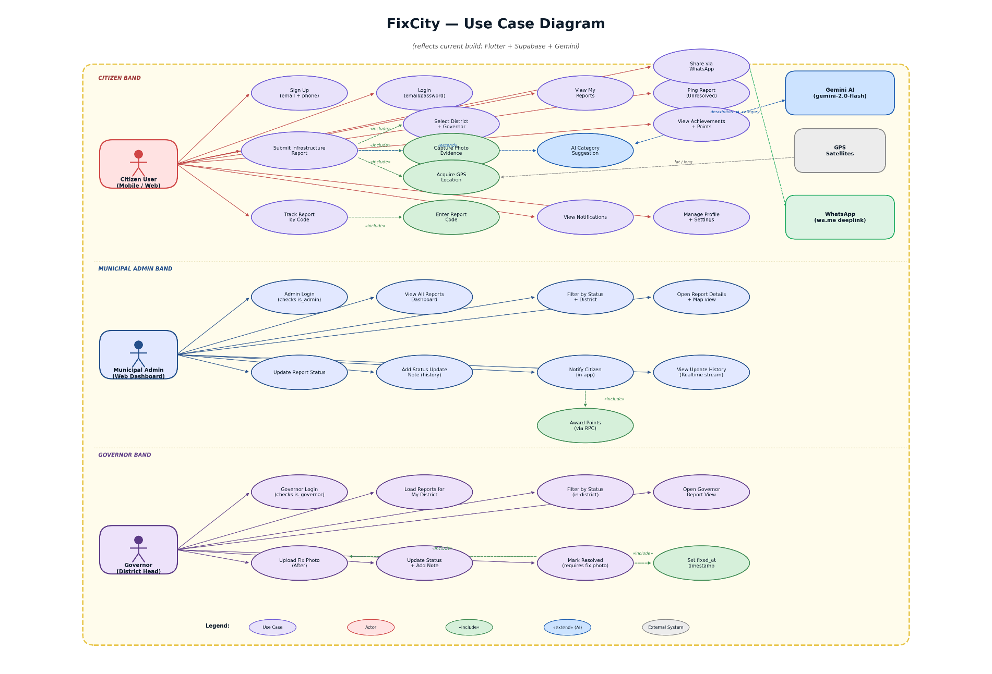

4.5.2 Detailed Use Case Descriptions
Use Case 1: Submit Problem Report
- Actor: Citizen
- Precondition: User has internet access and a compatible device.
- Main Flow:
  - User navigates to the "Submit Report" page.
  - User selects a Category from the dropdown.
  - User enters a Description.
  - User utilizes the "Get Location" button to auto-fill GPS coordinates.
  - User uploads a Photo (optional).
  - User clicks "Submit".
  - System validates input (e.g., checks if description is empty).
  - System saves data to the database with status "New".
  - System displays a "Success" message with the Tracking ID.
Use Case 2: Update Report Status
- Actor: Admin
- Precondition: Admin is logged in.
- Main Flow:
  - Admin views the dashboard list.
  - Admin selects a specific report to view details.
  - Admin changes the status dropdown (e.g., from "New" to "In Progress").
  - Admin adds an optional note (e.g., "Maintenance crew dispatched").
  - Admin clicks "Update".
  - System updates the database record.
  - System triggers an in-app notification to the original reporter.

4.6 Data Modeling
The system's data integrity relies on a robust relational database design. The core entities and their attributes are defined below.

4.6.1 Data Dictionary
Entity: auth_users
Description: Managed by Supabase Auth. Stores authenticated user account credentials.
- id (UUID, PK): Supabase Auth UID — unique identifier for every registered user.
- email (String): User's email address.
- last_sign_in (Timestamp): Most recent login timestamp.
Entity: profiles
Description: Stores extended user metadata, gamification data, and role flags.
- id (UUID, PK/FK): References auth_users.id — one-to-one relationship.
- full_name (String): Citizen's display name.
- phone (String): Contact number.
- is_admin (Boolean): Role flag identifying administrator accounts.
- is_governor (Boolean): Role flag identifying governor (district head) accounts.
- governor_district (String): District assigned to this governor.
- points (Integer): Gamification points incremented via RPC.
- sms_enabled (Boolean): SMS notification preference.
- created_at (Timestamp): Account creation date.
Entity: reports
Description: The central entity storing the details of reported infrastructure issues.
- id (UUID, PK): Unique identifier for the report.
- report_code (String): 10-character unique alphanumeric code generated on submission.
- user_id (UUID, FK): References auth_users.id — the user who submitted the report (nullable for anonymous submissions).
- category (String): Problem category key (e.g., cat_pothole, cat_trash, cat_lighting, cat_sewage, cat_water, cat_other).
- description (Text): User-provided details of the issue.
- photo_url (String): URL to the before-photo in Supabase Storage (files/reports/).
- fix_photo_url (String): URL to the after-photo uploaded by the governor upon resolution (files/fix_photos/).
- latitude / longitude (Float): Precise GPS coordinates (Precision 6).
- status (Enum): pending | in_progress | resolved.
- district (String): Administrative district of the report.
- governor_name / governor_phone (String): Assigned governor's contact details.
- ping_count (Integer): Number of times other users have endorsed this report as unresolved.
- fixed_at (Timestamp): Set when status transitions to resolved.
- created_at (Timestamp): Report submission timestamp.
Entity: status_updates
Description: An append-only audit table tracking the history of all changes for each report.
- id (Bigserial, PK): Auto-incrementing log ID.
- report_id (UUID, FK): References reports.id.
- text (Text): The status update note or message added by the official.
- updated_by (String): Identifier for the official making the change ("admin" or "governor").
- updated_at (Timestamp): Timestamp of the update.
Entity: notifications
Description: Stores in-app notifications delivered to users on report status changes.
- id (Bigserial, PK): Auto-incrementing notification ID.
- user_id (UUID, FK): References auth_users.id — the recipient of the notification.
- report_id (UUID, Soft FK): References reports.id — the report that triggered the notification (nullable).
- title (String): Notification heading.
- body (Text): Full notification message.
- is_read (Boolean): Read status, default false.
- created_at (Timestamp): Notification creation timestamp.

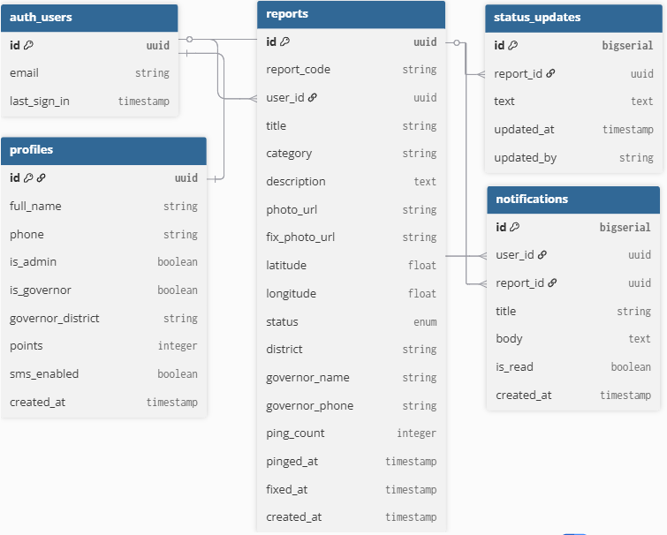
4.6.2 Entity Relationships
Figure 4: Entity Relationship Diagram (ERD)

- auth_users — profiles: One-to-One. Every authenticated user has exactly one profile record that stores their role flags and gamification points.
- auth_users — reports: One-to-Many. A user can submit multiple reports; each report belongs to one user (nullable for anonymous submissions).
- reports — status_updates: One-to-Many. A single report can accumulate multiple status update entries over its lifecycle.
- auth_users — notifications: One-to-Many. A user receives multiple notifications across different reports.
- reports — notifications: One-to-Many. A single report can trigger multiple notifications (e.g., on status change, on resolution).

5. System Design & Implementation

5.1 Introduction
Following the rigorous analysis of system requirements, this chapter details the architectural design and technical implementation of the FixCity platform. It outlines the structural framework of the application, utilizing a layered architecture to ensure scalability and maintainability. The chapter provides an in-depth examination of the User Interface (UI) design principles that guide the citizen experience. Furthermore, it documents the specific technologies employed for development—from the Supabase backend to the Flutter interface—including the AI integration layer using Google Gemini.

5.2 System Architecture
FixCity adopts a modern Client-Server Architecture utilizing a Backend-as-a-Service (BaaS) model.
Figure 5: System Architecture Data Flow Diagram (DFD)
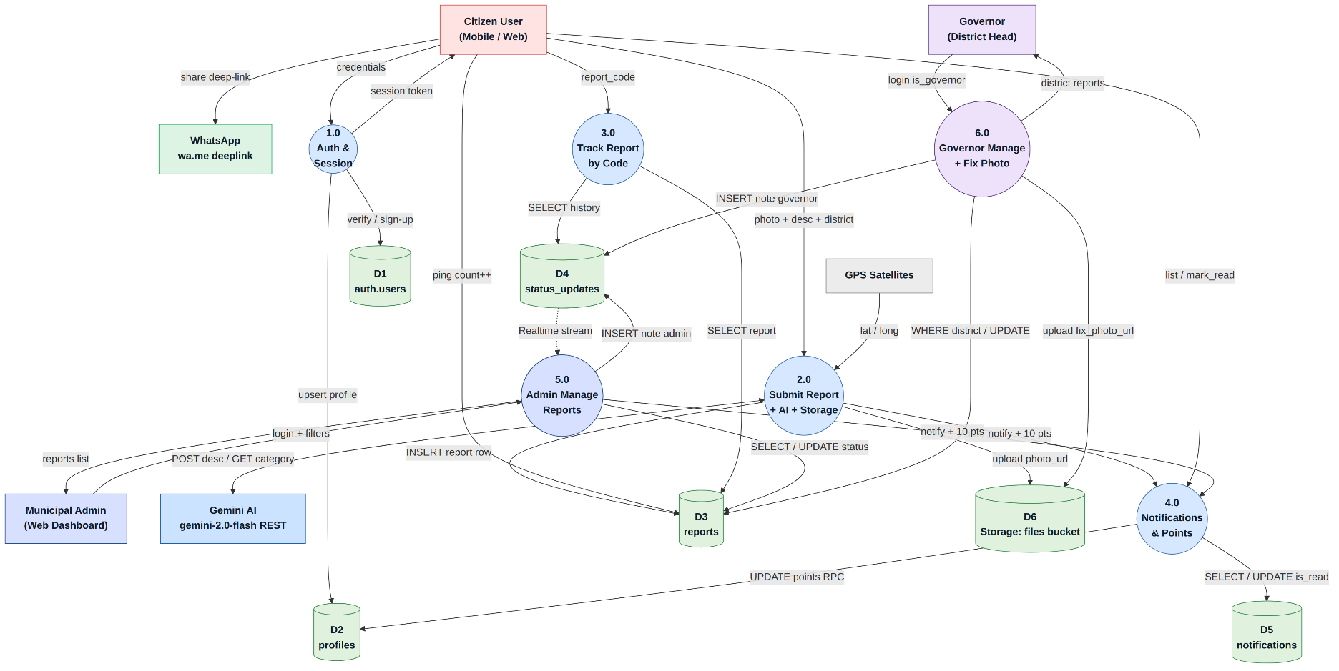

5.2.1 Client Layer (Mobile App)
The client side is a native mobile application built with Flutter.
- State Management: The app utilizes local state management to handle user inputs (forms, photos) before submission.
- UI Components: Custom widgets are designed using Material Design principles to ensure intuitive navigation.
- Function: The app handles GPS data acquisition directly from the device sensors and compresses images before upload to save bandwidth.

5.2.2 Backend Layer (Supabase)
The backend logic is offloaded to the Supabase cloud infrastructure.
- Database: A relational PostgreSQL database stores user profiles, report details, and status logs.
- Storage Buckets: A dedicated object storage bucket named "files" handles the hosting of evidence photos uploaded by users.
- Authentication: Secure user sessions are managed via Supabase Auth (supporting Email/Password logins).

5.2.3 Data Layer (Persistence)
The Data Layer is responsible for the persistent storage and retrieval of all application data, including user credentials, problem reports, and audit logs.
- Database Engine: The system utilizes PostgreSQL, hosted on the Supabase cloud platform. PostgreSQL was selected for its robust support for geospatial data, which is essential for storing and querying the location data of infrastructure reports.
- Data Consistency: By using PostgreSQL for both development and production environments, the system eliminates compatibility issues, ensuring a seamless deployment pipeline.
- Data Access: The application interacts with the database using the Supabase Flutter SDK, performing CRUD operations using secure, parameterized API calls that prevent SQL injection vulnerabilities while mapping database rows directly to Dart objects.

5.2.4 AI Integration Layer (Google Gemini)
A fourth functional layer integrates artificial intelligence into the reporting workflow. The system uses the Google Gemini 2.0 Flash API to automatically classify citizen reports into the appropriate problem category based on natural language descriptions submitted in Arabic or English.
- Primary Mode: The citizen types a title and description. The app sends this text to the Gemini API via HTTP POST. Gemini returns one of six category keys (cat_pothole, cat_trash, cat_lighting, cat_sewage, cat_water, cat_other), and the app auto-selects the matching category tile with a sparkle badge indicating AI selection.
- Fallback Mode: If the Gemini API is unavailable (CORS restriction on web, network error, or timeout), the system silently falls back to an offline keyword-matching classifier that recognizes problem-related vocabulary in both Arabic and English, ensuring uninterrupted functionality in any environment.
This dual-mode approach was a key differentiator recognized by the Gemini for Graduation Projects program, as it ensures the AI feature delivers value regardless of network conditions — a critical consideration for real-world deployment in areas with variable connectivity.

5.3 User Interface Design
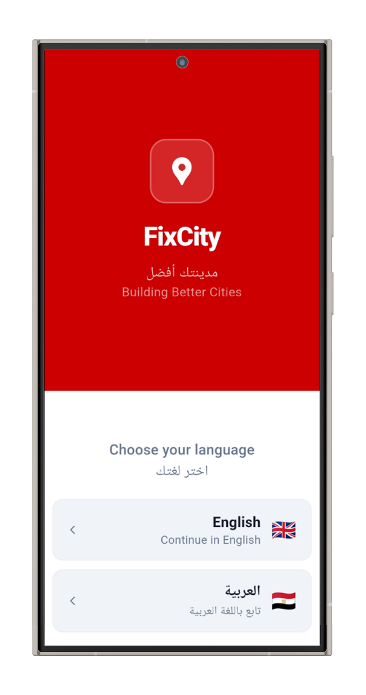
The design philosophy for FixCity prioritizes Simplicity and Accessibility. Given that the primary use case involves users reporting issues while outdoors, the interface must be intuitive and legible under various lighting conditions.
Figure 6: Mobile App Title Screen

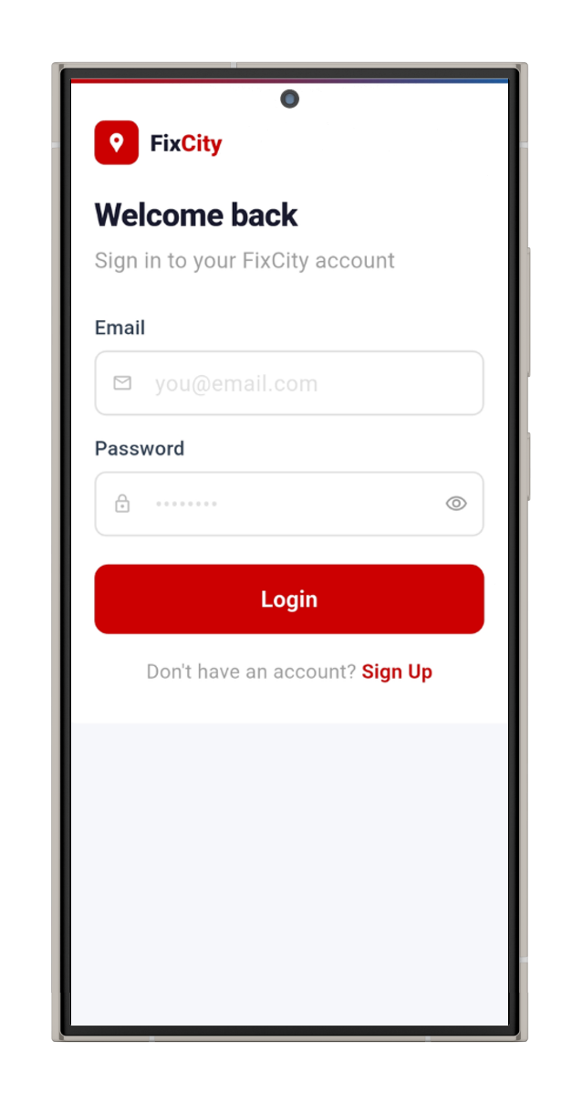
Figure 7: Sign In / Sign Up Screen
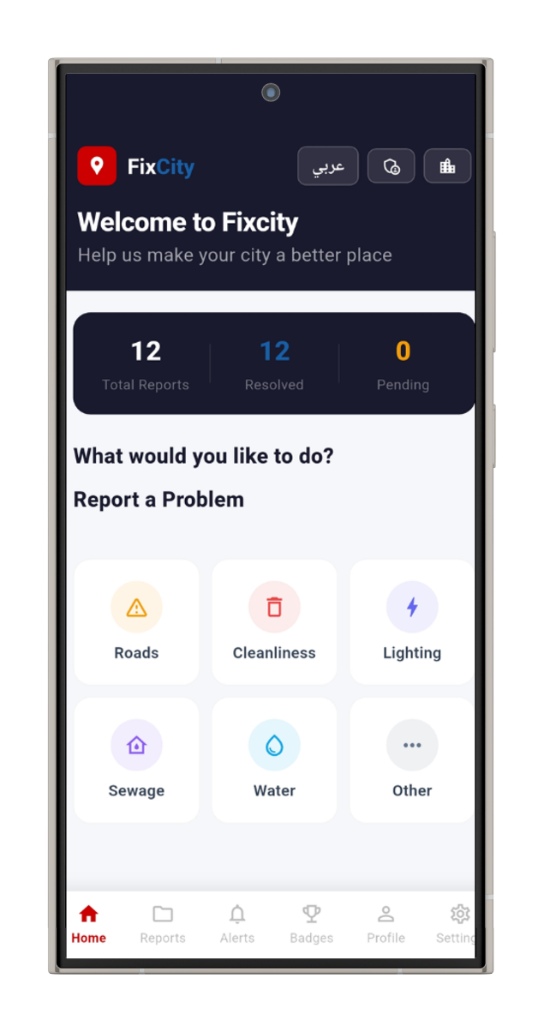
Figure 8: Home Page Dashboard

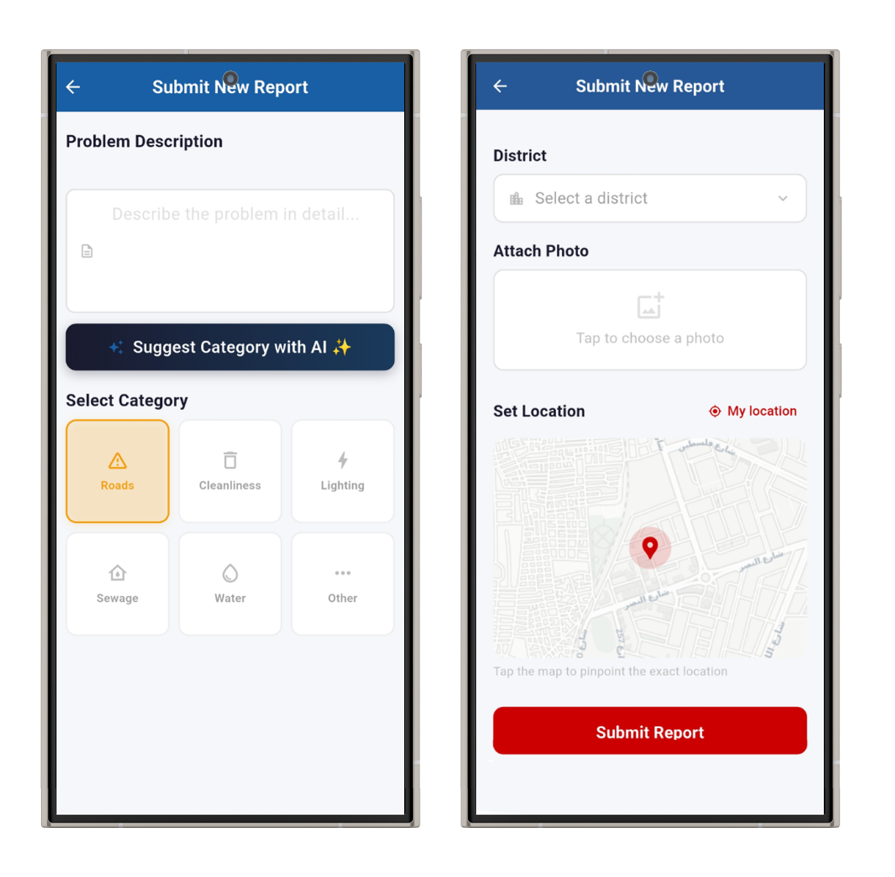
Figure 9: Report Submission Interface

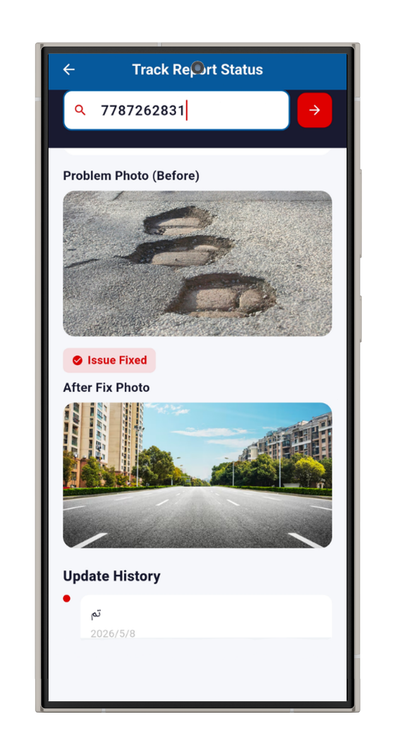
Figure 10: Status Tracking

5.3.1 Homepage & Reporting Form
The homepage serves as the primary entry point. It features a clean header with project branding and a prominent "Submit Report" form.
- Category Selection: A dropdown menu allows users to categorize the issue (e.g., "Pothole," "Street Light").
- Geolocation: A "Get Location" button utilizes the device's native Geolocation sensors to automatically populate the latitude and longitude fields, reducing user error.
- Photo Upload: An integrated file picker allows users to attach photos directly from their device's camera or gallery, with a preview capability to confirm the image before submission.

5.3.2 Submission Confirmation
Upon successful submission, the user is redirected to a confirmation page. This page displays a success message and, crucially, the generated Tracking ID. Clear instructions are provided on how to use this ID to check for future updates.

5.3.3 Administrative Dashboard
The admin dashboard is a restricted area accessible only to municipal workers via secure login.
- Table View: It presents a comprehensive table of all submitted reports, sortable by date and status.
- Filtering: Admins can filter the view to see only "New" reports or reports specific to a certain category (e.g., "Sanitation").
- Quick Actions: Action buttons allow for rapid status updates (e.g., marking a report as "Resolved"), which automatically updates the audit trail.

5.3.4 Status Tracking Page
This public-facing page allows citizens to enter their Tracking ID to view the lifecycle of their report.
- Visual Timeline: A graphical timeline displays the report's journey from "Submitted" to "In Review" to "Resolved".
- Admin Feedback: Any notes added by municipal workers (e.g., "Scheduled for repair on Monday") are visible here, enhancing transparency.

5.4 Implementation Details

5.4.1 Development Environment
The project was developed using Visual Studio Code equipped with the Dart and Flutter extensions. The application was tested on both Android Emulators and physical Android devices (Samsung Galaxy A346E, Android 14) to ensure hardware compatibility with Camera and GPS features.

5.4.2 Database Schema Implementation
Table 3: Database Schema
Table | Primary Key | Foreign Keys | Key Fields
auth_users | id (uuid) | — | email, last_sign_in
profiles | id (uuid) | id → auth_users.id | is_admin, is_governor, points
reports | id (uuid) | user_id → auth_users.id | report_code, status, category, photo_url
status_updates | id (bigserial) | report_id → reports.id | text, updated_by, updated_at
notifications | id (bigserial) | user_id → auth_users.id, report_id → reports.id | title, body, is_read

Row Level Security (RLS) policies are enforced on all tables. While anyone can insert a report, only authorized admins can update the status field. Storage policies allow public read access for report photos, but upload access is restricted to authenticated sessions.

5.4.3 Security Measures
- Row Level Security (RLS): Logic is enforced at the database layer, ensuring that even if the client app is compromised, unauthorized users cannot modify data.
- Secure API Keys: The application utilizes anonymous public keys for standard requests, while service-role keys are kept strictly on the server side for administrative tasks.

5.5 Testing and Quality Assurance
To ensure system reliability, a structured testing plan was executed. Detailed results are presented in Chapter 6.
- Unit Testing: Individual components, such as the Tracking ID generator and database models, were tested in isolation to verify they function correctly.
- Integration Testing: The interaction between the frontend forms and the backend database was tested to ensure data is correctly captured, stored, and retrieved.
- User Acceptance Testing (UAT): The system was presented to a group of 6 participants representing target demographics to gather feedback on usability and identify workflow bottlenecks.

5.6 Deployment Strategy
- Client Side: The Flutter application is compiled into an APK/AAB file, signed with a release key, and deployed to the Google Play Store for public download. ADB wireless debugging was used during development for physical device testing.
- Server Side: The backend logic is deployed to Supabase Cloud. Database migrations are managed via the Supabase CLI, ensuring that the production database schema remains consistent with the development environment.

5.7 Conclusion and Future Work
FixCity successfully demonstrates that digital transformation in the public sector does not require massive budgets or complex infrastructure. By delivering a functional, user-friendly mobile application, this project provides a blueprint for how Egyptian municipalities can modernize their operations using accessible technology.
Proposed future enhancements include: Advanced Push Notifications via Firebase Cloud Messaging (FCM); GIS Integration providing a visual heat map of infrastructure problems; and AI-powered photo analysis using Gemini Vision to automatically assess damage severity from uploaded photos.

6. Testing & Quality Assurance

6.1 Testing Strategy
The testing strategy for FixCity followed a structured, multi-phase approach. Testing was conducted in two environments: Google Chrome browser via flutter run -d chrome for rapid iteration, and a physical Samsung Galaxy A346E (Android 14) for real-world validation of GPS, camera, and touch interactions.

6.2 Unit Testing
Unit tests verified the correctness of isolated functions and logic components without dependency on external services.
Table 4: Unit Test Results
Test ID | Component | Test Description | Expected Result | Status
UT-01 | Report Code Generator | Generate 10 codes, verify uniqueness | All unique, 10 chars, uppercase | PASS
UT-02 | AI Keyword Classifier | Input: Arabic pothole text | Returns cat_pothole | PASS
UT-03 | AI Keyword Classifier | Input: "broken street light" | Returns cat_lighting | PASS
UT-04 | AI Keyword Classifier | Input: Arabic water leak text | Returns cat_water | PASS
UT-05 | AI Keyword Classifier | Input: "unrelated text xyz" | Returns cat_other | PASS
UT-06 | Form Validation | Submit with empty description | Prevents submission, error shown | PASS
UT-07 | Form Validation | Submit with no category selected | Prevents submission, error shown | PASS
UT-08 | Form Validation | Submit with no photo attached | Prevents submission, error shown | PASS
UT-09 | Language Toggle | Switch Arabic to English | LTR layout, labels in English | PASS
UT-10 | Language Toggle | Switch English to Arabic | RTL layout, labels in Arabic | PASS
UT-11 | Problem.fromSupabase() | Parse Supabase JSON response | All fields correctly mapped | PASS
UT-12 | Status Color Mapping | Map pending to expected color | Returns amber Color(0xFFF59E0B) | PASS

6.3 Integration Testing
Integration tests validated the correct interaction between the Flutter frontend and the Supabase backend across the full system stack.

Table 5: Integration Test Results
Test ID | Flow | Test Steps | Expected Result | Status
IT-01 | Citizen Registration | Sign up with new email/password | User in Auth, profile created | PASS
IT-02 | Citizen Login | Login with valid credentials | Session created, go to HomePage | PASS
IT-03 | Admin Login (Valid) | Login with is_admin=true account | Redirected to AdminDashboardPage | PASS
IT-04 | Admin Login (Invalid) | Login with citizen at admin page | Session revoked, Access Denied | PASS
IT-05 | Report Submission | Complete form and submit | Row in DB, photo in storage, code | PASS
IT-06 | Report Tracking (Valid) | Enter valid report code | Report details and timeline shown | PASS
IT-07 | Report Tracking (Invalid) | Enter non-existent code | Error: Report not found | PASS
IT-08 | Admin Status Update | Add update, change to resolved | DB updated, audit entry created | PASS
IT-09 | My Reports | Authenticated citizen opens page | Only user's own reports shown | PASS
IT-10 | Live Stats | Submit report, refresh home | Count incremented correctly | PASS
IT-11 | Gemini AI (Mobile) | Type description, tap AI button | Category auto-selected from Gemini | PASS
IT-12 | AI Fallback (Chrome) | Same test on Chrome browser | Keyword classifier activates | PASS
IT-13 | Photo Upload | Attach 2MB JPEG to report | Photo in Storage, URL in reports | PASS
IT-14 | Map Interaction | Tap different location on map | Marker moves, coordinates updated | PASS

6.4 User Acceptance Testing (UAT)

6.4.1 UAT Participants
UAT was conducted with 6 participants representing the target user demographics. Participants completed standardized tasks without assistance.

Table 6: UAT Participants
Participant | Age | Technical Level | Device
P1 | 22 | High (Student) | Samsung Galaxy A34
P2 | 45 | Low (Non-tech professional) | iPhone 13
P3 | 31 | Medium (Office worker) | Xiaomi Redmi Note 12
P4 | 19 | High (IT Student) | Samsung Galaxy S23
P5 | 55 | Low (Retired) | Huawei Y9
P6 | 28 | Medium (Engineer) | OnePlus Nord

6.4.2 UAT Task Results
Table 7: UAT Task Results
Task | Description | Completion Rate | Avg. Time | Notes
Task 1 | Select language and proceed to home | 6/6 (100%) | 18 sec | All completed without assistance
Task 2 | Submit report with photo and location | 6/6 (100%) | 2 min 14 sec | P2 needed extra time on photo button
Task 3 | Use AI category suggestion button | 5/6 (83%) | 45 sec | P5 did not understand AI button initially
Task 4 | Track a report using provided code | 6/6 (100%) | 38 sec | All completed quickly
Task 5 | Switch language mid-session | 6/6 (100%) | 12 sec | RTL/LTR switch worked correctly for all
Task 6 | Locate and open My Reports page | 5/6 (83%) | 1 min 2 sec | P5 initially confused with Track Reports

6.4.3 UAT Findings & Actions
- Positive: 100% of participants submitted a report within 3 minutes, validating the UI simplicity goal.
- Positive: AI suggestion button was well-received by technical users, described as impressive and intuitive.
- Action Taken: AI button label updated with sparkle emoji to communicate its AI nature more clearly.
- Action Taken: Three-page onboarding sequence added to orient first-time users before reaching the home screen.
- Positive: Language switching was universally successful across all tested devices and screen sizes.

6.5 Device Compatibility Testing
Table 8: Device Compatibility Testing Results
Device | Android Version | Screen Size | Notch Type | Result
Samsung Galaxy A346E | Android 14 | 6.4 inch | Punch-hole | PASS – primary test device
Samsung Galaxy S23 | Android 14 | 6.1 inch | Punch-hole | PASS
Xiaomi Redmi Note 12 | Android 13 | 6.67 inch | Teardrop | PASS
Huawei Y9 | Android 9 | 6.5 inch | Dewdrop | PASS
Google Chrome (PC) | N/A | Various | N/A | PASS – AI uses keyword fallback on web

6.6 Performance Testing
Performance metrics were recorded on the primary test device (Samsung Galaxy A346E) under normal WiFi conditions.
Table 9: Performance Testing Results
Metric | Target | Measured Result | Status
Cold app launch time | < 3 sec | 1.8 sec | PASS
Report submission (with photo) | < 10 sec | 4.2 sec avg | PASS
Map tile loading | < 3 sec | 2.1 sec (WiFi) | PASS
Report tracking query | < 2 sec | 0.9 sec avg | PASS
Home stats loading | < 2 sec | 1.1 sec avg | PASS
Admin dashboard (20 reports) | < 3 sec | 1.4 sec | PASS
AI classification (Gemini API) | < 8 sec | 2.3 sec avg | PASS
AI fallback (keyword matching) | < 0.1 sec | < 0.01 sec | PASS

6.7 Security Testing
- Unauthorized Admin Access: Direct navigation to /admin/dashboard without auth redirects to login — PASS
- Citizen Admin Attempt: Citizen account at admin login is immediately signed out with Access Denied — PASS
- Data Isolation: My Reports only returns the authenticated user's own reports — PASS
- RLS Enforcement: Direct API calls attempting to UPDATE status without admin credentials rejected with 403 — PASS
- API Key Security: No service-role keys found in client source code — PASS

7. Conclusion & Future Work

7.1 Project Summary
This project addressed a well-documented but largely unresolved challenge in Egyptian urban governance: the inefficient and inaccessible communication channel between citizens and municipal authorities for infrastructure problem reporting. The result is FixCity, a fully functional, bilingual, AI-enhanced mobile platform that democratizes the reporting process and provides municipal workers with a structured, real-time management tool.
The platform was accepted into the Gemini for Graduation Projects program (Cohort III) by Gemini Africa, in collaboration with the Academy of Scientific Research and Technology — recognition that validates both the technical quality and the social impact potential of the solution.

7.2 Achievement of Objectives
Table 10: Achievement of Objectives
Objective | Achievement | Status
Native mobile app for geo-tagged reports | Flutter app with GPS map picker and camera, deployed to Android | Achieved
Unique tracking code per report | 10-character alphanumeric code generated on submission | Achieved
AI-powered category classification | Google Gemini 2.0 Flash API with offline keyword fallback | Achieved
Role-based admin dashboard | Admin panel with RLS, filters, status management, real-time updates | Achieved
Bilingual Arabic/English support | Full RTL/LTR dynamic switching with custom translation map | Achieved
Security and data access control | Supabase RLS + is_admin role check on all admin routes | Achieved
Deploy to physical Android devices | Signed APK tested on Samsung A346E and four additional devices | Achieved

7.3 Research Contributions
- BaaS for civic technology: Demonstrates enterprise-grade features without dedicated server infrastructure, a reusable pattern for resource-constrained public sector projects.
- Dual-mode AI classification: Cloud AI with offline keyword fallback provides a reliable AI integration pattern for applications in varying network conditions.
- Bilingual Flutter architecture: Dynamic RTL/LTR implementation demonstrates a practical approach to Arabic/English bilingual mobile applications.
- Egyptian municipal technology blueprint: A cost-effective model for modernizing urban management workflows in small-to-medium Egyptian municipalities.

7.4 Limitations
- No Push Notifications: Citizens must actively open the app to check status; Firebase Cloud Messaging is planned for Phase 2.
- No Offline Support: Requires active internet connection; offline draft-with-later-sync is planned for Phase 2.
- AI Web Limitation: Gemini API is blocked by CORS in Chrome; keyword fallback activates seamlessly but Gemini classification is Android-only.
- Single Municipality Scope: Current architecture supports one municipality; multi-tenant support requires database restructuring.
- Manual Admin Account Creation: Admin accounts must be created manually in Supabase; no self-service invitation flow exists.

7.5 Future Work

7.5.1 Phase 2 Features (Short-Term)
- Push Notifications: Firebase Cloud Messaging for instant citizen alerts on status changes and admin notifications.
- AI Photo Analysis: Extend Gemini to analyze uploaded photos using Gemini Vision for damage classification.
- GIS Heat Map Dashboard: Admin-facing map view showing geographic distribution of reports.
- Offline Mode: Local SQLite caching for offline report drafting with automatic submission on reconnect.

7.5.2 Phase 3 Features (Long-Term)
- Multi-Municipality Support: Multi-tenant architecture for different municipalities with isolated data environments.
- Municipality ERP Integration: REST API layer enabling FixCity to push data into existing municipal systems.
- Advanced Analytics Dashboard: Data visualization showing resolution times, hotspots, and seasonal trends for municipal administrators.
- iOS Support: Expansion of the Flutter application to iOS with App Store deployment.

7.6 Final Conclusion
FixCity demonstrates that meaningful digital transformation in public services does not require massive budgets, proprietary infrastructure, or years of development. By combining Flutter's cross-platform capabilities, Supabase's zero-infrastructure backend, and Google Gemini's artificial intelligence, the team delivered a production-ready platform that is functional, secure, bilingual, and genuinely useful.
The platform directly addresses the Digital Divide identified in Chapter 1, where national digital transformation goals have not yet reached the last mile of municipal management. Every citizen with a smartphone can now report an infrastructure problem in under 3 minutes, in their preferred language, with GPS precision and photo evidence. Every municipal worker can manage, respond to, and resolve those reports from a clean, mobile-first dashboard.
The acceptance of this project into the Gemini for Graduation Projects program validates its real-world applicability and positions FixCity not merely as an academic exercise, but as a genuine foundation for civic technology in Egypt. In alignment with the United Nations Sustainable Development Goals, specifically SDG 11 (Sustainable Cities and Communities) and SDG 16 (Peace, Justice and Strong Institutions), FixCity represents a meaningful, scalable, and technically sound contribution to Egypt's journey toward a smarter, more transparent, and more accountable urban future.

8. References
[1] Supabase Inc. (2024). Supabase Documentation: The Open Source Firebase Alternative. Retrieved from https://supabase.com/docs
[2] "Digital Government in Egypt: Challenges and Opportunities," International Journal of Public Administration, 2022.
[3] mySociety. (2023). FixMyStreet Platform Documentation.
[4] "Business Process Digitalization in Public Sector," Journal of Government Information Systems, 2021.
[5] Google LLC. (2024). Flutter Framework Documentation. Retrieved from https://docs.flutter.dev
[6] "Municipal Service Delivery in Urban Egypt," Cairo University Urban Studies Journal, 2022.
[7] Google LLC. (2024). Gemini API Documentation: Generative Language Models. Retrieved from https://ai.google.dev/docs
[8] Gemini Africa & Academy of Scientific Research and Technology. (2025). Gemini for Graduation Projects Program — Cohort III. Egypt: Academy of Scientific Research and Technology.

9. Appendices

Appendix A: User Survey Questionnaire and Results Summary
A quantitative survey was conducted to validate the problem statement and assess the market readiness for a mobile reporting solution. The survey received 167 responses from urban residents.
Key Findings Summary:
- Public Need: 100% of respondents stated they have faced public infrastructure issues (broken lights, road damage, waste).
- Current Behavior: The "Silent Majority" phenomenon was confirmed, with 88.2% of respondents indicating they usually "Do not report" issues due to the lack of accessible channels.
- Device Preference: A significant majority (94.1%) prefer using a Mobile Phone for reporting over computers or laptops.
- Solution Acceptance: 100% of participants confirmed they would use an online platform like FixCity if it were available.
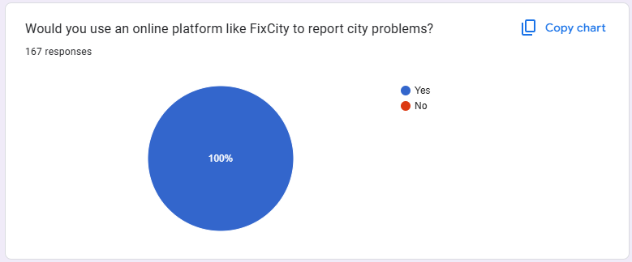
Figure 11: Survey Response – User Preference on Application Type

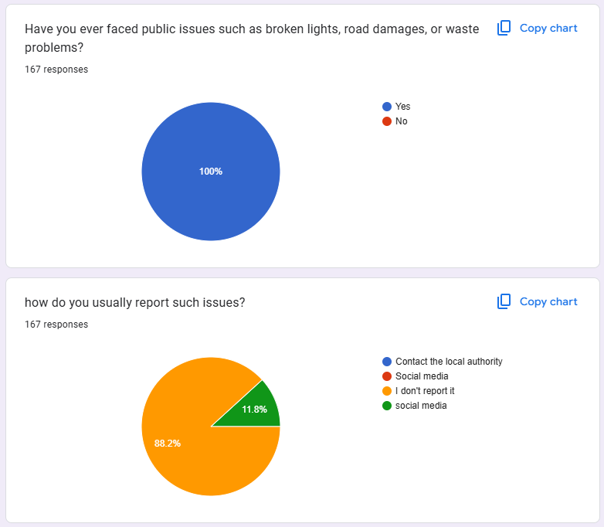
Figure 12: Survey Response – User Preference on Device for reporting

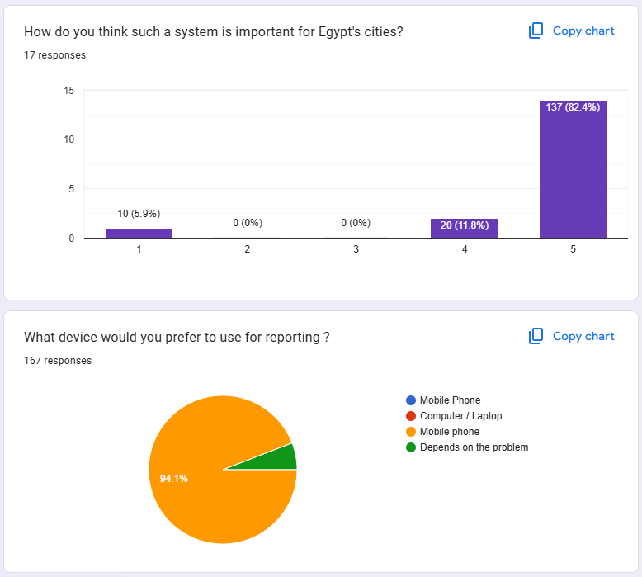
Figure 13: Survey Response – User Experience on Infrastructure Problems & Reports

Appendix B: System Implementation Timeline and Task Breakdown
Based on the phased implementation strategy outlined in Chapter 3, the following timeline projects the rollout of the FixCity platform over a 12-month period.
Table 11: System Implementation Timeline (Phased Rollout)
Phase | Duration | Key Activities | Deliverables
Phase 1: Awareness | Months 1–3 | Finalizing MVP development; presentations to local council members; digital social media outreach | Fully tested APK; Project Documentation; Marketing Materials
Phase 2: Pilot | Months 4–6 | Beta deployment in one partner municipality; training municipal staff; collecting real-world user feedback | Pilot Case Study; Performance Metrics Report; First 500 Active Users
Phase 3: Expansion | Months 7–12 | Regional rollout to adjacent districts; integration of advanced features (Push Notifications); partnership with local NGOs | Version 2.0 Release; 5,000 Active Users; Revenue Generation

Appendix C: Database Schema Detailed Design
The backend utilizes a relational PostgreSQL database hosted on Supabase. The following details the core table structures utilized in the MVP.
1. Table: profiles
- id (UUID, PK): Links to Supabase Auth ID.
- full_name (Text): Citizen's display name.
- is_admin (Boolean): Role flag identifying administrator accounts.
- is_governor (Boolean): Role flag identifying governor accounts.
- created_at (Timestamp): Account creation date.
2. Table: reports
- id (UUID, PK): Unique identifier for the report.
- user_id (UUID, FK): Reference to the submitting user (auth_users.id).
- category (Text): Problem category key (e.g., cat_pothole, cat_trash, cat_lighting).
- description (Text): User-provided details.
- latitude/longitude (Float): Precise GPS coordinates (Precision 6).
- photo_url (Text): URL to the report image in Supabase Storage.
- fix_photo_url (Text): URL to the resolution image uploaded by the governor.
- status (Enum): pending | in_progress | resolved.

3. Table: status_updates
- id (Bigserial, PK): Auto-incrementing log ID.
- report_id (UUID, FK): The report being updated.
- updated_by (Text): Identifier for the official making the change ("admin" or "governor").
- text (Text): The status update note or message added by the official.

Appendix D: User Interface Mockups and Wireframes
The design process utilized Figma to create high-fidelity prototypes prior to Flutter development. This ensured the "Simplicity and Accessibility" philosophy was met before writing a single line of code.
Interactive Prototype: View on Figma
Key Screens Included:
- Authentication: Login/Sign-up flows supporting secure access.
- Home Dashboard: Quick access to "Submit Report" and "Track Status".
- Reporting Interface: GPS auto-detection and Camera integration.
- Admin Panel: Map-based filtering of active city issues.

Appendix E: Source Code Documentation and Repository Information
The complete source code for the FixCity mobile application (Flutter) and backend configuration (Supabase) is hosted in a public repository.
Repository URL: https://github.com/moatazahmedshaker/Fixcity
- Platform: GitHub
- Technologies: Dart, Flutter, SQL (PostgreSQL)

Appendix F: Testing Plan and Quality Assurance Procedures
To ensure the reliability of the MVP, the following testing strategies were executed:
1. Unit Testing
- Scope: Individual Dart functions and logic components.
- Key Tests: Validation logic for description fields; GPS coordinate parsing reliability; Tracking ID generation uniqueness.
2. Integration Testing
- Scope: Interaction between Flutter Frontend and Supabase Backend.
- Key Tests: Auth Flow — verifying successful login returns a valid Session Token; Data Persistence — confirming a submitted report appears in the PostgreSQL database; Storage — verifying images are correctly uploaded to the bucket and linked to the report row.

3. User Acceptance Testing (UAT)
- Scope: Usability testing with non-technical users.
- Method: A group of 6 users were asked to complete defined tasks without assistance.
- Result: All users completed the core report submission task in under 3 minutes, validating the UI design.

