# GitHub Repository Links

* Megan’s Link: <https://github.com/mmcginley02/COP3502C_Lab6.git>
* Moataz’s Link: <https://github.com/moatazhikal3/COP3502C.Lab06.git>

# Changes Made by Partner

* Megan’s changes to Moataz’s epo

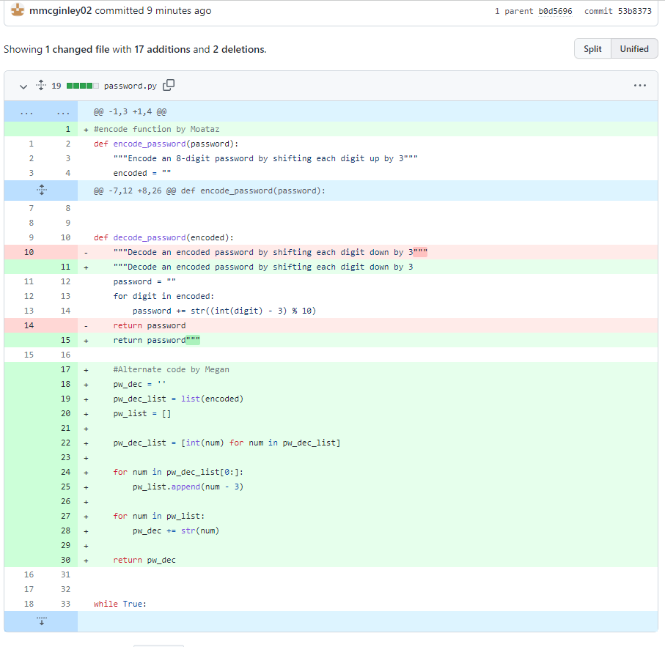

* Moataz’s changes to Megan’s repo

Add screenshot here