Alexandria University  
Faculty of Engineering  
Computer Architecture  
Spring 2025

**Register File Implementation Report**

**1. Student Information**

* **Name:** Waleed Emad Yahyaa
* **ID:** 20012197
* **Name:** Mohamed Atef Yousef
* **ID:** 20011630

**2. Introduction**

In this lab, we designed and implemented a 32-register file using VHDL. The register file allows read and write operations based on a control signal and a clock cycle mechanism. The design ensures that data is written in the first half of the clock cycle and read in the second half.

**3. Design Specifications**

**3.1 Inputs**

* **Three Register Numbers:** Two for reading and one for writing, each consisting of 5 bits.
* **Write Data:** A 32-bit input value to be stored in the selected register.
* **RegWrite Control Line:** Enables the write operation when set to '1'.
* **Clock Signal:** Controls read and write operations, where writing occurs in the first half cycle and reading in the second half.

**3.2 Outputs**

* **Two Read Data Outputs:** Corresponding to the values stored in the registers indexed by the two read addresses.

**4. VHDL Implementation**

The register file was implemented using an array of 32 registers, each 32 bits wide. The design adheres to the following logic:

* Writing occurs when RegWrite = '1' and the clock is in its falling edge.
* Reading occurs asynchronously and outputs the stored values based on the given read addresses.

**VHDL Code**

The complete VHDL implementation is included in the Appendix.

**5. Testbench and Simulation**

To verify the correctness of our design, a testbench was developed covering multiple test scenarios, including:

* Writing and reading from registers.
* Writing to register zero to confirm that it remains zero.
* Performing a read and write operation on the same register in the same clock cycle.
* Disabling the write operation and ensuring no unintended changes occur.

**Simulation Results**

Below are screenshots showing the behavior of the register file during multiple clock cycles. The results confirm that the implementation meets the expected functionality.

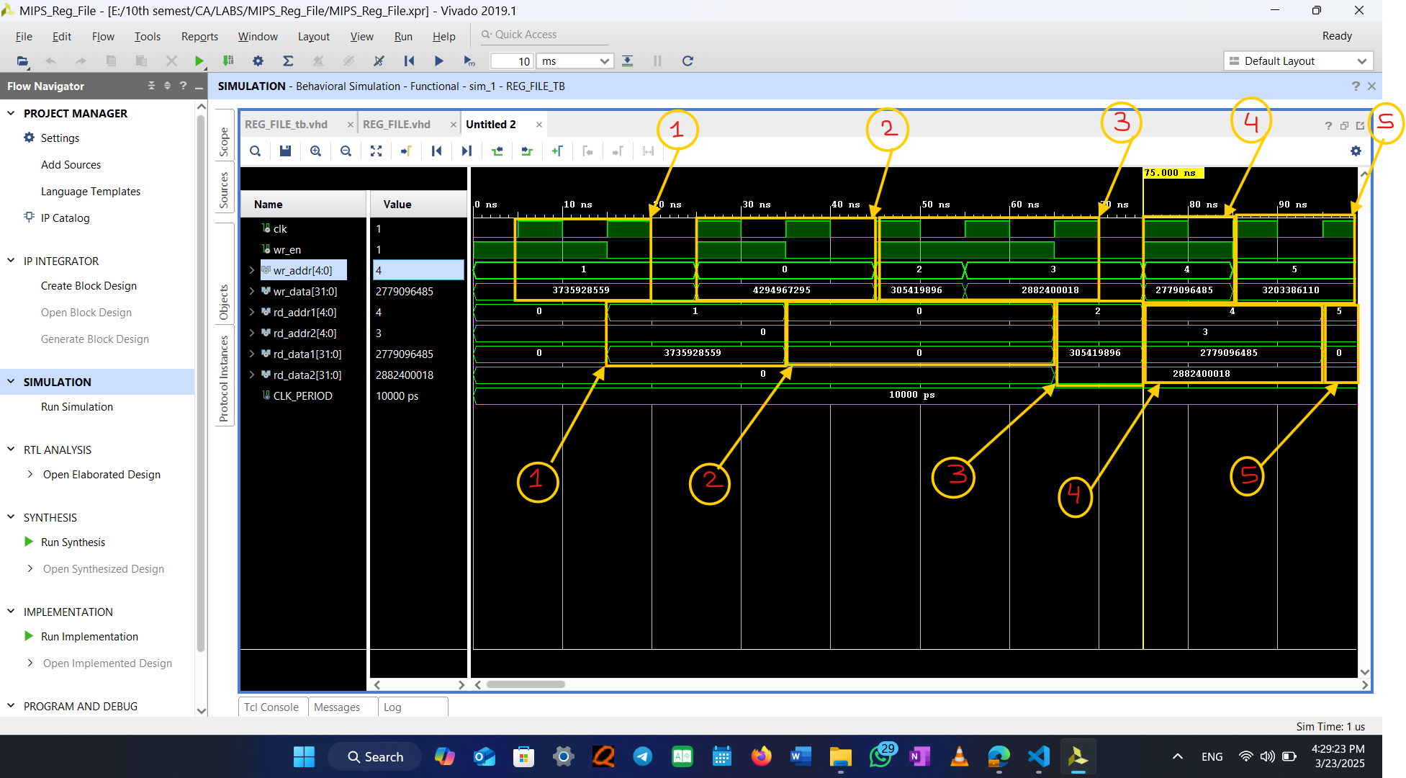

**6. Tools and Environment**

Vivado was used for compilation and simulation.

**7. Submission Details**

The report includes:

* The full VHDL implementation of the register file.
* A detailed testbench covering multiple scenarios.
* Screenshots demonstrating simulation results.
* A link to the complete project repository: <https://github.com/moateff/Computer-Architecture-labs>

**8. Conclusion**

The register file was successfully implemented and tested. The design meets all requirements, ensuring correct read/write operations and handling edge cases effectively.

**Appendix: VHDL Code**

*(Include VHDL code for the register file and testbench here.)*

----------------------------------------------------------------------------------

-- Company:

-- Engineer:

--

-- Create Date: 03/23/2025 04:08:59 AM

-- Design Name:

-- Module Name: REG_FILE - Behavioral

-- Project Name:

-- Target Devices:

-- Tool Versions:

-- Description:

--

-- Dependencies:

--

-- Revision:

-- Revision 0.01 - File Created

-- Additional Comments:

--

----------------------------------------------------------------------------------

library IEEE;

use IEEE.STD_LOGIC_1164.ALL;

use IEEE.NUMERIC_STD.ALL;

-- Uncomment the following library declaration if using

-- arithmetic functions with Signed or Unsigned values

--use IEEE.NUMERIC_STD.ALL;

-- Uncomment the following library declaration if instantiating

-- any Xilinx leaf cells in this code.

--library UNISIM;

--use UNISIM.VComponents.all;

entity REG_FILE is

    Port (

        clk       : in  STD_LOGIC;                      -- Clock signal

        wr_en     : in  STD_LOGIC;                      -- Write enable signal

        wr_addr   : in  STD_LOGIC_VECTOR (4 downto 0);  -- Write address (5-bit)

        wr_data   : in  STD_LOGIC_VECTOR (31 downto 0); -- Write data (32-bit)

        rd_addr1  : in  STD_LOGIC_VECTOR (4 downto 0);  -- Read address 1 (5-bit)

        rd_addr2  : in  STD_LOGIC_VECTOR (4 downto 0);  -- Read address 2 (5-bit)

        rd_data1  : out STD_LOGIC_VECTOR (31 downto 0); -- Read data 1 (32-bit)

        rd_data2  : out STD_LOGIC_VECTOR (31 downto 0)  -- Read data 2 (32-bit)

    );

end REG_FILE;

architecture Behavioral of REG_FILE is

    type reg_array is array (0 to 31) of STD_LOGIC_VECTOR(31 downto 0);

    signal reg_memory : reg_array := (others => (others => '0')); -- Initialize to zeros

begin

    -- Read logic: Outputs data from register memory

    rd_data1 <= reg_memory(to_integer(unsigned(rd_addr1))) when rd_addr1 /= "00000" else (others => '0');

    rd_data2 <= reg_memory(to_integer(unsigned(rd_addr2))) when rd_addr2 /= "00000" else (others => '0');

    -- Write logic: Updates register memory on rising edge of clk

    process (clk)

    begin

        if rising_edge(clk) then

            if wr_en = '1' then

                reg_memory(to_integer(unsigned(wr_addr))) <= wr_data;

            end if;

        end if;

    end process;

end Behavioral;

----------------------------------------------------------------------------------

-- Company:

-- Engineer:

--

-- Create Date: 03/23/2025 02:19:18 PM

-- Design Name:

-- Module Name: REG_FILE_tb - Behavioral

-- Project Name:

-- Target Devices:

-- Tool Versions:

-- Description:

--

-- Dependencies:

--

-- Revision:

-- Revision 0.01 - File Created

-- Additional Comments:

--

----------------------------------------------------------------------------------

library IEEE;

use IEEE.STD_LOGIC_1164.ALL;

use IEEE.NUMERIC_STD.ALL;

use std.textio.all;

entity REG_FILE_TB is

end REG_FILE_TB;

architecture testbench of REG_FILE_TB is

    -- DUT signals

    signal clk      : std_logic := '0';

    signal wr_en    : std_logic := '0';

    signal wr_addr  : std_logic_vector(4 downto 0) := (others => '0');

    signal wr_data  : std_logic_vector(31 downto 0) := (others => '0');

    signal rd_addr1 : std_logic_vector(4 downto 0) := (others => '0');

    signal rd_addr2 : std_logic_vector(4 downto 0) := (others => '0');

    signal rd_data1 : std_logic_vector(31 downto 0);

    signal rd_data2 : std_logic_vector(31 downto 0);

    constant CLK_PERIOD : time := 10 ns;

begin

    -- Instantiate the Register File DUT

    DUT: entity work.REG_FILE

        port map (

            clk      => clk,

            wr_en    => wr_en,

            wr_addr  => wr_addr,

            wr_data  => wr_data,

            rd_addr1 => rd_addr1,

            rd_addr2 => rd_addr2,

            rd_data1 => rd_data1,

            rd_data2 => rd_data2

        );

    -- Clock process

    clk_process: process

    begin

        while now < 500 ns loop  -- Limit simulation time

            clk <= '0';

            wait for CLK_PERIOD / 2;

            clk <= '1';

            wait for CLK_PERIOD / 2;

        end loop;

        wait;

    end process;

    -- Stimulus process

    stimulus_process: process

    begin

        report "Starting REG_FILE Testbench...";

        -- Test Case 1: Write and Read from Register

        wr_en   <= '1';

        wr_addr <= "00001";

        wr_data <= x"DEADBEEF";

        wait for CLK_PERIOD / 2;

        wait for CLK_PERIOD;

        wr_en   <= '0';

        -- Read back the value

        rd_addr1 <= "00001";

        wait for CLK_PERIOD;

        assert rd_data1 = x"DEADBEEF"

            report "Error: Incorrect data read from register!" severity error;

        -- Test Case 2: Writing to Register 0 (Should Remain Zero)

        wr_en   <= '1';

        wr_addr <= "00000";

        wr_data <= x"FFFFFFFF";

        wait for CLK_PERIOD;

        wr_en   <= '0';

        rd_addr1 <= "00000";

        wait for CLK_PERIOD;

        assert rd_data1 = x"00000000"

            report "Error: Register 0 should always be zero!" severity error;

        -- Test Case 3: Multiple Writes and Reads

        wr_en   <= '1';

        wr_addr <= "00010";

        wr_data <= x"12345678";

        wait for CLK_PERIOD;

        wr_addr <= "00011";

        wr_data <= x"ABCDEF12";

        wait for CLK_PERIOD;

        wr_en   <= '0';

        rd_addr1 <= "00010";

        rd_addr2 <= "00011";

        wait for CLK_PERIOD;

        assert rd_data1 = x"12345678"

            report "Error: Incorrect data read from register 2!" severity error;

        assert rd_data2 = x"ABCDEF12"

            report "Error: Incorrect data read from register 3!" severity error;

        -- Test Case 4: Write and Read in the Same Clock Cycle

        wr_en   <= '1';

        wr_addr <= "00100";

        wr_data <= x"A5A5A5A5";

        rd_addr1 <= "00100";

        wait for CLK_PERIOD;

        wr_en   <= '0';

        assert rd_data1 = x"A5A5A5A5"

            report "Error: Failed to read and write in the same cycle!" severity error;

        -- Test Case 5: RegWrite Disabled (wr_en = 0)

        wr_en   <= '0';

        wr_addr <= "00101";

        wr_data <= x"BEEFCAFE";

        wait for CLK_PERIOD;

        rd_addr1 <= "00101";

        wait for CLK_PERIOD;

        assert rd_data1 = x"00000000"

            report "Error: Data should not be written when wr_en is '0'!" severity error;

        report "Testbench Completed Successfully." severity note;

        wait;

    end process;

end testbench;