1. ipconfig command
> ipconfig
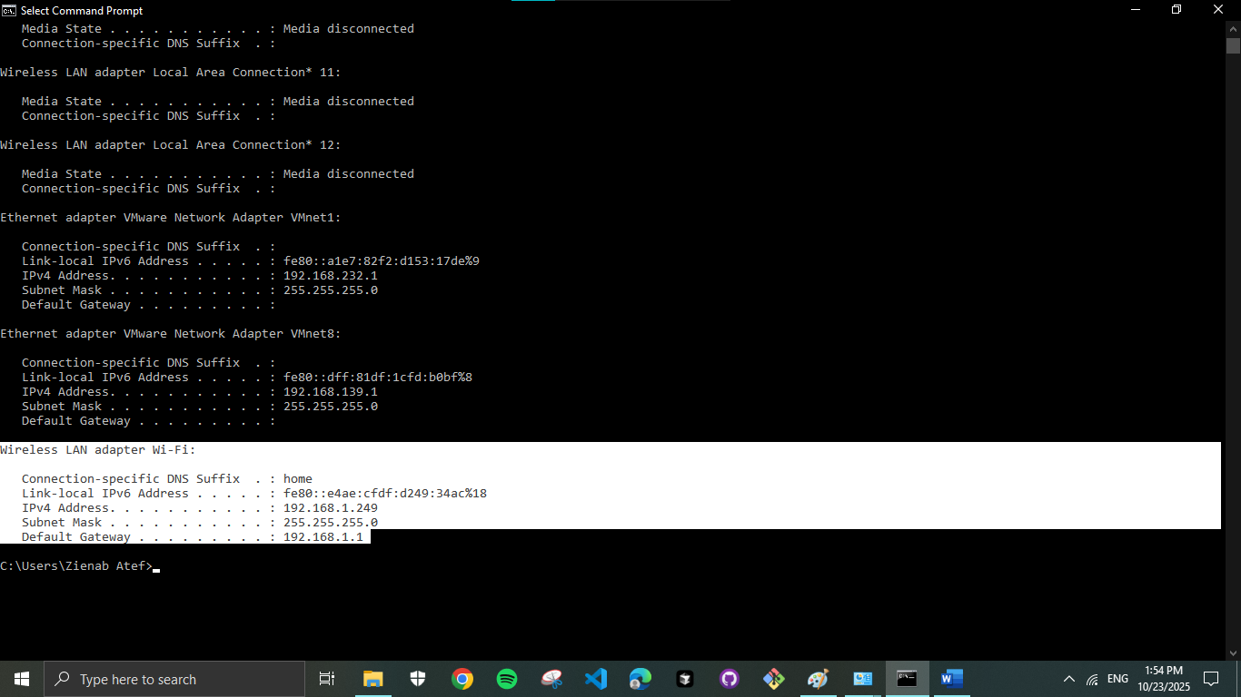

> ipconfig /all
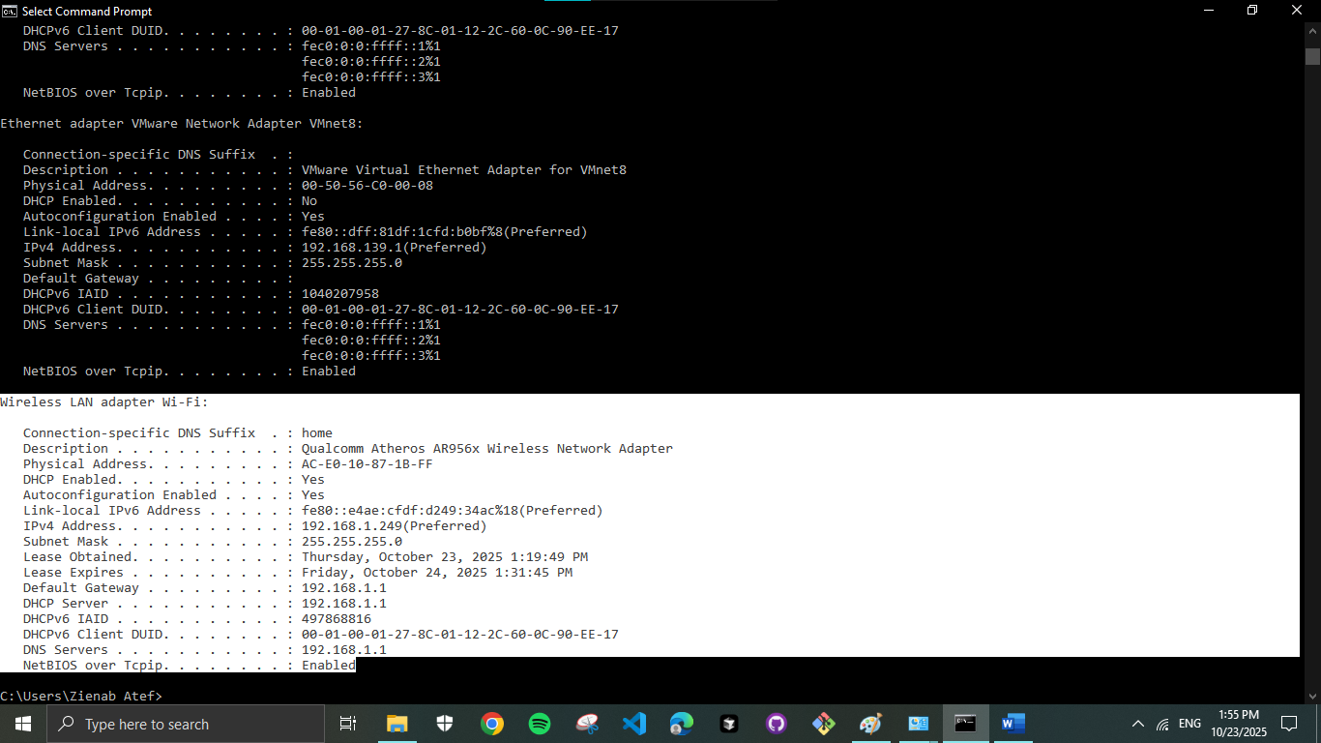

> ipconfig /release
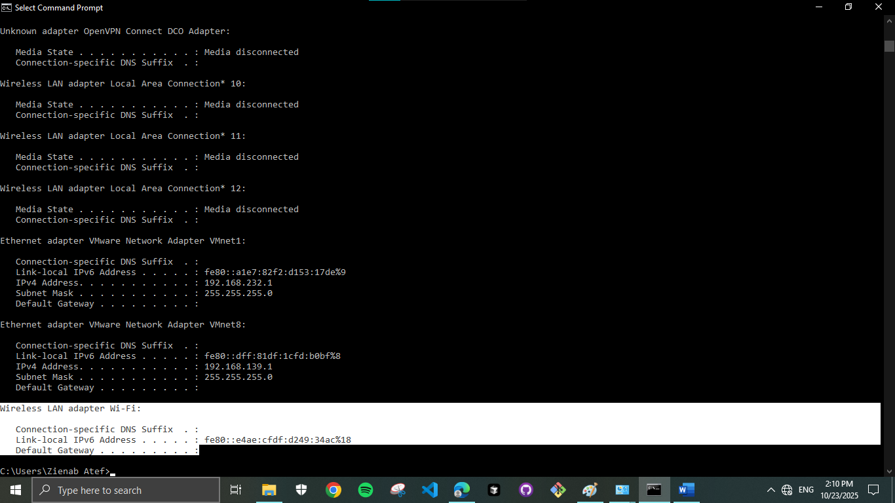

> ipconfig /renew
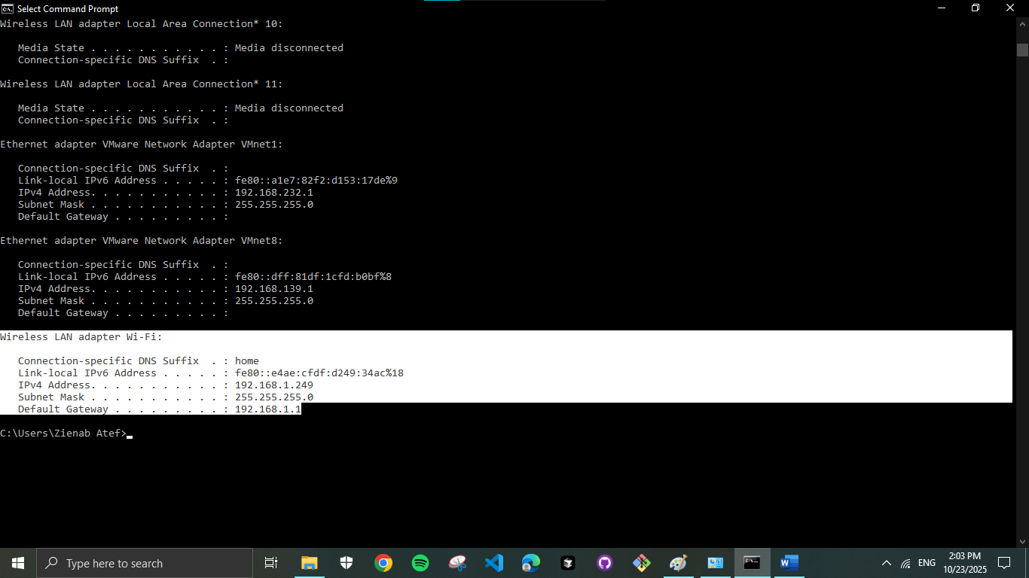

2. Configure IP address manually
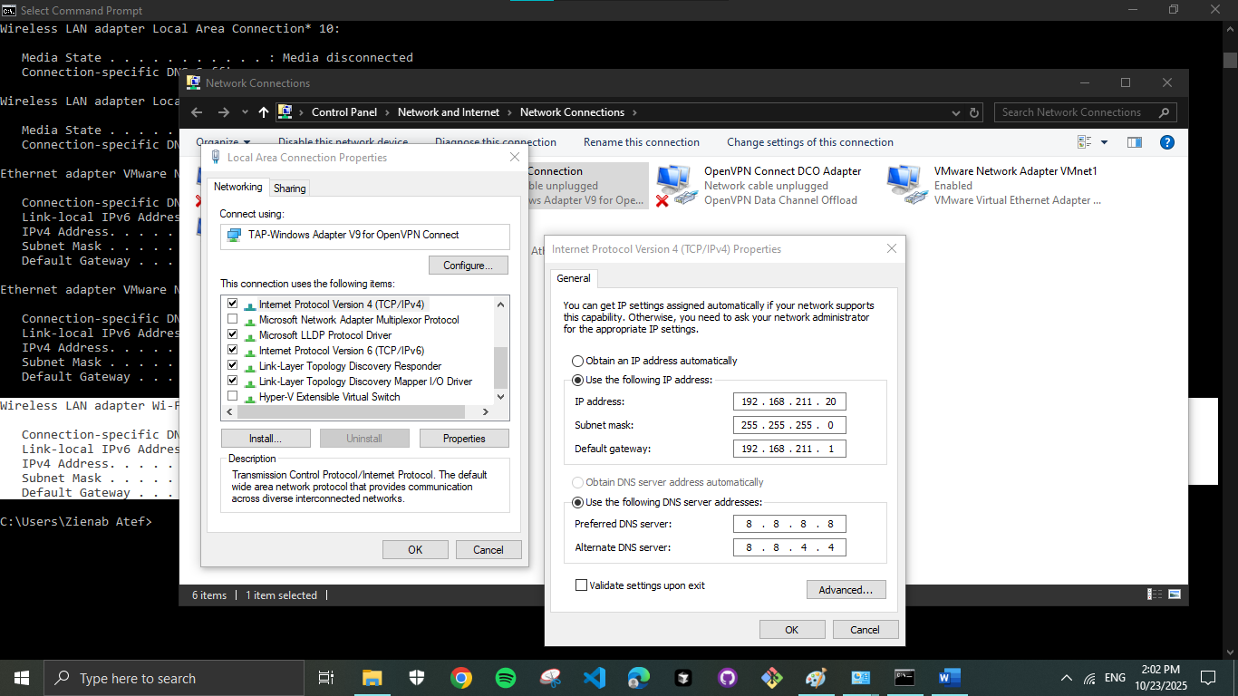

My real IP (static) address
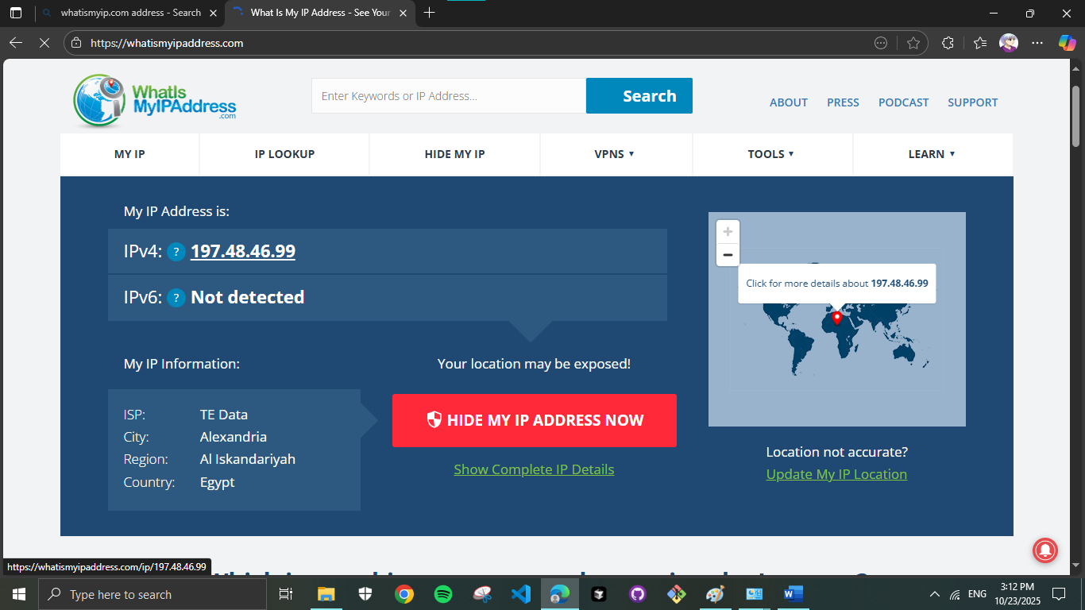

3. ping command
> ping 192.168.1.1
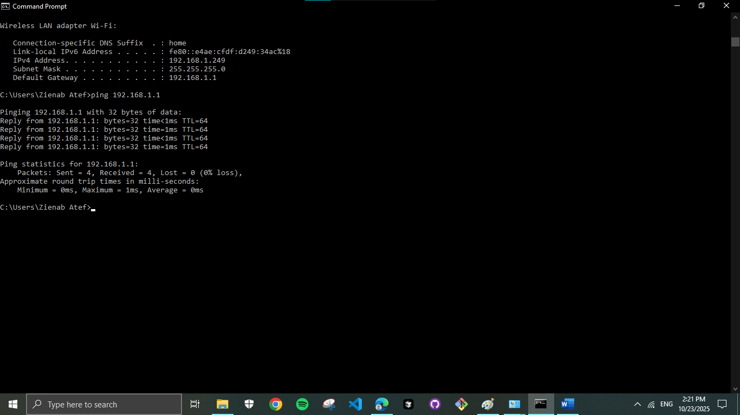

> ping Yahoo.com
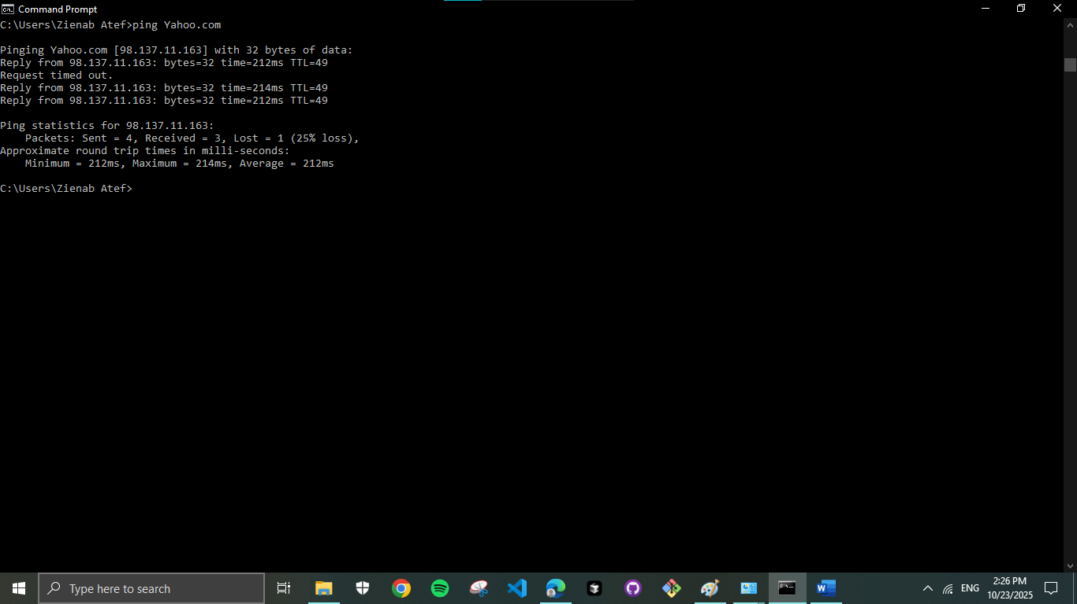

> ping 192.168.1.1 -t
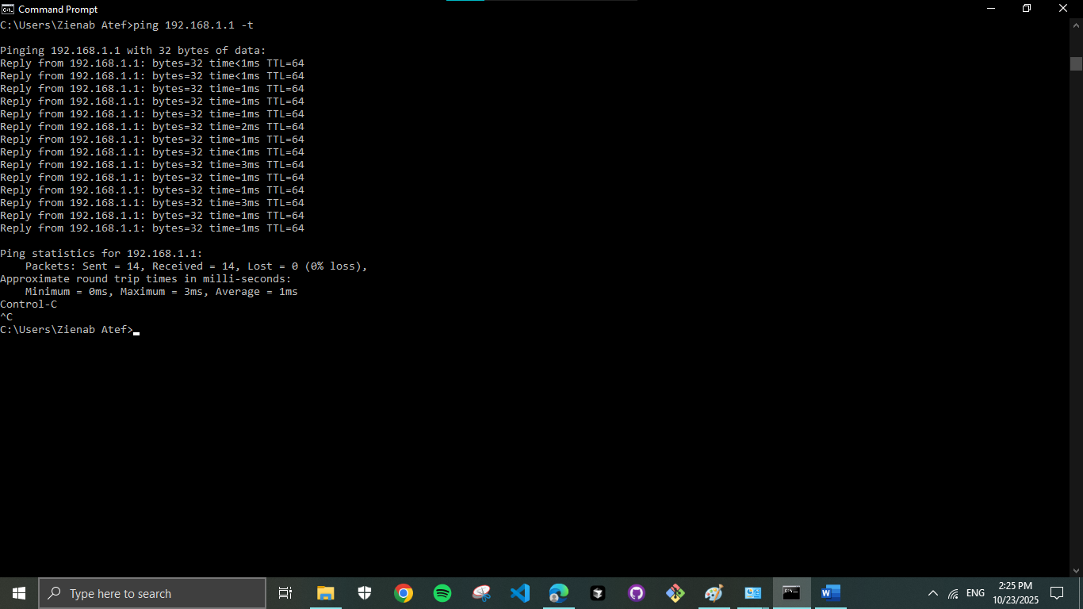

> ping 192.168.1.1 -n 7
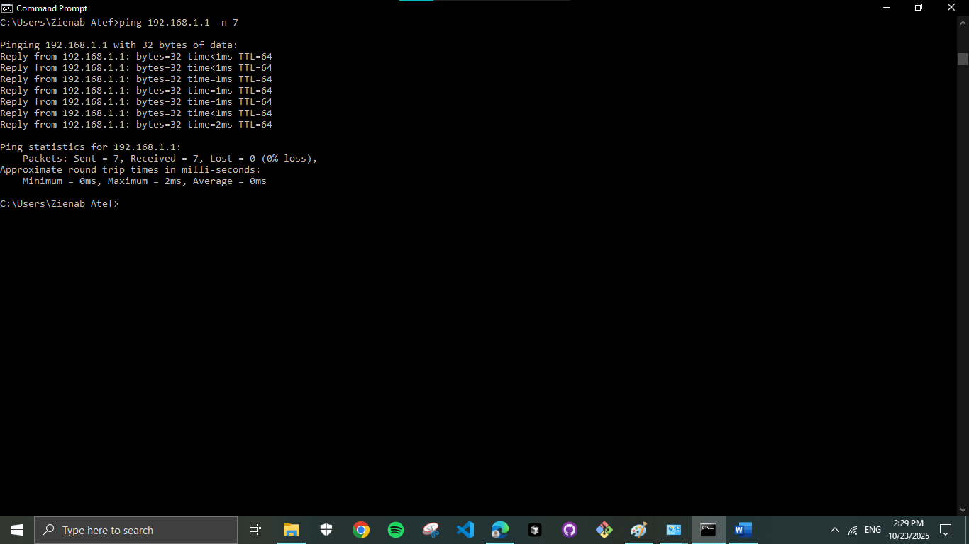

> ping Yahoo.com -l 200
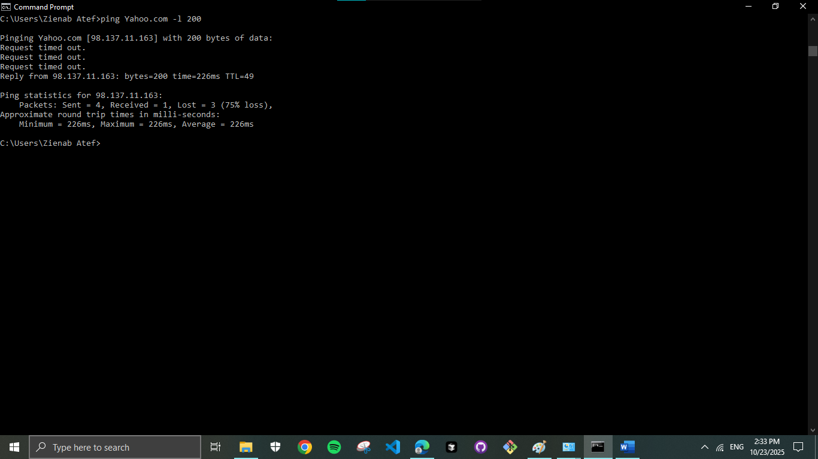

> ping Yahoo.com -l 200 -n 7
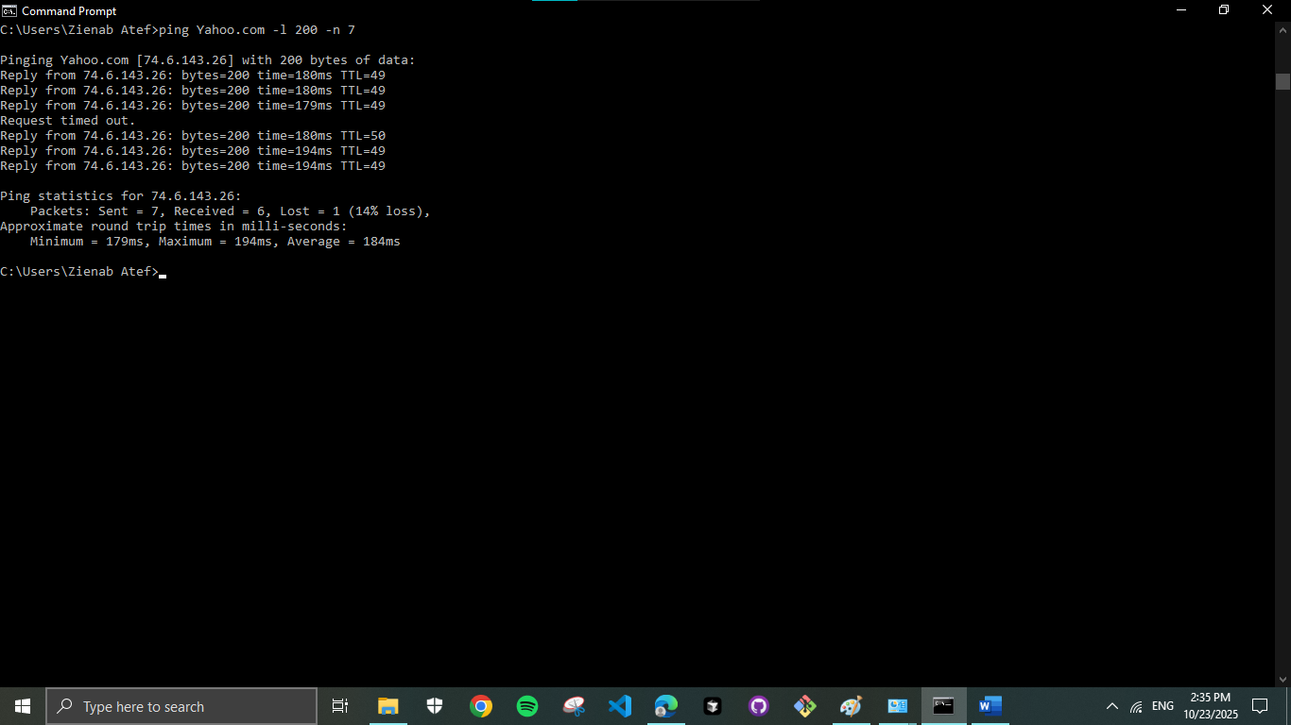

4. MAC address
> ipconfig /all
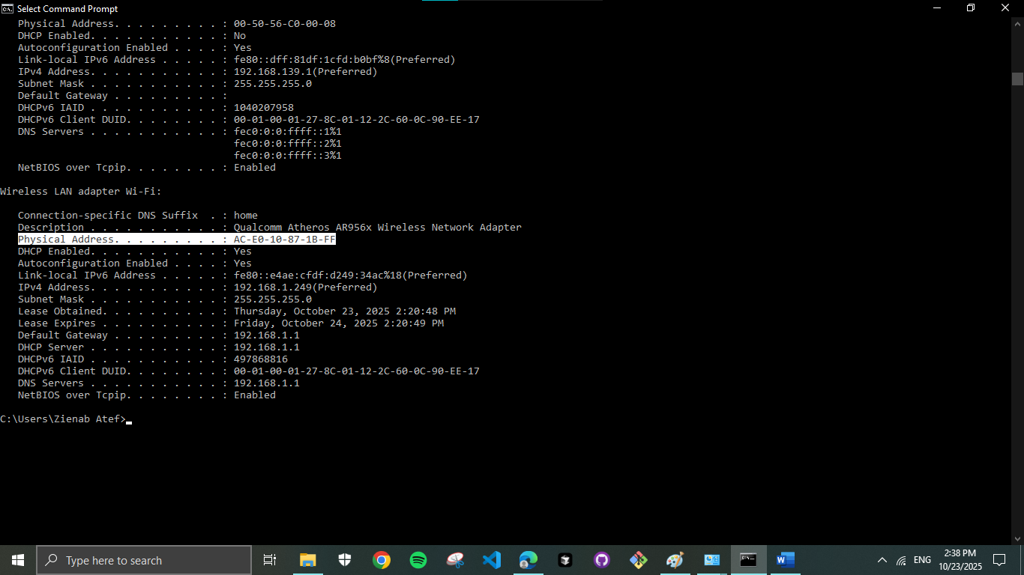

> getmac
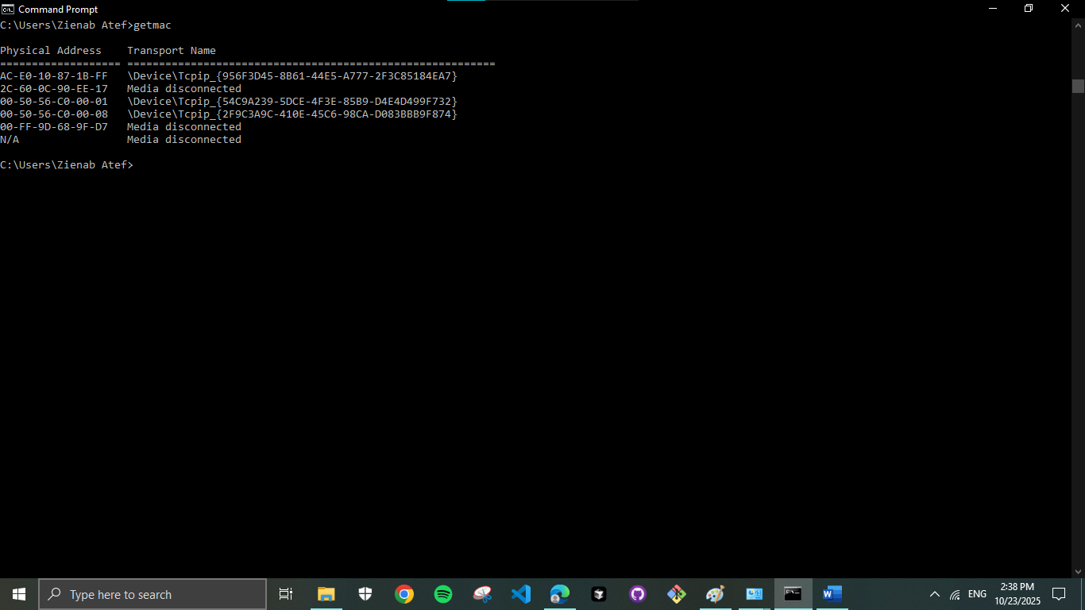

5. arp command
> arp -a
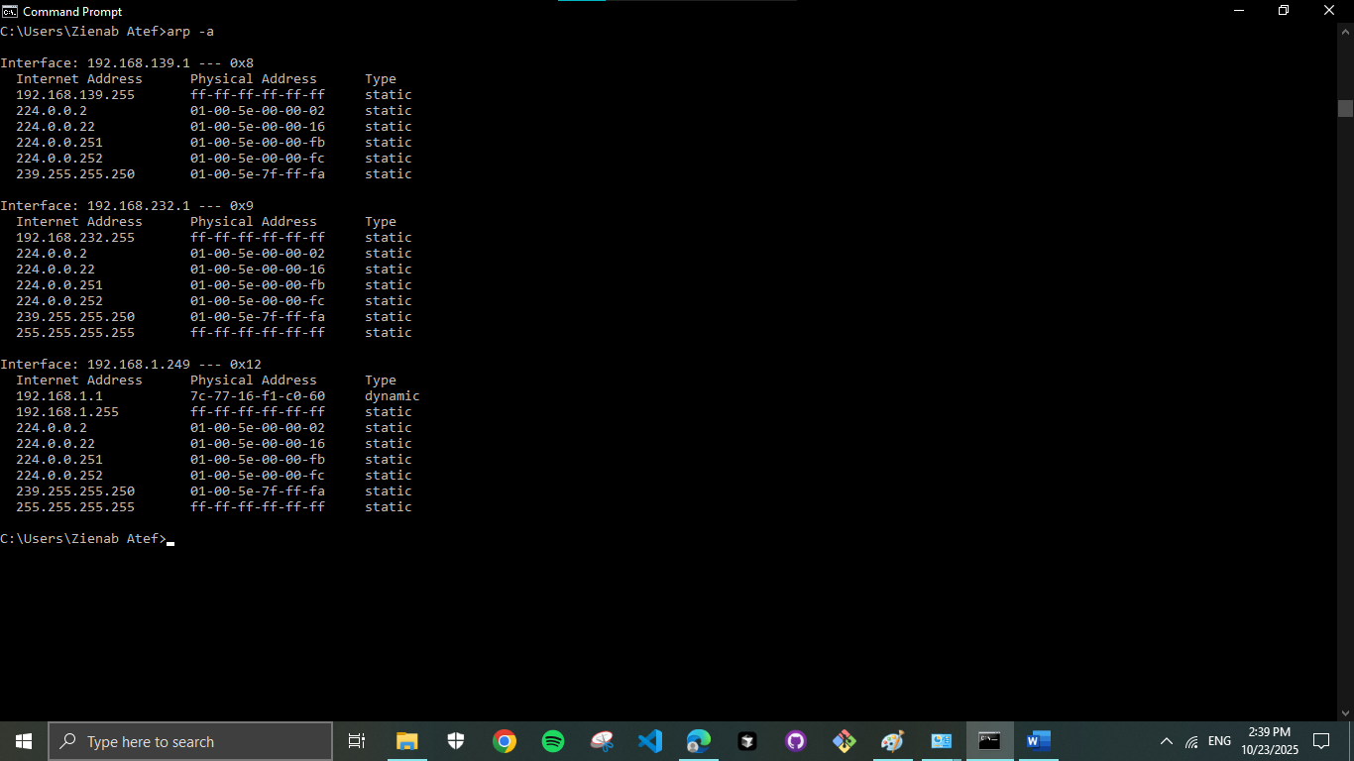

> arp -d
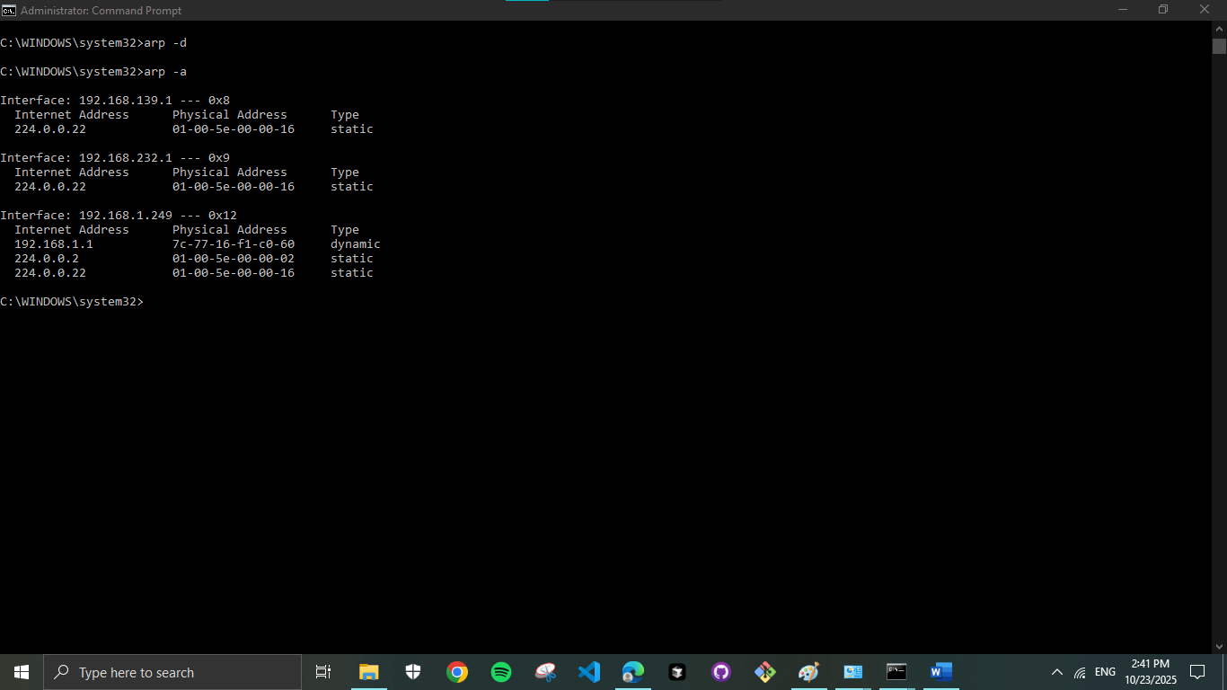

6. Opened ports and sessions
> netstat -n
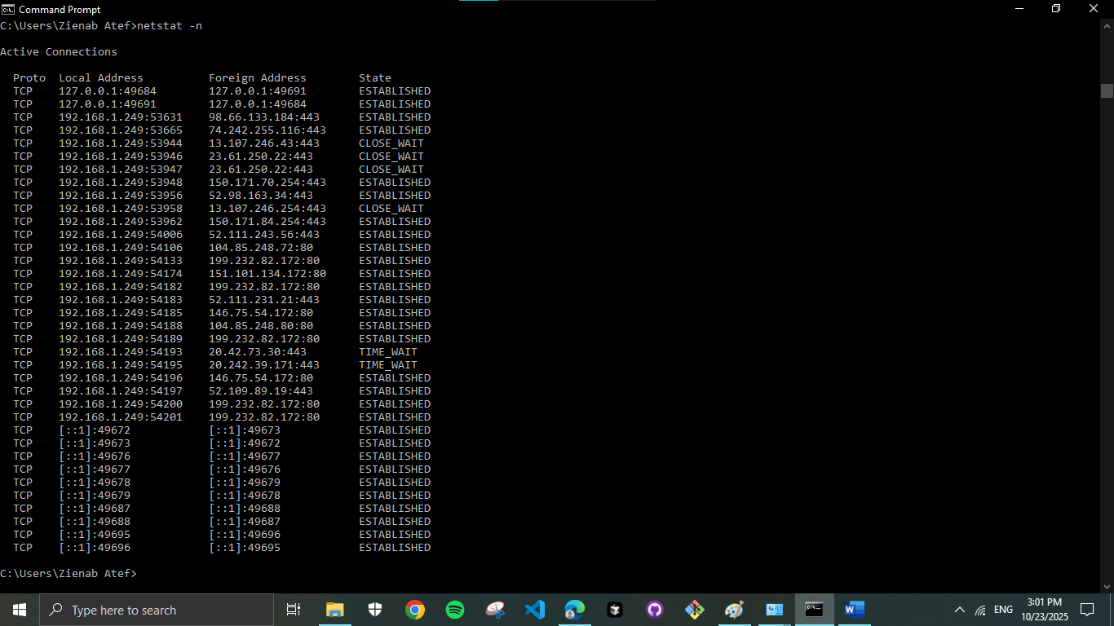

> netstat -a 192.168.1.1
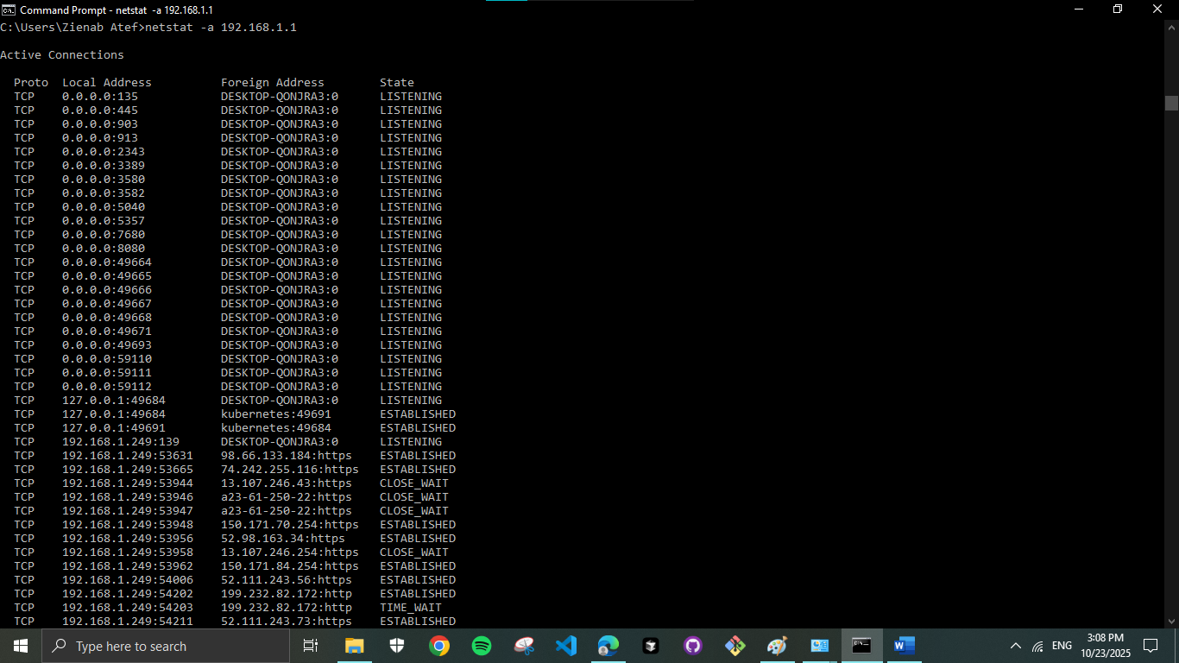

Why nslookup command is returning only one IP address of google.com?
The reason for that lies in the DNS lookup process. Google's IP addresses are used to perform load balancing, where the load balancer server's IP remains the same, and the internal server forwards the request to a particular server with the least load based on the load balancing algorithm. In contrast, Yahoo's IP addresses do not change and are used for authoritative DNS server queries.

7. Domain name system
> nslookup Yahoo.com
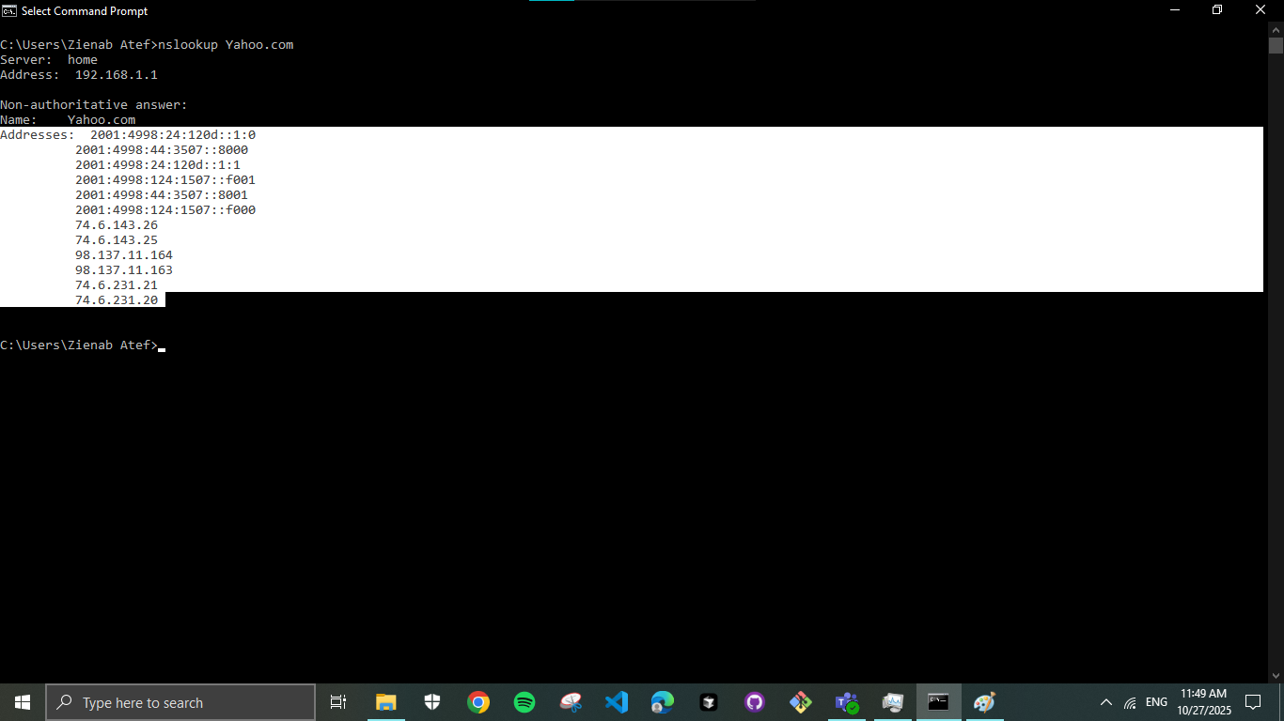

> nslookup 87.248.113.14
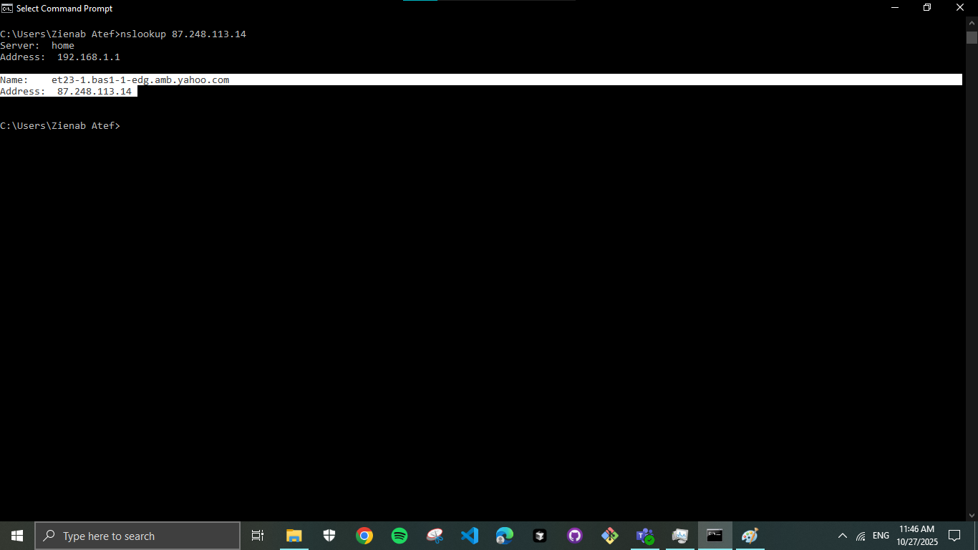

8. Dealing with FTP
Configure FTP server 127.0.0.1: 14147
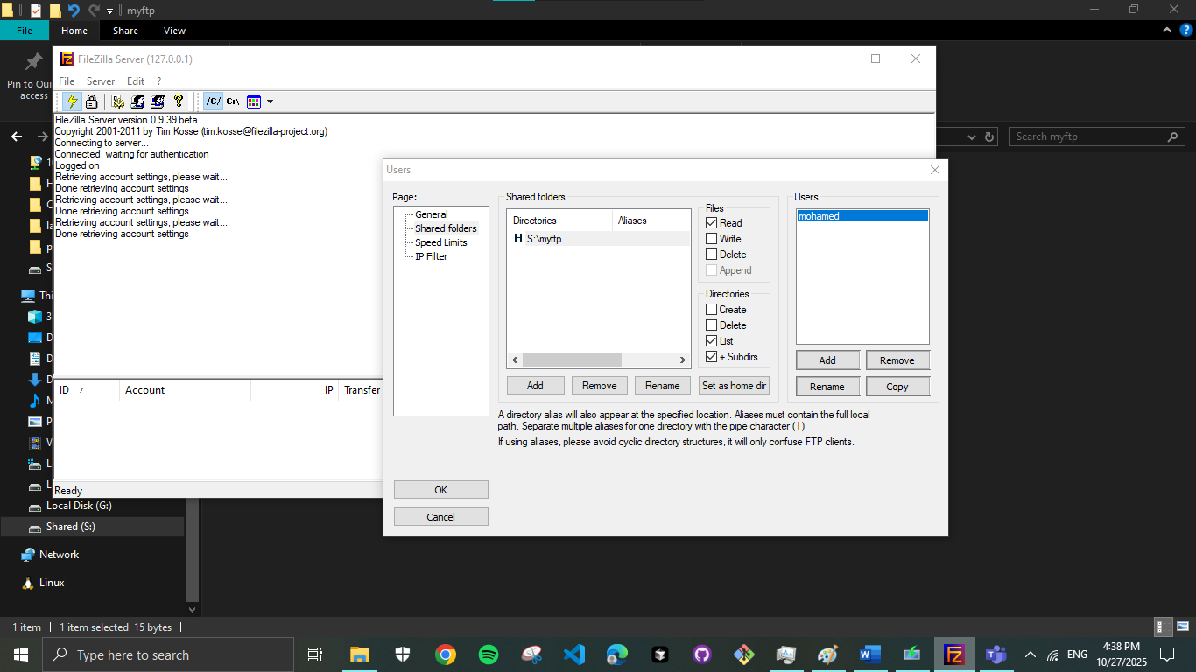

Configure FTP clients
Method 2 (using CMD)
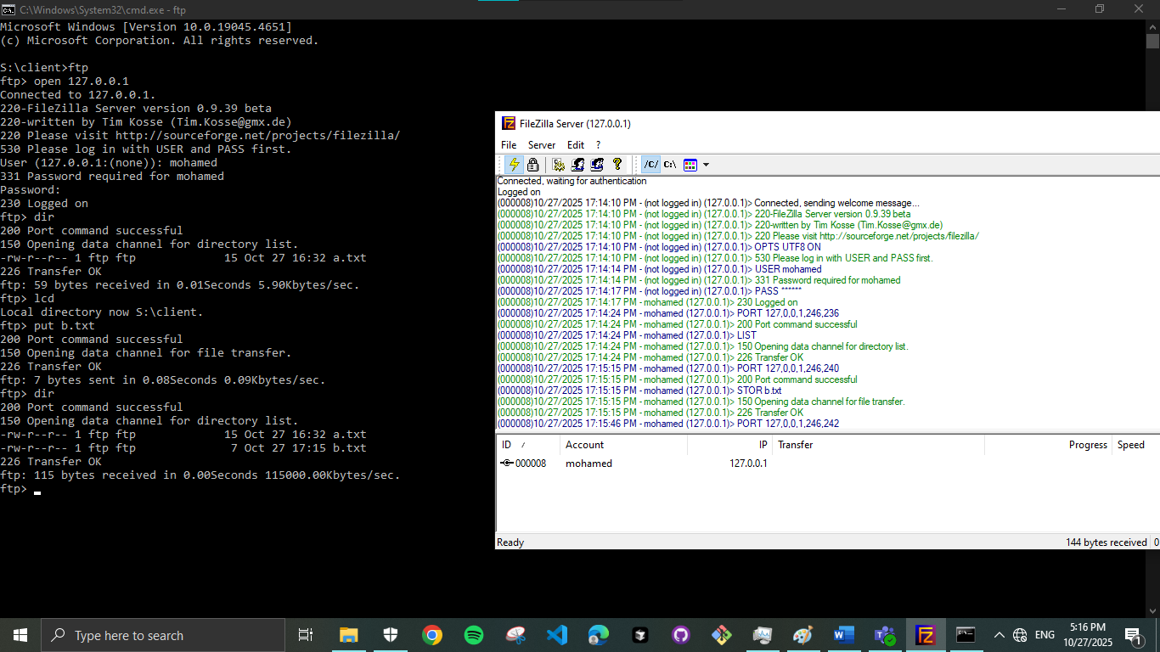

Method 3 (using Third party tool)
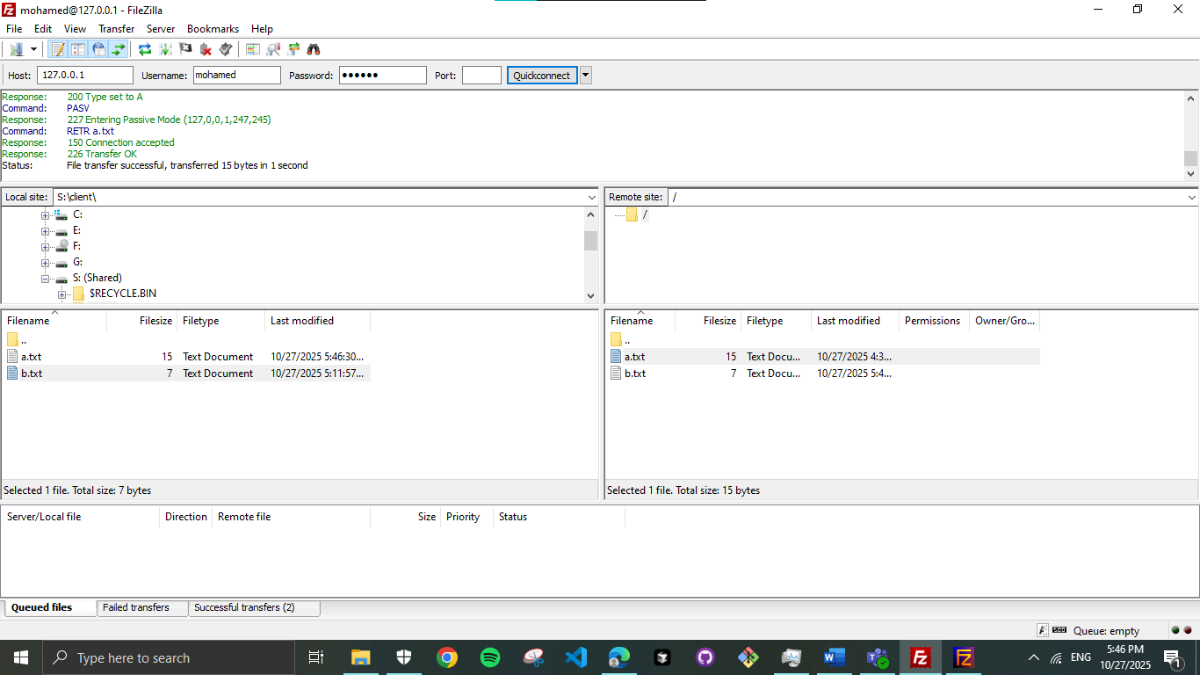

9. Remote Administration (using RDP)
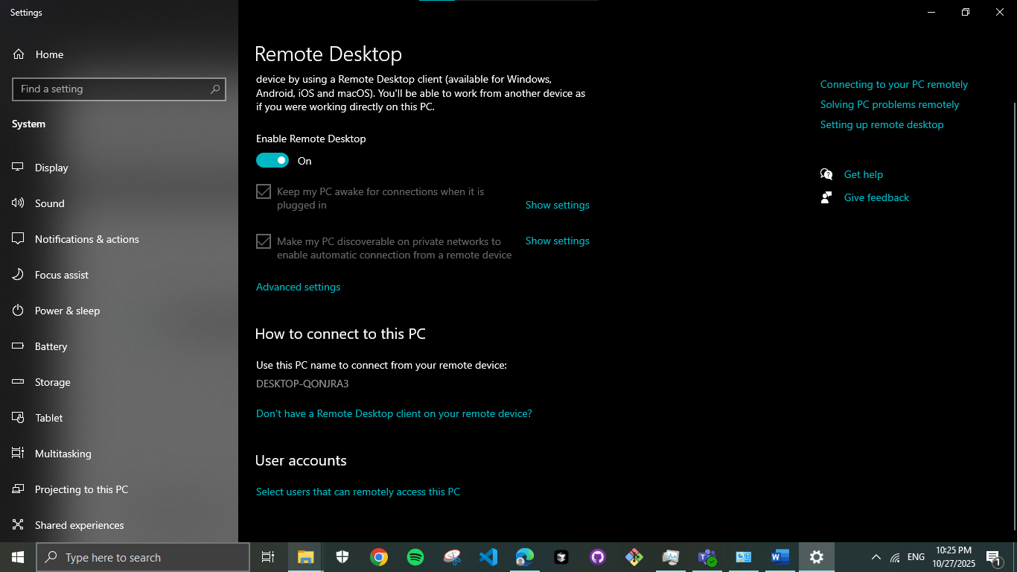

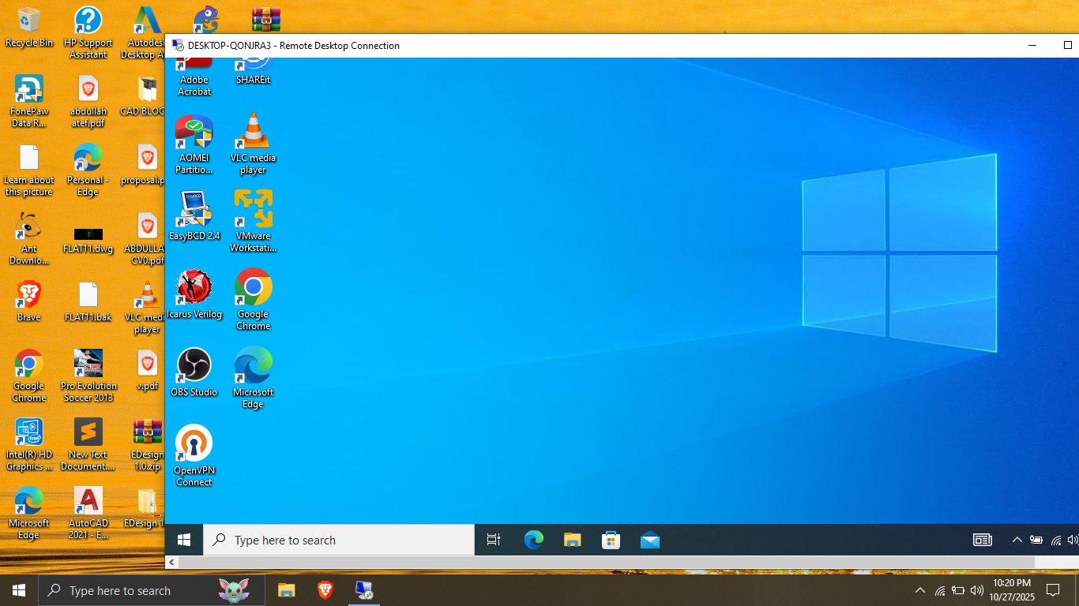

10. LANguard port scanner
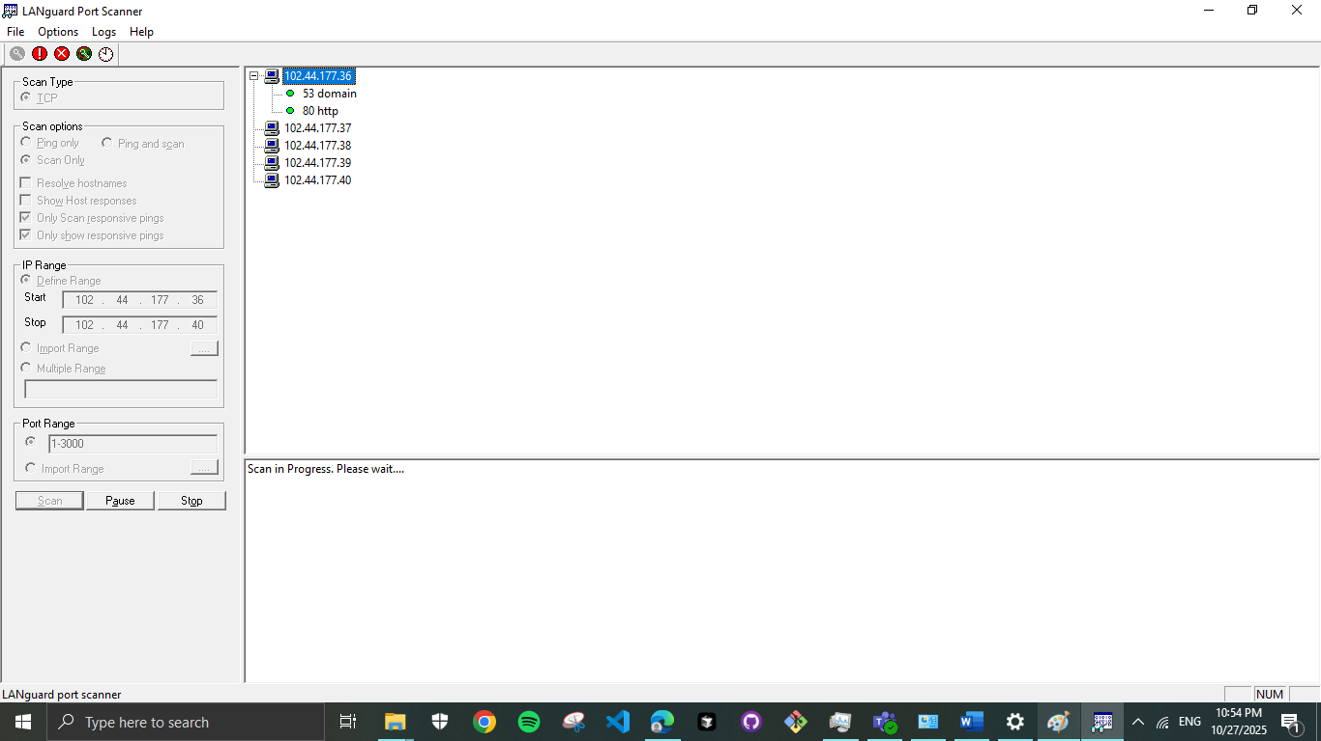

11. Advanced firewall options
