Home page
<!DOCTYPE html>
<html lang="en">
<head>
<meta charset="UTF-8">
<meta name="viewport" content="width=device-width, initial-scale=1.0">
<meta http-equiv="refresh" content="5;url=registration.html">

<link rel="stylesheet" href="style.css">

<title>Home-Page1</title>
</head>
<body>
<div>
<a href="login.html">
<img src="/images/enter_button.png" alt="Enter Button Image">
</a>
</div>
</body>
</html>

Registration page
<!DOCTYPE html>
<html lang="en">
<head>
<meta charset="UTF-8">
<meta name="viewport" content="width=device-width, initial-scale=1.0">

<link rel="stylesheet" href="style.css">

<title>Registration Form</title>

<style>
body {
background-color: rgb(205, 218, 236);
}

table, td {
margin: auto;
border: 3px solid rgb(175, 172, 172);
border-collapse: collapse;
padding: 15px;
}

h1 {
text-align: center;
text-decoration: underline;
font-weight: bold;
font-size: 20pt;
padding-bottom: 15px;
}

label {
font-weight: bold;
color: #5c1a1a;
}

input[type="submit"], input[type="reset"] {
padding: 10px 14px;
}

input[type="submit"] {
margin-right: 60px;
}

input[type="text"], input[type="email"],
input[type="password"], input[type="date"] {
width: 250px;
}

select {
width: 255px;
}
</style>
</head>
<body>
<h1>Registration Form</h1>
<table>
<form action="login.html" method="get">
<tr>
<td><label for="firstname">First Name</label></td>
<td>
<input type="text" id="firstname" name="firstname"
placeholder="Enter your first name">
</td>
</tr>
<tr>
<td><label for="lastname">Last Name</label></td>
<td>
<input type="text" id="lastname" name="lastname"
placeholder="Enter your last name">
</td>
</tr>
<tr>
<td><label for="email">Email</label></td>
<td>
<input type="email" id="email" name="email"
placeholder="Enter your email">
</td>
</tr>
<tr>
<td><label for="password">Password</label></td>
<td>
<input type="password" id="password" name="password"
placeholder="Enter your password">
</td>
</tr>
<tr>
<td rowspan="2"><label for="gender">Gender:</label></td>
<td>
<input type="radio" id="female" name="gender" value="Female">
<label for="female">Female</label>
</td>
</tr>
<tr>
<td>
<input type="radio" id="male" name="gender" value="Male">
<label for="male">Male</label>
</td>
</tr>
<tr>
<td><label for="country">Country</label></td>
<td>
<select id="country" name="country">
<option>Select a Country</option>
<optgroup label="Africa">
<option>Egypt</option>
<option>Sudan</option>
<option>Libya</option>
<option>Tunisia</option>
<option>Morocco</option>
</optgroup>
<optgroup label="Europe" disabled>
<option>Italy</option>
<option>Sweden</option>
<option>Spain</option>
</optgroup>
<optgroup label="Asia">
<option>Palestine</option>
<option>South Korea</option>
<option>India</option>
</optgroup>
</select>
</td>
</tr>
<tr>
<td><label for="birthday">Birthday</label></td>
<td><input type="date" id="birthday" name="birthday"></td>
</tr>
<tr>
<td colspan="2" style="text-align:center;"><label><u>Interests</u></label></td>
</tr>
<tr>
<td colspan="2" rowspan="1" style="text-align:center;">
<input type="checkbox" id="sports" name="interests" value="Sports">
<label for="sports" style="margin-right:25px;">Sports</label>

<input type="checkbox" id="music" name="interests" value="Music">
<label for="music" style="margin-right:25px;">Music</label>

<input type="checkbox" id="fashion" name="interests" value="Fashion">
<label for="fashion">Fashion</label><br><br>

<input type="checkbox" id="reading" name="interests" value="Reading">
<label for="reading" style="margin-right:12px;">Reading</label>

<input type="checkbox" id="shoping" name="interests" value="Shoping">
<label for="shoping" style="margin-right:8px;">Shoping</label>

<input type="checkbox" id="movies" name="interests" value="Movies">
<label for="movies" style="margin-right:6px;">Movies</label>
</td>
</tr>
<tr>
<td colspan="2" style="text-align:center;"><label for="bio"><u>Bio</u></label></td>
</tr>
<tr>
<td colspan="2"><textarea id="bio" name="bio" rows="4" cols="50" placeholder="Write about yourself..."></textarea></td>
</tr>
<tr>
<td colspan="2" style="text-align:center;">
<input type="submit" value="Register..">
<input type="reset" value="Clear..">
</td>
</tr>
</form>
</table>

</body>
</html>

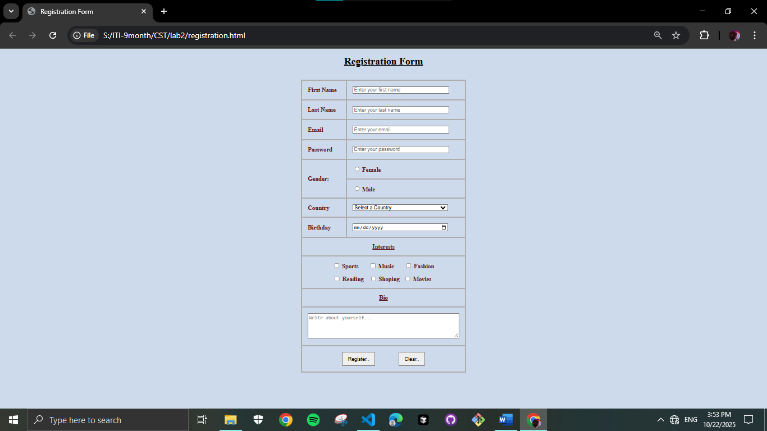

Login page
<!DOCTYPE html>
<html lang="en">
<head>
<meta charset="UTF-8">
<meta name="viewport" content="width=device-width, initial-scale=1.0">
<title>Document</title>

<style>
body {
background-color: rgb(205, 218, 236);
}

legend {
font-size: 17pt;
color: red;
}

input[type="text"], input[type="password"] {
width: 400px;
height: 30px;
padding-left: 10px;
}

form {
width: 400px;
margin: auto;
margin-top: 150px;
}

fieldset {
padding: 30px;
border: solid;
border-width: 5px;
border-color: rgb(73, 166, 219);
}

input[type="submit"] {
padding: 10px;
margin-left: 175px;
color: #a31e1e;
}

label {
font-weight: bold;
color: #5c1a1a;
}
</style>
</head>
<body>
<form action="mainpage.html" method="get">
<fieldset>
<legend><b>Login</b></legend>
<label for="username">User name:</label><br>
<input type="text" id="username" name="username"
placeholder="Enter user name"><br><br>

<label for="password">User password:</label><br>
<input type="password" id="password" name="password"
placeholder="Enter user password"><br><br>

<input type="checkbox" id="remember-me" name="remember-me" value="remember-me">
<label for="remember-me">Remember me</label><br><br>

<input type="submit" value="Sign in..">
</fieldset>
</form>
</body>
</html>

