**Software Construction & Development (SE-308-B)**



Project Title:

**POS (Point of Sale)**

Submitted by:

**Moazam Attiq (221400003)**

**Maida Kosser (221400091)**

Submitted to:

**Mam Sajiya Tariq**

**BS Software Engineering (V)**

**GIFT University, Gujranwala**

**4. Functional Requirements:**

|  |  |
| --- | --- |
| **Serial No** | **Functionality** |
| 1. **Product Management:** | |
| **1.1** | The system must enable product addition with key details (SKU, name, price, description, stock levels). |
| **1.2** | The system must provide functionality to search for products by SKU, name, or category. |
| 1. **Transaction Processing:** | |
| **2.1** | The system must allow sales personnel to scan products or manually enter item details during a transaction. |
| **2.2** | The system must calculate the total transaction amount, including applicable taxes, discounts, and fees. |
| 1. **Refunds and Voids:** | |
| **3.1** | The system must allow users to process refunds and void transactions, with proper tracking and approval workflows. |
|  | The system must allow users to manage multiple payment methods within a single transaction (e.g., partial cash payment, partial card payment). |
| 1. **Payment and Receipt:** | |
| **4.1** | The system must support payment processing via multiple methods, including cash, credit/debit cards, and mobile payments. |
| **4.2** | The system must generate an itemized receipt for each transaction, which can be printed or emailed to the customer. |
| 1. **Inventory Management:** | |
| **5.1** | The system must automatically update inventory levels in real time as products are sold. |
| **5.2** | The system must trigger low-stock alerts when inventory reaches predefined thresholds. |

**5. Non-Functional Requirements:**

|  |  |
| --- | --- |
| **Serial No** | **Non-Functional Requirement** |
| 1. **Performance:** | |
| **1.1** | The system must process transactions, including item entry and total calculation, in under **3 seconds** to ensure fast checkout. |
| 1. **Security:** | |
| **2.1** | The system must use **encryption protocols (SSL/TLS)** to secure sensitive data such as payment details, adhering to **PCI-DSS compliance**. |
| 1. **Availability:** | |
| **3.1** | The system must have an uptime of **99.9%**, with minimal downtime during scheduled maintenance to support business operations. |
| 1. **Usability:** | |
| **4.1** | The system's user interface must be **intuitive**, requiring minimal training for sales personnel to add products, process payments, and issue refunds. |
| 1. **Scalability:** | |
| **5.1** | The system must be able to handle **peak loads**, such as high transaction volumes during holiday sales or promotional events. |

**6.**  **Context Level Diagram/Data Flow Diagram:**

**Level 0:**

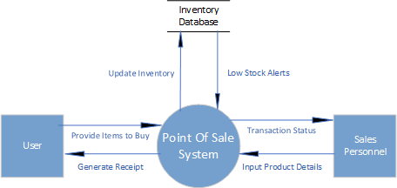

**Level 2:**

