**Software Construction & Development (SE-308-B)**



Project Title:

**POS (Point of Sale)**

Submitted by:

**Moazam Attiq (221400003)**

**Maida Kosser (221400091)**

Submitted to:

**Mam Sajiya Tariq**

**BS Software Engineering (V)**

**GIFT University, Gujranwala**

1. **Introduction:**

The **Point of Sale (POS) system** is designed for small grocery shops to manage sales transactions and provide receipts, all using a single terminal. It is a simple and user-friendly system that helps the shopkeeper efficiently manage daily sales and inventory efficiently.

1. **Scope:**

The **Point of Sale (POS) System** is designed to simplify sales processes for small shops with an easy-to-use platform. It allows users to add products with details like SKU, name, price, description, and stock levels.

* **Sales and Transactions:** Sales can be processed by scanning items or manually entering details, with the system automatically calculating the total amount, including taxes, discounts, and additional fees. Multiple payment methods such as cash, cards, and mobile payments are supported, along with options for partial payments using different methods. After each transaction, the system generates an itemized receipt, which can be printed or emailed to the customer.
* **Inventory and Security:** The system updates inventory levels in real time after each sale and sends low-stock alerts when predefined thresholds are reached. It also includes refund and void functionalities with proper tracking and approval processes. To ensure security, the system encrypts sensitive data, and guarantees high availability. With a fast, intuitive interface, it minimizes training time and processes transactions in under 3 seconds, making it ideal for efficient sales and inventory management in small shops.

1. **Feature Tree:**

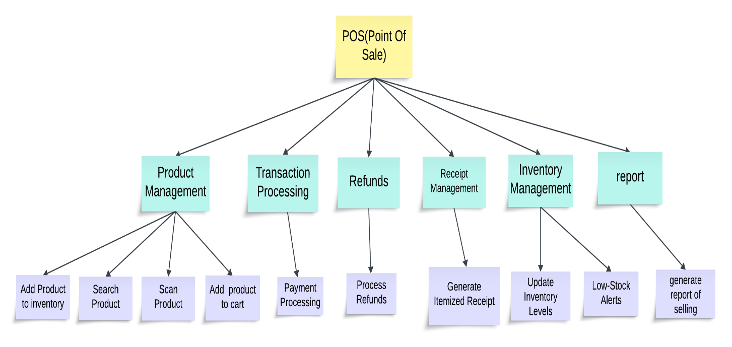

**4. Functional Requirements:**

|  |  |
| --- | --- |
| **Serial No** | **Functionality** |
| **FR-1: Product Management** | |
| **1.1** | The system shall allow sales personnel to add the products to the inventory. |
| **1.2** | The system shall allow sales personnel to search for products. |
| **1.3** | The system shall allow sales personnel to scan products. |
| **1.4** | The system shall allow sales personnel to add products to cart for selling. |
| **FR-2: Transaction Processing** | |
| **2.1** | The system shall be able to support payment processing. |
| **FR-3: Refunds** | |
| **3.1** | The system shall allow sales personnel to process refunds. |
| **FR-4: Inventory Management** | |
| **4.1** | The system shall be able to update inventory levels. |
| **4.2** | The system shall be able to alert low-stock alerts. |
| **FR-5: Receipt Management** | |
| **5.1** | The system shall be able to generate an itemized receipt. |
| **FR-6: Report** | |
| **6.1** | The system shall be able to generate the sales reports. |

**5. Non-Functional Requirements:**

|  |  |
| --- | --- |
| **Serial No** | **Non-Functional Requirement** |
| **NFR-1** | The system shall process transactions in under **3 seconds** to ensure fast checkout. |
| **NFR-2** | The system shall use **encryption protocols** to secure sensitive data such as payment details. |
| **NFR-3** | The system shall have an uptime of **99.9%**, minimal downtime during scheduled maintenance to support business operations. |
| **NFR-4** | The system user interface shall be **intuitive**, requiring minimal training for sales personnel to add products, process payments, and issue refunds. |
| **NFR-5** | The system must support 100 concurrent users normally and upto 200 in special days without any degradation in performance within 1 year. |

**6.**  **Context Level Diagram/Data Flow Diagram:**

**Level 0:**

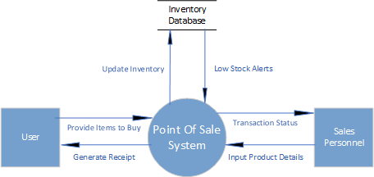

**Level 2:**

