**Software Construction & Development (SE-308-B)**



**Stage – 02 (Modeling)**

Project Title:

**POS (Point of Sale)**

Submitted by:

**Moazam Attiq (221400003)**

**Maida Kosser (221400091)**

Submitted to:

**Mam Sajiya Tariq**

**BS Software Engineering (V)**

**GIFT University, Gujranwala**

This stage deals with UML Diagram generation through MS Visio.

1. 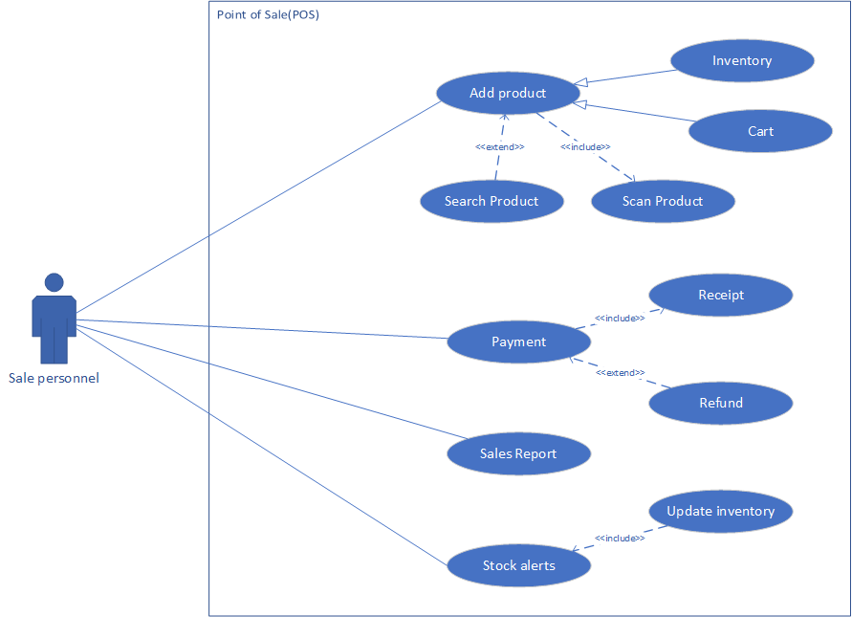**Use Case Diagram Diagram**
2. **Sequence & Collaboration Diagram**
   1. 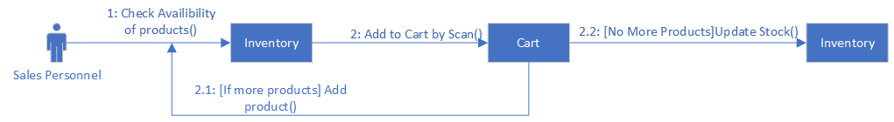**Add Product:**
      1. **Collaboration Diagram**
      2. 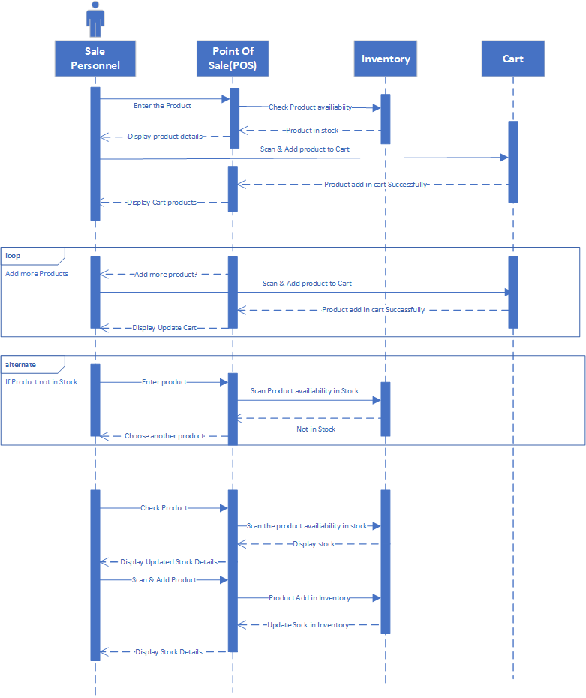**Sequence Diagram**
   2. **Search Product**
      1. 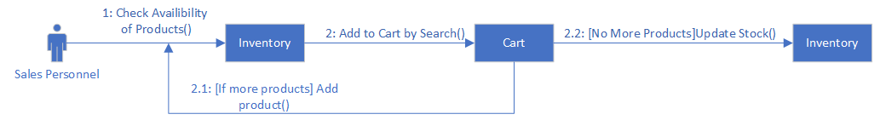**Collaboration Diagram**
      2. 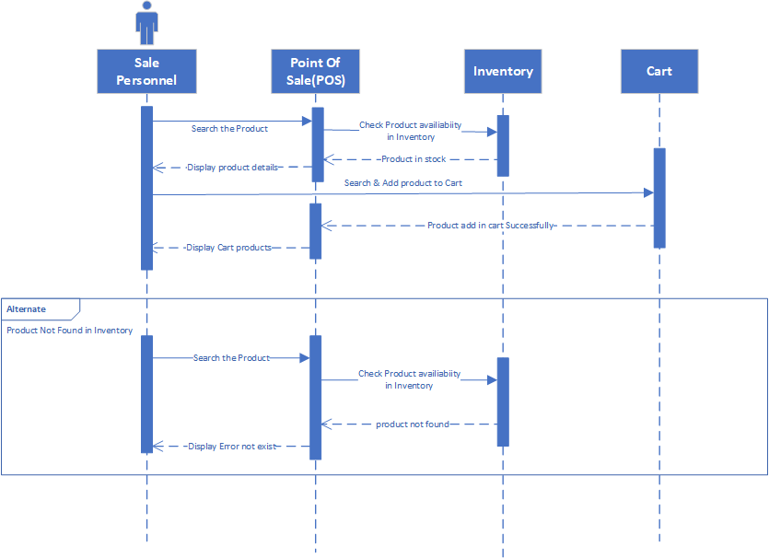**Sequence Diagram**
   3. **Payment**
      1. 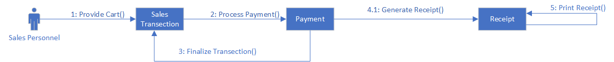**Collaboration Diagram**
      2. 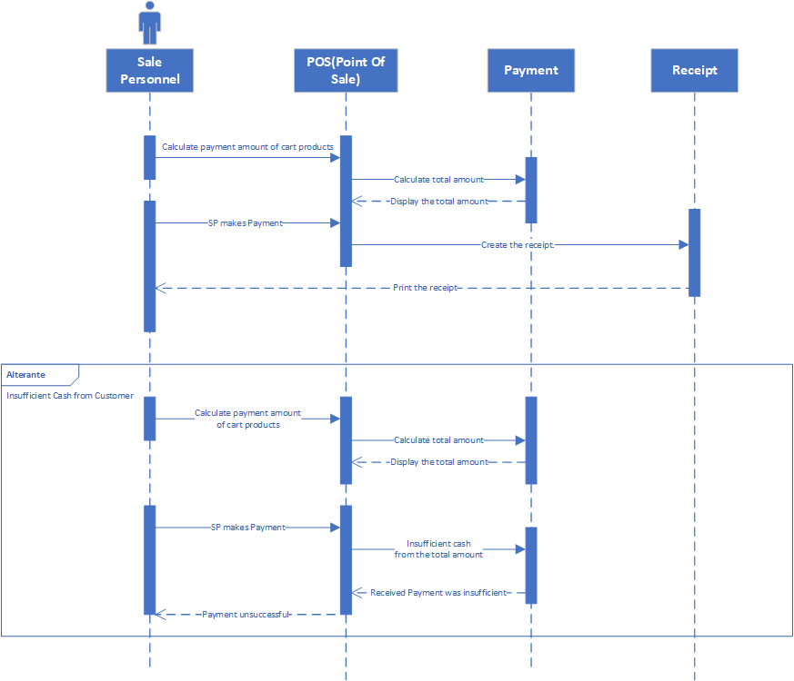**Sequence Diagram**
   4. **Refund**
      1. 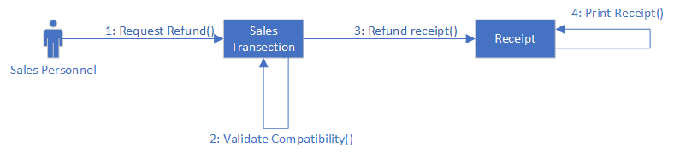**Collaboration Diagram**
      2. 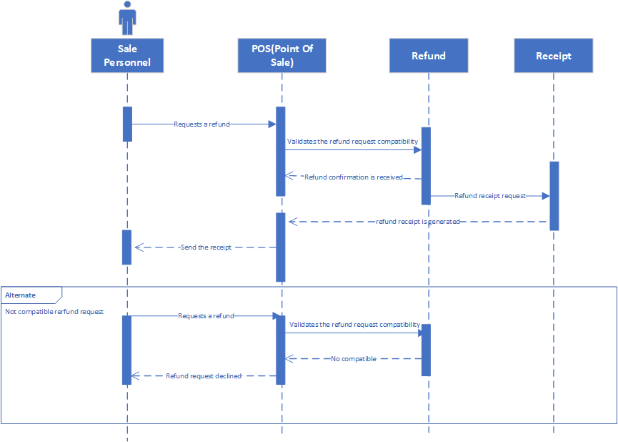**Sequence Diagram**
   5. **Low Stock Alerts**
      1. 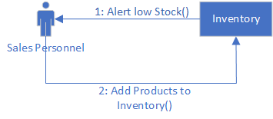**Collaboration Diagram**
      2. 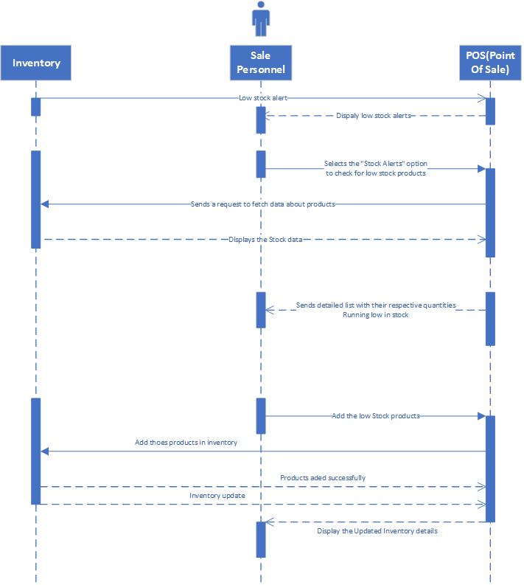**Sequence Diagram**
   6. **Sales Report**
      1. 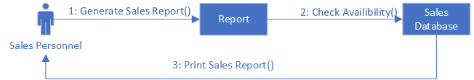**Collaboration Diagram**
      2. **Sequence Diagram**
3. **Deployment & Component Diagram**
   1. 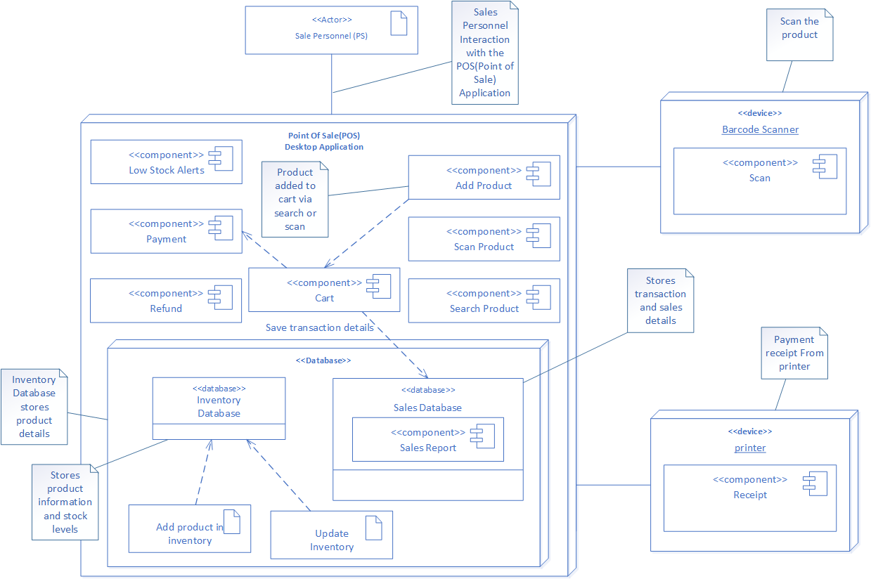**Deployment Diagram**
   2. 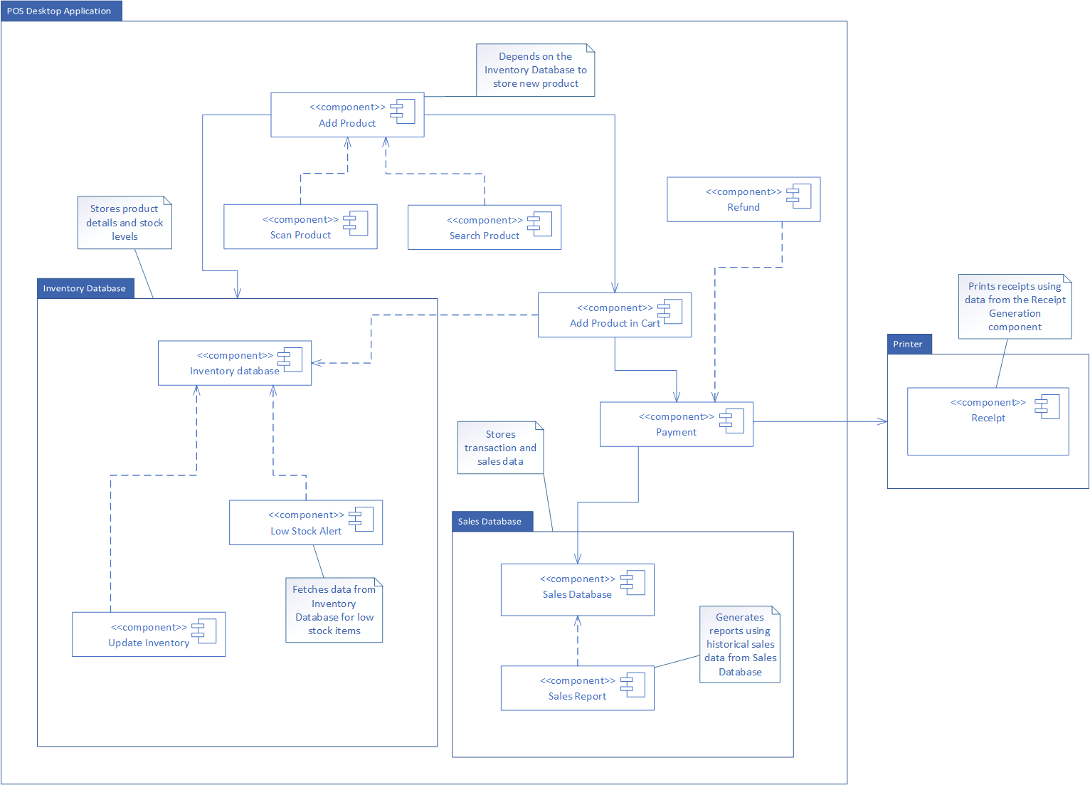**Component Diagram**
4. 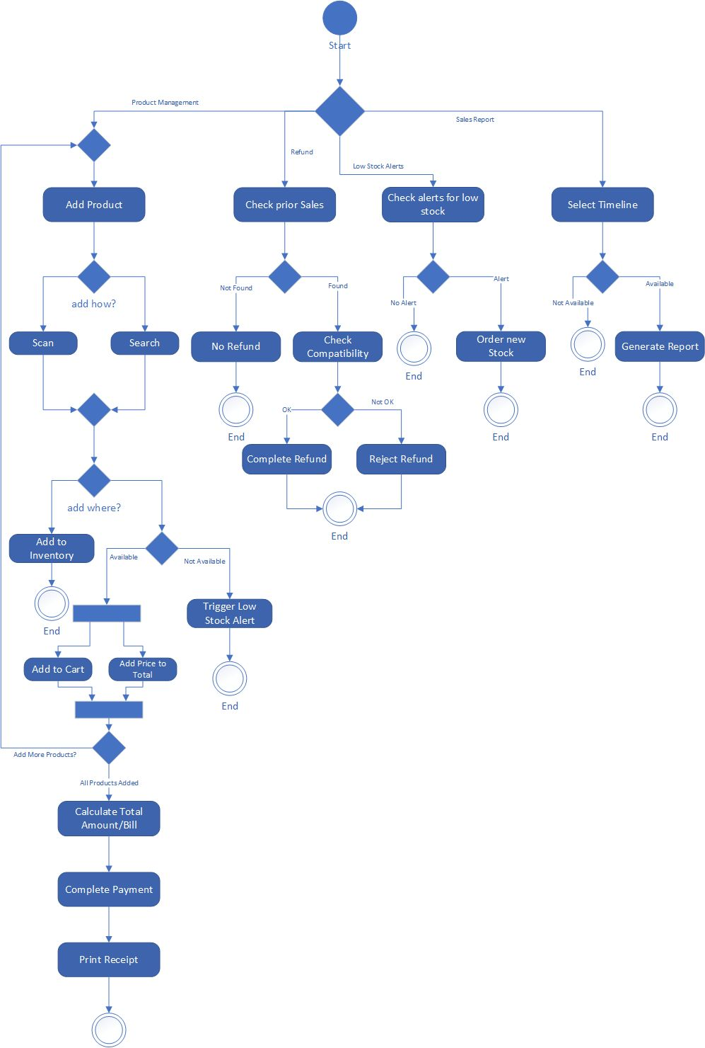**Activity Diagram**

**Justification:**

**Only one salesperson interacts with the POS system** using a desktop application. There is no need to separate responsibilities between multiple users or roles. The entire process is controlled by a **single user**, so dividing it into lanes or pools would be **unnecessary.**

1. 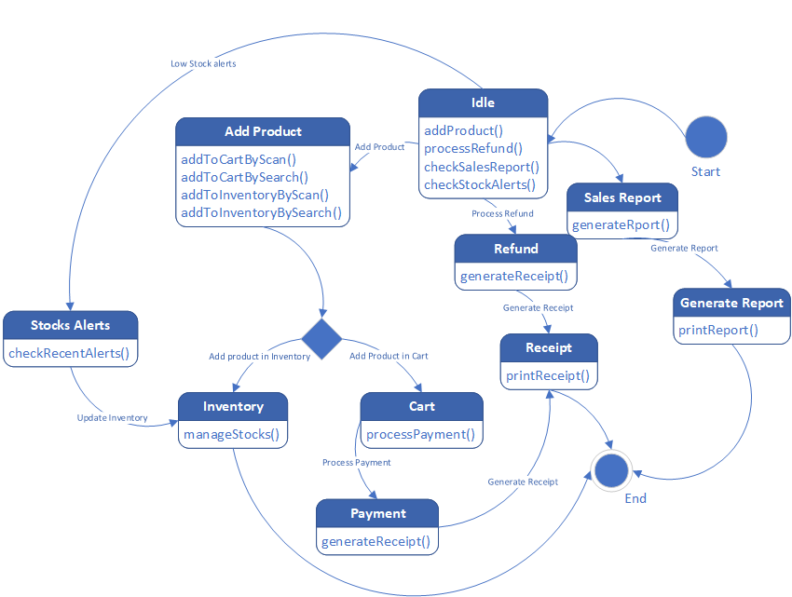**State Machine Diagram**

**Justification:**

The diagram effectively maps out the primary functionalities of a POS system, showcasing a seamless flow from product management to transaction processing and reporting. The inclusion of inventory management and alert systems demonstrates comprehensive control over stock levels and sales data. The decision points and multiple functions support flexibility in operation, enhancing the efficiency of the POS system.

1. **Class Diagram**

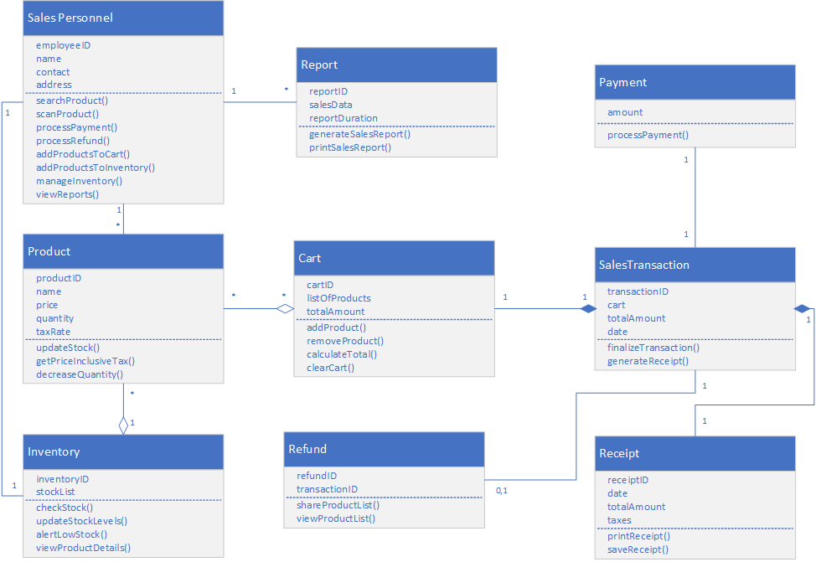

1. **SCD Project Status Report:**

**Date/Day: 01-02-2025**

**Project Name: POS (Point of Sale)**

**Project Lead: Maida Kosser**

**Report Date: 01-02-2025**

|  |  |  |  |
| --- | --- | --- | --- |
| **Task** | **Member Roll #** | **Assigned Task** % | **Completed %** |
| Use Case, Sequence & Collaboration, Deployment & Component, Activity, State Machine, Class Diagram | 221400091 | 50% | 50% |
| 221400003 | 50% | 50% |
| **Total** | | 100% | 100% |

**Section: B**

**Group No: 03**

**Project stage completion Percentage: 100%**

**Comments:**

**______________________________________________________**

**______________________________________________________**

**Project Lead: _____________ Instructor: _______________**