**<Train Reservation System>**

**Section: A**

**Group Members:**

|  |
| --- |
| Rida Akram – 221400007Noor Ajaz – 221400022 |
| Moazam Attiq - 221400003Ammar Qaiser - 221400040Ibrahim Iyaz - 221400027 |

**Submitted to:**

**Mam Anam Shahzadi**

**Submission date: 20-Aug-2024**

**Project Requirements:**

* System will allow admin to login and logout.
* System will allow passenger to login and logout.
* System will allow admin to book passenger(s) in a particular train (out of a list of trains in the particular route) in a particular class, up to a maximum seat limit.
* System will allow admin to remove passenger (s) from train who cancelled the booking.
* System will allow admin to get passengers list.
* System will allow passenger to check the availability of trains accordingly to the source and destination.
* System will allow passenger(s) to book ticket (mention class – 1st , Economy), mentioning the fare as well as number of people traveling.
* System will allow passenger(s) to choose (jazz cash/bank detail) and add payment details.
* System will allow passenger(s) to confirm booking at least 3 days before departure.
* System will allow passenger(s) to cancel ticket, without charges if done 3 days before departure; otherwise 50% deduction.

**Entity Relationship Diagram (ERD)**

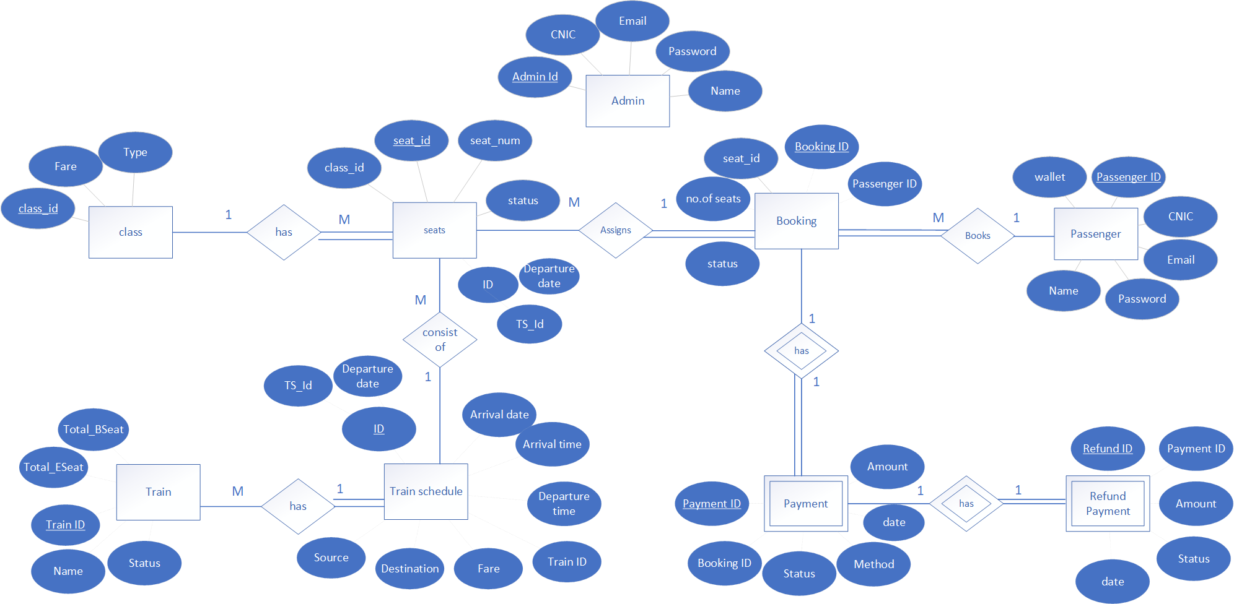

**Relational Model**

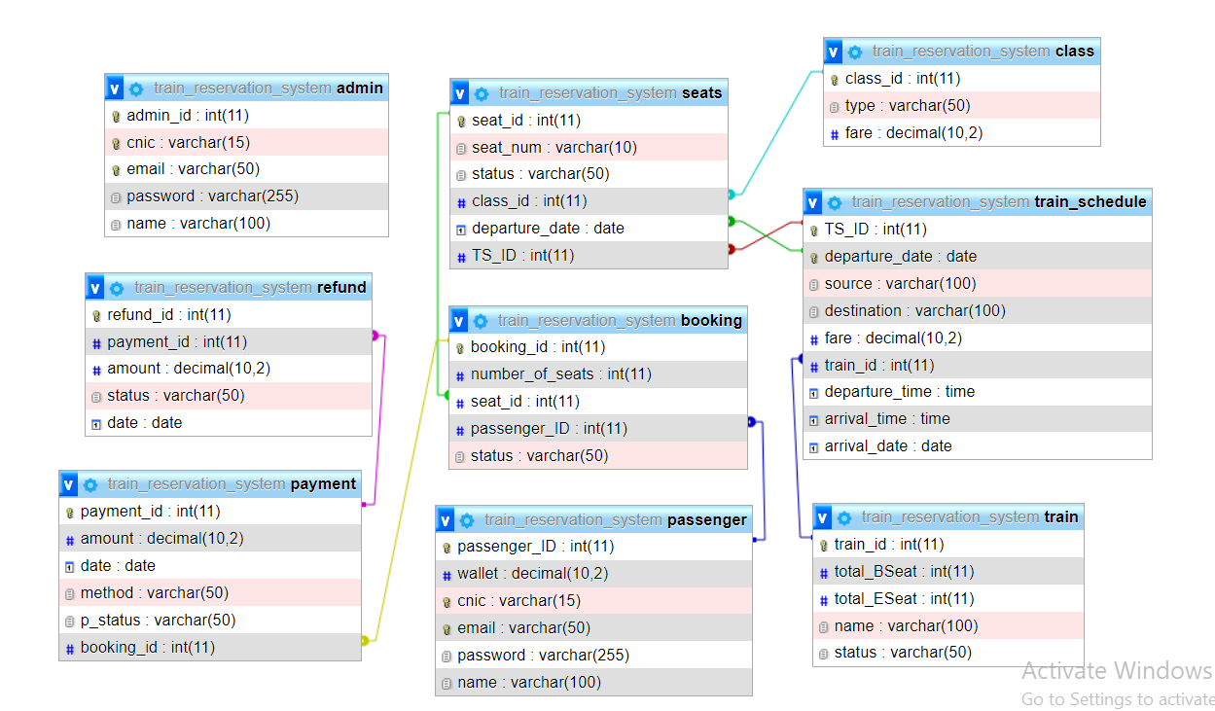

**Normalization Schema**

**1st Normal Form (1NF):**

A table is in the 1st Normal Form if:

* It contains only atomic (indivisible) values.
* Each column contains values of a single type.

Since all columns contain atomic values and each column has a unique name and contains a single type of data, so ERD is already in 1NF.

**2nd Normal Form (2NF):**

A table is in the 2nd Normal Form if:

* It is in 1NF.
* There is no partial dependency.

**Analysis for each table:**

* **Passenger:** This table has a single primary key (passenger_ID). All other columns are fully dependent on passenger_ID, so it is in 2NF.
* **Class:** This table also has a single primary key (class_id). All columns are fully dependent on class_id, so it is in 2NF.
* **Train:** This table has a single primary key (train_id). All columns are fully dependent on train_id, so it is in 2NF.
* **Train_Schedule:** This table has a composite primary key (TS_ID, departure_date). All non-key attributes (departure_date, source, destination, fare, train_id, departure_time, arrival_time, arrival_date) are dependent on both parts of the primary key, which satisfies 2NF.
* **Seats:** This table has a primary key (seat_id). All other attributes (seat_num, status, class_id, departure_date, TS_ID) are dependent on seat_id. The foreign key references to Class and Train_Schedule are correctly maintained, ensuring 2NF.
* **Admin:** This table has a single primary key (admin_id). All other columns are dependent on admin_id, so it is in 2NF.
* **Booking:** This table has a primary key (booking_id). All other columns (number_of_seats, seat_id, passenger_ID) are fully dependent on booking_id, so it is in 2NF.
* **Payment:** This table has a primary key (payment_id). All other columns (amount, date, method, status, booking_id) are dependent on payment_id, so it is in 2NF.
* **Refund:** This table has a primary key (refund_id). All other columns (payment_id, amount, status, date) are dependent on refund_id, so it is in 2NF.

**3rd Normal Form (3NF):**

A table is in the 3rd Normal Form if:

* It is in 2NF.
* There are no transitive dependencies (i.e., non-key attributes do not depend on other non-key attributes).

Since in the ERD no non- prime attribute identifies any other non-prime attribute so it is in 3NF.

**Project Screenshots**

**<Here add screenshots of pages against each functional requirement. To fulfill requirement which page you show in your front-end, take screenshot and put here. Maximum 10 pages>**



