

- S O F T W A R E D E S I G N D O C U M E N T ◆
Hotel Management & Smart Room Booking System
S M A R T B O O K — S D D
Version 1. 0 | Final Year Project

S T U D E N T N A M E
Moazam Ajmal

R O L L N U M B E R
S25BINFT7M04032

S E S S I O N
2025 – 2027

S U P E R V I S O R
Dr. Abdul Karim Nawaz

D E P A R T M E N T
Information Technology

D A T E
10 ,06, 2026

P R O J E C T T I T L E
Hotel Management and Smart Room Booking System


A C A D E M I C S U B M I S S I O N · I N F O R M A T I O N T E C H N O L O G Y · S E S S I O N 2 0 2 5 – 2 0 2 7
H O T E L B O O K I N G S Y S T E M S D D V 1 . 0 M O A Z A M A J M A L 2 0 2 6

Revision History

Date | Description | Author | Comments
10-06-2026 | <Version 1> | Moazam ajmal | First Draft for Final Year Project

Document Approval
The following Software Requirements Specification has been accepted and approved by the following:

Signature | Printed Name | Title | Date
 | Dr: Abdul karim nawaz | Supervisor, FYP | 10-06-2026

TABLE OF CONTENTS
- INTRODUCTION 4
  - Purpose 4
  - Scope 4
  - Overview 4
  - Reference Material 4
  - Definitions and Acronyms 5
- SYSTEM OVERVIEW 5
- SYSTEM ARCHITECTURE 5
  - Architectural Design 6
  - Decomposition Description 6
  - Design Rationale 7
- DATA DESIGN 7
  - Data Description 8
  - Data Dictionary 8
- COMPONENT DESIGN 9
- HUMAN INTERFACE DESIGN 11
  - Overview of User Interface 11
  - Screen Images 11
  - Screen Objects and Actions 11
- REQUIREMENTS MATRIX 13
- APPENDICES 15
  - Appendix A: ER Diagram 14
  - Appendix B: Sequence Diagrams 18
  - Appendix C: Technology Stack Details 19

INTRODUCTION

Purpose
The purpose of this Software Design Document (SDD) is to describe the architectural and detailed design of the Hotel Management and Smart Room Booking System (SmartBook). This document translates the approved Software Requirements Specification (SRS) into a structured design that will guide implementation. It is intended for the project developer (student), supervisor, and future maintainers of the system.

Scope
This document covers the complete system design for SmartBook, including system architecture, data design, component-level design, and user interface design. The system is a web-based application that allows guests to search and book hotel rooms while leveraging an AI-based recommendation engine for personalized room sorting and upselling. Administrators manage inventory, pricing, and bookings through a secure dashboard.

Overview
This SDD is organized into eight main sections. Section 2 provides a high-level overview of the system. Section 3 explains the system architecture and subsystem decomposition. Section 4 describes data structures and database design. Section 5 details component-level behavior.
Section 6 focuses on the user interface design. Section 7 maps design components to SRS requirements, and Section 8 provides supporting appendices.

Reference Material
Software Requirements Specification (SRS): Hotel Management and Smart Room Booking System

IEEE Std 1016-1998: Recommended Practice for Software Design Descriptions IEEE Std 830: Software Requirements Specification Guidelines

Definitions and Acronyms
SDD: Software Design Document

SRS: Software Requirements Specification

AI Engine: Backend machine learning module for personalization

Admin: Authorized hotel staff user

Guest: End-user who searches and books rooms

ORM: Object Relational Mapping

SYSTEM OVERVIEW
Smart Book is a web-based hotel management and smart booking system designed to automate room booking and enhance user experience through AI-powered personalization. The system operates in a client-server environment, where users interact via a web browser, and all business logic, AI processing, and data storage are handled on the server side.

The system supports two primary user roles: Guests and Administrators. Guests search and book rooms, while administrators manage inventory, pricing, and booking records. An AI engine works in the background to optimize room ranking and upsell suggestions.
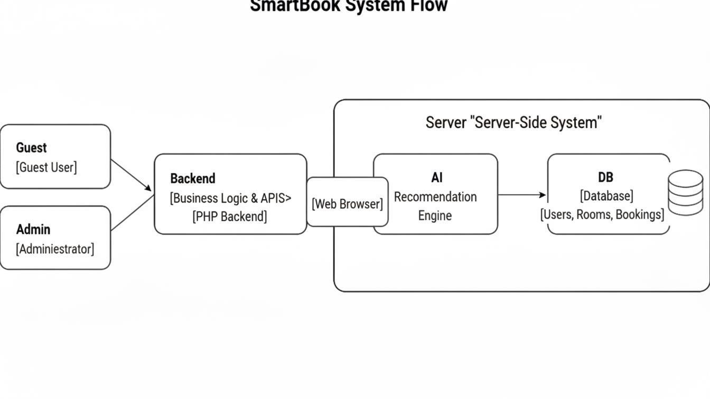

SYSTEM ARCHITECTURE

Architectural Design
The system follows a three-tier architecture:

Presentation Layer
Web-based user interface (HTML5, CSS3, JavaScript)

Handles user interactions, form submissions, and result display

Application Layer (Backend)
Implemented using PHP

Contains business logic, authentication, booking workflow, and AI orchestration

Data Layer
Relational Database (MySQL/PostgreSQL)

Stores users, rooms, bookings, transactions, and logs Subsystems include:
User Management Module Booking Management Module AI Recommendation Module Payment Module
Notification Module
Admin Management Module

All subsystems communicate through well-defined service interfaces within the backend.

Decomposition Description
The system is decomposed using an object-oriented approach:

User Management Subsystem: Handles registration, login, session management, and profile updates.

Booking Subsystem: Manages room search, availability checking, reservation, and confirmation.

AI Recommendation Subsystem: Analyzes user behavior and booking context to rank rooms and generate upsell suggestions.

Payment Subsystem: Supports online and cash-on-counter payment workflows.

Notification Subsystem: Sends confirmation and cancellation emails.

Admin Subsystem: Allows admins to manage rooms, pricing, availability, and reports.

Design Rationale
A three-tier architecture was selected to ensure scalability, maintainability, and separation of concerns. This design allows independent modification of the user interface, business logic, or database without impacting other layers. Alternative monolithic designs were rejected due to limited scalability and maintainability.
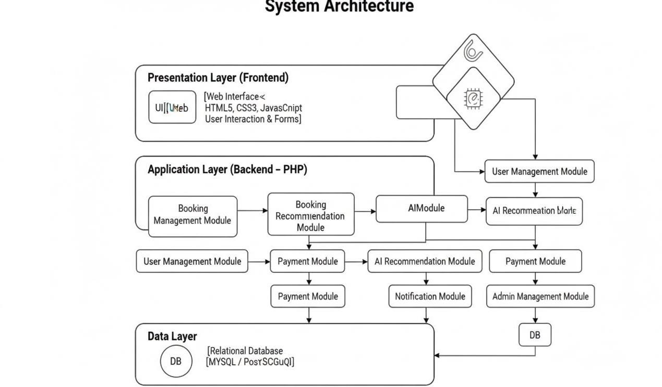

DATA DESIGN

Data Description
The system uses a relational database model. Core entities include Users, Rooms, Bookings, Payments, and Notifications. Data is stored persistently in a relational database and accessed via ORM to ensure data integrity and abstraction.

Data Dictionary

User
User ID (Integer, PK) Name (String)
Email (String, Unique) Password Hash (String) Role (Guest/Admin)

Room
Room ID (Integer, PK) Type (String)
Price (Decimal) Amenities (Text) Status (Enum)

Booking
Booking ID (Integer, PK) User ID (FK)
Room ID (FK) Check In Date (Date)
Check Out Date (Date) Status (Enum)

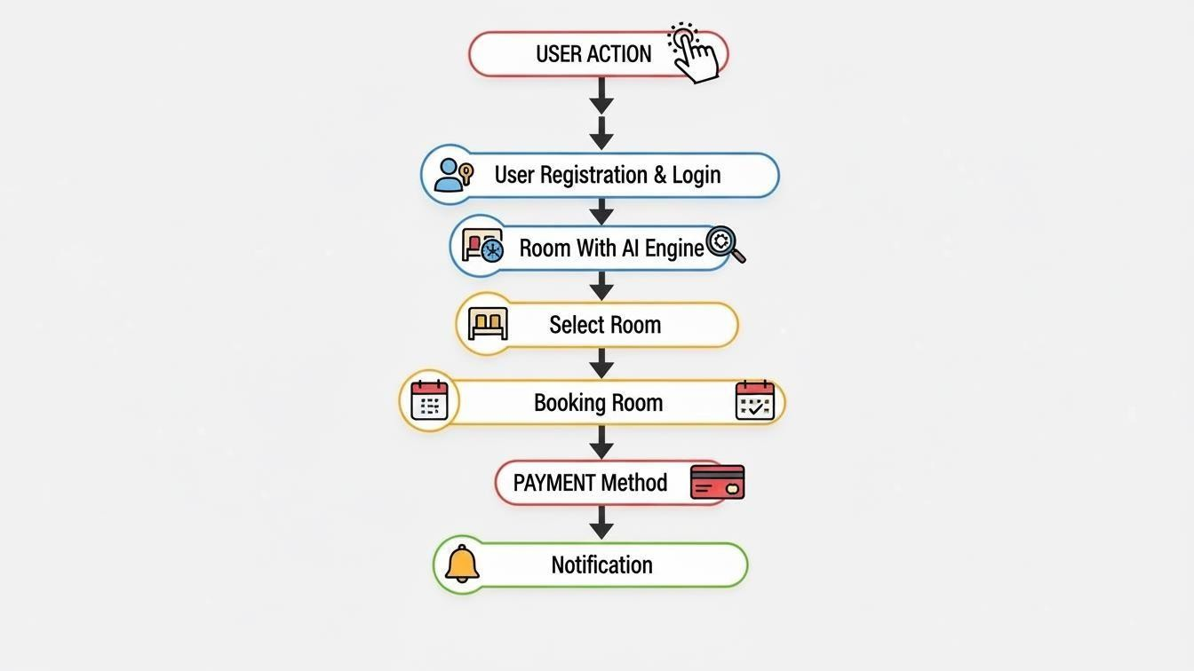
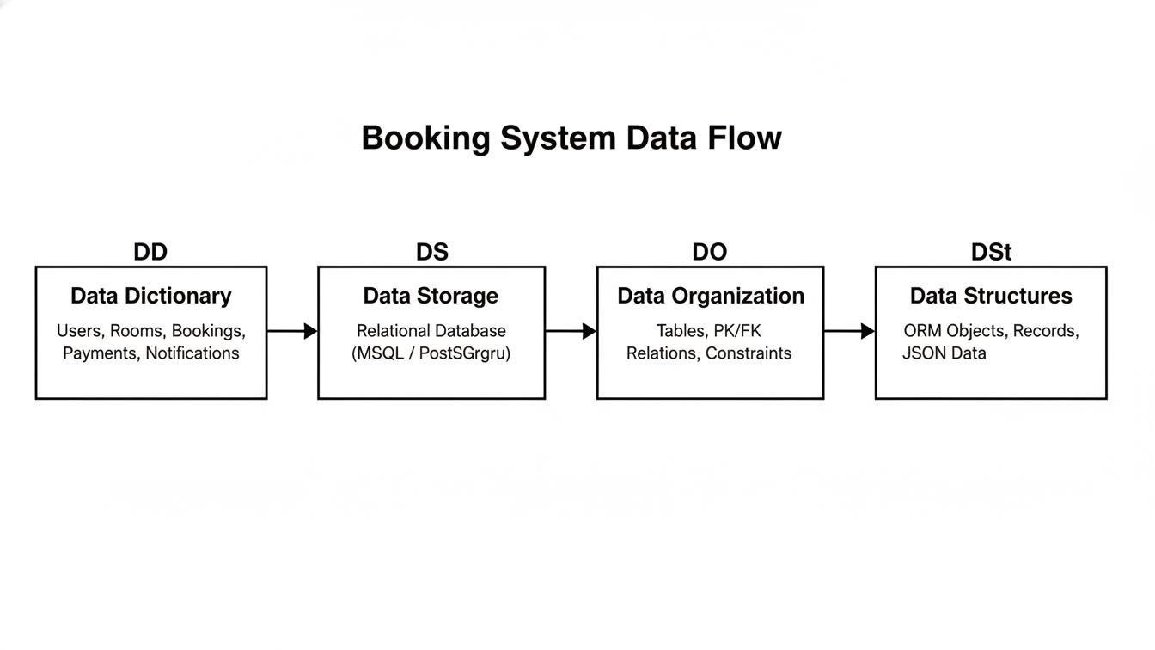

COMPONENT DESIGN
Each component exposes well-defined methods:

User Service: register User(), login User(), update Profile()

Booking Service: search Rooms(), check Availability(), confirm Booking()

AI Service: rank Rooms(), generate Upsell()

Payment Service: process Online Payment(), mark Cash Payment()

Notification Service: send Confirmation(), send Cancellation() Pseudo-code example (AI Room Ranking):
Input: User Profile, Available Rooms For each room in Available Rooms:
score = calculate Relevance(User Profile, room) Sort rooms by score descending
Return sorted list
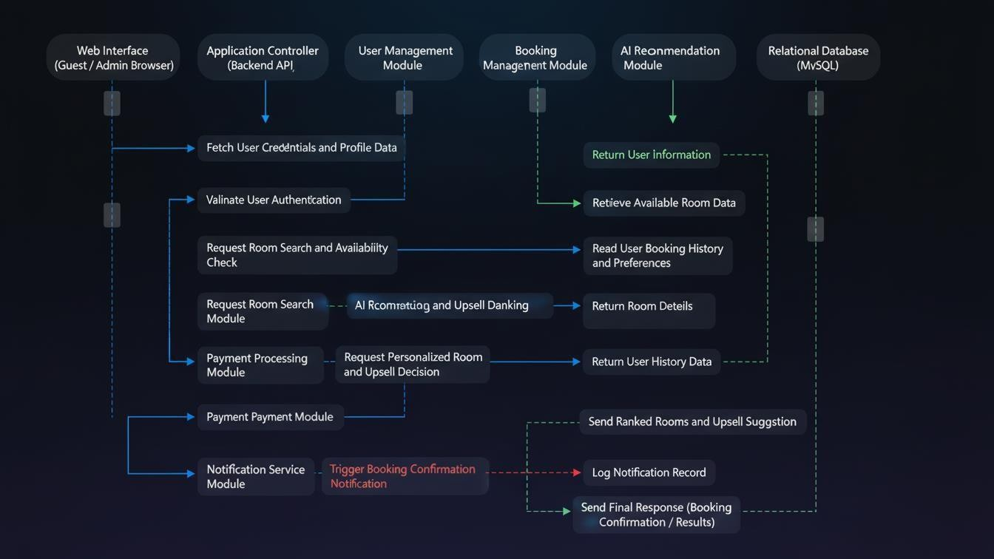

HUMAN INTERFACE DESIGN

Overview of User Interface
The user interface is web-based, responsive, and mobile-friendly. Guests can search rooms, view AI-sorted results, book rooms, and receive confirmations. Admins access a dashboard to manage inventory and bookings.

Screen Images
Screens include:

Login & Registration Page Room Search & Results Page Room Details & Booking Page Admin Dashboard
(Mockups / screenshots to be attached separately.)

Screen Objects and Actions
Buttons: Search, Book Now, Pay, Login, Save Changes Input Fields: Dates, Guests, Filters, Payment Details Actions trigger backend services via HTTP requests

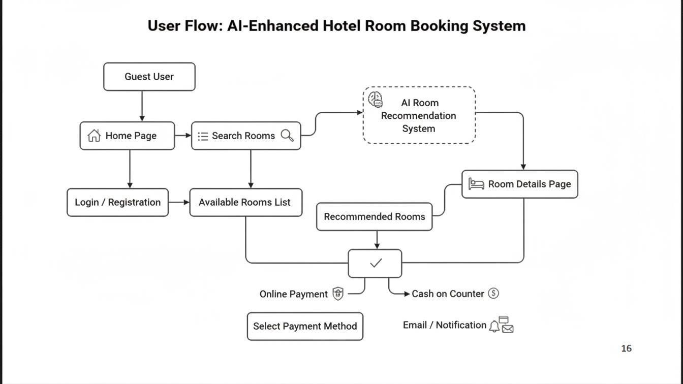

REQUIREMENTS MATRIX

SRS Requirement ID | Requirement Description | System Component
FR-1 | User can register and log in | User Module
FR-2 | User can search hotels by location, date, and filters | User Module / Booking Module
FR-3 | User can view hotel and room details | User Module
FR-4 | User can make a booking | Booking Module / Database Module
FR-5 | User can cancel a booking | Booking Module / Database Module
FR-6 | System sends booking confirmation emails | Booking Module / Backend Services
FR-7 | Admin can add, edit, or delete hotels | Admin Module / Database Module
FR-8 | Admin can manage rooms and pricing | Admin Module / Database Module
FR-9 | Admin can view and manage bookings | Admin Module / Backend Services
FR-10 | Admin can generate basic reports | Admin Module / Backend Services

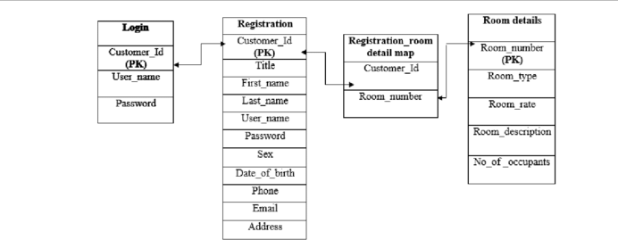

APPENDICES
Appendix A: ER Diagram
The Entity Relationship (ER) Diagram represents the logical structure of the database used in the Hotel Management and Smart Room Booking System (SmartBook). It illustrates the system’s core entities, their attributes, and the relationships between them. The ER diagram helps in understanding how data is organized, stored, and accessed within the system, ensuring data integrity and efficient database design.

Core Entities

User
The User entity represents both guests and administrators of the system. It stores user-related information required for authentication and authorization. Each user can perform multiple actions such as booking rooms or managing inventory depending on their role.

Room
The Room entity contains information about hotel rooms including room type, price, amenities, and availability status. Rooms are the primary resources managed by the system and are assigned to users through bookings.

Booking
The Booking entity acts as the central link between users and rooms. It stores reservation details such as check-in date, check-out date, and booking status. A user can make multiple bookings, while each booking is associated with one specific room.

Payment
The Payment entity records payment information related to a booking. It supports both online payments and cash-on-counter payments. Each booking generates a single payment record to track transaction status and amount.

Notification
The Notification entity represents system-generated messages such as booking confirmations and cancellations. Notifications are sent to users to keep them informed about the status of their bookings.

Relationships Between Entities
A User can make multiple Bookings, but each booking belongs to only one user.

A Room can be associated with multiple Bookings over time, but only one booking per date range.

Each Booking has one Payment record.

A User can receive multiple Notifications related to booking activities.

Importance of the ER Diagram
The ER diagram ensures:

Proper database normalization

Clear definition of relationships using primary and foreign keys Prevention of data redundancy
Efficient data retrieval and consistency

By clearly defining entities and their relationships, the ER diagram serves as a blueprint for database implementation and supports the overall reliability and scalability of the SmartBook system.

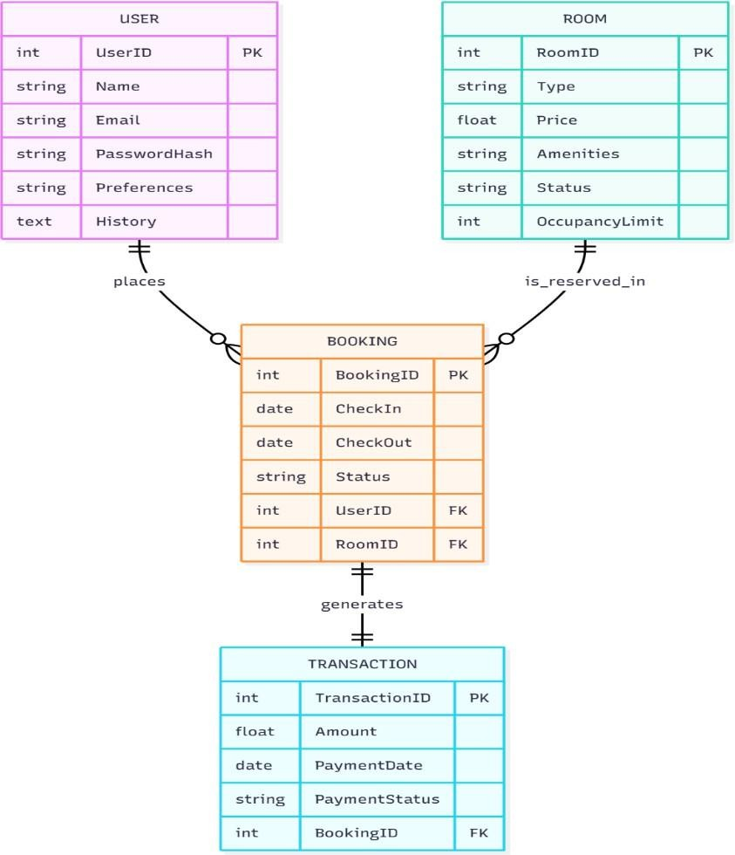

Appendix B: Sequence Diagrams
Sequence diagrams are used to model the dynamic behavior of the Smart Book system by illustrating how different system components interact with each other over time. These diagrams show the order of messages exchanged between actors, user interface components, backend services, the AI recommendation engine, and the database during the execution of specific use cases.

In the Smart Book system, sequence diagrams help explain how user requests are processed from the initial interaction at the web interface to backend processing and final responses. They provide a clear understanding of the control flow, data flow, and responsibilities of each component involved in system operations.

The sequence diagrams included in this appendix cover the major functional scenarios of the system, including:

User registration and login

Room search and AI-based room recommendation Room booking and payment processing Notification handling
Administrative inventory management
Each diagram begins with an actor (Guest or Administrator) interacting with the web interface. The request is then forwarded to the backend services, where business logic is executed. The backend communicates with the AI recommendation engine when personalization is required and accesses the database to retrieve or store persistent data. Finally, the system sends an appropriate response back to the user interface.

These diagrams support system design by:

Clarifying interactions between system components Ensuring correct sequencing of operations
Helping identify dependencies between modules Supporting implementation and testing activities
Overall, the sequence diagrams serve as a visual representation of how the Smart Book system behaves during runtime and complement the static design models presented in other sections of the document.

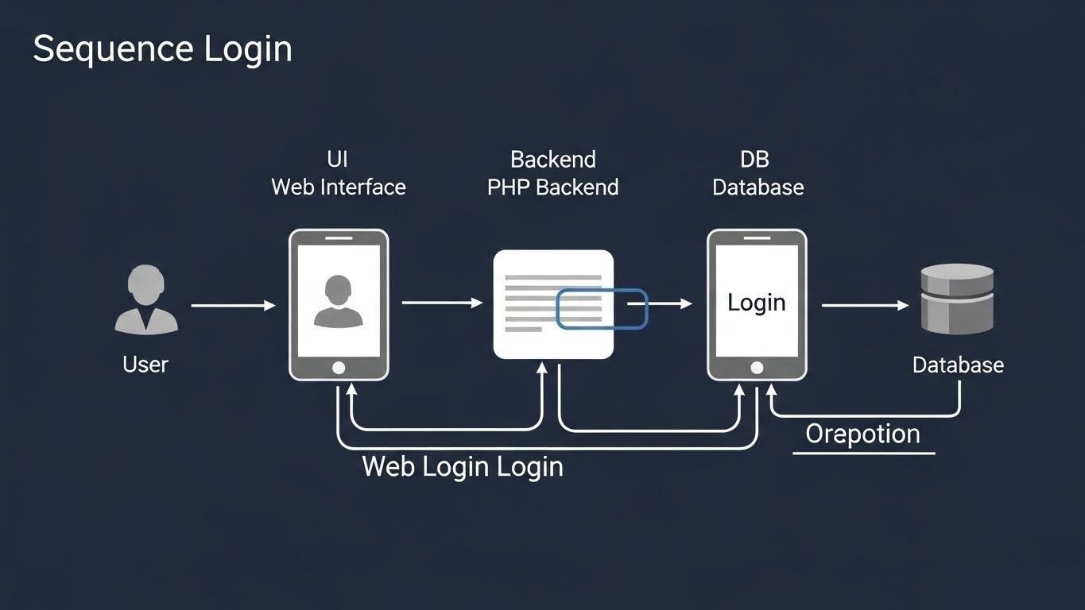

Appendix C: Technology Stack Details

Hotel Management and Smart Room Booking System
This appendix describes the technologies, frameworks, and tools used in the development of the Smart Book system. The selected technology stack ensures scalability, maintainability, security, and compatibility with modern web standards.

Programming Languages

Frontend
HTML5 – Structure and layout of web pages

CSS3 – Styling and responsive design

JavaScript – Client-side interactivity and form handling

Backend
PHP – Server-side business logic, authentication, booking workflow, and API handling

Web Frameworks & Libraries

Backend Framework
Core PHP (MVC-based structure)

REST-style endpoints for client–server communication

Frontend Libraries
Vanilla JavaScript (AJAX for asynchronous requests) Bootstrap (optional) for responsive UI components

Database Technology
Database Type: Relational Database

Supported Databases:
MySQL

PostgreSQL

Database Responsibilities:
Store user accounts, rooms, bookings, payments, and logs Maintain data integrity using primary and foreign key constraints

ORM / Data Access Layer

ORM / Database Access
PHP PDO / MySQLi

Ensures secure database interaction

Prevents SQL injection through prepared statements

AI Recommendation Technology

AI Recommendation Engine
Implemented as a backend service

Uses user preferences, booking history, and room attributes

Generates personalized room recommendations and upsell suggestions

AI Characteristics
Runs in the background

Acts as a decision-support component Does not require direct user interaction

Server & Deployment Environment

Web Server
Apache / Nginx

Hosting Environment
Localhost (XAMPP/WAMP) for development Cloud or shared hosting for deployment

Operating System
Windows / Linux

  - Communication Protocols Protocol: HTTP / HTTPS Data Format: JSON Purpose:
Client–server communication
API responses for room search, booking, and payments

Security Technologies
Password hashing using bcrypt HTTPS for secure communication Input validation and sanitization Protection against:
SQL Injection
Cross-Site Scripting (XSS)

Cross-Site Request Forgery (CSRF)

Development & Design Tools

IDE / Code Editor
Visual Studio Code

Diagramming Tools
Whisk / Whimsical draw.io

Version Control

Git (optional)

Supported Platforms

Client Side
Desktop browsers (Chrome, Edge) Mobile browsers

Server Side
PHP-supported hosting environments

