Image Processing

Name: - Moaz Ayman Zaki

ID: - 141593

Faculty: - Computer Science

# Problem Description: -

**Testing this picture**

|  |  |  |  |  |
| --- | --- | --- | --- | --- |
|  |  |  |  |  |
|  |  |  |  |  |
|  |  |  |  |  |
|  |  |  |  |  |

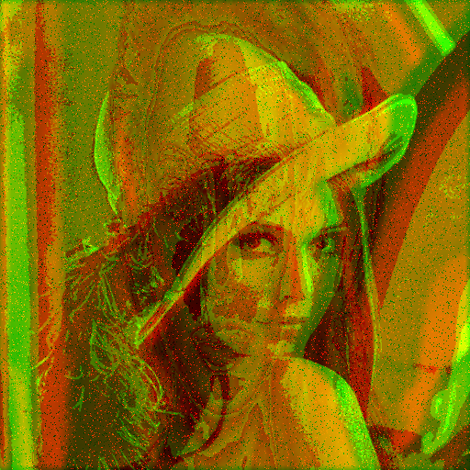

We need to classify our testing picture to which class it belongs to C1, C2, C3, C4, and C5. In order to recognize the characteristics of the testing picture and classify it to its similar class will use the following procedures: -

1. Transform it to gray scale.
2. Remove all the noises in the picture (salt & pepper…etc.) by Gauss filter to smoothen the picture.
3. Enhance by power law transformation by gamma=1.1 to whiten the picture more because as you increase gamma> 1 the more the picture will get whiten, gamma <1 gets more darker
4. Train 3 photos of each class given and take an average of the first 5 characteristics by FFT (Fast Fourier Transformation) after enhancement also.
5. Compare between the characteristics of the testing picture and each class by Euclidian rule.
6. The least distance will refer that it belongs to this class (Class 1).