Bahria University Lahore Campus
Department of Computer Science

Network Intrusion Detection
Using Random Forest
Information Security
Assignment 1

Submitted by: Moaz Sarwar
Student ID: ____________________
Course learning outcome: CLO 4
Submission: Individual
27 September 2026

GitHub profile: https://github.com/moazsarwar2004
Project repository:
https://github.com/moazsarwar2004/Network-Intrusion-Detection_

Executive summary
This project tests whether a machine learning model can help SecureNet Corp identify malicious network connections. A Random Forest was trained on the NSL-KDD dataset and evaluated on a separate test file. The model achieved 75.91% accuracy, 96.64% attack precision and 59.76% attack recall. Although most of its alerts were correct, it missed 5,164 attacks. It can therefore demonstrate how an ML-based detector works, but it is not reliable enough to replace an existing intrusion detection system. A small dashboard and a recorded-traffic replay are included to show how predictions are made.

1 Introduction
A firewall decides which connections are allowed according to a set of rules. However, an allowed connection can still be used for an attack. An intrusion detection system examines activity and raises alerts when it finds suspicious behaviour.
For the SecureNet Corp scenario, the aim is to build a tool that classifies a connection as normal or malicious. The project starts with labelled network records, prepares the features, trains a classifier and checks its predictions. The results are then examined from a security point of view: which attacks are detected, which are missed and how often normal traffic is flagged.

2 Dataset selection
NSL-KDD was selected because it is small enough for a laptop experiment and has documented network features and attack labels. It contains examples of denial of service, scanning and attempts to gain unauthorized access. These are relevant to an organization concerned about service availability and account security [1, 2].
The experiment uses KDDTrain+_20Percent.txt for training and KDDTest+.txt for testing. The training file contains 25,192 rows and the test file contains 22,544 rows. Each row has 41 network features, an attack name and a difficulty value. Examples of input features are protocol type, service, source bytes, destination bytes and connection counts.
The target is binary: normal traffic is labelled 0 and all attack records are labelled 1. The model does not try to predict the exact attack name. NSL-KDD is an older benchmark, so these results cannot be taken as evidence that the model will detect current attacks on a real network. The files were obtained from a public mirror because the original UNB page no longer provides the download [1, 3].

3 Methodology

Data preparation
The files were loaded with pandas and checked for missing values and repeated records. Neither file contained missing feature values. One duplicate training feature record was removed. Another 117 training records were removed because their features matched records in the test file. This left 25,074 training records. All 22,544 test records were retained, including 57 repeated feature rows.
The attack-name and difficulty columns were excluded from the inputs. The attack name contains the answer, while difficulty is benchmark information rather than a network measurement. Including these columns would make the evaluation misleading.
For numerical features, the pipeline uses median imputation followed by StandardScaler. For protocol, service and flag, it uses most-frequent imputation and one-hot encoding. Imputation is included even though these files have no missing features. One-hot encoding turns categories into separate indicator columns. All preprocessing settings are learned from training data only.

Exploring the data
After cleaning, the training set contains 13,426 normal records and 11,648 attack records. The chart also shows that neptune is much more common than the other training attacks. This matters because the model has fewer examples from which to learn less common attack patterns.
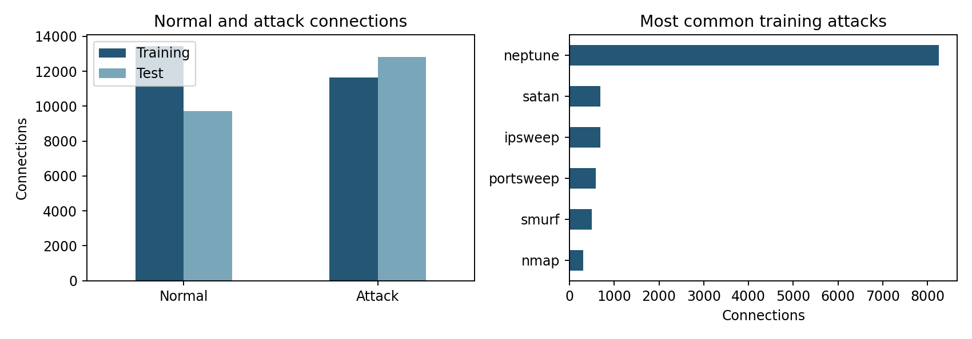
Figure 1. Class distribution and the most common training attacks.

Model development
Random Forest was chosen because it handles relationships between network features without requiring a complex neural-network setup. It trains multiple decision trees and averages their class probabilities [4]. This experiment uses 100 trees, maximum depth 20, minimum leaf size 2, balanced class weights and random seed 42. The settings were fixed before evaluating the test set.
The preprocessing steps and classifier are stored in one pipeline. Standard scaling is included to meet the preprocessing requirement, although Random Forest itself does not need scaled inputs. The fitted model receives 117 columns after encoding.

4 Results
The trained model was tested on the supplied test file. Attack is the positive class. Precision measures how many alerts are real attacks; recall measures how many actual attacks are detected. Both are necessary because a model can raise accurate alerts while still missing many attacks.
Measure | Result
Accuracy | 75.91%
Attack precision | 96.64%
Attack recall | 59.76%
Attack F1 score | 73.85%
False positive rate | 2.75%
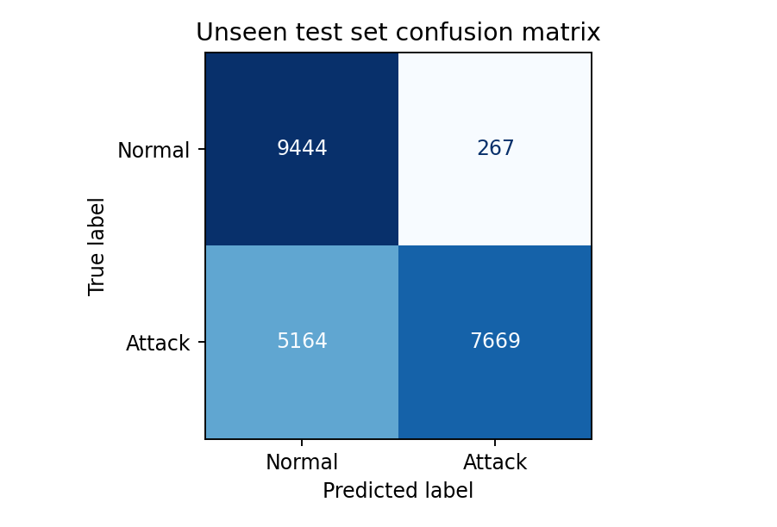
Figure 2. Predictions on the 22,544 test connections.
The model correctly classified 9,444 normal connections and detected 7,669 attacks. It incorrectly flagged 267 normal connections and missed 5,164 attacks. Attack precision is therefore 7,669 / (7,669 + 267), or 96.64%. Attack recall is 7,669 / (7,669 + 5,164), or 59.76%.
For comparison, predicting every connection as normal would give 43.08% accuracy and detect no attacks. The trained model improves on this baseline, but the number of missed attacks remains a serious weakness.

5 Security analysis
The overall score hides large differences between attack types. The model detected 4,655 of the 4,657 neptune records, but none of the 1,231 guess_passwd records. A password-guessing attempt could therefore pass without an alert. It also detected only 72 of 737 apache2 records and 4 of 685 processtable records.
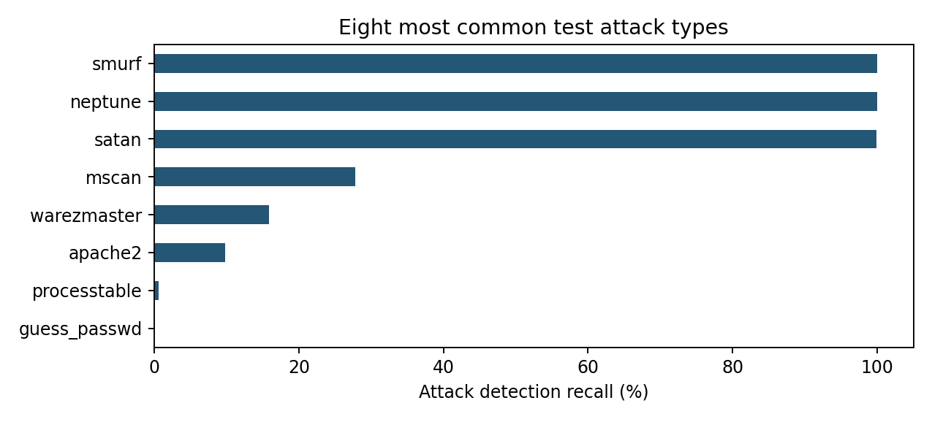
Figure 3. Detection recall for the eight most common test attack types.
These values measure whether each attack type was flagged as malicious. They are not multiclass results because the model only predicts normal or attack. Good detection of neptune does not mean that all denial-of-service attacks are detected.
The main concern is the false negatives: 40.24% of attacks were missed. False positives also matter because they take time to investigate and can cause analysts to ignore repeated alerts. Based on these results, the tool should support investigation alongside firewall rules, authentication controls and existing IDS alerts. Automatic blocking would require more testing.

6 Prediction demonstration
The replay script sends ten recorded feature rows through the saved pipeline one at a time. The dashboard shows the evaluation charts and lets the user predict an individual record or replay the ten records. Reloading the saved pipeline produced the same predictions as the original model for these records.
This demonstrates the prediction stage of real-time detection. It does not capture live packets. A live system would need a capture tool and a feature extractor that produces the same 41 features. Some features depend on completed connections or time windows, so prediction speed alone does not measure the full detection delay.
The dashboard can be started with python src/dashboard.py and opened at http://127.0.0.1:8000. The command-line replay is started with python src/replay.py --delay 0.3. The displayed attack score is a model estimate, not a guaranteed probability.

7 Conclusion and future work
The project produced a working classifier, a complete notebook and a demonstration of recorded-traffic prediction. It shows how pandas and scikit-learn can be used to prepare network data and build a security tool, which addresses CLO 4. The evaluation is also useful because it identifies where the solution fails.
The main finding is that high precision alone is not enough. Most alerts were correct, but the model missed about four out of ten attacks. It would therefore be unsuitable as the only line of defence for SecureNet Corp.
The next step would be to improve attack recall using a validation set taken only from the training data. Other classifiers and decision thresholds could then be compared without repeatedly tuning against the test file. Weak attack types should be examined separately rather than relying only on overall accuracy.
The model should also be tested on a newer dataset, such as UNSW-NB15 or CIC-IDS2017. Before live use, the feature collector would need to be checked against the training definitions, and the complete system would need measurements of detection delay and false alarms. Repeated test feature records are another limitation of this experiment; a future evaluation should also examine unique connections and traffic collected at different times.

References
[1] University of New Brunswick, Canadian Institute for Cybersecurity. ISCX NSL-KDD dataset 2009. https://www.unb.ca/cic/datasets/nsl.html
[2] Tavallaee, M., Bagheri, E., Lu, W., and Ghorbani, A. A. (2009). A Detailed Analysis of the KDD CUP 99 Data Set. IEEE CISDA. DOI: 10.1109/CISDA.2009.5356528.
[3] jmnwong. NSL-KDD-Dataset. Public dataset mirror. https://github.com/jmnwong/NSL-KDD-Dataset. The exact source revision and file checksums are recorded in data/manifest.json.
[4] scikit-learn. RandomForestClassifier documentation. https://scikit-learn.org/stable/modules/generated/sklearn.ensemble.RandomForestClassifier.html
[5] UCI KDD Archive. KDD Cup 1999 task description and feature definitions. https://kdd.ics.uci.edu/databases/kddcup99/task.html
Online sources accessed on 27 September 2026.

