**Finding / Main points:**

1. A close up of a map

   Description automatically generatedBy increasing the total monthly release volume, more revenue can be generated with same hydropeaking index value (Figure 1).

Figure 1 Pareto optimal Curve with 2Bugflow Days

1. In most of the cases with full optimization, same or more revenue can be generated even with low hydropeaking Index.

For instance, Figure 2:

Figure 2 Pareto optimal curve

From Figure 2, it is evident that with more monthly amount to release there is larger window of improvement in both objectives i.e. the gap width (represented by r is increasing). And while decreasing the total monthly release the case is vice versa.

In nutshell, it means that with optimization one can generate more revenue even with lower hydropeaking value in comparison to Bugflow releases.

1. With more volume to release, the hydropeaking values for the Bugflow Releases are peaking higher and the curve length is also squeezing(Figure 1 & Figure 2). Which means the model has only limited options for release pattern in order to meet the total monthly volume amount.
2. Increasing the number of constant Bugflow days is further constraining the model and also making it worst for both objectives (Figure 3 & Figure 4).

Figure 3 Pareto Optimal Curve with 3Bugflow days

1. 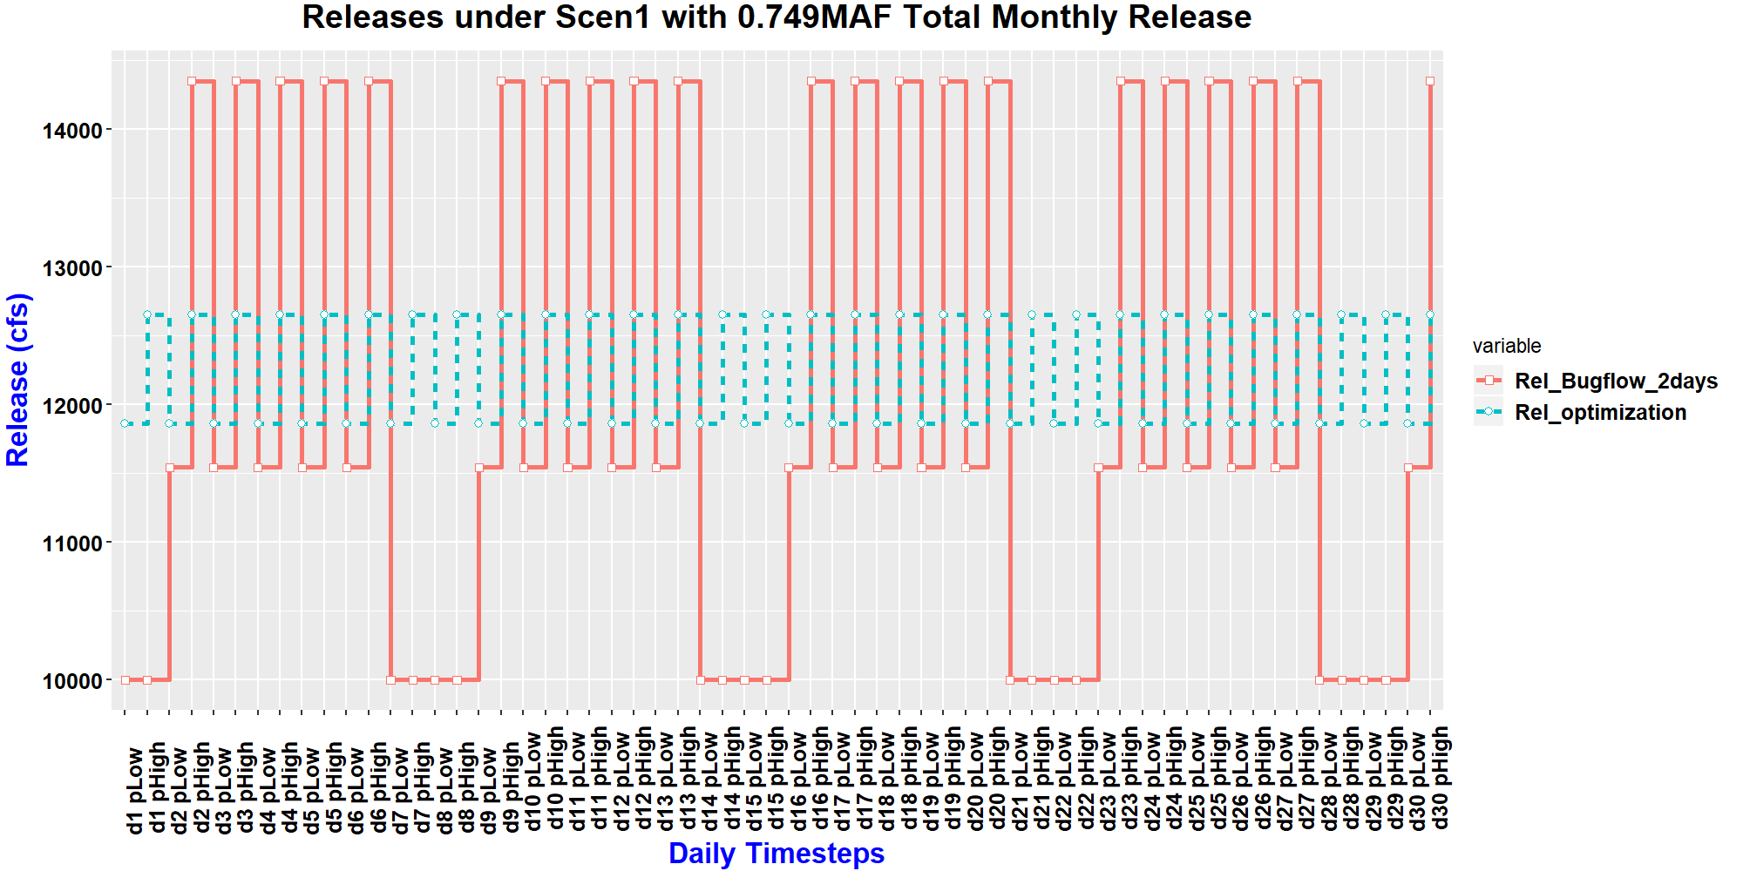A close up of a map

   Description automatically generatedAs expected, with low hydropeaking index (for instance: Scen1 shown in Figure 5 & Figure 6) there is significant amount of improvement window available between Bugflow releases and full optimization cases. Whereas, high hydropeaking index tries to constraint the model. For the reason, there is less variation between results of Bug flow and optimization run (figure 7 & figure 8) in comparison to low hydropeaking index case. Still model has flexibility to design the hydrograph differently for both cases, thus, difficult to exactly count the variation.

Figure 4 Releases for 2 Bugflow days with Low H.P Index

Figure 5 Pareto Optimal Curve with 4Bugflow days

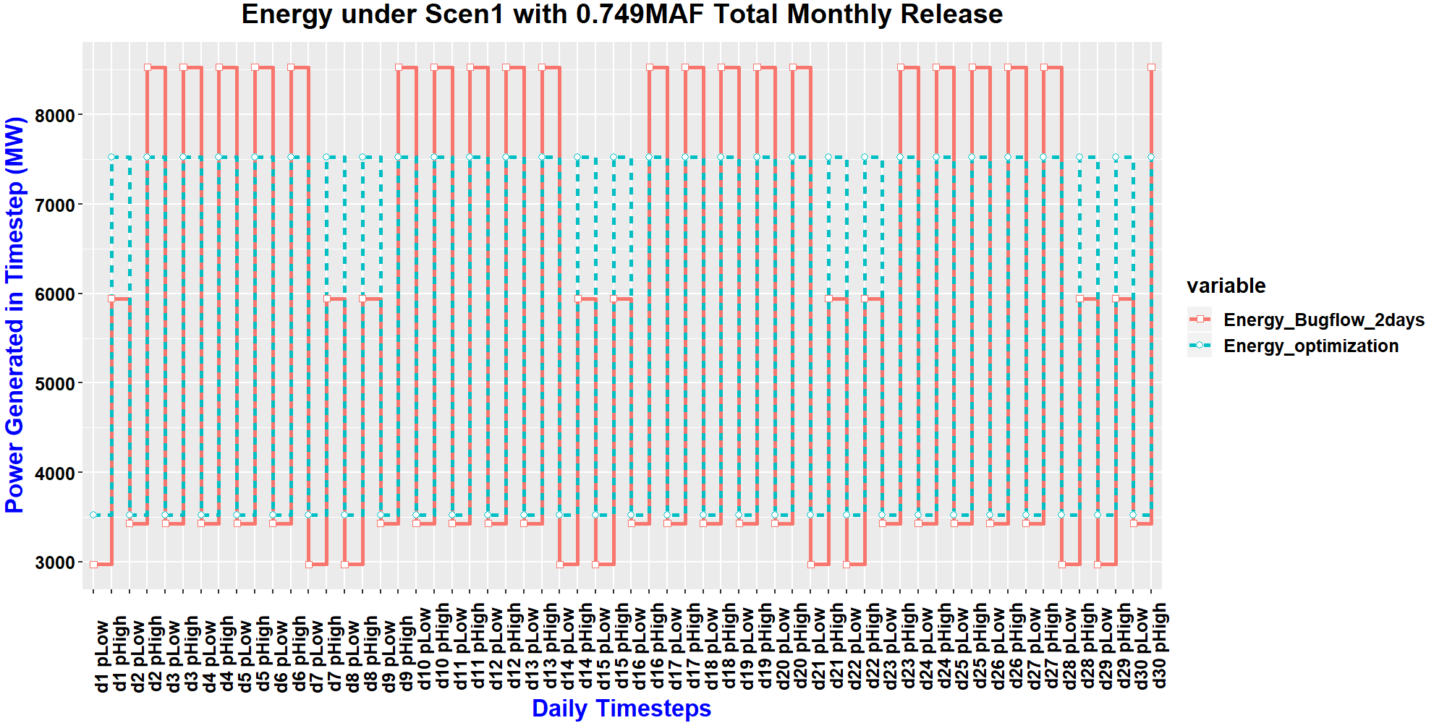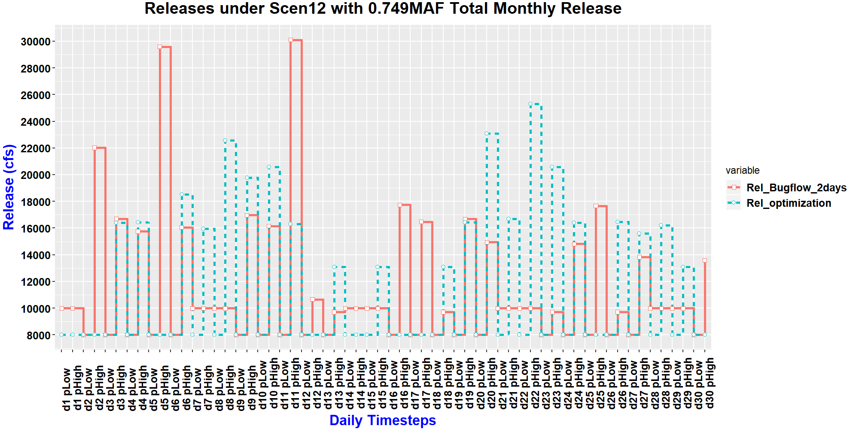

Figure 7 Releases for 2 Bugflow days with High H.P Index

Figure 6 Energy Generation for 2 Bugflow days with Low H.P Index

Figure 8 Energy Generation for 2 Bugflow days with High H.P Index

1. A screenshot of a cell phone

   Description automatically generatedIncreasing the number of Bug flow days is further harming the cause since it pushes the Bugflow values further away from the full optimization case (figure 9,10,11&12).

Figure 9 Releases with 3 Bugflow days having Low Hydropeaking Index

Figure 11 Releases with 4 Bugflow days having Low Hydropeaking Index

Figure 10 Energy Generation with 3 Bugflow days having Low Hydropeaking Index

Figure 12 Energy Generation with 4 Bugflow days having Low Hydropeaking Index

1. The constant release value (Bug Flow release) plays an important part in deciding both the objective values as well as output hydrograph and Energy generation pattern.
2. The results show that even with more constant Bugflow days the Hydropeaking objective is performing worst which proves that Hydropeaking index concept is not a good indicator to count the suitability for Bugs population.
3. The validation results of the model (as shown below in Table 1) shows that the start time and length of the periods considered also have major impact on hydropeaking index. However, it has less impact on revenue generated.

|  |  |  |  |  |  |  |
| --- | --- | --- | --- | --- | --- | --- |
| **S.No:** | **Senario** | **Flow volume (Ac-ft/ Month)** | **Energy Generated** | **Hydropeaking Index** | **Revenue generated ($)** | **Error w.r.t Hourly Revenue** |
| **1** | Observed | 749449.05 | 318194 | 0.156 |  |  |
| **2** | Model Simulated (1 Hr Time step | 749449.05 | 331452.7644 | 0.156 | 15548173.59 |  |
| **3** | Model Simulated (2 Time steps- 9:00 to 22:00 & 22:00 to 9:00) | 749449.05 | 331452.7644 | 0.099 | 15295675.23 | 1.6240 |
| **4** | Model Simulated (2 Time steps- 04:00 to 09:00 & 09:00 to 04:00) | 749449.05 | 331452.7644 | 0.159 | 15471397.25 | 0.4938 |
| **5** | Model Simulated (2 Time steps- 00:00 to 08:00 & 08:00 to 00:00) | 749449.05 | 331452.7644 | 0.111 | 15556917.72 | 0.0562 |
| **6** | Model Simulated (4 Timesteps -00:00 to 5:00, 5:00 to 10:00, 10:00 to 14:00 & 14:00 to 00:00) | 749449.05 | 331452.7644 | 0.132 | 15487948.43 | 0.3873 |