Bugs buy water from hydropower producers: modeling, tradeoffs, and multi-objective management

by

Moazzam Ali Rind

A research proposal submitted in partial fulfillment
of the requirements for the degree of

MASTER OF SCIENCE

Plan A

in

Civil and Environmental Engineering

Approved:

______________________________  David E. Rosenberg, Ph.D.  Major Professor |  | ______________________________  Bethany T. Neilson, Ph.D.  Committee Member
______________________________
Theodore Kennedy, Ph.D.
Committee Member

UTAH STATE UNIVERSITY
Logan, Utah

2021
Project Summary
This study quantifies tradeoffs between the number of days of steady reservoir release and hydropower revenue. The steady flow day— same releases throughout the day —helps aquatic invertebrates lay and hatch. A Bug Flow Experiment for Glen Canyon Dam where weekend summer releases were kept low and steady has been executed since 2018. The overarching question is: how does hydropower revenue vary as steady flow days expand from weekends to weekdays?
A linear optimization model and the constraint method were used to calculate tradeoffs. The model runs for one month with two sub-daily timesteps and is subjected to reservoir physical and managerial constraints. Two types of models are considered: Weekend-Weekday and Sunday-Saturday-Weekday. Comparison amongst models will help understand the importance of Saturday flow patterns (steady or unsteady) for monthly revenue. The study further explores impacts of monthly release volume, energy price differential between on- and off peak periods, pricing template (Weekend-Weekday vs Sunday-Saturday-Weekday), offset release, and length of periods on hydropower revenue. Finally, tradeoffs for different months of the year can guide ecosystem manager decisions of how many additional bug flow days to purchase and pay hydropower producers for lost revenue.

Introduction
Aquatic insects make a major part of the river food web (Kennedy et al., 2016). Specifically, in the Grand Canyon below Glen Canyon Dam, both native and non-native fish populations compete for the available food. On the other hand, various factors e.g. climate change, declining flows, population growth, etc. are reducing the natural river flows. Traditionally, humans believed that regulation of the river flows, e.g. development of reservoirs and diversions, can mitigate the water crisis. However, the implications of those anthropogenic actions on the ecosystems were either unknown or never given preference in comparison to the economic and societal benefits from those structure (Poff et al., 2007; Carpenter et al., 2011). As a result, today we have nearly all the major Earth’s rivers dammed (Nilsson et al., 2005) and the researchers and engineers are still working to identify and mitigate the negative impacts of river structures on the downstream ecology (Kareiva et al., 2000).
In general, water resources are managed for multiple and competing uses, such as water supply, hydropower generation, flood control, recreation, and environmental protection (Null and Lund, 2012). For instance, some of the world’s biggest dams e.g. Three Gorges Dam on the Yangtze River in China, the Itaipu Dam on the Paraná River in Brazil and Paraguay, the Hoover Dam and the Glen Canyon Dam on the Colorado River in the United States were commissioned to secure future water supply and generate hydropower (World Commission on Dams, 2000). Historically, the impacts of these artificial storages on the downstream eco-systems were over-shadowed by the financial and societal benefits. But recent interest in the ecosystem’s sustainability and wide recognition of the problem has introduced a new trend. Now, there has been pressure from various stakeholders e.g. government, public, environmental groups, researchers etc. to consider environmental objectives (Richter, 2014; Pegram et al., 2013; Hart, 2015). Also, numerous existing studies highlight the precedence of rivers increasingly managed for aquatic ecosystems in addition to the traditional water management practices (Null and Lund, 2012). Still, the concept of environmental flows is ambiguous and many decision makers and engineers are looking for precise metrics to represent and quantify the ecological objectives (Alafifi and Rosenberg, 2020).
For example, Kennedy at el., (2016) has identified days of steady low flows as a type of environmental flow that are helpful for the growth of aquatic invertebrates within the Grand Canyon. They used the hydropeaking index, which is a ratio of the amount variation in release to average release, as a metric to quantify the ecosystem objective. During their study, they observed that the sites with larger hydropeaking index (more variation in daily releases) have low aquatic insect diversity (EPT %). They concluded that dams with hydropeaking operations-- higher releases during daytime to meet energy demands and lower releases during nighttime-- have low aquatic insect diversity in the downstream. Out of 16 dams they considered in their work, they found that the Glen Canyon Dam and the Hoover Dam had the highest hydropeaking index value, hence, worst insect diversity. Other studies show cold releases from the reservoir (Stevens et al., 1997; Olden and Naiman, 2010), change in natural flow regime (Walker, 2017), etc. are also responsible for the low insect diversity.
Two types of models – simulation and optimization – are typically used for ecosystems modeling (Adams et al., 2017). The concept of environmental flows has been widely studied and applied, specifically during the last few decades, around the globe. A number of available studies e.g. Tharme (2003) and Arthington, 2012, are spotlighting the benefits and application methods of the environmental flows. Still, the art of translating ecological knowledge into operational paradigms is a hot research topic (Harman and Stewardson, 2005) and water managers and researchers are facing challenges to find balance between competing traditional water management and environmental objectives (Acreman et al., 2014; Richter, 2014; Poff et al., 2016).
This research extends the environmental flows Kennedy et al. (2016) suggested for the Glen Canyon Dam releases that steady low flow days encourages the bug-egg hatching process. However, the study uses a unique and transparent metric to represent the environmental objective--number of days of steady low flows during a month. The study quantifies the tradeoff between number of steady low flow days (ecosystem objective) and monthly hydropower revenue. Moreover, the study quantifies the impacts of different managerial decisions and uncertainties such as total monthly release volume, the price differential between weekday and weekend energy rates, and number of steady flow days, on monthly hydropower revenue generation.
One of the major contributions of this work is to inform and guide resolution of the conflict between hydropower generation and management to enhance aquatic invertebrates. The tradeoffs for different months identify the lost hydropower revenue or cost associated with each steady flow day. That financial information is helpful for ecosystem managers to plan or purchase steady flow days during different months. For example, if an ecosystem manager has an annual budget of $300,000 to spend on bug flows, the tradeoff results will inform his/her decision about the number of steady flow days to purchase and in which months. The overall proposal has been divided into subheadings staring with introduction, objectives, literature review, methodology, model validation, proposed work, preliminary results, work plan, and expected outcome and significance of the work.

Objectives
This study was initiated with four broad questions: 1) How much the total monthly hydropower revenue is impacted by bug flow days on weekends and weekdays? 2) How the influential factors such as total release volume, price differential between on- and off- peak periods, pricing template, offset release, and length of the periods affect the hydropower revenue? 3) How the tradeoff between bug flow days and hydropower revenue vary across months? And 4) How can the tradeoff information be used to encourage more cooperation among hydropower and aquatic invertebrate managers?
Answers to the questions can be expected by achieving the following objectives:
- Develop an optimization model for Glen Canyon Dam releases that can quantify the tradeoff between number of steady low flow days and monthly hydropower revenue for different monthly release volumes and other factors.
- Demonstrate how different factors such as price differential between on- and off-peaks during weekdays, energy prices between weekdays and weekend, total monthly release volume, length of the periods, averaged price for the period, and offset release between weekday off peak and steady weekend controls the cost of the Bug Flow Experiment, shape, and position of the tradeoff curves.
- Examine the effects of looking at steady flows on Sundays, Saturdays, and Weekdays rather than weekends and weekdays and explore the impacts of making Saturdays unsteady flow days.
- Describe tradeoffs across different months of the year and how tradeoffs can be used to quantify lost hydropower revenues. For example, how many bug flow days and during which months should an aquatic invertebrate manager spend an annual budget of say $300,000?

Literature Review
The world recognizes Grand Canyon because of its unique geology and spectacular scenery. Every year, the Grand Canyon National Park receives almost 6 million visitors (DOI, 2017). Besides, the Grand Canyon is one of the most studied geologic landscapes in the world and home to numerous native endemic species (NPS, 2018a). For instance, historically there were eight native fish species populating Colorado River with in the Grand Canyon (NPS, 2018b). Five out of eight fish species are still available today, where two from the available five (Humpback Chub and Razorback Suckers) are listed under the Endangered Species Act.
Different studies have identified various factors responsible for changes in the Grand Canyon’s ecosystems within the last century. For example, Poff et al., (2007) focused on change in the downstream water temperature due to inclusion of Glen Canyon Dam, Schmidt and Wilcock (2008) tracked the change in sediment transport, Olden and Naiman (2010) identified change in river water depth, and Walker (2017) discussed the change in river flow regime due to addition of Glen Canyon Dam. Kennedy et al., (2016) found that these stressors have adverse effects on aquatic life and often extirpate species that have linkages with nearshore environments during one or more stages of their life cycle.
For instance, traditional hydropeaking dam operations at Glen Canyon Dam keep releases during daytime high then make nighttime releases low (Førsund, 2015). This release pattern follows daily energy demands. Aquatic invertebrates are negatively affected by hydropeaking. Invertebrates cement and lay their eggs during dusk time at the river edge on rocks and other strata, when the releases are still high. During the night, minimum releases are made which cause the river water level to drop, width to shrink, and the shores dry out. This sub-daily flow fluctuation causes most invertebrate eggs to become desiccated; hence the overall invertebrates’ population is constrained. Those invertebrates are the primary food web for myriad species of fish, birds, bats, and other wildlife living within or along the river (Nakano and Murakami, 2001; Baxter et al., 2005).
Kennedy et al., (2016) verified the inverse relationship between hydropeaking and downstream insect diversity. They used a nonlinear metric called the “Hydropeaking Index”, which is a ratio of amount variation in release to average release, to represent ecosystem objective. Their calculations include daily hydropeaking index averaged over a period of at least 5 years for 16 dam sites across the Western United States. The results from their study shows that large dams e.g. Hoover Dam and Glen Canyon Dam had a high hydropeaking index value and almost no insect diversity. They suggested low steady weekend reservoir releases will improve the situation for aquatic invertebrates, because bug-eggs laid during stable low weekend releases will have minimum chances of desiccation. In addition, energy demand on weekends is relatively less (Førsund, 2015), therefore, replacing hydropeaking operations with steady flows on weekends would affect total monthly hydropower revenues less (USBR, 2016).
Starting the summer of 2018, steady low flows on weekends during summer months have been practiced each year (the Bug Flow Experiment) and the concept was also included in the prefer alternative of the long term experimental and monitoring program (LTEMP DEIS). Ploussard and Veselka (2019) looked at the financial implication of the 2018 Bug Flow Experiment. They created two scenarios: 1) summer months with bug flows, 2) summer months without bug flows, and quantified the expected difference in hydropower production between the scenarios. Also, they have identified factors responsible for the cost associated with the bug flows and examined the interdependencies amongst the factors.
Typically, a hydropower objective is a non-linear function (Yoo, 2009) that depends on the power generation release, reservoir storage level, turbine efficiencies, and operations in relationship to design efficiencies. Those releases that generate hydropower fluctuate through the day according to varying energy prices. Commonly, dynamic or nonlinear programing has been preferred to solve such problems because of multiple sub decisions required to reach the ultimate optimal decision or the nonlinearity created by multiplying release, reservoir level, turbine efficiencies, themselves functions of the level and release (e.g. Yakowitz, 1982; Ko et al., 1992; Tilmant et al., 2002). These optimization problems are computationally intensive (Hochbaum, 2007) and researchers have an interest to approximate nonlinear objectives by various linearization techniques.
For example, Rheinheimer et al. (2015) developed a linear programming model to maintain downstream cold water temperatures for Chinook salmon below Lake Spaulding, California. They considered that the reservoir has two completely mixed thermal layers (i.e. warm and cold pools) and the release decisions were made prior to, and independent from, temperature management decisions. These assumptions converted a non-linear problem with both quality (thermal layer selection) and quantity (release hydrograph) decisions into a linear problem with only the quality decision to make. Their analysis predicted benefits of having multiple temperature withdrawal structure in comparison to single intake level structure. Yoo (2009) used linear programming to maximize the annual energy production at Yongdam in South Korea. His approach was inspired from successive linear programming techniques, but to avoid reiterations, he considered weighted constant values of the storage water level and the water volume released for hydropower generation in the objective function to linearize the problem.
The decision about hydropower generation is primarily dependent upon the energy prices, those typically vary by time of the day and day of the week, e.g. weekday vs weekend (visit https://www.rockymountainpower.net/savings-energy-choices/electric-vehicles/utah-ev-time-of-use-rate.html). Our contacts at the Western Area Power Authority) that manages hydropower operations at Glen Canyon Dam suggested we consider an additional realistic factor used by power generation companies known as capacity value in modeling work. During certain time periods, the electricity demand exceeds the generation capacity. That additional required electricity is supplied from alternative sources like reserved generators or transported from nearby power markets (Texas Electricity, 2019) and sold at a very high price decided by consumer’s willingness to pay. Market capacity may vary based on factors like geographic location, weather, hydrologic conditions (e.g. drought), air temperature, and population growth etc. For example, on August 15, 2019, real-time energy prices in Houston, Texas hit the market capacity of $9,000/MW for the second time that week (Oseik, personal communication, 2020). Figure 1 also highlights that abnormal increase in energy prices during summer 2019 for ERCOT- a wholesale energy marketing company for Texas. Moreover, Figure 1 offers contextual information of energy pricing at wholesale market level across different US hubs and provide an average monthly comparison of prices during 2018-19.
There has been recent demand from WAPA to limit the steady flow days to Sundays only instead of both Saturdays and Sundays (Kennedy, personal communication, 2020). The on-peak (daytime) energy prices on Saturdays are higher than Sundays. Energy prices on Saturday are actually between Sunday and weekday prices. Hence, it is expected that there is potential to earn higher monthly hydropower revenue, specifically during the months with high energy prices.

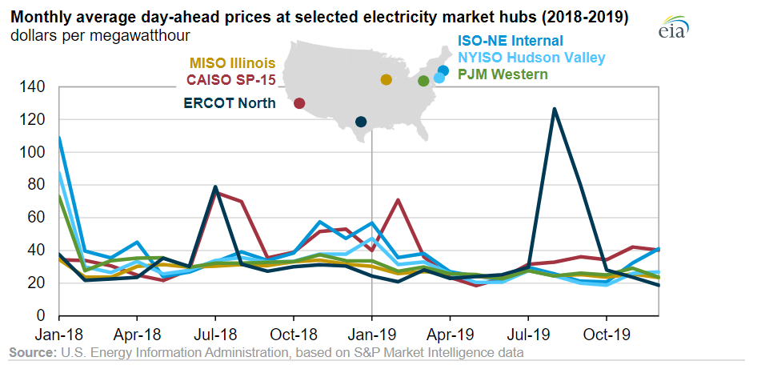Figure 1 Monthly electricity pricing in different US markets for years 2018-19 [Retrieved from https://www.eia.gov/todayinenergy/detail.php?id=42456]
This study is designed to quantify the tradeoff between days of steady flows good for aquatic invertebrates and hydropower revenue. Initially, we used the hydropeaking index --the fluctuation in flows quantified from the division of standard deviation of releases to average release-- used by Kennedy et al., (2016) to represent the invertebrate’s objective. The hydropeaking index is a non-linear metric, required a nonlinear model to solve, and therefore, solutions found were not guaranteed to be globally optimal. Subsequently, we used a linear aquatic ecosystem metric -- the number of days of steady low flows -- along with some assumptions -- constant reservoir water level and turbine efficiency through the month, daily hydrograph remains the same throughout the month, etc. – to transform the problem into a linear program. Linear programs can be solved by numerous commercial or public domain solvers and results are guaranteed to be global optimal solutions. Also, for the linear problems, the solvers auto-provide sensitivity information, e.g. shadow values (change in objective function value with relaxing binding constraint by single unit) and range of basis (range of right-hand side values of the constraints before the model update the results for decision variables), of the model inputs. The solution time of the linear problems is minimal too.
The findings from the research will guide water manger’s decision about the number of bug flow days and help them understand the impact of different factors -- Monthly release volume, energy prices amongst different days, price differential between on- and off- peak periods, length of the periods and offset release-- on the monthly hydropower revenue. In addition, the model provides managers with the opportunity to test different flow regimes and visualize the impacts on hydropower revenue. The tradeoffs show the hydropower revenue lost for different day types and flow patterns (steady or unsteady) across different months. This information can help adjust the number of steady low flow days during different months. For instance, it can be estimated that by giving up one steady flow day during high energy value month (e.g. August) can purchase several unsteady flow days during months with lower energy prices (e.g. June). Quantifying lost hydropower revenue from bug flow days in dollars ($) can help a broader audience of politicians, economists, hydropower companies, environmental groups, and general public engage in reservoir release and bug-flow decisions.
Methodology
The daily hydrograph was simplified by dividing the day into two periods: 1) pLow (off-peak) which starts at midnight and last till 8 a.m. and 2) pHigh (on-peak) which last between 8 a.m. and midnight. The duration of periods was selected in accordance to the energy pricing data provided by WAPA. The energy prices also vary by day of the week e.g. weekday vs weekend. Here we assumed that the energy price during weekends equals the off-peak energy price during weekdays. For instance, the model for June 2018 has 24.56$/MWh for low and 62.21$/MWh for high periods on weekdays, whereas 24.65$/MWh for both low and high periods on the weekends. The model defines the Glen Canyon dam release hydrograph in terms of four variables which remain the same throughout the month: a) a release which remains constant throughout the on- and off-peak periods of steady low flow days, b) release during off-peak period on a hydropeaking day that is also equal to or less than release during steady flow day, c) release during on-peak period on a hydropeaking day, and d) number of days with steady low releases (see Figure 2). The mentioned assumptions and static conditions at Lake Powell (e.g. minimum change in reservoir elevation, constant hydropower generation, etc.), specifically within a months’ time, helped transformed the nonlinear problem into linear.
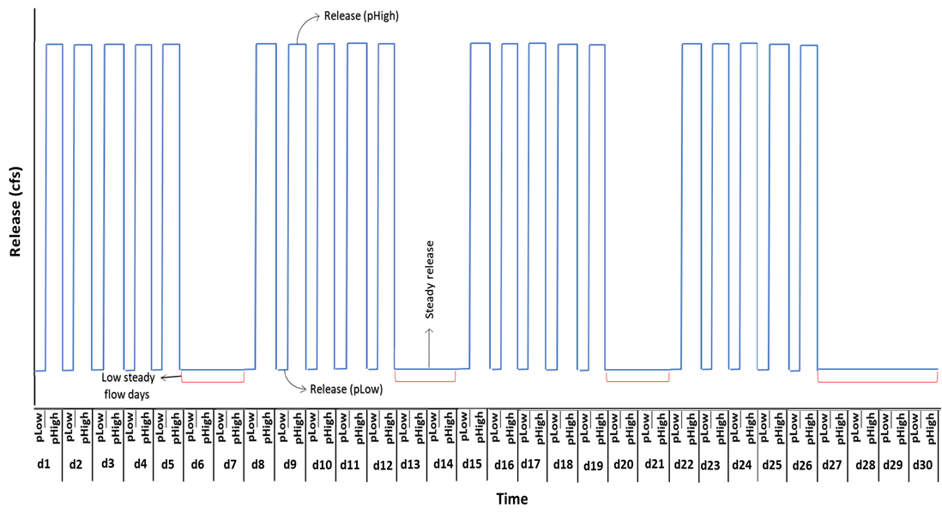
Figure 2 Example monthly hydrograph with 10 steady low flow days. On x-axis, d1 to d30 representing the days in a month with each day having two sub-daily periods (pLow and pHigh). The duration of pLow is assumed as 8 hours and pHigh as 16 hours. The y-axis shows release value within a period. The model places steady flow days on weekends first and then remaining steady day at the end of the month. For example, the model assumes the monthly calendar starts with Monday, it places the two extra steady day beyond weekends at the end of the month (i.e. on d29 and d30).
The model has two competing objectives: 1) aquatic invertebrate’s suitability represented by the number of days of steady low flow, and 2) Hydropower generation quantified by the total monthly hydropower revenue. To determine the tradeoff between the two objectives, we used the constraint method where the number of steady low flow days were constrained and varied from 0 to 30, and the monthly hydropower revenue was maximized for each day value. The model runs for one month with two sub-daily timesteps and is subject to reservoir mass balance, daily release limits, ramp rates, maximum energy generation, storage limits, and an exogenously specified monthly release volume. For instance, the power plant at Glen Canyon dam can hold releases between 8,000 to 31,500 cfs, Lake Powell has a maximum storage capacity of 25 MAF, and the rate of change of release for Glen Canyon Dam is 8,000 cfs per day (LTEMP, 2016). In total, the model has 12 decision variables, two objective functions, and 21 constraints. For instance, there are 4 release decisions, i.e. two periodic releases (pLow and pHigh) per each day type (weekdays and weekends), corresponding energy generation during each period and day, water available to release, end of the month storage, and total release volume during steady and unsteady flow days. The number of steady flow days (one of the objective functions) was predefined to the model. Further details about the mathematical formulation of the model can found in the Appendix.
The developed model was validated against the dataset from June 2018 and tested against variety of scenarios (e.g. total monthly volume, price differential between on-peak and off-peak periods during weekdays, offset release between off-peak weekday and weekends). The monthly release volume scenarios vary between 0.7 and 1.1 million acre-feet per month, the number of low flow days between 0 and 30 days, the on-peak weekday price lowered from $63.52 (base case) to $50.61 to $37.70 per MWh, and the offset release increased from 0 to 1000 cfs (H0 to H1000). The offset release is the additional release made on steady weekends in reference to the off-peak weekday release. The offset release was requested by WAPA to maximize the hydropower revenue especially during Saturday on-peak period. Finally, we ran the model with a scenario having the same energy prices for weekdays and weekends to check the sensitivity of model towards the pricing template.
In parallel, we also explored the non-linear metric (hydropeaking index) used by Kennedy at el., (2016). There were problems identified during the solution and results from the non-linear model. For instance, the model works better when the hydropeaking index was calculated over the month’s period i.e. single hydropeaking index value calculated for the month. On the contrary, when the model was setup to calculate the daily hydropeaking index values and then average over the month’s period (method used by Kennedy at el., 2016), the solutions became unstable and the solvers used were unable to find optimal answers. The reason being the increased number of release decisions the model had to make (now the model is making release decision for every day separately in contrast to paired releases decision for number of days during monthly hydropeaking index calculation). Also, the nonlinear model had multiple optima or near-optima. For example, the model could not differentiate between higher releases during a Tuesday and lower releases during a Wednesday and vice versa when both days have same energy prices. More generally, numerous release hydrographs can have the same total revenue.
Model Validation
Two scenarios of modeled Glen Canyon dam releases and energy generation were validated against observed values (Table 1). 15 mins observed release timeseries at Lees Ferry gage (station id: 09380000) for June 2018 was acquired from USGS Grand Canyon monitoring and research center website. Daily energy generation data was acquired from United States Bureau of Reclamation website (https://www.usbr.gov/rsvrWater/HistoricalApp.html). Scenario #1 is the observed data. Scenario #2 presents the results of a model where 15-minute observed releases were upscaled to hourly releases and hourly energy pricing provided in WAPA document were used. Scenario #3 is the linear programming formulation for the problem with two time-periods per day that took inputs of the monthly flow volume, 9 days of steady low flow, and energy prices of $63.52/MWh & $37.70/MWh for the pHigh and pLow periods. Each price was estimated as the total revenue generated from the hourly price and release data for that period for the month divided by the number of hours in the period for the month. These prices preserved the total monthly revenue between scenarios #2 and #3.
Table 1. Validation Scenarios
 | Scenario | Flow volume (Ac-ft/ Month) | Energy generated (MWh) | Revenue generated ($) | % Error in energy generated relative to observed
1 | Observed | 784,406 | 343,202 | NA
2 | Hourly | 784,406 | 351,093 | $18,308,079 | 2.3%
3 | Linear programming (2 periods: pHigh & pLow) | 784,406 | 351,093 | $18,308,092 | 2.3%
The results in Table 1 show that both models (hourly, and linear formulation model) generate about 2.3% more energy than observed. We looked through the elevation data of the reservoir and found that the storage level dropped by ~1.6 ft during the simulation month. That means an error of 0.2% can be expected from constant monthly head assumption. However, the main cause of energy over production can be the energy generation formula used. The time series of energy generation for all validation scenarios can be found in appendix Figure S1, and the hydrographs for each of the scenarios are presented in appendix Figure S2. We could not find data describing the actual hydropower revenue obtained by WAPA.
Proposed Work
There has been a recent demand from folks at U.S. Geological Survey’s Grand Canyon Monitoring and Research Center (GCMRC) to formulate a model with three types of days: Sundays, Saturdays, and weekdays. That model can help quantify the additional revenue that can be generated by giving up steady flow on Saturdays. The extra hydropower income during Saturdays may be used to buy additional steady days during different months.
For example, the energy demand during August is typically higher than in June. That also means that August energy prices will be higher than in June. The possible opportunity here is that giving up a single steady day during August may produce enough revenue to buy two or more steady days during June. The model can help to determine in which months to make steady low flows. One of the applications of the model is to inform the water managers about cost of each day type during different months. For instance, a water manager is provided with certain budget (e.g. $ 300,000) to buy additional steady flow days. The model estimation about the cost of each day type during different months can help that manager decide how best to spend the money to compensate the hydropower producer for lost revenue.
The model with Sundays, Saturdays, and weekdays is named as 3-Day-Type in this study, and it has additional constraints in comparison to the previous linear model. The 3-Day-Type model will have, in total, 27 decision variables, a single hydropower revenue objective function, and 88 constraints. The model will produce periodic releases and corresponding energy generation during each day type (Sundays, Saturdays, and weekdays) and day period (pHigh and pLow) with different flow pattern day (steady or unsteady flow day). It will also estimate the reservoir available water, volume released, and end of the month storage. Constraints include the energy generated during each period, the reservoir storage level, and releases must meet a total release volume. There are some constraints controlling the hydrograph, e.g. scenario with 2 steady days should have only steady Sundays, and unsteady Saturdays and Weekdays. So far, the model has been developed and corrected, however, its validation is currently under process. Then, the model will be run for different months of the year and a tradeoff curve of days of steady flow and hydropower revenue will be generated for each month. Currently, the model has monthly release volume and offset release scenarios, however, if further information is received from WAPA or GCMRC the model can have additional scenarios like price differential.
Preliminary Results
Figure 3 presents the calculated trade-offs between the number of steady low bug flow days (i.e. ecosystem objective) and hydropower revenue from the Weekend-Weekday model and for June 2018. Different curves in Figure 3 are results for distinct scenarios of total monthly release volume. Dots on the curves are the estimated trade-off values for scenarios of different number of steady low bug flow days. Each curve in Figure 3 shows a win-win situation (i.e. increase in number of steady days increases the total revenue) as we move up from zero to eight steady low flow days (movement along y-axis). The model shows that each added steady low flow day will add almost $60,000 to the total monthly revenues.
Above 8 steady low flow days, all the curves in Figure 3 change their direction as well as slope. Now, a win-lose situation manifests -- increase in number of days of steady releases decreases revenue from hydropower generation. With each added steady day, an amount of almost $62,750 deducts from the total monthly revenues. The reason behind the direction change was the situation where the additional steady days are replacing unsteady weekday releases. Weekday peak energy prices are higher than weekends. The transition point at 8 days corresponds to the number of weekend days in the month and also represents the current practice of the bug flow experiments.
In figure 3, the scenario with total monthly volume of 0.7 MAF does not follow the mentioned rates of revenue change. The reason is the rate of change of release constraint does not bind for this scenario – there is not enough water -- while the constraint binds for all other monthly volume scenarios.
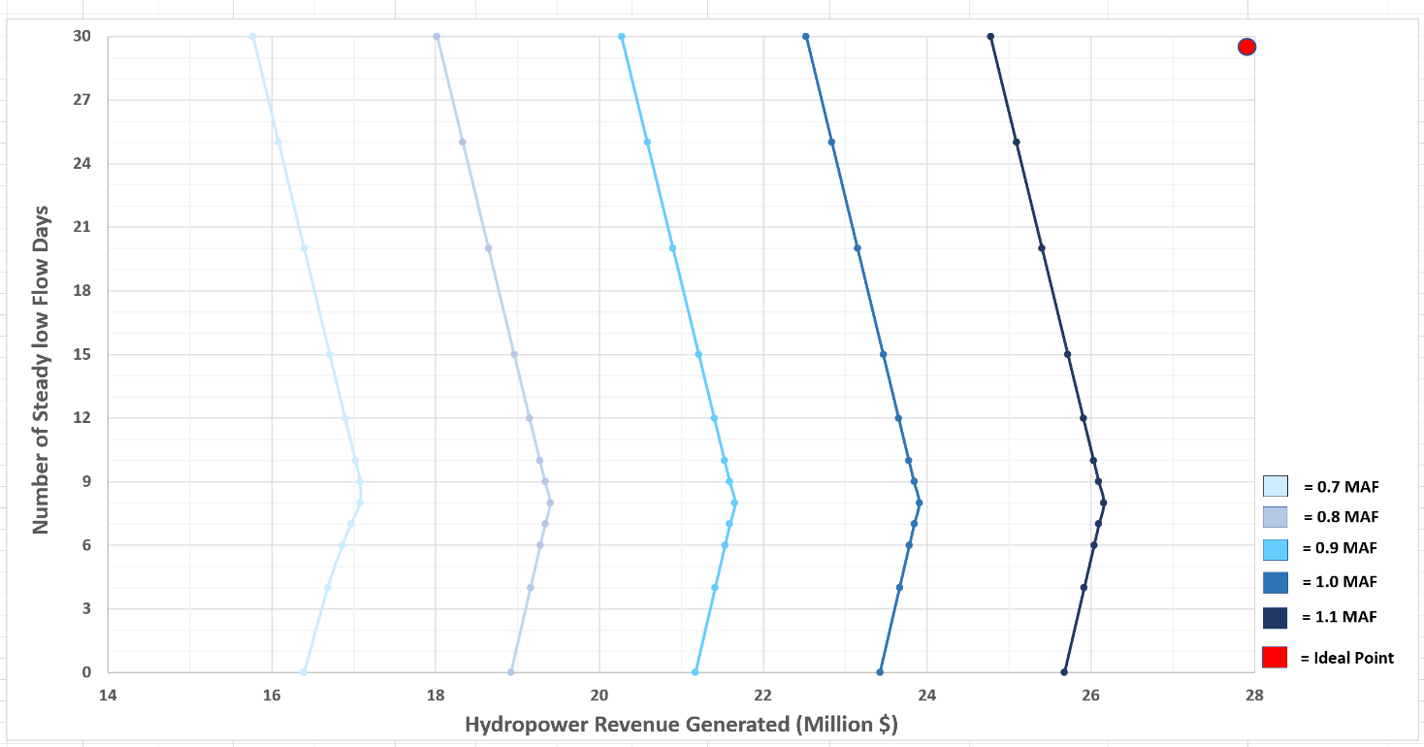
Figure 3 Trade-off between Number of steady low flow days and Hydropower revenue. Each color is representing a specific monthly volume scenario.
Another finding from Figure 3 is that the revenue from zero steady days equals the revenue from 15 steady low flow days (20 days for the 0.7 MAF per month release scenario). Which means 15 steady low flow days will generate the same revenues as were generated before the bug flow experiments (before summer 2018).
In Figure 3, it can also be noticed that increasing the total monthly release volume pushes the tradeoff curves right. Which means increasing the total monthly release volume benefit benefits hydropower revenue but does not harm bugs (win-stay the same). The model estimated that each added 0.1 MAF of monthly release volume will generate $2.25 million additional revenues.
The model produces a hydrograph for each steady low flow day scenario (Figure 4). For example, the hydrograph for the scenario with zero steady low flow days has hydropeaking on each day of the month (Figure 4, blue, pre-bug flow experiments practice). The hydrograph for eight steady low flow days scenario has steady low flows on weekends and hydropeaking on weekdays (Figure 4, green, current bug flow experiment practice). The hydrograph with 15 steady low flow days has steady days first placed on weekends, and the remaining steady days placed at the end of the month (Figure 4, orange). In actually, the weekday steady flows could be placed on other weekdays in the month and still generate the same hydropower revenue. The 30 steady low flow days hydrograph is flat (Figure 4, yellow). In Figure 4, it can be seen that with the increase in number of steady low flow days, the base flow also increases.
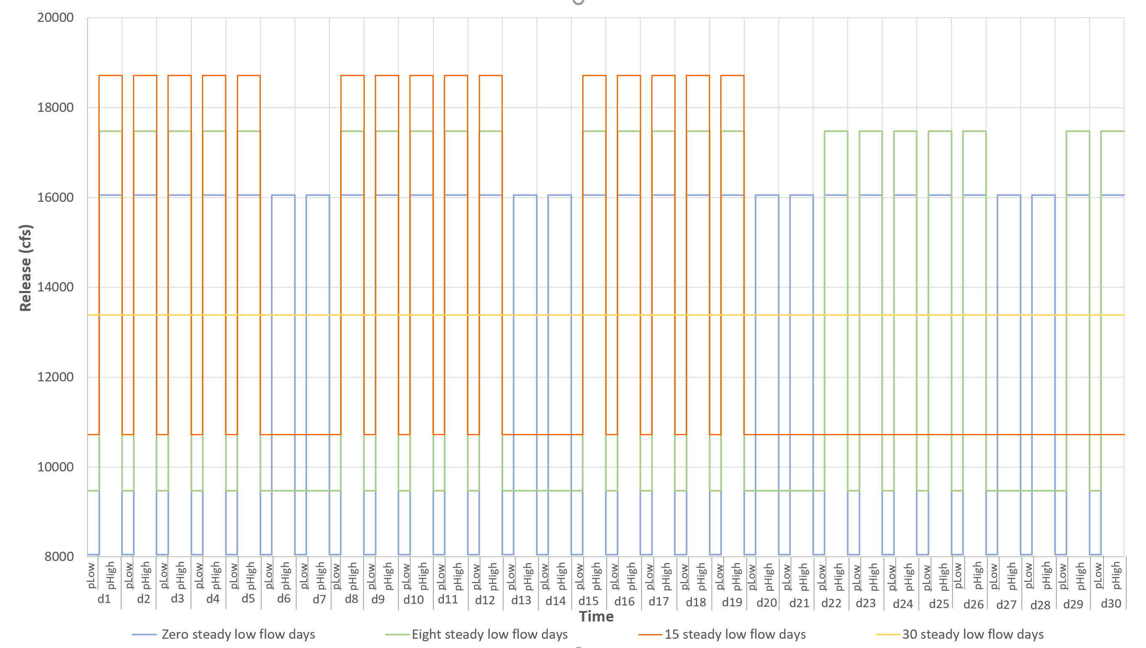
Figure 4 Monthly hydrographs for number of steady low flow days scenarios (0, 8, 15, and 30 steady days) with 0.8 MAF total monthly release volume.
Work Plan
This study is part of my Master’s Thesis which started in Spring 2019. Since then, I have been taking courses included in my program of study of water resources engineering, learned GAMS (General Algebraic Modeling System), reviewed research articles related to ecosystems of the Grand Canyon, interacted with different experts at GCMRC and WAPA to better understand different aspects of the Bug Flow Experiment, developed non-linear bug flow optimization model, created linear bug flow optimization model with two types of days (weekdays and weekends), started working on a linear bug flow optimization model with three types of days (Sundays, Saturdays, and weekdays), and formulated the research by writing this proposal. Throughout the time, there has been inputs from experts at both GCMRC and WAPA and I have shared preliminary results with them.
Currently, I am working on the solution and validation of the linear bug flow model with three day types (Sundays, Saturdays, and Weekdays). Once the model is validated, I expect to meet with folks from WAPA and GCMRC to share the results and get their input. Later, the model will be replicated for different months of the year. The replication will help me achieve my final objective i.e. how the financial information given in the tradeoff curves can help managers buy water and steady flow days within a month and across different months and compensate hydropower produces for lost revenue. Table 2 illustrates the overall work plan for my thesis with an anticipated completion date of Spring 2021.
Table 2 Work plan to complete the master’s thesis
Activity | Spring 2019 | Summer 2019 | Fall  2019 | Spring 2020 |  | Summer 2020 |  | Fall  2020 | Spring  2021
Course work
Literature review
Non-Linear model formulation
Linear model formulation
Linear model with 3 day types formulation
Write proposal
Write thesis
Defend thesis
Write journal article

Expected Outcomes and Significance of the Work
This study was initiated with an expectation to help water managers decide the number of steady low bug flow days during a month and tradeoffs with hydropower revenue. These two goals can be achieved via applying the model over different months and availability of the latest energy pricing data.
Overall, it can be expected that this study will offer a linear programming tool where water managers and hydropower producers can easily quantify the financial impacts of steady flow days under different financial, hydrologic, and other conditions. Moreover, the financial analysis presented in the study will promote mutual and informed decision-making process, for example to help estimate the lost hydropower revenue associated with different bug flow regimes. The study will offer tradeoffs under variety of scenarios (e.g. total monthly volume, energy price differential, and offset releases) which will be readily available for use. Lastly, the ecosystem metric (i.e. number of steady low flow days) used here not only distinguish the work but supports the broader application of the concept. For instance, the study can be easily applied to any hydropower producing dam; knowing the physical constraints of the reservoir, energy pricing, basic information about the release pattern, and managerial constraints.

References
Acreman, M., Arthington, A. H., Colloff, M. J., Couch, C., Crossman, N. D., Dyer, F., ... & Young, W. (2014). Environmental flows for natural, hybrid, and novel riverine ecosystems in a changing world. Frontiers in Ecology and the Environment, 12(8), 466-473.

Adams, L. E., Lund, J. R., Moyle, P. B., Quiñones, R. M., Herman, J. D., & O'Rear, T. A. (2017). Environmental hedging: A theory and method for reconciling reservoir operations for downstream ecology and water supply. Water Resources Research, 53(9), 7816-7831.

Alafifi, A. H., & Rosenberg, D. E. (2020). Systems modeling to improve river, riparian, and wetland habitat quality and area. Environmental Modelling & Software, 126, 104643.

Arthington, A. H. (2012). Environmental flows: saving rivers in the third millennium (Vol. 4). Univ of California Press.

Baxter, C. V., Fausch, K. D., & Carl Saunders, W. (2005). Tangled webs: reciprocal flows of invertebrate prey link streams and riparian zones. Freshwater biology, 50(2), 201-220.

Carpenter, S. R., Stanley, E. H., & Vander Zanden, M. J. (2011). State of the world's freshwater ecosystems: physical, chemical, and biological changes. Annual review of Environment and Resources, 36, 75-99.

[DOI] U.S. Department of the Interior (2017). 13 Things You Didn’t Know About Grand Canyon National Park.
https://www.doi.gov/blog/13-things-you-didnt-know-about-grand-canyon-national-park

Førsund, F. R. (2015). Hydropower economics (Vol. 217). Springer.

Hart, B.T., 2015. The Australian Murray Darling Basin Plan: challenges in its implementation (part 1). Int. J. Water Resour. Dev. 1-16.

Harman, C., & Stewardson, M. (2005). Optimizing dam release rules to meet environmental flow targets. River Research and Applications, 21(2‐3), 113-129.

Hochbaum, D. S. (2007). Complexity and algorithms for nonlinear optimization problems. Annals of Operations Research, 153(1), 257-296.

Kareiva, P., Marvier, M., & McClure, M. (2000). Recovery and management options for spring/summer chinook salmon in the Columbia River Basin. Science, 290(5493), 977-979.

Kennedy, T. A., Muehlbauer, J. D., Yackulic, C. B., Lytle, D. A., Miller, S. W., Dibble, K. L., ... & Baxter, C. V. (2016). Flow management for hydropower extirpates aquatic insects, undermining river food webs. BioScience, 66(7), 561-575.

Ko, S. K., Fontane, D. G., & Labadie, J. W. (1992). MULTIOBJECTWE OPTIMIZATION OF RESERVOIR SYSTEMS OPERATION 1. JAWRA Journal of the American Water Resources Association, 28(1), 111-127.
Gloss, S.P., Lovich, J.E., and Melis, T.S., eds., (2005), Chapter 1. The state of the Colorado River ecosystem in Grand Canyon: U.S. Geological Survey Circular 1282, 220 p. https://pubs.usgs.gov/circ/1282/c1282.pdf
[LTEMP] Record of Decision for the Glen Canyon Dam Long-Term Experimental and Management Plan (LTEMP) Final Environmental Impact Statement (2016). https://ltempeis.anl.gov/documents/docs/LTEMP_ROD.pdf
Nakano, S., & Murakami, M. (2001). Reciprocal subsidies: dynamic interdependence between terrestrial and aquatic food webs. Proceedings of the National Academy of Sciences, 98(1), 166-170.
Nilsson, C., Reidy, C. A., Dynesius, M., & Revenga, C. (2005). Fragmentation and flow regulation of the world's large river systems. Science, 308(5720), 405-408.

[NPS] National park services, 2012. Grand Canyon Ecosystems
https://www.nps.gov/grca/learn/education/upload/EcoArticle-Dec2011-12.pdf

[NPS] National Park Service (2018a). Grand Canyon National Park.
https://www.nps.gov/grca/learn/nature/index.htm

[NPS] National Park Service (2018b). Grand Canyon’s Native Fish.
https://www.nps.gov/grca/learn/nature/fish-native.htm

Null, S. E., & Lund, J. R., 2012. Fish habitat optimization to prioritize river restoration decisions. River research and applications, 28(9), 1378-1393.

Olden, J. D., & Naiman, R. J. (2010). Incorporating thermal regimes into environmental flows assessments: modifying dam operations to restore freshwater ecosystem integrity. Freshwater Biology, 55(1), 86-107.

Pegram, G., Li, Y., Le Quesne, T., Speed, J., Li, J., Shen, F., 2013. River Basin Planning: Principles. Procedures and Approaches for Strategic Planning. UNESCO, Paris.

Poff, N. L., Olden, J. D., Merritt, D. M., & Pepin, D. M. (2007). Homogenization of regional river dynamics by dams and global biodiversity implications. Proceedings of the National Academy of Sciences, 104(14), 5732-5737.

Poff, N. L., Brown, C. M., Grantham, T. E., Matthews, J. H., Palmer, M. A., Spence, C. M., ... & Baeza, A. (2016). Sustainable water management under future uncertainty with eco-engineering decision scaling. Nature Climate Change, 6(1), 25-34.

Ploussard, Q., & Veselka, T. D. (2019). Financial Analysis of the 2018 Glen Canyon Dam Bug Flow Experiment (No. ANL-19/19). Argonne National Lab. (ANL), Argonne, IL (United States).

Richter, B. (2014). Chasing water: a guide for moving from scarcity to sustainability. Island press.

Rheinheimer, D. E., Null, S. E., & Lund, J. R. (2015). Optimizing selective withdrawal from reservoirs to manage downstream temperatures with climate warming. Journal of Water Resources Planning and Management, 141(4), 04014063.

Schmidt, J. C., & Wilcock, P. R. (2008). Metrics for assessing the downstream effects of dams. Water Resources Research, 44(4).

Stevens, L. E., Shannon, J. P., & Blinn, D. W. (1997). Colorado River benthic ecology in Grand Canyon, Arizona, USA: dam, tributary and geomorphological influences. Regulated Rivers: Research & Management: An International Journal Devoted to River Research and Management, 13(2), 129-149.

Texas Electricity Summer Rates (May 2019 Update) | ElectricityPlans.com. (2019, January 25). Electricity Plans. https://electricityplans.com/texas-electricity-rates-increase-2019/

Tharme, R. E. (2003). A global perspective on environmental flow assessment: emerging trends in the development and application of environmental flow methodologies for rivers. River research and applications, 19(5‐6), 397-441.

Tilmant, A., Vanclooster, M., Duckstein, L., & Persoons, E. (2002). Comparison of fuzzy and nonfuzzy optimal reservoir operating policies. Journal of Water Resources Planning and Management, 128(6), 390-398.

[USBR] US Department of the Interior Bureau of Reclamation, 2016. Glen Canyon Dam Long-Term Experimental and Management Plan Environmental Impact Statement. Refer Alternative D; page ES-33 to 34. https://ltempeis.anl.gov/documents/draft-eis/

[USBR] U.S. Department of the Interior Bureau of Reclamation, 2019. Glen Canyon Unit https://www.usbr.gov/uc/rm/crsp/gc/index.html

Walker, W. (2017). Environmental Flow Regime Management in the Grand Canyon. University of California, Davis. https://watershed.ucdavis.edu/education/classes/files/content/page/WesWalker_revised.pdf

Yakowitz, S. (1982). Dynamic programming applications in water resources. Water resources research, 18(4), 673-696.

Yoo, J. H. (2009). Maximization of hydropower generation through the application of a linear programming model. Journal of Hydrology, 376(1-2), 182-187.

Appendix. Model Formulation

This section discusses the inputs to the weekday/weekend model, describes the parameters and decision variables used, and lists the constraints on the decision variables.
Indices/Sets:
d $∈$ D Days in Month: d1*d30
p $∈$ P Periods in a day: pLow & pHigh
v $∈$ tot_vol Total monthly volume scenarios: v1*v5
case $∈$ Case Defining number of steady flow days: case1*case4
Data:
initstorage Initial storage in the reservoir (Ac-ft)
Inflow (d) Daily Inflow to reservoir on day d (cfs)
evap Reservoir evaporation (ac-ft per day) considered constant
throughout the month.
EnergyRate (p) Averaged energy price during period p ($ per MWH)
Steady_Days Number of constant flow days in the month (days)
Decision Variables:
release(p) Reservoir release at period p during an unsteady flow day (cfs)
Energy_Gen(p) Hydropower generated during the period p on an unsteady flow day (MWh)
Steady_Release Steady reservoir release during a day of constant flow (cfs)
SteadyEn_Gen(p) Hydropower generated during the period p on a steady flow day (MWh)
Storage Reservoir storage at the end of the month (ac-ft)
Avail_water Total water available in the reservoir for the month (ac-ft)
Steady_outflow Portion of total monthly volume released during constant flow days (ac-ft)
Unsteady_Outflow Portion of total monthly volume released during unsteady flow days (ac-ft)
*factor = conversion factor from cfs to ac-ft per hour (i.e. 1 cfs = 0.083 ac-ft/hr)

Constraints:
1) Vol_monthlyrelease Total volume of water released in the month (ac-ft/month)
Steady_outflow + unsteady_outflow =Vol_monthlyrelease
2) Reservior Mass Balance (ac-ft)
Storage = Avail_water – Steady_outflow – unsteady_outflow – (evap * $Totaldays)$
Where
(a) Avail_water = initstorage + $\sum_{d∈D}{(inflow\left(d\right)*factor*( \sum_{p∈P}{Duration(p)}))}$
(b) Steady_outflow = Steady_Release *$\left( \sum_{p∈P}{Duration\left(p\right)}\right)*factor* Steady_Days$
(c) unsteady_outflow = ( $\sum_{p∈P}{Duration\left(p\right)}*factor*release (p))* (Totaldays-Steady_Days)$
3) Maximum Release limit (cfs)
release(p) ≤ maxRel ∀ p ∈ P
4) Minimum Release limit (cfs)
release(p) ≥minRel ∀ p ∈ P
5) Maximum Energy Generation limit (MWh)
Energy_Gen(p) ≤ 1320 × Duration(p) ∀ p ∈ P
6) Maximum Storage Limit (ac-ft)
storage ≤ maxstorage
7) Minimum Storage Required for Hydropower (ac-ft)
Storage ≥ minstorage
8) Ramp-up rate (cfs)
release("pHigh") -release("pLow") ≤ Daily_Ramprate ∀ p ∈ P
9) Equality Constraint (cfs)
Steady_Release = release(“pLow”)
9) Energy Generation during unsteady day (MWh)
Energy_Gen(p)= release(p) × Duration(p) × 0.03715
10) Energy Generation during steady day (MWh)
SteadyEn_Gen(p)= Steady_Release × Duration(p) × 0.03715
Note: The energy generation formula used here is provided by WAPA. Where the details about the factor involved in the formula are unknown.

Objective Function:
If Num_steady > weekends, then maximize:
ObjectiveVal = $\left(\sum_{p∈ P}{SteadyEn_Gen(p)*weekendRate\left(p\right)}\right)*weekends+ \left(\sum_{p∈ P}{SteadyEn_Gen*weekdayRate\left(p\right)}\right)*(Steady_Days-weekends)$ $+\left(\sum_{p∈ P}{Energy_Gen(p)*weekdayRate\left(p\right)}\right)*(Totaldays-Steady_Days)$
Else maximize:
ObjectiveVal = $\left(\sum_{p∈ P}{SteadyEn_Gen(p)*weekendRate\left(p\right)}\right)*Steady_Days+ \left(\sum_{p∈ P}{Energy_Gen(p)*weekendRate\left(p\right)}\right)*(weekends- Steady_Days)$ $+\left(\sum_{p∈ P}{Energy_Gen(p)*weekdayRate\left(p\right)}\right)*(Totaldays-weekends)$
Where Totaldays = total number of days in month
Weekends = total number of weekend days in the month
weekdayRate(p) = Energy prices on weekday
weekendRate(p) = Energy prices on the weekend
Model Validation Results
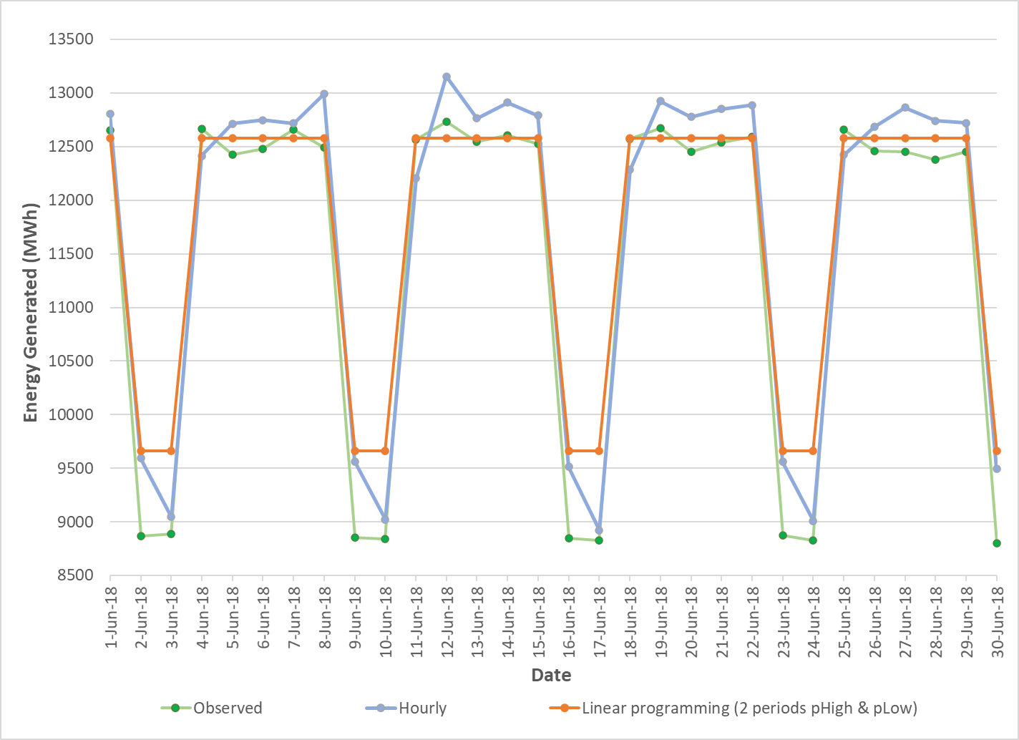
Figure S1 Daily energy generation comparison: observed energy amount vs energy generated from hourly model vs energy generated from linear model.
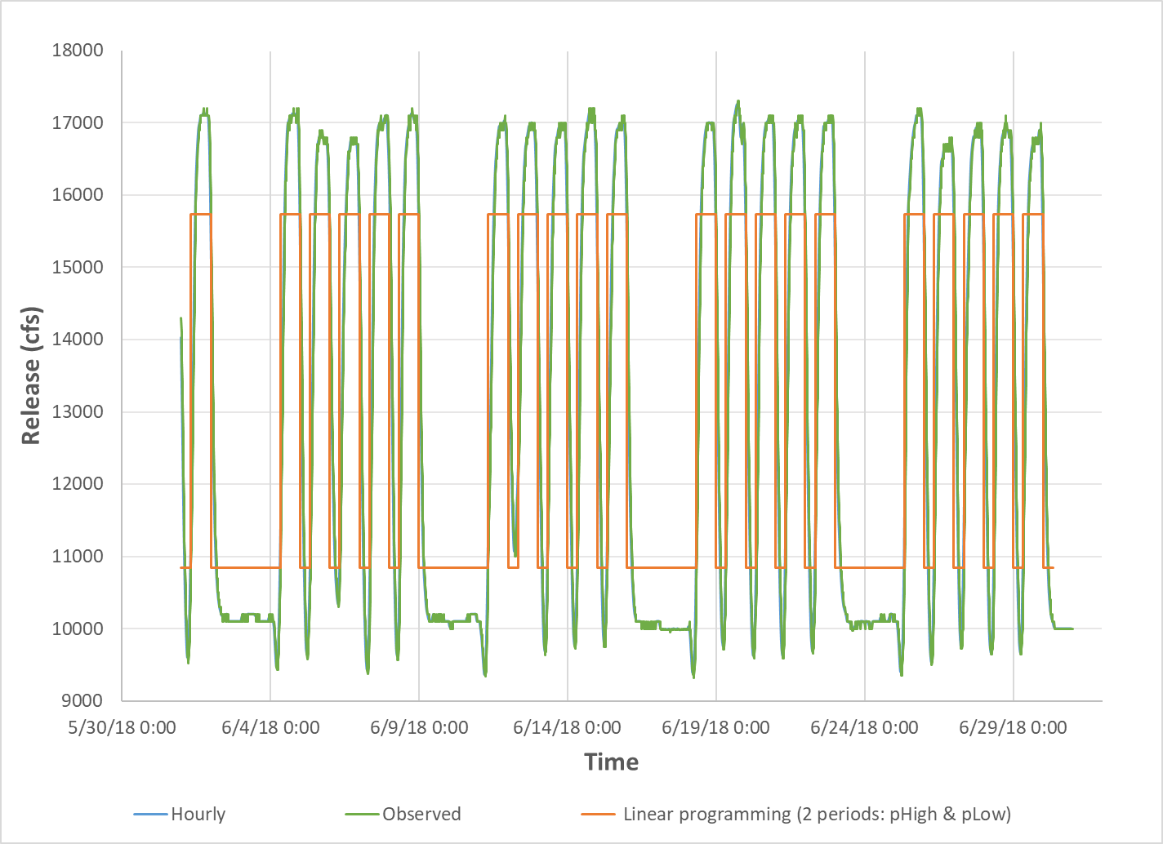
Figure S2 Releases comparison for June 2018: Observed releases vs releases from hourly model vs releases vs releases from linear model. Here, observed release and hourly hydrographs overlap.

