**Which evaporation estimation model to use? A case study of De bilt, Netherland.**

By: Moazzam Ali Rind

**Introduction**

Surface evaporation ranks 2nd in the list of dominant components of global hydrologic cycle after precipitation [1]. According to an estimate, 60% of the annual precipitation over the land surface is returned to the atmosphere via evaporation [2], and this amount is expected to swell under the impacts of climate change [3, 4, 5]. Due to this expected change, there will be additional burden on drinking water sources and the water available for natural ecosystems and agriculture will be further squeezed. The only mitigation to the system’s uncertainty is efficient water management which requires accurate estimation of hydrologic cycle components [1].

Estimation of evaporation is a daunting task because of its dependence on various factors e.g. climate, temperature, wind velocity, land use, solar radiations, etc. There are numerous evaporation models available today with each having its benefits and assumptions. Broadly these models are categorized into groups: 1) Combination models: Models based on theory and physical processes are represented. 2) Solar Radiation-based models: Models based on empirical relationships of solar radiations. 3) Datlon-based models: Models with both physical and empirical relationships. 4) Temperature-based models: Models with empirical relationships of temperatures. There is also a direct estimation of evaporation using estimated or measured latent heat flux (LE). Furthermore, numerous efforts have been made to estimate evaporation using remotely sensed datasets [e.g. 6 and 7].

This study is an effort to compare different available evaporation models and discuss some of the assumptions of each models. Except models based on remotely sensed datasets, the study has used few models from each categories and compared results to identify the influencing factors causing changes. The major contribution of this study is to provide easy access of all these evaporation models and provide guidance in selection of suitable evaporation model. In other words, the study has gathered all the models in one script and defined all the inputs and assumptions of each models for informed selection. Finally, the study is expected to encourage calibration of the available models for a locality and help researchers, water managers, farmers, and municipalities reevaluate their water consumption, conservation, and irrigation practices in order to minimize the evaporation losses.

**Objectives**

The overarching objective is to help with selection of the evaporation estimation model. Nevertheless, there are sub-objectives required to accomplish the objective:

1. Identify the data needs for each of the selected evaporation models.
2. Discuss the strengths and weaknesses of each of the models.
3. Discuss the computational efforts required for each of the models.
4. Using statistical analysis, compare the results from the models and recommend the suitable models for the study area.

**Study Site**

Depending on the available data, De bilt, Netherlands was selected as case study. Jansen and Teulling [1] has performed similar analysis for the area and mentioned the importance of evaporation estimation in densely populated, hydrologically sensitive, and low-lying area such as Netherlands. In that analysis, Jansen and Teulling [1] has used seven evaporation estimation methods whereas this study is using fourteen models in total. Additionally, the objective of this exercise is to provide easy access to the uses.

**Methods**

For this comparative study, I have selected fourteen different evaporation estimation models. Meng et al., (2020) has conducted a similar study over a highland open freshwater lake in Mountainous area, China and has defined nine models used. In their work, they have divided these models into three main categories:

1. Combination Methods: Bowen-ratio energy budget, Penman, Priestly-Taylor, DeBruin–Keijman, and Brutsaert–Stricker.
2. Solar Radiation-based Methods: Jensen–Haise and Makkink
3. Dalton-based Methods: Mass transfer and Ryan–Harleman

Remaining five models are discussed in Rosenberry [8] and Grysko [9]. Those models are categorized as:

1. Temperature-based Metods: Mather, Papadakis, Mass transfer
2. Direct estimation or estimation of LE.

R-script discussing data needs and assumptions for each of the model has been developed which can be assessed at <https://github.com/moazzamalirind/EvaporationModels>. GitHub directory is made public and contains a read me file that provide specific instructions for script usage. In addition, the R-script performs statistical analysis (e.g. coefficient of determination (R2), root mean square error (RMSE), relative bias (RB), and index of agreement (D)) and provides clear visualization of the results.

**Results**

Unfortunately, at this moment, there are no solid results to share. The reason being unavailability of required datasets or some of the available data is not helpful for assessment (e.g. water temperature is only available for 2021 November). There is an ongoing conversation with water authorities in Netherlands for data accessibility and few other researcher in the research area to share their datasets. Hopefully, in near future, further results will be calculated and shared at the GitHub repository. Also, the datasets used will be uploaded and analysis of the results will be shared at repository.

As a sample, Figure 1 shows the preliminary results from R-script for various evaporation models. The evaporation values in Figure 1 are unrealistic and highlights possible errors in the used dataset (most likely unit conversion error or wrong parameter are used for the analysis), However, the only take away from Figure 1 is that most of the evaporation estimates from different models closely follow each other. The results shown here are inconclusive and require further analysis to make any solid conclusions.

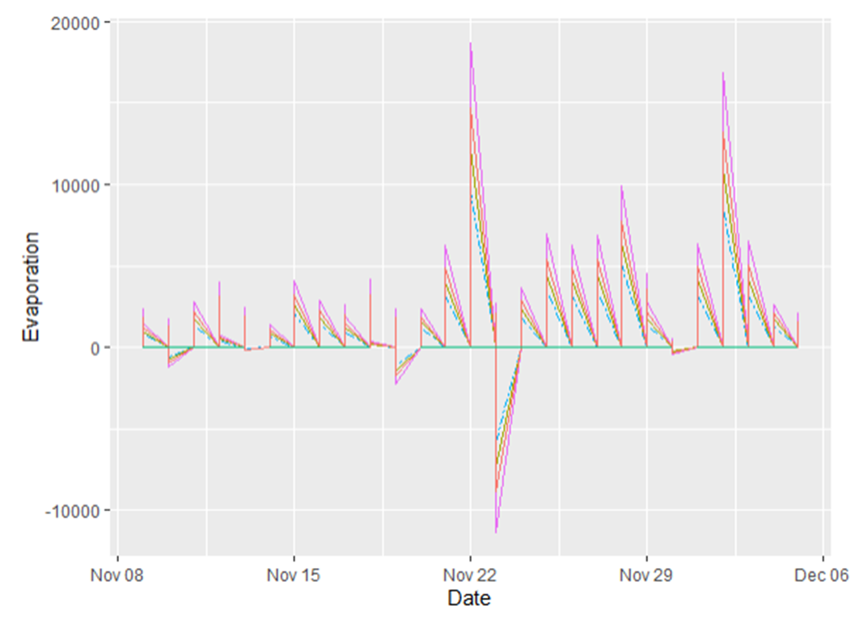

**Figure 1 Sample results from the R-script. Each color is representing specific evaporation model**

**Conclusion**

Evaporation plays a vital role in hydrologic cycle but its accurate estimation is still a challenging task. There are number of physical measurements, estimated parameters, and assumptions required during evaporation calculation. As a result, today there are numerous evaporation models available considering different physical and empirical relations between variables. However, selection of any particular evaporation model for a study area depends on available data and appropriateness of assumptions for the case study. This study is an effort to simplify the process of model selection by providing easy access of evaporation models and comparing results of each models. The assumptions of the models are discussed and inputs are mentioned along with required units in the developed script. This study was basically designed for water managers and farmers who are interested in evaporation estimation but has time and accessibility constraints. Nevertheless, this is an on-going study which is expect to improve with further availability of input datasets and suggestions from the users.

**Future work**

This is an active study which can be only used as a template for now. There requires additional efforts to completely achieve the objective of the study and make it acceptable for end users. The pending or work-in-progress steps are:

1. Acquire more data to perform analysis specially for summer months
2. Statistical analysis is still missing component
3. There is a possibility that this steady can be used to identify influencing variables to evaporation process at different timescales.
4. Improve the layout of the R-script and make it more user friendly.
5. Performing the analysis for a specific region and convert those findings in a possible publication.

**Acknowledgement**

Throughout the study, comments and suggestions from Dr. Jan Boll has been incomparable. Also, response from water authorities in Netherlands and few researchers are highly appreciated.

**References**

[1] Jansen, F. A., & Teuling, A. J. (2020). Evaporation from a large lowland reservoir–(dis) agreement between evaporation models from hourly to decadal timescales. *Hydrology and Earth System Sciences*, *24*(3), 1055-1072.

[2] Gianniou, S. K., & Antonopoulos, V. Z. (2007). Evaporation and energy budget in Lake Vegoritis, Greece. *Journal of Hydrology*, *345*(3-4), 212-223.

[3] Oki, T., & Kanae, S. (2006). Global hydrological cycles and world water resources, science, 313(5790), 1068-1072.

[4] Huntington, T. G. (2006). Evidence for intensification of the global water cycle: Review and synthesis. *Journal of Hydrology*, *319*(1-4), 83-95.

[5] Jung, M., Reichstein, M., Ciais, P., Seneviratne, S. I., Sheffield, J., Goulden, M. L., ... & Zhang, K. (2010). Recent decline in the global land evapotranspiration trend due to limited moisture supply. *Nature*, *467*(7318), 951-954.

[6] Zhao, G., & Gao, H. (2019). Estimating reservoir evaporation losses for the United States: Fusing remote sensing and modeling approaches. *Remote Sensing of Environment*, *226*, 109-124.

[7] Talsma, C. J., Good, S. P., Jimenez, C., Martens, B., Fisher, J. B., Miralles, D. G., ... & Purdy, A. J. (2018). Partitioning of evapotranspiration in remote sensing-based models. Agricultural and Forest Meteorology, 260, 131-143.

[8] Rosenberry, D. O., Stannard, D. I., Winter, T. C., & Martinez, M. L. (2004). Comparison of 13 equations for determining evapotranspiration from a prairie wetland, Cottonwood Lake area, North Dakota, USA. *Wetlands*, *24*(3), 483-497.

[9] Grysko, R. (2018). *Process-based methods to determine lake evaporation on different time scales* (Masters Dissertation, Washington State University).