**Quantifying trade-off between number of bug flow days and hydropower objectives for Glen Canyon Dam, Arizona, USA**

By: Moazzam Ali Rind

M.S. Student

Department of Civil and Environmental Engineering

Utah State University, Logan, Utah

Category: Master

Author’s contribution: There is no contribution in writing and organization of this manuscript except me. However, the presented study has been conducted under the supervision and guidance from Dr. David Rosenberg (Utah State University).

**Quantifying trade-off between number of bug flow days and hydropower objectives for Glen Canyon Dam, Arizona, USA**

**Abstract**

U.S. Geological Survey’s Grand Canyon Monitoring and Research Center (GCMRC) with inputs from Western Area Power Authority (WAPA) has been conducting summer flow experiments at Glen Canyon dam since 2018. Those experiment ensure steady weekend releases, which helps aquatic invertebrates lay and hatch eggs, and are known as “Bug Flow Experiments”. The overarching question is: how does hydropower revenue vary as steady flow days expand from weekends to weekdays? Here, we share results of a linear optimization model that quantify the tradeoff between number of steady low flow days and hydropower revenue objectives using the constraint method. The model runs for one month with two sub-daily timesteps and is subject to daily release limits, allowable daily release change, maximum energy generation, storage limits, and an exogenously specified monthly release volume. We tested scenarios that vary the month of the year, monthly flow volume, energy price differential, and weekend offset release. Preliminary results show: 1) Increasing the monthly release volume simultaneously improves the bug and hydropower revenue generation objectives. 2) Monthly Hydrograph with weekends being steady flow days generates the maximum hydropower revenue. Each added steady weekday, with existing energy prices, will deduct almost $62,750 from monthly revenue. 3) Each 0.1 MAF increase in monthly release volume generates $2.25 million of additional hydropower revenue. 4) Energy price differential between on- and off-peak periods controls the slope of tradeoff curves. 5) Hydropower revenue generated with 15 steady flow days per month equals the revenue generated by pre bug flow experiments hydrograph. This is a working document and materials will be updated over time based on work with GCMRC, WAPA, and others.

**Introduction**

Aquatic insects make up a major part of the river food web (Kennedy et al., 2016). Specifically, in the Grand Canyon below Glen Canyon Dam, both native and non-native fish populations compete for the available food. On the other hand, various factors e.g. climate change, declining flows, population growth, etc. are reducing the natural river flows. Traditionally, humans believed that regulation of the river flows, e.g. development of reservoirs and diversions, can mitigate the water crisis. However, the implications of those anthropogenic actions on the ecosystems were either unknown or never given preference in comparison to the economic and societal benefits from those structure (Poff et al., 2007; Carpenter et al., 2011). As a result, today we have nearly all the major Earth’s rivers dammed (Nilsson et al., 2005) and the researchers and engineers are still working to identify and mitigate the negative impacts of river structures on the downstream ecology (Kareiva et al., 2000).

In general, water resources are managed for multiple and competing uses, such as water supply, hydropower generation, flood control, recreation, and environmental protection (Null and Lund, 2012). Each of the water uses require development of hydraulic structures. For instance, dams are constructed to ensure multiple water uses: water supply, hydropower generation, flood control, and recreation. Historically, the impacts of these artificial storages on the downstream eco-systems were over-shadowed by the financial and societal benefits. Luckily, during the last few decades the interest in the ecosystem’s sustainability and wide recognition of the problem has introduced a new trend. Now, there has been pressure from various stakeholders e.g. government, public, environmental groups, researchers etc. to consider environmental objectives (Richter, 2014; Hart, 2015). Also, numerous existing studies highlight the precedence of rivers increasingly managed for aquatic ecosystems in addition to the traditional water management practices (Null and Lund, 2012). Still, the concept of environmental flows is ambiguous, and many decision makers and engineers are looking for precise metrics to represent and quantify the ecological objectives (Alafifi and Rosenberg, 2020).

For example, Kennedy at el., (2016) has identified days of steady low flows as a type of environmental flow that are helpful for the growth of aquatic invertebrates within the Grand Canyon. They used the hydropeaking index, which is a ratio of the amount variation in release to average release, as a metric to quantify the ecosystem objective. During their study, they observed that the sites with larger hydropeaking index (more variation in daily releases) have low aquatic insect diversity (EPT %). They concluded that dams with hydropeaking operations-- higher releases during daytime to meet energy demands and lower releases during nighttime-- have low aquatic insect diversity in the downstream. Out of 16 dams they considered in their work, they found that the Glen Canyon Dam and the Hoover Dam had the highest hydropeaking index value, hence, worst insect diversity. Other studies show cold releases from the reservoir (Stevens et al., 1997; Olden and Naiman, 2010), change in natural flow regime (Walker, 2017), etc. are also responsible for the low insect diversity.

Starting the summer of 2018, steady low flows on weekends during summer months have been practiced each year at Glen Canyon Dam (the Bug Flow Experiment) and the concept was also included in the prefer alternative of the long term experimental and monitoring program ([LTEMP DEIS](http://gcdamp.com/index.php?title=Long-term_Experimental_and_Management_Plan_(LTEMP))). Ploussard and Veselka (2019) looked at the financial implication of the 2018 Bug Flow Experiment. They created two scenarios: 1) summer months with bug flows, 2) summer months without bug flows, and quantified the expected difference in hydropower production between the scenarios. Also, they have identified factors responsible for the cost associated with the bug flows and examined the interdependencies amongst the factors.

Two types of models – simulation and optimization – are typically used for ecosystems modeling (Adams et al., 2017). Numerous studies, especially during last few decades, has modeled and successfully implemented the concept of environmental flows. Still, the art of translating ecological knowledge into operational paradigms is a hot research topic (Harman and Stewardson, 2005) and water managers and researchers are facing challenges to find balance between competing traditional water management and environmental objectives (Acreman et al., 2014; Richter, 2014; Poff et al., 2016).

Typically, a hydropower objective is a non-linear function (Yoo, 2009) that depends on the power generation release, reservoir storage level, turbine efficiencies, and operations in relationship to design efficiencies. Those releases that generate hydropower fluctuate through the day according to varying energy prices. Commonly, dynamic or nonlinear programing has been preferred to solve such problems because of multiple sub decisions required to reach the ultimate optimal decision or the nonlinearity created by multiplication amongst the variables like release, reservoir level, and turbine efficiency (e.g. Yakowitz, 1982; Tilmant et al., 2002). These optimization problems are computationally intensive (Hochbaum, 2007) and researchers have an interest to approximate nonlinear objectives by various linearization techniques.

For example, Rheinheimer et al. (2015) developed a linear programming model to maintain downstream cold water temperatures for Chinook salmon below Lake Spaulding, California. They considered that the reservoir have two completely mixed thermal layers (i.e. warm and cold pools) and the release decisions were made prior to, and independent from, temperature management decisions. These assumptions converted a non-linear problem with both quality (thermal layer selection) and quantity (release hydrograph) decisions into a linear problem with only the quality decision to make. Their analysis predicted benefits of having multiple temperature withdrawal structure in comparison to single intake level structure. Yoo (2009) used linear programming to maximize the annual energy production at Yong dam in South Korea. His approach was inspired from successive linear programming techniques, but to avoid reiterations, he considered weighted constant values of the storage water level and the water volume released for hydropower generation in the objective function to linearize the problem.

This research follows the same concept of the environmental flows Kennedy et al. (2016) suggested for the Glen Canyon Dam releases that steady low flow days encourages the bug-egg hatching process. However, the study uses a unique and transparent metric to represent the environmental objective--number of days of steady low flows during a month. The study quantifies the tradeoff between number of steady low flow days (ecosystem objective) and monthly hydropower revenue. Moreover, the study quantifies the impacts of different managerial decisions and uncertainties such as total monthly release volume, the price differential between weekday and weekend energy rates, and number of steady flow days, on monthly hydropower revenue generation.

The findings from the research will guide water manger’s decision about the number of bug flow days and help them understand the impact of different factors -- Monthly release volume, energy prices amongst different days, price differential between on- and off- peak periods, length of the periods and offset release-- on the monthly hydropower revenue. In addition, the model provides managers with the opportunity to test different flow regimes and visualize the impacts on hydropower revenue. This information can help adjust the number of steady low flow days during different months. For instance, it can be estimated that by giving up one steady flow day during high energy value month (e.g. August) can purchase several unsteady flow days during months with lower energy prices (e.g. June). Quantifying lost hydropower revenue from bug flow days in dollars ($) can help a broader audience of politicians, economists, hydropower companies, environmental groups, and general public engage in reservoir release and bug-flow decisions.

**Methods**

The daily hydrograph was simplified by dividing the day into two periods: 1) pLow (off-peak) which starts at midnight and last till 8 a.m. and 2) pHigh (on-peak) which last between 8 a.m. and midnight. The duration of periods was selected in accordance to the energy pricing data provided by WAPA. The energy prices also vary by day of the week e.g. weekday vs weekend. Here we assumed that the energy price during weekends equals the off-peak energy price during weekdays. For instance, the model for June 2018 has 24.56$/MWh for low and 62.21$/MWh for high periods on weekdays, whereas 24.65$/MWh for both low and high periods on the weekends. The model defines the Glen Canyon dam release hydrograph in terms of four variables which remain the same throughout the month: a) a release which remains constant throughout the on- and off-peak periods of steady low flow days, b) release during off-peak period on a hydropeaking day that is also equal to or less than release during steady flow day, c) release during on-peak period on a hydropeaking day, and d) number of days with steady low releases (see Figure 1). The mentioned assumptions and static conditions at Lake Powell (e.g. minimum change in reservoir elevation, constant hydropower generation, etc.), specifically within a months’ time, helped transformed the nonlinear problem into linear.

The model has two competing objectives: 1) aquatic invertebrate’s suitability represented by the number of days of steady low flow, and 2) Hydropower generation quantified by the total monthly hydropower revenue. To determine the tradeoff between the objectives, we used the constraint method where the number of steady low flow days were constrained and varied from 0 to 30, and the monthly hydropower revenue was maximized for each day value. The model runs for one

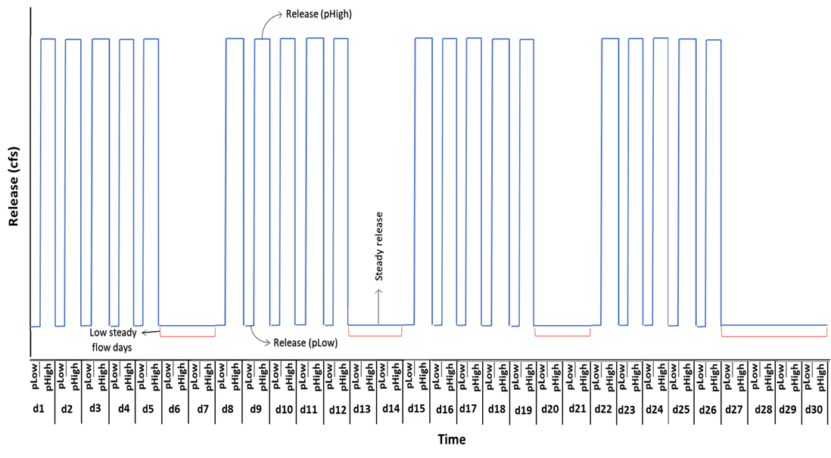month with two sub-daily timesteps and is subject to reservoir mass balance, daily release limits, ramp rates, maximum energy generation, storage limits, and an exogenously specified monthly release volume. For instance, the power plant at Glen Canyon dam can hold releases between 8,000 to 31,500 cfs, Lake Powell has a maximum storage capacity of 25 MAF, and the rate of change of release for Glen Canyon Dam is 8,000 cfs per day (LTEMP, 2016). In total, the model has 12 decision variables, two objective functions, and 21 constraints. The model decisions include: 1) Periodic releases (pLow and pHigh) during each day type (weekday and weekend). 2) Energy generation during each period and day. 3) Total water available to release. 4) End of the month storage. 5) Total release during steady and unsteady flow days.

Figure 1 Example monthly hydrograph with 10 steady low flow days. On x-axis, d1 to d30 representing the days in a month with each day having two sub-daily periods (pLow and pHigh). The duration of pLow is assumed as 8 hours and pHigh as 16 hours. The y-axis shows release value within a period. The model places steady flow days on weekends first and then remaining steady day at the end of the month. For example, here the model assumes the monthly calendar starts with Monday, it places the two extra steady day beyond weekends at the end of the month (i.e. on d29 and d30).

The developed model was validated against the dataset from June 2018 and tested against variety of scenarios (e.g. total monthly volume, price differential between on-peak and off-peak periods during weekdays, offset release between off-peak weekday and weekends). The monthly release volume scenarios vary between 0.7 and 1.1 million acre-feet per month, the number of low flow days between 0 and 30 days, the on-peak weekday price lowered from $63.52 (base case) to $50.61 to $37.70 per MWh, and the offset release increased from 0 to 1000 cfs (H0 to H1000). The offset release is the additional release made on steady weekends in reference to the off-peak weekday release. The offset release was requested by WAPA to maximize the hydropower revenue especially during Saturday on-peak period. Finally, we ran the model with a scenario having the same energy prices for weekdays and weekends to check the sensitivity of model towards the pricing template.

**Validation**

Two scenarios of modeled Glen Canyon dam releases and energy generation were validated against observed values (Table 1). 15 mins observed release timeseries at Lees Ferry gage (station id: 09380000) for June 2018 was acquired from USGS Grand Canyon monitoring and research center website. Daily energy generation data was acquired from United States Bureau of Reclamation website (<https://www.usbr.gov/rsvrWater/HistoricalApp.html>). Scenario #1 is the observed data. Scenario #2 presents the results of a model where 15-minute observed releases were upscaled to hourly releases and hourly energy pricing provided in WAPA document were used. Scenario #3 is the linear programming formulation for the problem with two time-periods per day that took inputs of the monthly flow volume, 9 days of steady low flow, and energy prices of $63.52/MWh & $37.70/MWh for the pHigh and pLow periods. Each price was estimated as the total revenue generated from the hourly price and release data for that period for the month divided by the number of hours in the period for the month. These prices preserved the total monthly revenue between scenarios #2 and #3.

Table 1. Validation Scenarios

|  |  |  |  |  |  |
| --- | --- | --- | --- | --- | --- |
|  | **Scenario** | **Flow volume (Ac-ft/ Month)** | **Energy generated (MWh)** | **Revenue generated ($)** | **% Error in energy generated relative to observed** |
| 1 | Observed | 784,406 | 343,202 | NA |  |
| 2 | Hourly | 784,406 | 351,093 | $18,308,079 | 2.3% |
| 3 | Linear programming (2 periods: pHigh & pLow) | 784,406 | 351,093 | $18,308,092 | 2.3% |

The results in Table 1 show that both models (hourly, and linear formulation model) generate about 2.3% more energy than observed. We looked through the elevation data of the reservoir and found that the storage level dropped by ~1.6 ft during the simulation month. That means an error of 0.2% can be expected from constant monthly head assumption. However, the main cause of energy over production can be the energy generation formula used. We could not find data describing the actual hydropower revenue obtained by WAPA.

**Results**

Figure 2 presents the calculated trade-offs between the number of steady low bug flow days (i.e. ecosystem objective) and hydropower revenue for June 2018. Different curves in Figure 2 are results for distinct scenarios of total monthly release volume. Dots on the curves are the estimated trade-off values for scenarios of different number of steady low bug flow days. Each curve in Figure 2 shows a win-win situation (i.e. increase in number of steady days increases the total revenue) as we move up from zero to eight steady low flow days (movement along y-axis). The model shows that each added steady low flow day will add almost $60,000 to the total monthly revenues.

Above 8 steady low flow days, all the curves in Figure 4 change their direction as well as slope. Now, a win-lose situation manifests -- increase in number of days of steady releases decreases revenue from hydropower generation. With each added steady day, an amount of almost $62,750 deducts from the total monthly revenues. The reason behind the direction change was the situation where the additional steady days are replacing unsteady weekday releases. Weekday peak energy prices are higher than weekends. The transition point at 8 days corresponds to the number of weekend days in the month and also represents the current practice of the bug flow experiments.

In figure 4, the scenario with total monthly volume of 0.7 MAF does not follow the mentioned rates of revenue change. The reason is the rate of change of release constraint does not bind for this scenario – there is not enough water -- while the constraint binds for all other monthly volume scenarios.

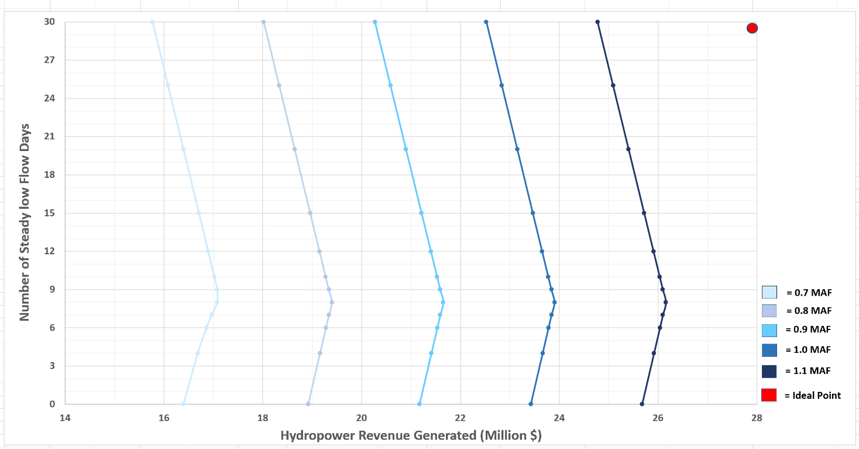

Figure 2 Trade-off between Number of steady low flow days and Hydropower revenue. Each color is representing a specific monthly volume scenario.

Another finding from Figure 2 is that the revenue from zero steady days equals the revenue from 15 steady low flow days (20 days for the 0.7 MAF per month release scenario). Which means 15 steady low flow days will generate the same revenues as were generated before the bug flow experiments (before summer 2018).

In Figure 2, it can also be noticed that increasing the total monthly release volume pushes the tradeoff curves right. Which means increasing the total monthly release volume benefit benefits hydropower revenue but does not harm bugs (win-stay the same). The model estimated that each added 0.1 MAF of monthly release volume will generate $2.25 million additional revenues.

The model produces a hydrograph for each steady low flow day scenario (Figure 3). For example, the hydrograph for the scenario with zero steady low flow days has hydropeaking on each day of the month (Figure 3, blue, pre-bug flow experiments practice). The hydrograph for eight steady low flow days scenario has steady low flows on weekends and hydropeaking on weekdays (Figure 3, green, current bug flow experiment practice). The hydrograph with 15 steady low flow days has steady days first placed on weekends, and the remaining steady days placed at the end of the month (Figure 3, orange). In actually, the weekday steady flows could be placed on other weekdays in the month and still generate the same hydropower revenue. The 30 steady low flow days hydrograph is flat (Figure 3, yellow). In Figure 3, it can be seen that with the increase in number of steady low flow days, the base flow also increases.

In addition, the model was tested with scenarios having different price differentials between on- and off-peak energy prices (Figure 4). By decreasing the price differentials from $25.82 (base case) to $12.91 to $0/MWH, the tradeoff curves shifted left to lower hydropower revenues. Also, decreasing the price differential between on- and off-peak prices flattens the slope of the tradeoff 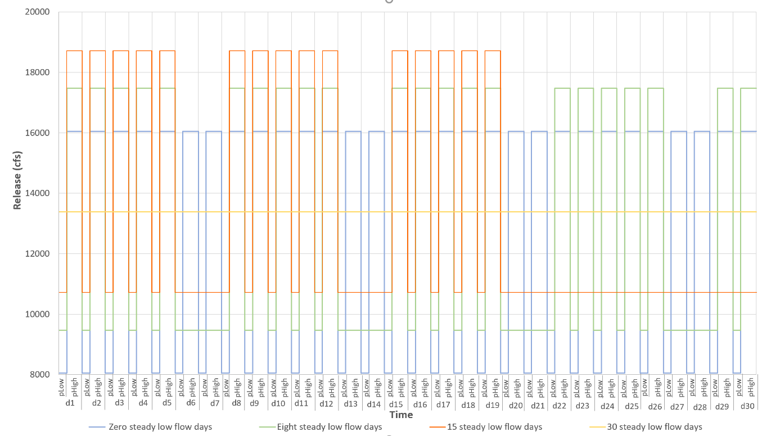curves from $62,750 to $31,370 to $0 revenue per added day of steady flow. With a price differential of $0/MWh, the tradeoff curve is a vertical line. Under this price scenario, the energy revenue is the same regardless of the number of days of steady low flow and regardless of whether the hydrograph is flat or has hydropeaking.

Figure 3 Monthly hydrographs for number of steady low flow days scenarios (0, 8, 15, and 30 steady days) with 0.8 MAF total monthly release volume.

Figure 5 shows the movement of tradeoff curves with different offset release scenarios. Increasing the offset release values shift the curves towards left (decrease in hydropower revenue). Depending upon the number of steady low flow days scenario, the loss by increasing 100 cfs offset release varies between $0 to $9,000 except for the 0.7 MAF volume scenario. The maximum revenue loss occurs during 8 steady flow days scenario (current bug flow experiment hydrograph) and zero dollars difference at both extreme points. This is an on-going research where the replication of model over different months of the year and comparison amongst tradeoffs of different months to guide the decision of number of steady flow days in specific months is still under process.

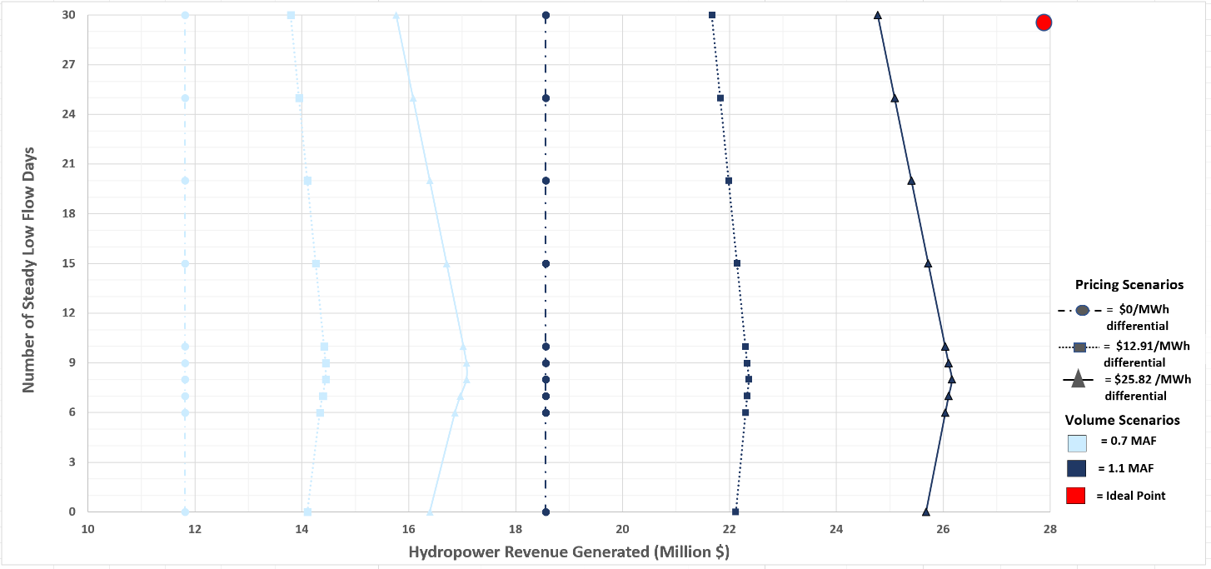

Figure 4 Tradeoff curves between Number of low bug flow days and Hydropower revenue for three of price differential scenarios. The type of line presents results of specific price differential scenario run i.e. dotted line is for 0$ price differential between on-peak and off-peak prices, dashed line is for half of current price differential ($12.91/MWh), and the solid line is for current price differential ($25.82/MWh). Different colors show specific monthly volume scenario.

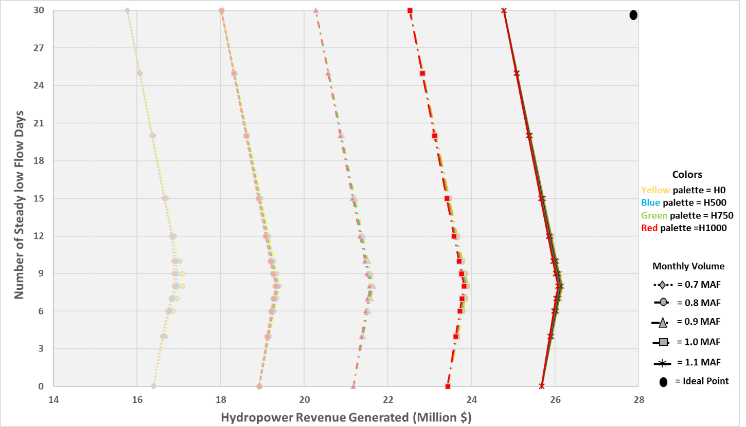

Figure 5 Tradeoff curves between Number of low bug flow days and Hydropower revenue for four of offset release scenarios. The type of line presents results of specific monthly volume scenarios. Different colors show specific weekend offset release scenarios, e.g. H0 means zero offset release between off-peak weekday and weekend, H500 equals 500 cfs offset release and so on.

**Conclusion**

This work quantifies the tradeoff between hydropower revenue and number of days of steady low flow under monthly release volumes, difference between on- and off-peaks energy pricing, and weekend offset release scenarios. Results show that the current practice of releasing steady low flows on weekend days gives the largest hydropower revenues. Each added day of steady flow on a weekday will subtract almost $62,750 from the total benefit. However, for release volumes above 0.7 MAF per month, 15 days of steady flows would generate the same hydropower revenues as 0 days of steady flows – the regime before the start of the bug flow experiments. Increasing the monthly release volume can benefit both bug and hydropower revenue generation objectives. The price differential controls the slope of the trade-off curves. And lastly, the effect of increasing weekend offset release over monthly hydropower revenue is trivial.

**Data Availability**

The input datafile, GAMS model codes, output files, and spreadsheets used during pre- and post processing can be found at: <https://github.com/moazzamalirind/GCD_BugFlowExperiment>

**Acknowlegdement**

This work is funded by center for Colorado River studies, Utah State university under the future of the Colorado River project. Also, the Higher Education Commission of Pakistan provided fellowship throughout the study period. In addition, we are thankful to the staff of GCMRC and WAPA; especially Clayton Palmer (WAPA), Craig Ellsworth (WAPA), and Ted Kennedy (GCMRC) for their continuous support and suggestions.

**References**

Acreman, M., Arthington, A.H., Colloff, M.J., Couch, C., Crossman, N.D., Dyer, F., Overton, I., Pollino,

C.A., Stewardson, M.J. and Young, W., 2014. Environmental flows for natural, hybrid, and novel riverine ecosystems in a changing world. Frontiers in Ecology and the Environment, *12*(8), pp.466-473.

Adams, L.E., Lund, J.R., Moyle, P.B., Quiñones, R.M., Herman, J.D. and O'Rear, T.A., 2017.

Environmental hedging: A theory and method for reconciling reservoir operations for downstream ecology and water supply. Water Resources Research, 53(9), pp.7816-7831.

Alafifi, A.H. and Rosenberg, D.E., 2020. Systems modeling to improve river, riparian, and wetland habitat

quality and area. Environmental Modelling & Software, 126, p.104643.

Carpenter, S.R., Stanley, E.H. and Vander Zanden, M.J., 2011. State of the world's freshwater ecosystems:

physical, chemical, and biological changes. Annual review of Environment and Resources, 36, pp.75-99.

Hart, B.T., 2016. The Australian Murray–Darling Basin plan: challenges in its implementation (part 1).

International Journal of Water Resources Development, 32(6), pp.819-834.

Harman, C. and Stewardson, M., 2005. Optimizing dam release rules to meet environmental flow

targets. River Research and Applications, 21(2‐3), pp.113-129.

Hochbaum, D.S., 2007. Complexity and algorithms for nonlinear optimization problems. Annals of

Operations Research, 153(1), pp.257-296.

Kareiva, P., Marvier, M. and McClure, M., 2000. Recovery and management options for spring/summer

chinook salmon in the Columbia River Basin. Science, 290(5493), pp.977-979.

Kennedy, T.A., Muehlbauer, J.D., Yackulic, C.B., Lytle, D.A., Miller, S.W., Dibble, K.L., Kortenhoeven,

E.W., Metcalfe, A.N. and Baxter, C.V., 2016. Flow management for hydropower extirpates aquatic insects, undermining river food webs. BioScience, 66(7), pp.561-575.

Nilsson, C., Reidy, C.A., Dynesius, M. and Revenga, C., 2005. Fragmentation and flow regulation of the

world's large river systems. Science, 308(5720), pp.405-408.

Null, S.E. and Lund, J.R., 2012. Fish habitat optimization to prioritize river restoration decisions. River

research and applications, 28(9), pp.1378-1393.

Olden, J.D. and Naiman, R.J., 2010. Incorporating thermal regimes into environmental flows assessments:

modifying dam operations to restore freshwater ecosystem integrity. Freshwater Biology, 55(1), pp.86-107.

Poff, N.L., Olden, J.D., Merritt, D.M. and Pepin, D.M., 2007. Homogenization of regional river dynamics

by dams and global biodiversity implications. Proceedings of the National Academy of Sciences, 104(14), pp.5732-5737.

Poff, N.L., Brown, C.M., Grantham, T.E., Matthews, J.H., Palmer, M.A., Spence, C.M., Wilby, R.L.,

Haasnoot, M., Mendoza, G.F., Dominique, K.C. and Baeza, A., 2016. Sustainable water management under future uncertainty with eco-engineering decision scaling. Nature Climate Change, 6(1), pp.25-34.

Ploussard, Q. and Veselka, T.D., 2019. Financial Analysis of the 2018 Glen Canyon Dam Bug Flow

Experiment (No. ANL-19/19). Argonne National Lab (ANL), Argonne, IL (United States).

Richter, B., 2014. Chasing water: a guide for moving from scarcity to sustainability. Island press.

Rheinheimer, D.E., Null, S.E. and Lund, J.R., 2015. Optimizing selective withdrawal from reservoirs to

manage downstream temperatures with climate warming. Journal of Water Resources Planning and

Management, 141(4), p.04014063.

Stevens, L.E., Shannon, J.P. and Blinn, D.W., 1997. Colorado River benthic ecology in Grand Canyon,

Arizona, USA: dam, tributary and geomorphological influences. Regulated Rivers: Research & Management: An International Journal Devoted to River Research and Management, 13(2), pp.129-149.

Walker, W., 2017. Environmental Flow Regime Management in the Grand Canyon. University of

California, Davis.

<https://watershed.ucdavis.edu/education/classes/files/content/page/WesWalker_revised.pdf>

Yakowitz, S., 1982. Dynamic programming applications in water resources. Water resources research,

18(4), pp.673-696.

Yoo, J.H., 2009. Maximization of hydropower generation through the application of a linear

programming model. Journal of Hydrology, 376(1-2), pp.182-187.