**Bugs Pay for Days of Steady Reservoir Releases to Reduce Hydropeaking-Ecosystem Conflict**

**Short title:** Reduce Hydropeaking-Ecosystem Conflict

M. Rind*, and D. E. Rosenberg *.

***Author full names and affiliations.***

Moazzam Ali Rind (moazzam.rind@wsu.edu)

*Department of Civil and Environmental Engineering, Utah State University, Logan, UT, USA.

David E. Rosenberg (david.rosenberg@usu.edu)

*Department of Civil and Environmental Engineering, Utah State University, Logan, UT, USA.

***Corresponding author.***

David Rosenberg

Email: david.rosenberg@usu.edu and Phone: +1 435-797-8689

***Abstract***

Steady low reservoir releases increase downstream primary and aquatic invertebrate (bugs) production. These releases also reduce hydropeaking value, raise costs for hydropower customers, and reduce funds to maintain infrastructure and repay loans. This study quantifies the win-lose tradeoff between hydropeaking value and days per month of steady low releases at Glen Canyon Dam, Arizona. We estimate win-lose tradeoffs for monthly release volumes of 0.71 to 0.95 million acre-feet from March to October 2018 and 0 to 31 days. Conservative estimates indicate that steady low releases on eight weekend days per summer month in 2018 reduced monthly hydropeaking value by $430,000 to $850,000. We used results to design a financial instrument that gives ecosystem managers a budget to choose days of steady low releases and compensate hydropower producers for lost value. One option to reduce costs is shifting days of steady low releases to spring/fall months. Next steps include discussing the proposed instrument with more U.S. Federal agencies, conducting more flow experiments, and monitoring how timing and more steady low flow days per month affect bug production. Managers may extend to other experimental releases that mobilize sediment, build sand bars, or disadvantage non-native fish.

***Keywords***

Aquatic invertebrates; Hydropower generation; Multi-objective optimization; Trade-off analysis.

***Highlights***

* Steady low reservoir releases increase primary and aquatic bug production, decrease hydropeaking value, and lower funds to maintain infrastructure (win-lose conflict).
* Federal and state agencies give ecosystem managers a budget to choose the number and timing of steady low releases and compensate hydropower producers for lost value (win-win scenario).
* One promising new experiment is shifting steady low releases from summer to spring/fall months.

# Introduction

Hydropeaking operations ramp up reservoir releases during the daytime and reduce nighttime releases to follow energy demands, increase hydropower value, and fulfill customer contracts. These operations also disadvantage downstream ecosystems (Bunn and Arthington, 2002; Liermann et al., 2012; Moog, 1993; Poff et al., 2007; Poff and Zimmerman, 2010; Vörösmarty et al., 2010; Winemiller et al., 2016). Researchers are challenged to quantify hydro-ecosystem tradeoffs, transform win-lose tradeoffs into wins, and help reduce conflict.

Multi-objective optimization methods are well established to quantify water supply, hydropower, ecosystem, and other tradeoffs (Porse et al., 2015; Wheeler et al., 2018; Wild et al., 2019). Numerous methods and metrics exist to estimate ecosystem impacts (Alafifi and Rosenberg, 2020; Chen and Olden, 2017; Hauer et al., 2018; Horne et al., 2016; Kraft et al., 2019; Rheinheimer et al., 2015). Jager and Smith (2008) suggest segmenting release regimes into different time periods at the annual, seasonal, or daily scale to benefit hydropower and ecosystem objectives. Daily hydropeaking creates distinct periods of high and low flow. This differentiation disadvantages taxa such as aquatic invertebrates that can only tolerate a narrow range of abiotic conditions. For example, Kennedy et al., (2016) identified a strong negative correlation between hydropeaking operations and insect (bug) diversity below Glen Canyon Dam, Arizona, and 15 other large reservoirs across the western U.S.

Several factors affect the ability to turn win-lose tradeoffs into wins. First, it is harder to find wins as the number of objectives increases (Hegwood et al., 2022). Tradeoffs are also more difficult to visualize as the number of objectives increases (Bonham et al., 2022; Rosenberg, 2015). Second, regions along concave tradeoff curves with maximum curvature or bulges (knee points) may identify promising areas for compromise (Null et al., 2021). Third, the degree of collaboration between researchers and system managers affects actionability. For example, Horne et al., (2016) found low implementation in their review of 42 ecosystem optimization studies because researchers did not follow the best practices of participatory modeling (Langsdale et al., 2013; Voinov et al., 2016). Also, physical and environmental systems are challenging to model, and managers rely on their experience rather than prescriptive solutions from optimization models (Horne et al., 2016). Fourth, successful implementation requires experimentation in concert with political and legislative support (Owusu et al., 2022). Hydropower-ecosystem conflicts are also more than numbers. Conflicts consume managers’ time and increase their work stress and anxiety (Unterhitzenberger et al., 2021).

This paper has goals to reduce a hydropeaking-ecosystem conflict by a) quantifying tradeoffs, b) developing a financial tool that gives ecologists more flexibility to schedule days of steady low flows that advantage bugs (bug flows), c) compensating hydropower producers for lost value, and d) using the financial tool to suggest new experimental steady low flows to reduce lost hydropeaking value. We answer four questions:

* 1. How is monthly hydropeaking value impacted by the number of consecutive days of steady low releases on Sundays, Saturdays, and weekdays?
  2. How do the shape and position of tradeoff curves vary with different monthly release volumes and contract and market energy prices across March to October months when bugs are most productive?
  3. How to use answers to questions (a) and (b) to design a financial instrument that gives ecosystem managers more flexibility to schedule bug flows and compensates hydropower producers for lost value?
  4. How to use the instrument to suggest new experiments to reduce the costs of bug flows?

We used the example of Glen Canyon Dam/Lake Powell, Colorado River, U.S. Experimental bug flows were conducted during weekends in summer months in 2018, 2019, 2020, and 2022. Future iterations are under review (USBR, 2024a). The experimental flows yielded promising results, with significant increases in midge (*Chironomidae*; 80%) and caddisfly (*Trichoptera*; 120%) populations in 2022. Conversely, a 50% decline in midges was observed in 2021 without the experiment while caddisfly abundance remained stable (CRB California, 2023). A technical report from the Glen Canyon Dam Long-Term Experimental and Management Plan (LTEMP) team also reported positive effects of experimental flows on bug populations, native fish numbers, and angler catch rates (LTEMP Team, 2022). The report additionally outlined the annual costs of the experimental flows and the Western Area Power Administration’s (WAPA) growing financial concerns, which threaten the experiment's sustainability. This study assesses the economic viability of the bug flow experiment. We quantify hydropeaking-ecosystem tradeoffs across a larger number of days of steady low flows per month. We also explore alternative operations that offset experimental costs while giving ecosystem managers more flexibility to schedule the timing and number of days of steady low releases.

The next section details the hydrologic, ecological, and institutional context of Glen Canyon Dam operations. Section 3 covers materials and methods, including our engagement strategy and the optimization model designed to maximize both hydropeaking value and consecutive days of steady low releases. The results section includes model validation and an analysis of trade-offs under various release volumes and pricing scenarios. Section 5 introduces a new financial tool to reduce WAPA's burden from experimental bug flows and suggests new experimental releases to alter the timing of bug flows to reduce lost hydropeaking value. The discussion section relates our findings to prior research, shares limitations, and suggests future directions. The conclusion summarizes the key findings.

# Study Area: Hydrologic, Ecological, and Institutional Context

Lake Powell is the second largest reservoir by storage volume (~25 million acre-feet) in the U.S (Root and Jones, 2022). Water from Wyoming, Colorado, Utah, New Mexico, and Arizona feeds into Lake Powell, formed by the Glen Canyon Dam, built in 1963 (Figure 1). Closure of Glen Canyon Dam has significantly altered river flow, temperature, and sediment delivery (Gloss et al., 2005). The flow regime of the Colorado River from Glen Canyon Dam through the Grand Canyon to Lake Mead has shifted from pre-dam seasonal variability to daily fluctuations driven by hydropeaking operations that follow energy demands (Topping et al., 2003). Post-dam releases primarily from the hypolimnion have led to constant year-round river temperatures, eliminating natural seasonal variability (Wright et al., 2009). This shift has altered the native ecosystem and promoted the establishment of non-native fish species (Cross et al., 2011). More recently, penstock releases have pulled from the warmer epilimnion to the benefit of small mouth bass (*Micropterus dolomieu*) downstream and the detriment of humpback chub (*Gila cypha*).

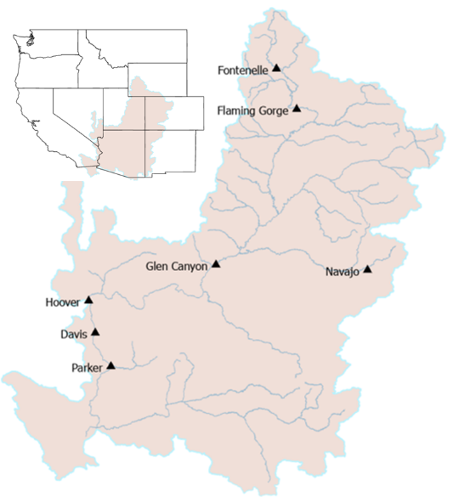

**Figure 1.** Location of Glen Canyon dam within the Colorado River Basin. Adapted from (Abernethy et al., 2021).

Glen Canyon Dam's hydropeaking operations provide low-cost energy to rural customers in seven Western U.S. states: Wyoming, Utah, Colorado, New Mexico, Arizona, Nevada, and Nebraska (USBR, 2023). These operations also impact riverbeds, water clarity, and ecosystem functioning (Deemer et al., 2022). Releases from the dam's cold hypolimnion layer maintain low downstream water temperatures, particularly in areas without tributary inflows (Cross et al., 2011). High flows entrain sediments (Vericat et al., 2020). Low flows expose aquatic life along the river's edge to desiccation (Angradi and Kubly, 1993; Kennedy et al., 2016; Young et al., 2011). Hydropeaking also erodes sandbars (Alvarez and Schmeeckle, 2013), which are vital habitats for aquatic vegetation and campsites for the Grand Canyon’s multi-million dollar rafting industry (Hoeting, 1998; USGS, 2015).

The Colorado River ecosystem in the Grand Canyon is food-limited (Cross et al., 2013, 2011; Hall Jr. et al., 2015; Kennedy et al., 2016, 2023). At the base, gross primary producers (algae) harvest solar energy. The primary producers are then food for aquatic invertebrates like stoneflies (*Plecoptera*), mayflies (*Ephemeroptera*), caddisflies, and midges. These bugs are also the food for threatened and endangered fish species like the humpback chub, razorback sucker (*Xyrauchen texanus*), bluehead sucker (*Catostomus discobolus*), Colorado pikeminnow (*Ptychocheilus lucius*), roundtail chub (*Gila robusta*), and bonytail (*Gila elegans*). Turbidity, canyon shading, and high river stage reduce light penetration and limit primary production. The disturbance of aquatic vegetation and drying of river edges following high flows also desiccate eggs that bugs lay at or near the water surface during high flows (Kennedy et al., 2016).

The annual Lake Powell release is set in the fall of each year with goals to equalize storage in Lake Powell and Lake Mead, better balance storage in the two reservoirs, meet a minimum objective release of 8.23 million acre-feet per year as a delivery requirement to California, Nevada, Arizona, and Mexico, and protect Lake Powell elevation 3,525 feet —1.8 million acre-feet above the minimum power pool elevation of 3,490 feet and 5.5 million acre-feet above the low-level outlets [dead pool] at 3,370 feet (Root and Jones, 2022; USBR, 2019, 2007). The release may be updated in the spring in response to changing reservoir levels. Recent conversations for new reservoir operations post-2026 propose to lower the minimum release to 6.0 million acre-feet per year when reservoir storage is low (Buschatzke et al., 2024). Once the annual release is set, monthly release volumes are set to maximize hydropower value in high load months of January, February, March, June, July, and August. Daily hydropeaking operations are subject to constraints on minimum release, maximum release, and rate of change in releases.

In the 1990s, managers started experimental releases above turbine capacity for several days in some years to gain downstream ecological benefits by replicating some of the pre-dam high flood flows. These experimental releases, known as “High Flow Experiments (HFEs),” are designed to generate flood flows, mobilize sediment, and rebuild downstream sandbars (Cross et al., 2011; Robinson and Uehlinger, 2008). During months of HFEs, the monthly release volume is maintained, leading to reduced hydropower releases on days outside HFE periods. Overall, HFEs prioritize downstream ecological and recreational benefits at the expense of some hydropower value (Melis, 2011).

As part of the preferred alternative for the 2016 Glen Canyon Dam Adaptive Management Program (GCDAMP), managers also started experimental steady low releases on weekends in summer months—bug flows (USBR, 2016). These flows aimed to keep bug eggs wet, increase bug production, and diversify species. Weekends were selected for their comparatively lower energy demands and hydropeaking value than weekdays (Førsund, 2015; USBR, 2023). The volume of water saved on the weekends due to steady low bug flows was redistributed to on- and off-peak weekday releases to preserve the required monthly release volume. The flows support the LTEMP resource goal for natural processes to “restore, to the extent practicable, ecological patterns and processes within their range of natural variability, including the natural abundance, diversity, and genetic and ecological integrity of the plant and animal species native to those ecosystems” (DOI, 2016).

Analysis of bug abundance data after experimental bug flows in summer 2018 and 2019 showed increased invertebrate production and diversity (Kennedy et al., 2023). Recent modeling work also suggests a second mechanism by which steady low flows may increase bug production (Cross et al., 2013; Deemer et al., 2022; Hall Jr. et al., 2015). In this second mechanism, steady low flows reduced downstream turbidity and lowered the water stage. Less turbidity and lower stage allow more sunlight to penetrate the water column and increase algae growth. More algae growth means more food for aquatic invertebrates. The same work also suggests that adding days and months of steady low flows in spring and fall may increase gross primary production (Deemer et al., 2022). The modeling of flannelmouth sucker (*Catostomus latipinnis*) further suggests increased growth in spring and summer that has approximately the same effect as a warmer river by 1 to 2 oC (Hansen et al., 2023). Unpublished data also suggest that steady low flows may benefit aquatic invertebrate larvae at multiple life stages, including growth of small larvae in fall months and larger larvae right before they emerge in spring months (Kennedy, personal communication, 2024). Finally, current hydropeaking results in daily fluctuations in flow that are 5 standard deviations from the mean (Palmquist et al., 2024). More days of steady low flows can reduce deviations towards something closer to natural flow variations.

The ecological gains of the bug flow experiments came with hydropower revenue losses, estimated at $165,000 from the 2018 and $327,000 from the 2019 Bug Flow Experiments, or approximately 1% of monthly hydropower value (Ploussard and Veselka, 2019; 2020). A financial analysis of the 2018 experiment highlighted the importance of timing (i.e. months of the year) in managing costs (Ploussard and Veselka, 2019). May and June, with lower energy prices, resulted in increased total revenue, while July and August, with higher prices, saw losses. These findings suggest that adjusting the experiment’s timing could help offset hydropower losses.

While impacts on hydropower value are small, there is concern because the adaptive management program uses hydropower revenues to pay for bug and other experimental releases. The bug flow experiment design creates a negative feedback loop that exacerbates conflict between hydropeaking and ecosystem operations. Bug and other experimental releases mean less revenue is available to maintain project infrastructure, repay project loans to the federal treasury, and fund additional experimental flows. Additionally, hydropower managers must purchase additional energy on the open market to fulfill low-price delivery contracts during high-load periods on weekends. Those costs are only partially offset by larger releases during high load periods on weekdays to preserve monthly release targets and comply with ramp rate constraints and measurable hourly energy demands.

Next, we describe an engagement process with managers that allowed us to formulate an optimization model to quantify tradeoffs between hydropeaking value and days of steady releases that increase bug production and diversity.

# Materials and Methods

3.1 Engagement–

We set out to quantify tradeoffs between hydropeaking operations and experimental steady low releases that advantage bugs. We had multiple interactions with WAPA (hydropower) and Grand Canyon Monitoring and Research Center (GCMRC, ecosystem) managers and scientists. Managers explained Glen Canyon Dam's prominent role in regional low-cost energy delivery, load balancing, and spinning reserves. Managers told us to focus on hydropeaking (load following) value and ignore load balancing and spinning reserve. Our interactions guided the definition of a hydropower objective to maximize hydropeaking value. Our interactions also pointed us to the literature that supports an ecosystem objective to increase the number of consecutive days per month of steady low releases and possibly shift days of steady low releases to spring/fall months (Deemer et al., 2022; Hall Jr. et al., 2015; Hansen et al., 2023; Kennedy et al., 2023; Palmquist et al., 2024). Managers explained how bug flows are funded and pointed us to the grey literature that describe operational constraints and show bug flow experiments increased bug production and diversity (Kennedy et al., 2023; Ploussard and Veselka, 2020, 2019; USBR, 2016). Additionally, the managers suggested that we turn 24-hourly decisions for releases into 2 periods per day—on-peak and off-peak. This suggestion is supported by hourly release hydrographs (Figure 2), energy price data, and our subsequent model validation (see section 4.1). Managers also shared relevant data to populate the model. All the above interactions followed best practices of collaborative modeling (Bourget et al., 2013; Langsdale et al., 2013; Palmer et al., 2013; Voinov et al., 2016)—particularly engaging parties early and identifying interests before discussing alternatives.

3.2 Hydropeaking objective

Typically, a hydropeaking objective to maximize value is a non-linear function that depends on the power generation release, the elevation difference between the reservoir water surface and tailwater, turbine efficiency, energy price, and release in relation to design efficiencies (e.g., Hochbaum, 2007; Ko et al., 1992; Tilmant et al., 2002; Yakowitz, 1982). This relationship can be linearized for reservoirs with large storage volumes such as Lake Powell where daily, weekly, or monthly release volumes draw down the reservoir water surface elevation a small amount relative to the operating head (Pérez-Díaz et al., 2010; Wang et al., 2015; Yoo, 2009). Lake Powell’s monthly elevation data (USBR, 2024b) shows minimal change relative to the tailwater elevation. This observation supports the assumption of a static reservoir elevation. We set the hydropower objective to maximize hydropeaking value, calculated by multiplying optimal turbine release with static head, turbine and generation efficiency, and energy price.

3.3 Ecosystem objective

Similarly, ecosystem objectives such as maximizing suitable habitat area and/or quality are non-linear functions that transition from unsuitable (e.g., 0) to suitable (e.g., 1) over a small range of a causal variable such as flow, water depth, or temperature (Alafifi and Rosenberg, 2020; Alminagorta et al., 2016). Discussions with GCMRC managers helped us see that primary production, bug abundance, and diversity increase proportionally to the number of consecutive days per month of steady low flows. For example, a week with steady low flow days on Saturday, Sunday, Monday, and Tuesday is preferable to Saturday, Sunday, Tuesday, and Thursday even though both week types have the same hydropeaking value.

3.4 Sub-problems

The annual Glen Canyon dam release for water supply and nested monthly release volumes for hydropower generation allowed us to break an inter-annual and annual multi-objective problem into monthly sub-problems. Each monthly sub-problem was defined by four parameters: monthly release volume, starting reservoir elevation, contract energy prices, and market energy prices. We could change any of the four parameters to represent any month of any year.

We further broke each monthly sub-problem into two weekly release patterns. The first weekly pattern—*steady low flow*—had 1 to 7 days of steady low flows on consecutive days. All remaining days of the week followed daily hydropeaking operations. In the second weekly flow pattern—*hydropeaking*—all days followed a hydropeaking schedule. We delineated 3 day types—Sundays, Saturdays, and weekdays—by analyzing hourly flows observed at Lees Ferry gauge (station id: USGS 09380000) for months with (e.g., August 2018) and without (e.g., August 2016) weekend steady low flows (Figure 2, blue line). Each day type had separate on-peak energy prices. The 2 weekly patterns and 3 day types allowed us to represent any number of days of steady low flows from 0 to 31 days per month. For instance, in a month with 10 steady low-flow days (e.g., August, starting on a Monday), the model places the first 4 steady days on Sundays where contract energy prices are low. The model places the next 4 days of steady flow on Saturdays, and the remaining 2 days on Mondays. In a month with 13 days of steady low flows, 4 Sundays, 4 Saturdays, 4 Mondays, and 1 Tuesday will be steady low releases while all other weekdays will be hydropeaking. In contrast, a month with zero steady low flow days means the model will decide releases for all weekends and weekdays with the flow pattern *hydropeaking*.

Within each day type, we divided daily releases into 2 time periods per day. The off-peak period had a single release value, low energy price, and duration of 8 hours from midnight to 8 a.m. (pLow). The on-peak period had a different release value, higher energy price, and a duration of 16 hours from 8 a.m. to midnight (pHigh; Figure 2, red line; Palmer, personal communication, 2019). On each day of steady low flow, the on- and off-peak releases had the same steady low release value. A release offset further defined the difference in flow between the release on a day of steady low flow and the next off-peak release on the next day with hydropeaking. We also explored a different number of periods per day, i.e., 3 and 4, and period lengths. We found monthly release volumes were identical and estimates of hydropower generation from 2 periods per day closely approximated actual hydropower generation. More specifically, the area under the hydrographs for the observed and modeled Sunday-Saturday-Weekend flow patterns were the same even though the traces do not overlay (Figure 2). Monthly revenue calculated at an hourly time step was 1.5 to 2.2% less than revenue modeled with 2 time periods per day (supplementary, Table S1).

3.5 Decision Variables

The annual, monthly, weekly, daily, and on- and off-peak sub-problems allowed us to model monthly operation—744 hourly decisions per month—with 12 characteristic flow decisions per month: 2 weekly flow patterns (*f ε* [*hydropeak, steady*]), 3 daytypes (*d ε* [*Saturday, Sunday, and Weekday*]), and 2 periods per day (*p ε* [*pHigh, pLow*]*)*. The August energy pricing data (Supplementary, Figure S1) also showed 2 periods per day.

3.6 Objective Functions

The equation to model monthly hydrogeneration value [$ per month] was:

$Hydrogeneration Value=\sum_{f,d,p}{{{Price}_{d,p}× Release}_{f,d,p}}{× Duration}_{p} × N{umDays}_{f,d} × 0.0375$ (eq. 1)

Where *Priced,p*is the energy price on day type *d* in period *p* [$ per MW-hr]; *Releasef,d,p* is the release for the flow pattern *f*, on day type *d*, in period *p* [cfs]; *Durationp* is the duration of period  *p* [hours]; *NumDaysf.d*is the number of days per month for flowpattern *f* and day type *d;* and 0.03715 is a conversion factor that represents energy generation per 1 cfs of release [MW-hr per cfs]. The conversion factor assumed a near-constant operating head, static turbine efficiency, and static generation efficiency. A collaborating hydropower manager shared the parameter value (Palmer, personal communication, 2019). The hydropower manager suggested to use the same conversion value for each month.

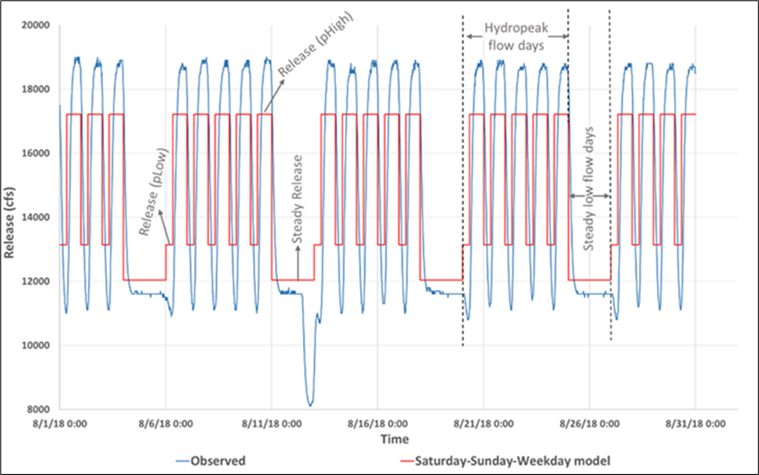

**Figure 2.** Comparison between hourly hydrograph observed at Lees Ferry gauge during August 2018 (blue) and the modeled hydrograph with 2 periods per day: pLow and pHigh (red).

3.7 Constraints

Seven physical constraints limit releases within infrastructure capacities. Ten managerial constraints specified the monthly release volume, limited the rate-of-change of releases during successive peak- and off-peak energy demand periods, set the number of steady low flow days per month, set releases for both periods to the low release on days of steady low flows, established relationships between low releases on different day types, and included offset releases. Additional details on the constraints are in the supplementary section, with the model structure shown in Supplementary Figure S5.

3.8 Input Data

The principal input data comprised on- and off-peak energy prices, monthly release volume, and number of days of steady low releases per month. We specified contract and market energy prices. These prices were used in two model variants.

*Contract prices* – Hydropower operators contract with power companies and rural electric utilities at long-term, fixed energy prices. We transformed hourly energy prices from 2014 provided by WAPA (Palmer, personal communication, 2019; also accessible at Rosenberg and Rind, 2023) into average contract prices for each modeled day type and period (Supplementary, Text S1). As an example, the estimated energy prices for off- and on-peak periods on a weekday in August were $50/MWh and $79/MWh, respectively. Sunday peak- and off-peak prices were the same as those for the weekday low period. We did not know the contract energy price for on-peak Saturday, so we averaged prices for on- and off-peak weekday periods, i.e., $64/MWh.

*Market prices* – Hydropower operators purchase electricity from private companies at a market rate and sell the purchased energy at the lower contract price when demand exceeds energy generation—either due to increased demand, reduced generation from bug flow releases, or power generation disruptions such as from turbine or generator maintenance (Figure 3). We did not find data for market prices. To assess the impact of changes in market prices, we created scenarios where market prices varied from $5 to $30/MWh above contract prices. In these scenarios, we applied a flat price increase to all days and periods. For example, With June 2014 weekday on-peak contract prices around $50/MWh, we added $5/MWh, resulting in a market price of $55/MWh.

For market pricing, we compared modeled releases with observed releases (Figure 3). For instance, if observed releases were higher than estimated, the resulting energy deficit was purchased at the market price (Figure 3, red fill). Conversely, higher modeled than observed releases created an energy surplus that was sold at the market price (Figure 3, light blue fill).

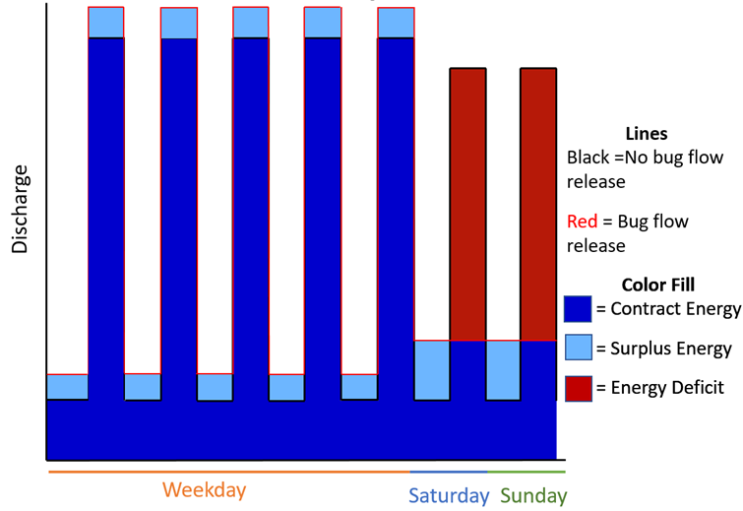

**Figure 3.** Conceptual model that compares market pricing for a case with weekday hydropeaking and steady low releases on the weekend (red line) to observed releases (black line). Dark blue-filled areas indicate energy priced at the contract price. Light blue fill represents surplus energy sold at the market price. Red fill shows energy deficits where energy is purchased at the market price. Releases are not scaled.

3.9 Model Formulation

The model formulation includes decision variables, objective functions, and constraints (Supplementary, Text S3). The model was implemented as a linear program in the General Algebraic Modeling System (GAMS; Hozlar, 1990). Addition of market prices required a different model setup called the Market-Contract price model.

We introduced a *Nobugflow_Reld,p*(cfs) parameter for observed hydrograph, i.e., pre-bug flow releases from 2017, 2016, and 2015 (Supplementary, Fig. S2 to S4). The Market-Contract price model had two further sub-models. First, releases for zero steady low flow days (i.e., hydropeaking pattern) were priced at contract rates (Figure 3, black line). Second, optimized releases for the number of steady low flow days are compared to observed releases to determine surplus or deficit energy generation. The differential energy is priced at market rate (Figure 3, red line/light blue and red fill). Further details are provided in supplementary text S4.

3.10 Model Solution. The bi-objective model used the constraint method to maximize hydropeaking value subject to the number of days per month of steady low releases. We varied the number of days of steady low releases from 0 to 31 days per month.

3.11 Scenarios. The model was solved for scenarios of different monthly release volumes, price differential between on and off-peak periods, contract and market energy prices, and flow offsets from Sunday to weekday low flows during March to October months when aquatic invertebrates are most productive. We varied the following parameters:

* Monthly release volume from 0.71 to 0.95 MAF,
* Contract price differential, e.g., August weekday on-peak contract price was reduced from $79 (base case) to $64.4 to $49.7 per MWh,
* Market price from $5 to $30/MWh above contract prices, and
* Offset release from 0 to 1000 cfs (H0 to H1000).

# Results

4.1 Validation

The Saturday-Sunday-Weekday model releases and energy generation were validated for March to October 2018against 15-minute flow data at Lees Ferry ([https://www.gcmrc.gov/‌‌‌‌‍discharge‌‌_qw_sediment/station/GCDAMP/09380000](https://www.gcmrc.gov/discharge_qw_sediment/station/GCDAMP/09380000)), aggregated hourly flows, and daily Glen Canyon power plant energy generation (<https://www.usbr.gov/rsvrWater/HistoricalApp.​​html)> (Supplementary, Table S1). For example, for August 2018 the flow volume for the observed, hourly, and Saturday-Sunday-Weekday models were identical (e.g., Supplementary, Fig. S6). Energy generation varied by only 4.2% in comparison to observed energy generation (Supplementary, Table S1 and Supplementary, Fig. S7). The possible reasons for surplus energy generation were an assumption that the reservoir head remains constant throughout the month and an outdated conversion factor (Supplementary, eq. S1). Validation over different months of 2018 showed that the energy generation error varied from 2.8% (July) to 9% (October; Supplementary, Table S1). Monthly revenue calculated at an hourly time step was 1.5 to 2.2% less than revenue modeled with 2 time periods per day (Supplementary, Table S1). We believe revenue validation at a 15-minute time-step will be similar because we do not observe large changes in flows across 1-hour periods for which we have energy pricing data.

4.2 Saturday-Sunday-Weekday Model

Using the Saturday-Sunday-Weekday model with contract prices, hydropeaking value increased by $56,000 for each added Sunday and by $3,900 for each added Saturday of steady low flow (Figure 4). The counter-intuitive increases in hydropeaking value per added weekend day of steady flow moved tradeoff curves closer to the ideal point of large hydropeaking value and more weekend days of steady low flows (Figure 4, red circle). The increase in hydropeaking value occurred because constraints Eq. S16 and S17 were relaxed during the load following pre-bug flow hydrograph. These constraints govern the relationship between on-peak releases on weekends and weekdays and activate only when steady bug flows extend beyond the weekend. Above 8 days of steady low weekend flows, hydropeaking values decreased by $64,000 per day for each weekday of steady low flow added. Here, constraints S7 and S8 controlled change in release between periods. Thus, the bug flow hydrograph with 8 weekend steady low flow days per month maximized hydropeaking value.

Each additional 0.11 MAF of monthly release volume from 0.72 to 0.94 MAF added an extra ~$3.5 million in monthly hydropower value (Figure 4, darker blue tradeoff curves pushed right and outward). The slopes on the 0.72 MAF per month tradeoff curve differed because constraints S7 and S8 did not bind with the lower monthly flow volume. For the release scenarios of 0.72, 0.83, and 0.94 MAF per month, hydropeaking value with zero steady flow days generated the same value as at 16, 12, and 12 days of steady low reservoir releases.

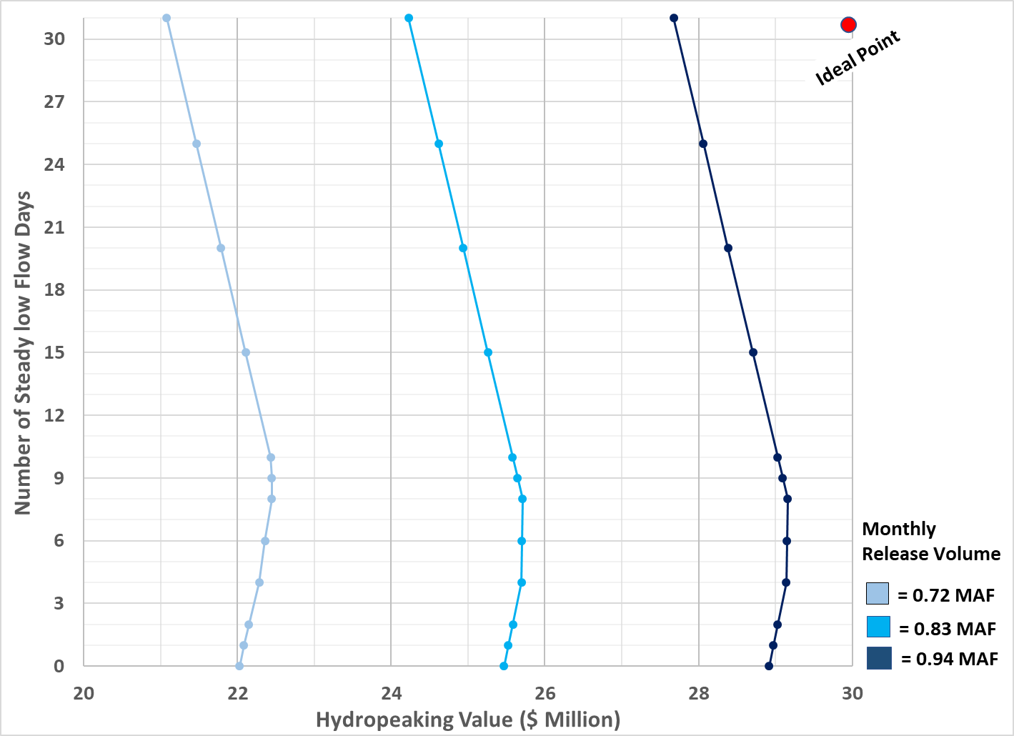

**Figure 4.** Tradeoffs between hydropeaking value and the number of steady low flow days from the Saturday-Sunday-Weekday model in August with contract prices, zero offsets, and monthly release volume.

The number of steady low flow days controlled the on- and off-peak releases (Supplementary, Fig. S8). Up to and including 8 steady low flow days, the model reduced off-peak releases on *hydropeak* days and steady low flow releases. The saved water was released during on-peak weekdays to maximize overall hydropeaking value. Above 8 steady low flow days, the constraint that defined the allowable change in release between periods was triggered, so the model increased peak and base releases.

A decreasing price difference between weekday on- and off-peak prices moved the tradeoff curves left towards less hydropeaking value (Supplementary, Fig. S9). An increase in offset releases slightly decreased hydropeaking value (Supplementary, Fig. S10). For the remainder of this analysis, we use only the single offset release of H1000 (1000 cfs differential between off-peak weekday and steady releases).

4.3 Market-Contract Pricing Model

Adding market pricing shifted the tradeoff curves left, reducing hydropeaking value compared to the Saturday-Sunday-Weekday model with only contract prices (Figure 5, orange vs. blue traces). We tested scenarios where market prices were $5 to $30/MWh above contract prices. The release hydrograph remained unchanged across the scenarios because the rate-of-change constraint between on- and off-peak periods was binding. An increase in market prices slightly increased hydropeaking value (Figure 5, orange vs green) because gains from selling surplus energy during off-peak Saturdays, Sundays, and weekdays plus on-peak weekdays were slightly higher than losses from purchasing deficit energy during on-peak Saturdays and Sundays. Across all market price scenarios, each added day of steady release pricing reduced hydropeaking value. No breakeven point was observed.

4.4 Costs for Bug Flows

We estimated that a $5/MWh market price increase above contract prices reduced monthly hydropeaking value by $0.2–$3.2 million from March to October, with 4 to 30/31 days of steady low flows per month (Table 1). The largest decreases in hydropeaking value were during high load months of May to August. The results also indicate that increases in market prices from $5 to $30/MWh above contract prices minimally changed the cost of bug flow experiments. For example, steady summer weekend releases reduced hydropeaking value by $0.6 to $0.9 million at $5/MWh (Table 1) compared to $0.1 to $0.8 million at $30/MWh (Supplementary, Table S3).

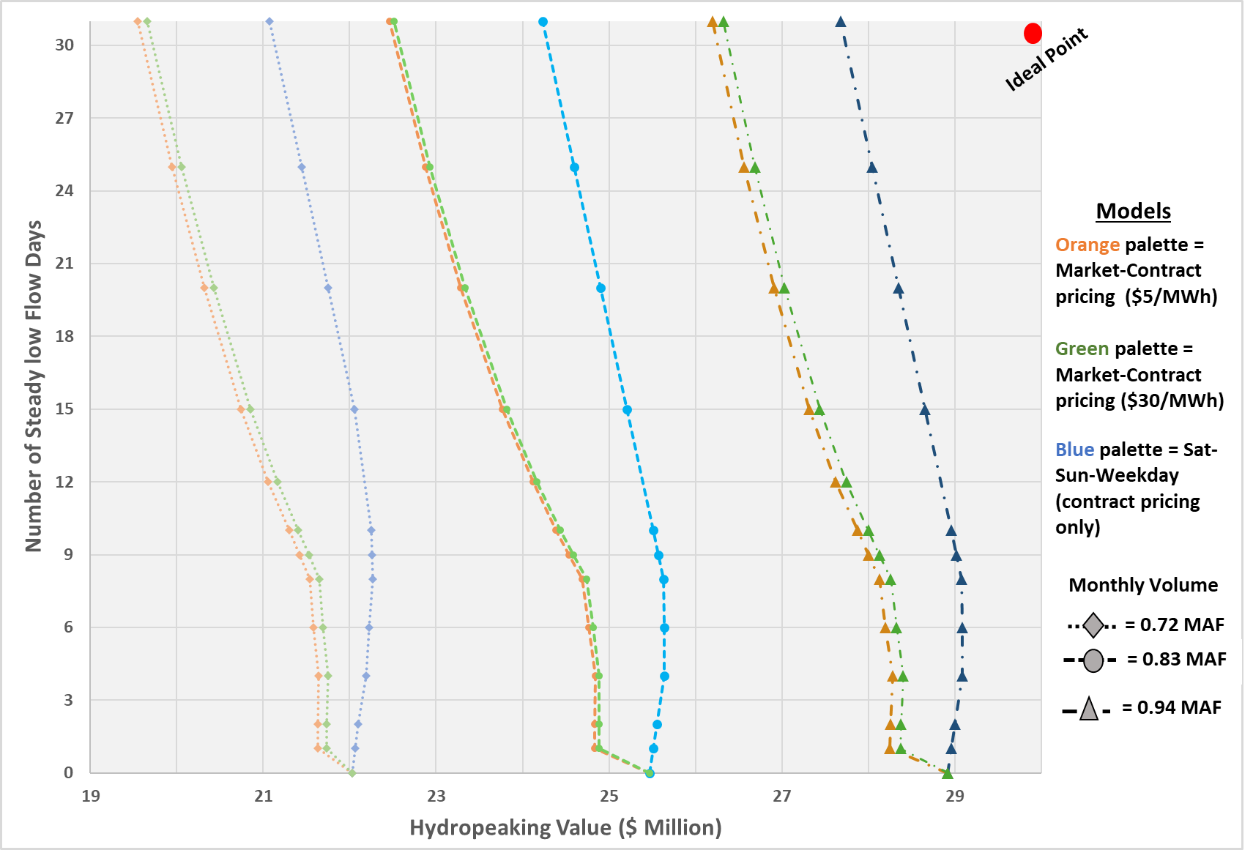

**Figure 5.** Comparison of tradeoffs with market (orange and green) and contract (blue) prices for different release volumes (line types and symbols) in August 2018 with 1000 cfs offset. Here, $5/MWh and $30/MWh indicate increases in contract pricing across all periods and day types.

**Table 1.** Cumulative loss of hydropeaking value ($ million) per added day of steady release in 2018 with 0.83 MAF release volume, H1000 (offset release), and market price $5/MWh above contract prices. Losses are calculated relative to zero steady low-flow days (hydropeaking). Rows highlighted in blue indicate percentage losses.

|  |  |  |  |  |  |  |  |  |  |  |
| --- | --- | --- | --- | --- | --- | --- | --- | --- | --- | --- |
| Month | Value at Zero Steady days | Cumulative loss of hydropeaking value ($ million) for the number of steady low flow days per month | | | | | | | | |
| **4** | **6** | **8** | **10** | **15** | **20** | **25** | **30** | **31** |
| March | 19.9 | 0.35 | 0.4 | 0.45 | 0.64 | 1.04 | 1.37 | 1.64 | - | 1.91 |
| 1.8% | 2.0% | 2.3% | 3.2% | 5.2% | 6.9% | 8.3% | - | 9.6% |
| April | 18.2 | 0.2 | 0.26 | 0.32 | 0.5 | 0.82 | 1.07 | 1.28 | 1.47 | - |
| 1.1% | 1.4% | 1.8% | 2.8% | 4.5% | 5.9% | 7.0% | 8.1% | - |
| May | 18.4 | 0.43 | 0.51 | 0.56 | 0.78 | 1.23 | 1.58 | 1.87 | - | 2.17 |
| 2.3% | 2.8% | 3.0% | 4.2% | 6.7% | 8.6% | 10.1% | - | 11.8% |
| June | 20.1 | 0.31 | 0.37 | 0.43 | 0.68 | 1.16 | 1.47 | 1.73 | 1.97 | - |
| 1.5% | 1.8% | 2.1% | 3.4% | 5.8% | 7.3% | 8.6% | 9.8% | - |
| July | 25.3 | 0.7 | 0.77 | 0.85 | 1.16 | 1.84 | 2.35 | 2.77 | - | 3.21 |
| 2.8% | 3.0% | 3.4% | 4.6% | 7.3% | 9.3% | 10.9% | - | 12.7% |
| August | 25.5 | 0.63 | 0.7 | 0.78 | 1.08 | 1.7 | 2.19 | 2.59 | - | 3.01 |
| 2.5% | 2.7% | 3.1% | 4.2% | 6.7% | 8.6% | 10.2% | - | 11.8% |
| September | 23.6 | 0.23 | 0.3 | 0.37 | 0.6 | 0.95 | 1.25 | 1.51 | 1.75 | - |
| 1.0% | 1.3% | 1.6% | 2.5% | 4.0% | 5.3% | 6.4% | 7.4% | - |
| October | 21.8 | 0.42 | 0.48 | 0.55 | 0.76 | 1.23 | 1.6 | 1.91 | - | 2.22 |
| 1.9% | 2.2% | 2.5% | 3.5% | 5.6% | 7.3% | 8.8% | - | 10.2% |

# Financial Instrument to Reduce Hydropeaking-Ecosystem Conflict.

The win-lose Market-Contract tradeoff curves (Figure 5, orange) highlight a conflict between hydropower producers and ecosystem managers. Under the current institutional arrangements, there is negative feedback where bug flows reduce hydropeaking value, increase costs to hydropower customers, decrease money for future bug flow experiments, and decrease money available to maintain project infrastructure and repay loans. This negative feedback loop exacerbates conflict between hydropower producers and ecosystem managers.

To reduce the conflict, we suggest that other federal and state agencies (e.g., Bureau of Reclamation, National Park Service, state fish and game agencies, etc.,) and/or environmental non-governmental organizations provide ecosystem managers a budget and greater flexibility to schedule the timing and number of days of steady low releases. The budget corresponds to the lost hydropeaking value for the current summertime weekend steady flow days. A $600,000 to $900,000 monthly budget corresponding to a $5/MWh increase in market prices over contract prices is 1/20th to 1/50th of the monthly Glen Canyon Dam hydropeaking value. Managers can use the budget and their ecosystem expertise to experiment with different days of steady low releases during the summer and/or fall months and compensate hydropower producers for the costs of days of steady low releases.

Graphically, the payments convert the left-sloping, win-lose Market-Contract tradeoff curves (Figure 5, orange) into vertical lines of constant hydropeaking value. These lines intercept the x-axis at the hydropeaking value in months with zero days of steady low releases (Table 1, Column 2, *Revenue*0 [$]). Mathematically:

Hydropeaking_Value0 = Hydropeaking_Valuen + Payment_for_SteadyReleasen  (eq. 2)

Here, *Hydropeaking_Value0* ($)and *Hydropeaking_Valuen* ($) are the modeled hydropeaking value for 0 and *n* days of steady releases (Figure 5, orange line). *Payment_for_SteadyReleasen* ($) is the difference in value between 0 and *n* days of steady low releases (Table 1).

The cumulative losses in hydropeaking value (Table 1) also suggest new experimental releases that can reduce bug flow costs—or increase the number of days of steady low flows without reducing hydropeaking value. One possibility is to shift days of steady low releases from summer to spring/fall months when hydropeaking value is lower and bug flows are not presently implemented (e.g., March, April, September, and October). Managers can then monitor whether the shifts increase gross primary production (Deemer et. al, 2022) and help small larvae in fall months and larger larvae right before they emerge in spring months (Kennedy, personal communication, 2024). Such shifts may also advantage native fish (Hensen et al, 2023) and reduce flow deviations closer to natural fluctuations (Palmquist, et al, 2024). The following are example scheduling shifts:

* Eight days of steady weekend releases in April and eight days of steady weekend releases in June that cost $600,000.
* Eight days of steady weekend and seven additional days of steady weekday releases in April for $530,000 or in September for $520,000.
* Six days of steady weekend releases in May and six days of steady weekend releases in July that cost $600,000.

There are several other combinations (see Supplementary Table S4). Similarly, Table 1 and Table S3 (Supplementary) can help efficiently allocate the available budget for purchasing a number of steady low-flow days.

# Discussion and Limitations

This study quantifies win-lose tradeoffs between hydropeaking value and the number of days of steady low releases that increase primary and aquatic invertebrate production. We propose an annual budget for ecosystem managers, offering them flexibility to select the number and timing of steady low-flow days and compensate hydropower producers for loss in hydropeaking value. This budget-based approach may better serve both ecosystem and hydropower objectives (win-win). The proposed budget-based approach contrasts the present institutional arrangement, where bug flow days are funded by hydropower revenue.

Ecosystem managers may use the budget to experiment with extending days of steady low releases from Glen Canyon Dam outside of summer months into spring and fall months. Managers can then monitor whether the shifts increase gross primary production (as suggested by Deemer et. al, 2022) and/or help small larvae in fall months and larger larvae right before they emerge in spring months (as suggested by Kennedy, personal communication, 2024). Managers may also monitor whether shifts reduce flow deviations closer to natural fluctuations (as suggested by Palmquist, et al, 2024) and advantage native fish (as suggested by Hensen et al, 2023).

Within the context of prior work, we discuss 9 factors that helped to reduce hydropeaking-ecosystem conflict at Glen Canyon Dam.

1. Flow partition. We found wins by partitioning the seasonal and weekly flow regimes into periods of steady low flows that benefited aquatic invertebrates and periods where hydropeaking allowed producers to maximize value. Prior work beneficially partitioned flow at either the inter-annual (Dalcin et al., 2023), seasonal (Chen and Olden, 2017; Jager and Uria-Martinez, 2023) , or daily (Jones, 2014) time scale.
2. Bi-objectives. Two objectives defined the modeled hydropower-bug conflict. Tradeoffs were visualized with Cartesian plots. In contrast, (Hegwood et al., 2022) reported more difficulty in finding wins as the number of objectives increases. Similarly, it is more challenging to visualize tradeoffs as the number of objectives increases (Bonham et al., 2022; Rosenberg, 2015).
3. Linear relationships. As a large-volume reservoir, Lake Powell sees only a small water surface drop from Glen Canyon Dam’s monthly releases relative to the operating head. Thus, the hydropower objective to maximize value was decomposed and linearized with respect to monthly release volume, month of the year, week type, and daily on- and off-peak periods. Similarly, ecosystem managers suggested expressing the bug objective as the number of days per month of steady low releases. This number varied from 0 to 31 days per month. Linear models and relationships are easier to represent, solve, visualize, and communicate.
4. Single reservoir system. The study system was for a single reservoir that was also the primary driver of the downstream flow regime. Tradeoffs and operations are more complex for geometries with multiple reservoirs in series or parallel (Lund and Guzman, 1999).
5. Concave tradeoffs. Null et al., (2021) hypothesized that points of maximum concavity may represent promising compromise operations. In this work, we found 3 concave tradeoffs:
   1. Existing bug flows on 8 weekend days per month with contract pricing. This point was closest to the ideal point of large hydropower value and many days of steady low flows.
   2. Switching bug flows to spring/fall months meant less cost per day for steady low releases. Lower cost per day pushed tradeoff curves closer to the ideal point.
   3. The new instrument to pay hydropower producers for days of bug flows preserved hydropeaking value across all numbers of days per month of steady low flow. Tradeoff curves became perfectly convex. Each curve passed through the ideal point of maximum hydropeaking value and a maximum number of days of steady low releases.
6. Provide insights and flexibility rather than prescriptions. Our work suggests a new framework for experimental flows. Give ecosystem managers a budget to choose the timing and number of days of new experimental steady low releases and then pay hydropower producers for the lost value. One potential new experiment is move days of bug flows from summer to spring/fall months to reduce costs. Flexibility allows ecosystem managers to use emerging data and their expert judgment to pick the number and timing of days of steady low flows rather than contesting new operations with hydropower managers. Flexibility also avoids the need for researchers to define and include ecosystem preferences in a model.
7. Repeated engagement and collaboration with managers. Ecosystem managers and hydropower operators defined the bi-objectives for hydropeaking value and the number of days of steady low flows in collaboration with researchers. We also regularly engaged with managers to acquire data, share preliminary results, discuss results, and put results in context.For example, engagement helped us understand current institutional arrangements such as offset releases, the difference between contract and market energy prices, and how experimental bug flows are funded. These institutional arrangements are not described in the peer-reviewed literature. As an example of this success, our collaborating hydropower and ecosystem managers invited us to present this work to the technical work group for the Glen Canyon Dam Adaptive Management Program (GCDAMP; Rind and Rosenberg, 2025). Technical work group members wanted to further investigate our findings and insights. These insights can inform the design and implementation of new, more expensive experimental releases (since August 2024) through Lake Powell’s low level river outlets that bypass hydropower generation and have the goal to lower downstream temperature and disadvantage small-mouth bass. Our engagement followed many best practices for collaborative and participatory modeling (Langsdale et al., 2013; Voinov et al., 2016). In contrast, prior ecosystem optimization efforts did not mention engagement with or take up by managers (Horne et al., 2016).
8. Situated work in institutional context, enabling legislation, and policy environment. Our engagement with ecosystem and hydropower managers also helped us identify how an ecosystem budget can correct an existing institutional arrangement and negative feedback loop where bug flows reduce hydropeaking value. The GCDAMP technical workgroup also provide a regulatory and policy environment where new operations can be discussed, implemented, and tested. In contrast, many similar efforts fail because there is not a larger environment to implement researcher recommendations (Owusu et al., 2022)

Our work also has limitations:

1. The energy generation formula we used does not capture a declining Lake Powell water levels across multiple years. Drawdown lowers energy head, efficiency, generation, and hydropower value. As energy generation decreases, we expect tradeoff curves for hydropeaking value and days of steady releases will shift left to lower hydropeaking value (e.g., Supplementary, Fig. S9). We also expect the tradeoff curves to show larger lost value per day of added steady low release.
2. We acknowledge that the use of 2014 energy prices may change the magnitude of reported hydropeaking values, lost value per day of steady low releases, and ecosystem budget.

We recommend the following next steps:

* Update results with more recent hydropower prices.
* Further validate results—use the proprietary GTMax SL model that hydropower producers use to schedule hydropower operations.
* Further engage people at federal agencies such as Reclamation and National Park Service and state fish and game agencies.
* Apply the proposed financial instrument to other reservoir releases that benefit ecosystems and reduce hydropower value. These releases may mobilize sediment, build sand bars, or disadvantage non-native fish (USBR, 2016).

# Conclusions

Steady low reservoir releases allow downstream invertebrates to lay and hatch more eggs. These releases also lower turbidity and water stage which increase algal production—an important food for bugs. Steady low releases also reduce hydropeaking value, increase costs to hydropower customers, lower funds to maintain project infrastructure, delay loan repayment, and exacerbate conflict between hydropower and ecosystem managers. We formulated and solved a bi-objective optimization model to quantify tradeoffs between hydropeaking value and the number of days of steady low releases. We validated monthly energy generation and revenue in the months of March to October 2018. We ran scenarios for different monthly release volumes, peak- and off-peak energy price differentials, offset releases, and market energy prices for March through October.

We found that the 2018 experiment of steady low releases for eight weekend days per summer month reduced hydropeaking value by $600,000 (May) to $900,000 (July). To reduce hydropower-ecosystem conflict, we suggested to give ecosystem managers a budget to choose the timing and number of days of new experimental steady low flows and then pay hydropower producers for the lost value. One potential experiment—also suggested by recent ecological monitoring and modeling—is to shift days of steady low releases from summer to spring/fall months.

We achieved the above results because we engaged with hydropower and ecosystem managers through the duration of our research project. We believe our work can be improved by including inputs from the proprietary GTMax SL model used by hydropower producers. We also believe that a financial instrument that gives ecosystem managers a budget to schedule steady low flows can be extended to other reservoir releases that reduce hydropower value such as mobilize sediment, build sand bars, and/or disadvantage non-native, invasive fish.

# Data Availability Statement

The data, models, code, and directions to use are available in a Hydroshare repository (Rind and Rosenberg, 2025). Bhupinderjeet Singh and Philip Moffatt at Washington State University, USA downloaded the materials and reproduced all figures and tables.

# Declaration of Competing Interest

The authors declare that they have no known competing financial interests or personal relationships that could have appeared to influence the work reported in this paper.

# Acknowledgments

The Higher Education Commission of Pakistan, the Future of the Colorado River Project, and the Utah Water Research Laboratory provided financial support. The funding sources had no involvement in the study design, data collection, analysis, interpretation, manuscript writing, or the decision to submit it for publication. Stanley Clayton Palmer (now deceased), Craig Ellsworth, Theodore Kennedy, and Jack Schmidt contributed data and/or discussion that helped identify tradeoffs between hydropeaking value and days of steady low flows.

# References

Abernethy, E.F., Muehlbauer, J.D., Kennedy, T.A., Tonkin, J.D., Van Driesche, R., Lytle, D.A., 2021. Hydropeaking intensity and dam proximity limit aquatic invertebrate diversity in the Colorado River Basin. Ecosphere 12, e03559. https://doi.org/10.1002/ecs2.3559

Alafifi, A.H., Rosenberg, D.E., 2020. Systems modeling to improve river, riparian, and wetland habitat quality and area. Environ. Model. Softw. 126, 104643. https://doi.org/10.1016/j.envsoft.2020.104643

Alminagorta, O., Rosenberg, D.E., Kettenring, K.M., 2016. Systems modeling to improve the hydro-ecological performance of diked wetlands. WATER Resour. Res. 52, 7070–7085. https://doi.org/10.1002/2015WR018105

Alvarez, L.V., Schmeeckle, M.W., 2013. Erosion of River Sandbars by Diurnal Stage Fluctuations in the Colorado River in the Marble and Grand Canyons: Full-Scale Laboratory Experiments. River Res. Appl. 29, 839–854. https://doi.org/10.1002/rra.2576

Angradi, T.R., Kubly, D.M., 1993. Effects of atmospheric exposure on chlorophyll a, biomass and productivity of the epilithon of a tailwater river. Regul. Rivers Res. Manag. 8, 345–358. https://doi.org/10.1002/rrr.3450080405

Bonham, N., Kasprzyk, J., Zagona, E., 2022. post-MORDM: Mapping policies to synthesize optimization and robustness results for decision-maker compromise. Environ. Model. Softw. 157, 105491. https://doi.org/10.1016/j.envsoft.2022.105491

Bourget, E.C., Langsdale, S.M., van den Belt, M., 2013. Featured Collection Introduction: Collaborative Modeling for Decision Support as a Tool to Implement IWRM. JAWRA J. Am. Water Resour. Assoc. 49, 605–608. https://doi.org/10.1111/jawr.12071

Bunn, S.E., Arthington, A.H., 2002. Basic Principles and Ecological Consequences of Altered Flow Regimes for Aquatic Biodiversity. Environ. Manage. 30, 492–507. https://doi.org/10.1007/s00267-002-2737-0

Buschatzke, T., Hamby, J.B., Entsminger, J., 2024. Lower Basin Alternative for the Post-2026 Coordinated Operation of the Colorado River Basin.

Chen, W., Olden, J.D., 2017. Designing flows to resolve human and environmental water needs in a dam-regulated river. Nat. Commun. 8, 2158. https://doi.org/10.1038/s41467-017-02226-4

CRB California, 2023. MONTHLY REPORT TO THE COLORADO RIVER BOARD OF CALIFORNIA.

Cross, W.F., Baxter, C.V., Donner, K.C., Rosi-Marshall, E.J., Kennedy, T.A., Hall Jr, R.O., Kelly, H.A.W., Rogers, R.S., 2011. Ecosystem ecology meets adaptive management: food web response to a controlled flood on the Colorado River, Glen Canyon. Ecol. Appl. 21, 2016–2033. https://doi.org/10.1890/10-1719.1

Cross, W.F., Baxter, C.V., Rosi-Marshall, E.J., Hall Jr., R.O., Kennedy, T.A., Donner, K.C., Wellard Kelly, H.A., Seegert, S.E.Z., Behn, K.E., Yard, M.D., 2013. Food-web dynamics in a large river discontinuum. Ecol. Monogr. 83, 311–337. https://doi.org/10.1890/12-1727.1

Dalcin, A.P., Marques, G.F., Tilmant, A., Olivares, M., 2023. Dynamic Adaptive Environmental Flows (DAE-Flows) to Reconcile Long-Term Ecosystem Demands With Hydropower Objectives. Water Resour. Res. 59, e2022WR034064. https://doi.org/10.1029/2022WR034064

Deemer, B.R., Yackulic, C.B., Hall, R.O., Jr, Dodrill, M.J., Kennedy, T.A., Muehlbauer, J.D., Topping, D.J., Voichick, N., Yard, M.D., 2022. Experimental reductions in subdaily flow fluctuations increased gross primary productivity for 425 river kilometers downstream. PNAS Nexus 1, pgac094. https://doi.org/10.1093/pnasnexus/pgac094

DOI, 2016. Glen Canyon Dam Long-Term Experimental and Management Plan Final Environmental Impact Statement.

Førsund, F.R., 2015. Hydropower Economics, International Series in Operations Research & Management Science. Springer US, Boston, MA. https://doi.org/10.1007/978-1-4899-7519-5

Gloss, S.P., Lovich, J.E., Melis, T.S., 2005. The State of the Colorado River Ecosystem in Grand Canyon, USGS Circular 1282.

Hall Jr., R.O., Yackulic, C.B., Kennedy, T.A., Yard, M.D., Rosi-Marshall, E.J., Voichick, N., Behn, K.E., 2015. Turbidity, light, temperature, and hydropeaking control primary productivity in the Colorado River, Grand Canyon. Limnol. Oceanogr. 60, 512–526. https://doi.org/10.1002/lno.10031

Hansen, L.E., Yackulic, C.B., Dickson, B.G., Deemer, B.R., Best, R.J., 2023. Linking ecosystem processes to consumer growth rates: gross primary productivity as a driver of freshwater fish somatic growth in a resource-limited river. Can. J. Fish. Aquat. Sci. 80, 1456–1469. https://doi.org/10.1139/cjfas-2022-0229

Hauer, C., Wagner, B., Aigner, J., Holzapfel, P., Flödl, P., Liedermann, M., Tritthart, M., Sindelar, C., Pulg, U., Klösch, M., Haimann, M., Donnum, B.O., Stickler, M., Habersack, H., 2018. State of the art, shortcomings and future challenges for a sustainable sediment management in hydropower: A review. Renew. Sustain. Energy Rev. 98, 40–55. https://doi.org/10.1016/j.rser.2018.08.031

Hegwood, M., Langendorf, R.E., Burgess, M.G., 2022. Why win-wins are rare in complex environmental management. Nat. Sustain. 5, 674–680. https://doi.org/10.1038/s41893-022-00866-z

Hochbaum, D.S., 2007. Complexity and algorithms for nonlinear optimization problems. Ann. Oper. Res. 153, 257–296. https://doi.org/10.1007/s10479-007-0172-6

Hoeting, J.A., 1998. Sandbars in the Colorado River: an Environmental Consulting Project. Stat. Sci. 9–13.

Horne, A., Szemis, J.M., Kaur, S., Webb, J.A., Stewardson, M.J., Costa, A., Boland, N., 2016. Optimization tools for environmental water decisions: A review of strengths, weaknesses, and opportunities to improve adoption. Environ. Model. Softw. 84, 326–338. https://doi.org/10.1016/j.envsoft.2016.06.028

Hozlar, E., 1990. Gams-General Algebraic Modeling System for Mathematical-Modeling. Ekonomicko-Matematicky Obzor 26, 96–99.

Jager, H.I., Smith, B.T., 2008. Sustainable reservoir operation: can we generate hydropower and preserve ecosystem values? River Res. Appl. 24, 340–352. https://doi.org/doi:10.1002/rra.1069

Jager, H.I., Uria-Martinez, R., 2023. Finding middle ground: Flow regimes designed for salmon and energy value. Water Biol. Secur. 2, 100183. https://doi.org/10.1016/j.watbs.2023.100183

Jones, N.E., 2014. The Dual Nature of Hydropeaking Rivers: Is Ecopeaking Possible? River Res. Appl. 30, 521–526. https://doi.org/10.1002/rra.2653

Kennedy, T.A., Muehlbauer, J.D., Yackulic, C.B., Lytle, D.A., Miller, S.W., Dibble, K.L., Kortenhoeven, E.W., Metcalfe, A.N., Baxter, C.V., 2016. Flow Management for Hydropower Extirpates Aquatic Insects, Undermining River Food Webs. BIOSCIENCE 66, 561–575. https://doi.org/10.1093/biosci/biw059

Kennedy, T.R., Muehlbauer, J., Metcalfe, A., Deemer, B., Ford, M., Szydlo, C., Behn, K., Yackulic, C., 2023. Experimental Bug Flows Enhance Natural Processes That Sustain The Colorado River Ecosystem.

Ko, S.-K., Fontane, D.G., Labadie, J.W., 1992. Multiobjectwe Optimization of Reservoir Systems Operation1. JAWRA J. Am. Water Resour. Assoc. 28, 111–127. https://doi.org/10.1111/j.1752-1688.1992.tb03158.x

Kraft, M., Rosenberg, D.E., Null, S.E., 2019. Prioritizing Stream Barrier Removal to Maximize Connected Aquatic Habitat and Minimize Water Scarcity. JAWRA J. Am. Water Resour. Assoc. 55, 382–400. https://doi.org/10.1111/1752-1688.12718

Langsdale, S., Beall, A., Bourget, E., Hagen, E., Kudlas, S., Palmer, R., Tate, D., Werick, W., 2013. Collaborative Modeling for Decision Support in Water Resources: Principles and Best Practices. JAWRA J. Am. Water Resour. Assoc. 49, 629–638. https://doi.org/10.1111/jawr.12065

Liermann, C.R., Nilsson, C., Robertson, J., Ng, R.Y., 2012. Implications of Dam Obstruction for Global Freshwater Fish Diversity. BioScience 62, 539–548. https://doi.org/10.1525/bio.2012.62.6.5

LTEMP Team, 2022. Final Recommendation to Implement Experimental Macroinvertebrate Production Flow Releases (“Bug Flows”) at Glen Canyon Dam in Water Year 2022.

Lund, J.R., Guzman, J., 1999. Derived Operating Rules for Reservoirs in Series or in Parallel. J. Water Resour. Plan. Manag. 125, 143–153. https://doi.org/10.1061/(ASCE)0733-9496(1999)125:3(143)

Melis, T.S., 2011. Effects of Three High-Flow Experiments on the Colorado River Ecosystem Downstream from Glen Canyon Dam, Arizona (No. U.S. Geological Survey Circular 1366). U.S. Geological Survey.

Moog, O., 1993. Quantification of daily peak hydropower effects on aquatic fauna and management to minimize environmental impacts. Regul. Rivers Res. Manag. 8, 5–14. https://doi.org/10.1002/rrr.3450080105

Null, S.E., Olivares, M.A., Cordera, F., Lund, J.R., 2021. Pareto Optimality and Compromise for Environmental Water Management. Water Resour. Res. 57, e2020WR028296. https://doi.org/10.1029/2020WR028296

Owusu, A., Mul, M., van der Zaag, P., Slinger, J., 2022. May the Odds Be in Your Favor: Why Many Attempts to Reoperate Dams for the Environment Stall. J. WATER Resour. Plan. Manag. 148, 04022009. https://doi.org/10.1061/(ASCE)WR.1943-5452.0001521

Palmer, R.N., Cardwell, H.E., Lorie, M.A., Werick, W., 2013. Disciplined Planning, Structured Participation, and Collaborative Modeling — Applying Shared Vision Planning to Water Resources. JAWRA J. Am. Water Resour. Assoc. 49, 614–628. https://doi.org/10.1111/jawr.12067

Palmquist, E.C., Deemer, B.R., Metcalfe, A.N., Kennedy, T.A., Bair, L.S., Fairley, H.C., Grams, P.E., Sankey, J.B., Yackulic, C.B., 2024. eZ flow metrics: Using z-scores to estimate deviations from natural flow in the Colorado River below Glen Canyon Dam. River Res. Appl. https://doi.org/10.1002/rra.4360

Pérez-Díaz, J.I., Wilhelmi, J.R., Arévalo, L.A., 2010. Optimal short-term operation schedule of a hydropower plant in a competitive electricity market. Energy Convers. Manag. 51, 2955–2966. https://doi.org/10.1016/j.enconman.2010.06.038

Ploussard, Q., Veselka, T.D., 2020. Financial Analysis of the 2019 Glen Canyon Dam Bug Flow Experiment (No. ANL-20/81). Argonne National Lab. (ANL), Argonne, IL (United States). https://doi.org/10.2172/1734861

Ploussard, Q., Veselka, T.D., 2019. Financial Analysis of the 2018 Glen Canyon Dam Bug Flow Experiment (No. ANL-19/19, 1526634). https://doi.org/10.2172/1526634

Poff, N.L., Olden, J.D., Merritt, D.M., Pepin, D.M., 2007. Homogenization of regional river dynamics by dams and global biodiversity implications. Proc. Natl. Acad. Sci. 104, 5732–5737. https://doi.org/10.1073/pnas.0609812104

Poff, N.L., Zimmerman, J.K.H., 2010. Ecological responses to altered flow regimes: a literature review to inform the science and management of environmental flows. Freshw. Biol. 55, 194–205. https://doi.org/10.1111/j.1365-2427.2009.02272.x

Porse, E.C., Sandoval-Solis, S., Lane, B.A., 2015. Integrating Environmental Flows into Multi-Objective Reservoir Management for a Transboundary, Water-Scarce River Basin: Rio Grande/Bravo. Water Resour. Manag. 29, 2471–2484. https://doi.org/10.1007/s11269-015-0952-8

Rheinheimer, D.E., Null, S.E., Lund, J.R., 2015. Optimizing Selective Withdrawal from Reservoirs to Manage Downstream Temperatures with Climate Warming. J. Water Resour. Plan. Manag. 141, 04014063. https://doi.org/10.1061/(ASCE)WR.1943-5452.0000447

Rind, M., Rosenberg, D., 2025. Bugs Pay for Days of Steady Reservoir Releases to Reduce Hydropeaking-Ecosystem Conflict. https://www.hydroshare.org/resource/209cf1b127b04806836345bf0f4b6c66/

Robinson, C.T., Uehlinger, U., 2008. Experimental Floods Cause Ecosystem Regime Shift in a Regulated River. Ecol. Appl. 18, 511–526. https://doi.org/10.1890/07-0886.1

Root, J.C., Jones, D., 2022. Elevation-area-capacity relationships of Lake Powell in 2018 and estimated loss of storage capacity since 1963 (No. 2022–5017), Scientific Investigations Report. U.S. Geological Survey. https://doi.org/10.3133/sir20225017

Rosenberg, D.E., 2015. Blended near-optimal alternative generation, visualization, and interaction for water resources decision making. Water Resour. Res. 51, 2047–2063. https://doi.org/10.1002/2013WR014667

Tilmant, A., Vanclooster, M., Duckstein, L., Persoons, E., 2002. Comparison of Fuzzy and Nonfuzzy Optimal Reservoir Operating Policies. J. Water Resour. Plan. Manag. 128, 390–398. https://doi.org/10.1061/(ASCE)0733-9496(2002)128:6(390)

Topping, D.J., Schmidt, J.C., Vierra Jr., L.E., 2003. Computation and analysis of the instantaneous-discharge record for the Colorado River at Lees Ferry, Arizona : May 8, 1921, through September 30, 2000 (USGS Numbered Series No. 1677), Computation and analysis of the instantaneous-discharge record for the Colorado River at Lees Ferry, Arizona : May 8, 1921, through September 30, 2000, Professional Paper. https://doi.org/10.3133/pp1677

Unterhitzenberger, C., Wilson, H., James Bryde, D., Rost, M., Joby, R., 2021. The stakeholder challenge: dealing with challenging situations involving stakeholders. Prod. Plan. Control 32, 926–941. https://doi.org/10.1080/09537287.2020.1776907

USBR, 2024a. Glen Canyon Dam Long-Term Experimental and Management Plan | Upper Colorado Basin | Bureau of Reclamation [WWW Document]. URL https://www.usbr.gov/uc/progact/amp/ltemp.html (accessed 8.8.24).

USBR, 2024b. Lake Powell and Lake Mead: End of Month Elevation charts.

USBR, 2023. Glen Canyon Dam | Upper Colorado Region | Bureau of Reclamation [WWW Document]. Glen Canyon Unit. URL https://www.usbr.gov/uc/rm/crsp/gc/ (accessed 12.9.23).

USBR, 2019. Drought Contingency Plans | Bureau of Reclamation [WWW Document]. URL https://www.usbr.gov/ColoradoRiverBasin/dcp/index.html (accessed 9.28.24).

USBR, 2016. LTEMP 2016 [WWW Document]. Integrating LTEMP GCDAMP Process. URL https://www.usbr.gov/uc/progact/amp/twg/2016-10-18-twg-meeting/Attach_08.pdf (accessed 12.9.23).

USBR, 2007. Record of Decision: Colorado River Interim Guidelines for Lower Basin Shortages and Coordinated Operations for Lakes Powell and Mead.

USGS, 2015. Rebuilding Sandbars in the Grand Canyon. URL https://www.usgs.gov/news/featured-story/rebuilding-sandbars-grand-canyon (accessed 8.18.24).

Vericat, D., Ville, F., Palau-Ibars, A., Batalla, R.J., 2020. Effects of Hydropeaking on Bed Mobility: Evidence from a Pyrenean River. Water 12, 178. https://doi.org/10.3390/w12010178

Voinov, A., Kolagani, N., McCall, M.K., Glynn, P.D., Kragt, M.E., Ostermann, F.O., Pierce, S.A., Ramu, P., 2016. Modelling with stakeholders – Next generation. Environ. Model. Softw. 77, 196–220. https://doi.org/10.1016/j.envsoft.2015.11.016

Vörösmarty, C.J., McIntyre, P.B., Gessner, M.O., Dudgeon, D., Prusevich, A., Green, P., Glidden, S., Bunn, S.E., Sullivan, C.A., Liermann, C.R., Davies, P.M., 2010. Global threats to human water security and river biodiversity. Nature 467, 555–561. https://doi.org/10.1038/nature09440

Wang, H., Brill, E.D., Ranjithan, R.S., Sankarasubramanian, A., 2015. A framework for incorporating ecological releases in single reservoir operation. Adv. Water Resour. 78, 9–21. https://doi.org/10.1016/j.advwatres.2015.01.006

Wheeler, K.G., Hall, J.W., Abdo, G.M., Dadson, S.J., Kasprzyk, J.R., Smith, R., Zagona, E.A., 2018. Exploring Cooperative Transboundary River Management Strategies for the Eastern Nile Basin. Water Resour. Res. 54, 9224–9254. https://doi.org/10.1029/2017WR022149

Wild, T.B., Reed, P.M., Loucks, D.P., Mallen-Cooper, M., Jensen, E.D., 2019. Balancing Hydropower Development and Ecological Impacts in the Mekong: Tradeoffs for Sambor Mega Dam. J. Water Resour. Plan. Manag. 145, 05018019. https://doi.org/10.1061/(ASCE)WR.1943-5452.0001036

Winemiller, K.O., McIntyre, P.B., Castello, L., Fluet-Chouinard, E., Giarrizzo, T., Nam, S., Baird, I.G., Darwall, W., Lujan, N.K., Harrison, I., Stiassny, M.L.J., Silvano, R.A.M., Fitzgerald, D.B., Pelicice, F.M., Agostinho, A.A., Gomes, L.C., Albert, J.S., Baran, E., Petrere, M., Zarfl, C., Mulligan, M., Sullivan, J.P., Arantes, C.C., Sousa, L.M., Koning, A.A., Hoeinghaus, D.J., Sabaj, M., Lundberg, J.G., Armbruster, J., Thieme, M.L., Petry, P., Zuanon, J., Vilara, G.T., Snoeks, J., Ou, C., Rainboth, W., Pavanelli, C.S., Akama, A., Soesbergen, A. van, Sáenz, L., 2016. Balancing hydropower and biodiversity in the Amazon, Congo, and Mekong. Science 351, 128–129. https://doi.org/10.1126/science.aac7082

Wright, S.A., Anderson, C.R., Voichick, N., 2009. A simplified water temperature model for the Colorado River below Glen Canyon Dam. River Res. Appl. 25, 675–686. https://doi.org/10.1002/rra.1179

Yakowitz, S., 1982. Dynamic programming applications in water resources. Water Resour. Res. 18, 673–696. https://doi.org/10.1029/WR018i004p00673

Yoo, J.-H., 2009. Maximization of hydropower generation through the application of a linear programming model. J. Hydrol. 376, 182–187. https://doi.org/10.1016/j.jhydrol.2009.07.026

Young, P.S., Cech, J.J., Thompson, L.C., 2011. Hydropower-related pulsed-flow impacts on stream fishes: a brief review, conceptual model, knowledge gaps, and research needs. Rev. Fish Biol. Fish. 21, 713–731. https://doi.org/10.1007/s11160-011-9211-0