**Points to consider for both models:**

1. The study considers 8 months from 2018 (March to October) and none of the months had HFE hydrograph. There was no bypass release (release through the outlets) nor spillway release during the considered months (refer observed data in excel file name “Observed months” to cross check). The HFE experiment in 2018 was conducted during the month of November, which this study does not consider because the month belong to winter season. There exists minimum interest to have bug flows during winter season, therefore, the study doesn’t consider months of November, December, January, February for calculation.
2. The elevation difference during each of the months during 2018 were:

|  |  |  |
| --- | --- | --- |
| S.No. | Months (2018) | Elevation difference (Start-End) in ft |
| 1 | March | 3.7 |
| 2 | April | 2.7 |
| 3 | May | 2.3 |
| 4 | June | 1.7 |
| 5 | July | 6.0 |
| 6 | August | 6.5 |
| 7 | September | 4.6 |
| 8 | October | 1.7 |

*\* Red shows decrease, and blue is for increase in reservoir elevation during the month.*

***Discussion:***On 1st March 2018, Lake Powell elevation was 3,616 ft and the minimum power pool level is 3,525 ft. Which means still there was significant head available during most of the months for hydropower generation. For sure, there will be some variation in hydropower generation depending upon change in elevation, but we are unaware about how much the generation is affected by decrease in 1 ft reservoir level. Also, at what level the energy generation start to get effected form head change, I have no information about that. For instance, I did some rough calculation last time for June with 1.7ft decrease and 80% -90% powerplant efficiency. I found the maximum error the constant head assumption can generate was 0.2% percent, whereas, the validation results show 2.3% surplus error.

1. This is what the GCD excel model (given by Clayton) says about flow to hydropower conversion:

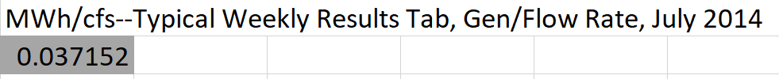

The GCD model uses this factor in calculation of revenue for all the months; not specifically for July only.

1. The energy prices given in the GCD model is for Monday (Weekday) only and possibly from 2014. We are unaware about the real energy prices for Saturday and Sunday.
2. Both the models (Weekend-Weekday and Saturday-Sunday-Weekday) were basically planned and designed with H0 (no offset release scenario). Therefore, the slope of the tradeoff curves was smooth, and shape was convex. With addition of the offset release, the hydrograph was basically forced to behave in particular manner. For example, 30 steady low flow days scenario is expected to have flat hydrograph. But with offset release, the weekends have now higher releases in comparison to the weekday releases. To make the hydrograph flat even with offset, we are required to have an additional constraint for 30 steady low flow days scenario. This additional constraint changes the slope of the curve. The following examples and details are explaining this discrepancy in more details.

**Weekend-Weekday Model**

**\****Note: All files for this section is available in Weekend-Weekday folder*

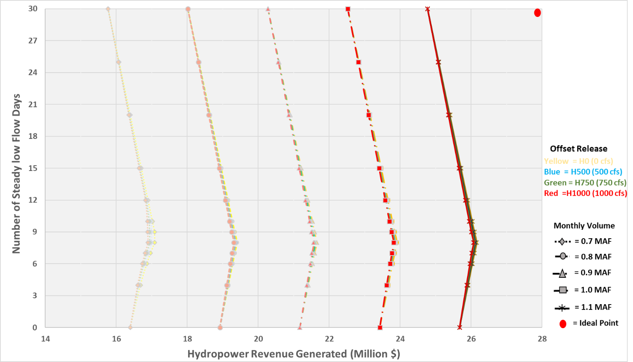The model works good for H0 (Zero offset release) scenario; but there are two possibilities with the offset release hydrographs: 1) The weekend release can be different from steady weekday. Which means weekends will have higher release (steady weekday + offset release) in comparison to steady weekday. We didn’t consider this possibility in our modeling work, because it will not create a flat hydrograph with 30 steady flow days. Also, the assumption of steady release across different day types (weekday and weekend) will be violated. 2) The steady release value for all weekdays and weekends should be same (flat hydrograph for 30 steady flow days). This scenario makes more sense in comparison to possibility #1 and produce convex curves (Figure 1).

Figure 1 Tradeoff curves between Number of low bug flow days and Hydropower revenue for four of offset release scenarios. The type of line presents results of specific monthly volume scenarios. Different colors show specific weekend offset release scenarios, e.g. H0 means zero offset release between off-peak weekday and weekend, H500 equals 500 cfs offset release and so on.

In Figure 1, each of the offset release scenario’s set of curves have different slope values. For specific values check excel file “Results_Graphs” and its slope worksheet. In that file, hydrographs can also be found.

**Saturday-Sunday-Weekday Model**

**\****Note: All files for this section is available in Saturday-Sunday-Weekday folder*