**Saturday Model Results Comparison**

This report compares the results from three different models: 1) Weekend-Weekday model that has two day types (weekend and weekday) in the month. 2) Saturday-Sunday-Weekday unconstrained model that has three day types (Saturday, Sunday, and Weekday) in the month. Besides, the model doesn’t have any constraint controlling the release during unsteady Saturdays and Sundays (unconstrained) except on-peak release should be equal to or greater than off -peak period release and the minimum release constraint i.e. if release is made by the model it should be than or equal to 8000 cfs. And 3) Saturday-Sunday-Weekday constrained model that has three day types (Saturday, Sunday, and Weekday) in the month. In addition, the model has a constraint that pLow (off-peak) releases on Weekdays, Saturdays, and Sundays should be equal (constrained). Still, the model can choose different on-peak (pHigh) releases during Weekdays, Saturdays, and Sundays.

Figure 1 compares results from the three models. The Weekend-Weekday model generates the lowest revenues (yellow, Figure 1), because the on-peak period energy price on Saturday equals the on-peak period energy on Sunday. The Sunday on- and off-peak prices are equal and also equivalent to off-peak price on Saturday and Weekday (i.e. minimum energy price). The Saturday-Sunday-Weekday constrained (green, Figure 1) and unconstrained (blue, Figure 1) models produce similar results; specifically, for scenarios with eight steady low flow days and above. In case of scenarios with number of steady low flow days below eight, the unconstraint model generates higher revenue in comparison to the constraint model. Moreover, the difference in revenue expands with the increase in monthly release volume (Figure 1). The reason for difference in revenue is that the unconstraint model decides to release minimum during unsteady Saturdays and Sundays, whereas it increases the flows during weekday periods. This move generates the maximum monthly hydropower revenue. In comparison, the constrained model has a binding constraint causing the off-peak period releases during different day types (Saturday, Sunday, and Weekday) to be same. As a result, the constrained model releases minimum during on-peak periods on unsteady Saturdays and Sundays and increase the on-peak period Weekdays flowrate. This move of increasing weekday’s on-peak release has been found beneficial for the overall monthly hydropower revenue.

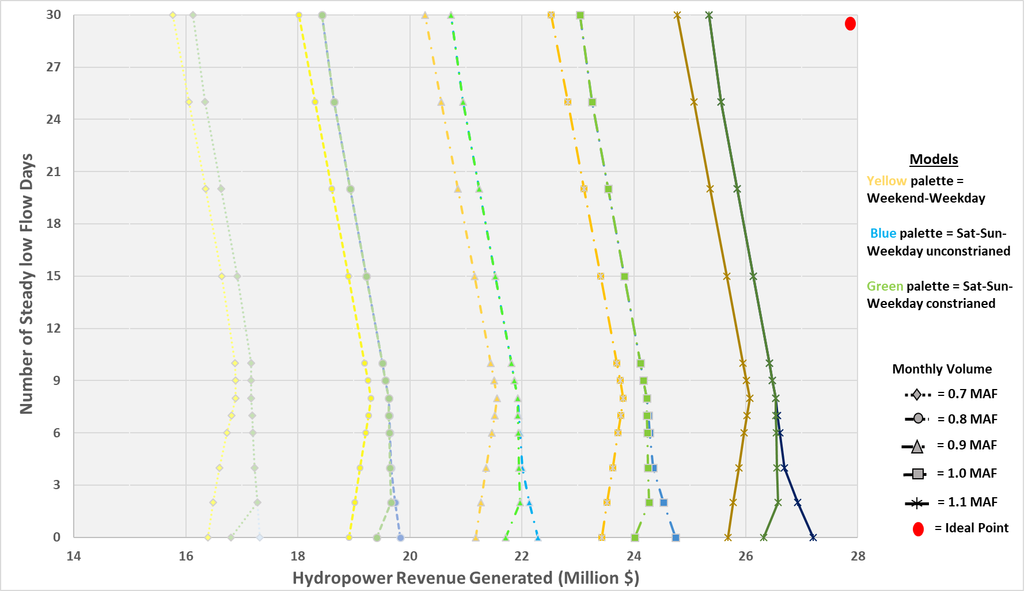

Figure 1 Trade-off between Number of steady low flow days and Hydropower revenue. Each color is representing results from specific models. Different line types and marker symbol shows monthly volume scenarios. The results shown are from models with 1000 cfs offset release.

The results from the Weekend-Weekday model (yellow, Figure 1) and for June 2018 shows that there is increase in hydropower revenue when we move up from zero to eight steady low flow days (movement along y-axis in Figure 1). With each additional steady low flow day, the model adds almost $48,800 to the total monthly revenues. The model estimates maximum revenue with eight steady low flow days. Eight steady low flow day means weekends being steady and hydropeaking on weekdays (current bug flow experiment practice). Whereas, above eight steady low flow days, the Weekend-Weekday model estimates deduction of $58,700 from the monthly hydropower revenue with each steady low flow day increase. It should be noted that the results discussed are from model with 1000 cfs offset release and 0.7 MAF release volume curve doesn’t follow the discussed slope values.

Results from the unconstrained model (blue, Figure 1) shows continuous decrease in hydropower revenue with increase in number of steady low flow days (movement along y-axis in Figure 1). Below eight steady low flow days scenarios, no stable slope was identified for any of the monthly release volume curves. For instance, the deduction from total monthly hydropower revenue with increase of each steady low flow days varies between $0 to $138,687. However, above eight steady low flow days, each of the curves has a constant slope i.e. deduction of $54,230 from total revenue with each added steady low flow day. The slope values mentioned here are not applicable to 0.7 MAF release volume scenario.

In case of constraint model, the results (green, Figure 1) shows that there is increase an increase of $126,872 per each additional steady low flow day as we move up from zero to two steady low flow days (movement along y-axis in Figure 1). From two to four steady low flow days, there is a deduction of $12,278. And from four to eight steady low flow days, the deduction amount condensed to $4,604 per each added steady flow day. Above eight steady low flow days, there is constant reduction of $54,230 from total revenue with addition of each steady low flow day. The slope values discussed here are not completely applicable for 0.7 MAF release volume scenario.

Figure 2, 3, and 4 is presenting the hydrograph from each of the three models and for different number of steady low flow days scenarios. The presented hydrographs are for V2 (0.8 MAF) release volume and H1000 (1000 cfs offset release) scenarios. Generally, increase in number of steady low flow days increases the base and peak flows for the hydrograph. However, Figure 3 and 4 nullify this assumption since the base and peak flows for 4 steady low flow hydrograph is greater than 8 steady low flow day hydrograph.

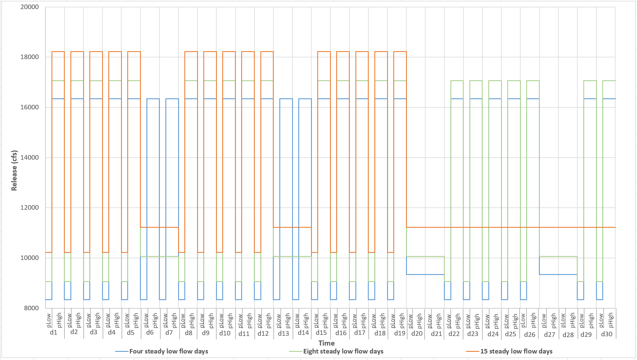

Figure 2 Monthly hydrographs from Weekend-Weekday model for volume scenario V2, different number of steady low flow day cases (various colors in the graph), and the weekend offset scenario was H1000. Here, it is assumed that monthly calendar starts on Monday and the additional steady days are added at the end of the month. For instance, case with 15 steady flow days has four steady Sundays (d7, d14, d21, and d28), four steady Saturdays (d6, d13, d20, and d28). There are seven steady weekdays (d22 to d26, and d29 to d30) and fifteen unsteady weekdays (d1 to d5, d8 to d12, and d15 to d19).

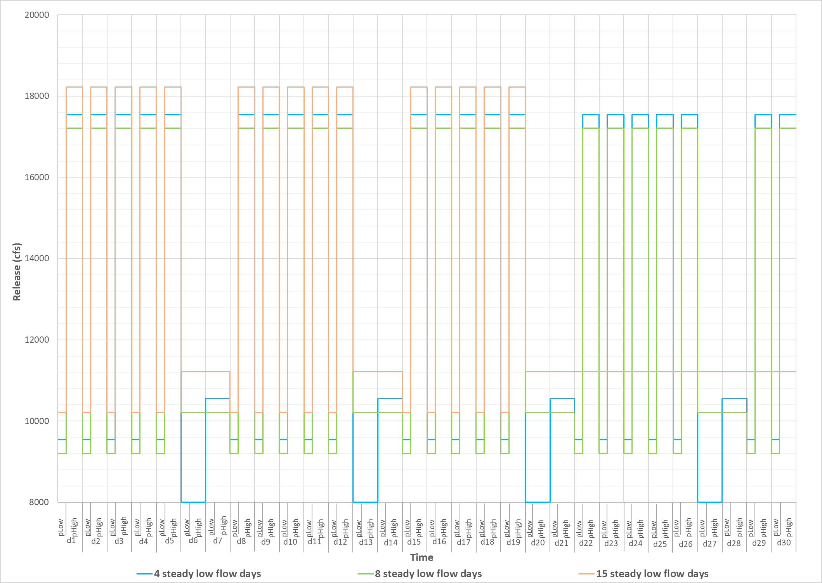

Figure 3 Monthly hydrographs from unconstrained Saturday-Sunday-Weekday model for volume scenario V2, different number of steady low flow day cases (various colors in the graph), and the weekend offset scenario was H1000.

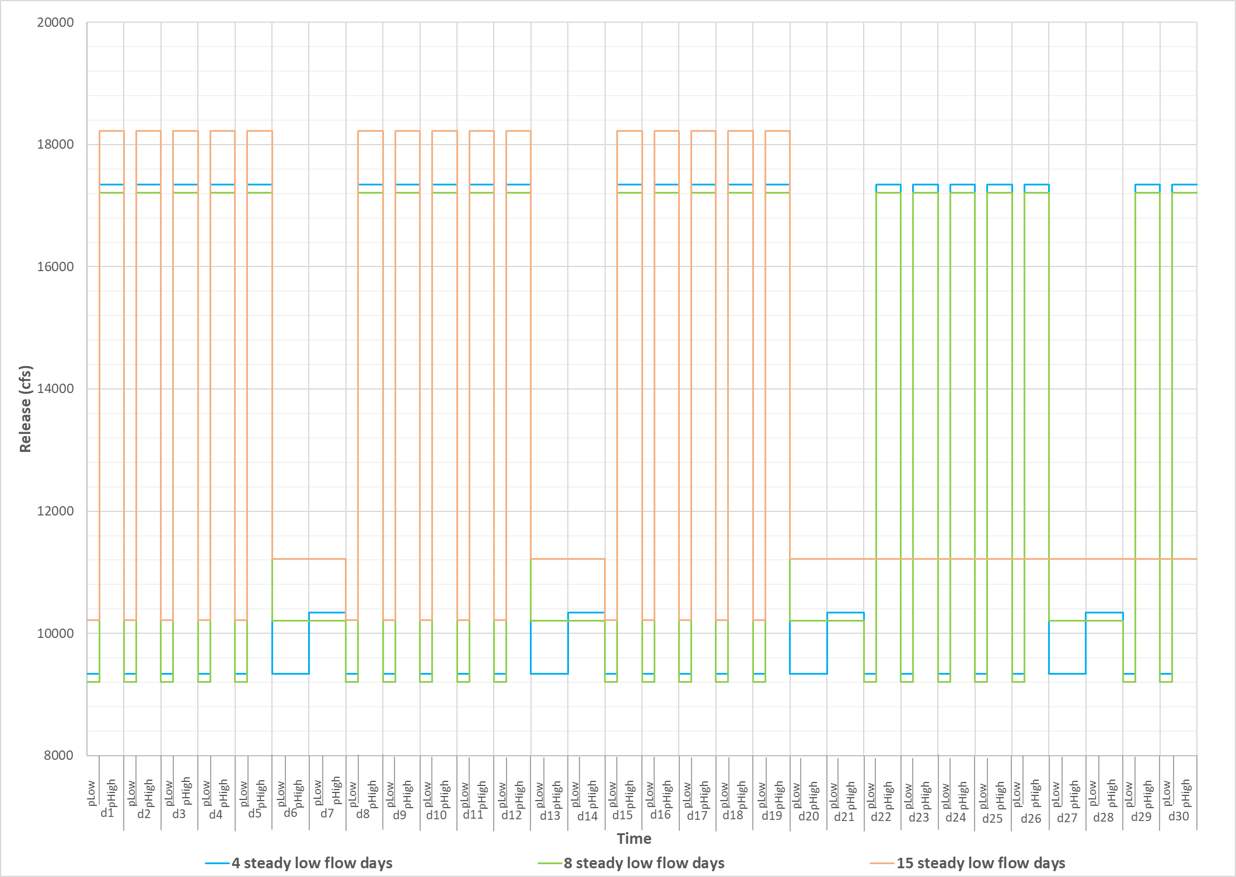

Figure 4 Monthly hydrographs from constrained Saturday-Sunday-Weekday model for volume scenario V2, different number of steady low flow day cases (various colors in the graph), and the weekend offset scenario was H1000.

**Learning from Saturday-Sunday-Weekday model**

* Increasing the number of steady low flow days in most of the cases decrease the monthly hydropower revenue. This fact was hidden in the Weekend-Weekday model, because that predicts increase in revenue from 0 to 8 steady low flow days.
* The importance of a particular flow pattern (steady or unsteady) on a Saturday is vividly highlighted by the Saturday-Sunday-Weekday model.
* Water manager can estimate the cost of specific flow pattern (steady or unsteady) on Saturdays from the finding of the model, which will ultimately help their decision about when and how much to pay hydropower produces for the revenue lost from bug flows.
* The Saturday-Sunday-Weekday model is dynamic in nature and can offer water manager to test number of possible hydrographs and estimate their impacts on hydropower revenue.

**Model Formulation**

This section discusses the inputs to the Saturday-Sunday-Weekday model, describes the parameters and decision variables used, and lists the constraints on the decision variables. Also, the constraint which differentiate the model being constrained or unconstrainted are discussed.

**Indices/Sets:**

d $∈$ D Types of days within the month: Sunday, Saturday, and Weekday

FlowPattern Types of flow pattern in the model: Steady and Unsteady

p $∈$ P Periods in a day: pLow & pHigh

v $∈$ tot_vol Total monthly volume scenarios: v1*v5

Nu_SteadyDays Cases with specific number of steady flow days: case1*case12

Offset Offset release between off-peak weekday and steady releases: H1*H4

**Data:**

**Initstorage**  Initial storage in the reservoir (Ac-ft)

**Inflow**  DailyInflow to reservoir on day **d** (cfs)

**evap**  Total monthly reservoir evaporation (ac-ft per month)

**EnergyRate** **(d,p)** Averaged energy price during period p for day d ($ per MWH)

**Duration(p)** Length of each period p (hrs)

**Days_Distribution(flowPattern, d, Nu_SteadyDays)**  Number of steady and unsteady Saturdays, Sundays, and Weekdays in the month.

**Decision Variables:**

**Release(FlowPattern, d, p)** Reservoir release for a specific **flow pattern** during day **d** and

period **p** (cfs)

**Energy_Gen(FlowPattern, d, p)** Hydropower for a specific **flow pattern** during day **d** and

period **p** (MWh)

**Storage** Reservoir storage at the end of the month (ac-ft)

**Released_vol** Total water released in the month (ac-ft)

**Constraints:**

**1) Reservior Mass Balance (ac-ft)**

Storage = Initstorage + (Inflow*Convert $\left( \sum_{p∈P}{Duration\left(p\right)}\right)$**Totaldays)- Released_vol – evap

Where, Convert = conversion factor from cfs to ac-ft per hour (i.e. 1 cfs = 0.083 ac-ft/hr)

And Totaldays= Total number of days in the month

**2) Minimum Storage Required for Hydropower (ac-ft)**

*Storage ≥ minstorage*

**3) Maximum Storage Limit (ac-ft)**

*Storage ≤ maxstorage*

**4) Maximum Release limit (cfs)**

*Release(FlowPattern, d, p) ≤ maxRel ∀ d∈ D and p ∈ P*

**4) Minimum Release limit (cfs)**

*Release(FlowPattern, d, p) ≥minRel ∀ d∈ D and p ∈ P*

**5) Total monthly release volume constraint (ac-ft)**

*TotMonth_volume= Released_vol*

*Where, Released_vol = $\left( \sum_{FlowPattern}{\sum_{d∈ D}{\sum_{p∈P }{Release\left(FlowPattern, d, p\right)*Convert*Duration(p)}}}\right)$*\* Num_Days(FlowPattern, d)

**6) Maximum Energy Generation limit (MWh)**

*Energy_Gen(FlowPattern, d, p) ≤ 1320 × Duration(p) ∀ d ∈ D and p ∈ P*

**8) Allowable change in release between periods (cfs)**

*Release(FlowPattern, d, "pHigh") - Release(FlowPattern, d, "pLow") ≤ Daily_RelRange*

*∀ d ∈ D and p ∈ P*

**9) Energy Generation during unsteady day (MWh)**

Energy_Gen(FlowPattern, d, p)= Release(FlowPattern, d, p) *×* Duration(p) *×* 0.03715

*∀ d ∈ D and p ∈ P*

*Note: The energy generation formula used here is provided by WAPA. Where the details about the factor involved in the formula are unknown.*

***Managerial constraints:***

**10) Zero Flow days (cfs)**

If Num_Days(FlowPattern, d) = 0, then Release (FlowPattern, d, p) =0 *∀ d ∈ D and p ∈ P*

**11) Steady Flow days (cfs)**

If Num_Days(“Steady”, d) > 0, then Release (“Steady”, d, “pHigh”) = Release (“Steady”, d, “pLow”) *∀ d ∈ D and p ∈ P*

**12) Offset Release (cfs)**

If Num_Days(“Unsteady”, “Weekday”) > 0 and Num_Days(“Steady”, “Sunday”) > 0, then Release (“Steady”, “Sunday”, “pLow”) = Release ("Unsteady","Weekday","pLow") + Weekend_Rel *∀ d ∈ D and p ∈ P*

Where, Weekend_Rel is the pre-defined offset release value (cfs)

\**Note: This is very influential constraint especially when number of steady low flow days are below 8. For example, in Figure 3 and 4 steady low flow days scenarios. In that scenario the offset release is 1000 cfs, which means the model has no choice but to select weekday off-release plus 1000 cfs for both periods on Sundays. Although, the model has opportunity to select different release for periods on Saturday, but it decides to go with minimum release on Saturdays to ensure maximum monthly hydropower revenue.*

**13) Flows on Steady Saturday (cfs)**

If Num_Days(“Steady”, “Saturday”) > 0, then Release (“Steady”, “Saturday”, p) = Release ("Steady","Sunday", p) *∀ p ∈ P*

**14) Flows on Steady Weekday (cfs)**

If Num_Days(“Steady”, “Weekday”) > 0, then Release (“Steady”, “Weekday”, p) = Release ("Steady","Sunday", p) *∀ p ∈ P*

**15) Constraint controlling on-peak release on a unsteady day greater than or equal to off-peak release**

If Num_Days(“Unsteady”, d) > 0, then Release (“Unsteady”, d, “pHigh”) >= Release (“Unsteady”, d, “pHigh”) *∀ d ∈ D*

When all the above constraints are activated, the model will produce results for the unconstrainted Saturday-Sunday-Weekday model. Whereas for the constrained model, two additional constraints are required:

**16) Unsteady days off-peak release (cfs)**

If Num_Days(“Unsteady”, d) > 0, then Release (“Unsteady”, d, “pLow”) = Release (“Unsteady”, “Weekday”, “pLow”) *∀ d ∈ D*

**17) Zero offset release (cfs)**

If Num_Days("Steady","Sunday") = 0, then Release (“Unsteady”, d, p) = Release (“Unsteady”, “Weekday”, p)

**Objective Function:**

***ObjectiveVal*** *= $\left( \sum_{FlowPattern}{\sum_{d∈ D}{\sum_{p∈P }{Energy_Gen\left(FlowPattern, d, p\right)*Energy_Price(d,p)}}}\right)*Num_Days\left(FlowPattern,d\right)$*

*∀ d ∈ D and p ∈ P*