**Instructions**

* Install Python in the folder by running “python-3.8.10-amd64.exe”. make sure you check this box.

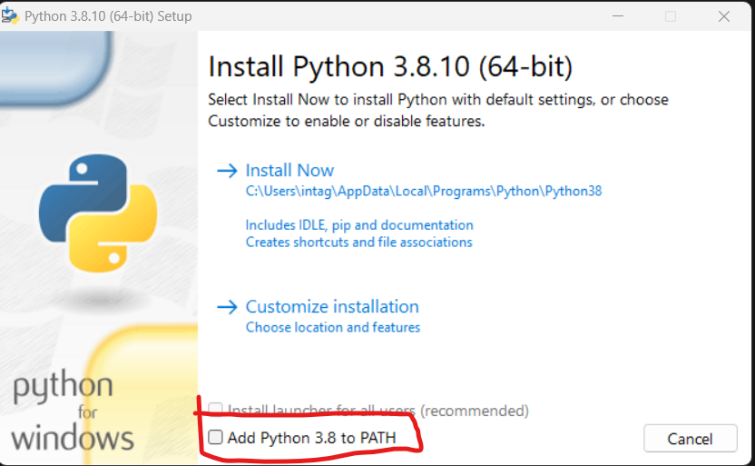

* Install Selenium Package by running “Install Python Packages.bat” file.
* Download chrome driver as per your chrome version and replace the chromedriver.exe in chromedriver_win32 folder.

After Installation just run.

* App.py