Screenshots of 5 layer protocol headers from Wireshark:

Request(http://cspb.teletalk.com.bd/)

Layer1:
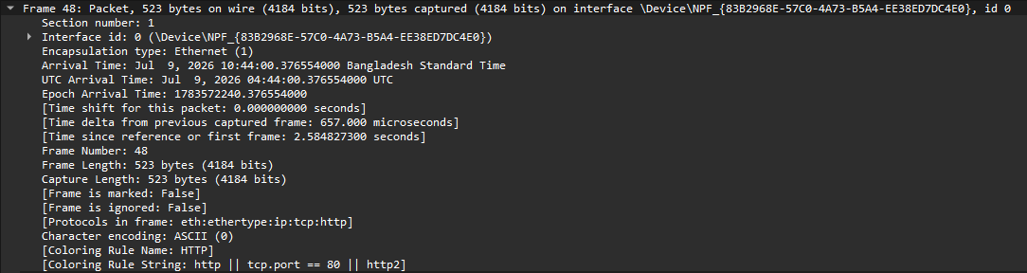
Screenshot shows the packet is 523 bytes, arrival timestamp, and reveals that it contains an HTTP request layered over Ethernet, IP, and TCP protocols.

Layer2:
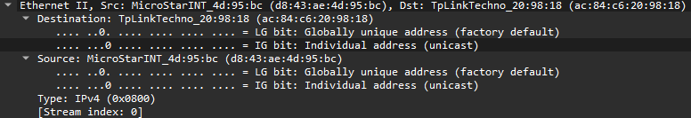
This is the Data Link layer, and the screenshot shows the source and destination MAC addresses, and identifies the payload as an IPv4 packet.

Layer3:
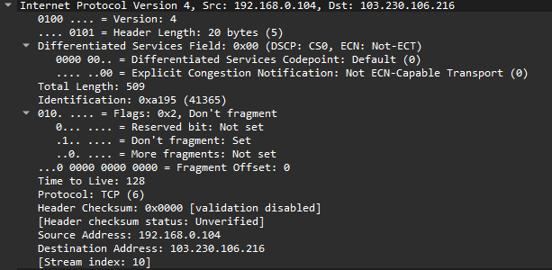
This is the Network layer (IPv4), the screenshot shows the source IP (192.168.0.104, my device) and destination IP (103.230.106.216, the web server) used to route the packet across the internet, along with fields like TTL (128) and Protocol (TCP), indicating the transport layer above it will use TCP.

Layer4:
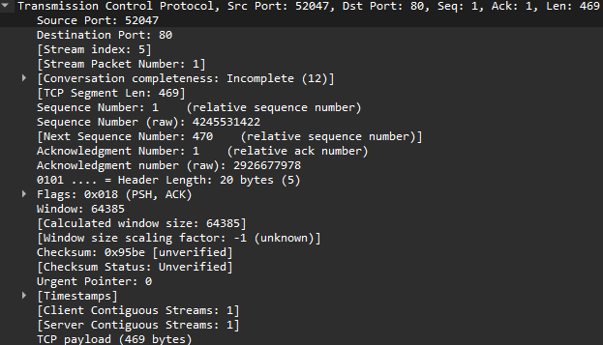
This is the Transport layer (TCP), the screenshot shows the source port (52047) and destination port (80, standard HTTP port).

Layer5:
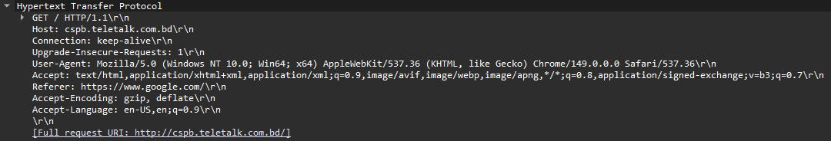
This is the Application layer (HTTP), the screenshot shows the actual HTTP GET request targeting cspb.teletalk.com.bd/.

Response

Layer1:
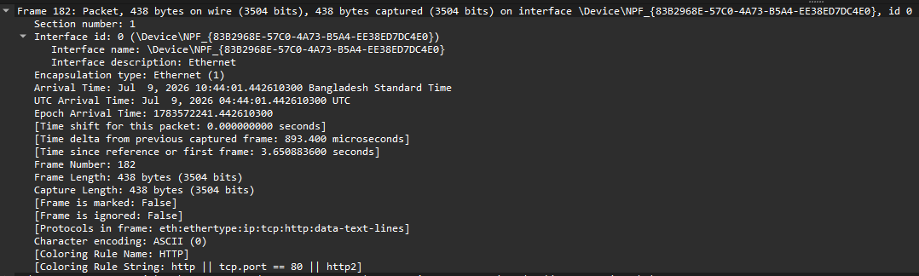
This is the Frame layer of the HTTP response packet (Frame 182), the screenshot shows this is a 438-byte frame captured shortly after the request .

Layer2:
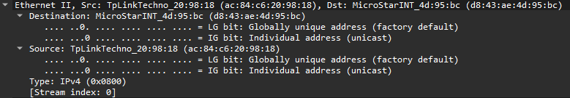
This is the Data Link layer of the response packet, and the source and destination MAC addresses are now reversed.

Layer3:
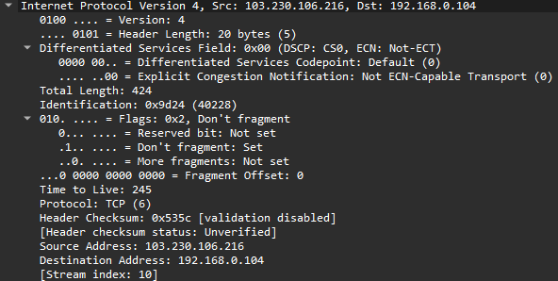
This is the Network layer (IPv4) of the response packet — the source and destination IPs are now reversed (103.230.106.216 → 192.168.0.104), confirming the web server is sending this packet back to your device over TCP.

Layer4:
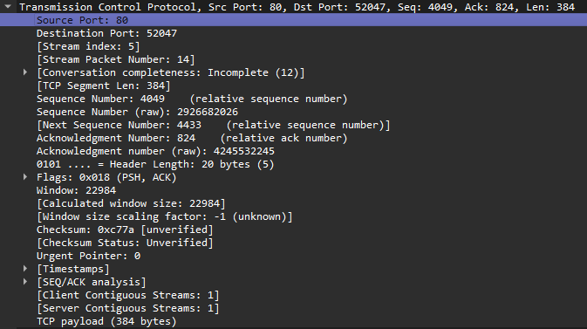
This is the Transport layer (TCP) of the response packet, the source port is now 80 (web server) and destination port is 52047 (my browser).

Layer5:
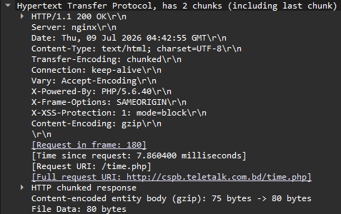
This is the Application layer (HTTP) of the response, screenshot shows the server's HTTP/1.1 200 OK reply, confirming the request succeeded.

